

Name: NANTHANI RAJENDRAN

Login ID: nanthani@oasis-portal.com

Course title: Tourism and Hospitality

Subject Code: BHM04

Submitted date: 11 Sept 2017

**Table of Contents**

|  |  |  |
| --- | --- | --- |
| No | Details | Page |
| 1 | Executive Summary | 2 |
| 2 | Introduction | 3 |
| 3 | Assignment Question |  |
|  | Part 1 | 4-6 |
|  | Part 2 | 7-10 |
|  | Part 3 | 11-13 |
|  | Part 4 | 14-19 |
| 4 | Conclusion | 20 |
| 5 | References | 21 |
|  | Appendix | 22 |

**Executive Summary**

Throughout this assignment, I learned and gained some knowledge on Tourism and Hospitality. I had a better understanding on what is tourism actually, why it is so important for a country's economical growth. I also got to know the categories in the tourism industry. I also have a better understanding on lodging accommodation, and also types of hotel accommodation found in the industry. I also got to know the entertainment sector and also the types of entertainments and its contribution to the tourism industry.

**Introduction**

Tourism is travel for pleasure or business. The purpose of tourism also the theory and practice of touring, the business of attracting, accommodating, and entertaining tourists, and the business of operating tours. Tourism may be international, or within the traveller's country. Tourism is a major source of income for many countries in this modern era and affects the economy of both the source and host countries. Tourism brings in large amounts of income into a local economy in the form of payment for things and services needed by tourists. Tourism is often seasonal, and impacts only become apparent after time, with varying effects, and at different stages of development.

**Assignment Questions**

**Question 1**

Define the Tourism and Hospitality.

Explain your understanding about Hospitality industry. (20 Marks)

**Define the Tourism**

Tourism is an activity of travelling and staying in other places which is not the usual environment of a particular person. This activity is mainly cause of leisure, business or other purposes. The frequency for this activity is for not more than one consecutive year. Tourism is a dynamic and competitive industry that requires the ability to adapt according to customers' changing needs and desires. This cause is important because customer’s satisfaction, safety and enjoyment are particularly the focus of tourism businesses. Tourism can be domestic or international. The international tourism has both incoming and outgoing implications on a country's balance of payment. Tourism is funding the large part of a country's economical growth nowadays both the source and host countries.

**Define the Hospitality**

The hospitality industry is a broad category of fields within service industry that includes lodging, event planning, theme parks, transportation, cruise line, and additional fields within the tourism industry. The hospitality industry is a multibillion-dollar industry that depends on the availability of leisure time and disposable income. People who work in the hospitality industry typically work in hotels, restaurants, or convention centers. Most people think that hotels alone belong to the hospitality industry, but hotels are only one sector of this industry. But, most of those positions are within the hotel industry. People who work in hospitality industry are trained to create wow customer service every time, have a welcoming feeling when people come to stay at their lodging facility and make sure it is clean every time. This industry relies heavily on providing an excellent level of service. Customers are visiting the business to get away from their troubles. A bad experience might keep them from returning ever again. Brand loyalty is very important to these customers, so the associated companies do their best to provide the best service. Companies hire employees based on skill and behavior. Most of these employees are great with customers, and they can give the customer what he or she needs without any mistake.

**Define the Tourism Hospitality**

The term tourism hospitality can be defined as providing customer service to traveller’s and strangers. Hospitality professionals often work in administrative or management position in a service based environment. They are also responsible to oversee the effort they have been taking is being paid of for the establishment. The hospitality and tourism industry is completely diverse. The overall goal of the industry is to ensure that the guests and customers have the pleasurable experience throughout the services that has been provided.

**Explain Hospitality Industry**

The strength of hospitality industry is the market for services always increasing. The industry gets the support of the government to operate efficiently. Somehow slow implementation of some services after researching thoroughly maybe one of few weakness of this industry. They are also prone to political events and it is indeed their weakness. The opportunities that always open in hospitality industry are such as rising income, benefits and the unique experience that you may consider having. The increasing number of competition is consider a major threat to start business related to hospitality.

7 P’s also are applied in this industry. The product that they can offer is via good hospitality services and also make things easier to have accommodation for the customers, good room services, etc. In the case of pricing, there are many strategies the management have to consider. Penetration, skimming, competition, psychological are few of those strategies. Mostly, hospitality industry provide promotions for their customer on few occasions in a year. They will advertise those promotions via internet, social media, print media and so on. A strategic place is the most important factor for a hospitality business. The employees are the backbone of the hospitality business because customers are always awaiting of good customer services. There are will be some procedure in every industry that have to be followed. The physical evidence for hospitality industry is good records of feedbacks and good money making.

**Question 2**

Brief on different type of Tourism categories.

Define Tourism. (20 Marks)

**Categories of tourism**

Tourism is one of the most flourishing industries in the world. There are millions of people across the globe travel miles and miles away from their homes and homeland, in order to see the distant lands and experience and learn new culture. The tourism industry exists in some form or the other in across the world, and tourists are seen traveling to some of the seemingly most inaccessible places. The tourism infrastructure has also developed to a great extent over the years. Thus, this situation is making it possible to reach and explore the difficult parts of the world without difficulties. There are many categories in tourism.

The first category of tourism is leisure tourism. Leisure tourism can be defined as a travel in which the primary motivation is to take a vacation from everyday life. Leisure tourism is often characterized as staying in nice hotels or resorts, relaxing on beaches or in a room, or going on guided tours and also gain the experiences in the local tourist spots. People who are experiencing stressful life may take on a leisure tour in order to feel relieved. In short, leisure tourism is a short getaway from all your problems and experience new climates, traditions or learn something new.

The second category in tourism is cultural tourism. Cultural tourism is the subset of tourism which is focusing on a country or region's culture, especially the lifestyle of the people in those geographical areas, the history of those people, their art, architecture, religion, and other elements that influenced them to shape up their way of life. Cultural tourism includes tourists to visit the urban areas, particularly historic or large cities and their cultural facilities to get a better picture. Cultural tourism also is a movement of persons to cultural attractions away from their normal place with the intention to gather new information and experiences to satisfy their cultural needs.

The third category in tourism is religious tourism. Religious tourism is also known as the spiritual tourism because both belief is significant to the others. Religious tourism is the faith tourism, where people travel individually or in groups for pilgrimage, missionary, or leisure purposes as well. Religious tourism is not only a visitation to a particular holy destination, but may also be travel for a humanitarian cause. Religious travel can be the primary reason for a tour but it can also be part of a tour and provide a destination with additional attractions to go for.

The fourth category of tourim is family tourism. Family tourism is the visitation that involves the whole family unit to go for other places other than their place of residence. Families represent a large and growing market for the tourism industry. Family tourism is driven by the increasing importance placed on promoting family togetherness, keeping family bonds alive and creating family memories.

The fifth category in tourism is health tourism. Health tourism is the perfect term for travel that focuses on medical treatments and the use of healthcare services. It covers a wide range of health-oriented, tourism ranging from preventive and health-conductive treatment to rehabilitational and curative forms of travel. People with rare conditions may travel to countries where the treatment is better understood by the people. Wellness of the person is the primary reason of this kind of tourism.

The sixth category of the tourism is sport tourism. Sports tourism is a type of active holiday. The purpose of a sporting tour is to exercise and keep physically fit. At the same time, the travellers enjoy their natural surroundings, fresh air and clean water. Travellers combine action and relaxation during a sporting holiday. Sports tourism is also traveling from one region, country, or state to another in order to watch a sports competition or game. While sports tourism has not always been extremely popular, during the recent decade the amount of people attending sporting events has drastically increased.

The seventh category of tourism is educational tourism. Educational tourism is one of the fastest growing areas of the travel and tourism. It is also increasingly popular new trend in the global tourism industry. The concept of a wide range of educational tourism has been changing the concept of tourism itself. Education and learning is their main purpose of this educational tourism to carry out.

The last category of tourism is business tourism. Business tourism is a travel for business purposes. Business travellers are businessmen and government officials. They travel on different missions. They often travel to attend a convention. During business tourism, individuals are still working and being paid, but are working away from both their workplace and home. Some definitions of tourism tend to exclude business travel.

**Tourism**

Tourism is an activity of travelling and staying in other places which is not the usual environment of a particular person. This activity is mainly cause of leisure, business or other purposes. The frequency for this activity is for not more than one consecutive year. Tourism is a dynamic and competitive industry that requires the ability to adapt according to customers' changing needs and desires. This cause is important because customer’s satisfaction, safety and enjoyment are particularly the focus of tourism businesses. Tourism can be domestic or international. The international tourism has both incoming and outgoing implications on a country's balance of payment. Tourism is funding the large part of a country's economical growth nowadays both the source and host countries.

**Question 3**

Describe the lodging accommodation and types of Hotel accommodation. (20 Marks)

**Lodging accommodation**

When people are travelling around or go from places to places, the three important things they need in common. The most important thing is accommodation. The other two things is food and also transportation. Lodging is the type of the residential accommodation. People who travel and stay away from their houses need a place to sleep, rest, food, safety and also shelter from hot and rainy weather, to store the luggage they carry around and access to common household functions. If the hotel and accommodation have been arranged, then the food will be easier to get and also easy access to transportation. In some cases, the lodging maybe self-catering, in which the food is not provided, but the cooking facilities are being provided. This component is very necessary in tourism development within any destination that seek to serve the visitors.

**Types of Hotel accommodation**

In tourism industry the most factor is always been accommodation. Hotels plays important part in providing places for tourists to have some rest, have sleep, freshen up themselves, to store their luggages that they have been carrying throughout, and also provides shelter from some inconvenient weather changes. Hotels are classified according to the hotel size, location, target markets, levels of service, facilities provided, number of rooms, ownership and affiliation etc. Hotel targets many markets and can be classified according to the markets they attempt to attract their guests. Common type of markets include business, airport, suites, residential, resort, timeshare, casino, convention and conference hotels.

Business hotels are also the type of hotel accommodation that business people or travellers prefer. This type of hotel accommodation is the largest group of hotel type. This type of hotels are located in business districts or nearby the business venues. Even though business hotels primarily serves business travellers, many tour groups, individual tourists and small conference groups find these hotels attractive. The amenities at business hotels may include complimentary newspapers, hot or cold beverages, free local telephone calls, or even breakfast.

Airport hotels are those hotels which are situated near or in airports. These type of hotels will primarily target business travellers and airline passengers. The airline passengers are those with overnight travel layovers or cancelled flights and airline crews or staffs. Some hotels might provide free transport from the hotels to the airports in order to gain more guests via good word of mouths. Some airport hotels also charges the guest by hour instead of normal daily night charges according to their guest preference.

The other types of hotel accommodation is suites hotel. These kind of hotels are the latest trend and the fastest growing segments in the hotel industry. Such hotels have a living room and a separate bedroom. This environment that has been provided by the hotel industry, easily will make their guests feel they are at home. This feel will attract more customer. This tactic is actually effective in pulling people into. Professionals such as accountants, lawyers, business men and executives find suite hotels particularly attractive as they can work and also entertain in an area besides the bedroom.

One of the fast emerging hotel accommodation is serviced apartment. Serviced apartment or also known as residential hotels provide long-term or permanent accommodation for their guest. Usually guest makes a lease agreement with the hotel. The duration of this agreement is minimum of one month up to a year or so. Serviced apartments generally include living room, bedroom, kitchen, private balcony, washing machines, kitchen utensils etc. The serviced apartment will provide housekeeping service only weekly once unlike hotels which are on daily basis.

The other type of hotel accommodation is resort hotel. Resort hotels are usually located in the mountains, on an island, or in some other exotic locations away from city. These hotels have recreational facilities, scenery, golf, tennis, sailing, skiing and swimming. Resort hotels provide enjoyable and memorable guest experiences that encourage guest to repeat to the resort.

**Question 4**

Explain the Significant of Entertainment in this industry.

(20 Marks)

**Entertainment sector**



Entertainment is a form of activities that take away people's stress basically come from work or school and give them properly amusement to relax. Entertainment is also a form of activity that holds the attention and interest of the people, or gives pleasure and delight. In tourism industry, entertainment is a very important sector. Although people's attention is held by different things, because individuals have different preferences in entertainment, most forms are recognisable and familiar to each other. Entertainment evolves and can be adapted to suit any scale, ranging from an individual who chooses a private entertainment and even for a global audience. This factor is again very necessary to hospitality industry as it involves one of the most important thing of the industry. Entertainment is the significant part of the industry. Satisfaction while having fun in a travel is the key to repeat to the travel places.

**Types of entertainment**

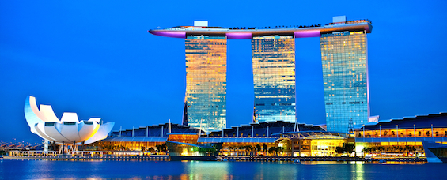

There are various types of entertainments in hospitality industry. The first entertainment in hospitality industry is marinas. A marina is basically a dock or basin with moorings and supplies for yachts and small boats. A marina is very different from a port in which marina does not handle large passenger ships or cargo from freighters. A marina may have refueling, washing and repair facilities, marine and boat chandlers, stores and restaurants. A marina may include ground facilities such as parking lots for vehicles and boat trailers. Fee-based services such as parking, use of picnic areas, pubs, and clubhouses for showers are usually included in long-term rental agreements. Marinas may be owned and operated by a private club, especially yacht clubs but also as private enterprises or municipal facilities. Marinas may be standalone private businesses, components of a resort, or owned and operated by public entities.

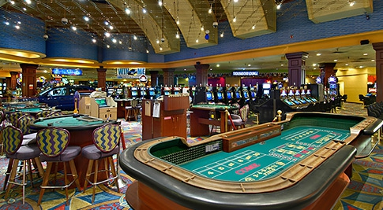

The second entertainment in the hospitality industry is sports and gaming. Many travelers seek out destinations that are particularly suited to specific activities, such as scuba diving or rock climbing. Some of these travel activities require specific gear, training, or planning to pursue, while others may be as simple as slipping into a warm spring to enjoy the soothing waters. There are several physical health benefits that the adventure activities during travelling give us. Selected group of people just may turn out to be adventure travelers: those who typically venture beyond the envelope in the outdoors.

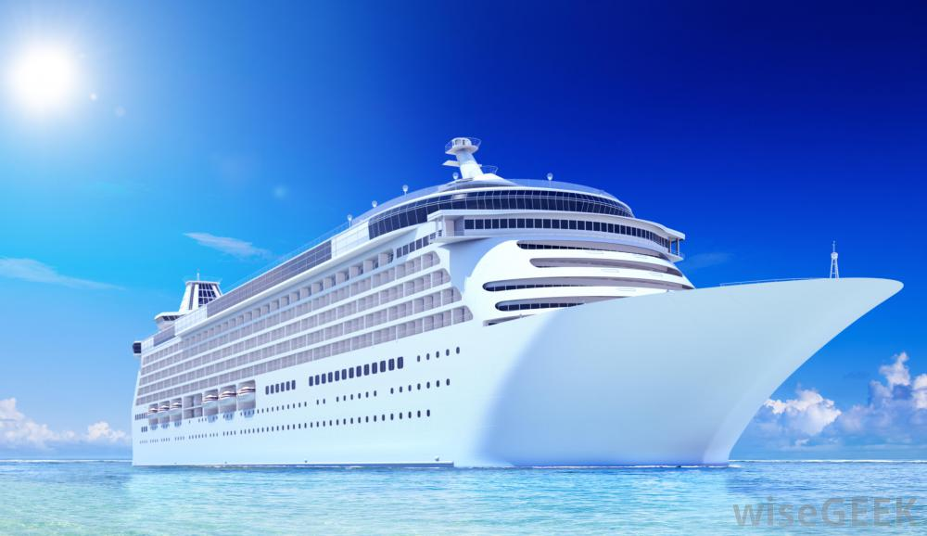

The third entertainment in the hospitality industry is cruise. A cruise ship is like a large floating holiday resort. On board you can enjoy the luxury and comfort of a star hotel and you can choose from different activities. Most cruise ships are equipped with several restaurants, bars, casinos, swimming pools, Jacuzzi, spa, gym, shops, theater and also cinema as well. The guests will be treated by friendly and well trained staffs. Each and every day on board of a cruise ship you have a large choice from various activities which are from relaxation to sports.

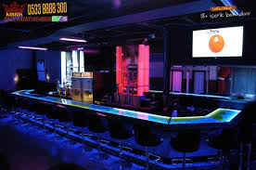

The fourth entertainment in the hospitality industry is nightclubs. A nightclub is a club that is open from the evening until early morning, having facilities such as a bar and disco or other entertainment. A nightclub is also an entertainment venue and bar which serves alcoholic beverages. The situation in a nightclub will be the inclusion of a stage for live music, one or more dance floor areas and a DJ booth, where a DJ plays recorded music and where coloured lights illuminate the dance area. Nightclubs are much more likely than pubs or sports bars to use bouncers to screen prospective clubgoers for entry. Some nightclub bouncers do not admit people with ripped jeans or other informal clothing or gang apparel as part of a dress code.

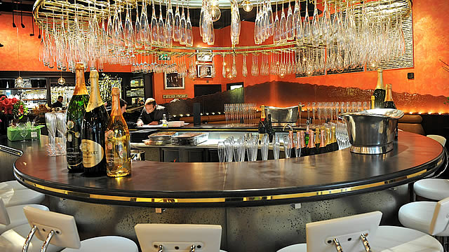

The fifth entertainment in the hospitality industry is bars. A bar is is a retail business establishment that serves alcoholic beverages, such as beer, wine, liquor, cocktails, and other beverages such as mineral water and soft drinks and often sell snack foods. Bars provide stools or chairs that are placed at tables or counters for their patrons. Bars that offer entertainment or live music are often referred to as music bars, live venues, or nightclubs.

**Conclusion**

In this assignment, there are various things regarding tourism and hospitality. Based on this assignment, I learned and understanding what is tourism in hospitality. Tourism is one of most important department to in hospitality business. Throughout this assignment, I study difference of type of categories. By this assignment I got better understanding how, can tourism department help hospitality to running successfully. I had better understanding about tourism and hospitality and entertainment industry in hospitality.

**References**

https://ideas.repec.org(Xhiliola Agaraj,2009)

smallbusiness.chron.com (Micheal Reynolds)

https://www.slideshare.net (Altin Baku)

www.tradeforum.org

www.tourismtattler.com ( October 2015)

https://scth.gov.sa (January 2017)

https://www.slideshare.net (Sha Zabala)

www.boomerandseniortravel.tv (Debbie Gerber, 2012)

https://www.quora.com (Nad Damon)

gov.nv.gov/ (Brian Sandovar)

https://en.m.wikipedia.org/

**Appendix**

Example:



Figure: 1 example picture of sectors hospitality industry