

Name: NANTHANI RAJENDRAN

Login ID: nanthani@oasis-portal.com

Course title: Essentials of Human Resource

Subject Code: BHM01

Submitted date: 17July2017

**Table of Contents**

|  |  |  |
| --- | --- | --- |
| No | Details | Page |
| 1 | Executive Summary | 2 |
| 2 | Introduction | 3 |
| 3 | Assignment Question |  |
|  | Part 1 | 4-6 |
|  | Part 2 | 6-16 |
|  | Part 3 | 17-29 |
|  | Part 4 | 30-35 |
| 4 | Conclusion | 36 |
| 5 | References | 37 |
|  | Appendix | 38 |

**Executive Summary**

Through this assignment, I studied about marketing and customer relationships. I had a better understanding on how they market the product and making a good relationship with their customers by selling the products or proving services. The first aspect in this assignment is a better understanding about marketing. Secondly, I will explain about the difference between marketing and customer service. In addition to that, I will give some explanation on the characteristics of marketing and customer service. The third part of this assignment will cover thee brief explanation and elaboration about marketing strategies. T had studied on how we can apply these strategies in hospitality management. Furthermore, I will explain about customer service skills, role and responsibility in hospitality management. The last part will be the importance and valuation of customer service in hospitality management.

**Introduction**

In this modern era of business world, marketing is the ultimate tool for any kind of business. Marketing is the action or business of promoting and selling product or service, including market research and advertising. The management is responsible for this process to identify anticipating and satisfying customer requirement which profit them. Marketing helps to achieve, maintain and raise the standard of living. Marketing is also means through which production of purchasing power converted into consumption. Marketing is also creates more job opportunities in the market and also these function create the needs for different specialization. The customer relationship process can be developed through marketing. A company markets a target product to satisfy the customer’s needs and wants. If they reaches the customer’s need, both parties will enjoy the benefits. This also will help the company to gain more customers and generate more revenues. Of all business, customer service department been the backbone to operate successfully.

**Assignment Questions**

**Question 1**

Briefly explain about Marketing in Hospitality and The importance of Hospitality Marketing. (20 Marks)

**Marketing in Hospitality**

Marketing is a critical strategy in which the activity, set of instincts, and processes for creating, communicating, delivering, and exchanging offerings that have value for customers. It includes advertising selling and delivering product to people. Marketing also helps create exchanges that creates satisfaction of an individual or a organization. Solely focus on customer’s satisfaction, marketing is the premier component of a business management hospitality industry is no different but hospitality marketing is different from company marketing. Hospitality marketing takes a look at how segments of the hospitality industry, such as hotels, restaurants, resorts and amusement parks. They are also utilize those marketing techniques to promote their product or services. Hospitality industry focuses on creating experiences and relationships with customer is an importance not only tangible products, such as room accommodations, tickets and food, but also intangible items such as creating a luxurious, fun, exciting, or relaxing atmosphere.

**Importance of Hospitality Marketing**

The success of a business often lies on good marketing strategies. Most of the aspect depends on successful marketing tactics. The overall marketing cover advertising, public relations, promotions and sales. Marketing is also a process of introduce the service or products to the potential customer. Marketing is very much important to hospitality industry.

Marketing in hospitality is important because the strategy create awareness among the potential customers. Or a business to succeed, the product or service must be well known to the customers. The customers maybe won’t have much awareness on the introduced product or service unless the organization do the marketing. Some more, the marketing strategy also helps new customers to discover us while marketing process is going on. Marketing make sure information on hotels, resorts and restaurant is easy to find and up-to-date.

Secondly, marketing also very important to increase sales or business revenue. One the service has been promoted, potential customer mostly will give a try on our service such as facilities and foods. This situation increase the change of improving the business to higher level in terms of profit and also improving services. As the awareness becoming reality, the customer who are keen to have the experience. The business also increase rapidly as the words spread.

Company reputation also one of the important of the marketing in hospitality. The success of a company often rests on a solid reputation. Marketing strategies helps to build a brand name and gets the recognition. The higher the expectations of publics towards a hotels or restaurants, the firmer the reputation gets. As the reputation grows, the business will expand. The reputation is build based on the good service an hotel or restaurant provide. This will lead to create a powerful brand name upon the reputation that the company have.

Marketing is also important to foster a healthy competition in the marketplace. Marketing helps to get the world out of pricing on the provided services, which not only reach the potential customers, but also the competitors who are competing for the customer’s business. Marketing help keep pricing competitive for a business to try to win over customers. Marketing ensures the healthy competition that allows small business and new business and to be successful and grow in the marketplace.

**Question 2**

Explain the difference between Marketing VS Customer Service.

Explain the Ethics of Marketing and Customer Service. (20 Marks)

**Differences between Marketing and Customer Service**

Marketing and customer service are two very different departments. However, smaet business persons realizing that customer service and marketing go hand in hand. It is really very crucial for organization to change the old ways of working individual as a department to marketing and customer service have to work in pair as each department can make the other’s job easier and achieve goals faster. Yet, there are still many differences each department possess.

|  |  |
| --- | --- |
| Marketing | Customer service |
| Advertises product or services | Provide the service or products by selling |
| Create trust | Promptness |
| Impulse buying | Provide assistance |
| Determine pricing | Quality service |
| Indirect interaction | Direct interaction |

Marketing department’s strategy is to advertise newly introduced products or service into the marketplace. They need to do research about the product or service before it get into sales and also ensure they recruits customer as much possible. Meanwhile, customer service is the department for handling the customers. They need to understand the concept or function of a product or service. It will be easier for them to explain about a product or service to their customer. They also need to be handle their customer after selling part has bern done. They also need to give assistance for their customer at any time because customer are very valuable any of business.

In a service based business, service is the main products. In other words, marketing department to sell confidence and trust, and ability of an organization to perform the service as described. When marketing a service, an organization need to instill trust and confidence in their abilities because instead of receiving a tangible product, the customer receives a promised result. Promptness is something related o time and being punctual or avoiding any kind of delays. Customer services department have to ensure that customer get the products or service in the promised time. This will strengthen the trust customer have on the organization.

Many products can be marketed in a way that triggers customer’s interest. Trigger this thought would become what a customer want. For example, if someone sees a pair of shoes which advertised customer wants and what the customer actually needs. In his case, the person will leave what he/she need behind and will go for what he/she wants. After getting the product in their hand, then it will be customer service department’s task give information how to use the products and detailing about the products. They also have to be there customer whenever customer needs them.

The marketing department have to determine the price of the newly advertised product in the market. They will have to consider the unit price, marketing costs and also distribution expenses. No matter what type of product you may sell, the pricing will effect directly on the success of a business. They may add some profits in their calculation. Low cost of a product may gain more customers but a quality customer service only can create loyalty among customers. So customer service quality also important cause it will bring a good reputation for the company and have a good ace value.

Customer service relies more on building a good relationship with their customers than marketing department. Direct interaction with customers by customer service department which resulting in maintaining good quality of services. It will directly affect the sales of company. They have to be maintain good morale, be polite and clear the doubts of their customer by giving relevant information. Meanwhile marketing department doesn’t interact directly with their customer but will also influence the sales of the company.

**Ethics of Marketing and Customer service**

**Ethics in Marketing**

|  |  |
| --- | --- |
| Marketing | Customer service |
| Honesty | Utilitarian |
| Integrity | Rights |
| Trust worthiness | Fairness |
| Loyalty | Virtues |
| Reputation and morale | Common good |

Marketing ethics is a process which deals with the moral principles behind the operation and regulation of marketing. Ethics marketing have the potential to benefit the society as a whole, both short term and in long term.

The first ethical approach in marketing is honesty. This is also means the marketing executives should be honest and truthful in providing information about their product in the market. Dishonesty in providing information to their customer may lead to misinterpretation. Honesty in marketing will gain the belief of the customers and will be coming back again and again to do business with the company.

The second ethical approach is integrity in marketing. Integrity is quality of being honest and having strong moral principles. The marketing executive must able to demonstrate personal integrity and should have the courage to take the decision which they feel is right even they face immense pressure. Hey have to stand firm in their belief.

The third approach in ethical marketing is trustworthiness. Trustworthiness means worthy of someone’s confidence. They are forthcoming in supply relevant information and correcting misapprehension of the fact. They make very reasonable effort to fulfil the letter. They do not interpret agreements in unreasonably technical in order to rationalize justifications for escaping their commitment.

The fourth approach of ethical marketing is loyalty. Loyalty means a strong feeling of support or allegiance. Loyalty marketing refers to building trust among recurrent customers, rewarding them for continually conducting business with a company. They should not disclose any confidential information to their friends or closed one their personal advantage. They should not get influenced by others.

The fifth approach of ethical marketing is reputation. Reputation is the opinion that people give to a company, how much respect or admiration a company receiving from their valuable customers. The reputation has evolved more into brand marketing since a good brand reputation ensures a good sales and high revenues for a company.

**Ethics in customer service**

Sometimes there will be a difficult situation arise where efficient ethical decision making skills will be used in order to resolve the issues. By using these ethical approach, it will help us to determine the right course of action. Sometimes with using these ethics, the situation will teach us to analyze the decision or reaction re correct for a particular issue. Customer service plays a vital role between the business and their clients. It is important to determine these ethics can influence the customer service department in handling their customers.

There are some ethical approach in customer service. The first ethics in customer service is utilitarian. Utilitarian is issuing refund to their customers. If the refund has been issued the probability of customer experiencing good customer service will be very high. This situation will also benefits the organization. They will get a fair review and maybe the customer who experienced good service will spread the word and it will lead to gain more customer in future. If things doesn’t go well, maybe there is a chance of customer will be in to try different item at your company. An improved customer service doesn’t lose their customer.

The second ethical approach is rights. Rights can be divided into two different categories which is company rights and customer rights respectively. The company’s right is to stand by their products or service and not issues to refund. The company can argue since the customer aren’t knowledgeable about their products or services. It will help them not to issue refund at earlier stage. Customer’s right is to ask for a refund of product that does not work well for them. The customers can argue since no information were given on how to use the product or service by the employee.

The third ethical approach is fairness. Refund cause reduced of profit rate an company which means they have to spend little bit in order to issue refund and the company will keep a good morale and face value to their customers. While on the other side, the customer will be satisfied with the service and will return to the company for another item or services. In other ways, the company will be also benefited if the customer coming back to them for another products or service. This situation create fairness by benefiting the both parties.

The fourth ethical approach in customer service is virtues. Virtues either can be good one or the bad one. The good one is respect. By giving the refund that a customer want, the customer feel respected and were given attention to their needs and will be not worried about their needs. There were also honesty, courtesy and commitment in the good virtue. The example of bad virtue is reputation. The customers experiencing bad customer service will give a bad reputation for a company. There are also other bad virtues such as greedy, apathy and hostility.

The last ethics that customer service approach is common good. By giving a refund, it will be also a promotion for the company. This action not only looking good from the customer side, but also good for the company’s reputation. A better reputation will give more profits to the company. The customers also will feel good when they receive a refund. Providing a good customer service will bring happiness in customers. This it will be spread like a wildfire and company able to gain more customers. This ethics also will influence the company having good economy resulting in more job opportunities.

**Question 3**

Describe about Marketing strategies and how you can apply your studies in Hospitality Management. (20 Marks)

**S.W.O.T**

S.W.O.T stands for strength, weakness, opportunities, and threats respectively. S.W.O.T is an assessment of strength and weakness of a company in relation to their competitors, and also opportunities and threats they may face in the industry. SWOT analysis is simple yet powerful which will uncover the hidden opportunities that yet to exploit. Strength and weakness usually will be internal to your organization and opportunities and threats influenced by external factors.

**Strength**

Strength of a company probably depends on what an organization excels at compared to their competitors and set apart from other companies. These things mostly strong brand, loyal customer base, strong balance sheet and so on. Strength are basically within your control. The organization can manipulate the factor that will drive your organization move forward.

**Weakness**

Weakness is describe as aspects of the business that will detract the value of the products which you markets or put your business in a situation of competitive disadvantages. An organization, in order to thrive in competitive market, successfully for a longer period of time, need to find what, are the weakness and should enhance these areas and turn into their strength slowly. Weakness can be classified as negative internal factor.

**Opportunities**

Opportunities is the reason a business is running on and mostly it will be the reason the business is likely to prosper. Opportunities influenced by external factors outside the organization. An organization should study what are the opportunities are in the market and have to be smart enough to grab those opportunities. There is a useful approach when looking at the opportunities is to look at strength and analyze whether it opens up any opportunities.

**Threats**

Threats is negative external factor that is beyond or your control that can put your business itself at risk. An organization have no control over these factor but they can have dome contigency plans that may benefit them if they were about to occur. Threats can be the weakness that maybe the threat a company may face, probably.

**7 P’s**



**Product**



A product is an item that is manufactured or product in order to satisfy the needs of certain group of people. A product can be in from the service or goods. A marketer must ensure that he has the right type of product that are in demand in the market. So during the planning period, he or she must do extensive research on the life cycle of the product. A marketer should always have the idea of improving their product. So that he or she can offer a better product than their competitors.

**Price**



The price of the product is basically the amount a customer pays in exchange for the product. Price of a product is very important component because it determines a company’s profit and survival. Price also determines the sales of the product and demand in the market. Low price products often will be in demand and also will be compared to their competitors. So if a product’s price is high they might can offer some discount of the price to gain more customers. Discount is price reduction for certain period. Payment of the price can be made by cash, online banking, credit cards and so on.

**Place**

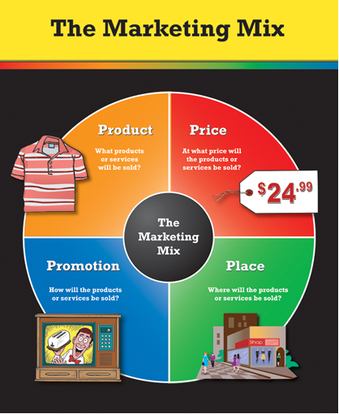

Place is where the exchange of product my happen. A marketer should think of the place where to position and distribute the product in a place that is accessible to potential buyer. The exchange can take place via face to face dealings or online purchasing. Online purchasing is where the marketer will advertise the product and if a customer wants the product he or she can make the payment via online payment method.

**Promotion**



Promotion is raising the customer awareness of a product or brand, generating sales, and creating brand loyalty of the valuable customers. Promotion is important factor of marketing. Promotion can be advertised in communication based mediums such as television, social media, radio commercials and also print media. Word of mouth is also a form of promotion because it ignites the potential buyer’s interest.

**People**

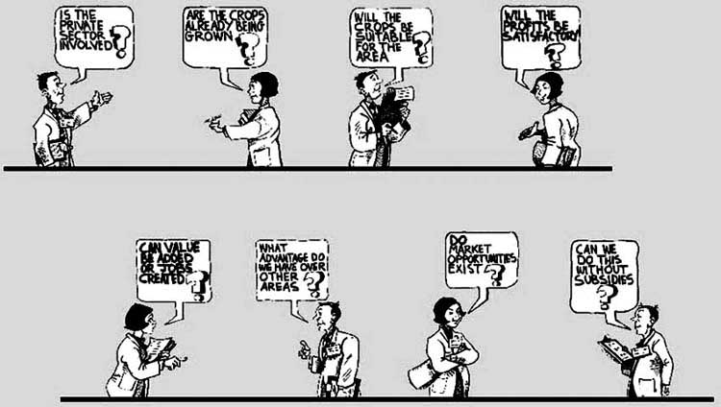

People are on target market that directly involve in the business in the environment such as supplier, marketer, recruiter and customer. The employees of the company is very important because they are the one who will provide good or service to the potential buyers or customers. So it’s very important to hire the right people to do the job effectively. Training have to be providing enhance their skills.

**Process**



Process is the procedures that an organization follows to ensure to reach their target customers. So it’s important to have a well planning process in place to minimize the cost to produce a product. The process will have to solely focus on their customers in order to satisfy the needs. It’s also important to have research and department. Their task is to do research from all possible angles and come out with ideas that can make their move forward to development process.

**Physical evidence**

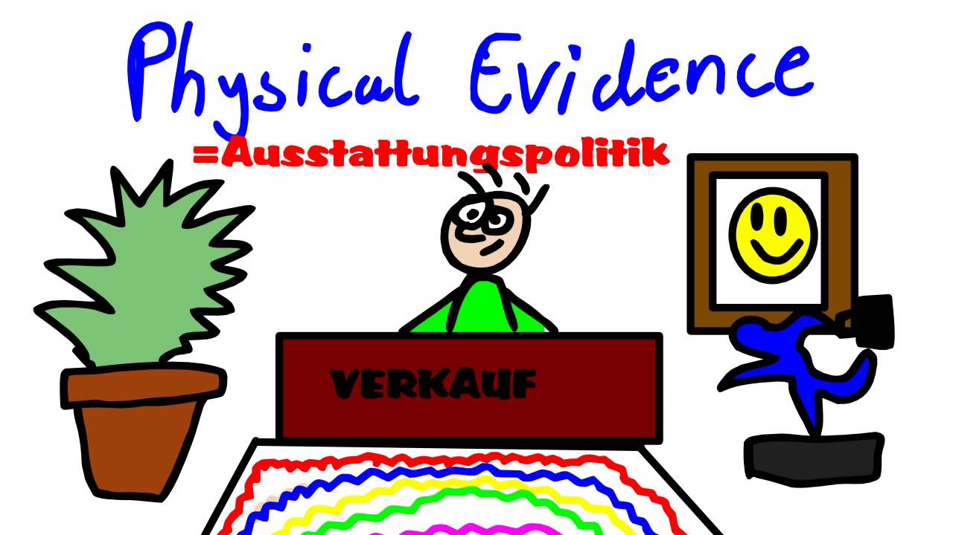

Physical evidence is the material part of a service that has been delivered. The customers tend to rely on physical cues to help them to evaluate the value of a product in the market before they buy it. The physical evidence should be the valuation of a business presence and establishment, this is also a concept of the branding.

**Marketing strategies in Hospitality management**

The strength of hospitality industry is the market for service always increasing. The industry gets the support of the government to operate efficiently. Somehow slow implementation of some service after researching thoroughly maybe one of few weakness of this industry. They are also prone to political events and I is indeed their weakness. The opportunities that always open in hospitality industry are such as rising income, benefit and the unique experience that you may consider having. The increasing number of competition is consider a major threat to start business to hospitality.

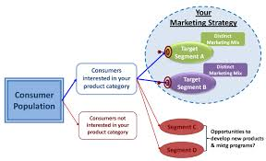

Figure : Example of Marketing Strategies

7 P’s also are applied in this industry. The product that they can offer is via good hospitality service and also make things easier to have accommodation for the customers, good room service, etc. In the case of pricing, there are many strategies the management have to consider. Penetration, skimming, competition, psychological are few of those strategies. Mostly, hospitality industry provide promotion for their customer on few occasions in a year. They will advertise those promotion via internet, social media, print media and so on. A strategic place is the most important factor for a hospitality business. The employees are the backbone of the hospitality business because customer are always awaiting of good customer service. There are will be some procedure in every industry that have to be followed. The physical evidence for hospitality industry is good records of feedback and good money making.

**Question 4**

Explain in detail on Customer Service Skills and Characteristics

Explain the Important of Hospitality Customer Service (20 Marks)

**Customer Service Skills and Characteristics**

Customer service is provision of service before and after of any purchases or service. The success of the customer service of a company is depends on the capability of the employees to handle their customer according to their customer’s needs and priorities. In this case, the organization is responsible to provide good training sessions for their customer service department staffs and also hiring the best person to fill in the job. There are many characteristics and skills required to be excellent customer service staffs.

The very first quality is promptness which means the ability to do, perform or deliver at once or without making any delays or on schedule. The deliveries must be on time or the product delivered should be good condition when the customer receive the goods. This situation might create trust of their customer and brings good reputation to the company. This simple act of customer service department may benefit the company in huge manner. Any cancellations or delays should be avoided and this must be their main concern.

Customer service staff also need to polite to their customer. Politeness is the behavior that is respectful or considerate of people towards a person. The main goal of being polite is to make their customer feeling relaxed and comfortable doing purchases with a company. It is appropriate to use good manners to their customers in any kind of business. This act make the customers feeling respectful toward an organization. Politeness is a losing art but it is a strong foundation in customer service.

Customer service jobs demands responsibility traits in their employees. Responsibility means the fact of being responsible, answerable for something within under a person authority. Responsibility in customer service is two sided. It covers the employee’s responsibility in his or her personal agendas such as attendance, providing good services, showing loyalty toward his or her company and also attitude. Responsibility is also means the ability of being responsible for their own mistakes and results which might determine the results in customer’s situation.

The customer service staff must be very knowledgeable of their products and service. Knowledgeable means the ability to possess greater knowledge, insight, or understanding about a particular thing. A customer service staff must be knowledgeable about the product or service for which they are responsible. Mostly the staff need to have some knowledge on most of the product or service. Along with the knowledge comes the confidence which will lead to customer’s satisfaction. If the staff don’t know the answer for a particular question which customer may ask, he or she is responsible to get to know answer and let know their customer as soon as possible.

Another trait of good customer service skills or characteristics is accuracy. Accuracy means the quality or state of being accurate or precise of the information he or she provide. Any information from a customer service staff must be 100% correct. Be it instructions, performance or information about warranties, everything must be fact-based. The actions performed also must be accurate.

**Importance of Hospitality Customer Service**

Hospitality is all about quality customer service that a organization provides. Customers are very important in this industry. Their satisfaction of the service is what this industry expecting to. Customer service is one of the key factor in a successful establishment. Customer service isn’t solely focus on the first impression, but it cares for how a firm caters their customers. Customer service plays an important part to assist customer and anticipate their need. This shows how important customer service is in every firm around.

The first important is customer’s expectation. Memories is always what a human being remember. It has to be a good one to keep in his or she mind and recall it often. While travelling, the guests always expects the hotel’s or tourist destination’s staff members to be courteous, helpful and friendly. They also expects the staff to be knowledgeable on the area and attractions nearby. If the staff can help the guest, it will create a memorable experience that they crave for.

Secondly, the online feedbacks influenced the business. In the modern world, people are very internet savvy. People find hotel rooms and do bookings, arranging trips using laptops and smartphones. They also write down their feedback based on the customer service they experienced from a particular organization. When guests do booking online, they always go for the hotel with good feedbacks within their budgets. Bad reviews are extremely damaging to the hotel or service based businesses.

They have to deliver what they have promised to their customers. Ay business need to keep their customer happy and satisfied but in hospitality industry it is essential to keep their customer happy all the time in order repetition of business and also for referral purpose. To make the customer keep coming back to a organization is to give what they had promised. If they can exceed the expectation of their customers, it would a great tool.

**Conclusion**

In this assignment, there are various things regarding essential of marketing and customer relationships. Based on this assignment, I learned and understanding what is marketing in hospitality. Marketing is most important department to running any business. Throughout this assignment, I study difference of between marketing and customer service. By this assignment I got better understanding how, can marketing and customer service department help organization to running successfully and how, they are applied marketing strategies and skills, in this business world and how they handle the customer , and make a successful business.

**References**

* Authors name: Mind tools editorial team
* Online: https://www.mindtools.com
* Authors name:
* Online: https://www.professionalacademy.com
* Authors name: Pamela Vaughan [ April 23,2012 ]
* Online: https://blog.hubspot.com
* Authors name: Bruce jones [ March 01, 2016 ]
* Online: https://hbr.org/

Authors name:

* Online: https://www.slidershare.net
* Authors name: Virginia tran
* Online: https://www.slideshare.net
* Authors name:
* Online: https: https://www.surveymonkey.com/
* Authors name: Christie lorette
* Online:smallbusiness.chron.com/
* Authors name: Alex mcann [3 October, 2013 ]
* Online: www.northwestbusinesslife.co.uk/
* Authors name: Alex morgan
* Online: smallbusiness.chron.com

**Appendix**

Example:



Figure 1: example of marketing strategy