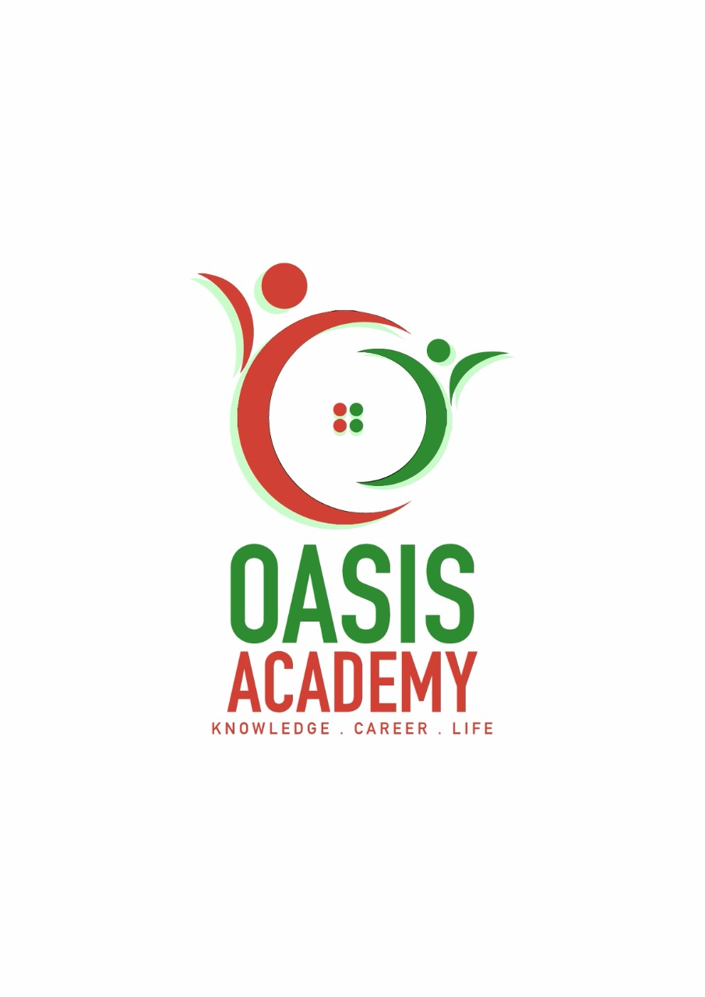

Name: NANTHANI RAJENDRAN

Login ID: nanthani@oasis-portal.com

Course title: Essentials of Human Resource

Subject Code: BHM01

Submitted date: 05Jun2017

**Table of Contents**

|  |  |  |
| --- | --- | --- |
| No | Details | Page |
| 1 | Executive Summary | 2 |
| 2 | Introduction | 3 |
| 3 | Assignment Question |  |
|  | Part 1 | 4-9 |
|  | Part 2 | 10-18 |
|  | Part 3 | 19-27 |
|  | Part 4 | 28-31 |
| 4 | Conclusion | 32 |
| 5 | References | 33-34 |
|  | Appendix | 35-36 |

**Executive Summary**

Through this assignment, I learned and gained some knowledge on Human Resource Management. I had a better understanding on how a human resource actually work. Why it so, important for any organization. First part of this assignment is about major activities and Human Resource Operation in Hospitality Management. On this part I understanding and able to define and describe the major activities and human resources operation in hospitality management with examples. Second part of this assignment I will explain human resources planning and action plan human resource planning in hotel industry. I also understand about the human resource planning trend in hospitality. Third part of this assignment I studied about the function of human resources and human resource policies. I can brief ad elaborate functions of management and how the policy applies I hospitality management. The final part of this assignment I covered this topic about organization behavior in hospitality and groups and structure organization. How they were applied in the day-to-day work and most importantly also about the organization behavior be it in groups or structure.

**Introduction**

Human resource department is effectively describe the process of planning and directing the applications, develop and utilize employment in Human resource. Human Resources management is the management of human resource. It’s designed to maximize employee performance in service of an employer’s strategic objectives. Human Resource maintains control can enhance employee’s perception of Human Resource throughout the workforce when they believe Human Resource considers employee to be its internal customers and render services with that in mind. An organization cannot build a good team of working professional without good human resources. A good human resource department is critical to an employee oriented, productive workplace in which employee are energized and engaged. The important of human resource is easily overlooked in the busy day–to–day in the each of these areas, but organization would be less successful. The role of human resource affects all level of people in an organization because employee is their man priority.

**Assignment Questions**

**Question 1**

Define the Major Activities and Human Resource Operation in Hospitality Management. (20 Marks)

**Human Resource Management**

Human resource management (HRM) is basic strategy to manage employee of an organization. It’s also requires Human Resource personnel to plan and directing application of new candidate for recruitment. Human Resource Management is also responsible for employee related issues and they have to handle the pressure and solve the issues to satisfy their employees. The main objective of profit while minimize the loss of an organization. It’s related to money flow within an organization.

**Major Activities**

**Recruitment**

One of the main activities of Human Resource Management is recruiting. Recruitment is a process of searching and having the best qualified candidates. The recruitment process includes analyzing the requirements of job. Human Resource have to identify the existing sources of applicants and develop them. This can make applicant get attracted to the advertised job. Recruitment process also include conducting job analyzes. They also need to be determine and managing wages. Major activities of Human Resource Management is also consists of arranging training for new employees. Lastly Human Resource Management also need to strice a balance between all levels of employees.

**Selecting**

Selection is the process of interviewing and evaluating the qualified candidates for a specific job. The further process will be selecting an individual for employment based on required criteria. Selection also need to address candidate’s experiences. Skills and knowledge and evaluating the suitability of the candidates for the job. Recruitment and selection process have different scopes. The former is to sort out the qualified candidates and shortlisting process while the latter is to find the best candidates to fill the jobs in the organizations.

**Training**

Training is a teaching process throughout practice and instructions. It is to help him or her to develop a particular skills to a desired standard. The provided training is a helpful tool for him or her to do the assigned task correctly and effectively. Training is a tool to increase the existing knowledge and skills. Every organizations should provide training sessions to all employees irrespective of their qualifications and skill.

**Motivation**

Motivation is general desire or willingness of someone to do something. It is also to help to stimulate desire energy in people to continue their interest and commiting themselves for the job, to make an effort to attain their goals. Motivations also can be defined as goal directed behavior while acting as catalyst to achieve goals. Motivations is a managerial task that should be provide to be the employees to inspire them to be at their 100%management can expect excellence from their respective employees only through motivations.

**Evaluation.**

Evaluation can be defined as a systematic way of determine the value of a job in relation to other job. Evaluation can also be done to measure the performance level of an employee in an organization. Evaluation is also vital to assess their relative worth for the purpose of establishing rational pay structure. Evaluation begins with job analysis and end at the point of determination of worth of a job. Both non analytical and analytical methods are used in evaluation process. Non analytical method were designed on the basis of the job while analytical method were designed on the basis of the job requirement.

**Compensation**

Compensation is something related to salary and benefits. This benefits ensures to provide cash and medical care for works who are injured or become ill direct result of the job. A claim will be paid if insurance carrier agrees the injury or illness is due to the work. This process is within the scope of Human Resource Management. Compensation will calculated based on performances of a person and also legal requirement. It’s also enable to attract some of the qualified applicants for the job.

**Human Resource Operation in Hospitality Management**

Human resource is a department of and organization that deals with employee relation issues. Human resource operation often refers to the services provided by an Human Resource department to business operation. The human resource operation practices to support the management and staff in their day-to-day business activities which important to meet the goal of an organization.

The front office is the most important department in hotel industry. This department is the nerve to hotel industry. A guest attain an impression of level of services he/she will get from a hotel through front office department. Front office department frequent role is to get in touch with guest and also help internally in the office. Front office department duties are such as answering phone calls, perform check in and check out and ETC.

Food and beverage department is so important in any hotel to maintain the food quality, food costing, managing restaurant and bars and ETC. For an employee to work in food and beverage department, he/she must be willing to serve the customer cheerfully and efficiently. There are many sub department in food and beverage such as restaurant, bar, kitchen and so on. The employee are always ready to serve customers according to their preferences.

Housekeeping refers to the management of duties and chores involved in the running of a household works, such as cleaning, cooking, maintenance, laundry and bill pay. This department is so essential to run the hotel business smoothly.

Maintenance and security department is so important to hotel industry. Maintenance department ensures the facilities are well maintained, also mechanical equipment, and utility systems of the hotel in a condition of operation excellence so that full service use many made at all times. The department also responsible for safe working environment. Security department safety of guest. This department is active when called upon but still is very active department.

**Question 2**

Describe in brief on Human Resource Planning and Planning Trend in Hospitality.

Explain about what is you understanding on Action Plan Human Resource Planning in Hotel Industry. (20 Marks)

**Human Resource Planning**

Human Resource Planning is an ongoing, continuous process of systematic planning to achieve optimum level use of an organization valuable asset which is human resource. The main objective of human resource planning to ensure the best fit between employee and jobs while avoiding manpower shortage. There are four major key steps in human resource planning.

Following are those steps:

**1. Current Human Resource Supply**

Assessment of the current human resource availability in the organization is the first and foremost step in Human Resource Planning. This step includes a study of the human resource strength of the organization in terms of numbers, skills, talents, competencies, qualifications, experience, age, tenures, performances ratings, ETC. During this stage, the consultants may conduct interviews with the mangers to understand the critical Human Resource issues they face and workforce capabilities they consider basic or crucial for various business processes.

**2. Future Human Resource Demand**

The second step in human resource planning is analysis of the future workforce requirements of the business. All their known Human Resource variable like attrition, lay-offs, foreseeable vacancies, retirements, ETC, are taken into consideration while determining future Human Resource demand.

**3 .Demand Forecast**

Next step is to match the current supply with the future demand of the Human Resource. This process ensures that we can create a demand forecast. It is so important to understand the business strategy and objectives.

**4. Human Resource Sourcing Strategy And Implementation**

After reviewing the gaps in the Human Resource supply and demand, the Human Resource consulting firm develops plan to meet these gaps as per the demand forecast created by them. This may include conducting communication programs with employee, relocation, talent acquisition, recruitment and outsourcing, talent management, training and coaching, and revision of policies.

**Planning Trends In Hospitality Management**

Assessing Human Resources

Demand Forecasting

Supply Forecasting

Matching

Demand

And Supply

Action Plan

Figure 1: Major step in Human Resource Planning

Hospitality directly related to hotel industry. There are also some

planning trends in hotel industry which have been applied in the

industry. The first and forecast trend is assessing. This is a

process in which is to stud and gather the information related to

job responsibilities and operations. The task here is to determine

which will best suits the job and of skills, knowledge and

abilities required to put in a good performance while fitting in

the role perfectly. The result of this process is job descriptions

and job specifications. This state contain educational

background, experience, skills, knowledge, and so on. Job

analysis is important when you need to advertise a vacancy.

This process is essential which will lead to recruitment and

selection process.

The second planning trend in demand forecasting. This is a process in which Human Resource need study and predict how much of quality of manpower will the organizations need in future. Quality means they need to evaluate a candidate’s knowledge in the required position an also he-she could well fit I the role or not. Quantity means need manpower which need to predict in numbers. Hospitality industry is largely a service provider industry. Some of the techniques that are useful in demand forecasting are managerial judgments, ratio-trend analysis. They are many organizations who are able to provide services emerging in market and this number most likely will be increasing. So there are many options for a job searching candidate to choose which organization he/she prefers to work for.

The third planning trend is supply forecasting. This process not only predicts the number but they also estimate the availability of current employees and also future employees. Availability of current employee mean the staff need to know how long an employee can work for and his/her future planning. This process can give a better understanding of the number of qualified candidate is still working in the organization. This process is a long process that have to do step by step. First they need to advertise a job vacancy for new recruitment. Once they receive applicant, they need to shortlist the qualified candidates and conduct interview session for them. After analysis their knowledge and skills, they can to next process which is selection. After selecting the candidate, Human Resource staff need to inform him/her about the job offer via phone calls or emails. Now it’s down to the candidate either to take the job offer or leave it.

The fourth trend is involving the second third trend which is to matching demand and supply. It can be defined as the vacant position will be filled by a right candidate in a right time to progress. This trend is very important because at this stage, Human Resource need to make the decision wisely and time which means will eliminate the risk of budget constraints and time wasted on a wrong candidate.

The final planning trend is action plan. This plan begins with recruitment plan, followed by training, development, retention, promotion, redeployment, redundancy, transfer ad succession plan. This plan is similar to the major activities if Human Resource Management which is recruiting employee and place them in the organization successfully. Recruitment I process of recruiting people for a role whereas training and development is important to improvise the abilities and skills of employees. Retention plan means the ability of an organization to retain their current employees and promotion is to reward or promote to higher level in the management for the best performing employees. Redundancy plan is always a backup plan while transfer means to transfer the employee to another branch with the organization.

**Action plan**

Action plan consist of recruitment plan, redeployment plan,

training plan and retention plan. The first plan is recruitment. A

recruitment plan can help the Human Resource to identify and

hire the best qualified candidate. Recruitment plan should

includes guidelines for hiring department to analyze the

candidate’s ability, skills and knowledge. Recruitment plan

helps to estimate the number of new hire required in the

organization.

Redundancy plan is termination of employee for business reason

or so. This situation arise sometimes cause of economic

conditions. When a position got diminished cause of the process

change in an organization, the person who is holding the job will

be terminated his contract by the organization. But the employee

can claim the compensation from organization.

Redeployment plan is a position switch plan where employee

moved to a department which in shortage of manpower. In this

process, they need to identify the surplus and shortage areas.

Human resource staff have to explain the reason redeployment

to their employee and help them to settle in. sometimes they

have to conduct some training session for them.

A training plan is a must because new recruitment may not aware

of carry out a task and so on. So in order to create an awareness

and help them to get a better understanding they need to conduct

a training session. Training session may improve the new

employee’s talent and enhance the development of the employee

resulting in good performance by the employee.

Retention plan is to retain the current employees. This plan also

Includes of performance appraisal, incentives and rewards to

Satisfy their employee and also as a motivation for them to work

hard. Its important to retain the employee because it is hard to

ill up the vacant position of a fully trained employee. Human

resource require to go long way in motivation their employee

to create a good working environment which will encourage the

employee to work under an organization for longer period.

**Question 3**

Brief about Human Resource Function and Human Resource Policies.

Describe the Function of Management and How the policy applies accordingly in Hospitality Management. (20 Marks)

**Human resource function**

Human resource have necessary function to handle the organization structure. It’s also essential to provide labor law compliances, hiring process and providing training, compensation process, relational assistance and help with handing specific performance issues. Without these functions the essential needs of management and staff would not exceeds. Below are the essential steps in human resource function.

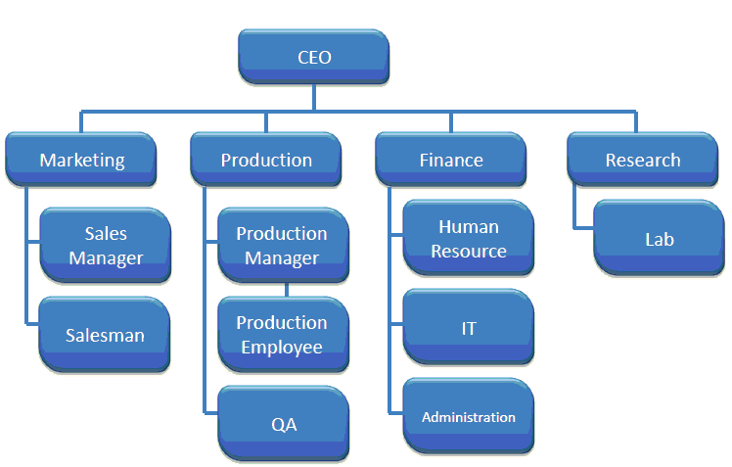

Figure 2: Example of Organization Structure

**1. Ensure Compliance with Labor Laws**

One of the primary duties of the human resource is to ensure the business operates in compliance with all labor laws. The department must be aware and applied with the set of rules employment regulations. This includes such as issues of break time and the age in which an individual can become employed.

**2. Recruitment and Training**

Recruitment new manpower providing training for new employees are primary responsibilities of the human resource team. This includes advertising available vacancies, interviewing and hiring candidates and setting hours of training for the new recruits.

**3. Safety**

Safety of employees is a very important factor in any industry. It’s management’s responsibility to provide safe working environment for their employees to avoid any unwanted incidents. One of the main task of management is to provide a safety training course for they are employees to help them to understand what is safety in working environment is all about. Management also should record the data any injuries and fatality reporting. If an employee got injured in working places, management should give compensation to the injured employee.

**4. Compensation and Benefits**

The distribution of payroll is under the responsibilities of human resource. Payroll exists in different division in big companies while in small business there will be a staff to handle. Health care benefit are handled by the human resource department.

**5. Employee Relations**

Another key function of the Human Resource department is the managing of employee relation. When there is a dispute or misunderstanding between employees or between employee and a manager, it is the human resource officers who intervene the situation and will get a solution for the problems.

**6. Employee Performance Improvement Plans**

The human resource department is often instrumental in setting up performance improvement plans. These plan is written proposal which is essential for the improvement of struggling employees to increase their performance level.

**Human Resource Policies**

Human resource policies are continuing guidelines on the approach of an organization which intends to adopt in managing the people within the organization. The policies represent some specific guidelines to Human Resource managers in various matters. A good Human Resource policy will explain which should be followed, with precision. Each organization have different set of business background therefore the policies that has been se will be different. Below are the policies for the human resource.

**1. Organization structure**

For an organization to progress effectively and also to help employee understand the formal structure of the organization, it is essential to have a structure policy. These policy should be applied in each department within the organization. To give their employee a better understanding on the organizational structure, the organization can should also the staffs together with management to construct the policy.

**2. Legal issues**

Legal issues caver any sort discrimination age, sex, color, origin, religion, medical leave, pregnancy leave, drug free working environment, disabilities and ETC. these allows an candidate who are attending an interview, have the rights to not answer any discrimination related question. Discrimination related question are completely prohibited. An interviewer can only ask about the candidate’s ability, skills and knowledge related to the job. For an employees, these policy allows him/her to protect themselves from any sort of discrimination. Moreover, legal issues also allows an employees to get some benefits from their management.

**3. Supervision guide**

Supervision is an action related to supervise employee and also provide direction. It is also o oversee a work of a staff and his/her progress. There are some levels in supervision. For example, supervisor supervise entry level staff while managers supervise the work of supervisors. Supervision often includes conducing a basic management skills such as decision making, problem solving and also planning process. The staff also need to manage their department and teams hiring and provide training for employee also some of task falls under supervision.

**4. Consistency**

Consistency can be defined as being in compliance with a set of rules, guidelines or policies. Having consistency in working environment have its own benefits. Workplace in which consistency is applied, it’s appear to be a better organized working environment. This feature assure their employee about their stability. When there is consistency, the workplace will likely to seem less chaotic. This situation creates comfortable within employees.

**Function of Management and Policies applied**

Hospitality industry established to provide service to people. This set out to be the industry’s main priority. The role of Human Resource in this issue is to take the responsibility of management and let the management focus on the business. Hospitality industry’s priority is to serve people expertly, this it’s a Human Resource department’s responsibility to recruit the best people to carry out the task. Human Resource department also have to manage issues regarding wages and compensation and ensures the wages offered in par with those competitors. Human Resource also have to provide programs to increase the growth of morale within employees to ensure the employees working towards achieving organization goals. Human Resource also need to protect their employees from working for long hours or without off days that may lead to dissatisfaction. Human Resource should know the employment law and make sure the organization obeys the law.

Policies are so vital for a better organization. One of the Human Resource policies is to ensure employee satisfy with his/her working environment. By communicating with employees, Human Resource staff can get to know about the problem they are facing and help them to solve the issues for the development of their employee. Promotion is also necessary to satisfy employee. Human Resource responsibility is to evaluate employee’s performance and to give promotion as per their individual performance. Human Resource also responsible to provide training session for their employees.

**Question 4**

Explain in detail about Organizational Behavior in Hospitality and brief on Groups and Structure in Organization. (20 Marks)

**Organization behavior in hospitality management**

Organization behavior is the study of the way people interact within the group. Hospitality organization must achieve excellence in human relations between staff and mangers, and that success starts with quality organization behavior. The main idea of the study of organizational behavior is that a scientific approach can be applied to the management of workers. Organizational behavior theories are used for human resource purpose to extract maximum output from an individual group members. In hospitality industry the employees of various personalities join together to perform various kind of job within a organization. Organizational behavior is so important because it helps Human Resource department to understand, predict and also its effects on the organization. Leadership and decision making skills will also be enhanced through organizational behavior. These enhancement will help if an employee get promotion to be a manager or in some other roles. Organizational behavior is goal oriented.

**Organizational behavior groups and structure**

Organizational behavior groups is the role groups in organization. Group structure, strategies, leadership, and reward allocation to members are viewed a inputs to the model. Group performance, quality of work life for group members, and ability to work independently in the future are considered as outcomes. A number of group process variables are seen as significant. Organizational structure defines how tasks are divided, grouped, and coordinated in organizations. Every organization has a structure that clarifies the roles that organizational members perform, so that everyone understand their responsibilities to the group. There are six elements in organizational structure.

Organizational structure

Groups

Figure 3: Example of Organization structure / Groups

**1. Chain of command**

This element is one of the most basic element in any organization. Chain of command is unbroken chain of line of authority that extends from upper level management all the way to bottom level staff. This element will ensures that who will report to whom which means an bottom level employee is responsible o report himself/herself to his/her superior who is a supervisor.

**2. Span of control**

This element will determine to which extent the authority of role lies. This is also means how many of subordinates can a superior staff manage. The area of span of control depends on the ratio of subordinates to the superior.

**3. Centralization**

Centralization is two types. One is centralized and the other one is decentralized. This element concentrate on the authority of decision making. Centralized organizational structure concentrate the decision making power to a single point which is a top level management. Decentralized is the decision making power spread wide and this element will slow down the decision making process.

**4. Specialization**

Specialization is the task or activities are broken down and divided into individual jobs which can help employee to be specialize in a task. This allows the work will be more efficient. They might became masters of their task.

**5. Formalization**

Formalization is how jobs are structure in an organization. In formal structure, the role will remain the same regardless who is the role or position. The employee’s skills and ability won’t be valued. However, in informal structure the skills and ability of an employee will be valued. This will allows the role or position will be altered according to the individual’s preference.

**6. Departmentalization**

This element is the process of grouping jobs together. There are two types of departmentalization. One is rigid and the other one is loose. Rigid departmentalization is there will very less communication between to different teams. Meanwhile in loose departmentalization, the interaction between two teams will be more often and collaboration may take place while performing some tasks.

**Conclusion**

In this assignment, there are various things regarding essential of human resource department. Based on this assignment, I learned and understanding what is human resource management. Human resource management is most important department to running any organization. Throughout this assignment, I study function of human resource and policies. By this assignment I got better understanding how, can human resource department help organization to running successfully and how, they are applied planning and trends, handle the staff problems, and make a successful organization.

**References**

* Authors name: Zeinul Haleem
* Online: https://www.slideshare.net/mobile/ZeinulHaleem2/human-resource-management-in-hotel-industry?qid=fc4819d9-1eda-4b80-91e3-4c006ab78cb7&v=&b=&from_search=3
* Authors name: Somitra Upadhyay
* Online: <https://www.slideshare.net/mobile/SomitraUpadhyay/hr-policies-of-fortune-landmark-hotel-and>
* Authors name: Dr. Rajasshrie Pillai
* Online:

https://www.slideshare.net/mobile/rajasshrie1/chapter-1-ob-38248150?qid=e8794fa5-89e9-4d6c-b850-fd24ead83c85&v=&b=&from_search=1

* Authors name: Yamini Periwal
* Online:

https://www.slideshare.net/mobile/happyspark/organizational-structure-behaviour

Authors name: Om Petal

* Online:

https://www.keka.com/5-major-functions-human-resource-management/

* Authors name: Muhammed Umer Khalid Habib
* Online:

https://www.slideshare.net/mobile/umerkhalidhabib/human-resource-planning-24053844

* Authors name: Farook Azam
* Online: https://www.slideshare.net/mobile/Farook_A_Azam/ahrm
* Authors name: Ruth Mayhew
* Online:

smallbusiness.chron.com/six-main-functions-human-resource-department-60693.html

* Authors name: Heather Reynolds
* Online:

https://www.slideshare.net/mobile/hclarkre/legal-issues-in-human-resources

* Authors name: vishnu
* Online:

https://www.slideshare.net/mobile/vishnuvsvn/demand-forecasting-in-supply-chain

* Authors name: Sajna Fathima
* Online:

https://www.slideshare.net/mobile/sajnafathima988/hr-supply-forecasting

**Appendix**

Example:

Assessing Human Resources

Demand Forecasting

Supply Forecasting

Matching

Demand

And Supply

Action Plan

Figure 1: Major step in Human Resource Planning



Figure 2: Example of Organization Structure

Organizational structure

Groups

Figure 3: Example of Organization structure / Groups