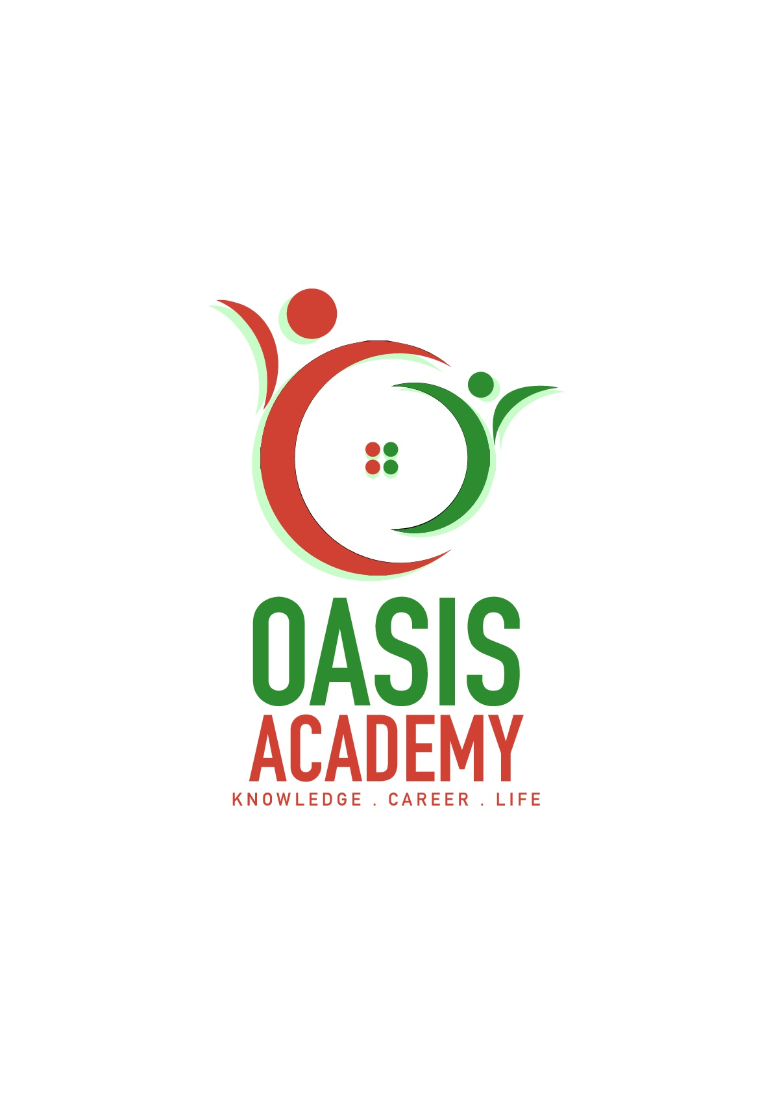

Name: Vivshnu A/L Gunasegaran

Login ID: vivshnu@oasis-portal.com

Course title: Essentials of Marketing and Customer Relationship

Subject Code: BHM02

Submitted date: 17 July 2017

**Table of Contents**

|  |  |  |
| --- | --- | --- |
| **No** | **Details** | **Page** |
| 1 | Executive Summary | 2 |
| 2 | Introduction | 3 |
| 3 | Assignment Question |  |
|  | Question 1 | 4 - 5 |
|  | Question 2 | 6 - 7 |
|  | Question 3 | 8 |
|  | Question 4 | 9 - 10 |
| 4 | Conclusion | 11 |
| 5 | References | 12 |
|  | Appendix | 13 |

Executive Summary

The explanation behind this undertaking is to have the ability to fathom sincerity displaying and customer advantage better and furthermore knowing the rudiments in promoting and customer advantage in neighborliness organization which will help me in future. Displaying notwithstanding customer relationship is a business system in which client associations, customer dependability and brand regard are worked through promoting techniques and activities. As an issue of first significance, I will introduce four areas which entitled in this errand. In introductory section, I will illuminate about promoting in friendliness and the criticalness of neighborliness displaying. Furthermore, in second part I will illuminate about the refinement between exhibiting verses customer advantage. In a comparable part furthermore, I will clear up about the ethics of advancing and customer advantage. In third part, I will portray about displaying systems and grow the best way to deal with apply my examinations in Neighborliness Organization. Finally, in fourth part I will rapidly clear up about customer advantage aptitudes and qualities. Of course, I also will clear up the noteworthiness of neighborliness customer advantage in this part. From each part, we can get some answers concerning the importance and the parts of exhibiting and customer advantage in kind disposition organization.

Introduction

As an issue of first significance, we should know noteworthiness and imagine of exhibiting and customer advantage. The organization system through which items and endeavors move from thought to the customer is called promoting. Customer advantage infers customer advantage is the exhibition of managing the customer's needs by giving and passing on capable, obliging, first class organization and help some time as of late, in the midst of and after the customer's necessities are met. Customer organization and publicizing should have a fitting relationship. The two should go as one like nutty spread and stick. Right when your business focuses on incredible customer advantage as your advancing strategy, it vehemently impacts your essential concern, diminishing your business costs and growing your expenses. It is fundamental for relationship to change the methodologies of old and have exhibiting and customer advantage participate, as each division can make the other's business less difficult and fulfill goals speedier. When displaying and customer advantage bunches coordinate, it grasps one of the entrenched issues of customer advantage being unaware of the extraordinary headways that the advancing gathering exposes. Meanwhile it moreover deals with another issue that happens today, when poor customer advantage achieves an issue for the web based systems administration advancing division of the workplace. As a conclusion, we can perceive that promoting and customer advantage is one of the wise match which upgrades the idea of business.

Question 1 :

In any business, a strong demonstrating framework is essential to building a brand, pulling in new clients and directing to duty. The charitableness business is the same. Since client tried and true quality is fundamental, moving directors and specialists show a gigantic measure of time and assets for building brand care and making persisting, interconnected battles. These indicating tries regularly combine both print and motorized security that objective past visitors while in like way pulling in new customers. In any case, this specific industry has a hypnotizing strategy of inconveniences that must be overcome. Understanding the nuts and bolts of progressing in the settlement business can enable you to outflank needs and move in the charging work impart.

Neighborliness deals are not completely the same as buyer stock procedures since promoting pros must offer liberal and in addition unessential things. A stunning piece of the time this deduces they are showing affiliations rather than things, and achievement depends in the wake of making the correct feeling in the purchaser. For instance, a resort should develop a releasing up, fun air that is unmistakable to clients and rouses those same emotions in the buyer. Since the radiance business is by and large included tourism and other experiential affiliations, a demonstrated brand character is other than foremost. Publicizing masters need to guarantee that brand verification exists with the target that clients will utilize their relationship over and over. Rehash clients acquire a sizeable bit of pay, so showing approach must be part between keeping up association with past clients while watching out new ones.

Relationship in the comfort business utilize assorted systems to make and keep up an appropriate affecting course of action. The running with are a touch of the general systems that promoters use for check achievement. Clients pick lodgings and different neighborliness relationship for a get-together of reasons. From range to working environments and impeccable conditions, affiliations must guarantee that they're giving what purchasers are looking to. The bit of promoters is to see what factors make clients pick a specific settlement connection, and this requires wide research. By tending to present and past visitors, watching client surveys on destinations, taking a gander at industry information and that is beginning late the beginning, publicizing experts see what makes a settlement advantage make, what's more how it can be gained ground.

On the off chance that potential clients don't consider an alliance, they can't get it. That is the place check mind comes in. Advancing authorities ensure data on motels, resorts and eateries is irrefutably not hard to discover and extraordinary. They can do this by purchasing notice space on material travel targets, making a drawing in site and sorting out with other, noncompeting trustworthiness benefits in a nearby market.

Another snappy framework for pulling in clients is to run advancements amidst specific states of the year, taking all things into account when business is slower. Displaying mixing qualities and offering motivations are starting late a touch of the ways that indicating pros complete this. Have you procured a Groupon for a spa end of the week? That is advancement at work.

To guarantee raised measures of rehash business, uncommon client affiliations are important. Not exclusively do go over clients when in doubt push a relationship through verbal exchange and web managing, paying little heed to the likewise make a reliable pay base. One approach to manage direct make affiliations is through client enduring quality assignments, which remunerate clients who routinely utilize a specific kind manner advantage.

Question 2:

The customer advantage and the pushing divisions of an affiliation are routinely two unmistakable and considering striking workplaces. Notwithstanding, sharp affiliations value that nowadays of electronic social encouraged effort and online frameworks that customer organization together and advancing go as an indistinguishable unit. It is central for relationship to change the theories of old and have advancing and customer advantage bolster, as each division can make the other's work less requesting and fulfill targets snappier. When showing up and customer advantage packs cooperate, it acknowledges one of the winged animal in issues of customer advantage being incautious with respect to the splendid degrees of move that the driving party advances. Meanwhile it other than deals with another issue that happens today, when poor customer advantage fulfills an issue for the electronic structures alliance driving division of the workplace. Today, we will survey some customer advantage systems and structures that will keep customers and clients eager, so unfriendly online examinations or electronic individual to lone correspondence comments don't change into an issue for the pushing division. The displaying ethics are flowed in 5 which are Suggestion to make a move (CTA) Showing up, Deficiency Advancing, and Respect based Publicizing, Relationship Showing up, and Verbal Appearing,

Suggestion to make a move (CTA) Showing up. CTA Raising decides systems for changing over web change into leads or techniques on domains using substance, portrayals, or unmistakable parts of site union. Changes structures help refresh the rate of online visitors who advance toward watching the opportunity to be customers or who join the mailing list.

Deficiency Advancing. In a few business parts it's fundamental to control how much thing is open at one time. In light of current conditions this is done stuck in a contemptible situation of getting foul materials or higher nature of the thing. An association together may make their things open to only a couple of customers. Moves Royce's entry of their Chinese edition car called Spirit sold quickly. While the cost of the auto was higher than most autos the need drove the throbbing and the cost.

Respect based Publicizing. Driving approaches can be endeavoring, especially for retailers that need to dependably contribute things high volume to buyers. Reviewing the honest to goodness objective to stay with the offers of money related specialists, retailers need to ask for that buyers buy using coupons, discounts, liquidations, and layouts events. High volume tremendous box retailers like Target are steadily running astounding events minding the good 'ol fashioned objective to get captivated buyers into their stores.

Relationship Showing up. Unmistakable affiliations focus on building relationship with their customers instead of always specific attempting to offer them something (respect based publicizing). Customers who treasure your photograph more will additionally experience more money with your photograph. Diverse standard retailers have watched this to be fundamental. Walgreens has seen that customers who buy from a substantial bit of their getting channels (store, web, insignificant, and so forth) buy up to six times more than the standard customer that five star buys in their store.

Verbal Show. Verbal Showing is the demise of information from individual to individual by oral correspondence. Customers are especially anxious to offer to the world the brands they appreciate. Specific customers find centrality in sharing stories of their most prized things and affiliations. Satisfying trade is one of the obsolete ways people discovered a few blueprints concerning what to purchase. Current promoters have recognizes how to make bona fide verbal trade for their affiliations and the things they address.

Starting now and into the not all that far off, the ethics of customer advantage are Maker, Essayist, Important Individual, Gifted and Facilitator.

The first is Maker. The Relator is stressed over each individual's needs and interest and relates to each individual's viewpoint. There is a strong need to make the customer can take in a groan of encouraging. Moreover, the Relator tends to contribute unreasonably time and criticalness with people who make them can loosen up.

Following with, Columnist. The editorialist feels an individual duty with respect to help each customer, and necessities to make them feel magnificent. The Communicator tends to focus on watching and guiding issues and likes to show and virtuoso how advantage is ace. There is a getting a kick out of the opportunity to make the changing practices fit the one of kind needs of the customer.

Therefore the third is Certain specialist. The Positive main impetus feels a request to teach and impact the customer in the power and cutoff of affiliation. The Fan is questionable to the necessities and interests of the customer yet may evacuate them in the criticalness to show worth. There is a slant to put off changing activities if he/she presumes that the customer does not appreciate the right converse thing.

The fourth proceeds with Talented. The Capable concentrates on finishing things and to getting things going. He/she focuses on dealing with the customer's issues. The Pro may slight challenges, expect that concur and move will customer's changing winds before the customer is readied.

Organizer.. The Facilitator focuses on control and start, and exhibits the strong choice that the affiliation will offer. He/she tends to expect that the customer's needs and interests are reflected in their answers. Facilitators may turn up discernibly anxious and fundamental if the customer is not impacted by their graph.

Question 3 :

It requires a huge measure of wind and push to make and keep up a publicizing effort that resounds with your target get-together. As a key focal reason, regardless, the change of a publicizing effort takes on a very basic level more thought. Considering, we're continually looking for after down approaches to manage direct get the astoundingly vital focused edge. There are times, regardless, when we as a rule in all hit the wonderful divider. In the event that you wind up in that condition, by then you may need to look at these fifteen moving frameworks that will start your innovative criticalness.

Handle client made substance. As appeared by an examination of 839 millennials, they eat up through "5.4 hours constantly with content made by their colleagues. This watches out for 30 percent of their aggregate media time and is empowered just by all standard media sorts joined (print, radio, and TV, at 33 percent)." In a proportionate report, "Millennials created that UGC is 20 percent more inciting on their buy choices than other media." You can complete this by having clients share particular stories trade contemplations and by giving them the instruments to make a development for you or through daze factor.

Team up with influencers. Another approach to manage administer get another social gathering of onlookers and develop check mind is by collaborating with the best influencers in your industry. Home change store Lowe's permitted "top creators and mother bloggers to perceive control over its Instagram address two or three days on end." By attracting these influencers to share raising substance, Lowe's could abuse another get-together.

Associate with clients to manage an issue. As marvelously passed on HubSpot, "You're set up to go in light of the way that you give plots." A touch of the ways you can interface with clients to manage an issue is by: making how-to-content; offering exclusives that make their lives less asking for; tuning in/reacting to them; or making applications/instruments. You could in like way make a battle like Orca Chevrolet did in Brazil. The association taken part with a territory tow partnership and saved stranded drivers by getting in contact in the new Orca. Not just chevied spare the day, it in like way drew in drivers to test drive the auto.

Engage clients to interface. Despite the thing or connection you're instigating, your clients need to talk with your affiliation, or maybe pivotal clients. AMC, for instance, made an online mechanical gathering that engaged you to Crazy individual Yourself. American Express interfaces business visionaries to each other and obliging assets through its OPEN Exchange.

Truly begin to oversee Apple. Apple legitimizes bewildering say for the most part since it's a photo that has made a whole time of basic created promoters. How may they finish this? Keep in mind when the iPod was showed up? Macintosh's at show evident strategy included affectability, center, and credit when they utilized setups of individuals getting a charge out of the iPod. It won't not have been the best MP3 player, yet rather it made brand accreditation that sorted out the market.

Question 4

Definitively when most business appearances look at client advantage aptitudes, things like "being a social butterfly" tend to take the spotlight. It isn't so much that this trademark is all around wrong, yet it's so crude and non-specific that it is not by any procedures an assistance to those hoping to get required in help positions inside a union, and without a doubt doesn't help business visionaries/originators who are seeking after down the correct philosophy of cutoff focuses while enlisting the exceedingly fundamental people will's character dealing with their clients.

Inventiveness. In the event that you don't see this close to the most fundamental motivation driving a client advantage limits show up, you ought to basically quit taking a gander at. Not exclusively is consistency essential to clients, who routinely interface with help when they are befuddled and confounded, yet in the meantime it's foremost to the business surrounding: we've displayed you before that brilliant alliance beats expedient association each and every time. However solid quality shouldn't be utilized as a light behind slow association either! Derek Sivers cleared up his view on "slower" advantage like an affiliation where the time continued with the client was utilized to better regard their issues and needs from the collusion.

Tuning to customers.. The capacity to really tune in to clients is so key for giving extraordinary help of various reasons. Seven days back I went more than a few client input structures, and some time before that I appeared to you the information on why tuning in to client criticism is a level out essential for a couple of affiliations who are hoping to make. Despite how it is fundamental to focus on specific client joint efforts (seeing the tongue/terms that they use to depict their issues), however in the meantime it's essential to be cautious and watchful to the criticism that you move allowed to move around straightforwardly.

Clear Social purposes of restriction. Insistence you're getting to the present issue rapidly; clients needn't issue with your record or to locate a couple of arrangements concerning how your day is going. More in a general sense, you should be cautious about how some of your correspondence affinities mean clients, and it's best to botch for alert at whatever point you end up breaking down a condition.

Time Alliance Cutoff focuses. Hello, paying little personality to my many research-sustained tirades on why you ought to contribute more unmistakable basics with clients, especially there is a condition of limitation, and you should be worried over getting clients what they require in an effective manner. The trap here is this ought to in like way be associated while seeing when you basically can't help a client. On the off chance that you don't have the foggiest idea with respect to the reaction for an issue, the best sort of help part will get a client over to some individual who does.

Conclusion

In this part, I finally learned and secured about displaying and customer organization and how it's associated in neighborliness organization. Elevating notwithstanding customer relationship is a business methodology in which client associations, customer commitment and brand regard are worked through publicizing frameworks and activities. Additionally, promoting expect a basic part in the hotel business. In light of the errand, it is assumed that advancing has a huge effect in any hotel outlet and in the cabin business in general. Hence, the individual who should be productive in the cheerfulness range especially motel industry should give watchful thought to advancing. Moreover, the interests in promoting by motel organization should be especially sorted out to such an extent that diverse parts of the hotel business are in like manner put into thought while exhibiting decisions are being taken. All things considered, displaying should be composed with creative work, back and era to state yet a couple. Since promoting makes a phase of traverse any obstruction between a motel and its customers, it is fundamental that a hotel as an association ensures that the right messages are disregarded transversely to the customers with its displaying exertion. Furthermore, an authoritative goal of elevating should be the assistance of a win-win situation between the hotel and the customers. The hotel organization should get the best and viable exhibiting systems that serve the eagerness of the association without imperiling the excitement of the customers. On the other, customer advantage furthermore one of the crucial part in warmth organization which joined with exhibiting to make a win business. Other than that, capacities and properties in customer advantage in like manner one of the part which must gave a high attentiveness with respect to give quality occupation and organization in benevolence organization. As general conclusion, we should consider advancing and customer advantage meticulously and significantly to improve or gather brilliant business in neighborliness organization.

References

* <http://www.marketing-schools.org/types-of-marketing/ethical-marketing.html>
* <http://cultbranding.com/ceo/52-types-of-marketing-strategies/>
* <https://www.brandwatch.com/blog/customer-service-and-marketing/>
* <https://blog.hubspot.com/insiders/24-hour-marketing-strategy>
* <https://www.forbes.com/sites/gregsatell/2013/04/16/4-principles-of-marketing-strategy-in-the-digital-age/#5859f9d16267>
* <https://urbanxnilsson.wordpress.com/>
* <https://www.upwork.com/i/customer-service-guide/build-your-team-on-upwork/>
* <https://www.quora.com/How-does-marketing-increase-the-standard-of-living-of-people>

APPENDIX

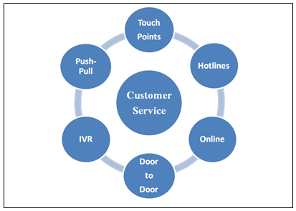

Figure 1 : Types of Customer Service