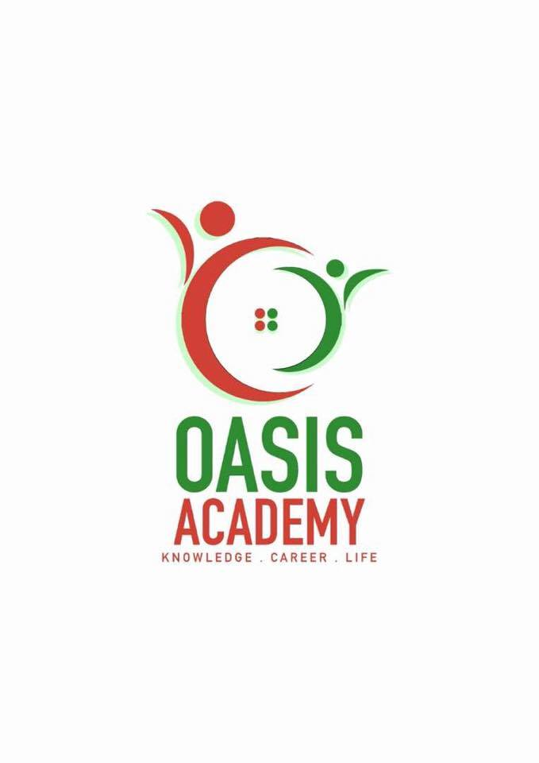

**Name:**  Kalaivani A/p Nahor Pichay

**Login ID**: kalaivani@oasis-portal.com

**Course title:** Essentials of Human Resource

**Subject Code**: BHM01

Submitted date: 5/6/2017

**Table of Contents**

|  |  |  |
| --- | --- | --- |
| No | Details | Page |
| 1 | Executive Summary | 3 |
| 2 | Introduction | 4 |
| 3 | Part 1 | 5-7 |
|  | Part 2 | 8-12 |
|  | Part 3 | 13-15 |
|  | Part 4 | 16-18 |
| 4 | Conclusion | 19 |
| 5 | References | 20 |
|  | Appendix | 21 |

**Executive Summary**

The purpose of doing this assignment is to give insight of HRM role in the organization. First, we discussed about definition of HR, continuously we also discussed on the points major activities, which are payrolls, benefits, recruitment, training and health and safety as well.

Then we explained a little depth about re-engineering work process for improved productivity; unforeseen workforce; mass customization; decentralized work sites; employee’s involvement.

Besides, in the third part we have explained about the payrolls; benefits; recruitment; training and also health and safety in detail. As a final touch, we also stated some points on organizational structures.

**Introduction**

Human Resource Management (usually referred to as HR) involves everything related to the employer-employee relationship and is about supporting and managing the organisation’s people and associated processes. It’s seen as a core business function essential to the organisation’s effective operation. Working in corporation or large companies is very popular nowadays because large companies are often with the large scale, huge capital and professional operation. Human resource has significant role in the organization. Human resource management is concerned with the people dimensions in management. Since every organization is made up of people, acquiring their services developing their skills, motivating them to high level of performance and ensuring that they continue to maintain their commitment to the organizational objectives. According to the book “Fundamentals of Human Resource Management”, human resource defined as the real sources of competitive leverage that are cultures and capabilities of your organization, that derived from how you manage your people. Besides that, Human Resource Management is the function performed in organizations that facilitates the most effective use of people to achieve organizational and individual goals. However, in my essay I did explained about the definition of HR, role of Human Resources in major activities such as payrolls, benefits, training and health and safety. Other than that, I also stated enough information on re-engineering work process for improved productivity, unforeseen workforce, mass customization, decentralized work sites and employees involvement.

Question 1

What is human resources? Human resources are known as a process used by all hospitality organization by effectively using all of the employees to enhance the performance. Most people think, Human resource is only in charge of recruitment. Well Human resources also plays a huge role in hiring, administrating and training employees as well. However, there are a few major activities of human resource operation which are, payrolls, benefits, recruitment, training and health and safety.

One of the major activities is Payrolls. Payroll involves of taking care of pay concerns is a main obligation of the HR division. Handling finance precisely and on time is of awesome significance to everybody at the organization. The principle sorts of pay that a HR proficient manages are ensured pay and variable pay. Ensured pay is a worker's time-based compensations or set pay, while variable pay is dependent upon execution by and large as rewards or motivators.

Another major activity is Benefits. HR is in charge of dealing with the advantages bundles offered by the business. Different social insurance arranges, benefit sharing data and annuities are among the offering of many organizations. The HR experts need a reasonable comprehension of these changed advantages, help make judgments on the best bundle for their organization and be capable at disclosing these advantages to the staff.

Following with Recruitment whereby hiring or taking people for the organization. The specific enrolment of workers is another significant segment taken care of by HR. This includes hunting down the perfect individuals to fit in particular parts. As indicated by the U.S. Branch of Work, HR experts frequently look over school grounds and employment fairs for potential competitors. HR can then check references, test for specific abilities and lead meetings to decide whether people are a solid match for the organization.

And the fourth major activity is Training. Representatives require singular direction when doled out to particular parts. The improvement of preparing projects to give significant abilities instruction and the educating of different conventions is taken care of by HR. The HR division works with administration to shape preparing plans that frequently incorporate manuals, peer coaching and practice openings.

And the last one is Health and Safety. Creating and testing the wellbeing and security conventions in the organization averts mischances and is required by law. HR agents ensure their business is in consistence with state wellbeing and security laws. They are likewise in charge of instructing staff with respect to these conventions. Ordinarily, the HR division routinely makes down to earth checks, for example, asserting labourers required in concoction procedures or hard work are wearing required wellbeing goggles or back props.

Question 2

Re-engineering work process for improved productivity. Albeit ceaseless change activities are certain begins in a significant number of our associations, they ordinarily concentrate on continuous incremental change. Such activity is naturally engaging – the consistent and lasting pursuit to improve things. However many organizations work in a situation that is dynamic-confronting quick and steady change. Thus consistent change projects may not be to the greatest advantage of the association. The issue with them is that they may give a misguided feeling that all is well and good. Progressing incremental switch abstains from confronting up to the likelihood that what the association may truly need is radical or quantum change. Such uncommon change brings about the re-building of the organization. Re-designing happens when over 70% of the work forms in an association are assessed and adjusted. It requires hierarchical individuals to reconsider what work ought to be done, how it is to be done and how to best execute these choices. Re-designing changes how associations do their business and straightforwardly influences the workers. Re-designing may leave certain workers baffled and irate and uncertain of what's in store. Likewise HRM must have components set up for representatives to get suitable heading of what to do and what's in store and also help with managing the contention that may penetrate the association. For re-building to produce its advantages HRM needs to offer expertise preparing to its representatives. Regardless of whether it's another procedure, an innovation upgrade, working in groups, having more basic leadership specialist, or something like that, representatives would require new aptitudes subsequently of the re-designing procedure.

Unforeseen workforce. An extremely significant piece of the cutting-edge workforce are the unforeseen laborers. Unforeseen laborers are people who are ordinarily enlisted for shorter timeframes. They perform particular assignments that frequently require extraordinary occupation aptitudes and are utilized when an association is encountering noteworthy deviations in its work process. At the point when an association settles on its key choice to utilize a sizable part of its workforce from the possibility positions, a few HRM issues gone to the bleeding edge. These incorporate having the capacity to have these virtual representatives accessible when required, giving booking alternatives that address their issues and settling on choices about regardless of whether advantages will be offered to the unforeseen work force. No association can make the move to an unexpected workforce without adequate arranging. All things considered, when these vital choices are being made, HRM must be a dynamic accomplice in these discourses. After its whole HRM division's obligation to find and bring into the association these impermanent laborers. As impermanent specialists are gotten, HRM will likewise have the obligation of rapidly adjusting them to the association. HRM will likewise need to think about to how it will draw in quality alternates. This is now and then done on consultancy premise. Consultancy work is regularly a brief span premise and to re-imagine the association's operation such a workforce of consultancy is fundamental.

Mass customization. There is a considerable measure going on as of now inside HR concerning mass customization, the ideal mix of large scale manufacturing with customization. We've seen organizations constructing business game plans with respect to learning styles and identities, enabling representatives to pick between lower base pay and higher rewards versus higher base pay and lower rewards, and changing from vocation steps with a straight shot to the top to profession grids where a sideways move is viewed as a decent profession move. Here, HR has made an awesome showing with regards to of applying HR standards to its own conventional useful processes.HR should take the instruments of promoting around customization for buyers and customers and applying them to the undertaking of ability division. The key is to enhance. At one outrageous, an individual work bargain for each individual would be confused. At the other outrageous, characterizing decency as "same for everybody" dangers missing imperative advantages of customization, and in reality, might be inefficient and unfair. Thus, HR ought to create standards for understanding the ideal level of customization in the business relationship. Additionally, on the grounds that customization will regularly imply that diverse gatherings of representatives get distinctive business courses of action in view of their needs or the way they contribute, HR must create rule that prepare pioneers to disclose these distinctions to workers. Our work recommends that while numerous HR chiefs comprehend the requirement for customization and separation on a basic level, they oppose it since they basically don't feel all around prepared to clarify them. It is far less demanding to state, "We do a similar thing for everybody, so it's out of my hands." The idea of reasonableness is here and there mistaken for treating everybody the same.

Decentralized work sites. Work destinations are getting increasingly decentralized. Working from home capacities that exist today have made it feasible for the representatives to be found anyplace on the globe. With this potential, the businesses never again need to consider finding a business close to its work constrain. Working from home additionally offers an open door for a business tin a high cost zone to have its work done in a range where bring down wages win. Decentralized work locales additionally offer open doors that may address the issues of the broadened workforce. The individuals who have family obligations like kid care, or the individuals who have incapacities may like to work in their homes instead of go to the association's office. For HRM, decentralized work destinations show a test. Quite a bit of that test spins around preparing chiefs in how to set up and guarantee suitable work quality and on-time consummation. Work at home may likewise require HRM to reexamine its remuneration arrangement. Will it pay by the hour, on a compensation premise, or by the occupation performed? Additionally, on the grounds that representatives in decentralized work locales are full time workers of the association instead of unexpected laborers, it will be association's obligation to guarantee wellbeing and security of the decentralized work drive.

Employees involvement. For now's association's to be effective there are various representative inclusion ideas that seem, by all accounts, to be acknowledged. These are designation, participative administration, work groups, objective setting, worker preparing and engaging of representatives. HRM has a huge part to play in worker inclusion. What is required is exhibited authority and additionally steady administration. Workers should be prepared and that is the place human asset administration has a noteworthy part to play. Representatives anticipated that would delegate, to have choices anticipatively took care of, to work in groups, or to set objectives can't do as such unless they know and comprehend what it is that they are to do. Engaging workers requires broad preparing in all parts of the occupation. Laborers may need to see how new employment configuration forms. They may require preparing in relational aptitudes to make participative and work groups work legitimately.

Question 3

Payrolls。The allotment of finance goes under the duties of the human asset office. While finance frequently exists as a different division in expansive organizations, in independent companies, it is for the most part taken care of by a little HR staff. Medicinal services advantages are likewise taken care of by the human asset division.

Benefits。Human asset work obliges gives a sensible strategy to picking how much operators ought to be paid for playing out specific occupations. Pay is unmistakably identified with the upkeep of HR. Since pay is a huge cost to different affiliations, it is a basic idea in human asset arranging. Pay impacts staffing in that individuals are by and large maneuverer into affiliations offering a greater measure of pay as a final product of the work performed. It is identified with operator progress in that it gives a basic boost in spurring pros to greater measures of occupation execution and to higher paying organizations in the connection

Recruitment。The achievement of scouts and work authorities generally is measured by the measure of positions they fill and the time it takes to fill those positions. Selection specialists who work in-house - rather than affiliations that give picking and staffing associations - acknowledge a key part in working up the business' workforce. They propel work postings, source hopefuls, screen candidates, organize preparatory social occasions and mastermind using tries with executives in charge of settling on the last choice of contenders.

Training。Associations must outfit operators with the contraptions basic for their prospering which, in light of present circumstances, gathers giving new authorities wide colleague arranging with help them move into another dynamic culture. Different HR work environments in like way give association prepare and fit progress. Authority arranging might be required of starting late contracted and impelled administrators and executives on centres, for example, execution association and how to oversee appoint relations matters at the work environment level. Proficient change openings are for workers examining for remarkable open passages or specialists who need to satisfy solitary objectives, for example, completing a specialist guideline. Wanders, for example, educational cost help and informational cost repayment programs a significant part of the time are inside the zone of the HR prepare and movement zone.

Health and Safety。Working condition security is an essential variable. Under the Word related Thriving and Flourishing Show of 1970, associations have a vow to give a secured workplace to delegates. One of the standard segments of HR is to bolster working environment security arranging and keep up authoritatively summoned logs for work space wickedness and difficulty indicating. In like way, HR success and hazard pros a significant part of the time work actually with HR benefits specialists to deal with the affiliation's labourer’s pay issues.

Question 4

Organizational behavior is a use of learning about human conduct in associations as it identifies with other framework components, for example, structure, innovation and the outside social framework. What is 'Organizational Structure’? Organizational structure is a framework that comprises of express and understood institutional tenets and strategies intended to blueprint how different function parts and duties are appointed, controlled and facilitated. Authoritative structure additionally decides how data streams from level to level inside the organization. For instance, in a brought together structure, choices spill out of the top down, while in a decentralized structure, the choices are made at different diverse levels.

At its most elevated amount, a hierarchical structure is either concentrated or decentralized. Generally, associations have been organized with brought together administration and a characterized hierarchy of leadership. The military, for instance, is an association well known for its profoundly incorporated structure, with a long and particular chain of command of bosses and subordinates. In any case, there has been an ascent in decentralized associations, just like the case with numerous innovation new companies. This enables the organizations to stay quick, dexterous and versatile, with practically every worker getting an abnormal state of individual office.

Four sorts of basic authoritative structures are actualized in this present reality. The to begin with, and most normal, is a practical structure. This is additionally alluded to as a bureaucratic hierarchical structure and separates an organization in view of the specialization of its workforce. Most little to-medium estimated organizations execute a useful structure. Partitioning the firm into offices comprising of promoting, deals and operations is the demonstration of utilizing a bureaucratic authoritative structure.

The second sort is regular among vast organizations with numerous specialty units. Called the divisional or multi-divisional structure, an organization that uses this strategy structures its initiative group in view of the items, activities or auxiliaries they work. A decent case of this structure is Johnson and Johnson. With a huge number of items and lines of business, the organization structures itself so every specialty unit works as its own organization with its own leader.

Sort and is utilized among numerous new companies. Hierarchy of leadership and gives its workers a considerable measure of self-rule. Organizations that utilization this kind of structure have a rapid of usage.

Last organizational structure is a framework structure. It is additionally the most confounding and the slightest utilized. This structure networks workers crosswise over various bosses, divisions or offices. A worker working for a matrixes organization, for instance, may have obligations in both deals and client benefit.

**Conclusion**

Basically, Human asset operations assumes a tremendous part on improving the organization's execution whereby, HR oversees and handles the representatives a legitimate administration by the HR division can prompt extraordinary achievement.

**References**

* <http://www.icmrindia.org/courseware/Intro%20to%20Hrm/Human%20Resource%20Management.htm>
* <http://yourbusiness.azcentral.com/role-human-resource-department-hospitality-organization-8084.html>
* <http://hotelexecutive.com/business_review/3009/hotel-human-resources-five-greatest-challenges-and-what-to-do-about-them>
* <https://hr.uoregon.edu/recruit>
* <https://www.inc.com/encyclopedia/human-resource-management.html>
* <http://www.whatishumanresource.com/Human-Resource-Management-functions>
* <https://www.cipd.co.uk/knowledge/strategy/hr>
* <https://hrtrendinstitute.com/2016/11/23/hr_trends_2017/>
* <https://www.fastcompany.com/3066976/the-top-five-hr-trends-for-2017>
* <https://www.forbes.com/sites/jeannemeister/2017/01/05/the-employee-experience-is-the-future-of-work-10-hr-trends-for-2017/#4a9b1bf320a6>
* <https://www.humanresourcestoday.com/hr-trends/>
* <https://www.ingentis.com/orgmanager/orgchartsoftware/org-chart-software/>
* <http://www.businessdictionary.com/definition/organizational-structure.html>
* <http://www.investopedia.com/terms/o/organizational-structure.asp>