Name : ERAGUNATHAN a/l SUBRAMANIAM

Login ID: eragunathan@oasis-portal.com

Course title: Tourism and Hospitality

Subject Code: BHM 04

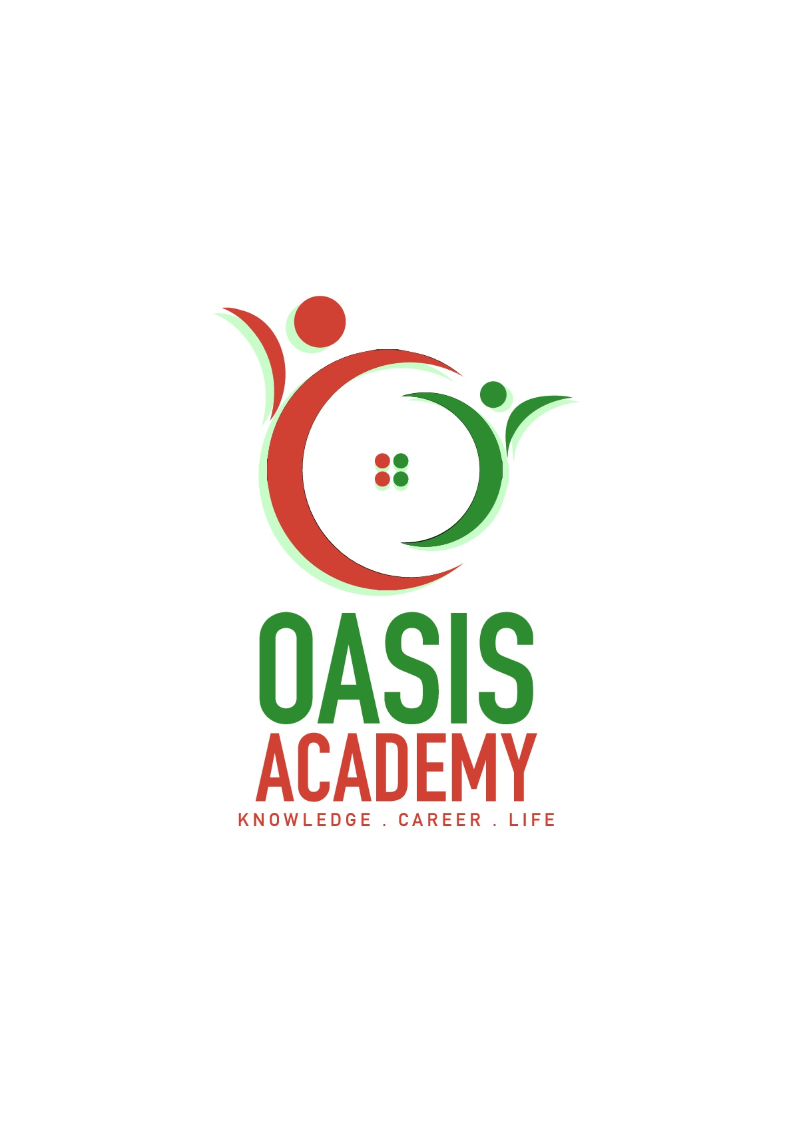

Submitted date: 11th September 2017

**Table of Contents**

|  |  |  |
| --- | --- | --- |
| **No** | **Details** | **Page** |
| 1 | Executive Summary | 2 |
| 2 | Introduction | 3 |
| 3 | Assignment Question |  |
|  | Part 1 | 4 - 6 |
|  | Part 2 | 7 - 9 |
|  | Part 3 | 10 - 11 |
|  | Part 4 | 12 - 13 |
| 4 | Conclusion | 14 |
| 5 | References | 15 - 16 |
|  |  |  |

**Executive Summary**

The motivation behind this task is the thing that I comprehend about tourism and accommodation. I will characterize tourism and friendliness. At that point will be brief about the kind of tourism classes. What's more will be clarifying the cabin settlement and the sort of inn convenience. At long last I will secured about the huge of the amusement in tourism and cordiality industry.

**Introduction**

Tourism is a dynamic and centered industry that requires the ability to alter dependably to customer's changing needs and need, as the shopper dedication, prosperity and satisfaction. Particularly the grouping of tourism business. Advancing of the enchanting and distinctive features of a travel objective and plan of workplaces and organizations for the delight of voyagers (tourists). Tourism includes the activities of individual making a trek to and staying set up outside from typical condition for not more than one consecutive year for unwinding business and distinctive purposes. Additionally tourism that evaluates its present and future financial, social and natural impacts, keeping an eye on the prerequisites of visitor. Neighborliness is tied in with giving food, drink and comfort. It's furthermore incorporates redirection, wellbeing and entertainment experts. The settlement business is impressively more broad than most extraordinary endeavors. In any case, this industry applies to any association that focused on customer steadfastness. This industry depends absolutely on customer being energetic. The sincerity business is there upgrading business conducing another basic branch in the budgetary parts of the country. Accomplices numerous kind of industry such explorer, the transportation and sustenance altering.

Question -

Tourism is a multi-disciplinary field of focus with the explanation behind preparing people with capacity, duty and aptitude for organization, displaying and operation. The developing business that give sustenance, settlement and tourism organizations to people a long way from home. Tourism is the matter of offering organizations to people in the midst of some recreation for example lodgings, restaurants and excursions. A social, social and money related wonder which include the advancement of people to countries or place outside from consistent condition for individual or business purposes.

What is significance of sincerity? There have been assorted importance of convenience. The show of insightfulness in welcoming and dealing with the fundamental needs of a guests, generally in association food, drink and comfort. Suggests the relationship method between a guest and a host. The degree of this industry and its traits of including both considerable and unimportant features in the organization movement. A champion among the most describing parts of this cheerfulness industry is that it focus on purchaser devotion. The cheerfulness business is a board grouping of field inside organizations industry that consolidates lodging, event masterminding, entertainment meccas, transportation, voyage line and additional field inside tourism industry.

Greatest and fastest creating industry on the planet. A champion among the most stimulating piece of this industry is that it is involved such colossal quantities of calling. The neighborliness and tourism industry is unique and consolidates various range including RV parks, sustenance establishment, recreational workplaces, camp grounds, lodgings and youth motels. The matter of giving customer organizations to voyager or untouchable. More accountable for directing the operations and achievement of an establishment, for instance, cabin and restaurant. Friendliness is to ensure that guests and customer have pleasurable experience, can in like manner be accountable for operation, for instance, contracting and getting ready new staff.

A contemporaneous human exchange which is intentionally gone into and planned to redesign the mutual success of the social occasions stressed through the game plan of accommodation and sustenance and beverages. Likewise customer don't buy profit transport yet buy contribution and don't buy profit quality however buy memories. Neighborliness requires the guest to feel that the host is as a rule cordial through assessments of magnanimity a need to please and a true blue see for the guests as a man. It is stressed over more than sustenance, drink and safe house. Generally the most indispensable obligation of all was the guest's security.

Staff or representatives who has an immediate contact with a visitor or client. He or she will welcome, welcome, help, give and convey a decent administrations and items to the visitor also. Likewise turn into a man who will give an awesome decent initial introduction to the visitor as well. The few front of the house staff individuals, for example, Server/waitress,Bartenders,Greeter,Manager,Receptionist

Performing obligations in the background the significant and most difficult, reality of working in this industry. He or she might possibly has a constrained time to meet the visitors as well. The few back of the house staff part, for example, Chef,Housekeeper, Stewards, Nourishment buyer, Night review, Dishwasher, Open region.

Question 2 -

The tourism part is one of the greatest money – making fragment on the planet. It is a routinely making industry, where new strengths seems to show sporadically. As a thought has gained impressive ground today and the development has been requested into various arrangements. The unmistakable orders of tourism are as under:-

Amusement tourism. This is when people go to a place that is a not exactly the same as standard regular day to day existence to loosen up and have a huge amount of fun. Shorelines, entertainment stop and camp grounds are the as often as possible the most generally perceived place.

Social tourism. To get know its history and social then this the kind of tourism called as social tourism. May visit unmistakable purpose of enthusiasm of a particular country. Also go to festivity and capacities remembering the ultimate objective to get an unrivaled understanding of people, conviction and practices.

Nature tourism. For explorers who need to see untamed life or thrive in the joy of essentially being in the midst of nature. Eco tourism and nature trek are all bit of this kind of tourism. Fowl searching for example is one the activity that nature vacationers are enchanted with doing. It is normally careful has low impact and advantageous to the area gathering.

Pleasure tourism. Numerous people today are stressed in the corporate rat race and in the need of reclamation. Go on trips that restore souls and spirits. For the most part join yoga workshops, detox journey among others.

Amusement tourism. Voyagers here target put which known for a particular wearing office. Skiing for example is a sort of tourism. Also joined into this characterization are the people who go to an objective to experience amusement, for instance, FIF World Holder, Olympic and other.

Religious tourism. Is another kind of tourism where people go to a religious zone or regions to take after the steps of their originator or to go to a religious administration?

Restorative and prosperity tourism. Where the central centralization of the travel is improving one's prosperity, physical appearance and wellbeing. Furthermore certain countries propel the capacity of experts and masters in the field of remedial surgery.

Undertaking tourism. That is given nourishment to the people who need to achieve something past visit standard guest's goals. These kind trips incorporate testing practices like shake climbing, mountain climbing, and wild water sculling.

Tourism is the development or work on going by especially for enchant. The business or industry of giving information, comfort, transportation and diverse organizations to vacationers. Is the show of go for mainly loosening up and business purposes? In addition tourism is not only an entertainment and fun activity. Or, on the other hand possibly it is moreover the business which draws settlement and connects with guests and help makes compensation for the country. Tourism fortunate us to explore new culture, meet new people and improve places. It's similarly helps in the money related progress of a country and makes fill in also. Tourism is in like manner a splendid procedure for social exchange.

Question 3 -

The cabin offers a basic part in trading associations, gatherings and recreational workplaces in numerous countries. In various areas, the cabin is a basic interest for guests to attract clients, and they are more prepared to consume through money than at home. The hotel business is depicted by sumptuous motels from indulgence resorts and campgrounds. Accommodation is an absolutely wide branch of the hotel business, including bed to breakfast business and motel to other settlement workplaces. Customer advantage is essential for settlement organizations. This is not all, viability, comfort, and perfect workplaces are moreover the preface. A lavishness resort should give customers security and prohibitive organizations to cut it in the claim to fame. They are the three essential sorts of lodgings and offices, which is Settlement, Suite, and Resort. Settlement is when people take off beginning with one place then onto the following, they require a place to rest, a shelter that shields them from the enormities of nature. This incited a booking lodge and accommodation. Suite is despite the general stay, the hotel moreover offers extraordinary suites. When in doubt, suites are fitting for formal enlistment, which is expensive appeared differently in relation to general room advantage. Resort is the second rate class of settlement that is predominant among voyagers is a resort. These impact you to close nature and give you a basic rest from your formal calendars. The going with are a segment of the gathering of settlement; the cabin gives voyagers paid accommodation and distinctive organizations for the guests. Dependent upon the size, region and workplaces, the hotel is generally from one star to five stars yet furthermore inspected and other rating outlines are moreover used to describe lodgings around the world. Boutique hotel regularly completed in a subject self-sufficient style, the degree of the boutique motel private, focused on giving guests astonishing altered inclusion. Timeshare is an escape property with shared ownership and use rights. Also, the choice of time-sharing rental can be an ideal choice for staying in hotel rooms, giving quality workplaces and better regard. Climbers Hotel is a cabin for spending voyagers, generally attracting young customers. The room is living arrangement structure the restroom is shared, notwithstanding the way that there may be a private room. Despite house costs, you can in like manner give light meals. A self-giving sustenance establishment may be fundamentally one of the other comfort sorts, yet what's more offers an outstanding buffet office. The unit should be outfitted with a totally arranged kitchen to meet the best number, for example, checking coolers, stoves, cutlery, pottery, cookware, cleaning equipment. The kitchen should be world class to the guests, not the offer.

The meaning of a settlement is something that satisfies a specific needs. Convenience offices assume an imperative part in promoting any traveler's goal. The type of low spending cabins or inns to world class lavish lodging likewise accessible at all the real vacationer goal to give the visitors a home far from home. That give a place to the traveler to remain. Additionally settlement one of the parts of travel make the experience more chipper and vital.

A lodging for the most part the biggest of all convenience sorts. There is regularly a typical gathering region and room for the most part open specifically onto a passage. The on location eatery and different offices are more open to people in general then the other settlement sort. An extensive variety of visitor administrations is accessible such a room administrations.

Resort. A spread out accumulation of single or twofold story settlement units. Like a lodging in that is offers a wide range offices. Units might be leased and accessible on time share. Generally utilized for excursion or getaways. Alongside lodging room will be regular ranges pleasantries, swimming pool, eating, amusement room and different offices.

Boutique inn. A boutique lodging is a 5 star foundation every one of the highlights and offices of an ordinary inn in a remarkable and select style. These properties are for the most part little, include top class administration and promoted to the rich.

Motel. Room normally open out to parking garage. As the name suggests it cook generally to driver. The motel are claimed secretly and these are antiquated.

Quaint little inn a private home which visitors are be convenience around evening time in private rooms? The proprietor or supervisor lives in the house or on the property. People in general range of the house such kitchen and parlor have either restricted access for visitors. Breakfast incorporate into the cost and different suppers might be accessible by plan.

Question 4 -

Excitement is a type of exercises take a way people push fundamentally originate from school or work and give legitimately diversion to unwind. In tourism industry excitement is a vital area. Visitors would love to visit some particular place such motion picture theaters, Water Stop, jamboree et cetera. Tourism is the second biggest gathering of work and its happens to be generally assorted. A few occupations in diversion and excitement field incorporate film theater chief, club merchant, google worker, exhibition hall, ski teacher et cetera. There is a huge of assortment of things can do in the stimulation.

This is an again key classification of the friendliness business as it include the most imperative thing of accommodation. The purchaser and beneficiary of all cordiality administrations. So this part of neighborliness flourishes for all and to engage. Stimulation is a critical piece of travel nowadays. On the off chance that voyaging background absences of fun and diversion at that point won't not be capable appreciate. Also for the effective running of a friendliness business it is critical whatever number stimulation exercises as could reasonably be expected. Entertainment is any movement that individuals improve the situation rest, unwinding and delight.

There a couple of the exercises which can be expressed with regards to stimulation in tourism are clubs, games and gaming, marinas, bars and voyage.

Dance club . Who doesn't love to move on their main tune when on a break? We as a whole do. This why inns have dance club benefits in them.

Games and gaming. Is an essential things which individuals are searching for on their travel? Subsequently gambling club, swimming pool and other comparable exercises are turning into a basic piece of the friendliness business.

Marinas. Are a standout amongst the most mainstream spots to go when it's come to celebrating, can coexist with peers on a private yacht where can move, play amusements and appreciate the best of life.

Bars. Lounging around a table and having a few beverages with companions is dependably a reviving knowledge. This why bars make a critical piece of amusement division of the accommodation business.

Journey. Aside from marinas, journey administrations are likewise turning into a fundamental parts of the neighborliness business. Presently individuals jump at the chance to spend their days on extravagance ships which cruise over the blue seas under clear sky.

**Conclusion**

In this part, finally I learned and secured about tourism and settlement industry. Tourism is a dynamic and forceful industry that requires the ability to modify ceaselessly to customer's changing needs and need, as the shopper dependability, prosperity and fulfillment. Cordiality is tied in with giving sustenance, drink and comfort. It's furthermore incorporates fervor, health and entertainment masters. The convenience business is fundamentally more broad than most extraordinary endeavors. Greatest and fastest creating industry on the planet. A champion among the most invigorating piece of this industry is that it is contained such countless. The neighborliness and tourism industry is unique and fuses various zone including RV parks, sustenance establishment, recreational workplaces, camp grounds, lodgings and youth motels. As a thought has gained some astonishing ground today and the development has been described into various arrangements. The various groupings of tourism, for instance, social tourism, religious tourism, endeavor tourism and whatnot. What is lodging settlement? Associations that development, have, direct and work lodging workplaces including motels and full organizations hotels, typically out in nature, routinely delivered utilizing logs, woods or other regular material. Settlement workplaces accept a basic part in propelling any voyager's objective. The kind of low spending lodges or lodgings to world class luxurious motel in like manner available at all the noteworthy guest objective to give the voyagers a home a long way from home. Incitement is a sort of activities take a way people extend in a general sense begin from school or work and give truly pleasure to loosen up. In tourism industry incitement is a crucial division. Voyagers would love to visit some specific place such movie theaters, Water Stop, reasonable and so forth.

**References**

<http://www.besthospitalitydegrees.com/faq/what-exactly-is-the-hospitality-industry/>

<https://www.visitbritain.org/introduction-tourism>

<http://www.tourismsociety.org/page/88/tourism-definitions.htm>

<http://yourbusiness.azcentral.com/three-categories-hospitality-industry-24003.html>

<https://www.wisdomjobs.com/e-university/hotel-front-office-management-tutorial-369/types-of-lodging-facilities-12982.html>

[https://www.hotwire.com/helpcenter/hotels/searching-and-booking/locations-properties-reservatio](https://www.hotwire.com/helpcenter/hotels/searching-and-booking/locations-properties-reservations/what-different-lodging-types.jsp)

[ns/what-different-lodging-types.jsp](https://www.hotwire.com/helpcenter/hotels/searching-and-booking/locations-properties-reservations/what-different-lodging-types.jsp)

<http://www.luxuryaccommodationsblog.com/post/114961446726/different-types-accommodation-tourism>

<http://www.tc.gov.yk.ca/tourism.html>

<https://opentextbc.ca/introtourism/chapter/chapter-1-history-and-overview/>

<https://www.beyond.com/tourism/defined>

<https://www.merriam-webster.com/dictionary/tourism>

<http://www.besthospitalitydegrees.com/faq/what-exactly-is-the-hospitality-industry/>

<https://www.slideshare.net/anamena78/types-of-accommodation-43990556>