

Name: **SURESH S/O TENNARASU**

Login ID: **XXXXXXXXXX**

Course title: **Essentials of Accounting Fundamentals**

Subject Code: **XXXXX**

Submitted date:16/08/2017

**Table of Contents**

|  |  |  |
| --- | --- | --- |
| No | Details | Page |
| 1 | Executive Summary | 2 |
| 2 | Introduction | 3 |
| 3 | Assignment Question |  |
|  | Part 1 | 4 |
|  | Part 2 | 5-14 |
|  | Part 3 | 15 |
|  | Part 4 | 16-17 |
|  | Part 5 | 18 |
| 4 | Conclusion | 19 |
| 5 | References | 20 |
| 6 | Appendix | 21 |

**Executive Summary**

In the module, I covered the topic about the role of accounting. What is accounting and definition of accounting.In the first part, I learned and also got explain about role of accounting. In the second part,I have introduce about balance sheet and explain about it more briefly . I also explain of the three parts of balance sheets with some examples.Third part, I have clearly answered for a question entitled “why does a company’s profit appear as a credit on its balance sheet?” . In part 4, I have learned about the introduction of accounting equation and explain about it with some equations.Lastly,I have able to define and explain more briefly about final accounts.

**Introduction**

Accounting is famously known as the "language of business". It is a means through which business entities communicate information to different users. Its function is to provide quantitative information, primarily financial in nature, about economic entities that is intended to be useful in making economic decisions, in making reasoned choices among alternative courses of action. Basic purpose of accounting is to provide information needed by users in making economic decisions. These users include: current and potential investors, management, lenders, creditors, the government, employees, customers, and the general public. These users have varied interests and therefore have different information needs.

Accounting is one of the oldest business disciplines. It has never failed to provide opportunities to career-seekers. The high demand for accounting services makes it a stable profession amidst economic fluctuations.Different fields of specialization have evolved over the years. Today, holding a certification in a specific field gives the holder an edge over those who are uncertified.The branches of accounting (fields of specialization) include: financial accounting, management accounting, cost accounting, auditing, tax accounting, accounting information systems, fiduciary, and forensic accounting.Accounting professionals work in at least one of the 4 major areas of accounting practice: public accounting, private accounting, government accounting, and accounting education.

The American Institute of Certified Public Accountants (AICPA) defined accounting as: "the art of recording, classifying, and summarizing in a significant manner and in terms of money, transactions and events which are, in part at least of financial character, and interpreting the results thereof". Accounting is a means through which information about a business entity is communicated.Through the financial statements, the end-product reports in accounting, it delivers information to different users. It is the system of recording, summarizing, and analyzing an economic entity's financial transactions. Effectively communicating this information is key to the success of every business. Those who rely on financial information include internal users, such as a company's managers and employees, and external users, such as banks, investors, governmental agencies, financial analysts, and labor unions. These users depend upon data supplied by accountants to answer the following types of questions:

• Is the company profitable?

• Is there enough cash to meet payroll needs?

• How much debt does the company have?

• How does the company's net income compare to its budget?

• What is the balance owed by customers?

• Has the company consistently paid cash dividends?

• How much income does each division generate?

• Should the company invest money to expand?

Accountants must present an organization's financial information in clear, concise reports that help make questions like these easy to answer. The most common accounting reports are called financial statements.

**Assignment Questions**

**Question 1**

Define the role of accounting.

Accounting is the systematic recording of financial transactions and the reporting of such transactions for decision making purposes.As such, it can be seen that the main role of accounting is to assist in better decision making. The type of decision varies from business to business – in terms of nature, size, form and location. The role of accounting in business is to help internal and external stakeholders make better business decisions by providing them with financial information. Below is a list of some of the role of accounting in the decision making process:

1. It allows the entrepreneur to know how much is earned. This can be compared with other alternatives to doing business. For example, an entrepreneur who is earning $1 000 a month from business but would otherwise earn $1 500 as an employee may prefer to close down business and take up a job.

2. Accounting allows the entrepreneur to have a follow up of trade payables and trade receivables and as such make better decisions about cash management.

3. Accounting makes information readily available to banks and financial institutions to allow them approve or disapprove a loan request.

4. By calculating ratios from accounting data, owners and investors may compare the results of the business with its past performances as well as with other businesses.

5. Accounting information allows the government to assess the reasonableness of the amount of tax being paid by the business.

6. Employees and trade unions may use accounting records to justify their demand for wage increase and changes in working conditions.

**Question 2**

Explain the Introduction of balance sheet.

The accounting balance sheet is one of the major financial statements used by accountants and business owners. The balance sheet is also referred to as the statement of financial position.

The balance sheet presents a company's financial position at the end of a specified date. A Balance Sheet is fundamentally a statement of financial position as of a certain date. A balance sheet can be prepared for an individual, a partnership, a corporation or any other entity that has assets and debts. Because the balance sheet informs the reader of a company's financial position as of one moment in time, it allows someone like a creditor to see what a company *owns* as well as what it *owes* to other parties as of the date indicated in the heading.

Balance sheets are typically compiled to report to owners or other interested parties such as lenders, exactly what the company looks like financially at a given point in time. In order to have amounts to report, an entity would need a financial record keeping system that would show balances at the end of a day, week or whatever reporting timeframe was needed.A basic balance sheet will have three sections; assets, liabilities, and owner's equity. A balance sheet is so named because it must be "balanced" using the formula; assets minus liabilities equals owner's equity.

This is valuable information to the banker who wants to determine whether or not a company qualifies for additional credit or loans. Others who would be interested in the balance sheet include current investors, potential investors, company management, suppliers, some customers, competitors, government agencies, and labor unions.

Three sections of balance sheets :

* Assests
* Liabilities
* Equity

Assets

* Items of ownership convertible into cash; total resources of a person or business, as cash, notes and accounts receivable; securities and accounts receivable, securities, inventories, goodwill, fixtures, machinery, or real estate (as opposed to liabilities).

[Assets](https://www.accountingcoach.com/terms/A/assets) are things that the company owns. They are the resources of the company that have been acquired through transactions, and have future economic value that can be measured and expressed in dollars. Assets also include costs paid in advance that have not yet [expired](https://www.accountingcoach.com/terms/E/expired-costs), such as prepaid advertising, prepaid insurance, prepaid legal fees, and prepaid rent. Examples of asset accounts that are reported on a company's balance sheet include:

* [Cash](https://www.accountingcoach.com/terms/C/cash)
* [Petty Cash](https://www.accountingcoach.com/terms/P/petty-cash)
* [Temporary Investments](https://www.accountingcoach.com/terms/T/temporary-investments)
* [Accounts Receivable](https://www.accountingcoach.com/terms/A/accounts-receivable)
* [Inventory](https://www.accountingcoach.com/terms/I/inventory)
* [Supplies](https://www.accountingcoach.com/terms/S/supplies)
* [Prepaid Insurance](https://www.accountingcoach.com/terms/P/prepaid-insurance)
* [Land](https://www.accountingcoach.com/terms/L/land)
* [Land Improvements](https://www.accountingcoach.com/terms/L/land-improvements)
* [Buildings](https://www.accountingcoach.com/terms/B/buildings)
* [Equipment](https://www.accountingcoach.com/terms/E/equipment)
* [Goodwill](https://www.accountingcoach.com/terms/G/goodwill)

Usually asset accounts will have *debit* balances.[Contra assets](https://www.accountingcoach.com/terms/C/contra-asset-account) are asset accounts with *credit* balances.

Examples of contra asset accounts include:

* [Allowance for Doubtful Accounts](https://www.accountingcoach.com/terms/A/allowance-for-doubtful-accounts)
* [Accumulated Depreciation-Land Improvements](https://www.accountingcoach.com/terms/A/accumulated-depreciation-land-improvements)
* [Accumulated Depreciation-Buildings](https://www.accountingcoach.com/terms/A/accumulated-depreciation-buildings)
* [Accumulated Depreciation-Equipment](https://www.accountingcoach.com/terms/A/accumulated-depreciation-equipment)
* [Accumulated Depletion](https://www.accountingcoach.com/terms/A/accumulated-depletion)
* Etc.

**Classifications Of Assets On The Balance Sheet**

Accountants usually prepare [classified balance sheets](https://www.accountingcoach.com/terms/C/classified-balance-sheet). "Classified" means that the balance sheet accounts are presented in distinct groupings, categories, or classifications. The **asset classifications** and their order of appearance on the balance sheet are:

* [Current Assets](https://www.accountingcoach.com/terms/C/current-assets)
* [Investments](https://www.accountingcoach.com/terms/I/investments)
* [Property, Plant, and Equipment](https://www.accountingcoach.com/terms/P/property-plant-and-equipment)
* [Intangible Assets](https://www.accountingcoach.com/terms/I/intangible-assets)
* [Other Assets](https://www.accountingcoach.com/terms/O/other-assets)

An outline of a balance sheet using the balance sheet classifications is shown here:

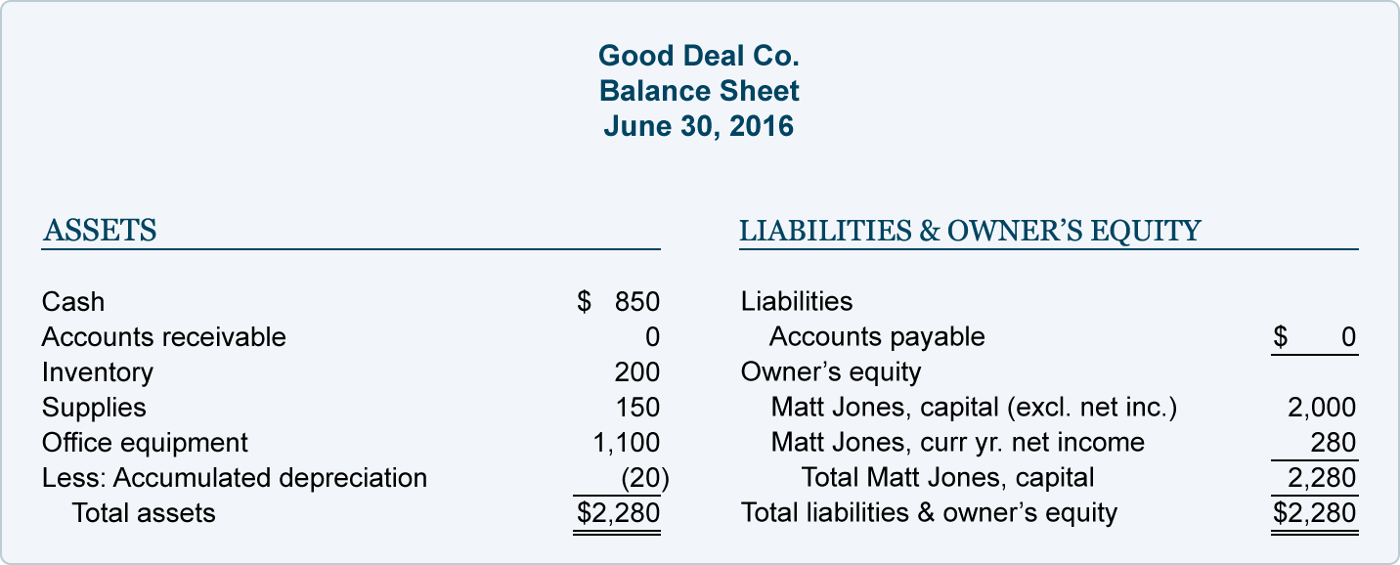

**Effect of Cost Principle and Monetary Unit Assumption**

The amounts reported in the asset accounts and on the balance sheet reflect actual costs recorded at the time of a transaction. For example, let's say a company acquires 40 acres of land in the year 1950 at a cost of $20,000. Then, in 1990, it pays $400,000 for an adjacent 40-acre parcel. The company's [Land](https://www.accountingcoach.com/terms/L/land) account will show a balance of $420,000 ($20,000 for the first parcel plus $400,000 for the second parcel.). This account balance of $420,000 will appear on today's balance sheet even though these parcels of land have appreciated to a current market value of $3,000,000.

There are two guidelines that oblige the accountant to report $420,000 on the balance sheet rather than the current market value of $3,000,000: (1) the [cost principle](https://www.accountingcoach.com/terms/C/cost-principle) directs the accountant to report the company's assets at their original historical cost, and (2) the [monetary unit assumption](https://www.accountingcoach.com/terms/M/monetary-unit-assumption) directs the accountant to presume the U.S. dollar is stable over time—it is not affected by inflation or deflation. In effect, the accountant is assuming that a 1950 dollar, a 1990 dollar, and a 2016 dollar all have the same purchasing power.

The cost principle and monetary unit assumption may also mean that some very valuable resources will not be reported on the balance sheet. A company's team of brilliant scientists will not be listed as an asset on the company's balance sheet, because (a) the company did not purchase the team in a transaction (cost principle) and (b) it's impossible for accountants to know how to put a dollar value on the team (monetary unit assumption).

Coca-Cola's logo, Nike's logo, and the trade names for most consumer products companies are likely to be their most valuable assets. If those names and logos were developed internally, it is reasonable that they will not appear on the company balance sheet. If, however, a company should *purchase* a product name and logo from another company, that cost will appear as an asset on the balance sheet of the acquiring company.

Remember, accounting principles and guidelines place some limitations on what is reported as an asset on the company's balance sheet.

**Effect of Conservatism**

While the cost principle and monetary unit assumption generally prevent assets from being reported on the balance sheet at an amount greater than cost, conservatism will result in some assets being reported at *less* than cost. For example, assume the *cost* of a company's inventory was $30,000, but now the *current cost* of the same items in inventory has dropped to $27,000. The conservatism guideline instructs the company to report Inventory on its balance sheet at $27,000. The $3,000 difference is reported immediately as a loss on the company's income statement.

**Effect of Matching Principle**

The matching principle will also cause certain assets to be reported on the accounting balance sheet at *less* than cost. For example, if a company has Accounts Receivable of $50,000 but anticipates that it will collect only $48,500 due to some customers' financial problems, the company will report a credit balance of $1,500 in the contra asset account Allowance for Doubtful Accounts. The combination of the asset Accounts Receivable with a debit balance of $50,000 and the contra asset Allowance for Doubtful Accounts with a *credit* balance will mean that the balance sheet will report the net amount of $48,500. The income statement will report the $1,500 adjustment as Bad Debts Expense.

The matching principle also requires that the cost of buildings and equipment be depreciated over their useful lives. This means that over time the cost of these assets will be moved from the balance sheet to Depreciation Expense on the income statement. As time goes on, the amounts reported on the balance sheet for these long-term assets will be reduced.

Liabilities

* An amount of money in a company that is owed to someone and has to be paid in the future, such as tax, debt, interest, and mortgage payments.

Liabilities are obligations of the company; they are amounts owed to creditors for a past transaction and they usually have the word "payable" in their account title. Along with owner's equity, liabilities can be thought of as asource of the company's assets. They can also be thought of as a claim against a company's assets. For example, a company's balance sheet reports assets of $100,000 and Accounts Payable of $40,000 and owner's equity of $60,000. The source of the company's assets are creditors/suppliers for $40,000 and the owners for $60,000. The creditors/suppliers have a claim against the company's assets and the owner can claim what remains after the Accounts Payable have been paid.

Liabilities also include amounts received in advance for future services. Since the amount received (recorded as the asset Cash) has not yet been earned, the company defers the reporting of revenues and instead reports a liability such as Unearned Revenues or Customer Deposits. (For a further discussion on deferred revenues/prepayments see the Explanation of Adjusting Entries.)

Examples of liability accounts reported on a company's balance sheet include:

• Notes Payable

• Accounts Payable

• Salaries Payable

• Wages Payable

• Interest Payable

• Other Accrued Expenses Payable

• Income Taxes Payable

• Customer Deposits

• Warranty Liability

• Lawsuits Payable

• Unearned Revenues

• Bonds Payable

Liability accounts will normally have credit balances.

Contra liabilities are liability accounts with debit balances. (A debit balance in a liability account is contrary—or contra—to a liability account's usual credit balance.) Examples of contra liability accounts include:

• Discount on Notes Payable

• Discount on Bonds Payable

• Debt Issue Costs

• Bond Issue Costs

Classifications Of Liabilities On The Balance Sheet

Liability and contra liability accounts are usually classified (put into distinct groupings, categories, or classifications) on the balance sheet. The liability classifications and their order of appearance on the balance sheet are:

• Current Liabilities

• Long Term Liabilities

To see how various liability accounts are placed within these classifications, click here to view the sample balance sheet in Part 4.

Commitments

A company's commitments (such as signing a contract to obtain future services or to purchase goods) may belegally binding, but they are not considered a liability on the balance sheet until some services or goods have been received. Commitments (if significant in amount) should be disclosed in the notes to the balance sheet.

Form vs. Substance

The leasing of a certain asset may—on the surface—appear to be a rental of the asset, but in substance it may involve a binding agreement to purchase the asset and to finance it through monthly payments. Accountants must look past the form and focus on the substance of the transaction. If, in substance, a lease is an agreement to purchase an asset and to create a note payable, the accounting rules require that the asset and the liability be reported in the accounts and on the balance sheet.

Contingent Liabilities

Three examples of contingent liabilities include warranty of a company's products, the guarantee of another party's loan, and lawsuits filed against a company. Contingent liabilities are potential liabilities. Because they are dependent upon some future event occurring or not occurring, they may or may not become actual liabilities.

To illustrate this, let's assume that a company is sued for $100,000 by a former employee who claims he was wrongfully terminated. Does the company have a liability of $100,000? It depends. If the company was justified in the termination of the employee and has documentation and witnesses to support its action, this might be considered a frivolous lawsuit and there may be no liability. On the other hand, if the company was not justified in the termination and it is clear that the company acted improperly, the company will likely have an income statement loss and a balance sheet liability.

The accounting rules for these contingencies are as follows: If the contingent loss is probable and the amount of the loss can be estimated, the company needs to record a liability on its balance sheet and a loss on its income statement. If the contingent loss is remote, no liability or loss is recorded and there is no need to include this in the notes to the financial statements. If the contingent loss lies somewhere in between, it should be disclosed in the notes to the financial statements.

Current vs. Long-term Liabilities

If a company has a loan payable that requires it to make monthly payments for several years, only the principal due in the next twelve months should be reported on the balance sheet as a current liability. The remaining principal amount should be reported as a long-term liability. The interest on the loan that pertains to the future is not recorded on the balance sheet; only unpaid interest up to the date of the balance sheet is reported as a liability.

Notes to the Financial Statements

As the above discussion indicates, the notes to the financial statements can reveal important information that should not be overlooked when reading a company's balance sheet.

Equity

* Ownership interest in a company, as determined by subtracting liabilities from assets.

Owner's Equity can be thought of as a source of the company's assets. Owner's equity is sometimes referred to as the book value of the company, because owner's equity is equal to the reported asset amounts minus the reported liability amounts.

Owner's equity may also be referred to as the residual of assets minus liabilities. These

references make sense if you think of the basic accounting equation:

Assets = Liabilities + Owner's Equity

and just rearrange the terms:

Owner's Equity = Assets – Liabilities

"Owner's Equity" are the words used on the balance sheet when the company is a sole proprietorship. If the company is a corporation, the words Stockholders' Equity are used instead of Owner's Equity. An example of an owner's equity account is Mary Smith, Capital (where Mary Smith is the owner of the sole proprietorship). Examples of stockholders' equity accounts include:

▪ Common Stock

▪ Preferred Stock

▪ Paid-in Capital in Excess of Par Value

▪ Paid-in Capital from Treasury Stock

▪ Retained Earnings

▪ Accumulated Other Comprehensive Income

▪ Etc.

Both owner's equity and stockholders' equity accounts will normally have credit balances.

Contra owner's equity accounts are a category of owner equity accounts with debit balances. (A debit balance in an owner's equity account is contrary—or contra—to an owner's equity account's usual credit balance.) An example of a contra owner's equity account is Mary Smith, Drawing (where Mary Smith is the owner of the sole proprietorship). An example of a contra stockholders' equity account is Treasury Stock.

* Classifications of Owner's Equity On The Balance Sheet

Owner's equity is generally represented on the balance sheet with two or three accounts (e.g., Mary Smith, Capital; Mary Smith, Drawing; and perhaps Current Year's Net Income). See the sample balance sheet in Part 4.

The stockholders' equity section of a corporation's balance sheet is:

• Paid-in Capital

• Retained Earnings

• Accumulated Other Comprehensive Income

• Treasury Stock

The example of stockholders' equity section of a corporation's balance sheet is:

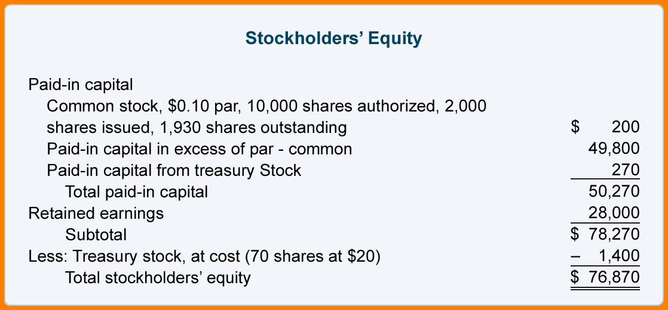

**Owner's Equity vs. Company's Market Value**

Since the asset amounts report the cost of the assets at the time of the transaction or less they do not reflect current fair market values. (For example, computers which had a cost of $100,000 two years ago may now have abook value of $60,000. However, the current value of the computers might be just $35,000. An office building purchased by the company 15 years ago at a cost of $400,000 may now have a book value of $200,000. However, the current value of the building might be $900,000.) Since the assets are not reported on the balance sheet at their current fair market value, owner's equity appearing on the balance sheet is not an indication of the fair market value of the company.

**Owner's Equity and Temporary Accounts**

Revenues, gains, expenses, and losses are income statement accounts. Revenues and gains cause owner's equity to increase. Expenses and losses cause owner's equity to decrease. If a company performs a service and increases its assets, owner's equity will increase when the Service Revenues account is closed to owner's equity at the end of the accounting year.

**Question 3**

Why does a company’s profit appear as a credit on its balance sheet?

The accounting equation and the double entry system provide an explanation why a company's profit appears as a credit on its balance sheet.

Asset accounts usually have debit balances while liabilities and owner's or stockholders' equity usually have credit balances. When a company provides services for cash, its asset Cash is increased by a debit and its owner's equity is increased by a credit. The credit is initially recorded in a revenue account, but revenue accounts are temporary accounts that cause owner's equity to increase.

If the owner withdraws some cash for personal use, the asset Cash will decrease through a credit and the owner's equity will decrease through the debit part of the accounting entry. The debit might initially be recorded in the sole proprietor's Drawing account but this account is also a temporary account that will cause the owner's equity to decrease.

Generally speaking, the credit balance reported in the owner's or stockholders' equity section of the balance sheet reflects the owners' investments in the company plus the profits earned minus the amounts distributed to the owners since the time that the company began.

**Question 4**

Define the introduction to the accounting equation.

From the large, multi-national corporation down to the corner beauty salon, every business transaction will have an effect on a company’s financial position. The financial position of a company is measured by the following items:

1. Assets (what it owns)

2. Liabilities (what it owes to others)

3. Owner’s Equity (the difference between assets and liabilities)

The accounting equation (or basic accounting equation) offers us a simple way to understand how these three amounts relate to each other. The accounting equation for a sole proprietorship is:

Assets= Liabilities + owner’s equity

The accounting equation for a corporation is:

Assets= Liabilities+ Stockholders Equity

Assets are a company’s resources—things the company owns. Examples of assets include cash, accounts receivable, inventory, prepaid insurance, investments, land, buildings, equipment, and goodwill. From the accounting equation, we see that the amount of assets must equal the combined amount of liabilities plus owner’s (or stockholders’) equity.

Liabilities are a company’s obligations—amounts the company owes. Examples of liabilities include notes or loans payable, accounts payable, salaries and wages payable, interest payable, and income taxes payable (if the company is a regular corporation). Liabilities can be viewed in two ways:

(1) as claims by creditors against the company’s assets, and

(2) a source—along with owner or stockholder equity—of the company’s assets.

Owner’s equity or stockholders’ equity is the amount left over after liabilities are deducted from assets

Assets – Liabilities = Owner’s (or Stockholders’) Equity.

Owner’s or stockholders’ equity also reports the amounts invested into the company by the owners plus the cumulative net income of the company that has not been withdrawn or distributed to the owners.

If a company keeps accurate records, the accounting equation will always be “in balance,” meaning the left side should always equal the right side. The balance is maintained because every business transaction affects at least two of a company’s accounts. For example, when a company borrows money from a bank, the company’s assets will increase and its liabilities will increase by the same amount. When a company purchases inventory for cash, one asset will increase and one asset will decrease. Because there are two or more accounts affected by every transaction, the accounting system is referred to as double-entry accounting.

A company keeps track of all of its transactions by recording them in accounts in the company’s general ledger.Each account in the general ledger is designated as to its type: asset, liability, owner’s equity, revenue, expense, gain, or loss account.

We created a visual tutorial to demonstrate how a variety of transactions will affect the accounting equation and the financial statements. It is available in AccountingCoach PRO along with test questions that pertain to the accounting equation.

Balance Sheet and Income Statement

The balance sheet is also known as the statement of financial position and it reflects the accounting equation. The balance sheet reports a company’s assets, liabilities, and owner’s (or stockholders’) equity at a specific point in time. Like the accounting equation, it shows that a company’s total amount of assets equals the total amount of liabilities plus owner’s (or stockholders’) equity.

The income statement is the financial statement that reports a company’s revenues and expenses and the resulting net income. While the balance sheet is concerned with one point in time, the income statement covers a time interval or period of time. The income statement will explain part of the change in the owner’s or stockholders’ equity during the time interval between two balance sheets.

Examples

In our examples in the following pages of this topic, we show how a given transaction affects the accounting equation. We also show how the same transaction affects specific accounts by providing the journal entry that is used to record the transaction in the company’s general ledger.

Our examples will show the effect of each transaction on the balance sheet and income statement. Our examples also assume that the accrual basis of accounting is being followed.

Parts 2 – 6 illustrate transactions involving a sole proprietorship.

Parts 7 – 10 illustrate almost identical transactions as they would take place in a corporation.

**Question 5**

Explain the definition and explanation of final accounts.

Definition :

The financial statements of an organization made up at the end of an accounting period, usually the fiscal year.For a manufacturer, the final accounts consist of (1) manufacturing account, (2) trading account, (3) profit and loss account, and (4) profit and loss appropriation account. A commercial company's final accounts will include all of the above except the manufacturing account. Together, these accounts show the gross profit, net income, and distribution of net income figures of the company.

Every businessman goes into a business with the idea of making profit, which is the reward of this effort. He tries his best to get more and more profit at the smallest economic cost.

The role of accounting is to accumulate accounting data in such a manner that the amount of profit made or loss sustained during a particular period ascertained. The "final accounts" enable us to check on the conduct of the business, and to discover whether it is being run profitably. They are the means of conveying to the owner/owners, management, creditors, and interested outsiders a concise picture of profitability and financial position of the business.

The preparation of the final accounts is not the first stage of an accounting cycle but they are the final products of the accounting cycle, that is why, they are called final accounts.

These accounts summaries all the accounting information recorded in the original books of entry and the ledger consisted of hundreds of thousands of pages.

The final accounts or financial statements consists of:

1. Trading and profit and loss account or income statement, which is prepared to know the profit earned or loss suffered by the business during a specific period.

2. Balance sheet, which is prepared to know the financial position of the business on a particular date.

These two items or statements are collectively known as "final accounts or financial statements".

**References**

1. <https://www.accountingcoach.com/balance-sheet/explanation/3>
2. <http://www.accountingverse.com/accounting-basics/introduction-to-accounting.html>
3. <https://www.cliffsnotes.com/study-guides/accounting/accounting-principles-i/principles-of-accounting/introduction-to-accounting>
4. <https://www.boundless.com/accounting/textbooks/boundless-accounting-textbook/introduction-to-accounting-1/overview-of-key-elements-of-the-business-19/the-role-of-accounting-in-the-business-119-7274/>
5. <http://www.accountingverse.com/accounting-basics/what-is-accounting.html>
6. <http://www.accountingverse.com/accounting-basics/purpose-of-accounting.html>
7. <http://www.accountingverse.com/accounting-basics/introduction-to-accounting-summary.html>

**Conclusion**

In this assignment,I have learned a lot about accounting sector.I have also gain my knowledge About the three sectors of balance sheets,assests,liabilities and equity.There are five types of questions were given to me.I have managed to answered it with my knowledge on accounting and the help of some online websites.In the first question,I have explain about the role accounting and I were give some examples of list on the decision making process.Such as ;allows the entrepreneur to know how much is earned, allows the entrepreneur to have a follow up of trade payables and trade receivables, by calculating ratios from accounting data, and etc.

Then,in the second part,I introduce about the balance sheets.I have begin the explanation of the accounting balance sheet with its major components, elements, or major categories:(1)Assets (2) Liabilities (3)Owner's (Stockholders') Equity.I have present a sample balance sheet image too.

Besides that,in part III, I have answered to a question about “Why does a company’s profit appear as a credit on its balance sheet?”.I have improve my knowledge in this section about balance sheets in company sides. Moreover,in the part 5,I have explain about final accounts.Then I also explain more accurately about final accounts.

Finally,Above all the questions,I have covered up the whole topic and understood very well about accounting.Accounting is playing an important role in all the industries,now one of the major resources in the community,and the most important and valueable management all around the world.

**Appendix**

Example:

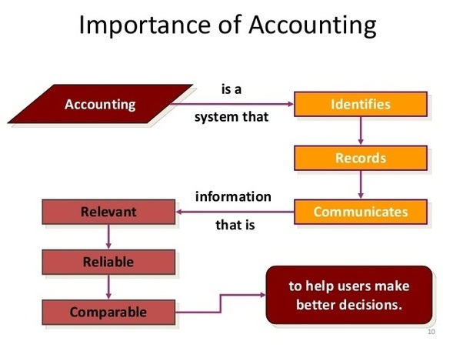

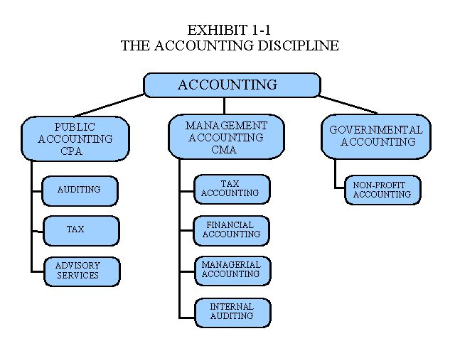

**THE END**