CYAFSF Website Enhancements
Developer-Ready Handoff | Approved Pages
Canadian Youth and Family Support Foundation
Scope | Implement the approved About Us, Programs, and Family Support page designs.
Layout | Follow the approved mockups. Do not redesign or introduce unrelated sections.
Navigation | Remove Events from the main navigation for now. Keep About, Programs, Family Support, Resources, Get Involved, Contact Us, and Donate.
Images | Use appropriate, clear, high-quality images. Avoid repeated, pixelated, awkwardly cropped, or half-cut images.

Implementation Notes
- Maintain the existing CYAFSF branding, colors, typography, spacing, CTA treatment, header, and footer style shown in the approved mockups.
- If any button, CTA, or radio-style control redirects users back to the same page without a purposeful action or in-page destination, remove it.
- All buttons and links must redirect to the correct destination and be tested after implementation.
- Ensure responsive behavior on desktop, tablet, and mobile.
- Use the approved page copy shown in the mockups; do not add unsupported service claims.

1. About Us - Approved
- Implement the approved About Us page as shown.
- Retain: Our Purpose, Our Values, Our Story, Leadership & Governance, Where We Serve, Governance & Accountability, final CTA, and footer.
- Use images in the purpose/story/leadership areas as shown; icons remain appropriate for values.

Approved Mockup
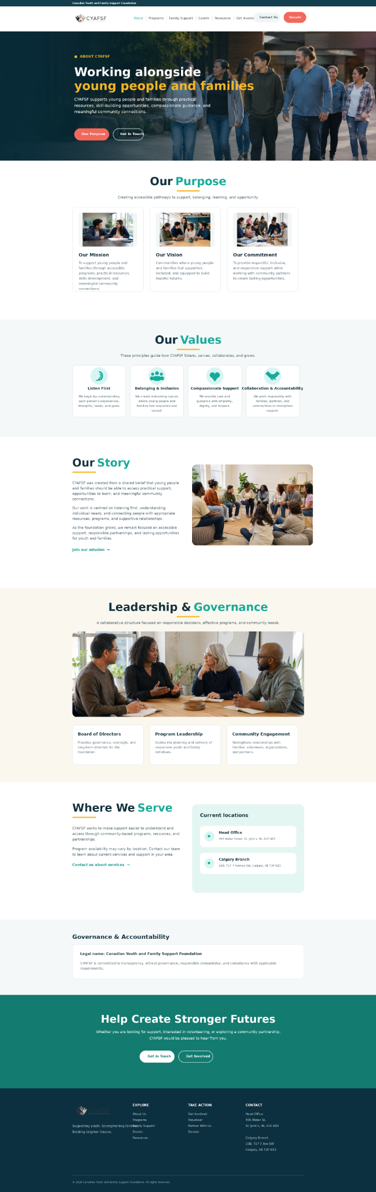

2. Programs - Approved
- Implement the approved Programs & Services page as shown.
- Retain Program Categories, Programs Designed to Create Change, Who We Help, donation CTA, and footer.
- Program content includes Youth Empowerment Programs, Family Support Services, Mental Wellness Education, Youth Resilience Initiative, Family Wellness Program, Mental Wellness Awareness Campaign, Youth Mentorship Program, Community Support Network, and Crisis & Support Resource Navigation.
- Event-related activities remain within the relevant programs; no separate Events page is required at this stage.

Approved Mockup
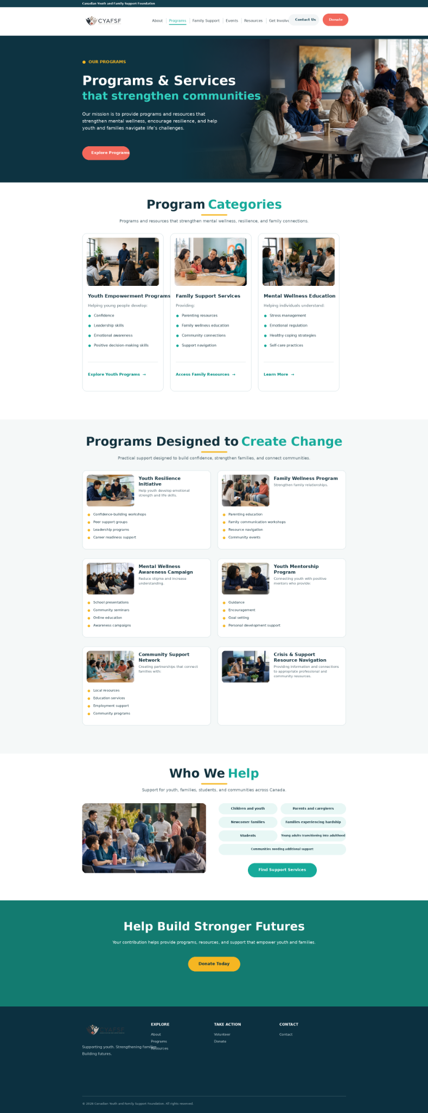

3. Family Support - Approved
- Implement the approved Family Support page design shown.
- For final content, use “Family Wellness & Communication” instead of “Family Counselling.”
- Use “Crisis & Support Resource Navigation” instead of “Crisis Support.”
- Retain Parent Support Groups, Resource Navigation, Parent Education Workshops, Family Activities & Events, Who We Help, support CTA, and contact/footer area.
- Use individual high-quality images for the family support service cards rather than icon-only cards.

Approved Mockup
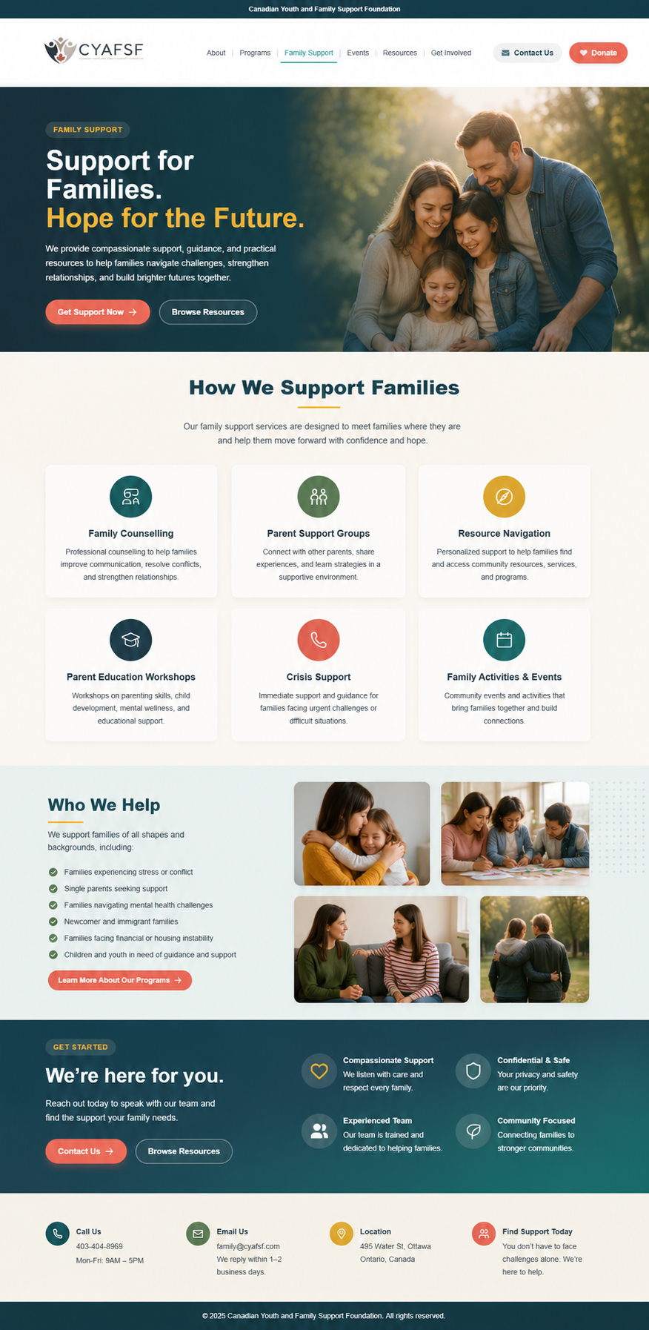

Final Developer QA
- Match approved mockups before sign-off.
- No repeated or visibly cut images.
- No broken buttons, links, or incorrect CTA redirects.
- Verify text readability and image overlays.
- Verify desktop, tablet, and mobile layouts.
- Remove any button, CTA, or radio-style control that only redirects to the same page and serves no functional purpose.
- Confirm Events has been removed from the main navigation.

