JDBC
(JAVA Database Connectivity)

Created By: Chandan kumar singh

JDBC (Java Data Base Connectivity)

JDBC is the java API which facilitates connectivity of java application to database. Before understands its API we must understand its needs.

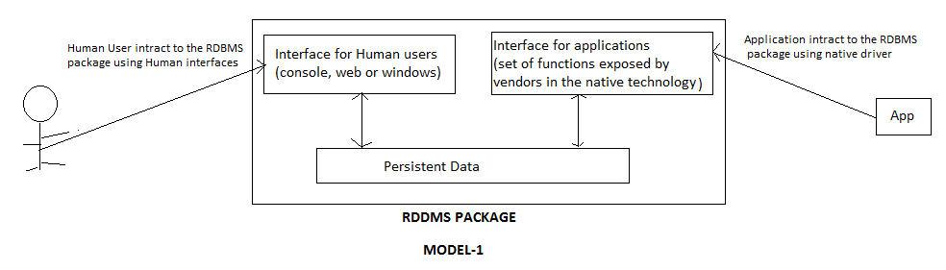

Users of RDBMS package can be divided in to 2 categories-
- Human User
- Application
A database vendor provide interface for human user as well as application in his RDBMS package.
Interface of an application represents a set of functions which are defines by the data base vendors in the native technology of the database.
Using a native driver in an application for interacting with an RDBMS package has following problems-
1- Application developers need to learn multiple API’s for multiple databases.
2- Application need to be modified each time RDBMS package is change.

Solution of these problems is provided by ODBC. ODBC ( open database connectivity) is a set of c functions prototype , implementation of these is provided by database vendors.

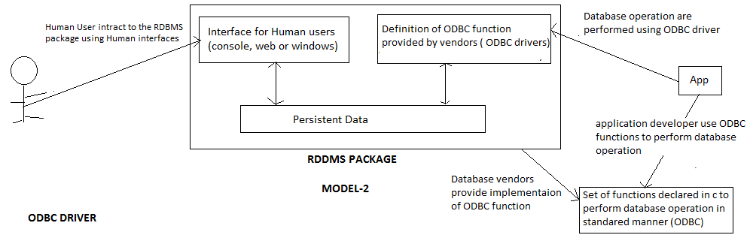
Advantage of MODEL-2
- Application developer need to single API to write code.
- Database change without the modification in application.

Disadvantage of MODEL-2
- ODBC functions are written in c language. Hence developers need to invoke c functions for different database packages. To facilitate interaction of java application to databases in JAVA, Sun Micro System provide JDBC(Java Data Base Connectivity).

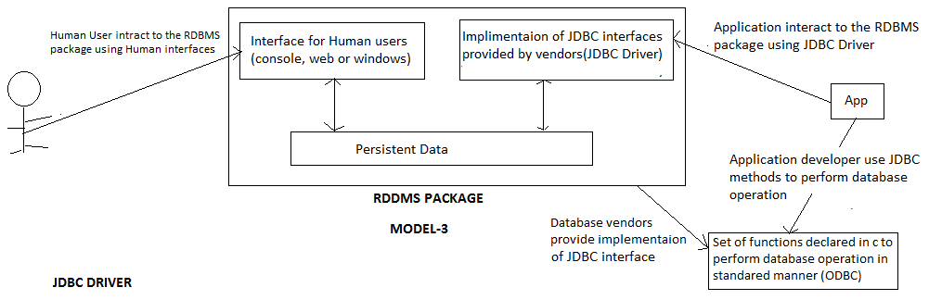

Different vendors provides implementation of JDBC interface in different ways, depending upon vendors implementations we are have 4 types of JDBC drivers-
- Type 1 or JDBC-ODBC Bridge Driver
- Type 2 or Native Driver
- Type 3 or Network Driver
- Type 4 or Pure Java Native Driver

- Type 1 or JDBC-ODBC Bridge Driver
In Type-1 JDBC driver, driver classes
Provided by vendors that is in c language invokes ODBC functions using JNI (Java Native Interface) that is this drivers is simple JAVA wrapper ODBC.

Advantage
1- Advantage of this driver is that single driver implementation can be used with all
databases.
Disadvantage
1- Measure disadvantage is performance degradation. Each database operation
required multiple calls and conversion which degrades performance.
2- ODBC driver need to be installed on each machine where application is to be
executed.

2- Type 2 or Native Driver:
In this driver JDBC classes invokes function of native drivers using JNI.

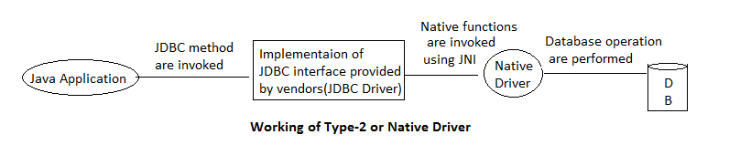
Advantage
- Better performance is obtaining as compare to Type-1 Driver.
- ODBC Driver is not required.
Disadvantage
- Native Driver is needed to install each machine on which application is to execute.
- Different driver implementation is required for each database.

3- Type 3 or Network Driver
In this driver implementation classes of JBDC interface invokes function of native drivers over the network using the standard network protocols such as TCP/IP.
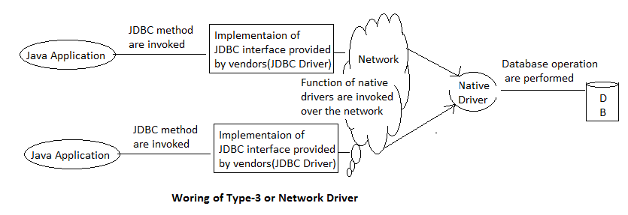

Advantage
1- Native driver need to be installed on a single machine on the network.
Disadvantage
1- Performance is degraded because of additional network overhead.

4- Type 4 or Pure Java Native Driver
In this driver implementation classes of JDBC drivers interact to the database using database specific protocols and format.

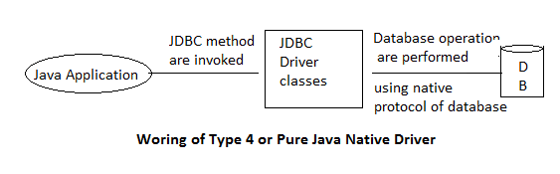
Advantage
- Better performance is obtaining as compare to other drivers.
- ODBC and native drivers is not required.
Disadvantage
1- For each database different implementation is required.

Classes and interfaces of JDBC API

Java.sql package contains all method and interfaces of JDBC API.

- DriverManager class
- Connection interface
- Statement interface
- PreparedStatement interface
- CallableStatement interface
- ResultSet interface
- ResultSetMetaData interface
- DataBaseMetaData interface
- SQLException class

1- DriverManager:
DriverManager class is a utility class that provides facility of
managing drivers and act as a factory of Connection.

2- Connection:
Connection interface provides method for managing database connection and acts as a factory of Statement.

3- Statement:
This interface provides methods for executing queries and acts as a factory of ResultSet.

4- PreparedStatement:
It is sub interface of Statement interface which has the functionality of executing parameterized queries.

5- CallableStatement:
It is sub interface of PreparedStatement interface and adds functionality of executing stored procedure and function.

6- ResultSet:
This interface provides method for managing data return by select query and act as a factory of ResultSetMetaData.
7- ResultSetMetaData:
This interface provide methods for obtaining information about the result contained in the ResultSet.
8- DataBaseMetaData :
This interface provides functionality of obtaining information about the database.

9- SQLException:
This is the super class of all database related exception.
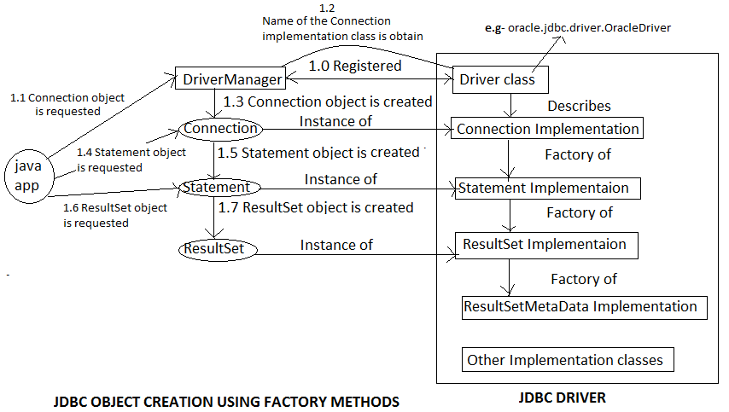

Steps for connecting a java application to a database

- Register the driver
- Creating Connection
- Creating Statement
- Executing query
- Closing Connection

1- Register the driver:
Driver class is register in the DriverManager. Driver class is a vendor provided class which describes connection implementation of vendor. Driver classes are implemented by vendors in such a way that each driver class contains registration logic in its static block that is in order to register a driver class, driver class is simply need to be loaded.
forName() of java.lang.Class is used to dynamic load a class.
Syntax :
In case of Type-1 driver sun.jdbc.odbc.JdbcOdbcDriver class need to be loaded.
NOTE: Implementation of Type-1 driver is provided by sun Microsystems as a part of core java library.

2- Creating Connection :
Connection object is created. getConnection() method of DriverManager class is used to create Connection object.
1) public static Connection getConnection(String URL) throws SQLException
2) public static Connection getConnection(String URL, String user, String password) throws SQLException

Each driver requires some information of database to establish a connection to it. Information to driver is provided as URL, different drivers require different information hence format of URL differs from driver to driver.
In case of Type-1 driver it has following formate :
“jdbc.odbc.data source name”
Example :
Let “mydb” be a data source name(DSN) :
Connection con=DriverManager.getConnection(“jdbc:odbc:mydb”);

3- Creating Statement:
createStatement() method of Connection interface is used for creating Statement object.
public Statement createStatement() throws SQLException
Example :
Statement stmt=con.createStatement();

4- Executing query:
Statement interface provides following methods for executing query-
1) public ResultSet executeQuery(String selectQuery) throws SQLException
2) public int executeUpdate(String nonSelectQuery) throws SQLException
3) public void execute(String SQLquery) throws SQLException
Example :
ResultSet rset=stmt.executeQuery(“select * from emp”);

5- Closing connection:
close() method of Connection interface is used for closing the connection for the database.
public void close() throws SQLException
Example :
Con.close();

In case of select query following additional steps are required before closing the connection:
6- Data is fetch from the ResultSet:
Fetching data from the ResultSet is a 2 step process-
1) Record pointer is place on the desired record in the ResultSet.
2) Value of individual field of the record is read.
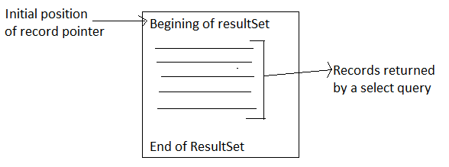
next() : ResultSet interface is provide next() method that is used to read the value of individual data member.
public boolean next()

ResultSet Interface provides various getter methods to read the value of individual data members.
General signature of these method is :
public type getType(int fieldIndex) throws SQLException
Actual method :
public String getString(int fieldIndex) throws SQLException
public int getInt fieldIndex) throws SQLException
public Clob getBlob (int fieldIndex) throws SQLException
public Blob getBlob(int fieldIndex) throws SQLException
public InputStream getBinaryStream(int fieldIndex) throws SQLException
public Date getDate(int fieldIndex) throws SQLException
public Time getTime(int fieldIndex) throws SQLException
etc.

Type -1 driver (JDBC-ODBC BRIDGE DRIVER)

Example 1- Type-1 driver (Database connectivity program with Microsoft Access)
First need to create table -
Table Name : emp
Tables fields : id(Number) , name(Text), job(Text), sal(Number)
Second need to create DSN(Data Source Name)-
Start->control panel->Administrative Tools-> Data Sources (ODBC)
import java.sql.*;
class SelectTest
{
public static void main(String args[])
{
try
{
Class.forName("sun.jdbc.odbc.JdbcOdbcDriver");
Connection con=DriverManager.getConnection("jdbc:odbc:rupendra");
Statement stmt=con.createStatement();
ResultSet rset=stmt.executeQuery("select * from emp");
while(rset.next())
{
System.out.println(rset.getInt(1)+"\t"+rset.getString(2)+
"\t"+rset.getString(3)+"\t"+rset.getInt(4));
}
con.close();
}
catch(Exception e)
{
System.out.println(e);
}
}
}
Output :
1 deepak executive 12000
2 rahul manager 45000
3 rajaram cunductor 15000

Example 2- Type-1 driver (Database connectivity program with Oracle)
First need to create table -
Table Name : emp
Tables fields : id(Number) , name(Text), job(Text), sal(Number)
Second need to create DSN(Data Source Name)-
Start->control panel->Administrative Tools-> Data Sources (ODBC)
import java.sql.*;
class SelectTest
{
public static void main(String args[])
{
try
{
Class.forName("sun.jdbc.odbc.JdbcOdbcDriver");
Connection }
con=DriverManager.getConnection("jdbc:odbc:oracle1","system","oracle");
Statement stmt=con.createStatement();
ResultSet rset=stmt.executeQuery("select * from emp");
while(rset.next())
{
System.out.println(rset.getInt(1)+"\t"+rset.getString(2)
+"\t"+rset.getString(3)+"\t"+rset.getInt(4));
}
con.close();
}
catch(Exception e)
{
System.out.println(e);
}
}
}
Output :
1 rupendra sharma software engineer 450000
2 rahul sharma C.A 550000

Type -4 driver (PURE JAVA NATIVE DRIVER)

In case of Type-4 driver for oracle following driver class need to be loaded:

URL has following format for Type-4 driver:
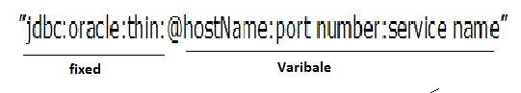
Value of hostname, port number and service name is stored in a text file named tnsnames.ora in its installation folder.
In order to use Type -4 JDBC driver JAR file containing implementation classes of JDBC interfaces need to be added to the classpath environment variable. Oracle provides implementation of Type-4 JDBC driver through JAR file names ojdbcVersionNo.JAR (e.g- ojdbc14.jar).

FULL PATH:
tnsnames.ora: C:\oraclexe\app\oracle\product\10.2.0\server\NETWORK\ADMIN\tnsnames.ora
JDBC DRIVER PATH:
C:\oraclexe\app\oracle\product\10.2.0\server\jdbc\lib\ojdbc14.jar

Example 1- Type-4 driver (Database connectivity program with Oracle)
First need to create table -
Table Name : emp
Tables fields : id(Number) , name(Text), job(Text), sal(Number)
Make following changes in the previous program for Type-4 Driver
Class.forName("oracle.jdbc.driver.OracleDriver");
Connection con=
DriverManager.getConnection("jdbc:oracle:thin:@localhost:1521:xe","system","oracle");

class SelectTest1
{
public static void main(String args[])
{
try
{
Class.forName("oracle.jdbc.driver.OracleDriver");
Connection con=DriverManager.getConnection
("jdbc:oracle:thin:@localhost:1521:xe","system","oracle");
Statement stmt=con.createStatement();
ResultSet rset=stmt.executeQuery("select * from emp");
while(rset.next())
{
System.out.println(rset.getInt(1)+"\t"+rset.getString(2)
+"\t"+rset.getString(3)+"\t"+rset.getInt(4));
}
con.close();
}
catch(Exception e)
{
System.out.println(e);
}
}
}
Output :
1 rupendra sharma software engineer 450000
2 rahul sharma C.A 550000

Example 2- Fully functional Type-4 driver (Database connectivity program with Oracle)
1- First need to create table -
Table Name : emp
Tables fields : id(Number) , name(Text), job(Text), sal(Number)
2- Create Properties file named (db.properties) that contains following entry-
driver=oracle.jdbc.driver.OracleDriver
url=jdbc:oracle:thin:@localhost:1521:xe
user=system
password=oracle
3- Create a ConnectionProvider class-
import java.sql.*;
import java.io.*;
import java.util.*;

class ConnectionProvider
{
static Properties prop;
static
{
try
{
prop=new Properties();
prop.load(new FileInputStream("db.properties"));
}
catch(Exception e)
{
System.out.println(e);
}
}

public static Connection getConnection()
{
Connection con=null;
try
{
Class.forName(prop.getProperty("driver"));
con=DriverManager.getConnection(prop.getProperty("url"),
prop.getProperty("user"),prop.getProperty("password"));
}
catch(Exception e)
{
System.out.println(e);
}
return con;
}
}
4- program that use ConnectionProvider class to create connection with database

import java.sql.*;
class DriverTest
{
public static void main(String args[])
{
try
{
Connection con=ConnectionProvider.getConnection();
Statement stmt=con.createStatement();
ResultSet rset=stmt.executeQuery("select * from emp");
while(rset.next())
{
System.out.println(rset.getInt(1)+"\t"+rset.getString(2)
+"\t"+rset.getString(3)+"\t"+rset.getInt(4));
}
con.close();
}
catch(Exception e)
{
System.out.println(e);
}
}
}
Output :
1 rupendra sharma software engineer 450000
2 rahul sharma C.A 550000

Example 3- Type-4 driver (Find the name of driver classes that is used in program for making connection)
import java.sql.*;

class DriverNameTest
{
public static void main(String args[])
{
try
{
Connection con=ConnectionProvider.getConnection();
Statement stmt=con.createStatement();
ResultSet rset=stmt.executeQuery("select * from emp");

System.out.println("Name of Connection class:"+con.getClass().getName());
System.out.println("Name of Statement class:"+stmt.getClass().getName());
System.out.println("Name of Statement class:"+rset.getClass().getName());
con.close();
}
catch(Exception e)
{
System.out.println(e);
}
}
}
Output :
In case of TYPE-1 Driver
Name of Connection class:sun.jdbc.odbc.JdbcOdbcConnection
Name of Statement class:sun.jdbc.odbc.JdbcOdbcStatement
Name of ResultSet class:sun.jdbc.odbc.JdbcOdbcResultSet
In case of TYPE-4 Driver
Name of Connection class:oracle.jdbc.driver.T4CConnection
Name of Statement class:oracle.jdbc.driver.T4CStatement
Name of Statement class:oracle.jdbc.driver.OracleResultSetImpl

PreparedStatement interface

This PreparedStatement interface is sub interface of Statement interface. It is provide the facility to execute the parameterized query and executing similar type query in a batch.
PrepareStatement() method of Connection interface is used to create a PreparedStatement object.
public PreparedStatement PrepareStatement(String Parameterized query) throws SQLException
public PreparedStatement PrepareStatement(String Parameterized query) throws SQLException

NOTE: ? is used to specify a parameter in query.

Example:
PreparedStatement stmt=con.prepareStatement(“select * from emp where job=?”);

value of all parameter need to be set before executing a query using PreparedStatement. PreparedStatement interface provides setter methods for set a value of parameter.
General Signature of these methods is:
public void setType(int paraMeterIndex, type value) throws SQLException
Actual Method:
public void setString(int paraMeterIndex, String value) throws SQLException
public void setInt(int paraMeterIndex, int value) throws SQLException
etc.

PreparedStatement interface is overloaded query execution methods of statements interface.
public ResultSet executeQuery() throws SQLException
public ResultSet executeUpdate() throws SQLException
public ResultSet execute() throws SQLException

Example 1- program to insert record in table (Demonstrate the use of PreparedStatement)
import java.sql.*;
import java.io.*;

class InsertTest
{
public static void main(String args[])
{
try
{
Class.forName("oracle.jdbc.driver.OracleDriver");
Connection con=DriverManager.getConnection("jdbc:oracle:thin:@localhost:1521:xe","system","oracle");
PreparedStatement stmt=con.prepareStatement("insert into emp values(?,?,?,?)");
BufferedReader br=new BufferedReader(new InputStreamReader(System.in));
while(true)
{
System.out.print("Enter The Employee ID : ");
int i=Integer.parseInt(br.readLine());
System.out.print("Enter The Employee Name : ");
String n=br.readLine();
System.out.print("Enter the Employee Designation : ");
String d=br.readLine();
System.out.print("Enter the Employee Salary : ");
int s=Integer.parseInt(br.readLine());
stmt.setInt(1,i);
stmt.setString(2,n);
stmt.setString(3,d);
stmt.setInt(4,s);
stmt.executeUpdate();
System.out.print("You want to insert more record (yes/no) :");
String ans=br.readLine();
if(ans.startsWith("n"))
break;
}
con.close();
System.out.println("Successfully inserted....");
}
catch(Exception e)
{
System.out.println(e);
}
}
}
Output :
Enter The Employee ID : 101
Enter The Employee Name : rajan
Enter the Employee Designation : developer
Enter the Employee Salary : 18000
You want to insert more record (yes/no) :y
Enter The Employee ID : 102
Enter The Employee Name : deepak]
Enter the Employee Designation : manager]
Enter the Employee Salary : 15000
You want to insert more record (yes/no) :n
Successfully inserted....

Execution of a query requires following steps in a database:
- Query is parsed ( To removing bracket, semicolon etc from query string)
- Query is compiled
- Query is optimize ( finding efficient technique to execute query)
- Query is executed

In case of PreparedStatement interface 1st 3 steps are performs only ones when the query submitted first time. Only the last step is perform in subsequent submitting of the query.
In case of Statement interface all steps are perform each time query submitted for execution. That PreparedStatement provide better performance than Statement if same query is to be executed multiple times.

Problem in previous programs:

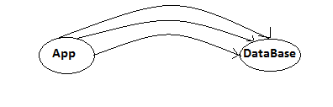
Solution:
PreparedStatement interface provide the facility of executing similar type of query in a bath. Execution of a query in bath results are better performance because networking overhead involve in individual query submitted is reduced.

Following steps are required for batch execution of query:
- Queries are add to the batch after completion. addBatch() method is used for this purpose.
public void addBatch() throws SQLException // PreparedStatement
public void addBatch(String Query) throws SQLException // Statement
- When all queries are added to the batch, batch submitted to execution. executeBatch() method is used for this purpose.
public void executeBatch() throws SQLException

Requirements of batch processing:
- Same type of query can be executed in batch.
- Select query is not be executed in batch. (Batch processing use where human intervention is not required such as bank draft box).

Example 2- program to insert record in table using batch processing technique (Demonstrate the use of PreparedStatement)
import java.sql.*;
import java.io.*;
class InsertBatchTest
{
public static void main(String args[])
{
try
{
Class.forName("oracle.jdbc.driver.OracleDriver");
Connection con=DriverManager.getConnection("jdbc:oracle:thin:@localhost:1521:xe","system","oracle");
PreparedStatement stmt=con.prepareStatement("insert into emp values(?,?,?,?)");
BufferedReader br=new BufferedReader(new InputStreamReader(System.in));
while(true)
{
System.out.print("Enter The Employee ID : ");
int i=Integer.parseInt(br.readLine());
System.out.print("Enter The Employee Name : ");
String n=br.readLine();
System.out.print("Enter the Employee Designation : ");
String d=br.readLine();
System.out.print("Enter the Employee Salary : ");
int s=Integer.parseInt(br.readLine());
stmt.setInt(1,i);
stmt.setString(2,n);
stmt.setString(3,d);
stmt.setInt(4,s);
stmt.addBatch();
System.out.print("You want to insert more record (yes/no) :");
String ans=br.readLine();
if(ans.startsWith("n"))
break;
}
stmt.executeBatch();
con.close();
System.out.println("Successfully inserted....");
}
catch(Exception e)
{
System.out.println(e);
}
}
}
Output :
Enter The Employee ID : 106
Enter The Employee Name : cccccccccc
Enter the Employee Designation : ddddddddddd
Enter the Employee Salary : 12000
You want to insert more record (yes/no) :y
Enter The Employee ID : 106
Enter The Employee Name : gggggggggggg
Enter the Employee Designation : hhhhhhhhhhhhhhh
Enter the Employee Salary : 123
You want to insert more record (yes/no) :
Successfully inserted....

Transaction

A transaction is set of sequential logically related statement which represent single task from user prospective. To execute logically related query as transaction it must be perform entirely. Connection interface provides methods for transacting queries.
Following steps are required to execute logically related query as transaction:
- setAutocommit(): This method is used to enable or disable auto committing queries. By default queries are automatically committed as soon as they are successfully executed. In order to execute query as part of transaction this auto committing behavior of connection is to be disable.
public void setAutocommit(boolean flag) throws SQLException
- commit(): This method is use to explicitly commit successfully executed query.
public void commit() throws SQLException
- rollback() : This method is used to rollback successfully executed but uncommitted queries.
public void rollback() throws SQLException

Example 1- Transaction program
1- - First create table named account -
Table Name : account
Tables fields : acno(Number) , balance(Number)
NOTE- set constrain on balance field ( >0)
import java.sql.*;
import java.io.*;

class TranferTest
{
public static void main(String args[])
{
Connection con=null; // In try block it is not accessible in catch bock so writer here
try
{
Class.forName("oracle.jdbc.driver.OracleDriver");
con=DriverManager.getConnection
("jdbc:oracle:thin:@localhost:1521:xe","system","oracle");
con.setAutoCommit(false); // auto commit is disable
PreparedStatement stmt1=con.prepareStatement
("update account set balance=balance+? where acno=?");
PreparedStatement stmt2=con.prepareStatement
("update account set balance=balance-? where acno=?");
BufferedReader br=new BufferedReader(new InputStreamReader(System.in));
System.out.print("Enter Source A/C Number : ");
int src=Integer.parseInt(br.readLine());
System.out.print("Enter Target A/C Number : ");
int target=Integer.parseInt(br.readLine());
System.out.print("Enter Amount :");
int amt=Integer.parseInt(br.readLine());
stmt1.setInt(1,amt);
stmt1.setInt(2,target);
stmt1.executeUpdate();

stmt2.setInt(1,amt);
stmt2.setInt(2,src);
stmt2.executeUpdate();
con.commit(); // query are explicitly committed
con.close();
System.out.println("Successfully Tranferred.....");
}
catch(Exception e)
{
System.out.println("Transaction failed , rolling back.....");
try
{
con.rollback();
System.out.println("Successfully rollback....");
}
catch(Exception e1)
{
System.out.println("Can not be rollback...");
}
}
}
}
Output :
D:\JAVA\1- PROGRAMS\JDBC>java TranferTest
Enter Source A/C Number : 101
Enter Target A/C Number : 103
Enter Amount :1000
Successfully Tranferred.....

D:\JAVA\1- PROGRAMS\JDBC>java TranferTest
Enter Source A/C Number : 101
Enter Target A/C Number : 103
Enter Amount :1000
Transaction failed , rolling back.....
Successfully rollback....

The application which uses database for persistence data are based on either of the following models:
- Thick client model
- Thin client model
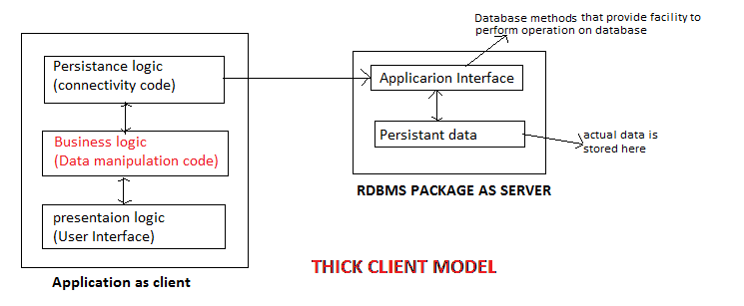

In Thick client model application, business logic (insert, delete, update queries) is implemented as a part of application.
Advantage: Advantage of this model is database independency.
Disadvantage: Disadvantage of this model is degradation of performance (due to round trip), if lots of manipulation (insert, delete, update queries) are required in database.

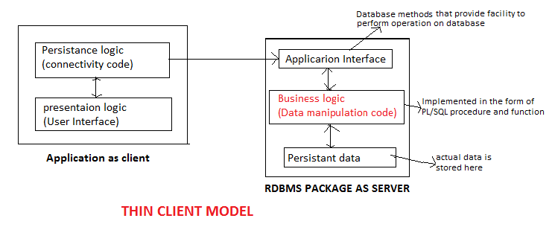

In Thin client model application, business logic is implemented as a part of RDBMS package. Business logic is implemented on the RDBMS package in the form of PL/SQL procedure and functions.
This model is used in those applications where a lot of modification (insert, delete, update) are to be perform on data.
Advantage: Advantage of this model is better performance.
Disadvantage: Measure disadvantage is this approach is database dependency.
NOTE:
Procedural language : (java, PL/SQL, c, c++ ) kya karna hai, kai se karna hai.
Non Procedural language : (SQL) kya karna hai.

PL/SQL is a procedural language which provides the facility of defining business logic in term of procedure, function and triggers. Basic difference between PL/SQL procedure and function is in the way of returning result. Function explicitly return there result whereas procedure can only return there result implicitly.

In PL/SQL parameter of procedure and function can be of following types
Type of parameter | Purpose
IN | Use to pass input to procedure and function
OUT | Used to receive result indirectly from procedure
INOUT | Used to pass input as well as receive result from procedure

In c language:
int a=5, b;  square(a,&b);  void square(int x, int *y)  {  *y=x x x;  } | int a=5;  square(&a);  void square(int *p)  {  *p=*p x *p;  }
Here x is used to receive input and y is used to return result indirectly.  Functionality of x and y is represent IN and OUT type parameters respectively in PL/SQL. | Here p is used to receive input as well as to return result. Functionality of p is represent INOUT parameter in PL/SQL

Syntax of defining PL/SQL procedure:
create or replace procedure procedureName(paraName [IN,OUT,INOUT] Data Type,…)
is
local variable declaration
begin
body of procedure
end;

Syntax of defining PL/SQL function:
create or replace function function Name(paraName [IN,OUT,INOUT] Data Type,…)
return returnType
is
local variable declaration
begin
body of procedure
end;

Following steps are required to invoke procedure and function in java application:
- CallableStatement object is created. This is used to invoke procedure and functions. prepareCall() method of Connection interface is used to cerate CallableStatement object.
public CallableStatement prepareCall(String CallableString) throws SQException
CallableString has following format:
1) for procedure:
“{ call procedureName(?,?,?,… )}”
2) for function:
“{ ?=call procedureName(?,?,?,… )}”
- Value of IN type parameter is set. Setter methods of preparedStatement interface are used for this purpose. (e.g- setInt(index, value), etc..).
- Return type specify each OUT type parameter. registerOutParameter() of CallableStatement interface is used to specify the type of OUT type parameter.
public void registerOutParameter(int parameterIndex, int jdbcType) throws SQLException
Note: To specify the value of jdbcType, static final int constants are defined in java.sql.Types class.
Commonly used constant are:
Types.INTEGER
Types.VARCHAR
Types.BLOB
- Procedre and function is executed using the execute() method.
- Value of OUT type parameter id fetched. CallableStatement interface provides getter methods for this purpose.
General Signature:
public Type getType(int parameterIndex) throws SQLException;
- Connection is closed.

Create procedure:
create or replace procedure GETNAME(eid IN NUMBER, ename OUT VARCHAR2)
is
begin
select name into ename from emp where id=eid;
end;

Create function:
create or replace function GETSALARY(eid IN NUMBER)
return NUMBER
is
s NUMBER(8);
begin
select salary into s from emp where id=eid;
return s;
end;

Example 1- Procedure Invoking Program (Procedure Name: GETNAME)
NOTE: Table name is: emp
id name job salary
NUMBER VARCHAR2 VARCHAR2 NUMBER
import java.sql.*;
import java.io.*;

class ProcTest
{
public static void main(String args[])
{
try
{

Class.forName("oracle.jdbc.driver.OracleDriver");
Connection
con=DriverManager.getConnection("jdbc:oracle:thin:@localhost:1521:xe","system","oracle");
CallableStatement stmt=con.prepareCall("{call GETNAME(?,?)}");
BufferedReader br=new BufferedReader(new InputStreamReader(System.in));
System.out.print("Enter Id: ");
int id=Integer.parseInt(br.readLine());
stmt.setInt(1,id);
stmt.registerOutParameter(2,Types.VARCHAR);
stmt.execute();
System.out.println("Name is : "+stmt.getString(2));
con.close();
}
catch(Exception e)
{
System.out.println(e);
}
}
}

Output :
Enter Id: 1
Name is : deepak

Enter Id: 2
Name is : rupendra

Enter Id: 3
java.sql.SQLException: ORA-01403: no data found
ORA-06512: at "SYSTEM.GETNAME", line 6
ORA-06512: at line 1

Example 2- Procedure Invoking Program (Procedure Name: GETDETAIL)
NOTE: Table name is: emp
id name job salary
NUMBER VARCHAR2 VARCHAR2 NUMBER
iimport java.sql.*;
import java.io.*;

class ProcTest1
{
public static void main(String args[])
{
try
{

Class.forName("oracle.jdbc.driver.OracleDriver");
Connection con=DriverManager.getConnection("jdbc:oracle:thin:@localhost:1521:xe","system","oracle");
CallableStatement stmt=con.prepareCall("{call GETDETAIL(?,?,?,?)}");
BufferedReader br=new BufferedReader(new InputStreamReader(System.in));
System.out.print("Enter Id: ");
int id=Integer.parseInt(br.readLine());
stmt.setInt(1,id);
stmt.registerOutParameter(2,Types.VARCHAR);
stmt.registerOutParameter(3,Types.VARCHAR);
stmt.registerOutParameter(4,Types.INTEGER);
stmt.execute();
System.out.println("Employee Details............");
System.out.println("ID is : "+id);
System.out.println("Name is : "+stmt.getString(2));
System.out.println("Job is : "+stmt.getString(3));
System.out.println("Salary is : "+stmt.getInt(4));
con.close();
}
catch(Exception e)
{
System.out.println(e);
}
}
}
Output :
Enter Id: 101
Employee Details............
ID is : 101
Name is : amit
Job is : Trainee
Salary is : 5000

Enter Id: 102
Employee Details............
ID is : 102
Name is : rupendra
Job is : Trainer
Salary is : 25000

Example 1- Function Invoking Program (Function Name: GETSALARY)
NOTE: Table name is: emp
id name job salary
NUMBER VARCHAR2 VARCHAR2 NUMBER
import java.sql.*;
import java.io.*;

class FunTest
{
public static void main(String args[])
{
try
{
Class.forName("oracle.jdbc.driver.OracleDriver");
Connection con=DriverManager.getConnection("jdbc:oracle:thin:@localhost:1521:xe","system","oracle");
CallableStatement stmt=con.prepareCall("{?=call GETSALARY(?)}");
BufferedReader br=new BufferedReader(new InputStreamReader(System.in));
System.out.print("Enter Id: ");
int id=Integer.parseInt(br.readLine());
stmt.setInt(2,id);
stmt.registerOutParameter(1,Types.INTEGER);
stmt.execute();
System.out.println("Salary is : "+stmt.getInt(1));
con.close();
}
catch(Exception e)
{
System.out.println(e);
}
}
}
Output :
Enter Id: 1
Salary is : 23000
Enter Id: 2
Salary is : 34000
Enter Id: 3
java.sql.SQLException: ORA-01403: no data found
ORA-06512: at "SYSTEM.GETSALARY", line 7
ORA-06512: at line 1

Example 1- Database initialization Program (Corporate level Program)
NOTE: Table name is: emp
id name job salary
NUMBER VARCHAR2 VARCHAR2 NUMBER
First create a “db.sql” file and store all procedure, function and SQL queries adding appropriate separator-

CREATE TABLE EMP
( ID NUMBER,
NAME VARCHAR2(4000),
JOB VARCHAR2(4000),
SALARY VARCHAR2(4000)
)
/
insert into emp values(101,'amit','Trainee',5000)
/
insert into emp values(102,'rupendra','Trainer',25000)
/
create or replace procedure GETNAME
(eid IN NUMBER,
ename OUT VARCHAR2)
is
begin
select name into ename from emp where id=eid;
end;
/
create or replace procedure GETDETAIL
(eid in NUMBER, ename OUT VARCHAR2, ejob OUT VARCHAR2, esalary OUT NUMBER)
is
begin
select name,job,salary into ename,ejob,esalary from emp where id=eid;
end;
/
create or replace function GETSALARY
(eid in NUMBER)
return NUMBER
is
s NUMBER(8);
begin
select salary into s from emp where id=eid;
return s;
end;

import java.sql.*;
import java.io.*;
import java.util.*;

class DbInitilizer
{
public static void main(String args[])
{
try
{

Class.forName("oracle.jdbc.driver.OracleDriver");
Connection con=DriverManager.getConnection("jdbc:oracle:thin:@localhost:1521:xe","system","oracle");
Statement stmt=con.createStatement();
FileInputStream f=new FileInputStream("db.sql");
byte data[]=new byte[f.available()];
f.read(data); //To read db.sql element into data[] array String queries=new String(data); // To read data[] element into queries String
StringTokenizer str=new StringTokenizer(queries,"/");
while(str.hasMoreTokens())
{
String q=str.nextToken();
stmt.execute(q);
}
f.close();
con.close();
System.out.println("Database Successfully Initilized..........");
}
catch(Exception e)
{
System.out.println(e);
}
}
}
Output :
Database Successfully Initilized..........

ResultSetMetaData interface

ResultSetMetaData provides facility for obtaining information about the result contained in the ResultSet.
getMetaData() method of ResultSet interface is used to obtain ResultSetMetaData object.
public ResultSetMetaData getMetaData() throws SQLException

Commonly used methods of ResultSetMetaData interface:
1- getColumnCount(): Is used to find out the number of column in ResultSet.
public int getColumnCount() throws SQLException
2- getColumnName(): Is used to find out the name of columns in Result.
public String getColumnName(int ColIndex) throws SQLException
3- getColumnTypName(): Is used to find out data type of a column.
public String geColumnTypeName(int ColIndex) throws SQLException
4- getTableName(): Is used to find out the table name of a column.
public String getTableName(int ColIndex) throws SQLException
etc….

Example 1- Program to describe the use of (ResultSetMetaData)
import java.sql.*;
import java.io.*;

class Selector
{
public static void main(String arr[])
{
try
{
Class.forName("oracle.jdbc.driver.OracleDriver");
Connection con=DriverManager.getConnection("jdbc:oracle:thin:@localhost:1521:xe","system","oracle");
Statement stmt=con.createStatement();
String query="select * from "+arr[0];
ResultSet rset=stmt.executeQuery(query);
System.out.println("Following Records Are Selected....");
ResultSetMetaData rmd=rset.getMetaData();
int c=rmd.getColumnCount();
for(int i=1;i<=c;i++)
{
System.out.print(rmd.getColumnName(i)+"\t");
}
System.out.println();
for(int i=1;i<=c;i++)
{
System.out.print(rmd.getColumnTypeName(i)+"\t");
}
while(rset.next())
{
System.out.println(); // For starting next line
for(int i=1;i<=c;i++)
{
System.out.print(rset.getString(i)+"\t");
}
}
con.close();
}
catch(Exception e)
{
System.out.println(e);
}
}
}
Output :
ID NAME JOB SALARY
NUMBER VARCHAR2 VARCHAR2 VARCHAR2
101 amit Trainee 5000
102 rupendra Trainer 25000

DatabaseMetaData interface

This interface provides methods for obtaining information about database.
getMetaData() method of Connection interface is used to obtain DatabaseMetaData object.
public DatabaseMetaData getMetaData() throws SQLException

Commonly used method of DatabaseMetaData interface:
1- getDatabaseProductName(): Is used to find out the name of RDBMS package we are connected.
public String getDatabaseProductName()
2- getDriverName(): Is used to find out details of driver.
public String getDriverName()
3- getTables(): Is used to obtain the information of database object (such as tables, procedure, function, cursor etc.).
public ResultSet getTables(String Catalog, String schema, String pattern, String[] criteria) throws SQLException;
Out of the 4 parameter of this method, first 3 is optional that is null can be specify as there values. Last parameter is used to identify the data dictionary for selecting information.
In order to select the information from the database, “TABLE” is used as value of this parameter.
Example:
Let dmd be a DatabaseMetaData object:
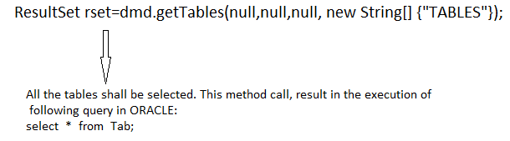
NOTE:
1- Third field of the ResultSet return by getTables() method, contains name of the tables (database object).
2- % : 0 or more
- : one character
schema : User information privileges and works done by user.
Catalog : Collection of something, menu, Group of something
Third parameter of the method is used to specify the pattern if its value is specify then only those tables (database object) are selected, name of which matches with the pattern.
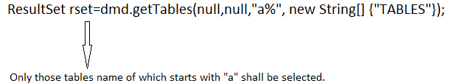

Second parameter specifies the schema. Schema is a logical term which describes user privilege given to the user, database object (tables) created and owned by the user.
EXAMPLE: Adding new user means creating schema.
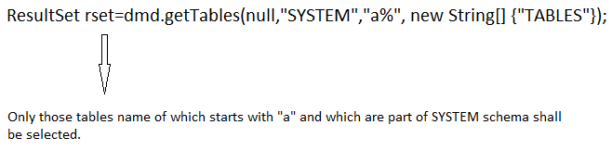
First parameter is used to specify catalog. Catalog is a collection of users, database and schema. Catalog is used to manage users and databases.
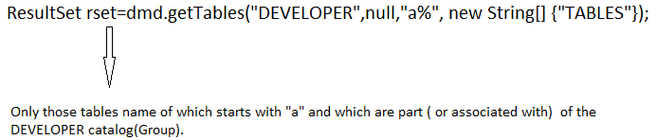

Example 1- Program to describe the use of (DatabaseMetaData)
import java.sql.*;
class DmdTest
{
public static void main(String args[])
{
try
{
Class.forName("oracle.jdbc.driver.OracleDriver");
Connection con=DriverManager.getConnection("jdbc:oracle:thin:@localhost:1521:xe","system","oracle");
DatabaseMetaData dmd=con.getMetaData();
System.out.println("RDBMS package is: "+dmd.getDatabaseProductName());
System.out.println("Driver is: "+dmd.getDriverName());
ResultSet rset=dmd.getTables(null,"SYSTEM",null,new String[] {"TABLE"});
System.out.println("Following tables are selected.....");
while(rset.next())
{
System.out.println(rset.getString(3));
}
con.close();
}
catch(Exception e)
{
System.out.println(e);
}
}
}
Output :

RDBMS package is: Oracle
Driver is: Oracle JDBC driver
Following tables are selected.....
Tables names…..

