- Annotations represents metadata that is associated to a class or any of its members. This information is either used by the compiler, class loader or by the Runtime Environment. Feature of annotation is added to Java from Jdk 1.5 and this feature provides an alternative to XML based configurations.
- In Web Applications, Enterprise Applications and Applications which uses frameworks such as Struts, Spring, Hibernate etc. an Application Developer need to provide configuration and other information in the form of XML along with Application. The problem with XML is verbosity. Annotations removes this problem.
  - Annotations can be of 2 types-
    - Marker Annotations doesn’t have members i.e. it don’t carry any information. They simply act as a flag. Marker annotations are used to divide classes into 2 categories:-
      - Classes on which Annotations are applied.
      - Classes on which Annotations is not applied.

  - Marker Annotations simply act as a flag i.e. they doesn’t represent any information. They are simply used to divide classes into groups.
    - Syntax of applying Marker Annotations-
@AnnotationName
Example-
Serializable interface can be replaced by a Marker Annotation as :-
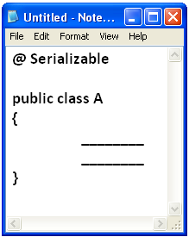

    - Non-Marker Annotations are used to associate information to its class and its members.
    - Syntax of applying Non Marker Annotations-
@ AnnotationName(memberName=value, O O O)
Example-
Information required for the management of a Servlet can be provided to a Web Server as:-

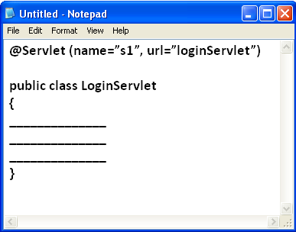

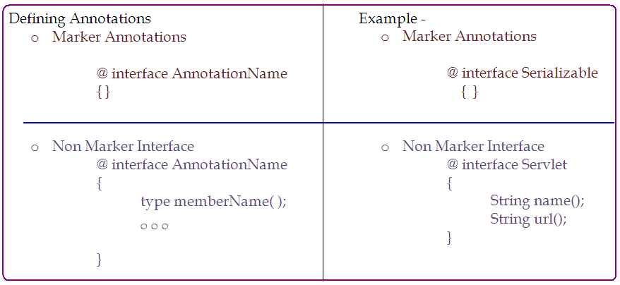
- At the time of defining an Annotation its Target Element and Retention Policy need to be specified.
Target Element represents member of the class which can be annotated by the Annotation.
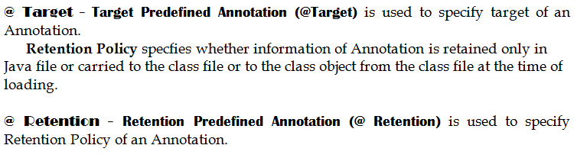
Retention Policy | Purpose
SOURCE | Annotation information is retained only in source file i.e. it is not stored in class file by the compiler. Such type of annotation are meant to provide some information to the compiler.
CLASS | Annotation information is stored to the class file by the compiler but it is not loaded into class object by the class loader. Such annotations are used to provide the information to the class loader.
RUNTIME | Annotation information is stored to the class file by compiler, loaded into class object by the class loader. Such annotations are used for runtime environment, web services, framework etc.

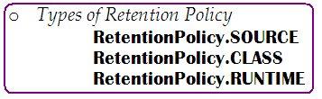

- Diagrammatic Representation
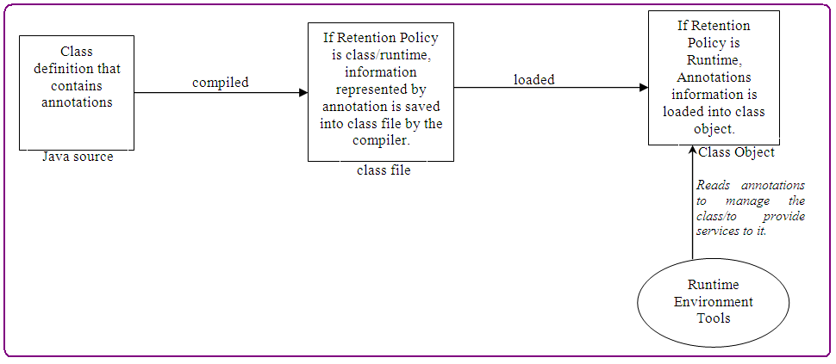

- Following methods are added to java.lang.Class to support Annotations:-
  - isAnnotationPresent( ) method returns true if specified annotation is applied the class.
public boolean isAnnotationPresent( class AnnotationClass);

  - getAnnotation( ) method returns object of specified annotation;.
public Object getAnnotation( class AnnotationClass);

