- Spring is a framework that is based on two concepts-
  - IOC (Inversion of Control).
  - AOP (Aspect Oriented Programming).
- As a Framework, Spring is not confined to any specific type of applications or any specific domain. It can be used in a console application, in a Windows Application, in a Web Application, in an Enterprise Application etc.
- Spring Framework is a collection of interdependent modules which can be used collectively or in parts. Major modules of this framework are –
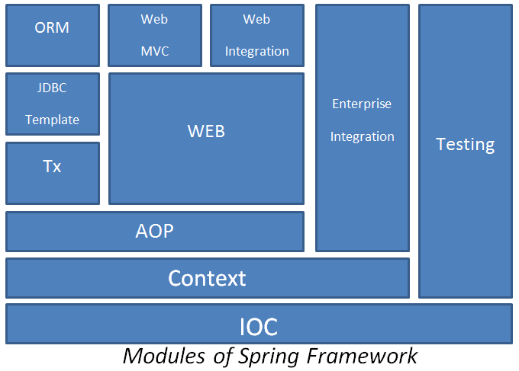

  - IOC - This is the core module of the framework which represents basic implementation of an IOC container.
  - Context – This module is built over IOC & represents an advance implementation of IOC container.
  - AOP – This module is built over context & provides basic infrastructure for Aspect Oriented Programming.
  - Tx – This module provides the facility of declarative transaction management.
  - JDBC Template – This module provides an implementation of Template Design Pattern for simplifying JDBC operations.
  - ORM – This module provides an implementation of Spring Applications with ORM framework such as Hibernate, Toplink, Ibatis etc.
  - WEB - This module is built over AOP & provides implementation of common task such as transfer of request parameters to domain objects, type conversion file uploading & downloading etc.
  - Web MVC - This module provides an implementation of MVC pattern for developing Web Applications.
  - Web Integration –This module facilitate integration of Spring Applications with third party MVC applications such as Struts.
  - Enterprise Integration – This module provides the facility of integrating Enterprise services such as JMS, JNDI, Java Mail etc. of Spring Applications.
  - Testing- This module facilitate integration & unit testing.
- IOC – IOC is a design pattern which states that an Application Developer must focus only on the usage of objects not on the creation of objects and managing their life cycles i.e. this design pattern takes the responsibility of creating objects & managing their life cycles from the Application Developers & assign it to a runtime environment called IOC container. The motto behind this shifting of control from the developer to the IOC container is to facilitate loose coupling between objects. When objects are loosely coupled, their maintanence is easy.
- In Conventional Programming, objects have dependency on each other. These dependencies are satisfied by directly referencing one object into another. Direct references of objects create tight coupling between them which results in maintanence problem.
Example –
Let there be three classes named A, B, & C. A has dependency on B which has dependency on C. An Application need to do following things in order to use A.

Here, Application Developer is responsible for creating objects, satisfying their dependencies, and then using them.
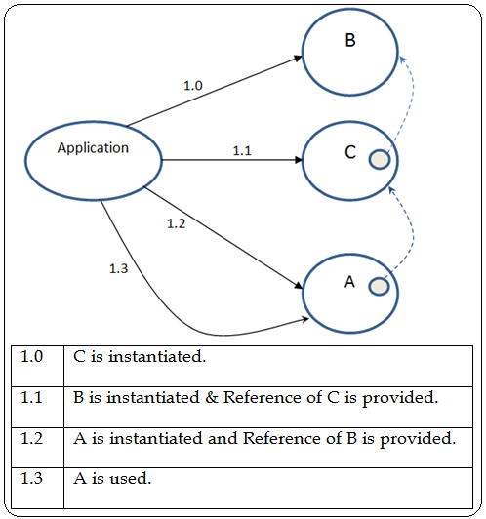

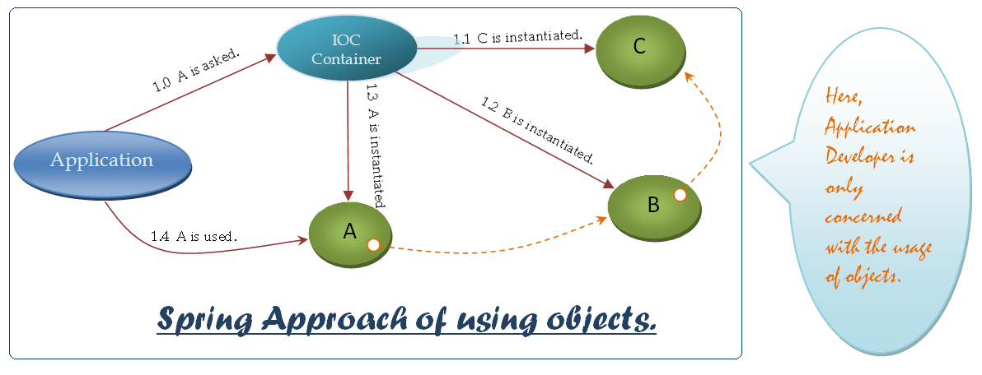
- Implementation of IOC can be provided in two ways -
  - Dependency Injection (DI)
  - Dependency Lookup(DL)
- Spring IOC implementation supports Dependency Injection. In DI, dependencies of objects are satisfied unasked i.e. IOC container identifies the dependencies of objects on its own & satisfies them.
- Dependency Lookup – This is an alternative method of implementing IOC in which an object need to ask IOC container for its dependent objects.
- Terminology related with Spring.
  - Bean is an object that is created by the IOC container and life cycle of which is managed by the IOC container.
  - BeanFactory is an interface provided by the framework which describes basic functionality of an IOC container. All the IOC containers provide implementation of this interface.
  - Resource is an interface provided by the framework which provides object representation of bean configurations.
  - Bean Configuration represents the information of an object & its dependencies which is required by the IOC container in order to manage it.

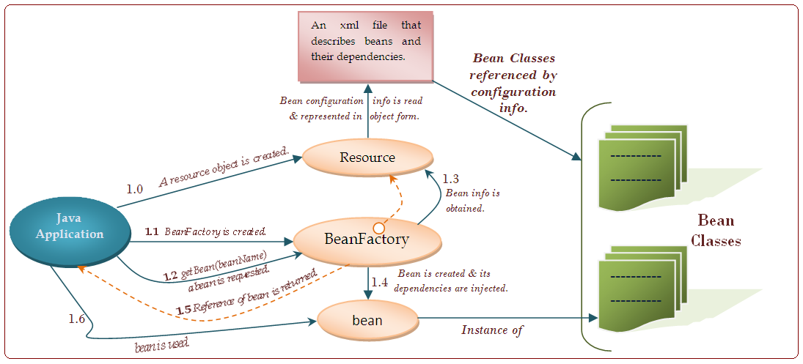

  - Number.java
package mypack;

  - Compiler .java
package mypack;

public class Complex implements Number
{
int r, i;
public Complex(int i, int r)
{
this.r=r;
this.i=i;
}

public Number add(Number n)
{
Complex c =(Complex)n;
int r = this.r + c.r;
int i = this.i + c.i;
return new Complex(r, i);
}

public void display()
{
System.out.println(r + "+" + i "i");
}
}
  - Rational.java

package mypack;

public class Rational implements Number
{
int p, q;
public Rational(int p, int q)
{
this.p=p;
this.q=q;
}

public Number add(Number n)
{
Rational r =(Rational)n;
int p = this.p + r.q + this.q * r.p;
int q = this.q * r.q;
return new Rational(p, q);
}

public void display()
{
System.out.println(p + "/" + q);
}
}

  - NumberUser.java
  - applicationContext.xml
  - IOCNumberUser.java
Dated : 05.12.10
- XML elements of configuration file-
<bean> is the main element of configuration file that is used to specify the configuration of a bean.
It has following attributes-
  - id is an optional attribute that is used to give a alias to a <bean>.
  - class is an optional attribute that specifies fully qualified name of bean class.
  - factory-method is an optional attribute that specifies name of the factory method to be used by the IOC container for creating the bean.
  - scope is an optional attribute which specifies whether bean is singleton or prototype. By default all beans are singleton i.e. IOC container creates a single instance and returns its reference each time bean is requested. In case of prototype bean each time bean is requested a new instance is created.
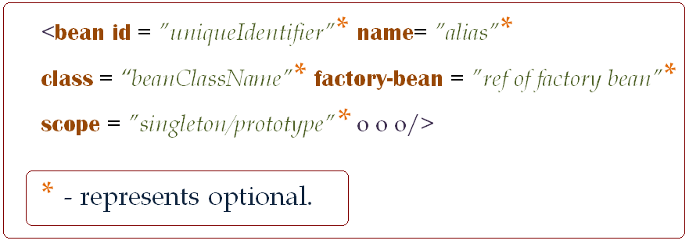

- IOC container uses id, name & class as identifies for the bean in the same sequence.
- Usage of name attribute –
Problem description – Let there be two implementation of an object and there are two users. Each user is using one implementation. After sometime one user need to switch to another implementation. You are required to affect the change in such a way that if this user wants to revert back to its previous implementation then it can be done.

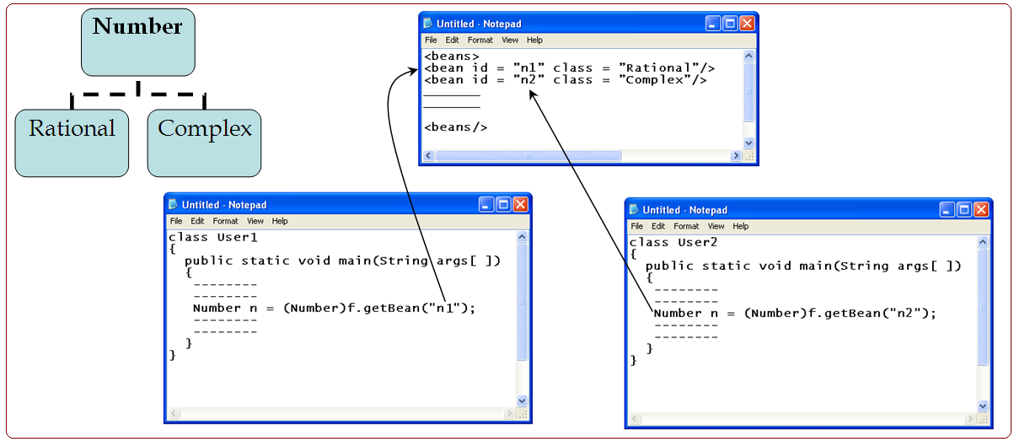
Instead of this we will as follows -
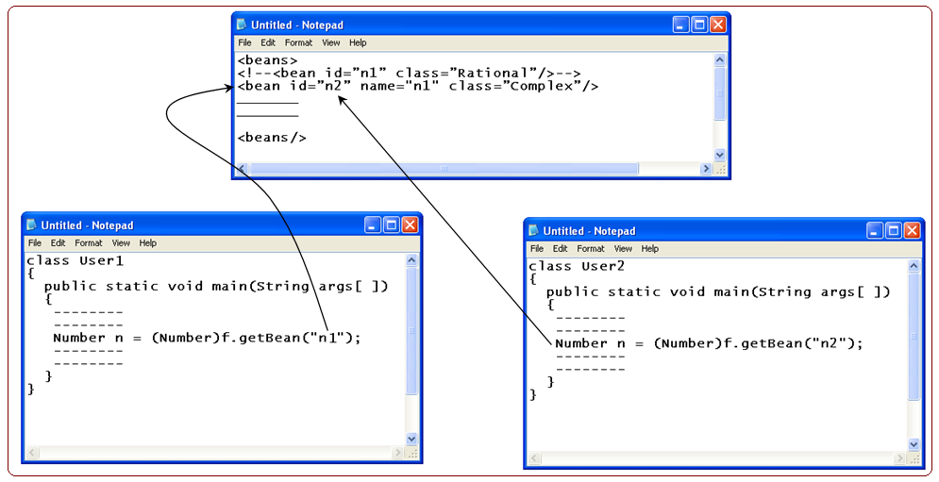

- Using factory for creating a bean-
  - IOC Container can create a bean using a factory method. A factory method can be implemented in one of the following three ways-
    - static factory method in same class.
    - static factory method in a different class.
    - Non-static factory method in a different class.
  - static factory method in same class.
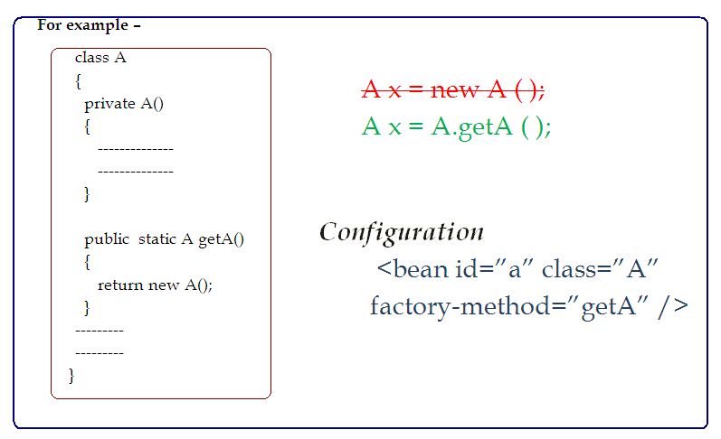

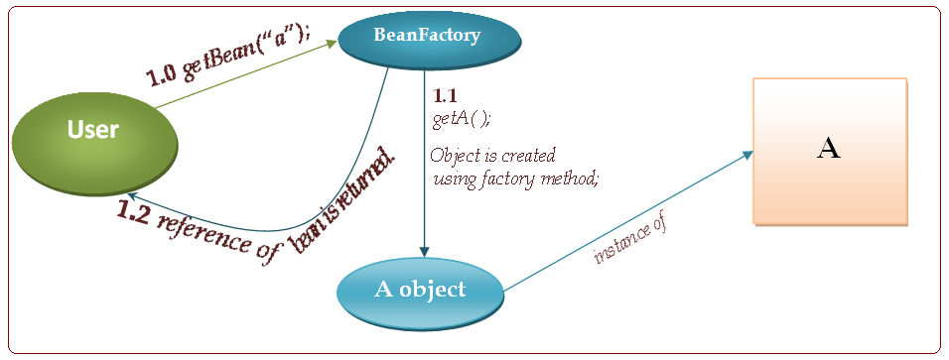

  - static factory method in a different class.
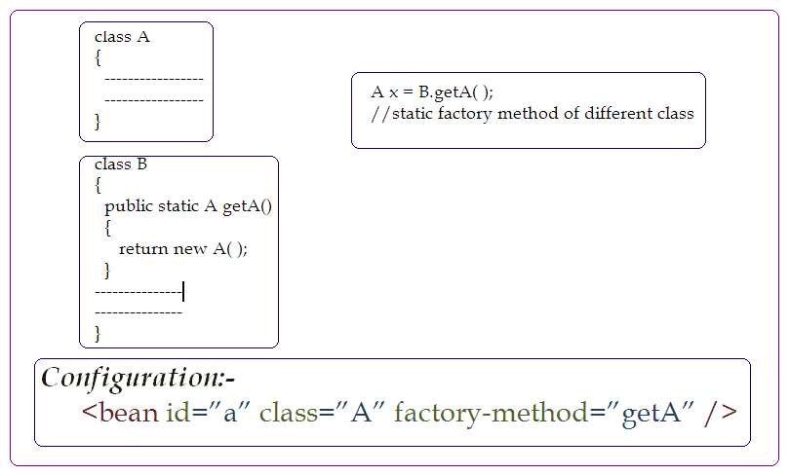
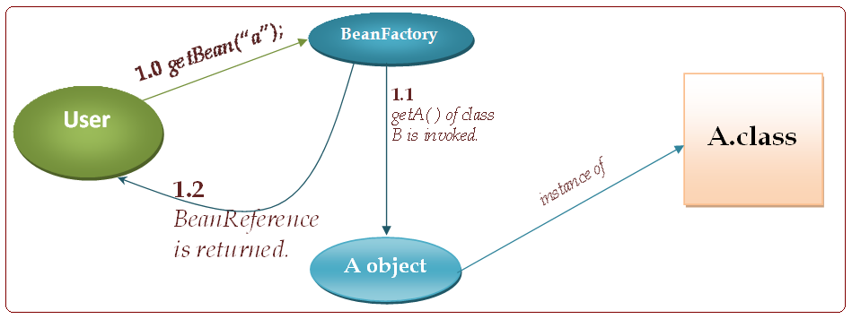
  - Non - static factory method in a different class.

class A
{
--------
--------
}

class B
{
public A getA( )
{
return new A( );
}
-------------
-------------
}
Dated: 11.12.10
- In case of constructor injection all the dependencies of a bean are injected with the help of a constructor i.e. bean class defines constructor which receives dependent objects or values or parameters.
- <constructor-arg> is subelement of <bean> is used to specify the value to specify the value of parameter.
<bean --->
<constructor-arg value=”parameterValue” or
ref=”name of ”
</bean>

Note : If a bean class contains constructor that receive a primitive value as parameter & a constructor that receive String parameter then by default constructor having String parameter shall be invoked irrespective of the type of value passed. To let the Spring invoked constructor with primitive value <type> attribute of <constructor-arg> element is used.

Example
  - A.java
  - Person.java
  - Address.java
  - application.xml
  - Test.java
  - Student.java

- Setter Injection – In case of setter injection IOC container injects the dependency of a bean by invoking setter methods defined by it. In configuration file to specify a dependency to be injected by setter method property subelement of bean is used.
Example –

- Auto Wiring is the facility provided by IOC container to Application Developers to input dependencies of beans by Auto identification i.e. Dependency information of a bean is not specified by the Application Developer in configuration file. It is auto detected by the IOC container.
IOC container uses either of the following methods for identifying & injecting dependencies –
- Autowiring by type.
- Autowiring by Name.
- Autowiring by Constructor.
- Autowiring by Autodetect.
- Autowiring by type – In this approach IOC Container uses the type of properties of a Bean to identify its dependencies & satisfies them by using the bean of identifying type defined in configuration file.
- This approach can only be used if only one bean of a type is configured. In case, there are more than one bean of a type configured in XML file then this approach won’t work.
- Autowiring by Name – In this approach IOC container uses the name of the bean to find out & inject their dependencies.
    - Example
Advantage – This approach can be used in situations where more than one
bean of a type are configured.
Disadvantage – Bean name in the configuration file need to be same as the
name of properties of the depending bean.
- Autowiring by Constructor – In this approach IOC Container uses the constructor having highest number of parameters of the bean to identify its dependencies & then uses the type of constructor parameters to inject dependencies.
- Autowiring by Auto Detect – In this approach, IOC container uses by Type approach if bean class has default constructor & by constructor approach if bean class doesn’t have default constructor.
- Bean Initialization & destruction – In a Spring Application IOC container creates bean objects and manages their life cycle. Sometimes a bean developer want to perform some intitialization at the time of bean creation and want to perform some clean up operations at the time to bean destruction.
IOC container provides bean initialization & destruction facility to Application Developers in two ways –
  - Non – Intrusive Approach – In Non-Intusive approach bean developer defines an intialization method & specifies it with the bean configuration using inti() method attribute.

Let a method named init( ) be defined in a bean.
class A
{
public void init( )
{
----------
----------
}
----------
----------
}

<bean id=”a” class=”A” init-method=”init”/>

  - Intrusive Approach – In intrusive approach framework provides an interface named initializing bean which provides one method named afterPropertiesSet( ) [ public void afterPropertiesSet( ); ]. This interface need to be implemented by bean class in order to specify intialization logic.

class A implements InitializingBean
{
public void afterPropertiesSet( )
{
----------
----------
}
}
<bean id=”a” class=”A”/>
Note : - In case afterPropertiesSet( ) method is defined and an additional initialization method is defined then IOC container invokes additional initialization method after its own initialization method.
- Spring Framework provides an advanced implementation of IOC container by the name applicationContext. It extends BeanFactory and adds functionality of ResourceManagement, BeanPooling & Internationalization i.e. a BeanFactory creates a bean only when it is requested whereas an applicationContext creates all singleton beans at the time of startup.
Example –
Programs to write –
A.java, B.java, applicatonContext.xml, Test.java

- Destruction code/logic can be added to a bean either by implementing DisposableBean interface & defining its sole method destroy( ) or by defining any method in the Bean class & specifying it using destroy( ) method attribute.
Note : Destruction logic or destroy methods are only invoked by the IOC container when Beans are unloaded i.e. a Bean is unloaded only when neither IOC container nor application holds its reference.
IOC container always holds the reference of the Beans created by it. In order to destroy a Bean, IOC container need to be explicitly informed about releasing the Bean reference. Framework or IOC container provides methods for this purpose.
public void destroySingleton(String beanName);
public void destroySingletons();
Example –
Changes made in A.java, applicationContext.xml, Test.java
- BeanNameAware & BeanFactoryAware interfaces provide callback methods which are used by the IOC container to provide beanname and its own reference to a bean. These interfaces provide following method –
BeanNameAware – public void setBeanName(String name);
BeanFactoryAware – public void setBeanFactory(BeanFactory factory);

BeanNameAware interface is implemented by bean to know the name used by the IOC container to manage it.
BeanFactoryAware interface is implemented by bean when it wants to interact with its IOC container.
Problem assignment:-
Let there be a bean of singleton scope named a which has a dependency on a prototype scope bean named b.

B.java, A.java, applicationContext.xml, Test.java
Change in B.java, A.java

- Lookup method injection is the facility provided by the framework to inject a method that returns the reference of prototype bean in a singleton bean. Lookup method injection facility is used in singleton beans which has dependency on prototype beans such as bean A in previous example. In order to use lookup method injection singleton bean is implemented as abstract class which contains an abstract lookup method that returns the reference of prototype bean. IOC container dynamically creates a subclass of the abstract class & provides implementation of lookup method.

Example
c.java, changes made in applicationContext.xml

Notes: In order to use lookup method injection clib jar file need to be added to the application.

Dated : 18.12.10
- Aspect Oriented Programming
Aspect Oriented Programming is a programming model which complement Object Oriented Programming by providing an efficient approach of implementing cross cutting concern.
  - A concern represents a task that is either performed independently or in association with other task. A concern is said to be cross cutting if it participate in multiple behaviours.
  - Following example demonstrates concerns and their association with behaviours.
  - Let there be a bank for which Automation need to be performed i.e. operations of the bank have to be automated. Two of the most common operation in the Banking Application is deposit of the money & withdraw of the money.
  - In both these operations multiple concern or subtask are involved such as Validation, Login, sending message etc. Some of these task is to be performed in the same way in both operations. These tasks represents Cross Cutting Concern.
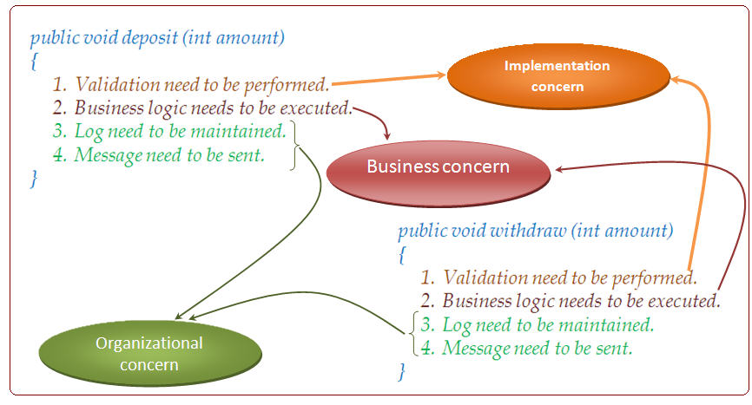
- Following operation can be implemented using Object Oriented model as follows -
class Validator
{
public boolean isValid(int amt)
{
----------------------
----------------------
}
}

class Upper
{
public void log(String msg)
{
----------------------
----------------------
}
}

class messageSender()
{
public void deposit(int amt)
{
------
------
if (validator.isValid(amt))
{
balance + = amount;
loger.log(---);
MessageSender.sendMsg(----);
}
}

public boolean withdraw(int amount)
{
-------------------
-------------------
if (validator.isValid(amt))
{
balance - = amt;
logger.log(----);
MessageSender.sendMsg(-----);
-----------------
}
---------
---------
}

- This approach of implementing Cross Cutting Concern has following problem.
  - Business method are responsible for invoking optional concern i.e. they are aware of the workflow is changed i.e. if some new concerns are added or existing concerns are removed then methods need to be modified.
- Diagram

OOPS based implementation workflows controlled by business object

- Aspect Oriented programming states that application object must concentrate only on business logic they must not be concerned with the work flow i.e. responsibility of controlling the work flow of business operation should be left on IOC container in AOP model implementation or organizational concern which are associated to a business operations are provided to the IOC Container in a Declarative Manner (through XML config file).
- Terminology Related to AOP –
  - Join point – A join point represents an easily distinguishable point. In the execution of an application such as initialization of a class creation of an object etc.
  - Advise – An advice represent a piece of code or a concern that is to be applied to a Join Point.
  - Pointcut – A pointcut is a collection of Join Point on which some advice has to be applied.
  - Aspect – An Aspect is a collection of Join Point and Advices.
  - Weaving is a process of inserting Advices to the Point Cut. AOP implementation supports two types of weaving.
    - Static Weaving.
    - Dynamic Weaving

In case of Static Weaving, Advices are inserted at the time of compilation.
Advantage - The advantage of this approach is performance.
Disadvantage –
- Special AOP a compiler are required to view Advices at the time of Compilation.
- Each time Advices or their flow is changed Application need to be recompiled.

Dynamic Weaving – In this approach Advices are inserted using Dynamic Proxy.
Advantage –
- Special AOP compilers are not required.
- Application need to be recompiled when Advices or their flow is changed.

Disadvantage –
- Performance is degraded because of the additional overhead introduced by dynamic proxy.

- Spring AOP implementation support Dynamic Weaving i.e Spring AOP implementation Dynamic Proxy are used to apply Advices.
Dynamic Proxies can be of two types –
        - JDK Dynamic Proxy
        - CGLIB Dynamic Proxy
Example –

- JDK Dynamic Proxies are used to insert Advices to the object of those classes which implement some interfaces i.e. a JDK Dynamic Proxy can only proxying functionality of interfaces implemented by the class.
- CGLIB Dynamic Proxies are used to Proxy any class whether some interfaces are implemented by it or not.
- SPRING AOP implementation support only method invocation Joint Point.

UNDERSTANDING JDK DYNAMIC PROXY

JDK Dynamic Proxy is an object of dynamically generated class which extends java.lang.reflect.Proxy class & implements those interfaces which are implemented by the Target class.
Let there be a class named A which implement an interface named Printable that contains one method named print().
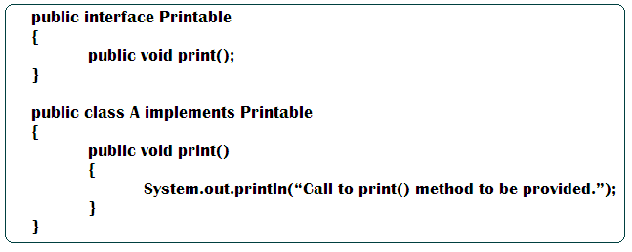

- A Dynamic proxy for class A need to be created so that some Advices can be applied before & after invocation of print( ) method.
- JDK Dynamic proxy proxies the functionality of its target class but doesn’t insert advices. It uses an object of type java.lang.relfect.InvocationHandler for inserting Advices. InvocationHandler is an interface & implementation of which need to be provided by Application Developer. This interface contains one method.

public Object invoke(Object proxy, method m, Object[ ] arg) throws Exception;

Working of JDK Dynamic Proxy
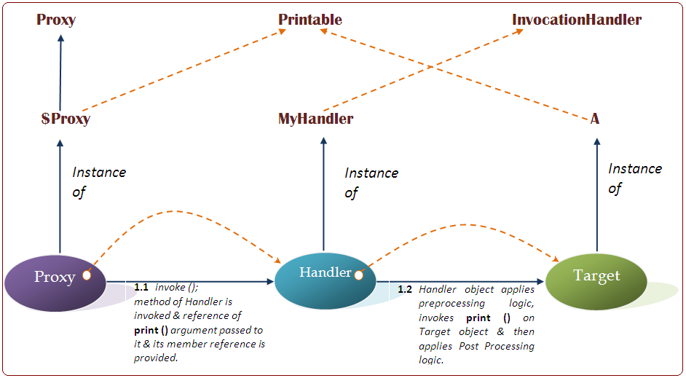

- MyHandler.java
import java.lang.reflect.*;

public class MyHandler implements InvocationHandler
{
Printable target;
public MyHandler(Printable target)
{
this.target=target;
}

public Object invoke(Object proxy, Method m, Object [ ] args ) throws Throwable
{
System.out.println(“Before advices can be inserted here…. ”);
Object o = m.invoke(target.args);
System.out.println(“After advices can be inserted here…. ”);
return o;
}
}
- ProxyTest.java

import java.lang.reflect.Proxy;

public class ProxyTest
{
public static void main(String args[ ])
{
try
{
System.out.println(“Creating Target Object….”);
A target = new A();
System.out.println(“Creating invocation Handler for the target….”);
MyHandler handler = new MyHandler(target);
System.out.println(“Creating proxy…”);
Printable proxy = (Printable) Proxy.newProxyInstance(target.getClass().getClassLoader, target.getClass().getInterfaces(), Handler);
System.out.println(“Invoking print() on Proxy…”);
Proxy.print();
}catch(Exception e)
{
System.out.println(e);
}
}
}

- Printable.java
- A.java
Dated : 25.12.10
- Apply AfterAdvice, AroundAdvice & Afterthrows advices:-
- AfterAdvice is used to insert concern after the invocation of a method.
- AroundAdvice is used to insert concern before & after execution of a method.
- AfterThrowsAdvice is used to insert concerns in case some exception is thrown by method.
- To apply all these advices, an Application Developer need to provide implementation of the interface provided by the framework for the Advice & this Advice object need to be specified as interceptor in the definition of ProxyFactoryBean.
- To apply After Advice to a method implementation of org.springframework.Aop.AfterReturningAdvice need to be provided. This interface contains one method named afterReturning().

public void afterReturning(Object target. Method method, Object[] args, Object returnValue) throws Throwable;

- In case of AroundAdvice, Application Developer insert concerns before proxied method is invoked on the target object, then invokes the proxied method on the target object & finally inserts concerns after proxied method is completed on the Target object. In this case Application Developer has control over the value returned by the actual method i.e. Application Developer can change it if there is a need to do so.
- In order to apply AroundAdvice on a method implementation of a org.aopalliance.intercept.MethodInterceptor interface need to be provided. This interface provides one method named invoke().

public Object invoke(MethodInvocation mi) throws Throwable

- In the invoke method an object of type MethodInvocation is provided by the proxy to the Application developer. This object encapsulate the method called on the Target object. It provides a method named proceed() that is used by the Application Developer to invoke the method on the Target object.
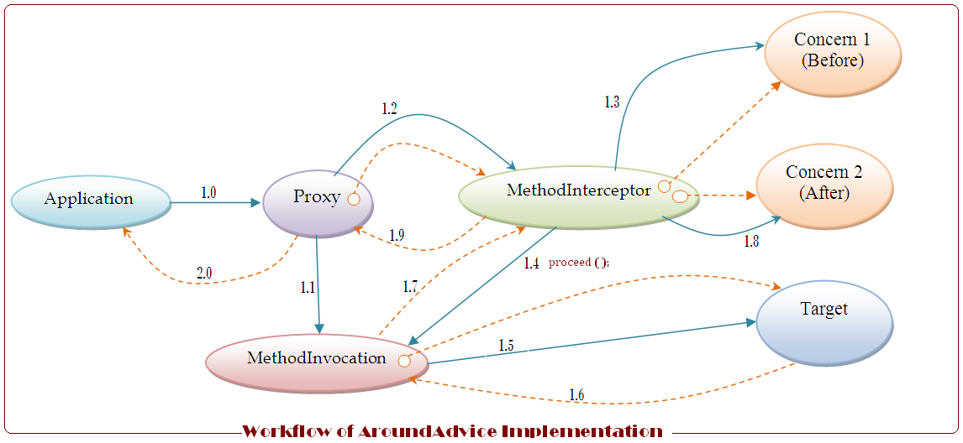
1.0 | Method is invoked on proxy object.
1.1 | MethodInvocation object is created by the Proxy to invoke method on the Target object.
1.2 | MethodInterceptor is invoked & Reference of the MethodInvocation object is provided.
1.3 | BeforeAdvice is applied.
1.4 | MethodInvocation is asked to invoke actual method on Target object.
1.5 | Actual method on Target object is invoked by MethodInvocation.
1.6 | Method is completed & value is returned.
1.7 | Value returned by method is returned to MethodInterceptor.
1.8 | AfterAdvice is applied.
1.9 | Value returned by MethodInterceptor or a changed one is returned.
2.0 | Value is returned to application.

- Apply AfterThrowsAdvice - In order to apply after throw advice, ThrowsAdvice interface provided by the framework need to be implemented.
org.springframework.aop.ThrowsAdvice;

This interface does not provide any methods. You can define a method having either of the following signature to insert some logic in case of an exception.

public void afterThrowing(Exception e);
public void afterThrowing(Method method, Object[ ] args, Object target, Exception e);

Example –

- AB.java(interface)
- A.java
- MyAfterAdvice.java
- MyAroundAdvisor.java
- ThrowsAdvisor.java
- AfterTest.java
- applicationContext.xml

- By default Advices define for a Target object are applied on all the methods of the Target object.
In order to apply an object only on specific method concept of point cut & advices are used. A point cut helps the IOC container to identify a method & an advisor tells with advices are associated to a point cut that is an advisor represent an application of aspects. Spring Framework provides predefined implementation of point cuts & advisors.
Most commonly used point cut implementation is Name, Match, Method, Point Cut which used a method Name to identify it.
Commonly used implementation of advisor is default point cut advisor.
Example –

To simplify uses of Point Cut & Advisor framework provide utility classes which combine the functionality of Point Cut & Advisor in to single object default Name match, method, Point Cut Advisor is one such utility class which combines the functionality of Name Match method Point Cut & Point Cut Advisor.
Dated : 26.12.10
Template
- Template is a behavioural design pattern that is used to implement those behaviours which involves sequence of steps some of which can be perform in more than one ways. For example
In order to perform an operation in database following 4 steps are to be performed in the given sequence –
- Connection is open.
- Statement is created.
- Query is executed.
- Connection is closed.
- Out of these 4 steps, first two can be implemented in more than one ways i.e.
  - A connection can be directly created by the programmer or
  - It can be obtained for the connection pool.

- In the same way, different users may create different statements for their own query.
- Above example is a potential candidate for applying Template Design Pattern.
- Implementation of Template Design Pattern is provided in a form of template method.
- A Template method is a method that performs a predefined sequence of task which are implemented in such a way that any of these can be varied.
- To vary implementation of subtask template method uses abstract method to perform them i.e. a Template method invokes abstract method which are implemented by different user in their own way.
Following example demonstrate the need of template design pattern.

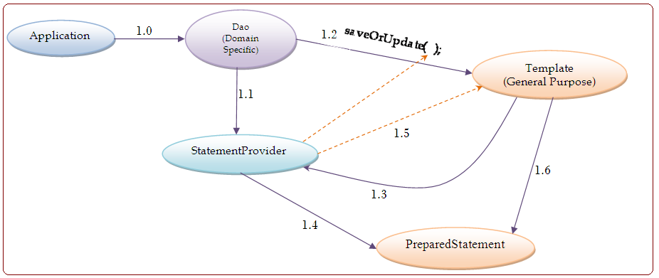

1.0 | save(e);  Dao is asked to save domain object in database.
1.1 | A StatementProvider object is provided.
1.2 | Template is asked to performed operation using statement provider.
1.3 | getStatement (con);  StatementProvider is asked to provide statement.
1.4 | A PreparedStatement object is created for the operation.
1.5 | Reference of PreparedStatement is returned.
1.6 | executeUpdate();  Query is asked.

Example –

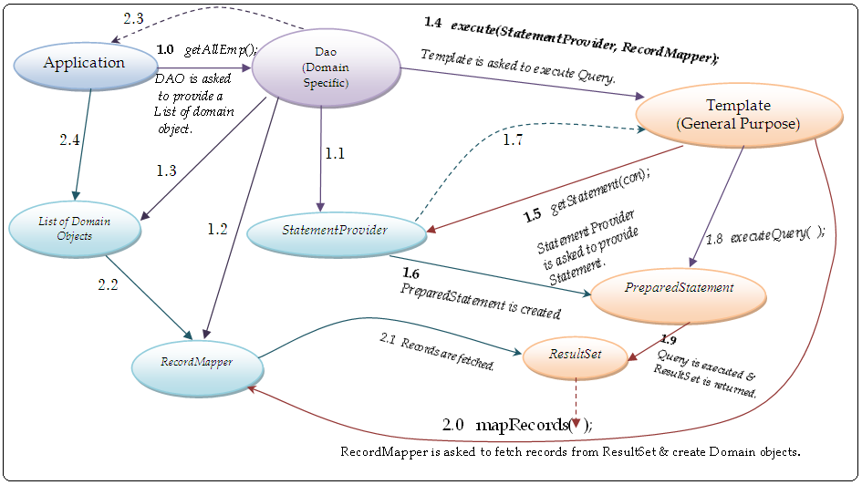
1.1 | StatementProvider is created.
1.2 | RecordMapper object is created.
1.3 | List of Domain object is created.
1.7 | Reference of PreparedStatement is returned.
2.2 | For each Record, a domain object is created & & added to the
2.3 | List of domain objects is returned.
2.4 | Domain objects are fetched.

