git branch dev

$ git push --set-upstream origin dev
원격 저장소에 dev브랜치를 올릴것이다.

Default branch 를 dev변경

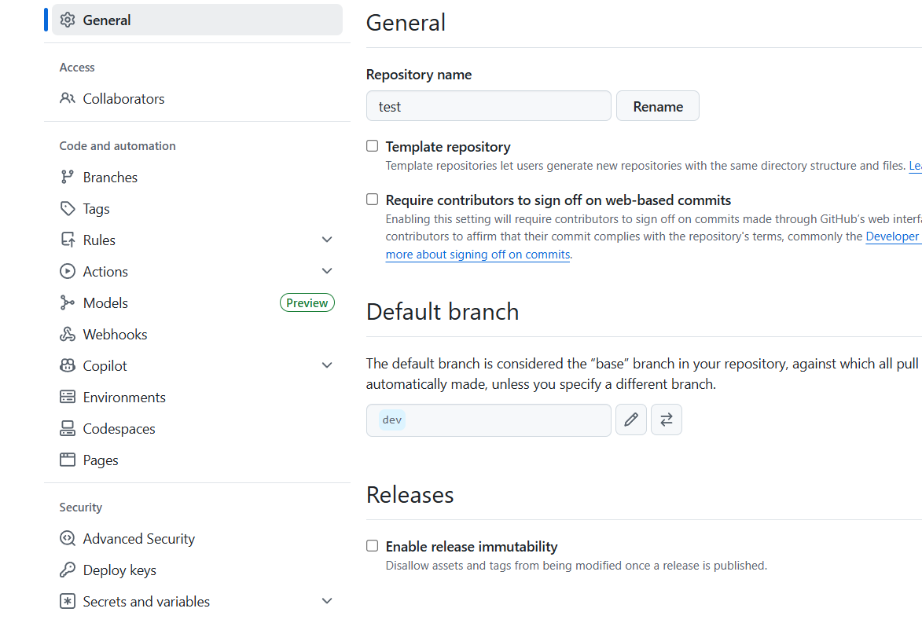

git checkout dev
$ git branch one

$ git branch two
$ git branch three

$ git branch
* dev
main
one
three
two

TJ@DESKTOP-QCRJUG5 MINGW64 ~/Desktop/test (dev)
$ git checkout one
Switched to branch 'one'

TJ@DESKTOP-QCRJUG5 MINGW64 ~/Desktop/test (one)
$ echo 'hello world' >> one.txt

$ git add .
warning: in the working copy of 'one.txt', LF will be replaced by CRLF the next time Git touches it

TJ@DESKTOP-QCRJUG5 MINGW64 ~/Desktop/test (one)
$ git commit -m "one"
[one f800231] one
1 file changed, 1 insertion(+)
create mode 100644 one.txt

TJ@DESKTOP-QCRJUG5 MINGW64 ~/Desktop/test (one)
$ git push
fatal: The current branch one has no upstream branch.
To push the current branch and set the remote as upstream, use

git push --set-upstream origin one

To have this happen automatically for branches without a tracking
upstream, see 'push.autoSetupRemote' in 'git help config'.

TJ@DESKTOP-QCRJUG5 MINGW64 ~/Desktop/test (one)

머지후 삭제

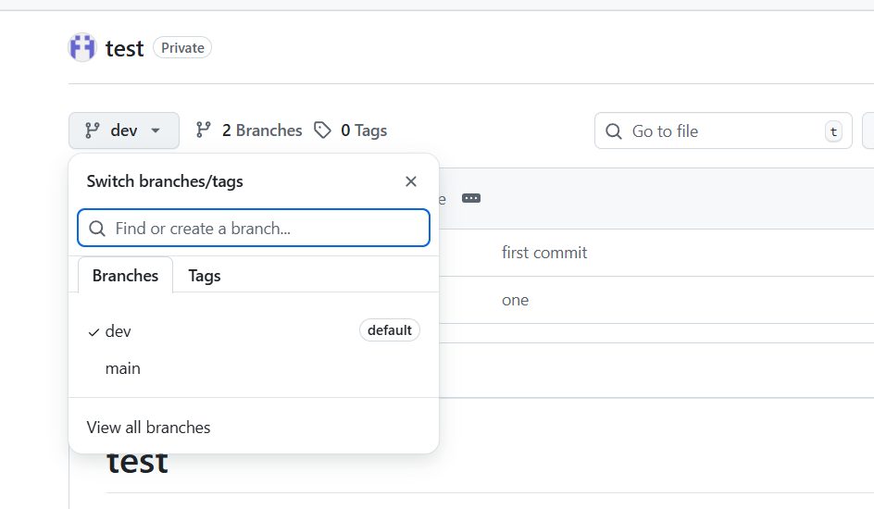

$ git branch
* dev
main
one
three
two

TJ@DESKTOP-QCRJUG5 MINGW64 ~/Desktop/test (dev)
$ git branch -d one
깃 브랜치 지우기

Gir checkout dev

git branch -d two
# main 브랜치로 이동
git checkout main

# dev 브랜치 내용을 main으로 병합
git merge dev

# 충돌이 있으면 해결 후 commit

# 원격 main에 push
git push origin main

