- .

  - -

CRITICAL CARE NURSING CME 2020
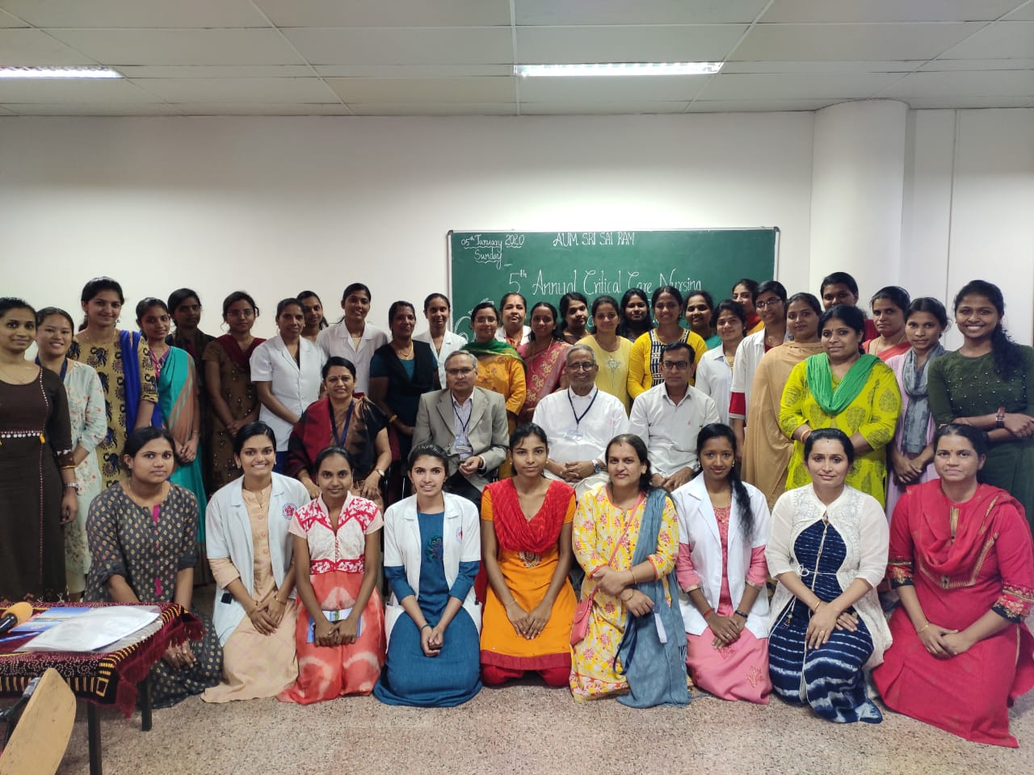
FELICITATION BY ISA IN 2017
CCM UPDATE 2020