**TERM SHEET**

**for the**

**SynPat Open Licensing Program**

***Non-Binding - subject to NDA***

Acquisition of _Patents ___ Patents; _July___, 2015

The purpose of this non-binding Term Sheet is to facilitate discussions between Syndicated Patent Acquisitions Corp. (“SynPat”) and ____EDWIN A HERNANDEZ__ (“Seller”) concerning the possible acquisition of certain of Seller’s patents by SynPat. A binding purchase commitment can only result from the execution of a mutually satisfactory Patent Purchase Agreement (“PPA”) between SynPat and Seller that incorporates the terms of this Term Sheet, except as such terms may be modified by mutual agreement.

WHEREAS, Seller owns certain Patents (as hereinafter defined) related to ___ System, apparatus, and methods for proactive allocation of wireless communication resources__ and is willing to sell the Patents to SynPat; and

WHEREAS, SynPat is interested in purchasing the Patents from Seller pursuant to SynPat’s analysis indicating that acquisition of the Patents for SynPat’s Open Licensing Program would allow more than ten (10) operating companies to obtain licenses under the Patents if offered for a regular license price of approximately $__1,500,000__, and therefore SynPat is willing to fund and execute a 100-day due diligence process to validate its analysis; and

WHEREAS, within the due diligence period, Seller may solicit sale of the Patents to others but may not sell, transfer or otherwise encumber the Patents; and

WHEREAS, the Parties are willing to engage in sale of the Patents according to the terms and conditions set forth herein.

**Term:**

If within 100 days from signing the PPA, SynPat does not inform Seller that the due diligence was completed successfully, the PPA will expire.

**Acquisition:**

The rights to the Patents will be conveyed from Seller to SynPat in two steps:

1. Upon SynPat’s notice to Seller that the due diligence was completed successfully, SynPat will be conveyed the exclusive right to grant licenses under the Patents.
2. Within 7 days from SynPat’s notice of successful due diligence, Seller will be paid $____3,000,000____ (the “Upfront Price”), and upon such payment, SynPat will be conveyed all other rights including title to the Patents (the “Closing”).

In addition to the Upfront Price, Seller will receive from SynPat one-third (1/3) of any amount received by SynPat during the Regular and the Risk Averse licensing stages, and also from any sale of the Patents (“Royalty Payments”).

**Cost Licensing:**

During the 100-day diligence period, SynPat will offer operating companies to join an ad-hoc syndicate to fund the Upfront Price and to receive from SynPat:

* a non-exclusive license under the Patents, and
* an option to acquire exclusive rights to sub-license a designated third party of their choice, and
* an amount equal to the Royalty Payments, which will be equally divided among the accepting companies (“Participants”).

Each Participant will pay directly to Seller an amount equal to the Upfront Price divided by the number of accepting companies (“Cost Price”).

In the event the addressable market is less responsive than expected and does not timely react to the opportunity to fund the acquisition, SynPat may decide to include funds from financial sources.

**Regular Licensing:**

During the four (4) month period following the Closing (“Regular Licensing”), SynPat will offer licenses under the Patents at 50% markup on top of the Cost Price, i.e, at a price equal to 1.5 x Cost Price (“Regular Price”).

**Risk Averse Licensing:**

After the four (4) month Regular Licensing stage (“Risk Averse Licensing”), SynPat will offer licenses under the Patents at a premium price, equal to twice the Regular Price (“Validated Price”), reflecting the market’s acknowledgment and validation of the Patents.

**Sale:**

During the Risk Averse Licensing stage, SynPat will be permitted to sell the Patents, and the Patents might be asserted against “free riders” (companies to whom SynPat presents evidence of clear infringement, and yet, despite the offered opportunities to acquire a license under the Patents, such companies disregard the offers without challenging the evidence of use against them).

Seller is entitled to mandate *a priori* that after such a sale of the Patents by SynPat, the Patents will not be asserted against free riders or any designated companies.

**Confidentiality:**

The terms included herein are deemed confidential and subject to the Non-Disclosure Agreement in existence between SynPat and Seller.

**EXAMPLE**

The following example demonstrates a typical scenario where the agreed Upfront Price is __$7.5M__ and an addressable market of 10 licensees divided as follows:

* In first 100 days: 30% of the market (3 Participants) will share a $3M Upfront Price, each pays $1M.
* Within 4 months thereafter: 50% of the market (5 Regular Licensees) will acquire licenses at $1.5M each.
* Thereafter: 20% of the market (2 Risk Averse Licensees) will acquire licenses at $3M each.
* The total amount paid to Seller is $7.5M.
* The total license cost for each Participant is negative $500K (a free license + $500K return)

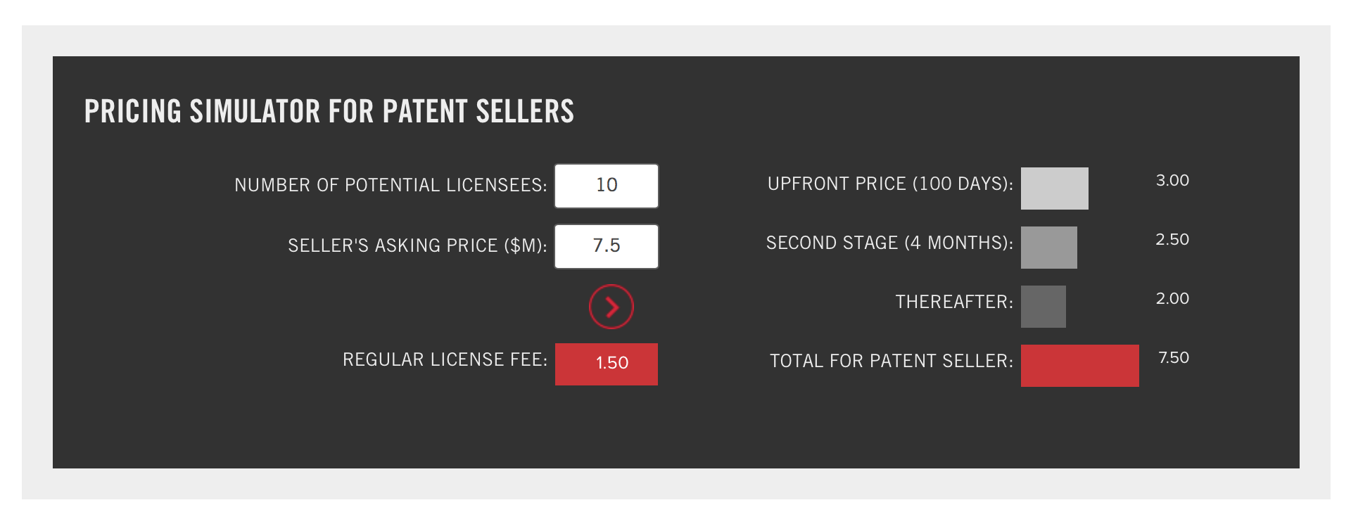

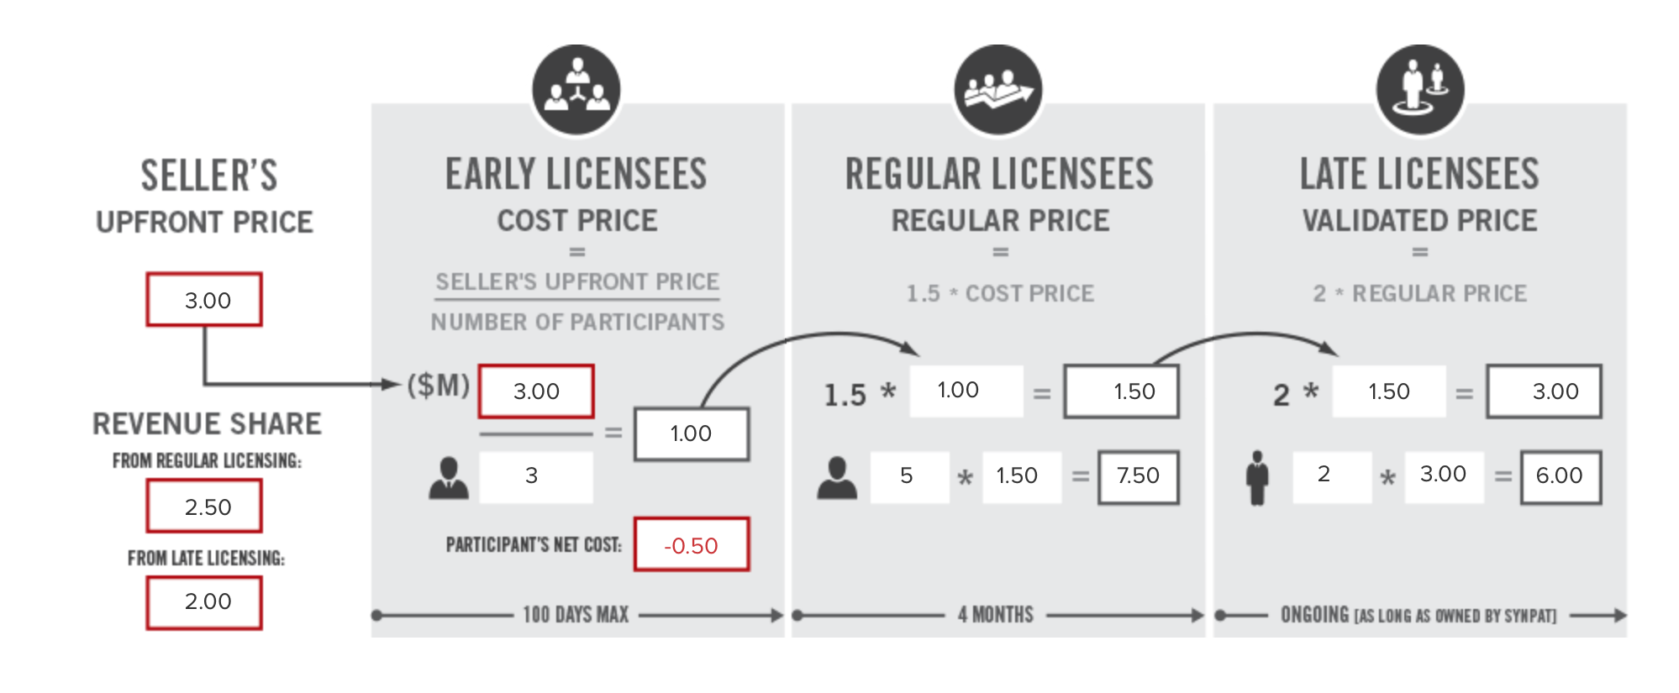

(Source: [www.synpat.com/patentees](http://www.synpat.com/patentees))

**TERM SHEET**

**for the**

**SynPat Open Licensing Program**

***Non-Binding - subject to NDA***

Acquisition of _Patents ___ Patents; _July___, 2015

The purpose of this non-binding Term Sheet is to facilitate discussions between Syndicated Patent Acquisitions Corp. (“SynPat”) and ____EDWIN A HERNANDEZ__ (“Seller”) concerning the possible acquisition of certain of Seller’s patents by SynPat. A binding purchase commitment can only result from the execution of a mutually satisfactory Patent Purchase Agreement (“PPA”) between SynPat and Seller that incorporates the terms of this Term Sheet, except as such terms may be modified by mutual agreement.

WHEREAS, Seller owns certain Patents (as hereinafter defined) related to ___ Rapid Mobility Network Emulator and System (US 7,231,330)__ and is willing to sell the Patents to SynPat; and

WHEREAS, SynPat is interested in purchasing the Patents from Seller pursuant to SynPat’s analysis indicating that acquisition of the Patents for SynPat’s Open Licensing Program would allow more than ten (10) operating companies to obtain licenses under the Patents if offered for a regular license price of approximately $__1,500,000__, and therefore SynPat is willing to fund and execute a 100-day due diligence process to validate its analysis; and

WHEREAS, within the due diligence period, Seller may solicit sale of the Patents to others but may not sell, transfer or otherwise encumber the Patents; and

WHEREAS, the Parties are willing to engage in sale of the Patents according to the terms and conditions set forth herein.

**Term:**

If within 100 days from signing the PPA, SynPat does not inform Seller that the due diligence was completed successfully, the PPA will expire.

**Acquisition:**

The rights to the Patents will be conveyed from Seller to SynPat in two steps:

1. Upon SynPat’s notice to Seller that the due diligence was completed successfully, SynPat will be conveyed the exclusive right to grant licenses under the Patents.
2. Within 7 days from SynPat’s notice of successful due diligence, Seller will be paid $____3,000,000____ (the “Upfront Price”), and upon such payment, SynPat will be conveyed all other rights including title to the Patents (the “Closing”).

In addition to the Upfront Price, Seller will receive from SynPat one-third (1/3) of any amount received by SynPat during the Regular and the Risk Averse licensing stages, and also from any sale of the Patents (“Royalty Payments”).

**Cost Licensing:**

During the 100-day diligence period, SynPat will offer operating companies to join an ad-hoc syndicate to fund the Upfront Price and to receive from SynPat:

* a non-exclusive license under the Patents, and
* an option to acquire exclusive rights to sub-license a designated third party of their choice, and
* an amount equal to the Royalty Payments, which will be equally divided among the accepting companies (“Participants”).

Each Participant will pay directly to Seller an amount equal to the Upfront Price divided by the number of accepting companies (“Cost Price”).

In the event the addressable market is less responsive than expected and does not timely react to the opportunity to fund the acquisition, SynPat may decide to include funds from financial sources.

**Regular Licensing:**

During the four (4) month period following the Closing (“Regular Licensing”), SynPat will offer licenses under the Patents at 50% markup on top of the Cost Price, i.e, at a price equal to 1.5 x Cost Price (“Regular Price”).

**Risk Averse Licensing:**

After the four (4) month Regular Licensing stage (“Risk Averse Licensing”), SynPat will offer licenses under the Patents at a premium price, equal to twice the Regular Price (“Validated Price”), reflecting the market’s acknowledgment and validation of the Patents.

**Sale:**

During the Risk Averse Licensing stage, SynPat will be permitted to sell the Patents, and the Patents might be asserted against “free riders” (companies to whom SynPat presents evidence of clear infringement, and yet, despite the offered opportunities to acquire a license under the Patents, such companies disregard the offers without challenging the evidence of use against them).

Seller is entitled to mandate *a priori* that after such a sale of the Patents by SynPat, the Patents will not be asserted against free riders or any designated companies.

**Confidentiality:**

The terms included herein are deemed confidential and subject to the Non-Disclosure Agreement in existence between SynPat and Seller.

**EXAMPLE**

The following example demonstrates a typical scenario where the agreed Upfront Price is $7.5M and an addressable market of 10 licensees divided as follows:

* In first 100 days: 30% of the market (3 Participants) will share a $3M Upfront Price, each pays $1M.
* Within 4 months thereafter: 50% of the market (5 Regular Licensees) will acquire licenses at $1.5M each.
* Thereafter: 20% of the market (2 Risk Averse Licensees) will acquire licenses at $3M each.
* The total amount paid to Seller is $7.5M.
* The total license cost for each Participant is negative $500K (a free license + $500K return)





(Source: [www.synpat.com/patentees](http://www.synpat.com/patentees))