<https://edit.yahoo.com/forgot?stage=fe140&ea=gr9N8THEb1X4CD4ruWUeQJYlvSQQ0IfgPlHE5a0h4vyH.7xWgfBnL9_SQSQVWpM5OJKfo_KEGcW0a9pxZ6Zx48X1oO6lN_uIwPnnzd0JZgbKia2Hrb7OYT0pboJVnBnNruacZ1stwR1qrXI_Nd3wRe8Eu7S00r8jbbkgqorvshHJV8qYx5Y-&intl=us&partner=reg&done=https%3A%2F%2Fmail.yahoo.com>

<https://edit.yahoo.com/forgot?stage=fe140&ea=gr9N8THEb1X4CD4ruWUeQJYlvSQQ0IfgPlHE5a0h4vyH.7xWgfBnL9_SQSQVWpM5OJKfo_KEGcW0a9pxZ6Zx48X1oO6lN_uIwPnnzd0JZgbKia2Hrb7OYT0pboJVnBnNruacZ1stwR1qrXI_Nd3wRe8Eu7S00r8jbbkgqorvshHJV8qYx5Y-&intl=us&partner=reg&done=https%3A%2F%2Fmail.yahoo.c>

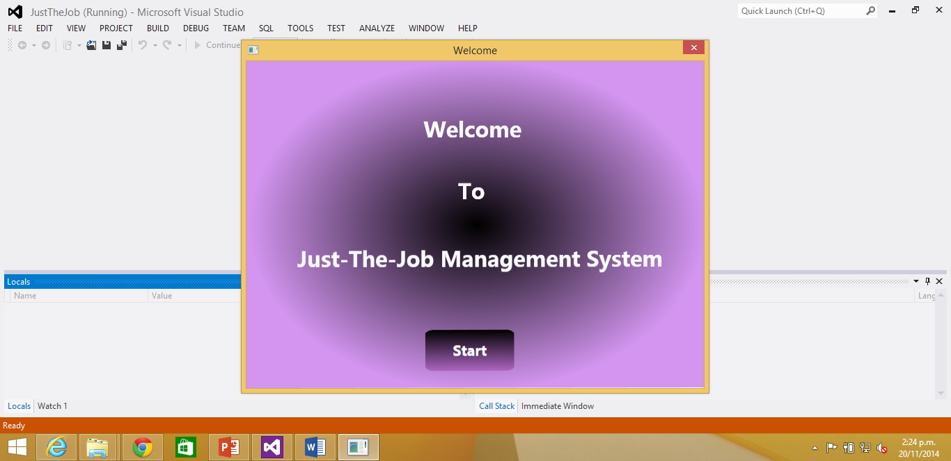om

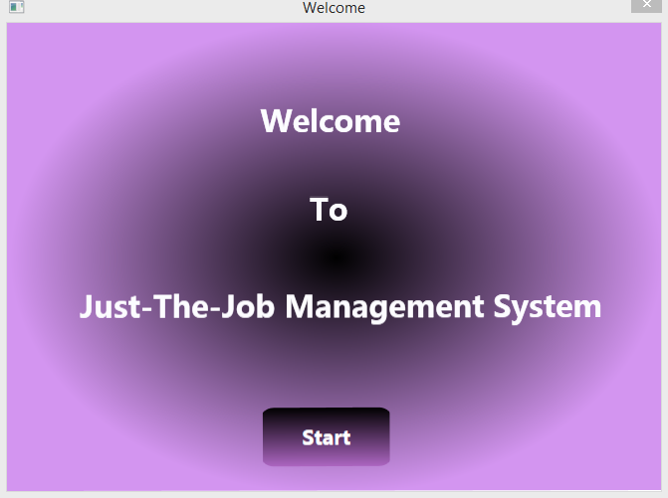

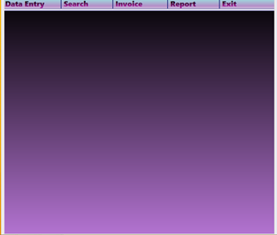

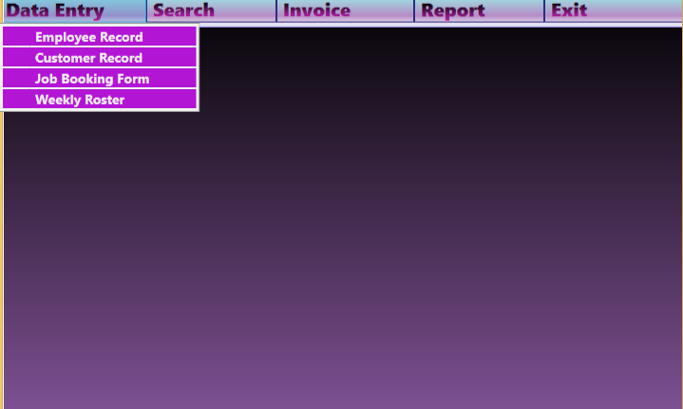

Texture PowerPoint Templates

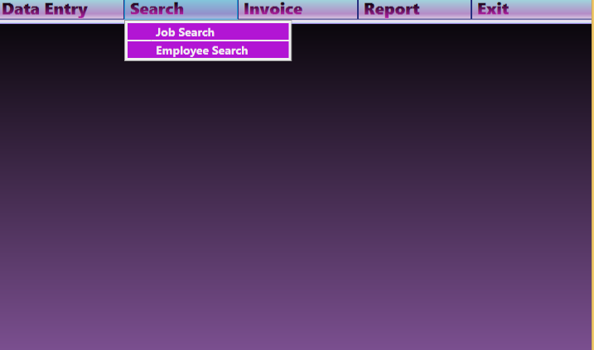

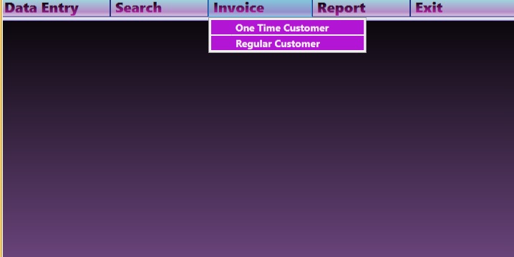

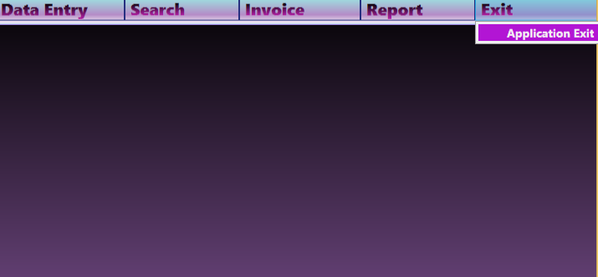

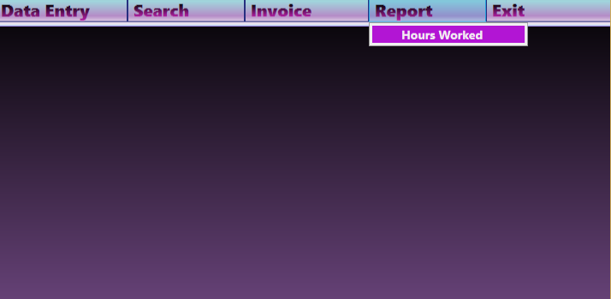

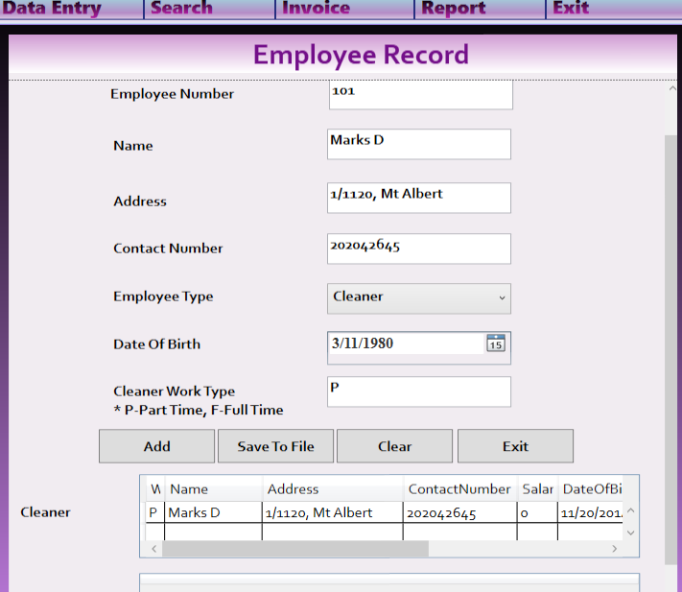

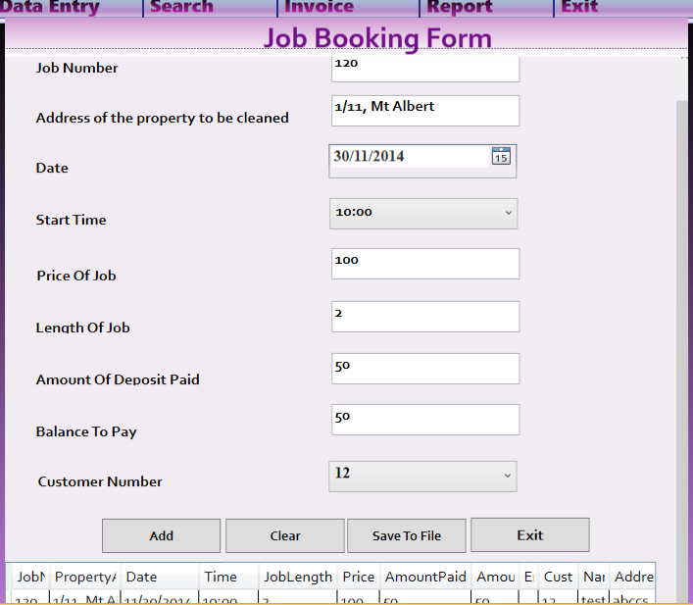

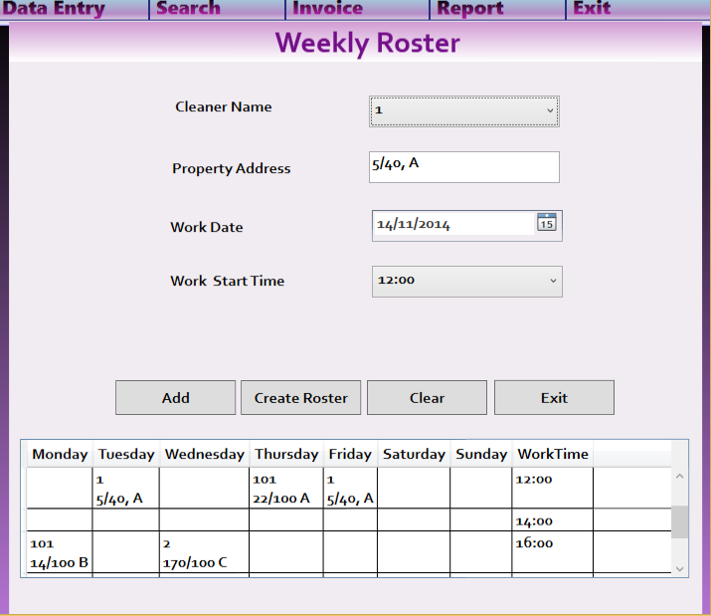

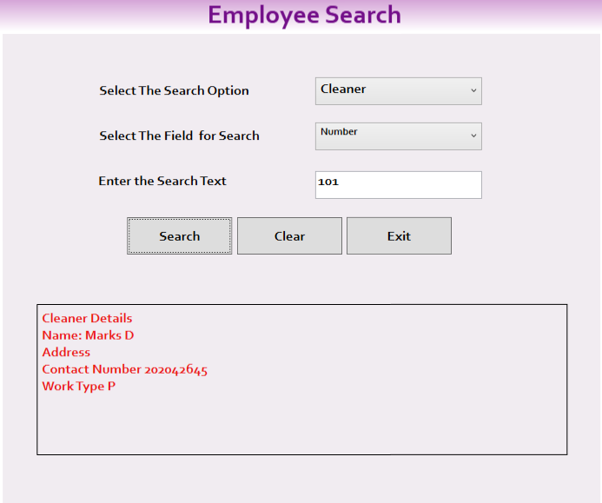

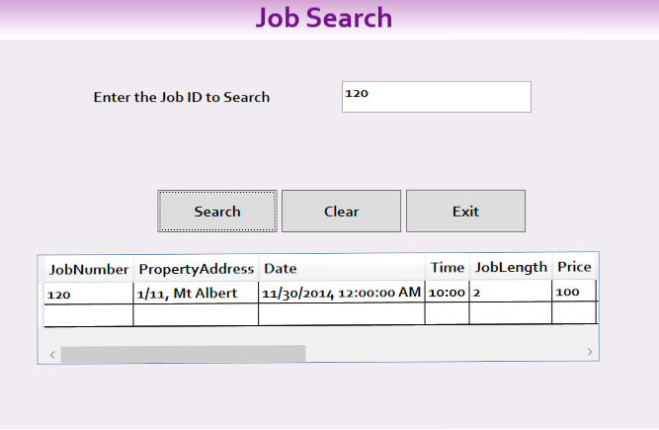

(Fonua, Classes and Objects Model Lecture 10, 2014)

(Fonua, Inheritance Lecture 9, 2014)

(Fonua, Classes and Objects Model Lecture 10, 2014)

(Fonua, Classes and Objects Model Lecture 10, 2014)

(Fonua, Encapsulation and Collection Lecture8, 2014)

(Robinson, 2014)

(Leung, 2014)

# References

Fonua, H. H. (2014, Oct). Classes and Objects Model Lecture 10. Auckland, NZ.

Fonua, H. H. (2014). Encapsulation and Collection Lecture8. Auckland, NZ.

Fonua, H. H. (2014, Oct). Inheritance Lecture 9. Auckland, NZ.

Leung, T. (2014). Creating Reports. In T. Leung, *Visual Studio Lightswitch 2012.* Apress. Retrieved from msdn.microsoft.com: http://msdn.microsoft.com/en-us/library/ms252067.aspx

Robinson, S. (2014). File and Registry Operations. In *Professional C#.* Wiley Publishing Inc.

