OXFORD BROOKES UNIVERSITY
School of Technology

P00801: E-Business Information Systems
(Semester 2, 2010/2011)

Lecture 6: E-Business Modelling with UML

Sample Answers to Practical Exercise Questions

1. The following is a narrative description of the business process of organisation of conferences with regards to the submitting, reviewing and accepting papers.

The author completes an online form that requests the user to input author name, correspondence address, email and, title of paper. The system validates this data and, if correct, asks the author to submit the paper. The author then browses to find the correct paper on their system and submits it. Once received and stored, the system returns to the author a reference number for the paper. Authors may submit as many papers as they like to be considered for acceptance to the conference up until the deadline date for submissions. Papers are allocated to referees for assessment. They review each paper and submit to the system their decision. Once the programme organiser has agreed the decisions authors are informed by email. Accepted papers are then schedule to be delivered at a conference. This involves allocating a date, time and place for the presentation of the paper.

1.1 Analyse the above text and then draw a use case diagram using an UML modelling tool such as StarUML.

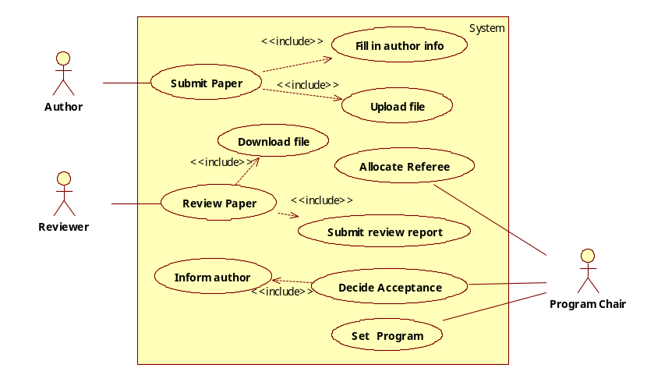
SAMPLE ANSWER:

1.2. Derive an activity diagram from the narrative text by following the steps outlined below.
- Translate the above narrative text into an activity list. An activity list consists of a sequences of short sentences in the form of
name + verb + noun [+ condition],
where the condition is optional. Such sentences are called activities. For example, the following is an activity.
‘the author completes an online form’.
- Transform each activity in the list into an activity/action node of the activity diagram;
- Identify the actors involved in the business process, and associate the actors to each action/activity node;
- Identify the sequential execution order, parallelism/concurrency and synchronisation as well between the actions/activities, and draw the control flows between the action/activity nodes, add synchronisation bar as necessary;
- Draw a swimlane for each actor and place the action/activity nodes in appropriate swimlane;
- Identify the objects passed between the activities, and add object nodes and object flows into the diagram.

SAMPLE ANSWER:
(1) The activity list is given below.
- The system requests the user to input author name, correspondence address, email and, title of paper if the date is before the deadline.
- The author completes an online form that contains the data.
- The system validates this data.
- The system asks the author to submit the paper, if the data is correct.
- The author browses their system.
- The author find the correct paper on their system.
- The author submits the paper.
- The system receives the paper.
- The system stores the paper.
- The system assigns a reference number for the paper.
- The system returns the reference number to the author.
- The author goes back to activity 4) if they want to submit another paper.
- System allocates papers to referees for assessment.
- Referee reviews each paper.
- Referee submits their assessments to the system.
- The programme organiser make decisions on each paper’s acceptance.
- The system emails the author of each paper of the decision.
- The system creates a schedule for delivering accepted papers at a conference by allocating a date, time and place for the presentation of each paper.
(2) The action/activity nodes are marked on the activity list as bold font.
(3) The actors are the name part of the activities.
(4) In this exercise, the actions are all sequentially ordered as in the activity list. The parallelism and concurrency only occur in the form of different referees can perform their reviews and assessments in parallel.
(5) The actors are:
(a) Author; (b) The system; (c) Referee; (d) Conference programme organiser;
(6) The objects involved in this process are:
(a) online form; (b) paper; (c) paper’s reference number; (d) assessment report;
(e) decision; (f) conference schudel.
The derived activity diagram is given below.

Complete online form
Request user input
Validate online form
Ask for submission
Browse system
Find paper
Submit paper
Receive paper
Store paper
Assign reference number
Return reference number
Allocate to referee
Review paper
Submit assessment
Make decision
Email decision
Create schedule
Online form
Online form
Paper
Reference number
Paper
Assessment report
Decisions
Schedule
Author
System
Referee
Organiser
More paper

1.3. Review the activity diagram to identify information missing in the narrative text.

SAMPLE ANSWER:
There are a number problems that can be found and improved in the examination of the activity diagram.
First, what if a validation action fails? Such as if the online form is not valid, what action(s) should be taken? The diagram is incomplete on this issue.
Second, if an action/activity involves two participants, the duality principle of task analysis developed in HCI theory requires each participant to have a corresponding action/activity. For example, the submission of an online form to the system is an action of the author. It requires the system to take the action of receiving an online form. In the narrative text, this duality is often taken for granted, thus usually not given explicitly. Therefore, it is not represented in the activity diagram as derived by following the above steps. Consequently, the diagram is incomplete. Therefore, more action(s)/activities should be added into the diagram. These problems are because that the diagram is directly translated from the narrative text.

2. The following is a use case description of the examination paper preparation support system. Draw a UML activity diagram according to the description.
Use case name: submit question
Participant: lecturer
Entry conditions:
- The question is ready and stored in a file
- The lecturer is assigned to the module
Exit conditions:
- The file is uploaded to the system
- The module leader is notified of the availability of the question
- The event is logged by the system
Flow of Events:
- The lecturer logs into the system by entering his/her username and password;
- The system checks the username and password;
- The system displays the list of modules of which he/she is the lecturer, module leader and/or internal examiner;
- The lecturer selects a module and his/her role in the module as a lecturer;
- The system prompts the user to enter the file name and location on his/her computer, and additional information if any;
- The lecturer enters file name and location, and types in the additional information;
- The lecturer submits the questions and the file is uploaded to the system;
- The system saves the file;
- The system confirms the success of uploading the file.
- The system notifies the module leader of the submission of the questions.
Exceptional conditions and alternative flow of events:
When the username and password is not correct:
3.1: display error message, go back to step 1;
When the lecturer is not listed on the module:
4.1: quit the system;
Special requirements:
- The file should be encrypted when transmitted from lecturer’s computer to the server
- The notification of success in uploading the file should be within 20 seconds
- The event should be recorded in a log file to contain the following information:
  - name of the lecturer,
  - date and time of the event,
  - the name of the event (upload exam question),
  - the file on the server that stores the questions.

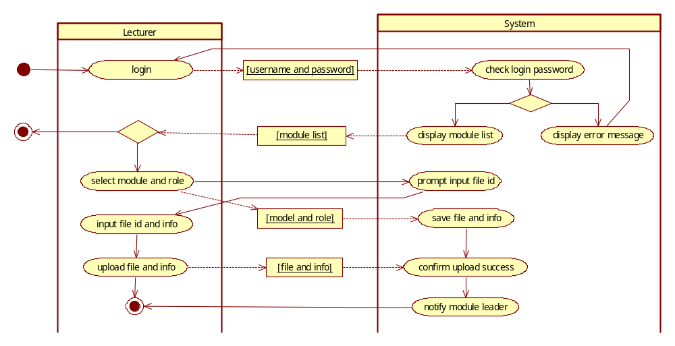
SAMPLE ANSWER:

3. The following is the use case description of using ATM machine to withdraw money from a bank account. Draw a UML activity diagram according to the description.

Name of use case: Withdraw money from bank account
Actors: Customer: A customer is client of the bank who has an account. A customer can deposit and withdraw money to his/her account by using an ATM machine, and make queries of the balance on his/her account.
Entry condition:
- The customer has a cash card of the account, which records the account number.
- The ATM machine is in the state of ‘Ready to Serve’.
Exit condition:
- The customer has obtained the money as he/she required and the balance of the account is updated.
Flow of events:
- The customer inserts the card into the ATM machine;
- The ATM machine reads the account number recorded on the card;
- The ATM machine request the bank’s service computer to check card validity;
- The bank’s server confirms the validity;
- The ATM machine prompt the client to input PIN;
- The customer enters PIN;
- The ATM machine sends the PIN to the bank’s server to check if the PIN is correct.
- The bank’s server confirms the PIN is correct;
- The ATM machine prompts the customer to select a service from ‘Withdraw cash’, ‘Request Statement’ and ‘Balance Query’.
- The customer selects ‘Withdraw cash’.
- The ATM machine send a message to the bank’s server to request send the amount of money available to withdraw;
- The Sever sends the ATM machine the amount available to withdraw.
- The ATM machine displays the amount available and prompts the customer to enter the amount required.
- If the amount is less than or equals to the amount available, the ATM machine returns the card.
- The customer takes the card.
- The ATM machine dispatches the cash.
- The customer takes the cash.
- The ATM machine sends a message to the bank’s server to report the completion of the transaction.
- The ATM returns the state ‘Ready to Serve’ the next customer.
Exceptions and alternative flow of events
- The card is invalid:
4.1. (1) The bank’s server replies the ATM with a message that the card is invalid.
(2) The ATM display a message on the screen to inform the customer that the card is invalid.
(3) The ATM machine returns the card to the customer.
(4) The system returns to the state of ‘Ready to Serve’ to the next customer.
- The PIN number that the customer entered is incorrect:
8.1. (1) The banks server replies that the PIN is incorrect;
(2) The ATM machine displays a message on the screen to inform that the PIN is incorrect;
(3) Back to step 5.
- The required amount is greater than the amount available:
14.1. (1) The system displays a message that the amount is not available;
(2) Back to step 13.
- The customer does not take card for 15 second:
15.1 (1) The ATM machine takes the card display a message to the customer that he/she can get the card back from his/her bank branch.
(2) The system returns to the state of ‘Ready to Serve’ the next customer.

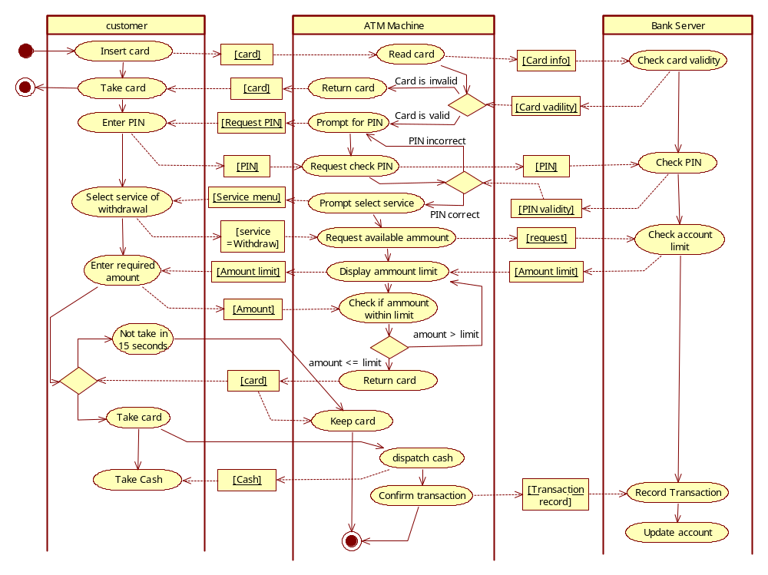
SAMPLE ANSWER:

4. The following are description of systems. Draw a UML class diagram to represent the structural model for each of them.
4.1. A university offers a number of degree programmes, which are classified into BSc (Hons) degree programme, MSc degree program and PhD degree programme. To teach students in various programmes, the university runs a number of course modules. A particular module could be acceptable to a program, or compulsory to a program, or not acceptable at all to the programme. Each BSc (Hons) degree programme contains a number of modules as acceptable or compulsory, which are classified into stage I modules, advanced modules and honours modules. For a student who studies a BSc (Hons) degree programme, in order to obtain the degree he/she must complete a study plan that consists of at least 8 stage I modules, 16 advanced/honours modules and 4 honours modules that are acceptable to the programme.

SAMPLE ANSWER:
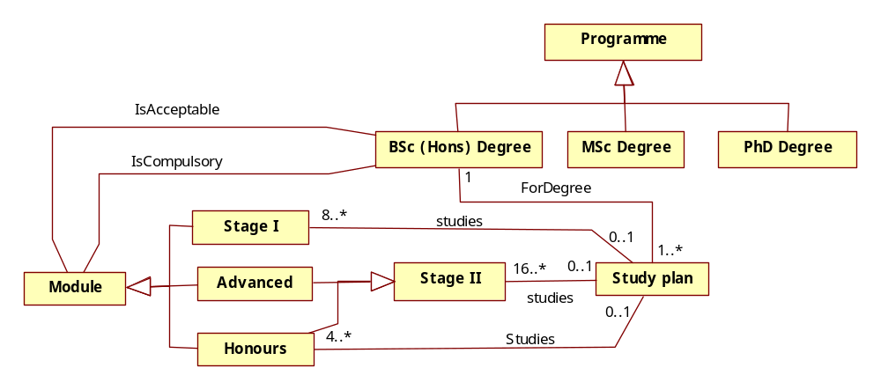
4.2. A hotel has a number of rooms that can be rent by guests. There are also a number of bathrooms, which are either connected to a specific room or are used to service multiple rooms on the floor. The rooms are classified into three types: single rooms, double rooms and family rooms. Each single room can only be rent to at most one guest. Each double room can be rent to at most two guests. Each family room can be rent to a family of up to two adults and two children.

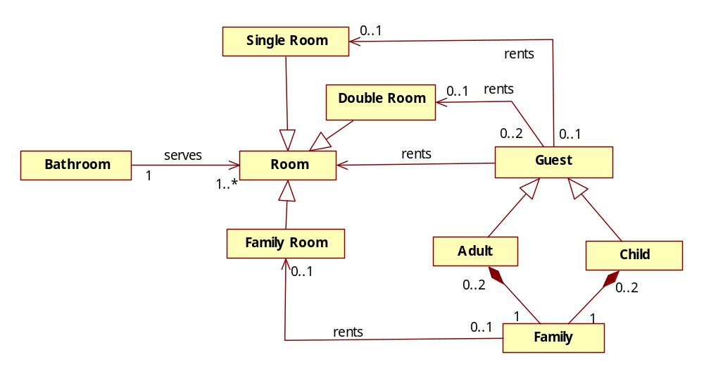
SAMPLE ANSWER:

