How to create a hybrid PDF file
- First, create your document in LibreOffice. You can open any format LibreOffice supports.
- Now, from the File menu, select Export as PDF...
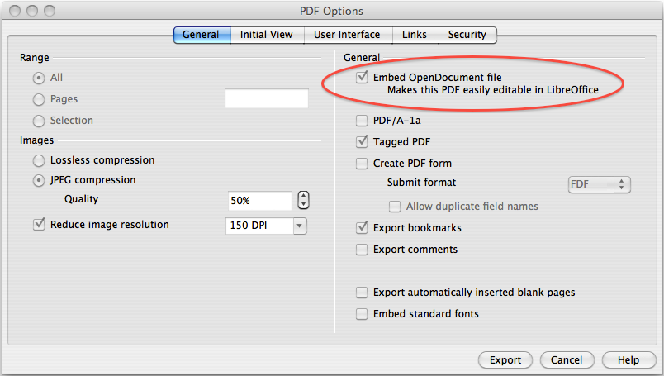
- Check the check-box at the top on the right, “Embed OpenDocument file”
- You may also want to change some other settings – if you wish to retain image resolution for example.
- Click Export and complete the save process.
- The PDF you just made will open as normal in PDF readers but will be editable if opened in LibreOffice (or OpenOffice.org, NeoOffice and others). Try dragging and dropping the file on the title bar.
- Now all PDF files you make in LibreOffice will be hybrids until you uncheck that check-box.

This PDF is itself a hybrid PDF – try dragging it to LibreOffice! For more information, read the ComputerWorldUK article about editable PDFs.

© 2012 Simon Phipps, licensed under CC-BY-SA

