What is a hybrid PDF file?
It's a PDF that anyone can view, but which includes the source document embedded within it so that people with modern office suites can also edit it if they want to.

How to create a hybrid PDF file
- First, create your document in LibreOffice. You can open any format LibreOffice supports.
- Now, from the File menu, select Export as PDF...
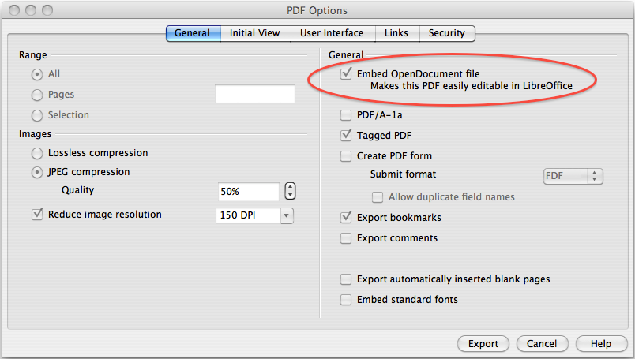
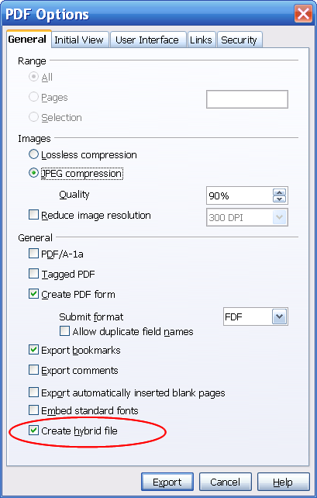
- Check the check-box to ask for the editable ODF file to be inserted into the PDF you are making. The Windows and Mac dialogs are shown above with the option circled.
- You may also want to change some other settings – if you wish to retain image resolution for example. Remember, large images make large files!
- Click the Export button and complete the save process that it causes.
- Congratulations! You just made a hybrid PDF!
- The PDF you just made will open as normal in PDF readers but will be editable if opened in LibreOffice (or OpenOffice.org, NeoOffice and others), including via drag-and-drop.
- Now all PDF files you make in LibreOffice will be hybrids until you uncheck that check-box.

This PDF is itself a hybrid PDF – try dragging it to LibreOffice! For more information, read the ComputerWorldUK article about editable PDFs. There's also a video tutorial available.

Text & Mac screenshot © 2012 Simon Phipps, licensed under CC-BY-SA
Windows screenshot © 2012 Paul Hutchinson, licensed under CC-BY-SA

This capability also exists in recent releases of OpenOffice.org and NeoOffice.
To open Hybrid PDFs, your copy of LibreOffice or OpenOffice.org will need to have the PDF Import filters installed. These are included by default in current downloads of LibreOffice, but you may have to install manually on copies obtained in other ways, such as from Ubuntu default installs. On Ubuntu, look for a package called libreoffice-pdfimport

