Instructions for Dialogue-2022 Proceedings
Author 1  Affiliation / Address line 1  Affiliation / Address line 2  Affiliation / Address line 3  email@domain | Author 2  Affiliation / Address line 1  Affiliation / Address line 2  Affiliation / Address line 3  email@domain
Abstract
This document contains the instructions for preparing a paper submitted to DIALOGUE-2022 or accepted for publication in its proceedings. The document itself conforms to its own specifications, and is therefore an example of what your manuscript should look like. These instructions should be used for both papers submitted for review and for final versions of accepted papers. Authors are asked to conform to all the directions reported in this document.
Keywords: kw1; kw2; kw3; kw4
DOI: 10.28995/2075-7182-2021-20-XX-XX
Инструкция для конференции Диалог 2022
Автор 1  Аффилиация / адресная строка 1  Аффилиация / адресная строка 2  Аффилиация / адресная строка 3  email@domain | Автор 2  Аффилиация / адресная строка 1  Аффилиация / адресная строка 2  Аффилиация / адресная строка 3  email@domain
Аннотация
Данный документ содержит инструкции по подготовке доклада, представленного на конференции ДИАЛОГ 2022 или принятого к публикации в его сборнике. Сам документ соответствует своим собственным спецификациям и, следовательно, является примером того, как должна выглядеть ваша рукопись. Эти инструкции следует использовать как для статей, представленных на рецензирование, так и для окончательных версий принятых статей. Авторов просят соблюдать все указания, указанные в этом документе.
Ключевые слова: кс1; кс2; кс3; кс4
- Credits
This document has been adapted by Serge Sharoff from the instructions for COLING-2020 proceedings compiled by Fei Liu and Liang Huang, which are, in turn, based on the instructions for COLING-2018 proceedings compiled by Xiaodan Zhu and Zhiyuan Liu, which are, in turn, based on the instructions for COLING-2016 proceedings compiled by Hitoshi Isahara and Masao Utiyama, which are, in turn, based on the instructions for COLING-2014 proceedings compiled by Joachim Wagner, Liadh Kelly and Lorraine Goeuriot, which are, in turn, based on the instructions for earlier ACL proceedings, including those for ACL-2014 by Alexander Koller and Yusuke Miyao, those for ACL-2012 by Maggie Li and Michael White, those for ACL-2010 by Jing-Shing Chang and Philipp Koehn, those for ACL-2008 by Johanna D. Moore, Simone Teufel, James Allan, and Sadaoki Furui, those for ACL-2005 by Hwee Tou Ng and Kemal Oflazer, those for ACL-2002 by Eugene Charniak and Dekang Lin, and earlier ACL and EACL formats. Those versions were written by several people, including John Chen, Henry S. Thompson and Donald Walker. Additional elements were taken from the formatting instructions of the International Joint Conference on Artificial Intelligence.
- Introduction
The following instructions are directed to authors of papers submitted to DIALOGUE-2021 or accepted for publication in its proceedings. All authors are required to adhere to these specifications. Authors are required to provide a Portable Document Format (PDF) version of their papers. The proceedings are designed for printing on A4 paper.
- General Instructions
Manuscripts must be in single-column format. Type single-spaced. Start all pages directly under the top margin. See the guidelines later regarding formatting the first page. The lengths of manuscripts should not exceed the maximum page limit described in Section 4. Do not number the pages.
  - Electronically-available Resources
We strongly prefer that you prepare your PDF files using LaTeX with the official DIALOGUE-2021 style file (DIALOGUE2020.sty). These files are available in DIALOGUE2021.zip at http://DIALOGUE2020.org/.
You can alternatively use Microsoft Word to produce your PDF file. In this case, we strongly recommend the use of the Word template file (Dialogue2021.dotx) in DIALOGUE2021.zip. If you have an option, we recommend that you use the LATEX2e version. If you will be using the Microsoft Word template, you must anonymize your source file so that the pdf produced does not retain your identity. This can be done by removing any personal information from your source document properties.
  - Format of Electronic Manuscript
For the production of the electronic manuscript you must use Adobe's Portable Document Format (PDF). PDF files are usually produced from LATEX using the pdflatex command. It is also possible to use xelatex, if the use of the full range of UTF8 characters is important for your paper.
If your version of LATEX produces Postscript files, you can convert these into PDF using ps2pdf or dvipdf. On Windows, you can also use Adobe Distiller to generate PDF.
Please make sure that your PDF file includes all the necessary fonts (especially tree diagrams, symbols, and fonts for non-Latin characters). When you print or create the PDF file, there is usually an option in your printer setup to include none, all or just non-standard fonts. Please make sure that you select the option of including ALL the fonts. Before sending it, test your PDF by printing it from a computer different from the one where it was created. Moreover, some word processors may generate very large PDF files, where each page is rendered as an image. Such images may reproduce poorly. In this case, try alternative ways to obtain the PDF. One way on some systems is to install a driver for a postscript printer, send your document to the printer specifying “Output to a file”, then convert the file to PDF.
It is of utmost importance to specify the A4 format (21 cm x 29.7 cm) when formatting the paper. When working with dvips, for instance, one should specify -t a4.
If you cannot meet the above requirements for the production of your electronic submission, please contact the publication co-chairs as soon as possible.
  - Layout
Format manuscripts with a single column to a page, in the manner these instructions are formatted. The exact dimensions for a page on A4 paper are:
- Left and right margins: 2.5 cm
- Top margin: 2.5 cm
- Bottom margin: 2.5 cm
- Width: 16.0 cm
- Height: 24.7 cm
Papers should not be submitted on any other paper size. If you cannot meet the above requirements for the production of your electronic submission, please contact the publication co-chairs above as soon as possible.
  - Fonts
For reasons of uniformity, Adobe's Times Roman font should be used. In LATEX2e this is accomplished by putting
\usepackage{times}
\usepackage{latexsym}
in the preamble. If Times Roman is unavailable, use Computer Modern Roman (LATEX2e's default). Note that the latter is about 10% less dense than Adobe's Times Roman font.
The Times New Roman font, which is configured for us in the Microsoft Word template (Dialogue2021.dotx) and which some Linux distributions offer for installation, can be used as well.

Type of Text | Font Size | Style
paper title | 15 pt | bold
author names | 12 pt | bold
author affiliation | 12 pt
the word “Abstract” | 12 pt | bold
section titles | 12 pt | bold
document text | 11 pt
captions | 11 pt
sub-captions | 9 pt
abstract text | 9 pt
bibliography | 10 pt
footnotes | 9 pt
Table 1: Font guide
  - The First Page
Centre the title, author's name(s) and affiliation(s) across the page. Do not use footnotes for affiliations. Do not include the paper ID number assigned during the submission process. Do not include the authors’ names or affiliations in the version submitted for review.
Title: Place the title centred at the top of the first page, in a 15 pt bold font. (For a complete guide to font sizes and styles, see Table 1.) Long titles should be typed on two lines without a blank line intervening. Approximately, put the title at 5.0 cm from the top of the page, followed by a blank line, then the author's names(s), and the affiliation on the following line. Do not use only initials for given names (middle initials are allowed). Do not format surnames in all capitals (e.g., use “Schlangen” not “SCHLANGEN”). Do not format title and section headings in all capitals as well except for proper names (such as “BLEU”) that are conventionally in all capitals. The affiliation should contain the author's complete address, and if possible, an electronic mail address. Start the body of the first page 7.5 cm from the top of the page.
The title, author names and addresses should be completely identical to those entered to the electronical paper submission website in order to maintain the consistency of author information among all publications of the conference. If they are different, the publication co-chairs may resolve the difference without consulting with you; so it is in your own interest to double-check that the information is consistent.
Abstract: Type the abstract between addresses and main body. The width of the abstract text should be smaller than main body by about 0.6 cm on each side. Centre the word Abstract in a 9 pt bold font above the body of the abstract. The abstract should be a concise summary of the general thesis and conclusions of the paper. It should be no longer than 200 words. The abstract text should be in 9 pt font.
Text: Begin typing the main body of the text immediately after the abstract, observing the single-column format as shown in the present document. Do not include page numbers.
Indent when starting a new paragraph. Use 11 pt for text and subsection headings, 12 pt for section headings and 15 pt for the title.
Licence: Include a licence statement as an unmarked (unnumbered) footnote on the first page of the final, camera-ready paper.
Examples: for linguistic examples please use the covington package:
- Dit is een voorbeeldje in het Nederlands.
This is a little example in Dutch.
‘This is a little example in Dutch.’
  - Sections
Headings: Type and label section and subsection headings in the style shown on the present document. Use numbered sections (Arabic numerals) in order to facilitate cross references. Number subsections with the section number and the subsection number separated by a dot, in Arabic numerals. Do not number subsubsections.
Please do not use anonymous citations and do not include any of the following when submitting your paper for review: acknowledgements, project names, grant numbers, and names or URLs of resources or tools that have only been made publicly available in the last 3 weeks or are about to be made public and would compromise the anonymity of the submission. Papers that do not conform to these requirements may be rejected without review. These details can, however, be included in the camera-ready, final paper.
In LaTex, for an anonymized submission, ensure that \DIALOGUEfinalcopy at the top of this document is commented out. For a camera-ready submission, ensure that \DIALOGUEfinalcopy at the top of this document is not commented out.
References: Gather the full set of references together under the heading References; place the section before any Appendices, unless they contain references. Use of full names for authors rather than initials is preferred.
The Bibtex style files provided follow the Russian GOST referencing format. In particular, please use these examples for your Bibtex references:
- Example citing an article in a journal: [1].
- Example citing an article in proceedings: [2].
- Example citing an arxiv paper: [3].
- Example citing a publication in Russian [4]
Appendices: Appendices, if any, directly follow the text and the references (but see above). Letter them in sequence and provide an informative title: Appendix A. Title of Appendix.
  - Footnotes
Footnotes: Put footnotes at the bottom of the page and use 9 pt text. They may be numbered or referred to by asterisks or other symbols. Footnotes should be separated from the text by a line.
  - Graphics
Illustrations: Place figures, tables, and photographs in the paper near where they are first discussed, rather than at the end, if possible.
Captions: Provide a caption for every illustration; number each one sequentially in the form: “Figure 1: Caption of the Figure.” “Table 1: Caption of the Table.” Type the captions of the figures and tables below the body, using 11 pt text.
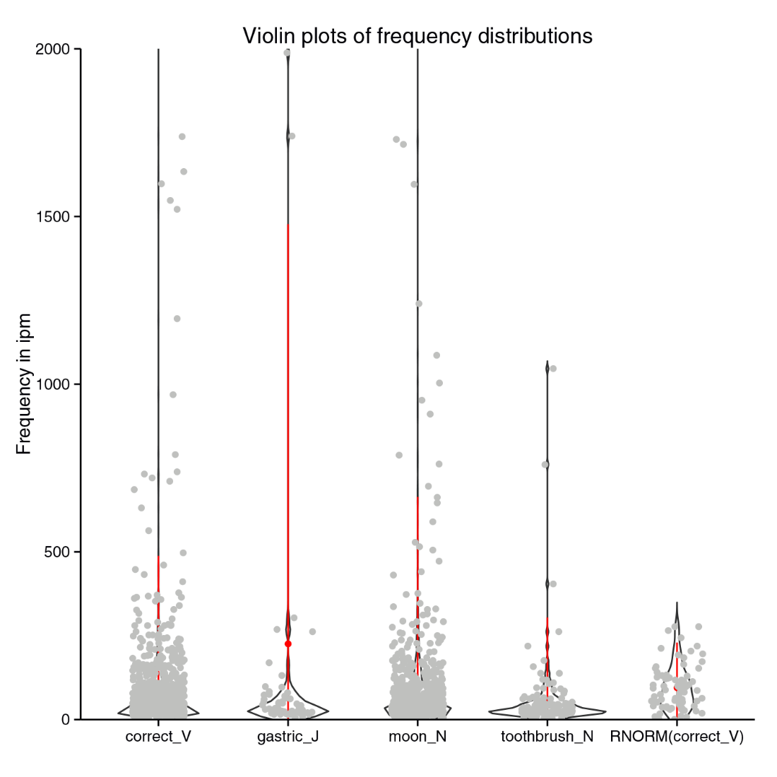
Figure 1: Example of a figure environment
Narrow graphics together with the single-column format may lead to large empty spaces, see for example the wide margins on both sides of Table 1. If you have multiple graphics with related content, it may be preferable to combine them in one graphic. You can identify the sub-graphics with sub-captions below the sub-graphics numbered (a), (b), (c) etc. and using 9 pt text. The LaTeX packages wrapfig, subfig, subtable and/or subcaption may be useful.
- Length of Submission
The length of the text without an abstract and bibliography should not exceed 20,000 characters (including spaces). Authors of accepted papers will be given additional space in the camera-ready version to reflect space needed for changes stemming from reviewer’s comments.
Papers that do not conform to the specified length and formatting requirements may be rejected without review.
Acknowledgements
The acknowledgements should go immediately before the references. Do not number the acknowledgements section. Do not include this section when submitting your paper for review.
References
- Aho Alfred V., Ullman Jeffrey D. The Theory of Parsing, Translation and Compiling. — Englewood Cliffs, NJ : Prentice-Hall, 1972. — Vol. 1.
- Borschinger Benjamin, Johnson Mark et al. A particle filter algorithm for Bayesian wordsegmentation // Proceedings of the Australasian Language Technology Association Workshop 2011. — Canberra, Australia, 2011. — P. 10–18.
- Rasooli Mohammad Sadegh, Tetreault Joel R. Yara Parser: A Fast and Accurate Dependency Parser // Computing Research Repository. — 2015. — Vol. arXiv:1503.06733. — version 2. Access mode: http://arxiv.org/abs/1503.06733.
- Zaliznyak A.A., Mikaelyan I.L. (2006), Emailing as a linguistic object [Perepiska po elektronnoy pochte kak lingvisticheskiy ob"ekt], Computational Linguistics and Intellectual Technologies: Proceedings of the International Conference “Dialog 2006” [Komp’yuternaya Lingvistika i Intellektual’nye Tekhnologii: Trudy Mezhdunarodnoy Konferentsii “Dialog 2006”], Bekasovo, pp.157–162.
- Zagurenko A.G., Korotovskih V.A., Kolesnikov A.A., Timonov A.V., Kardymon D.V. (2008), Techno-economic optimization of the design of hydraulic fracturing [Tekhniko-ekonomicheskaya optimizatsiya dizayna gidrorazryva plasta], Oil Industry [Neftyanoe hozyaystvo], Vol. 11, pp. 54–57.
References
- Aho Alfred V., Ullman Jeffrey D. The Theory of Parsing, Translation and Compiling. — Englewood Cliffs, NJ : Prentice-Hall, 1972. — Vol. 1.
- Borschinger Benjamin, Johnson Mark et al. A particle filter algorithm for Bayesian wordsegmentation // Proceedings of the Australasian Language Technology Association Workshop 2011. — Canberra, Australia, 2011. — P. 10–18.
- Rasooli Mohammad Sadegh, Tetreault Joel R. Yara Parser: A Fast and Accurate Dependency Parser // Computing Research Repository. — 2015. — Vol. arXiv:1503.06733. — version 2. Access mode: http://arxiv.org/abs/1503.06733.
- Ляшевская О. Н., Шаров С. А. Частотный словарь современного русского языка. — Москва : Азбуковник, 2009.

This is how a footnote should appear.
Note the line separating the footnotes from the text.
References, Scopus version
References, РИНЦ version

