Chapter 7
Genome Rearrangement

In this chapter, we shall discuss the problem of genome rearrangement. The term genome refers to all of the genes. In a species, there are a large number of genes and the ordering of the genes is hugely important. Since we are interested in the order of genes, we label each gene a unique number. This number can be unsigned. If a label of a gene is signed, for instance –5, it means that this gene is the reverse of another gene, which is labeled as 5.

To compare two genomes, we often find that these two genomes contain the same set of genes. But the order of the genes is different in different genomes. For example, it was found that both human X chromosome and mouse X chromosome contain eight genes which are identical. They are labeled as 1, 2, …, 8. In human, the genes are ordered as

4, 6, 1, 7, 2, 3, 5, 8

and in mouse, they are ordered as

1, 2, 3, 4, 5, 6, 7, 8.

Similarly, it was found that a set of genes are in cabbage as

1, –5, 4, -3, 2

and in turnip, they are ordered as

1, 2, 3, 4, 5.

The comparison of two genomes is significant because it provides us some insight as to how far away genetically these species are. If two genomes are similar to each other, they are genetically close; otherwise they are not. The question is how we measure the similarity of two genomes. Essentially, we measure the similarity of two genomes by measuring how easy it is to transform one genome to another by some operations. In this chapter, we shall introduce two operations, namely transposition and reversal.

Since we are transforming a sequence of numbers into another sequence, without losing generality, we may always assume that the target sequence is 1, 2, …, n. A reversal inverts the order of a substring of any length, and a transposition swaps two adjacent substrings of any length without changing the order of two substrings. We will introduce these operations in detail later, and two examples describing two operations are as follows,

A reversal: Genome X: 3 1 5 2 4 → Genome Y: 3 2 5 1 4.
A transposition: Genome X: 3 1 5 2 4 → Genome Y: 3 2 4 1 5.

The similarity between two sequences will be measured by the minimum number of operations to transform a sequence into another. Because the target sequence is always 1, 2, …, n, we may view the problem as a sorting problem. But this is not a usual sorting problem which we are familiar with. Our sorting problem is to sort a sequence in such a way that the number of operations is minimized. In other words, we are interested in finding algorithms which always sort a sequence with minimum number of operations, such as transpositions or reversals.

Example 7.1 An Example of Sorting by Reversal.

Consider a sequence

1 4 5 3 2.

We may sort the above sequence by reversal as follows:

1 4 5 3 2
1 2 3 5 4
1 2 3 4 5.

Example 7.2 An Example of Sorting by Transposition

Let us consider the same sequence in Example 7.1. The sorting by transposition may proceed as follows:

1 4 5 3 2
1 3 2 4 5
1 2 3 4 5.

In the following, we shall first introduce sorting by transposition.

7.1 Definitions and Notations for Sorting by Transposition
We now start to introduce sorting by transposition. First of all, although we are talking about sorting, our input is different from ordinary inputs for sorting. It must satisfy the following conditions:
- The input sequence cannot contain two identical numbers. For instance, it cannot contain two 5’s.
- No negative number may appear in the input sequence. Note that this condition is not required when we discuss sorting by reversal.
- If i and j appear in the sequence and 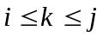, k must appear in the sequence. That is, we do not allow the case where 5 and 7 appear, but 6 does not appear.

In summary, we may simply define our input to be a permutation of 1, 2, …, n. That is, the input genome is represented by a permutation 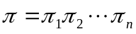. For reasons which will become clear later, we extend the permutation to include 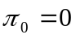 and 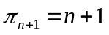. For instance, a typical input permutation is 0 2 4 1 3 5.

For a permutation , a transposition, denoted by 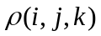 (defined for all 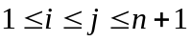 and all 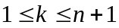 such that 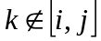), swaps the substrings 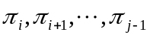 and 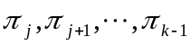 in the permutation. For instance, 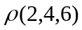 in permutation 0 7 2 3 6 1 5 4 8 swaps substrings (2 3) and (6 1) and results in 0 7 6 1 2 3 5 4 8. Given a permutation and a transposition , the application of to is denoted as 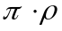.

For all 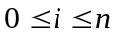 in a permutation, there is a breakpoint between 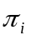 and 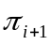 if 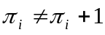. For instance, for a permutation 0 2 3 1 4 5, the permutation with breakpoints added is 0, 2 3, 1, 4 5. A sorted permutation contains no breakpoints. A permutation without breakpoints is called an identity permutation. Consequently, we may say that our job is to sort the input permutation into an identity permutation.

The problem of sorting by transposition is now formally defined as follows: Given two permutation and , the sorting by transposition problem is to find a series of transpositions 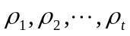 such that 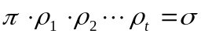 and t is minimum. This t is called the transposition distance between and . As indicated before, without losing generality, we shall assume that is always an identity permutation in the form of 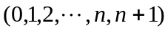. In the following, we will introduce the algorithm for sorting by transposition according to [BP98]. Note that the complexity status of the problem of sorting by transpositions is unknown.

It is perhaps worth pointing out that the sorting by transposition problem is not an ordinary sorting problem. Ordinarily, the job of sorting is simply to sort. But the sorting by transposition problem is not only to sort; its main function is to find the minimum number of transpositions to transform one permutation to the identity permutation. Thus, we may, for clarity, define the sorting for transposition problem as follows: Given a permutation , find the minimum number of steps of transpositions needed to transform to an identity permutation. Thus it is important for a reader to understand that the sorting by transposition problem is an optimization problem.

7.2. Lower Bounds for the Sorting by Transposition Problem

Since the identity permutation is a permutation with 0 breakpoints, sorting a permutation corresponds to decreasing the number of breakpoints. For each transposition, at most 3 breakpoints can be decreased, and therefore, a trivial lower bound is 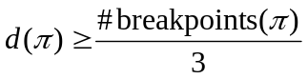.

The above formula gives us a trivial upper bound of sorting by transposition problem.

In [BP98], Bafna and Pevzner introduced the notion of a cycle graph of a permutation, and used the cycle graph to obtain improved lower bounds. A cycle graph of , denoted by 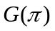, is the directed edge-colored graph with vertex set 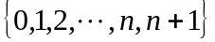 and edge set defined as follows. For all 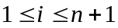, gray edges are directed from i-1 to i and black edges from to 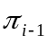. An example of cycle graphs is shown in Fig. 7.2-1.

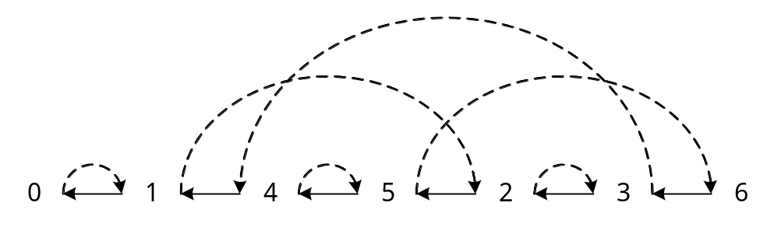
Figure 7.2-1. A cycle graph of a permutation 0 1 4 5 2 3 6

An alternating cycle of a colored graph is a cycle where each pair of adjacent edges are of different colors. For each vertex in , every incoming edge is uniquely paired with an outgoing edge of different color. Hence, the edge set of can be decomposed into alternating cycles. One example for the decomposition of a cycle graph into alternating cycles is shown in Fig. 7.1-2.

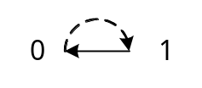, 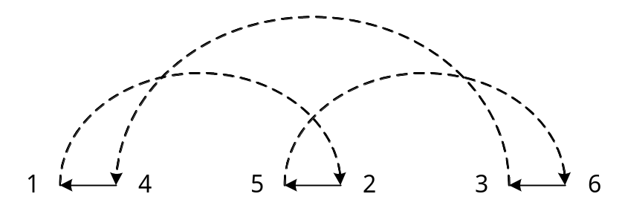, 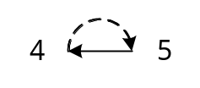 and 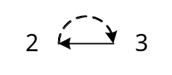.
Figure 7.1-2. The decomposition of a cycle graph into alternating cycles

We use k-cycle to refer to an alternating cycle which contains k numbers of black edges. We say that a 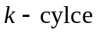 is long if 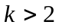, and short otherwise. Two examples about long and short alternating cycles are show in Fig. 7.2-3.

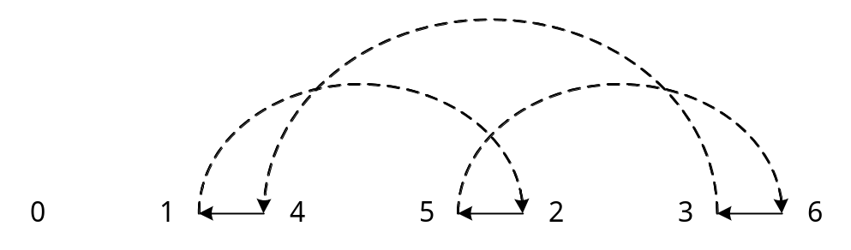
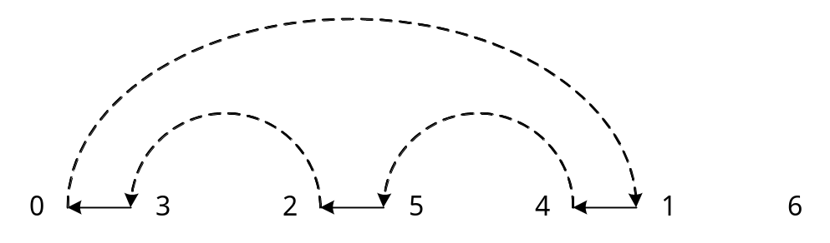
(a)
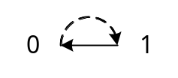
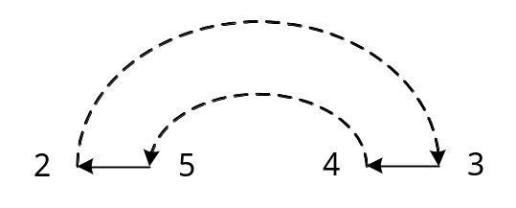
(b)
Figure 7.2-3. Long and short alternating cycles: (a) long alternating cycles, (b) short alternating cycles

In Fig. 7.2-4, we show the cycle graph of an identity permutation.

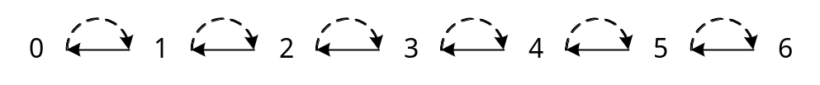
Fig. 7.2-4. The cycle graph of an identity graph

As suggested in Fig. 7.2-4, in an identity permutation, each vertex x points to another vertex y through a gray edge, and vertex y points backwardly to x through a black edge. We call this kind of cycle graphs regular. The sorting by transposition problem is to transform a cycle graph which is not regular into a regular cycle graph.

Since we will be always dealing with alternating cycles, we shall simply call an alternating cycle as a cycle. There are at most 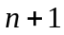 cycles in 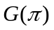, and the only permutation with cycles is the identity permutation. We denote the number of cycle in as 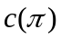 for a permutation . Consequently, the purpose of sorting is increasing the number of cycles from to . We also denote the change in number of cycles due to transposition as 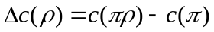 for a permutation .

Let us consider the following permutation:

0 3 4 1 2 5

Suppose we perform a transposition on substrings (3 4) and (1 2) as indicated above, we achieve the following:

0 1 2 3 4 5.

The reader can easily see that the above transposition is quite ideal. The original permutation has three break points. After the transposition, there are no break points. This can be explained by using the alternating cycle diagram. Suppose that the transposition is and suppose its corresponding vertices in involved in the permutation, namely 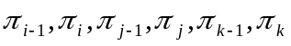 are in one cycle as shown in Fig. 7.2-5.

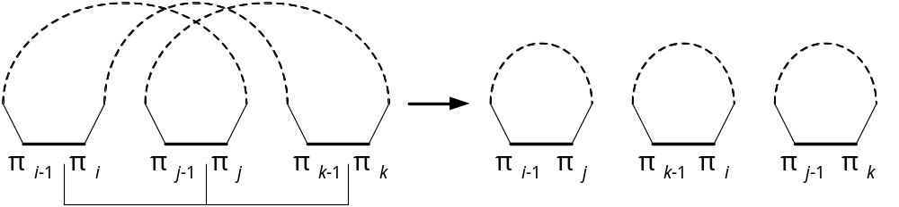
Figure 7-2-5. A special case of transposition with 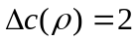

As shown in Fig. 7.2-5, this particular kind of transposition increases the number of cycles by 2. Thus we have a better lower bound 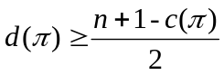. Any sorting by transposition algorithm which produces a transposition distance equal to this lower bound 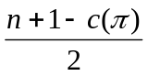 must be an optimal algorithm. Up to now, there is no such algorithm yet. Of course, there is a possibility that the lower bound is not high enough. In the next section, we shall achieve a 2-approximation algorithm

7.3 A 2-Approximation Algorithm for the Sorting by Transposition Problem

The case in Fig. 7.2-5 is a very much desirable one because it is a transposition which increases the number of cycles by 2. Ideally, we hope that there are such kinds of cycles in our permutation at any moment. Unfortunately, this is not true. As a result, we must handle the other cases.

We first assign a number from 1 to to the black edges of , and say that a transposition acts on black edges i, j and k. An example for assigning the number to the black edges is shown in Fig. 7.3-1.

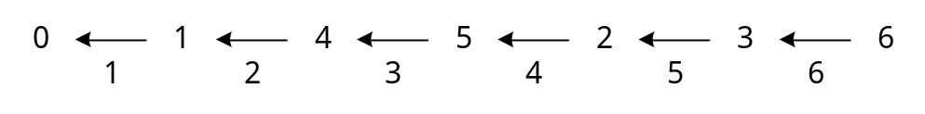
Figure 7.3-1. A permutation with black edges of labeled

Note that a cycle can be represented by 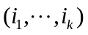 according to the visiting black edges from to , where is the rightmost black edge in the cycle. For instance, there are four alternating cycles in the in Fig. 7.3-2. The rightmost black edge in cycle b is black edge 6, so cycle b is represented as (6, 2, 4).

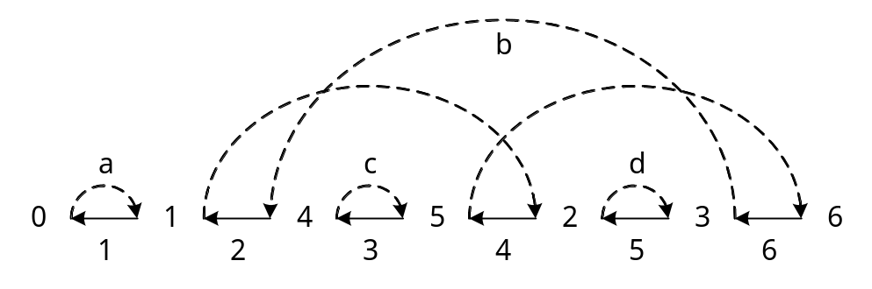
Figure 7.3-2. A permutation with containing four cycles

There are two different kinds of cycles, non-oriented and oriented cycles. For all 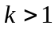, a cycle 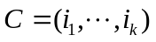 is non-oriented if 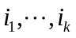 is a decreasing sequence; C is oriented otherwise. Two examples for non-oriented and oriented cycles are shown in Fig. 7.3-3.

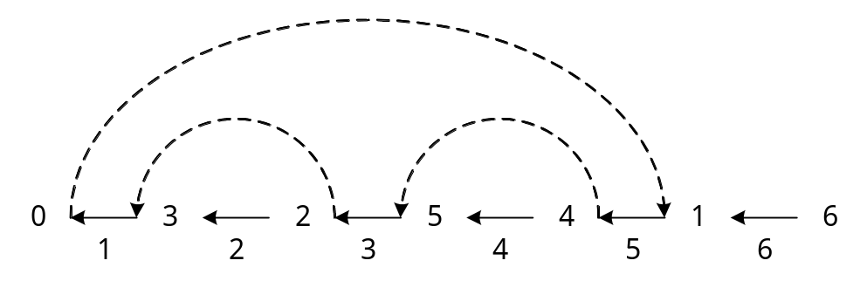
(a)
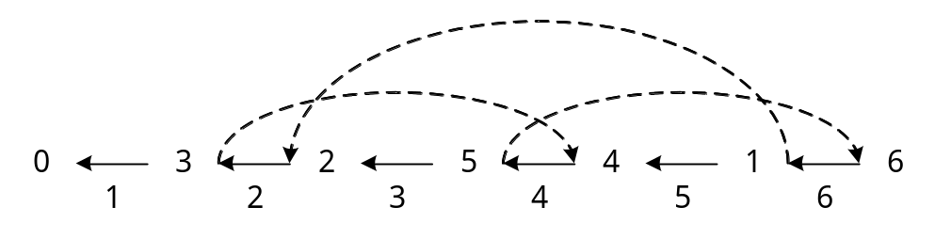
(b)
Figure 7.3-3. Oriented and non-oriented cycles (a) non-oriented cycle (5, 3, 1) (b)oriented cycle (6, 2, 4)

We shall call a transposition as if 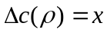. Assume that a cycle is an oriented cycle. We can prove that there exists a in C, 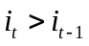, 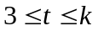 and a transposition ρ( i_{t-1}, i_{t}, i₁ ) such that 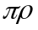 creates a 1-cycle containing vertices 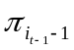 and 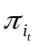 and other cycles. Therefore, ρ is a 2-move transposition. In conclusion, there is a 2-move transposition on every oriented cycle. An example is shown in Fig. 7.3-4. In this example, the input permutation is 0 4 5 1 6 3 2 7. As shown in Fig. 7.3-4(a), there are three cycles. Among them, the cycle (6,1,3,4) is an oriented cycle. As shown in Fig. 7.3-4(a), there is a transposition 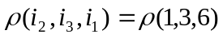. This transposition corresponds to swapping the substrings (4 5) and (1 6 3). After applying this transposition, the permutation becomes 0 1 6 3 4 5 2 7 and there will be 5 cycles. As one can see, the number of cycles is increased by 2.
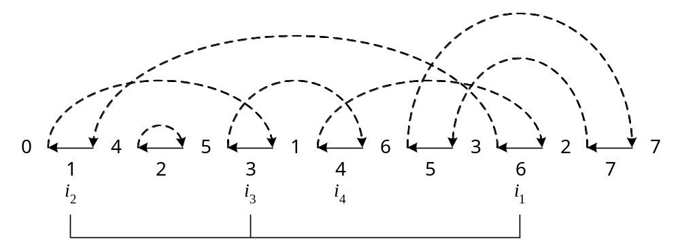
(a) A permutation: 0 4 5 1 6 3 2 7, = 3, an oriented cycle (6, 1, 3, 4) and a transposition 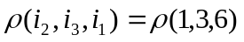

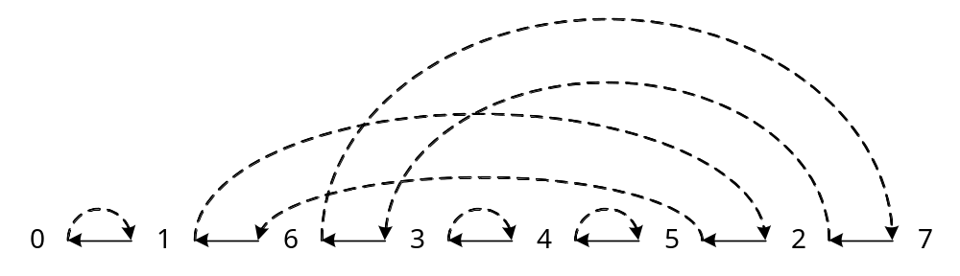
(b) The cycle graph after transposition
Figure 7.3-4. An oriented cycle allowing a 2-move

Consider Fig. 7.3-5(a). Note that there is no oriented cycle in the graph. It can be easily seen that there must exist more than one non-oriented cycle. Assume that a cycle 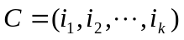 is a non-oriented cycle. Let the position of the maximal element of permutation in the interval 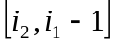 be r, and the position of 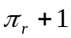in be s. We can show that 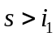 and transposition 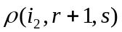is a 0-move which transforms a non-oriented cycle C into an oriented cycle 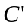 allowing a 2-move. Therefore, there is a 0-move followed by a 2-move on a non-oriented cycle. An example is shown in Fig. 7.3-5.

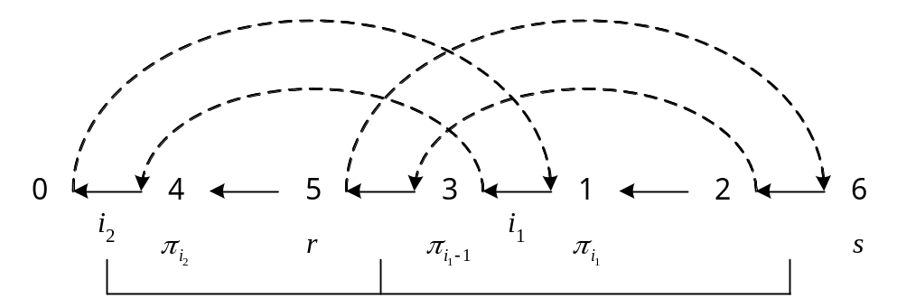
(a)
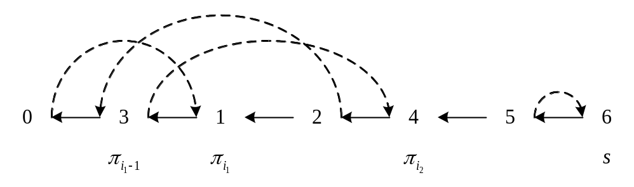
(b)
Figure 7.3-5. A non-oriented cycle allowing 0, 2-moves, (a) A permutation: 0 4 5 3 1 2 6, a non-oriented cycle 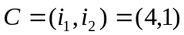, r = 2, s = 6, a transposition ρ(1,3,6), 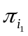 = 1, 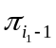 = 3 and 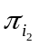 = 4, (b) The cycle graph after the transposition.

From the previous discussion, we can see that for an arbitrary permutation , there exists either a 2-move permutation or a 0-move permutation followed by a 2-move permutation. We thus have obtained an upper bound of the transposition distance. That is 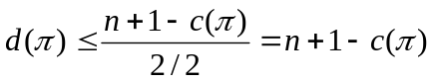 for sorting by transposition. That is, we have an algorithm which can produce a transposition distance not higher than 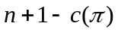.

Because of the lower bound, 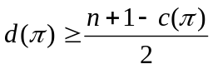, and the upper bound, 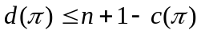, there is an approximation algorithm for sorting by transpositions with performance ratio 2.

2-Approximation Algorithm for Sorting by Transposition
Algorithm 7.1 A 2-approximation algorithm to find an approximation solution for the problem of sorting by transpositions.
Input: Two permutations and
Output: The minimal distance between two permutations and
Step 1: Re-label two permutations for sorting permutation into the identity permutation.
Step 2: Construct the cycle graph of permutation . Let the distance 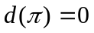.
While there is an oriented cycle
Perform a 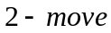, 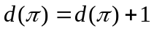
While there is a non-oriented cycle
Perform a 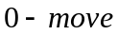 followed by , 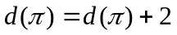
Output the distance 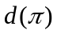

There is an example for the 2-approximation algorithm in Fig. 7.3-6. The algorithm goes as follows:
- Since there is an oriented cycle (6, 1, 3, 4), we perform a transposition ρ(1,3,6) on it. The result is shown in Fig. 7.3-6(c).
- As shown in Fig. 7.3-6(b), no oriented cycle exists in the cycle graph, and there are two non-oriented cycles (6, 2) and (7, 3). We perform transposition ρ(2,3,7) followed by transposition ρ(2,5,6). The result of transposition ρ(2,3,7) is shown in Fig. 7.3-6(d), and the result of applying transposition ρ(2,5,6) is shown in Fig. 7.3-6(e).

The entire process of applying the transpositions is shown as follows:
0 4 5 1 6 3 2 7
- 1 6 3 4 5 2 7
- 1 3 4 5 2 6 7
0 1 2 3 4 5 6 7

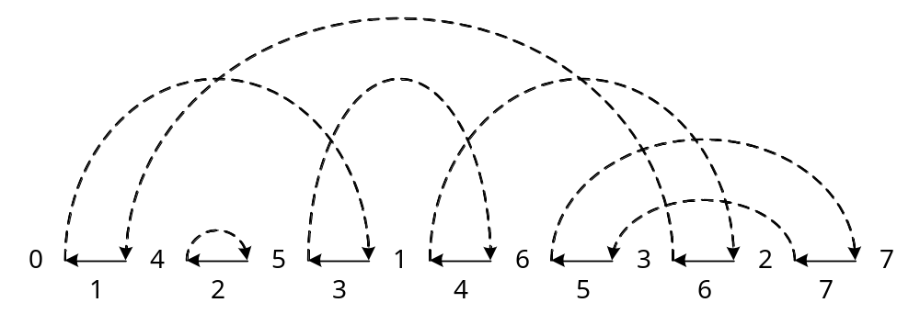
(a)
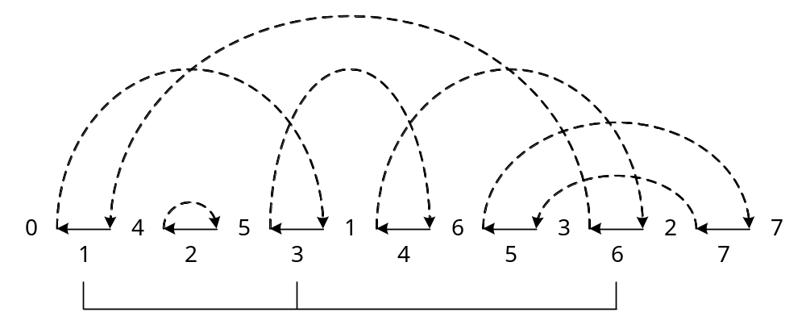
(b)
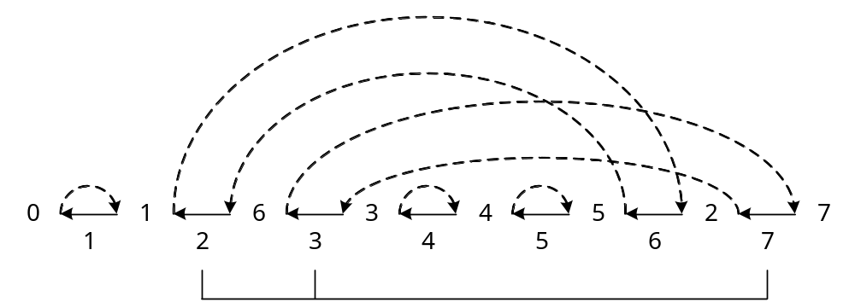
(c)
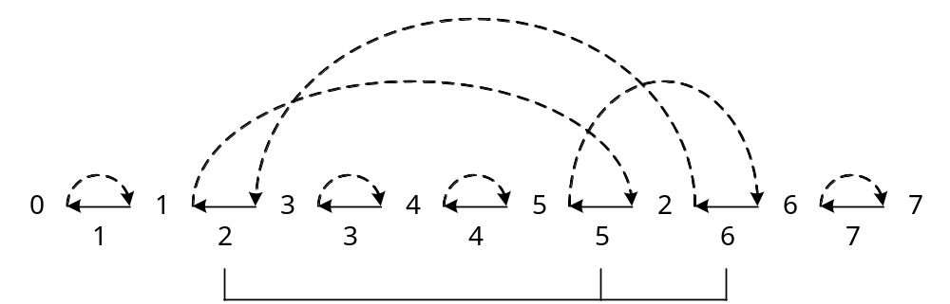
(d)
(e)

Figure 7.3-6. An example for 2-approximation algorithm. (a) The cycle graph of a permutation: 4 5 1 6 3 2, an oriented cycle (6, 1, 3, 4), a cycle (2), and a non-oriented cycle (7, 5). (b) A transposition ρ(1,3,6) for the oriented cycle (6, 1, 3, 4) (c) The cycle graph after a 2-move, two non-oriented cycles (6, 2) and (7, 3), other cycles (1), (4) and (5) and a transposition ρ(2,3,7) for the non-oriented cycle. (d) The cycle graph after (c), an oriented cycle (6, 2, 5), other cycles (1), (3), (4) and (7) and a transposition ρ(2,5,6) acting on the oriented cycle. (e) The final cycle graph after 3 transpositions, a 2-move, a 0-move and a 2-move.

7.4 A 1.75-Approximation Algorithm

In this section, we shall introduce a 1.75-approximation algorithm which was also proposed by Bafna and Pevzner [BP98]. Previously, we measure the performance of an algorithm by the number of cycles increased by the transpositions we perform. The larger number of cycles an average transposition in an algorithm produces, the better this algorithm is because it will more quickly lead to an identity permutation. In this section, we introduce a new term, the odd and even cycles. A cycle is called odd (even) if the number of black edges in this cycle is odd (even). Fig. 7.4-1 shows odd and even cycles.

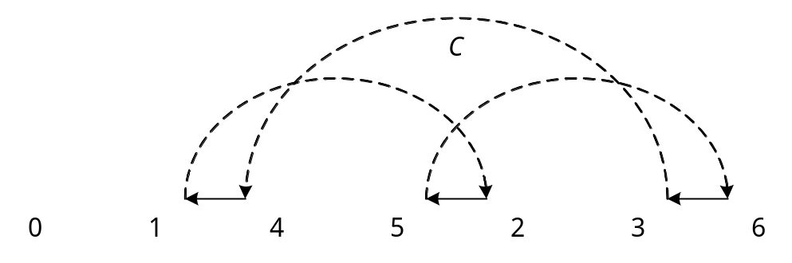

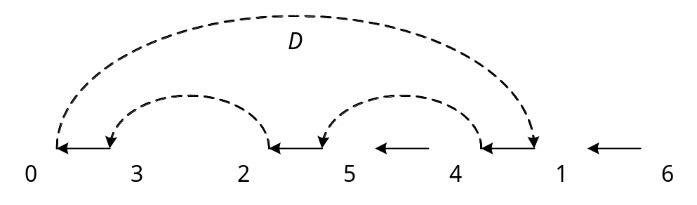
(a)

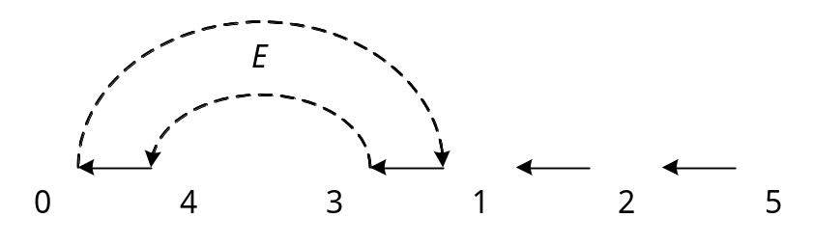
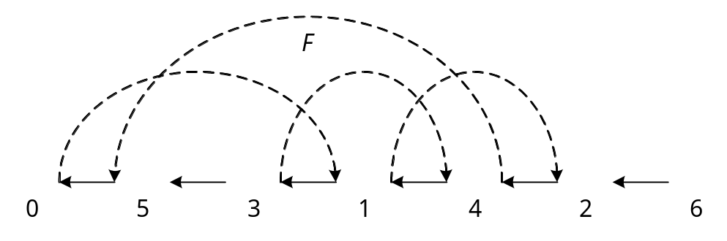
(b)
Fig. 7.4-1: Odd and even cycles (a) Odd cycles, (b) Even cycles.

In the identity permutation with n numbers, there are 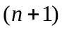 odd cycles. We thus may think that our algorithm increases the number of odd cycles and decreases even cycles until there are odd cycles. Let 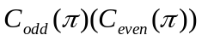denote the number of odd(even) cycles in permutation . Let us define an objective function as follows:

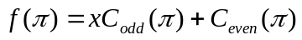. (7.4-1)

where 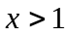.

Let 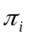 denote the identity permutation. Then,

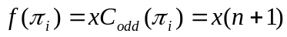 (7.4-2)

For an arbitrary permutation which is not the identity permutation,

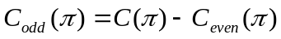 (7.4-3)

Substituting Equation (7.4-3) into Equation (7.4-1), we have

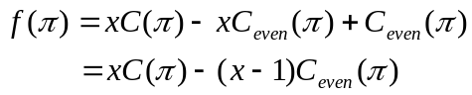 (7.4-4)

Since 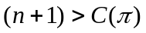, 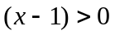 and 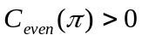, we have

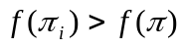. (7.4-5)

Thus, the sorting by transposition may now be considered as a process of maximizing 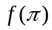.

We shall now present the precise 1.75-approximation algorithm later. In the following, let us first prove the performance ratio is indeed 1.75. As pointed out before, the largest number of cycles that a transposition can produce is 2. Thus

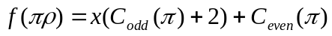 (7.4-6)

Thus the largest gain of is

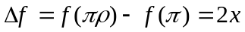. (7.4-7)

In the 1.75-approximation algorithm, we divide the cycles into long cycles and short cycles. For a long cycle, the permutation performed by the approximation algorithm produces four cycles in three consecutive transpositions, and we do not know that four increased cycles are odd or even. In the worst case, each transposition performed on a long cycles increases  even cycles on the average. Thus, 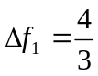. For a short cycle, the transposition of the approximation algorithm increases four odd cycles and decreases two even cycles in two consecutive transpositions. In this case, 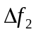 is

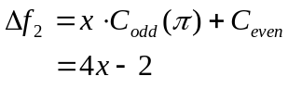

Thus, is 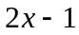 on the average. In the worst case, we have to find 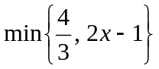. As shown in Fig. 7.4-2, this x can be found by letting 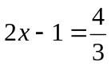 and 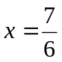. The performance ratio is now found to be

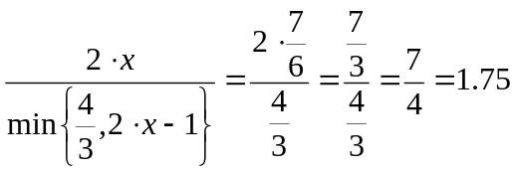 (7.4-8)

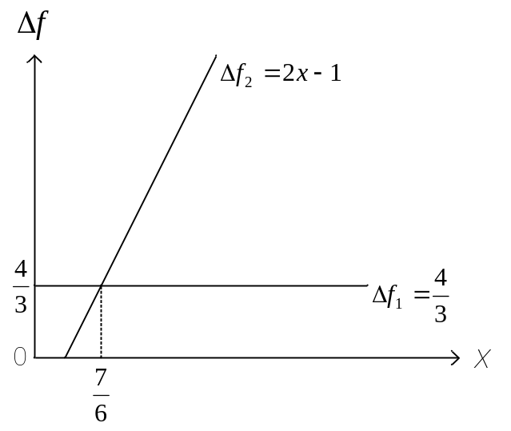
Fig. 7.4-2 The intersection of and .

In the following, we shall show why a permutation on a long cycle can increase four cycles in three consecutive transposition, and on a short cycle can increase two odd cycle and decrease one even cycle on the average. We shall not formally prove this property as it is rather difficult to do so. Instead, we shall illustrate this by examples.

In this approximation algorithm, for a short cycle, we can perform two transpositions which will increase four odd cycles and decrease two even cycles. An example is shown in Fig. 7.4-3. In the permutation, 0 3 2 1 4, there are only two even cycles, (3, 1) and (4, 2). We perform a 0-move transposition ρ(2,3,4) as shown in Fig. 7.4-3(a). This transposition increases two odd cycles and decreases two even cycles as shown in Fig. 7,4-3(b). After this 0-move, the new permutation is 0 3 1 2 4 and there are only two odd cycles, (4, 1, 2) and (3). We further perform a 2-move transposition ρ(1,2,4) which acts on an odd cycle (4, 1, 2) and the result is shown in Fig. 7.4-3-(c). By now, the permutation is sorted and there are four odd cycles, (1), (2), (3) and (4). Thus these two permutations totally increase four odd cycles and decrease two even cycles. Thus, a permutation on a short cycle can increase two odd cycles and decrease one even cycle on the average. We admit that this is only an example. The proof that we can perform such transpositions for every short cycle is rather complicated and beyond the scope of this book.

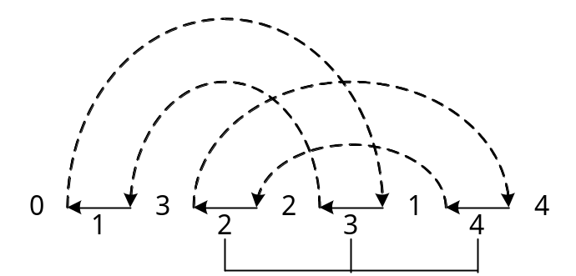
(a)
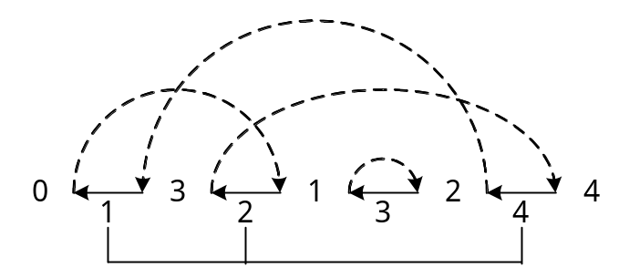
(b)
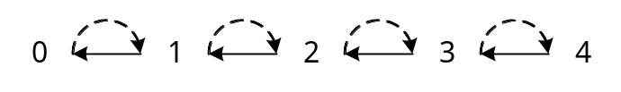
(c)
Fig. 7.4-3 An example for the short cycle: (a) 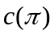 = 2, 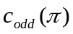 = 0, 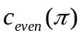 = 2 and a transposition ρ(2,3,4), (b) = 2, = 2, = 0 and a transposition ρ(1,2,4), (c) = 4, = 4 and = 0

For long cycles, 0-2-2-moves can be performed in the 1.75-approximation algorithm. An example is shown in Fig. 7.4-4. In the permutation 0 5 4 3 2 1 6, there are two long cycles, (6, 4, 2) and (5, 3, 1) which are both odd. We first perform a 0-move transposition acting on one of the two long cycles as shown in Fig. 7.4-4(a). After the 0-move ρ(2,4,6), the new permutation is 0 5 2 1 4 3 6, and there are one long odd oriented cycle, (5, 1, 3) and one long non-oriented cycle (6, 4, 2) which is also odd, as shown in Fig. 7.4-4(b). We have not increased the number of odd cycles after this move. Next, we perform a 2-move transposition ρ(1,3,5), which acts on an odd cycle (5, 1, 3) as shown in Fig. 7.4-4(b). This transposition increases two odd cycles as shown in Fig. 7.4-4(c). There are now four odd cycles: (1), (3), (5) and (6, 2, 4). Finally, we perform a 2-move transposition ρ(2,4,6) acting on cycle (6, 2, 4). This transposition again increases two odd cycles and the permutation is now sorted as shown in Fig. 7.4-4(d). Thus there are totally three transpositions which increase four odd cycles during the whole process. Thus, a permutation on a long cycle can increase odd cycles in average.

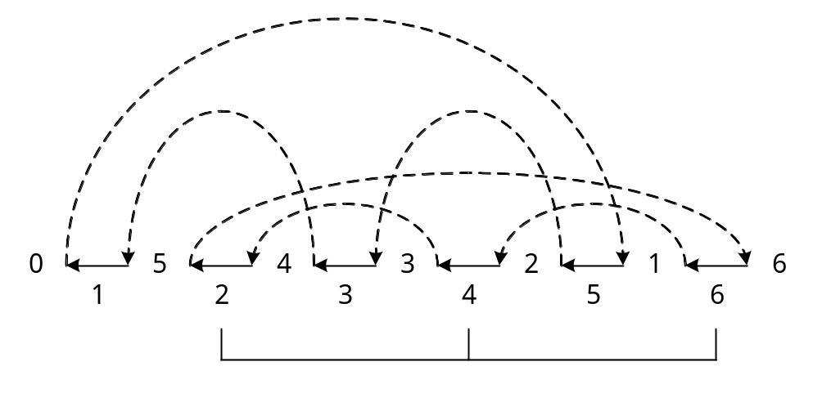
(a)

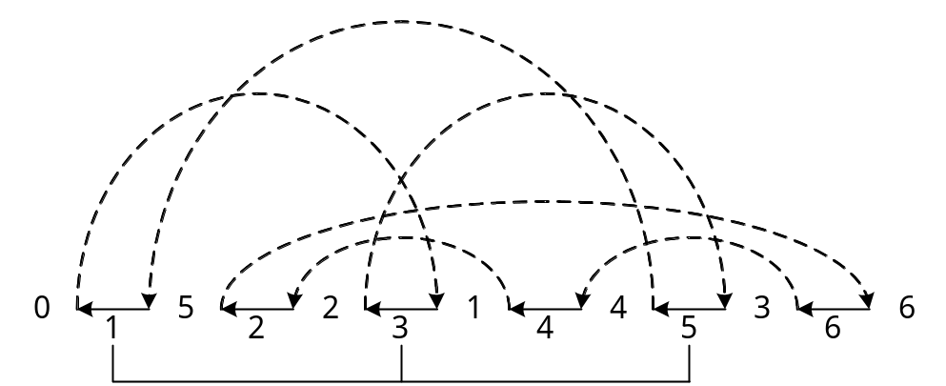
(b)

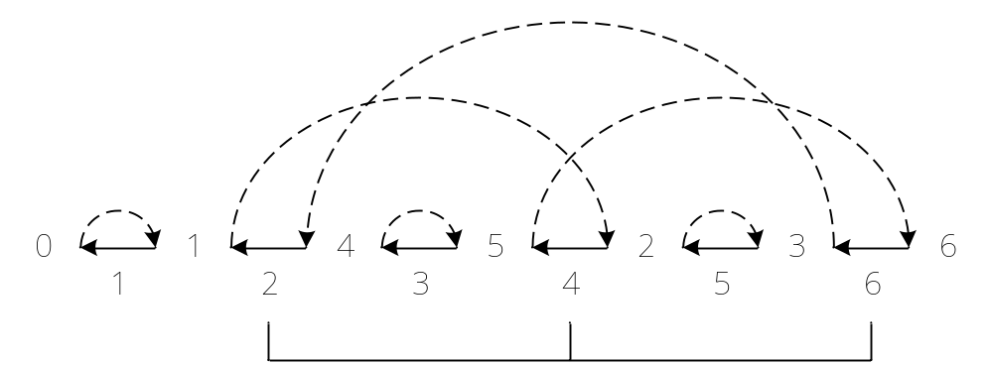
(c)

(d)
Fig. 7.4-4 An example for the long cycle: (a) = 2, = 2, = 0 and a transposition ρ(2,4,6), (b) = 2, = 2, = 0 and a transposition ρ(1,3,5), (c) = 4, = 4, = 0 and a transposition ρ(2,4,6), (d) = 6, = 6 and = 0

We admit that we have not give a formal proof of the properties as claimed above because it is too complicated to do so. We are not going to present the precise 1.75-appximation sorting by transposition algorithm either because, again, it will be very much complicated to describe different transpositions for different cases. We hope that the reader can appreciate the basic spirit of the algorithm.

A 1.5-approximation algorithm was also given by Bafna and Pevzner in [BP98]. We cannot present it as it is even more complicated than the 1.75-approximation algorithm.

