LWIP USER GUIDE

Table of contents

1. Introduction 3
2. Developing a network application with lwIP and VDK 5
2.1. Use the socket API header file 6
2.2. Ensuring that semaphores can be created 6
2.3. Initialize the SSL interrupt and device driver managers 6
2.4. Initialize and set up the kernel api library 6
2.5. Open the device driver for the Ethernet MAC controller 6
2.6. Configure EBIU controller to give DMA priority over processor 7
2.7. Supply the MAC address that it is to be used to the device driver 7
2.8. Supply memory to the Ethernet device driver 7
2.9. Notify the device driver library that the Ethernet driver will use the Dataflow method 8
2.10. Initialize and configure the lwIP stack 8
2.11. Notify the Ethernet driver that it should now start to operate. 8
2.12. Wait for the physical link to be established 8
2.13. lwIP stack shutdown 8
3. lwIP – Multiple Network Interfaces 8
4. The lwIP stack elements 9
5. Building the lwIP stack with custom options 11
5.1. lwIP memory configuration 11
6. TCP/IP Configuration Plugin 12
6.1. The operation of the plugin 13
6.2. Using the plugin 14
6.2.1. General page 14
6.2.2. IP page 16
6.2.3. Network0 page 17
6.2.4. Network1 page 18
6.2.5. TCP/UDP/ARP page 19
6.2.6. Debug page 20
6.2.7. Memory page 21
7. Socket API and other Documentation. 21
8. TCP/IP examples 22
8.1. DNS Client 22
8.2. inetd server 22
8.3. FileServer application 23
8.3.1. FileServer host application 23
8.3.2. FileServer Blackfin example 25
8.4. TCP/IP Tracing 25
8.4.1. Tracing over BTC 27
8.4.2. Tracing over TCP/IP 28
8.4.3. Multicast 28

Introduction

The lwIP TCP/IP stack package on Analog Devices Blackfin family of processors consists of the freely available lwIP stack. The ported stack uses a standardized driver interface to allow it to be used with different Ethernet controllers. The drivers are all implemented as part of the ADI driver model and use the System Services Libraries (SSL).

For more information on lwIP stack visit http://www.sics.se/~adam/lwIP/, the sources for the stack are maintained at http://savannah.nongnu.org/cgi-bin/viewcvs/lwIP/lwIP/

The stack provides the standard BSD socket API to the application and has been structured to decouple it from both the operating environment and the specific network interface being used. The stack is connected to the surrounding environment by means of two standardized interfaces which are implemented as a different library for each separate environment.
lwIP Core Library (liblwIPbf5xxx.dlb
TCPIP Wrapper (tcpipbf5xxx.dlb
Ethernet Peripheral Drivers
(adi_ether_bf537.dlb,lan91c11bf5xxx.dlb)
K
E
R
N
A
L
BSD Socket API
SSL Driver API
Kernel API
Application
lwIP subsystem Architecture

Kernel Abstraction:
The kernel API abstracts the primitive operating system services. The kernel abstraction simplifies the migration of lwIP stack to different operating system environments. The basic services include synchronization services, interrupt services, and timer based callback services. The kervdkbfxxx.dlb libraries provide an implementation of the interface to enable the stack to be used with VDK on the various Blackfin processors. The stack can be used with other kernels by providing an implementation of the kernel API interface for the required kernel and processor.
The kernel API is defined in the document kernel_api.html which is held in the <install_path>\Blackfin\lib\src\lwip\contrib\ports\ADSP-Blackfin\docs\ directory.

Ethernet Driver Abstraction:
The stack can support any Ethernet controller which has a driver that supports the driver interface SMSC_LAN91c111_DeviceDriver.doc specifies the driver interface for SMSC LAN91c111 and BF537EthernetDeviceDriverdesign.doc has the design details about BF537 Ethernet driver. These documents were held in the <install_path>\Blackfin\lib\src\lwip\contrib\ports\ADSP-Blackfin\docs\ directory. The interface definition provides a common set of functions that must be provided by each implementation. Each implementation can also provide an extended set of functionality. The stack itself will only use the common functions but application can take advantage of the extended functions. Available for use with the stack are implementations of the driver interface for various network cards/boards including
  - The Blackfin BF526/27 Ethernet MAC controller
  - The Blackfin BF537 Ethernet MAC controller
  - The Blackfin USBLAN EZ-Extender card which uses the SMSC LAN91C111 Ethernet controller
  - The Blackfin BF548 EZ-kit with SMSC LAN9218 Ethernet controller

VisualDSP++ provides a wizard which will create a VDK project with TCP/IP support built in and ready to use. The standard BSD sockets API is the main programming interface that the stack provides to the application. The details of the socket interface can be accessed by opening the file index.html which is in the <install_path>>\Blackfin\lib\src\lwip\contrib\ports\ADSP-Blackfin\docs\socket-api directory.

The configuration of the stack can be effected using a supplied VisualDSP plugin that will generate a tailored header file and an initialised C structure that the stack uses. The plugin allows the main configuration parameters to be modified. Alternatively the stack can be fully configured by modifying the standard lwIP header files manually.

Support is also provided to allow the tracing of frames sent and received by the stack either directly on the Blackfin processor or to a host based application using a TCP/IP connection or the Background Telemetry Channel.

The stack supports the following protocols
TCP | Transport Control Protocol
UDP | User Datagram Protocol
IP | Internet Protocol
ICMP | Internet Control Message Protocol
IGMP | Internet Group Management Protocol
ARP | Address Resolution Protocol
DHCP | Dynamic Host Configuration Protocol (DHCP client supporting BOOTP)
One of the principal aims when porting the stack was to minimize the changes that were required to be made to the sources of the actual lwIP stack to enable subsequent stack updates to be integrated easily. The main changes that were made are outlined below
- Base memory allocation was changed from static arrays to enable it to be dynamically allocated when the stack was being initialized.
- The procedure used to set per thread socket errors
- Added an additional field to some structures to ensure correct alignment

All of the changes made to the stack are under the control of the pre-processor variable __ADSPBLACKFIN__.

The sources for the lwIP stack are provided under a BSD style license whose terms are included in the VisualDSP++ license terms.

Developing a network application with lwIP and VDK
The simplest way of creating an application that uses the lwIP stack is to use the project creation wizard and select the project type as “TCP/IP Stack application using LwIP and VDK”. The created project will incorporate everything needed for the stack and will also create a boot thread that will take the necessary steps to initialize the stack and the drivers that it may need.

It is possible to add support for the stack to an existing VDK application and the steps needed to do this are described below. The code generated by the project wizard can be incorporated into an existing application to simplify integrating support.

An application that wishes to use the lwIP stack with VDK is responsible for creating a VDK thread type that the lwIP stack will use to create any threads that it requires during operation. The application also has to initialize some System Service Library components as well as creating an instance of the driver for the appropriate Ethernet controller.

The steps involved in creating an application that uses the lwIP stack can be summarized as:
- Specifying and using the header file for the socket API
- Ensure that sufficient VDK semaphores are configured
- Initialize the SSL interrupt and device driver managers
- Initialize and set up the kernel api library
- Open the device driver for the Ethernet MAC controller and pass the handle for the driver to the lwIP stack
- Configure EBIU controller to give DMA priority over processor
- Supply the MAC address that it is to be used to the device driver
- Supply memory to the device driver to enable it to support the appropriate number of simultaneous reads and write
- Notify the device driver library that the Ethernet driver will use the Dataflow method
- Initialize and configure the lwIP stack supplying memory for the stack to use as its internal heap
- Notify the Ethernet driver that it should now start to operate
- Wait for the physical link to be established

Use the socket API header file
The header files lwip\sockets.h and lwip\inet.h define the available BSD socket API and should be included in the source files of any application that uses the stack.

Ensuring that semaphores can be created
In the kernel tab you must also ensure that under the Semaphores entry, the “Maximum Active Semaphores” value is increased sufficiently to allow the stack to create any semaphores it needs to effect synchronization between threads. In addition to the number of semaphores that the application itself needs you should allow for:
- four semaphores for the stack itself
- one periodic semaphore by the lwIP application
- one semaphore for each simultaneously opened socket

Initialize the SSL interrupt and device driver managers
The SSL interrupt manager is initialized with a call on the function adi_int_Init and you must supply some memory for it to use. The supplied memory is used to enable multiple devices to be associated with each interrupt level.
The SSL device driver manager is initialized with a call on the function adi_int_Dev and you must supply some memory for it to use. The supplied memory is used to support multiple simultaneously open device drivers. The call also returns a handle for the device driver manager that must be used when you open the Ethernet device driver.
The default lwIP project generated through the wizard contains adi_ssl_Init.h which can be selectively changed to enable other system services drivers or fine tune supplied memory blocks to the various managers.

Initialize and set up the kernel api library
The kernel API library is used to interface the stack to the particular OS that is being used. The kernel library must be initialized by a call on the function ker_init. Currently the passed parameter should always be zero. After the library has been opened the ker_set_auxdata function is called to notify the library of the VDK thread type identifier it should use when the stack needs to create a thread.

Open the device driver for the Ethernet MAC controller
The device driver for the Ethernet MAC controller is opened by calling the function adi_dev_Open and passing in the address of the function table for the controller that is being used. You must also supply the handle for the previously opened callback queue and the name of the call back function that that device driver should invoke. The name of the function that must be passed as the callback function must be stack_callback_handler. This function is provided by the lwIP stack implementation.

The adi_dev_Open function will return a handle for the device driver which is passed into the stack by a call on the function set_pli_services.

Configure EBIU controller to give DMA priority over processor

To avoid frequent DMA over and under runs on the BF537 when using the EMAC controller with driver buffers located in SDRAM the EBIU controller must be configured to give DMA transfers priority over the processor when accessing SDRAM. This can be done by setting the CDPRIO bit in EBIU_AMGCTL register. Default project generated through wizard sets this bit.

Supply the MAC address that it is to be used to the device driver

The BF537 internal EMAC Ethernet controller does not retain the MAC address and so the address must be set up each time. The MAC address assigned to each EZ-KIT is stored in Flash memory or OTP memory. The application must retrieve the MAC address and pass it into the device driver by invoking adi_dev_Control with the command ADI_ETHER_CMD_SET_MAC_ADDR.

Supply memory to the Ethernet device driver
Each Ethernet device driver may have different memory requirements to support multiple simultaneously active reads and writes of frames on the Ethernet. The memory being supplied to the driver is passed by invoking the adi_dev_Control function with the command ADI_ETHER_CMD_SUPPLY_MEM. The Ethernet driver is identified by passing in the handle returned when the driver was opened. The passed structures specify how much memory the application is supplying to the driver.

The driver updates the passed structure with the maximum number of simultaneous reads and writes it will be able to support. Please note, applications must pass enough buffers to Ethernet device driver. If there are no buffers available within the Ethernet device driver either to send or receive packets then the packet will be dropped with buffer overrun or under run errors.

Notify the device driver library that the Ethernet driver will use the Dataflow method

The application uses the adi_dev_Control function and passes the command ADI_DEV_CMD_SET_DATAFLOW_METHOD with a parameter value of TRUE to notify the device driver manager that this is the method that the driver uses to transfer data between the device and the application.

Initialize and configure the lwIP stack
The lwIP stack is then initialized by calling the function init_stack and supplying a block of memory that the stack can use as its internal heap.

Notify the Ethernet driver that it should now start to operate.
After the lwIP stack has been initialized, the Ethernet controller drive is told to start operating by a call on the function adi_dev_Control and passing the command ADI_ETHER_CMD_START. At this point the driver will initialize the Ethernet MAC physical controller and enable interrupts from the MAC controller.

Wait for the physical link to be established
The physical link to the Ethernet media must be established before you can successfully send and receive frames. It is therefore best to wait until the physical link has been established before attempting to communicate.

The status of the physical link can be determined by querying the registers of the physical MAC controller and waiting until it indicates the link has been established.

lwIP stack shutdown
stop_stack() API can be used to shutdown the lwIP subsystem. It releases resources held by the lwIP TCP/IP stack. The released resources include the internal lwip TCP/IP threads, semaphores and memory dynamically allocated inside stack. Application supplied memory to the init_stack() has to be freed by the application. stop_stack() can not be issued from the thread’s destructor. Before issuing stop_stack() its advised to shutdown the underlying Ethernet driver using ADI_ETHER_CMD_SHUTDOWN_DRIVER.

lwIP – Multiple Network Interfaces

lwIP TCP/IP stack can be used with multiple network interfaces. In such a scenario multiple Ethernet drivers will be active in the system. In lwIP each network interface is uniquely represented with a network interface structure (struct netif). These structures are kept in a global linear linked list. Each network interface consists of three IP level entities the IP Address (ip_addr), Subnet Mask (netmask) and Gateway (gw) that are used by the IP layer to determine the best possible route.

Ethernet Driver (#1)
Ethernet Driver (#2)
Interface #1 Interface #2
lwIP TCP/IP Stack
Socket App
LAN

Each outgoing packet is handled by the function ip_output(), which uses the function ip route() to find the best network interface to transmit the packet on. The ip_route() function finds the appropriate network interface by linearly searching the list of network interfaces. During the search the destination IP address of the IP packet is masked with the netmask of the network interface. If the masked destination address is equal to the masked IP address of the interface, the interface is chosen. If no match is found, a default network interface is used. By default netif[0] is the default network interface, this can be changed using netif_set_default() in the init_stack().

The lwIP stack elements
The source code for the lwIP stack and documentation is located with-in the sub-directories’ of the directory <install_path> \Blackfin\lib\src\lwip.

<install_path> \Blackfin\lib\src\lwip\doc and its subdirectories contain the documentation distributed by lwIP.
<install_path> \Blackfin\lib\src\lwip\contrib\ports\adsp-blackfin\docs and its subdirectories contain the documentation for socket-api, lwIP User Guide and html based TCP, UDP socket examples.

doc | lwIP distributed documentation
docs | BSD Socket API documentation, Ethernet driver documentation, lwIP User Guide

Ethernet Device Drivers were located with-in the sub-directories of the directory <install_path>\Blackfin\lib\src\drivers\ethernet\ as described in below table

Directory | Description
ADI_ETHER_BF526 | BF526 Ethernet driver sources
ADI_ETHER_BF527 | BF527 Ethernet driver sources
ADI_ETHER_BF537 | BF537 Ethernet driver sources
LAN91C111 (533/537/561/538) | USB-LAN EZ-EXTENDER driver(s)
LAN91c111_dma | USB-LAN EZ-EXTENDER driver using MDMA
LAN9218 | SMSC LAN9218 Ethernet driver

Stack Examples were located within the subdirectories of the directory
<install-path>\Blackfin\Examples\ as described below.

Directory | Description
ADSP-BF526 Ez-kit Lite\LAN | Socket examples for BF526 processor
ADSP-BF527 Ez-kit Lite\LAN | Socket examples for BF527 processor
ADSP-BF537 Ez-kit Lite\LAN | Socket examples for BF537 processor
ADSP-BF548 Ez-kit Lite\LAN | Socket examples for BF548 processor
USB-LAN EZ-Extender\LAN | Socket examples for BF533,537,561,538 processors (USB-LAN EZ-Extender card)
ADSP-BF537 Ez-kit Lite\LAN\Host\  USB-LAN EZ-Extender \LAN\Host\ etc., | Windows Host portion of socket examples

The projects used to build the lwIP stack as a library are located in the directory

<install_path\Blackfin\lib\src\lwip\contrib\ports\ADSP-Blackfin\proj\lwIPv4lib

Project Name | Description | Library Name
liblwIP-533.dpj | lwIP library project for BF533 processor | liblwIPBf533.dlb
liblwIP-537.dpj | lwIP library project for BF537 processor | liblwIPBF537.dlb
liblwIP-538.dpj | lwIP library project for BF538 processor | liblwIPBF538.dlb
liblwIP-561.dpj | lwIP library project for BF561 processor | liblwIPBF561.dlb
liblwIP-526.dpj | lwIP library project for BF526 processor | liblwIPBF526.dlb
liblwIP-527.dpj | lwIP library project for BF527 processor | liblwIPBF527.dlb
liblwIP-548.dpj | lwIP library project for BF548 processor | liblwIPBF548.dlb

The pre-built versions of these libraries are located in the <install_path>\Blackfin\lib directory and the directory <install_path>\Blackfin\include\lwip contains the header files that should be included by an application that uses the stack.

Building the lwIP stack with custom options

The lwIP stack is statically configured at compile time using the presence or absence of preprocessor variables to determine what protocols and other stack features are to be included when the stack is compiled. Similarly pre-processor variables control the run time size of the stack by specifying information such as the maximum number of connections to be supported, the amount of memory and the size and number of buffers to be supported etc.

All of the stack source files use a include a reference to the “lwip/opt.h” header file that is normally resolved using the default include paths to the file

<install_path>\ Blackfin\lib\src\lwip\lwip\src\include\lwip/opt.h

When using the liblwIP-5xx.dpj project files. This lwip/opt.h header file contains a standard set of all the definitions that are involved in configuring the lwIP stack. The lwip/opt.h file itself starts by including a reference to the “lwipopts.h” header file which causes any user defined preprocessor variables to be set up and override the standard settings in the lwip/opt.h file. The include paths defined in the liblwIP-5xx.dpj project files mean that the

<install_path>\Blackfin\lib\src\lwip\contrib\ports\ADSP-blackfin\proj\lwIPv4lib\lwipopts.h

file is used to resolve references to lwipopts.h header file.

Hence the lwipopts.h file can be used to set up the configuration that the stack will be built to support without having to modify the standard lwip/opt.h file.

After changing the options in the lwipopts.h file, you need to re-build the liblwIPbf5xx.dlb using the matching project file.

lwIP memory configuration

The application supplies a memory area that the lwIP stack uses to meet all its memory requirements. This memory area is used as outlined below

lwip_memory_area_start
Num_rx * size_rx +
Num_rx * size_tx +
Overload
(def::~16k - 10 *1560)
Rx / Tx buffers that are used by the Ethernet device drivers

lwIP Heap (mem)

MemoryPool (memp)

Packet buffers (pbuf)

ram_ptr
lwIP RAM used for as transient heap (def: 64k )

memp_ptr
Pool memory (def: 7K)
pbuf_pool_ptr

Packet buffers
(def: 64K)
lwip_memory_area_end

The table below indicates the minimum recommended size for the memory area that should be passed to the stack for various configurations.

Application Type | Driver buffers | Heap | Memory Pool | Packet buffers | Total size
Default | Rx = 8 * 1560  Tx = 2 * 1548  ~16K bytes | ~64 Kbytes | ~7 Kbytes | ~64 Kbytes | ~151Kbytes
Applications  (Audio/ Video)  (Large packet size) | Rx = 16 * 1560  Tx = 8 * 1560  ~50K bytes | ~128 Kbytes | ~7 Kbytes | ~128 Kbytes | ~313 Kbytes
Small Applications  (Control Applications)  (Small packet size) | Rx = 8 * 256  Tx = 8 * 256  ~4K bytes | ~8 Kbytes | ~7 Kbytes | ~8 Kbytes | ~27 Kbytes

TCP/IP Configuration Plugin

The configuration plugin simplifies the process of configuring the lwIP stack. It allows application developers to specify the main configuration options for the lwIP stack via an IDDE plugin that provides a graphical user interface. The plugin generates a configuration header file that is automatically processed first as each of the stack source files is compiled. When the configuration header file is used then the contents of the lwipopts.h file are effectively ignored.

The configuration plugin is not enabled by default. To enable the plugin select the Settings\Preferences menu item and then choose the Plugins tab and then select the item “TCP/IP Configuration Manager”.

The operation of the plugin
Once you have selected the configuration you require, the plugin saves the configuration details in a configuration file with a TCP extension and creates a header file (a .h file) with the same name that is automatically included at the start of each source file. The .TCP file is added to the current project within a folder called TCP/IP Configuration and the project options are changed to ensure that the generated .h file is pre-processed at the start of each source file using the –include compiler command line option.

If you save the selected configuration in a file called terminal.tcp then the name of the generated header file will be terminal.h and the header file is created in the same directory as the .tcp file.

The configuration plugin can be used in two modes.
- To Configure an application with static IP address (No DHCP)
- To Configure the lwip stack with various stack options.

A: To Configure an application with static IP Address
- Open the application and make sure it’s the currently active project.
- Invoke the TCP/IP plugin from Settings→TCP/IP Configuration Menu
- Edit Network0 with the below settings
  - UnCheck Use DHCP checkbox.
  - Setup appropriate IP Address, SubnetMask, Gateway Address

- Save the configuration from the General Page
- The Plugin will generate a .h /.c and .tcp file and add them to the application project.
- Rebuild the project.

B: To Configure the lwip stack with various stack options
- Open the liblwIPbf5xxx project and make sure it’s the currently active project.
- Double click on the .tcp file which is present under TCP/IP Configuration folder in the project window.
- Edit appropriate settings for the Stack. Note that in Network0 and Network1 property pages Use DHCP item should always be checked in whilst building with the liblwIPxxx library project. If an application requires a static IP address it can be set by following the steps as specified in above section A.
- Build library project and copy the library to Blackfin\lib directory.

Once the .tcp file has been added to the project, then double clicking on the filename in the project tab will open the configuration plugin to process the file.

When you open the configuration plugin using the Settings\TCP/IP Configuration… menu item the plugin checks to see if the current project contains a .tcp file and if it does it will automatically process the project’s .tcp file.

Using the plugin
Once the plugin has been opened it shows a dialog which contains seven property pages

- The General page allows you to select which protocols are to be supported and the level of statistics that the stack should generate.
- The IP page allows you to select options for the operation of the IP protocol and to specify the number of network adapters to be supported by the stack.
- The Network0 page allows you to configure the support for the first network adapter.
- The Network1 page allows you to configure the support for the second network adapter if more than one adapter is to be supported.
- The TCP/UDP/ARP page allows you to configure the setup for these protocols.
- The Debug page allows you to select the level of lwIP debugging and tracing messages that the stack is to generate.
- The Memory page allows you to configure the number and size of buffers in the memory pool that the stack should use.

General page

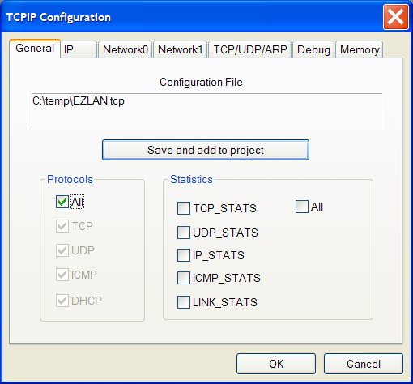

In addition to configuring the set of protocols to be supported, the General page also allows you to control the amount of statistical information that the stack collects.

When you click on the OK button the configuration utility will automatically save any changes in the specified configuration file and update the header file associated with the current project.

If you click on the Save and add to project button then you can save the configuration to a new file and have the corresponding generated header file used in the current project.

IP page
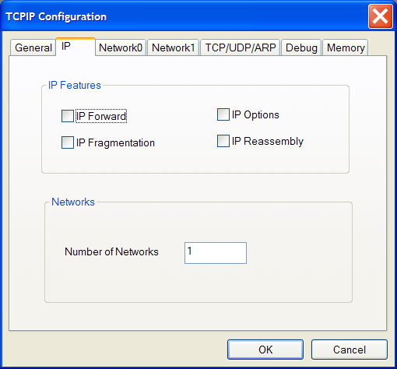

The IP page allows you to control the optional IP protocol features
- Check IP Forward if you wish to have the ability to forward IP packets across network interfaces. If you have only one network interface, you should leave this box unchecked.
- Check IP options if IP options are to be allowed. If this box is left unchecked then packets with unrecognized IP options are dropped.
- If IP Fragmentation is checked then IP packets will be segmented appropriately.
- If IP Reassembly is checked then support for re-assembling fragmented packets is provided.

Although you can specify that more than two network adapters are to be supported the plugin itself only supports configuring two network adapters. Any additional network adapters have to be configured at run time.

Network0 page
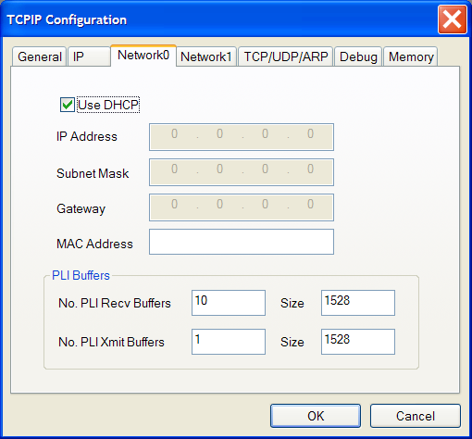

If DHCP is not to be used by a network adapter then you must configure the appropriate setting for the IP Address of the adapter, its subnet mask and the IP address of the gateway for the subnet.

The number and size of the buffers to be supplied to the Ethernet driver must be specified as appropriate to the expected loading on the adapter.

Network1 page

If DHCP is not to be used by a network adapter then you must configure the appropriate setting for the IP Address of the adapter, its subnet mask and the IP address of the gateway for the subnet.

The number and size of the buffers to be supplied to the Ethernet driver must be specified as appropriate to the expected loading on the adapter.

TCP/UDP/ARP page

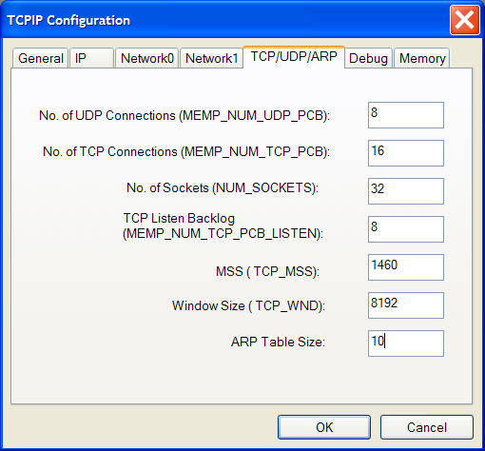

You need to configure sufficient UDP ‘connection’s and TCP connections depending on the expected maximum number of simultaneous UDP receives and active connections. Similarly the maximum number of outstanding listen requests has to be specified as well as the maximum number of simultaneously open sockets that are required.

The MSS field specifies the maximum size of TCP segment that the stack will support while the window size specifies the maximum TCP receive window that the stack will support.

The ARP table size specifies the maximum number of address resolution mapping entries that the stack will maintain.

Debug page

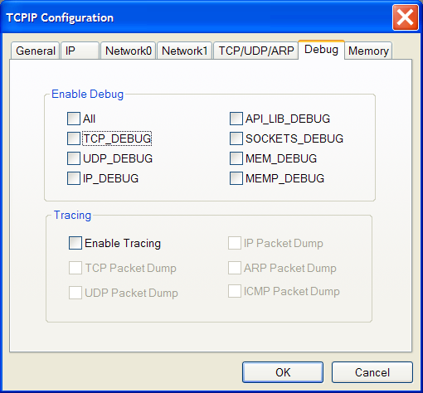

The amount of debugging and tracing messages that the stack will generate can be controlled using this page.

Memory page

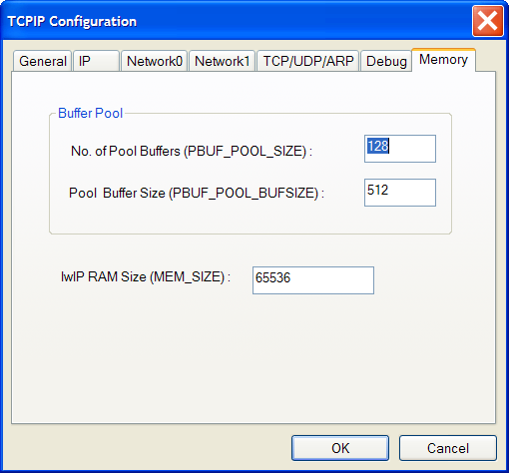

This page allows you to specify the number of pool buffers and the size of each pool buffer.

Socket API and other Documentation.

The description of the socket API that is supported by the stack can be accessed from the html file called

<install_path>\ Blackfin\lib\src\lwip\docs\socket-api\index.html

Ethernet Device Driver details were present in the below documents.
<install_path>\ Blackfin\lib\src\lwip\docs\SMSCLAN91c111_DeviceDriver.doc
<install_path>\ Blackfin\lib\src\lwip\docs\BF537EthernetDeviceDriverDesign.doc

TCP/IP examples

DNS Client

The DNS client example shows how to convert a host name into the required IP address. The supplied client only supports a forward lookup and does not provide support for mapping an IP address to the corresponding host name.

The file dns.c contains the implementation of the DNS protocol and can be used in other projects. The IP address for the DNS server has to be set in the variable DNS_HOST_ADDR.

The DNS client project is located in the directories

Using Blackfin EZ-kit build in Ethernet connector:
<install_path>\Blackfin\Examples\ADSP-Bf5xx EZ-kit Lite\LAN\DNS_Client

Using USB-LAN EZ Extender (BF533, BF561, BF537 )
<install_path>\Blackfin\Examples\USB-LAN EZ-Extender\LAN\DNS_Client

inetd server

The inetd server is an example of how you can provide a server which accepts incoming connections and depending on the port the connection is received on offers various different services.

The example provides support for the following services
- A data generator which simply sends back a continuous stream of alphanumeric characters
- A discard server which simple accepts and consumes any incoming data
- An echo server that returns any received data back to the sender

The inetd server project is located in the directory

Using Blackfin EZ-kit build in Ethernet connector:
<install_path>\ Blackfin\Examples\ ADSP-Bf5xx EZ-kit Lite \LAN\INETD

Using USB-LAN EZ Extender (BF533, BF561, BF537 )
<install_path>\ Blackfin\Examples\USB-LAN EZ-Extender\LAN\INETD

A Windows based inetd client application is also provided which works in sync with the inetd server application. This application can be used to connect to the inetd server, by taking the server ip address and the server port number. Inetd client application uses Windows socket library.

The inetd client project (InetdClient.dsw) is located in the directory

<install_path>\Blackfin\Examples\ ADSP-Bf5xx EZ-kit Lite \LAN\Host\InetdClient
A copy of the above is also present in
<install_path>\Blackfin\Examples\USB-LAN EZ-EXTENDER\LAN\Host\InetdClient

InetdClient.exe is also provided in the directory
<install_path>\Blackfin\Examples\ ADSP-Bf5xx EZ-kit Lite \LAN\Host\InetdClient\

Alternatively users can use the ‘telnet’ application to telnet to the inetd server ports. More information is present in the Readme.txt file present in the project Documentation folder.

FileServer application

The FileServer application privides Windows host support to enable standard C/C++ file input/output from the Blackfin to be received/sent to the host over TCP/IP connections.

The FileServer sources are supplied in the directory

Using Blackfin EZ-kit build in Ethernet connector:
<install_path>\Blackfin\Examples\ADSP-BF5xx EZ-Kit Lite\LAN\Host\FILESERVER
A copy of it is also present in
<install_path>\Blackfin\Examples\USB-LAN Ex-Extender\LAN\Host\FILESERVER

A Microsoft Visual C++ 6.0 workspace file (fileserver.dsw) is included to allow the application to be built or modified. A built application FileServer.exe is also supplied in the <install_path>\Blackfin\Examples\ADSP-BF5xx EZ-Kit Lite\LAN\Host\FILESERVER directory. A copy of the above is also present in <install_path>\Blackfin\Examples\USB-LAN EZ Extender\\LAN\Host\FILESERVER

FileServer host application

Once started the FileServer application produces a window as shown below.

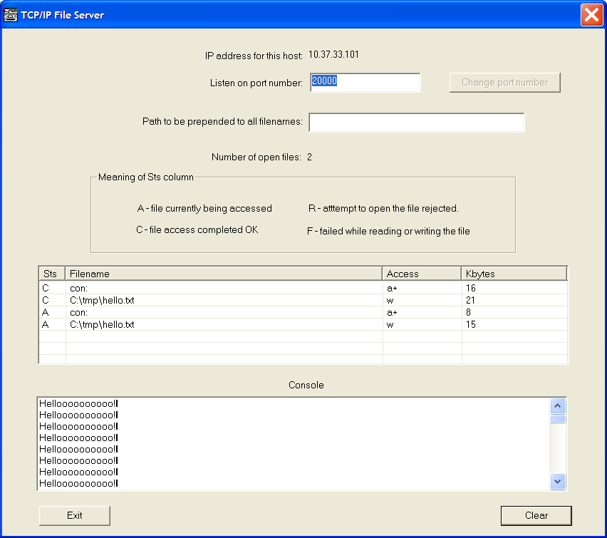

The port that the server listens on for connections from a Blackfin defaults to 20000, but can be changed if required.

The FileServer runs with no user authentication which means that by default anyone connecting to the host could have access to all files stored on the system. You can restrict transfers to and from the host by specifying a directory name in the control labeled “Path to be prepended to all filenames”. If this control is set then the FileServer will restrict access to files within the specified directory and its sub-directories.

The status of all current and previous transfers is shown indicating the direction of transfer, the amount of data transferred and if the access was successful.

If the Blackfin application opens the file named con: for write access then any data sent to the file will be shown in the console window.

The IP address of the Windows host is shown at the top of the window.

FileServer Blackfin example

An application can switch all of its file input/output to be transferred to a FileServer host by using the code that is in the file called FileServerStdio.c that is located in the directory

Using Blackfin EZ-kit build in Ethernet connector:
<install_path>Blackfin\Examples\ADSP-BF5xx EZ-KIT Lite\LAN\FileServerStdio

Using USB-LAN EZ Extender (BF533, BF561, BF537 )
<install_path>Blackfin\Examples\USB-LAN EZ-EXTENDER\LAN\FileServerStdio

The function FS_STDIO_init in the file will re-direct all output to stdout and stderr to the console window on the FileServer application. All input or output to any subsequently opened file will also be re-directed to the Fileserver application.

The Run function of the lwip_sysboot_threadtype invokes the FS_STDIO_init function once the stack has been initialized. The host IP address must be updated to match the IP address of the host where the FileServer application is running. It then sends 1000 lines of data to both the console and to the file C:\tmp\hello.txt on the host.

TCP/IP Tracing

The TCPIP Tracing application provides Windows host support to allow the recording of events as they happen and to trace all or some packets as they are being sent or received by the Blackfin application and stack.
The TCPIP tracing application sources are supplied in the directory

<install_path>\Blackfin\Examples\ADSP-BF5xx EZ-Kit Lite\LAN\Host\TCPIPTrc

A copy of it is also present in
<install_path>\Blackfin\Examples\USB-LAN EZ-EXTENDER\\LAN\Host\TCPIPTrc

A Microsoft Visual C++ 6.0 workspace file (TCPIPTrc.dsw) is included to allow the application to be built or modified. A built application TCPIPTrc.exe is also supplied in the <install_path>\Blackfin\Examples\ADSP-BF5xx EZ-Kit Lite\LAN\Host\TCPIPTrc directory.A copy of it is also present in <install_path>\Blackfin\Examples\USB-LAN EZ-EXTENDER\\LAN\Host\

Events can be passed from the Blackfin application to the host system using either BTC or a TCP/IP connection. The use of BTC allows the actions which occur as the stack is starting to be traced, where as only normal operation can be traced over a TCP/IP connection.

The image below shows the window displayed by the TCPIPTrc windows application. If the port number is set to zero then the application assumes that the data will be collected using a BTC channel, otherwise the application will listen for a TCP/IP connection on the specified port.

The received data is displayed as it arrives and stored in a cyclic buffer that holds by default the last 256 events.

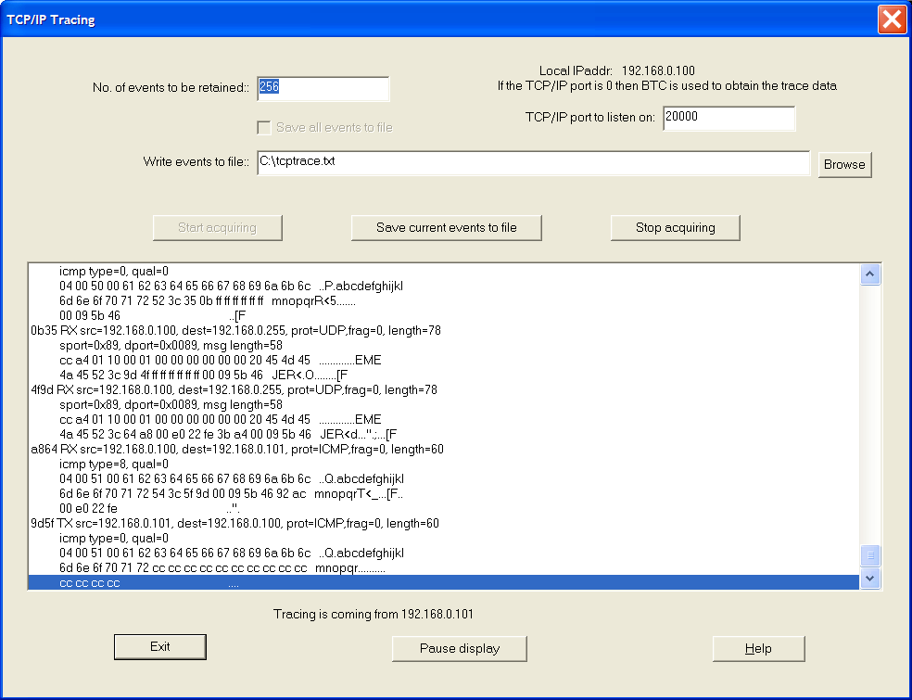

The tracing can re activated and stopped by clicking on the Acquire and Stop acquiring buttons. When you click on the Pause display button, the trace display stops being updated but the trace data continues to be collected and stored in the cyclic buffer.

The text below shows the information displayed in a typical trace file

c15d TX src=192.168.0.101, dest=192.168.0.100, prot=TCP,frag=64, length=40
sport=0x1001, dport=0x4e20, seq=196e, ack=0x97b7dce1, win=8192 code=ACK
00 00 cc cc cc cc cc cc cc cc cc cc cc cc cc cc ................
c15d TX src=192.168.0.101, dest=192.168.0.100, prot=TCP,frag=64, length=40
sport=0x1001, dport=0x4e20, seq=196e, ack=0x97b7dce1, win=8192 code=ACK
00 00 54 3c 4c ba 00 09 5b 46 92 ac 00 e0 22 fe ..T<L...[F....".
ba4c TX src=192.168.0.101, dest=192.168.0.100, prot=TCP,frag=64, length=100
sport=0x1001, dport=0x4e20, seq=196e, ack=0x97b7dce1, win=8192 code=PSH ACK
54 38 5d c1 00 09 52 3c 58 c5 00 e0 22 fe 3b a4 T8]...R<X...".;.
00 09 5b 46 ..[F
c558 RX src=192.168.0.100, dest=192.168.0.101, prot=TCP,frag=64, length=40
sport=0x4e20, dport=0x1001, seq=97b7dce1, ack=0x19aa, win=17460 code=ACK
3c 4d b5 c3 c2 c2 cc cc cc cc cc cc cc cc cc cc <M..............
cc cc cc cc ....
c15d TX src=192.168.0.101, dest=192.168.0.100, prot=TCP,frag=64, length=40
sport=0x1001, dport=0x4e20, seq=196e, ack=0x97b7dce1, win=8192 code=ACK
00 00 54 3c 4c ba 00 09 5b 46 92 ac 00 e0 22 fe ..T<L...[F....".
ba4c TX src=192.168.0.101, dest=192.168.0.100, prot=TCP,frag=64, length=100
sport=0x1001, dport=0x4e20, seq=196e, ack=0x97b7dce1, win=8192 code=PSH ACK
54 38 5d c1 00 09 52 3c 58 c5 00 e0 22 fe 3b a4 T8]...R<X...".;.
00 09 5b 46 ..[F
c558 RX src=192.168.0.100, dest=192.168.0.101, prot=TCP,frag=64, length=40
sport=0x4e20, dport=0x1001, seq=97b7dce1, ack=0x19aa, win=17460 code=ACK
3c 4d b5 c3 c2 c2 54 3c ae ef 00 09 5b 46 92 ac <M....T<....[F..
00 e0 22 fe ..".
efae TX src=192.168.0.101, dest=192.168.0.100, prot=TCP,frag=64, length=168
sport=0x1001, dport=0x4e20, seq=19aa, ack=0x97b7dce1, win=8192 code=PSH ACK
54 3c 4c ba 00 09 52 3c d4 27 00 e0 22 fe 3b a4 T<L...R<.'..".;.
00 09 5b 46 ..[F
27d4 RX src=192.168.0.100, dest=192.168.0.101, prot=TCP,frag=64, length=40
sport=0x4e20, dport=0x1001, seq=97b7dce1, ack=0x1a2a, win=17332 code=ACK
86 33 23 be a8 8a 52 3c 5e 70 ff ff ff ff ff ff .3#...R<^p......
00 80 c8 0c ....
705e RX src=192.168.0.1, dest=239.255.255.250, prot=UDP,frag=0, length=280
sport=0x76c, dport=0x076c, msg length=260
4e 4f 54 49 46 59 20 2a 20 48 54 54 50 2f 31 2e NOTIFY.*.HTTP/1.
31 0d 52 3c 81 6f ff ff ff ff ff ff 00 80 c8 0c 1.R<.o..........
6f81 RX src=192.168.0.1, dest=239.255.255.250, prot=UDP,frag=0, length=298
sport=0x76c, dport=0x076c, msg length=278
4e 4f 54 49 46 59 20 2a 20 48 54 54 50 2f 31 2e NOTIFY.*.HTTP/1.
31 0d 52 3c fc 6b ff ff ff ff ff ff 00 80 c8 0c 1.R<.k..........

Tracing over BTC

The example project (BtcTrace.dpj) showing how to use BTC to transfer the trace data to the host is located in the directory

Using Blackfin EZ-kit build in Ethernet connector:
<install_path>\Blackfin\Examples\ADSP-BF5xx EZ-KIT Lite\LAN\BTC_Trace

Using USB-LAN EZ Extender (BF533, BF561, BF537 )
<install_path>\Blackfin\Examples\USB-LAN EZ-EXTENDER\\LAN\BTC_Trace

The elements that need to be added to a project to provide support for tracing over BTC are

- A thread such as the BtcPoller thread that runs at a higher priority than the application threads. This thread is responsible for
  - Initializing the tracing support and providing the name for the memory area that will be used to communicate with the host.
  - An entry for this named area must be added to the BTC MAP table as shown in the example thread.
  - It then starts the tracing by specifying the name of the function that the stack invokes to record an event.
  - Finally it sits in a loop calling the Trace_Poll function to enable the application to respond to BTC requests from the host.
- The code to effect the tracing is provided in the functions trace.c, trace.h, trace_btc.c and trace_btc.h and these need to be added to the project.
- If this thread is given sufficient priority to run before the lwip_sysboot_threadtype.c then you can trace the actions of the stack as it makes the initial connection to the network.
- To minimize problems with the host BTC requests, you can increase the BTC timeout by right clicking on the BTC memory window.
- You should activate the tracing on the host after the application is loaded.

Tracing over TCP/IP
The example project (TcpTrace.dpj) showing how to use TCP/IP to transfer the trace data to the host is located in the directory

Using Blackfin EZ-kit build in Ethernet connector:
<install_path>\Blackfin\Examples\ADSP-BF5xx EZ-KIT Lite\LAN\TCPIP_Trace

Using USB-LAN EZ Extender (BF533, BF561, BF537 )
<install_path>\Blackfin\Examples\USB-LAN EZ-EXTENDER\\LAN\TCPIP_Trace

The elements that need to be added to a project to provide support for tracing over TCP/IP are

- The function lwip_sysboot_threadtype_RunFunction in the file lwip_sysboot_threadtype.c needs to call the Trace_Init function after the stack is operational. The call specifies the IP address and port number that the tracing info should be sent to.
- A thread such as the TcpPolle r thread that runs at a higher priority than the application threads. This thread waits until the stack is fully started and then runs in a loop calling the function Trace_Maintain.
- The code to affect the tracing is provided in the functions trace.c, trace.h, trace_tcp.c and trace_tcp.h and this need to be added to the project.

Multicast
Multicasting enables communication between multiple machines without incurring any extra packet overhead. A multicast example is provided which demonstrates how to send multicast data over the Ethernet. The Blackfin application works as host that transfer multicast data to a multicast IP address without connected to any receiver. Windows application works as receiver that receives data from the multicast IP address.

The Blackfin multicast sender example is located at:
<install_path>\Blackfin\Examples\ADSP-BF526 EZ-KIT Lite\LAN\Multicast_Sender

The Windows multicast receiver example is located at:
<install_path>\Blackfin\Examples\ADSP-BF526 EZ-KIT Lite\LAN\Host\MulticastReceiver

A Microsoft Visual Studio .Net 2003 workspace file (MulticastReceiver.vcproj) is included to allow the application to be built and modified.

Message “Hello World#” is sent out from Blackfin EZ-kit to multicast IP address. The Windows multicast receiver displays this message in the output window after its reception. Multiple Windows multicast receivers can run at the same time on different PC to receive multicast data simultaneously.

