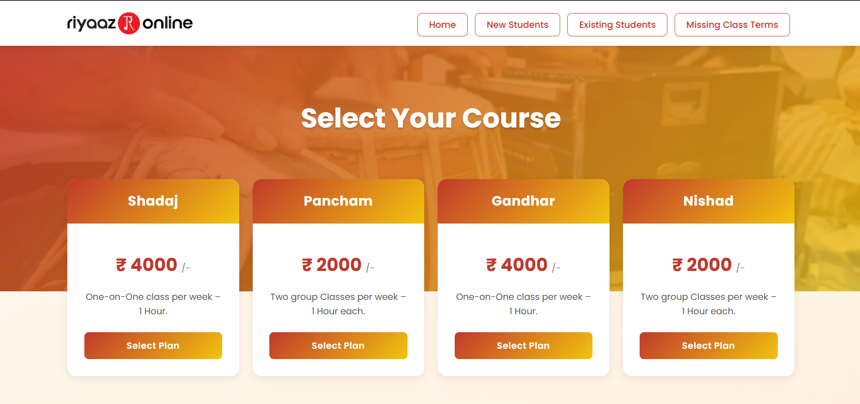

1. Click on Existing students button to go payments page

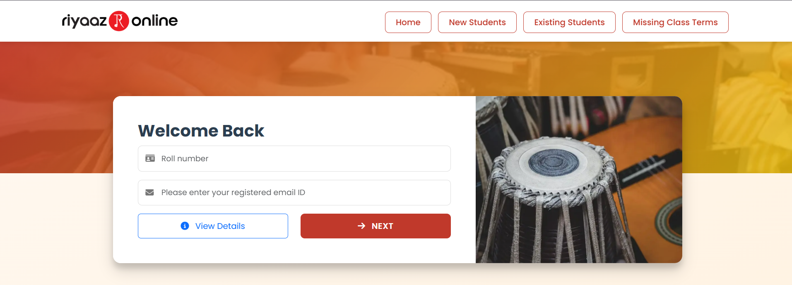

1. Enter your Roll number in Roll Number field
2. Enter your registered email address in email field
3. Click on view details to check details and click on next button

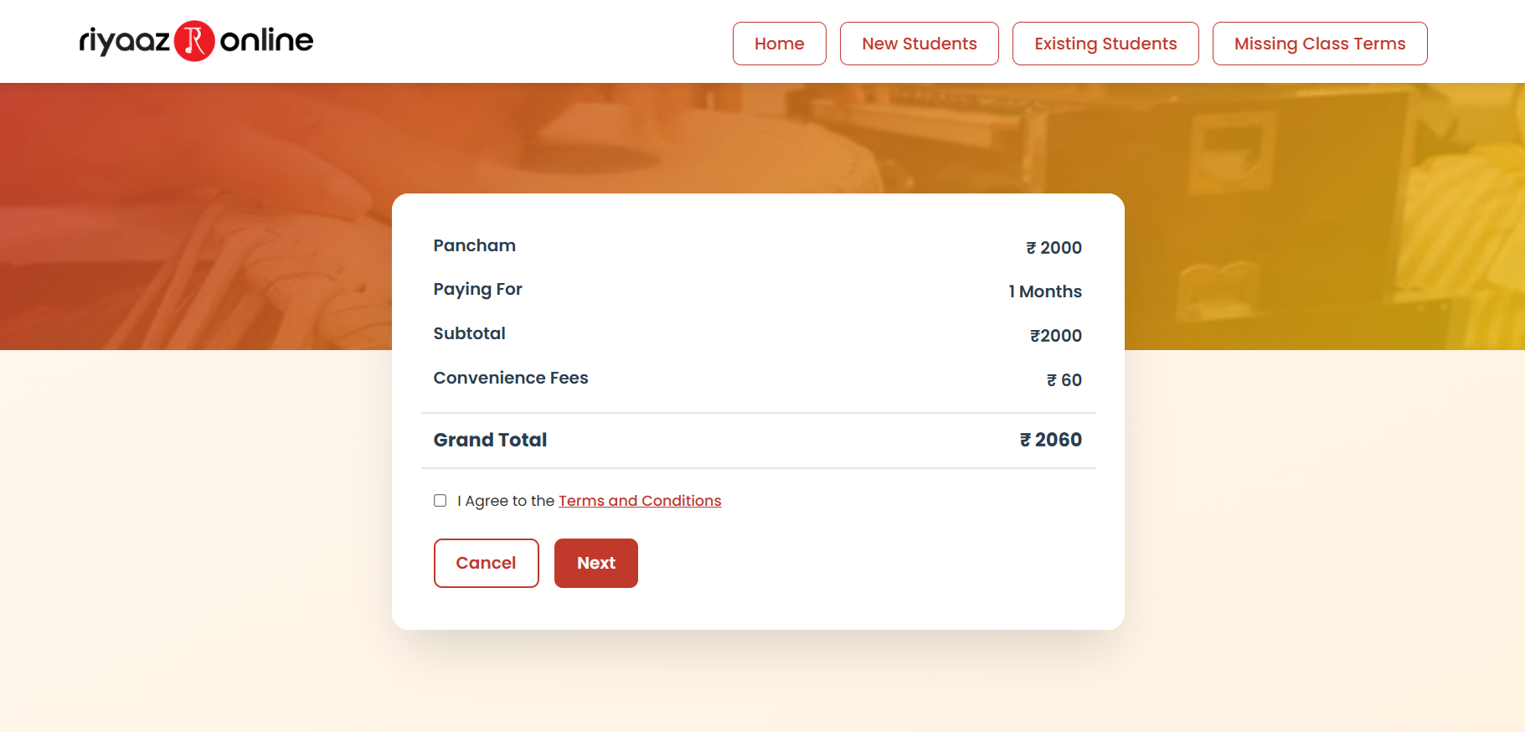

1. Check I Agree to the terms and conditions then click on next button to go to payment page
2. Next make payment and you will get a confirmation mail about the payment

**To make your fees payment hassle free and on time, we have also facilitated the below features.**

1. Once you enter your roll number and email id, you can go to view details to check all your details along with your next payment due date.

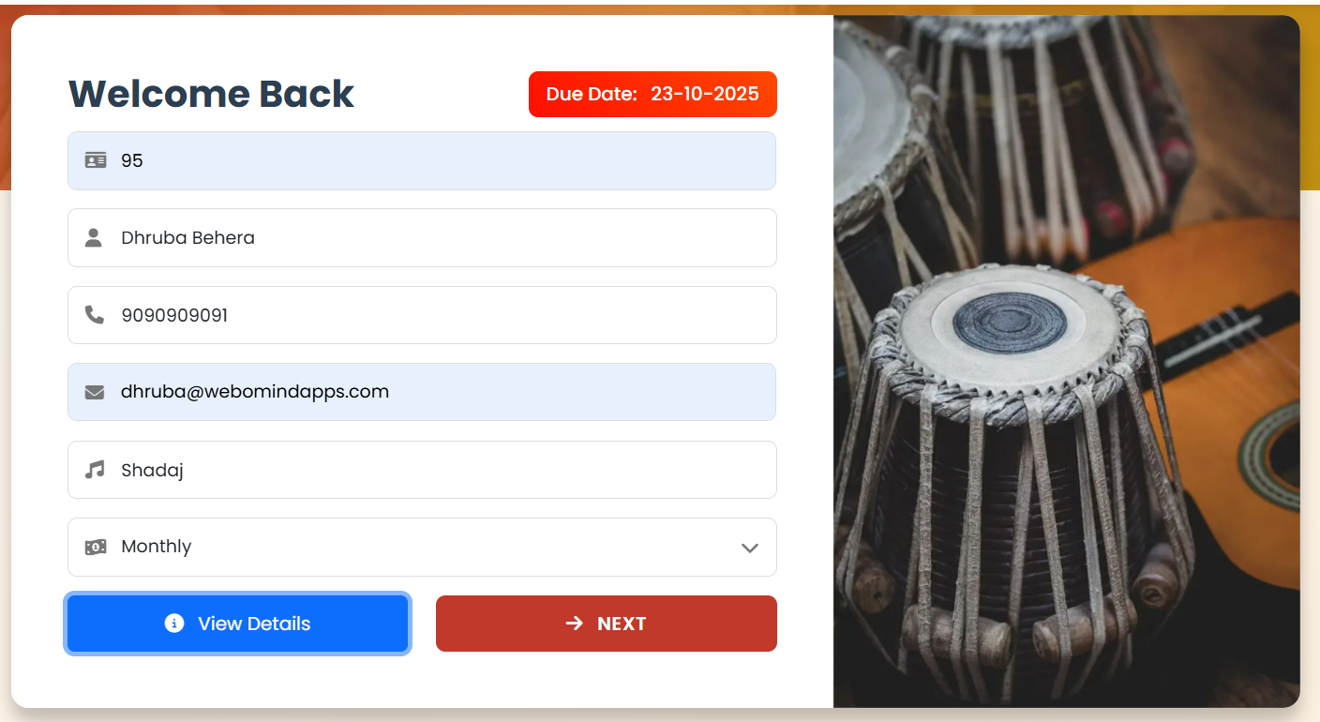

1. From now onwards all the Indian students will get multiple SMS reminders to your registered mobile number only & All the international students will get the same reminders to your registered mail ids only.
2. You will get these reminders before 7 days, 3 days, 1 day and on the day of the due date

**Hope to see you all, make your fees payments on or before the due dates without any further folllow ups.**

Thanks for your understanding and cooperation.

Regards,

*Reet Sir*