CODERA — Claude Deep Instructions
Working document • v0.5
Purpose: this document will be expanded step by step. Steps 1–4 are defined in this version. Future Codera layout/content steps (including the final 01/02/03/04/05 structure) are intentionally omitted until their requirements are finalized.

STEP 1 — BUILD CLAUDE’S DESIGN INTELLIGENCE LIBRARY
This step happens before any new Codera redesign, 3D logo implementation, layout reconstruction, motion redesign, or content work.
The objective is not to teach Claude one Codera aesthetic. The objective is to build a reusable, broad design-intelligence system that Claude can apply to future client work across very different industries, audiences, moods, and commercial goals.

1. Mission
• Use https://styles.refero.design as the primary design-learning source.
• Systematically cover the full breadth of design styles and categories available there, not only dark, premium, tech, or agency aesthetics.
• Learn transferable design principles rather than copying specific websites, layouts, components, or visual identities.
• Build a persistent Codera design knowledge base that can be reused for future projects such as construction, healthcare, children’s retail, hospitality, SaaS, legal, fashion, ecommerce, luxury, industrial, editorial, playful, and other categories.

2. Breadth Requirement
Do not reduce “good design” to a single fashionable look. Do not default to dark mode, huge typography, glassmorphism, gradients, 3D, minimalism, brutalism, or any other trend.
The library must understand and distinguish many visual directions, including at minimum:
• dark / cinematic
• light / editorial
• warm editorial
• minimal / Swiss-influenced
• luxury / fashion
• architectural / industrial
• corporate / institutional
• healthcare / clinical
• playful / children
• ecommerce / product-first
• hospitality / sensory
• organic / natural
• tech / SaaS
• brutalist / experimental
• high-color / expressive
• soft pastel / friendly
• image-led / art-directed
• typography-led / editorial

3. Learning Workflow

PASS A — Broad extraction
Aim for complete catalogue coverage. Enumerate and inspect every style system entry that is accessible through Refero rather than stopping after a representative sample. Assign every accessible entry to the evolving taxonomy. If technical, access, pagination, or context limitations prevent complete traversal, record exactly what could not be covered; never claim exhaustive coverage when it was not achieved. The later deep-study pass may use selected representatives, but the broad coverage pass must be catalogue-wide.

PASS B — Taxonomy and clustering
Group related systems into coherent style archetypes. Identify similarities and meaningful differences in tone, layout, typography, color, spacing, imagery, component weight, interaction, and content density.

PASS C — Deep study
Select strong representative examples from every major archetype and analyze them deeply. Study why the design works, not merely what it looks like.

PASS D — Synthesis
Convert the observations into reusable design rules, decision frameworks, anti-patterns, and industry/style mappings that can guide future autonomous design decisions.

4. What Claude Must Learn From the References
Typography: display/body scale relationships, type pairing, weight discipline, line length, line-height, tracking, responsive sizing, hierarchy, readability, and when large type is or is not appropriate.
Color: canvas tone, contrast, semantic hierarchy, accent discipline, dark/light balance, opacity, saturation, warmth, and how color changes emotional tone.
Spacing: rhythm, macro vs micro spacing, section density, whitespace, alignment, padding systems, and how spacing changes perceived quality.
Composition: focal points, balance, asymmetry, grids, layering, object scale, negative space, density, and visual flow.
Layout: editorial, modular, asymmetric, product-led, card-based, image-led, spatial, full-bleed, grid, and hybrid layout patterns.
Components: navigation, buttons, cards, forms, metadata, filters, project presentation, commerce elements, trust elements, and CTA treatment.
Imagery: photography, crops, art direction, masks, texture, illustration, product imagery, image density, and image/text relationships.
Motion: when motion improves hierarchy and storytelling, when it harms readability, motion hierarchy, transition purpose, pacing, restraint, and stillness.
Responsive design: how composition changes across desktop, tablet, and mobile rather than merely shrinking.
Commercial fit: how the appropriate design direction changes with audience, trust requirements, price position, brand personality, sector, product type, and conversion goal.

5. Required Persistent Output
Create a reusable design-intelligence library inside the project. The exact filenames may be improved if a clearer structure emerges, but the information architecture must cover the following:
CODERA_DESIGN_INTELLIGENCE/
├── 00_INDEX.md
├── 01_DESIGN_FOUNDATIONS.md
├── 02_STYLE_TAXONOMY.md
├── 03_INDUSTRY_STYLE_MATRIX.md
├── 04_TYPOGRAPHY_SYSTEMS.md
├── 05_COLOR_SYSTEMS.md
├── 06_LAYOUT_SYSTEMS.md
├── 07_COMPONENT_LANGUAGE.md
├── 08_MOTION_AND_SPATIAL_DESIGN.md
├── 09_MOBILE_DESIGN.md
├── 10_DESIGN_ANTI_PATTERNS.md
├── DESIGN_DECISION_ENGINE.md
└── styles/
├── editorial/
├── luxury/
├── minimal/
├── industrial/
├── healthcare/
├── kids/
├── playful/
├── ecommerce/
├── cinematic/
├── tech/
├── corporate/
├── hospitality/
└── ...
When complete, package the reusable knowledge base as `CODERA_DESIGN_INTELLIGENCE.zip` while keeping the source files available in the project.

6. Required Structure for Each Style Archetype
Each style/archetype record should define at least:
• name / archetype
• emotional tone
• typical audience and business fit
• poor-fit contexts
• canvas/background behavior
• color logic
• typography logic
• spacing and density
• layout/composition principles
• imagery direction
• component language
• motion behavior
• mobile adaptation
• strengths
• failure modes / common mistakes
• how to combine it with other styles without losing coherence

7. Design Decision Engine
Create a decision framework that forces Claude to choose a visual direction from the client and business context rather than from personal/default aesthetic preference.
Before selecting a style, evaluate at minimum:
• industry
• audience
• price positioning
• brand personality
• product or service
• trust requirements
• emotional target
• content type and content volume
• image/asset availability
• primary conversion goal
• device and interaction context
• technical constraints

8. Permanent Deep Design Rules
• Never default to dark mode, minimalism, glassmorphism, gradients, large typography, 3D, or any other fashionable aesthetic. Style must be derived from the client’s industry, audience, positioning, emotional objective, content, and commercial goal.
• Design taste means knowing not only what looks good, but what is appropriate.
• A design system is not a collection of colors and components. It is a coherent set of decisions about typography, scale, spacing, composition, hierarchy, imagery, interaction, motion, tone, and restraint.
• Motion must support composition and hierarchy. It must never be used to hide weak static design.
• A strong screen should still look intentionally composed if all animation is paused.
• Do not copy a reference. Extract the logic behind why it works and adapt that logic to the new context.

9. Codera-Specific Learning Outcome
After building the broad library, apply the learning to Codera without locking Codera into a full-dark aesthetic.
The current Codera direction is too emotionally monotone and gloomy. The next Codera direction should use a deliberate dynamic contrast system:
• dark graphite / black-titanium states where cinematic depth is useful
• light or warm-light states to create relief, clarity, freshness, and rhythm
• project-specific color where the work itself benefits from it
• controlled transitions between dark and light to create dramaturgy
• a limited accent strategy rather than constant monochrome darkness
Codera should not prove that it can build only one dark premium style. Its own website should demonstrate strong art direction while remaining capable of showcasing very different client aesthetics.

10. Validation Gate for Step 1
Do not consider Step 1 complete until all of the following are true:
□ The learning coverage is broad and not biased toward Codera’s current dark aesthetic.
□ The major visual style families are represented in the taxonomy.
□ Typography, color, layout, composition, spacing, components, imagery, motion, responsive behavior, and commercial fit are all documented.
□ The Design Decision Engine can meaningfully distinguish, for example, a construction-company website from a children’s ecommerce website.
□ The knowledge base explains when a style is inappropriate, not only when it is attractive.
□ The Codera-specific recommendation includes a deliberate dark/light rhythm rather than full-dark monotony.
□ The library is reusable for future client projects.
□ The source material has been synthesized into principles rather than copied.
□ `CODERA_DESIGN_INTELLIGENCE.zip` is produced and its source files remain available.

11. Step 1 Completion Gate
Do not continue beyond Step 1 until the design-intelligence library has been created, validated, and its limitations honestly reported. Once Step 1 passes this gate, continue to Step 2.

STEP 2 — CREATE THE APPROVED CODERA 3D RIBBON LOGO
Use the separate `CODERA_3D_LOGO_CREATION_PACK.zip` supplied with this task. The approved logo imagery inside that package, together with the embedded preview below, is the source of truth for the Codera mark.
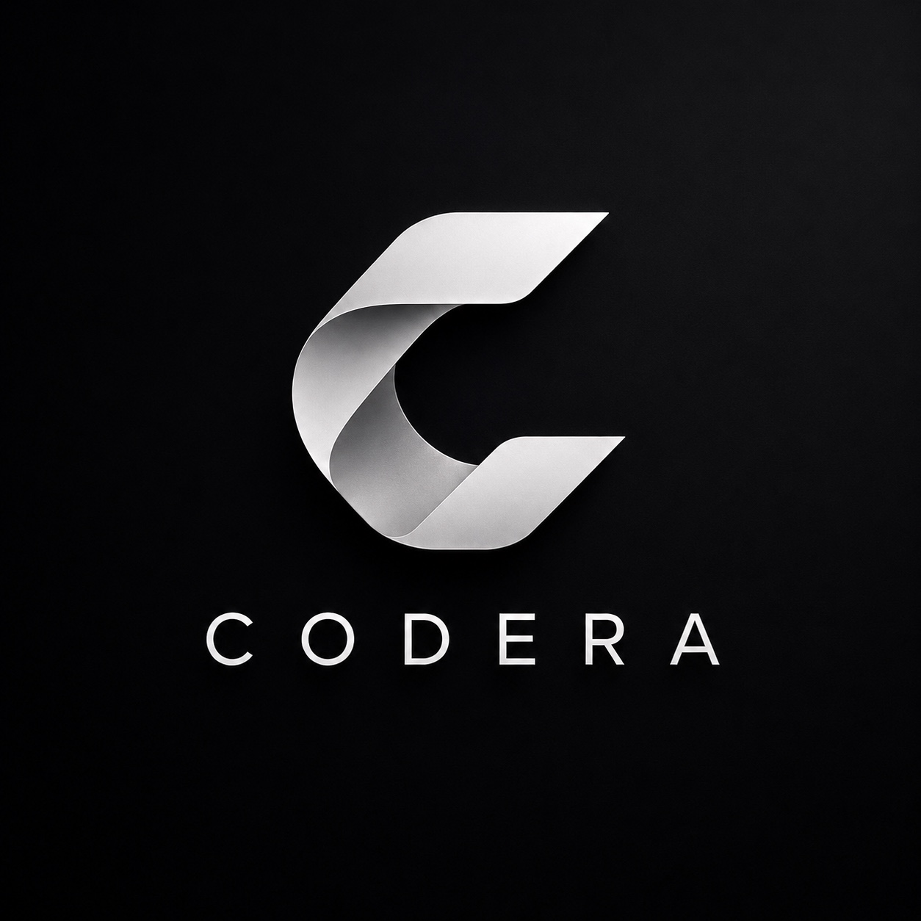
Approved Codera logo reference — authoritative visual identity for Step 2

Required Input Package
• Required file: `CODERA_3D_LOGO_CREATION_PACK.zip`.
• Open the ZIP and read `README_CREATE_3D_LOGO.md` completely before modelling.
• If the ZIP is missing, inaccessible, corrupted, or does not contain the approved references, STOP Step 2 and request the correct package. Do not improvise the logo from memory.
• Do not use any previously rejected Codera GLB/OBJ or earlier extruded-C interpretation unless it is explicitly included in the approved package. The rejected extruded-C approach is not an acceptable fallback.
• The Codera mark is a real folded/twisted ribbon forming a C. It is not a flat C extruded into depth.
• Create a faithful production-quality 3D ribbon asset suitable for Three.js / React Three Fiber.
• Preserve the approved silhouette, opening, top and bottom terminals, fold logic, central twist, and brand recognition.
• The front orthographic render must closely match the approved 2D brand mark.
• The oblique render must reveal believable ribbon depth and front/back surface relationships.
• The model must be optimized for realtime use, use clean geometry and normals, and permit material replacement.
• Do not continue with a logo that merely resembles a generic metallic C.

Required Deliverables
• production GLB asset
• source 3D file where the environment allows it
• front validation render
• 3/4 oblique validation render
• brief technical report including geometry/polycount, materials, file size, and any compromises

Step 2 Completion Gate
Do not integrate the 3D logo into the live Codera experience until the front-view identity has been compared against the approved reference, the 3/4 view proves a real ribbon construction, and the production GLB passes basic realtime-web suitability checks. A model that only approximately resembles the approved C does not pass.

STEP 3 — STUDY REFOKUS-LEVEL SPATIAL AND INTERACTION DESIGN
After the broad design education from Step 1 and the approved 3D logo from Step 2, study high-end spatial creative-development references with Refokus as the main execution benchmark.
• Study spatial storytelling, camera choreography, scene continuity, interaction hierarchy, pacing, stillness, depth, lighting, material behavior, and how 2D typography synchronizes with 3D motion.
• Do not copy a Refokus project. Extract principles that can be adapted to Codera.
• Pay special attention to how high-quality sites create impact without making the user perform excessive scrolling.
• Study how strong scenes transition into one another without feeling like conventional stacked website sections.
• Study how motion supports readability rather than competing with it.
• Study how dark and light states are used to create visual rhythm and emotional contrast.
• Use these findings to extend the reusable design-intelligence library, especially its motion/spatial-design guidance.

Step 3 Completion Gate
At the end of Step 3, continue to Step 4 only for the current-site audit. Do not redesign the Codera page layout, define the future 01/02/03/04/05 content structure, or begin implementation yet.

STEP 4 — AUDIT THE CURRENT CODERA DESIGN AND INTERACTION FAILURES
Before redesigning anything, inspect the current live Codera website and the current implementation. This step is diagnostic. Do not begin broad visual reconstruction until the failures below are verified.

1. Current /02 Transformation Scene
• The current /02 treatment is visually unacceptable and feels dated rather than premium.
• The floating window containing the old website looks like an outdated 2010–2012 web-design trope and must not survive the redesign.
• Do not keep, restyle, or cosmetically polish the floating old-site window. Replace the entire visual concept and transition.
• The current redesigned website shown inside /02 is also too weak. A transformation scene cannot demonstrate a mediocre redesign.
• The replacement must feel native to Codera’s spatial world, not like a before/after widget inserted into it.

2. Current /03 Selected Work
• The websites currently shown in /03 do not visually correspond to the quality level of the Codera website.
• Codera cannot present itself as a 9/10 creative-development studio while demonstrating 5/10 portfolio concepts.
• Konštrukt, Vitalis, Forma, or any replacement concept shown in /03 must be redesigned to the same art-direction standard expected from Codera itself.
• Use the Step 1 Design Intelligence Library when creating these concepts. Each project should have its own appropriate visual direction rather than looking like a weaker version of Codera.
• The work must prove range: different industries should be allowed to use different design languages, palettes, typography, density, and imagery while maintaining Codera-level execution quality.

3. Mobile Navigation Failure
• The current mobile menu is not reliably functional. Treat this as a release-blocking interaction defect.
• Navigation must be tested as an actual touch interface, not only as a resized desktop viewport.
• Test open, close, tap outside, navigation target activation, scroll lock, orientation change, focus behavior, and return to page content.
• No navigation element may be declared complete while any primary mobile interaction is broken.

4. Text Failures Inside 5D / Spatial States
• Text currently becomes partially transparent, too faint, clipped, cropped, incomplete, overlapped, or exits before it can be read.
• This must be treated as a fundamental design failure, not a minor animation bug.
• Readability always overrides choreography.
• Every important text state must have a clear ENTER → FULLY READABLE HOLD → EXIT sequence.
• Do not leave important copy hovering at low opacity for a large part of its lifetime.
• No headline or supporting text may be cut by viewport edges, masks, containers, transforms, or 3D layers unless that crop is deliberately designed and still preserves comprehension.
• Every major 5D state must pass a static-frame test: if motion is paused at the intended reading moment, the composition and typography must still look excellent.

5. Scroll Responsiveness and Input Fidelity
• The current desktop scroll feels heavy, delayed, and disconnected from user input.
• The existing long pinned timeline and scrub damping must be audited as a structural problem, not cosmetically smoothed over.
• Do not add Lenis, Locomotive Scroll, ScrollSmoother, or another synthetic smooth-scroll layer merely to disguise poor interaction architecture.
• The visual world may interpolate smoothly, but user input must feel immediate.
• Mouse wheel, trackpad, touch scroll, swipe, and tap must each be tested as distinct input modes.
• The target is: user input → immediate visual response → controlled cinematic motion.
• The user should experience more while scrolling less.

6. Functional Interaction Baseline
• All buttons, links, CTAs, navigation items, project controls, sliders, swipe targets, and interactive surfaces must be functional.
• Desktop success means both mouse-wheel and trackpad behavior are acceptable.
• Mobile success means actual touch logic is coherent and does not depend on hover.
• Interaction latency, stuck states, scroll traps, accidental overlays, dead click areas, and non-responsive controls are release blockers.

7. Tonal / Color Problem
• The current Codera visual direction is too uniformly dark and can feel gloomy or emotionally monotone.
• Do not interpret premium design as permanent black/graphite darkness.
• The next design must introduce deliberate lightness: warm white, mineral light, pale silver, project-specific color, or another carefully selected light state.
• Use dark/light contrast as dramaturgy. A bright state after a dark spatial sequence can create more impact than adding another dark effect.
• Codera should demonstrate that it understands color and art direction beyond a single dark-tech aesthetic.

8. QA / Release Integrity
• The current project has previously been declared finished while remote GitHub Actions CI was still failing. Treat this as a process failure.
• Local screenshots or local Playwright results are not enough to claim release readiness when the remote CI run is red. If remote CI cannot be accessed, report that limitation instead of treating local success as equivalent.
• Real iPhone Safari behavior has not been fully validated. Mobile quality must not be inferred only from desktop emulation or synthetic FPS checks. If a real iPhone/Safari device is not available to Claude, state that limitation explicitly and do not claim real-device validation; prepare a concrete user validation checklist instead.
• Future completion claims must distinguish: local validation, remote CI validation, preview validation, and real-device validation.

9. Experience Length and Section-Like Structure
• The current experience is too long relative to the amount of meaningful visual change.
• The user is required to perform too much scrolling for too little progression.
• The experience still feels like multiple website sections connected by effects rather than one authored spatial journey.
• The redesign must increase visual/narrative change per unit of scroll and create stronger continuity between states.
• Do not finalize the exact future 01/02/03/04/05 content/layout structure yet; that will be specified in a later step.

10. Audit Output
Produce a concise audit grouped into KEEP / REBUILD / REMOVE / VERIFY. For each issue above, confirm whether it exists in the current live build and identify the actual implementation responsible. Do not yet solve future content/layout questions that have not been specified.

Step 4 Completion Gate
At the end of Step 4, STOP. The failures must be verified and documented, but do not yet redesign the future 01/02/03/04/05 layout or begin implementation. Do not claim that an issue is fixed merely because a local screenshot looks acceptable.

