# Smart Car Pool

## Task Assignments

### Prem

1. Grunt setup
2. Project Structure Creation
3. Push notification implementation
4. Google Maps service integrations
5. Offer pool page integration
6. Splash screen, icons, push notification icons
7. *OPT Auto reading (optional)*
8. *Share application on contact (optional)*
9. *Show list of users (Optional)*
10. *Any user can search the ride until the ride is finished (Optional)*

### Richa

1. Login integration
2. ~~Login using Google~~
3. ~~Login using Facebook~~
4. Share Application feature
5. Show the list of joined and pending status
6. Google Location Service integration
7. Current Location plugin
8. *Feedback page (optional)*
9. *Change Password (optional)*
10. *Forgot Password (optional)*

### Anusha

1. Software installation
2. Quick access settings
3. Signup page
4. Login page
5. Search pool page (if not able to complete then Static design)
6. Offer pool page (if not able to complete then Static design)
7. My pool status -(if not able to complete then Static design)
8. Design Presentation
9. *My profile (Optional)*

### Suresh

1. Backend software installation
2. Database design
3. JSON Based web service creation
4. Push notification Submission to GCM
5. Testing of application
6. Design presentation

### Mohsin

1. Splash Screen images, Icons and logos (Prem)
2. Give Presentation (Richa, Suresh, Prem)
3. Power point presentation creation (Anusha, Richa)
4. Testing of application (Suresh, Anusha)
5. ~~User Interface Ideas~~

## Quick Access Settings

1. All the folder related with the project should add in window favorites) (This will save time, eve machine share folder structure and project settings)

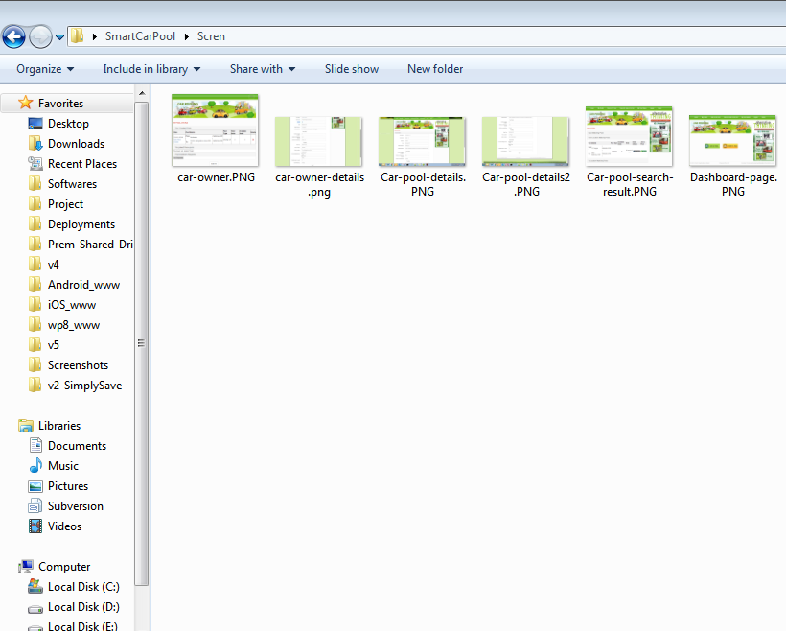

1. Windows Task bar should content all the required software



1. Eclipse Shortcut keys settings (Import key preference) You will get **Ecllipse-Preferences.epf** you have to just import in every machine

Steps to import in eclipse

***File -> import -> Select Preferences -> choose Ecllipse-Preferences.epf file and click on finish***

Eclipse Shortcuts

|  |  |  |
| --- | --- | --- |
| # | Options | Shortcut keys |
|  | To Duplication Lines | Ctrl + D |
|  | To Delete Lines | Ctrl + R |
|  | File Search | Ctrl + Alt + F |
|  | To Run Project in device | Ctrl + F5 |
|  | Close All Opened files | Ctrl + Shift + W |
|  | Project Refresh | F5 |

1. Eclipse work space creation for searching in files
2. Eclipse files editor should work (HTML File should open in HTML editor, CSS file to CSS editor and JS file to JS editor)

## Check List

1. Always make change in outer www folder (run cordova prepare command to copy changes in platform www)
2. Put proper comment for the functions and statements
3. ***common.functions.js*** should contains all the common function which is going to use more than one places
4. ***common.login.functions.js*** should contains only login, logout, forgot password, change password related functions
5. HTML 5 form elements must be used as per requirement (if need to input mobile number then input type must be ***tel***, if input used for email then input type must be ***email***)
6. SCSS will help use to organise the CSS using programming logic so use that)
   1. ***variables.scss*** This will contains only variables settings
   2. **predefined classes** (mostly we have to use predefined classes not need to create own class (if new requirement then create class)
   3. Predefined class will available for these things (xs, normal, lg, xl, xxl)
      1. Margin (maring-top-xs for specific side, margin-lg- for all size)
      2. Padding (padding-top-xs for specific side, padding -lg- for all size)
      3. Font-size
      4. Colours
      5. Background colours
      6. Border-radius

## Technology to be used

1. Cordova
2. Android + iOS Development (second priority)
3. SVN (Local SVN configuration)
4. SCSS (1. [http://sass-lang.com/guide 2](http://sass-lang.com/guide%202). online SCSS compiler <http://www.sassmeister.com/>)
5. Angular JS (<https://angularjs.org/> )
6. ionic framework (<http://ionicframework.com/docs/components/>, <http://ionicframework.com/docs/api/>, <http://ionicframework.com/html5-input-types/> , <http://codepen.io/ionic/pens/public> )
7. Bracket editor for code formatting
8. Grunt for the code minification and SCSS compilation (<http://gruntjs.com/getting-started> )

## Required Software

(<https://github.com/webpkm/cordova-grunt-integration> )

1. Java (https://www.java.com/en/download/)
2. Eclipse
3. Notepad ++ (https://notepad-plus-plus.org/repository/7.x/7.1/npp.7.1.Installer.x64.exe)
4. ADT
5. Android SDK
6. Tortoise SVN (https://tortoisesvn.net/downloads.html)
7. Node JS (https://nodejs.org/dist/v4.6.1/node-v4.6.1-x64.msi)
8. Cordova Install globally
9. Ruby (http://dl.bintray.com/oneclick/rubyinstaller/rubyinstaller-2.3.1.exe)
10. Bracket editor (<https://github.com/adobe/brackets/releases/download/release-1.7/Brackets.Release.1.7.msi>)
11. Grunt CLI (npm install -g grunt-cli)

## Screen flow

1. Login screen
2. Signup page
3. Dashboard page
4. Offer a ride screen
5. Search a ride screen
6. Join a pool screen
7. Messages/notifications screen
8. Ride details screen
9. List of joined screen
10. Pool owner details screen
11. *Forgot password (Options)*
12. *Change password (Options)*
13. *My Profile (Options)*

### Login screen

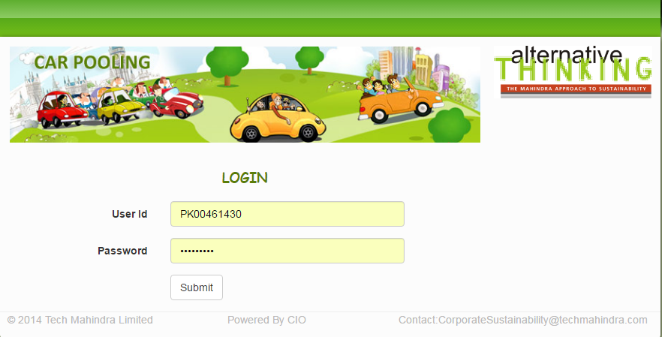

### Signup page

### Dashboard page

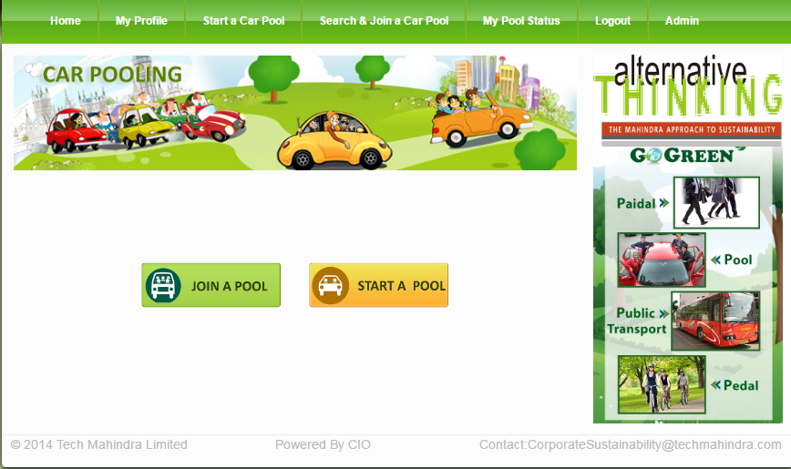

### Offer a ride screen

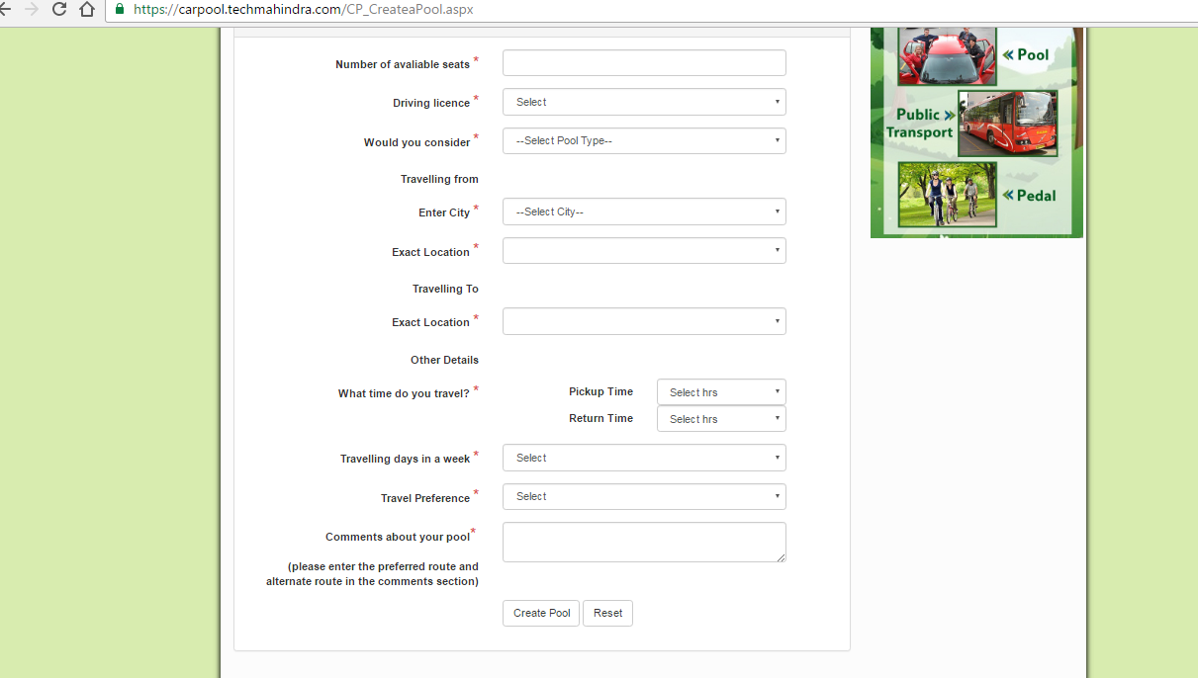

### Search a ride screen

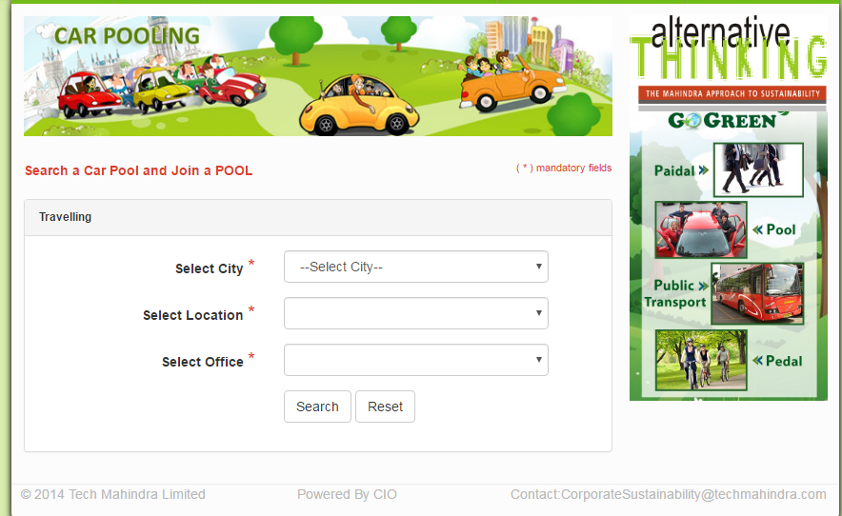

### Join a pool screen

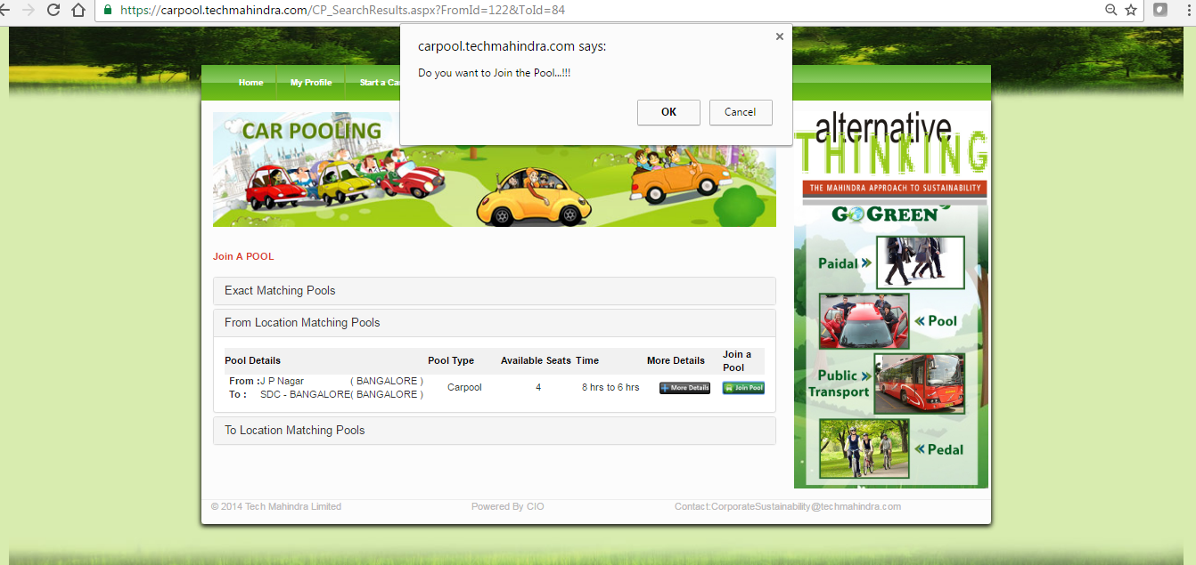

### Messages/notifications screen

### Ride details screen

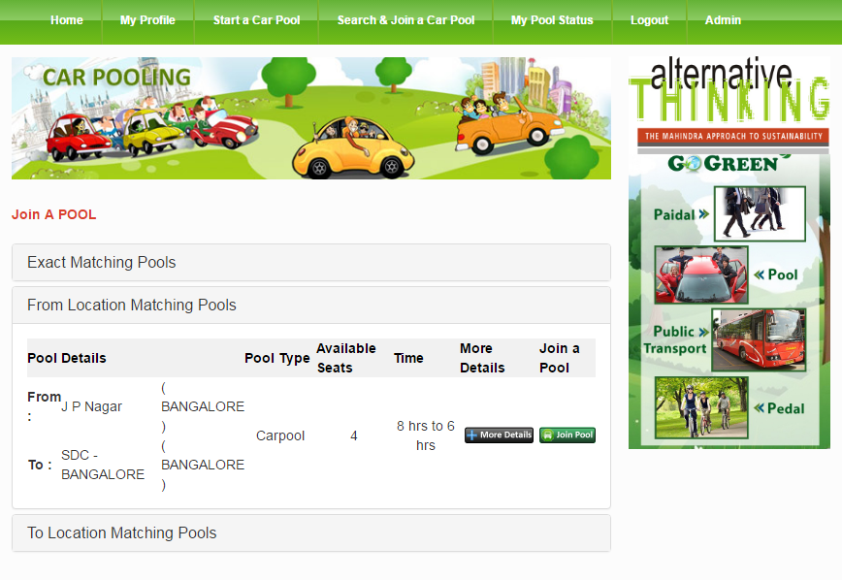

### List of joined screen

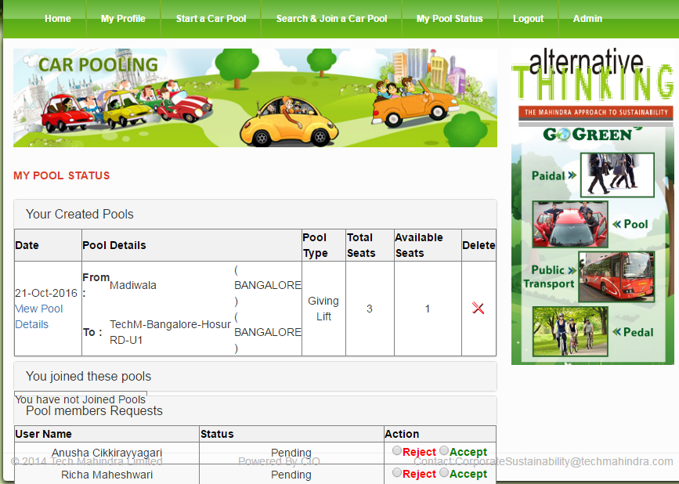

### Pool owner details screen

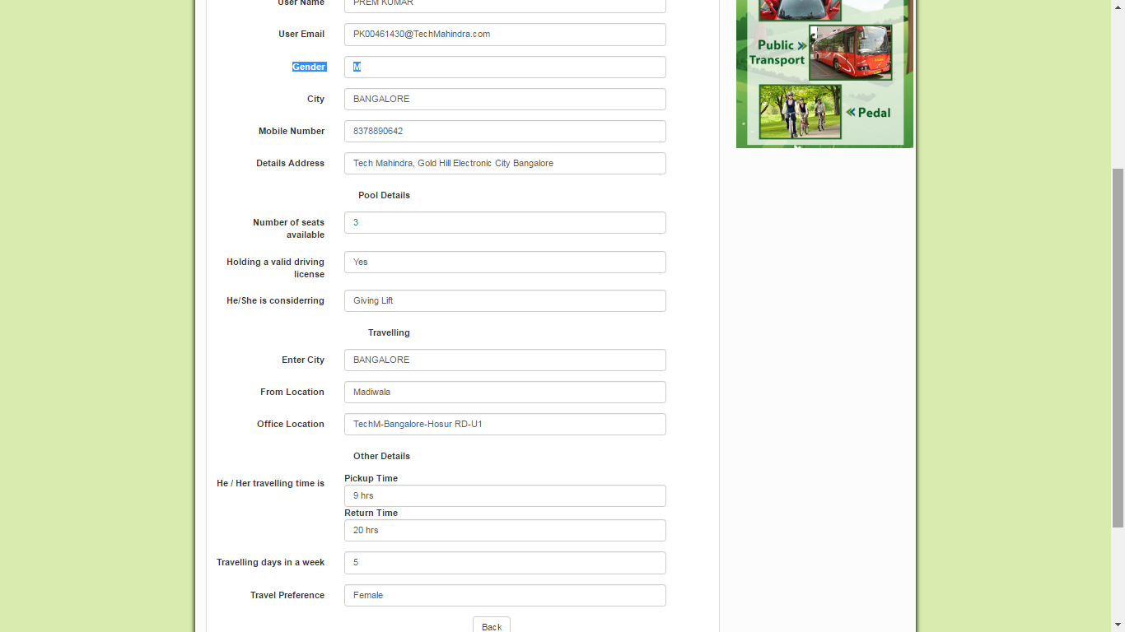

### *Forgot password (Options)*

### *Change password (Options)*

### *My Profile (Options)*

## Push Notification Scenario

### Offer a ride join ride

**Richa offer a ride**

Prem Search and want to join the ride (He clicked on join a ride button). He got 3 list of same ride. Once he clicked on the first ride then remaining ride join button will hide immediately.

He clicks on join ride.

Now Richa got notification like this

Accept

Reject

Prem wants to join your ride.

From: **Hosa Road** To: **TechM Office**

On: 11 Oct 10:00 AM

**Ride Confirmation**

Hi Prem, Richa has accepted your ride request From: Hosa Road To: TechM Office

**Ride Rejected**

Hi Prem, Richa has rejected your ride request.

Next Step

Next Step

Now, 10 Minutes before Prem will get notification show that, your ride is going to start within 10 Minutes. And Join button will replace with **Accepted**

Now Prem can join remain list of available pull. (But he cannot join again Richa’s ride. And Join ride button will replace with **Rejected**

### Start a ride

**Richa will get notification that “it’s time to start your ride”**

Start Now

Snooze 15 Minutes later

Hi Richa, you have to start your ride now as per your schedule.

From: **Hosa Road** To: **TechM Office**

On: 11 Oct 10:00 AM

Now, All joined user will get notification like that your ride is started now.

Now, All joined user will go notification like that your ride delayed by 15 minutes. It will start (Ride time + 15 minutes)

### Your ride is finished (Optional)

Finish ride

All user will got notification

Submit Now

Not Now

Hi Prem, ride was finished. Feel free to give your feedback about your ride

Take to Feedback page

Nothing need to do.

## JSON Based Services details

1. Authenticate User
2. Signup service
3. Create New Pool
4. Search Pool
5. Join pool
6. Pool owner details
7. List of joined person details
8. *User profile details (Optional)*
9. *Forgot password (Optional)*
10. *Reset password (Optional)*
11. *Get user list (Optional)*