WEBRIQ INTERNAL PLATFORM ARCHITECTURE
Central Hub
Comprehensive Specification & Architectural Plan
Version 2.1 Draft · June 2026 · For Internal Review
AI Orchestration · Native Project Management · HR System · PWA — Any Device
MAJOR CHANGE: Zoho suite fully decommissioned.
The Hub becomes the company's system of record for Project Management, Client Requests, and HR Operations.
Confidential — Internal Use Only · WebriQ © 2026

Table of Contents
1. Executive Summary 3
2. Vision & Strategic Goals 3
3. What Changed from v0.1 5
4. System Architecture Overview 6
5. Core Design Principles (Revised) 8
6. Technology Stack & Key Technical Decisions 9
7. Feature Modules — Overview Specs 11
8. Technical Specifications 18
9. Integration Map (Revised) 24
10. Zoho Migration Plan 25
11. MVP Scope & Acceptance Criteria (v2.0) 28
12. Phase Roadmap (Revised) 30
13. Success Metrics 32
14. Decision Log (v2.0) 33
15. Open Items 35
Figures: 1 — Zoho Replacement Map (§1) · 2 — System Architecture (§4) · 3 — Task Lifecycle (§4) · 4 — Unified AI Chat (§7J) · 5 — Realtime Architecture (§8.5) · 6 — Migration Cutover (§10) · 7 — Phase Roadmap (§12)

1. Executive Summary
Revision 2.1 (post-review): adds the explicit StackShift publish → dev URL user story (§7B), a migration map from the existing v0.1 codebase (§10.6), an honest Phase 0 split into 0A/0B (§12, total ~22 weeks), a minimal read-only stats page pulled into MVP (M14), and open item O12 for Zoho status-mapping sign-off.
The WebriQ Central Hub v2.0 is a unified, AI-orchestrated internal operations platform that replaces the entire Zoho suite currently in use. It keeps everything that made v0.1 valuable — the AI Orchestration pipeline (classify → assess → plan → human gate → execute → reply), the LLM Wiki institutional memory, and the Sanity/GitHub execution integrations — but now owns its own data rather than synthesizing data from Zoho.
This eliminates webhook sync complexity, bidirectional state conflicts (DIRECT_ZOHO_EDIT flags), per-seat Zoho licensing, and gives the AI layer first-party access to every operational record. The platform is delivered as a Next.js Progressive Web App — installable and fully functional on desktop, tablet, and mobile from a single codebase.
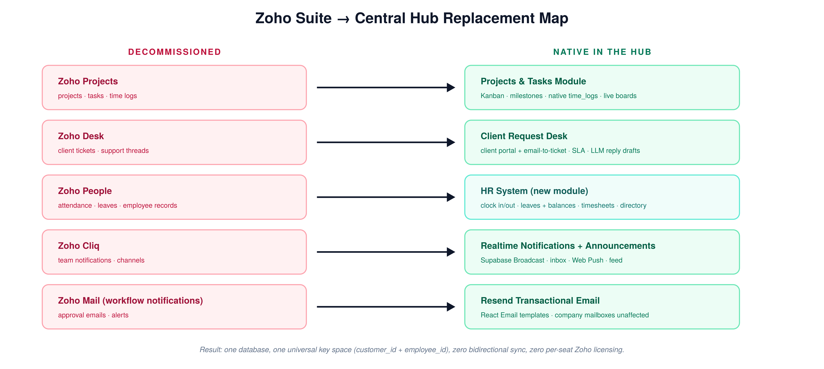
Figure 1 — Every Zoho product maps to a native Hub module. Company mailboxes remain on a standard email provider.

2. Vision & Strategic Goals
- One system of record. Projects, client requests, HR, and knowledge live in one database under one customer_id / employee_id key space. No sync, no drift, no duplicate truth.
- AI-native by design. Because the Hub owns the data, every LLM action (classification, planning, digest, HR queries) reads and writes first-party records — no API round-trips to external systems for core data.
- Operational autonomy roadmap intact. The phased trust model (manual → assisted → supervised → autonomous) from v0.1 carries forward unchanged.
- Any device, anywhere. PWA with offline-tolerant shell, responsive layouts, installable on iOS, Android, and desktop.
- Cost ownership. Replace recurring Zoho per-seat fees with infrastructure the company controls (Supabase + Vercel + Anthropic API usage).

3. What Changed from v0.1
Area | v0.1 | v2.0
Role of Hub | Orchestration layer above Zoho | System of record for PM + Desk + HR
Principle P4 | “Hub = Intent, Zoho = Execution” | Retired. Hub = Intent and Execution
Task/ticket source | Zoho webhooks → classification | Internal event bus (Postgres triggers) → classification
Time logs | Pulled read-only from Zoho Projects | Native time_logs table, written in-Hub
Notifications | Zoho Cliq incoming webhooks | Supabase Realtime Broadcast + in-app inbox + Resend email
HR | Out of scope (Zoho People) | New first-class module: attendance, leaves, timesheets, directory, holidays, announcements
Client intake | Zoho Desk tickets | Native client portal + email-to-ticket ingestion
Realtime | Not specified | Supabase Realtime (Decision D16)
Open item O3 (Zoho webhooks) | HIGH priority | Closed — obsolete

Everything else — LLM Wiki, two-tier KB, playbooks, orchestration models, Sanity/GitHub execution, multi-tenant design, customer_id as universal key — carries forward unchanged.

4. System Architecture Overview

4.1 High-Level System Map
The integration surface shrinks dramatically: in v0.1 the Hub had bidirectional sync with four Zoho products. In v2.0, all operational data is internal; only execution targets (Sanity, GitHub, product APIs) and email delivery (Resend) remain external — and all are outbound-initiated.
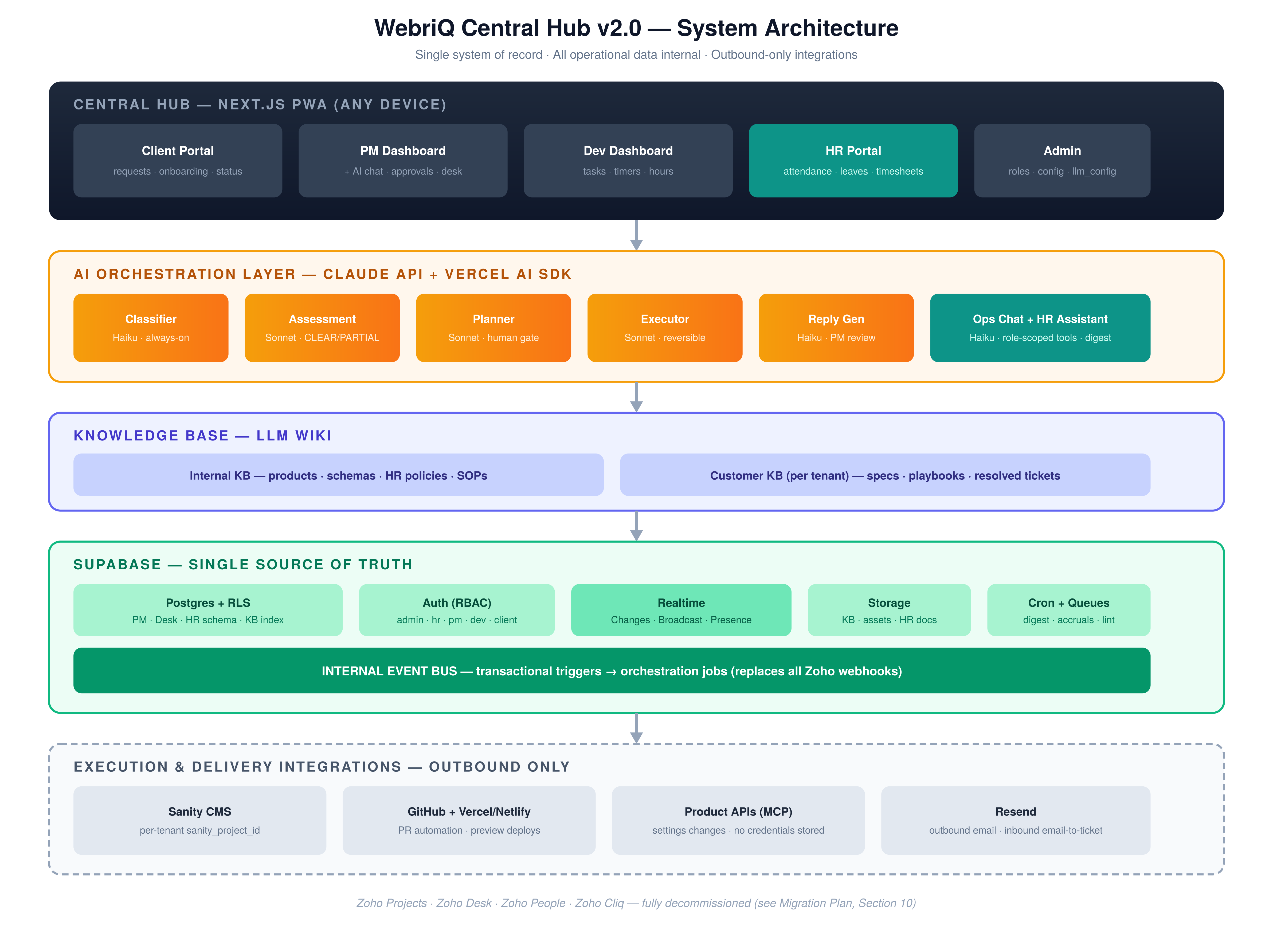
Figure 2 — Five-layer architecture. The internal event bus replaces all Zoho webhooks.

4.2 Core Task Lifecycle Flow
The pipeline itself is unchanged from v0.1 — only the entry point changes (internal events instead of Zoho webhooks) and the status sync-back step disappears entirely.
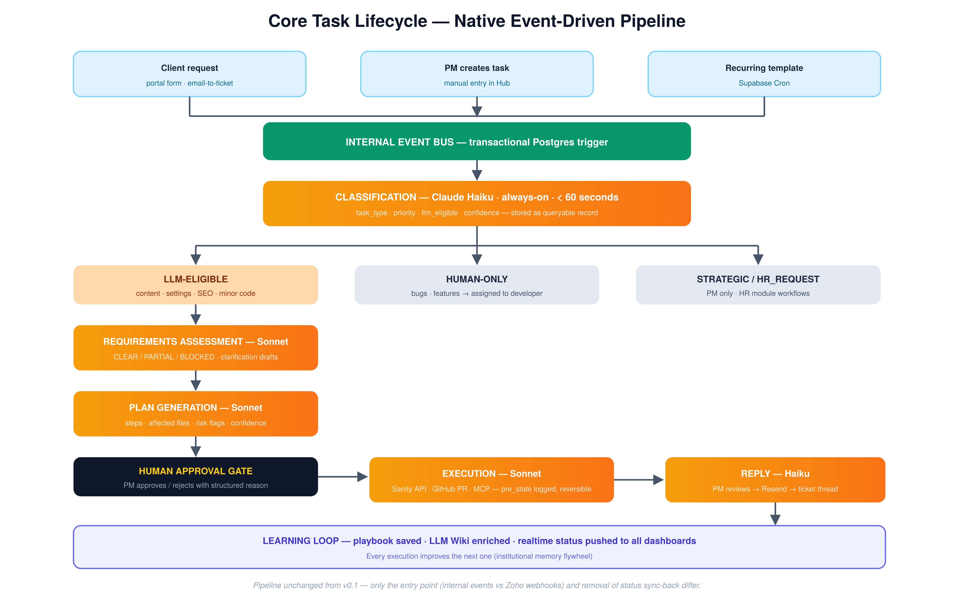
Figure 3 — Native event-driven task lifecycle with the human approval gate preserved.

5. Core Design Principles (Revised)
ID | Principle | Description
P1 | Universal keys | customer_id and employee_id reference every object. Created in Hub. Never duplicated.
P2 | Classification Always On | Runs on every incoming ticket/task without exception.
P3 | Requirements Before Execution | No plan generated for incomplete requirements.
P4 | Hub is the System of Record (NEW) | All PM, Desk, and HR state lives in Supabase. External systems are execution targets only — never sources of operational truth.
P5 | No Autonomous Production Writes | Code goes to a feature branch + PR. API actions log pre_state for reversibility. Humans merge.
P6 | Context Chain is Sacred | Every task carries full history: description → classification → assessment → clarification → plan → approval → execution → reply.
P7 | Model Selection is Configurable | Per-layer via llm_config table, no code changes.
P8 | Manual First, Autonomous Later | Human gates at MVP; autonomy unlocked by playbook confidence.
P9 | HR Data is Privileged (NEW) | HR records sit behind dedicated RLS policies and a separate role. LLM access to HR data is read-scoped, per-requester, and never enters customer-facing pipelines or the Customer KB.
P10 | Realtime is Additive, Not Required (NEW) | Every realtime feature degrades gracefully to fetch-on-load. A dropped websocket never blocks work.

6. Technology Stack & Key Technical Decisions
Layer | Technology | Notes
Framework | Next.js 15+ (App Router) | Server Components for dashboards, Server Actions for mutations, Route Handlers for APIs/webhooks
PWA | Serwist (@serwist/next) | Service worker, offline shell, install prompts, push-ready
Styling | Tailwind CSS v4 | —
Components | shadcn/ui + Lucide React | Data tables, calendars (attendance/leave), command palette, sheets for mobile
AI | Vercel AI SDK + Claude API | Streaming chat, structured outputs, tool calling, MCP support
Database / Auth / Storage / Cron | Supabase | Postgres + RLS, Supabase Auth, Storage (KB files, assets, HR docs), pg_cron + Queues
Realtime | Supabase Realtime | Replaces Socket.io — see D16 below. Postgres Changes, Broadcast, Presence
CMS execution target | Sanity API | Per-tenant sanity_project_id isolation
Code execution target | GitHub API + Actions | PR automation, Claude Code in CI, preview deploys
Transactional email | Resend + React Email | Approvals, ticket replies, digests, magic links; inbound email-to-ticket
Hosting | Vercel (primary) / Netlify (fallback) | Edge-cached static shell, serverless API routes, Vercel Cron backup scheduler
Push notifications | Web Push API | Mobile/desktop push via service worker, no native apps needed

D16 — Why Supabase Realtime instead of Socket.io
- Hosting incompatibility. Socket.io needs a persistent stateful server. Vercel/Netlify functions are ephemeral — a separate websocket server (Railway/Fly.io) plus a Redis adapter would be required.
- Already in the stack. Supabase Realtime ships with the database already in use; channels are authorized by the same RLS policies that protect the tables.
- Covers all three needs. Postgres Changes → live task boards. Broadcast → instant notifications. Presence → online / clocked-in indicators.
- Less code. With Socket.io every mutation needs an explicit server emit; with Postgres Changes the database is the event source.
Fallback path: if a future feature genuinely needs sub-50ms bidirectional messaging at high fan-out (e.g., collaborative cursors), a dedicated websocket service can be added then. Nothing in this architecture forecloses it.

7. Feature Modules — Overview Specs

7A. Onboarding & Client Hub (carried forward from v0.1)
- Unified, login-free onboarding entry point per customer (tokenized share link).
- Dynamic, modular forms with conditional logic; progressive completion (save / resume).
- File and asset upload to Supabase Storage; PM dashboard with completion % and missing fields.
- Centralized customer profile with product instance mapping (StackShift, PublishForge, CiteForge, PipelineForge).
- On completion the Hub auto-creates the native project (v0.1 created a Zoho Project — now internal).

7B. Project Management (native — replaces Zoho Projects)
Core objects: Projects → Milestones → Tasks → Subtasks → Comments → Time Logs → Attachments.
- Project workspace per customer/product instance, linked via customer_product_id.
- Task board (Kanban: Backlog / To Do / In Progress / For Review / Done) plus list and calendar views — boards update live via Realtime.
- Task fields: title, rich description, type (Task Taxonomy), priority, multiple assignees, due date, estimate, labels, linked ticket, linked PR / preview URL.
- Recurring task templates instantiated by Supabase Cron.
- Auto-assignment & round-robin (Phase 3): eligible pool = not on dedicated client, not on approved leave (native HR check — v0.1 needed Zoho People for this), below PM-configured load threshold; assignment reason logged.
- Review & closure workflow: dev marks “For Review” → PM notified in realtime → PM closes from the Hub. No external sync step.
- Prompt-based PM queries: “show all overdue tasks for CiteForge”, “compare logged hours by developer for May”.
- Activity feed per project (every status change, comment, execution event).

User Story US-PUB-1 — Publish to StackShift dev URL (PM-visible)
As a PM, when a content task is ready, I click “Publish to dev” on the task; the Hub pushes the content to the customer's StackShift staging environment and the resulting dev URL appears on the task and in the client reply — without me touching Sanity Studio or Vercel.
- Trigger: a “Publish to dev” action on tasks of type CONTENT_UPDATE / BLOG_PUBLISH / ASSET_UPLOAD, available once the task reaches For Review (PM and Admin roles only; logged to audit_logs).
- Pipeline: Hub writes/publishes the document set via the Sanity execution path (per-tenant sanity_project_id) → the StackShift site rebuild is triggered (deploy hook) → the Vercel/Netlify deploy webhook returns the staging deployment → Hub captures it into tasks.preview_url and execution_records.preview_url.
- Surfacing: the dev URL renders as a labeled “Dev preview” chip on the task card and task detail, is included in the Reply Generation draft to the client, and is queryable from the Ops Chat (“give me the dev URL for the CiteForge blog task”).
- States & failure: PUBLISHING → PUBLISHED(dev) → (later) PUBLISHED(prod). Build failure surfaces on the task with the deploy log link; publish is retryable; pre_state captured so the publish is revertible (P5).
- Acceptance (AC7): PM clicks Publish to dev on a completed content task; within one rebuild cycle the dev URL is visible on the task and included in the drafted client reply.

7C. Client Request Desk (native — replaces Zoho Desk)
- Client portal: authenticated clients submit structured requests, attach files, view status of open/closed requests, and reply in-thread.
- Email-to-ticket: an inbound address (e.g., support@…) is parsed into a ticket; replies are threaded by ticket reference.
- Ticket fields: subject, body, channel (portal / email / manual), customer, product, priority, status (NEW / OPEN / WAITING_ON_CLIENT / WAITING_ON_US / RESOLVED / CLOSED), SLA timestamps.
- Every new ticket fires the event bus → Classification within 60 seconds (same acceptance criterion as v0.1).
- Ticket ↔ Task linkage: a ticket can spawn one or more internal tasks; closing logic is configurable.
- Canned responses + LLM Reply Generation drafts (PM reviews before send; sent via Resend, threaded into the portal).
- SLA timers and breach flags surface in the PM digest.

7D. Developer Workflow (carried forward, Zoho links removed)
- Today view: assigned tasks/tickets, overdue highlighted, due-soon next.
- Team unassigned pool with one-click self-assign (PM notified via Realtime Broadcast).
- Hours summary (today / week) from native time_logs; built-in timer plus manual entry.
- Prompt queries: “what open tasks do I have?”, “how many hours did I log today?”
- Linked GitHub PRs and Vercel/Netlify preview URLs inline on tasks.

7E. HR System (NEW — replaces Zoho People + HR flows in Cliq/Mail)

7E.1 Employee Directory & Records
- Employee profile: personal info, role, department, employment type, start date, manager, emergency contact, documents (contracts, IDs — Supabase Storage with HR-only RLS).
- Org structure: manager relationships drive approval routing.
- Roles: admin, hr, pm, developer, client — an employee user can hold pm/developer plus employee context; hr unlocks the privileged views.

7E.2 Attendance
- Web clock-in / clock-out from the PWA (works on phones); each punch stores timestamp, optional geolocation/IP (policy-configurable), device fingerprint.
- Daily attendance status — PRESENT / LATE / HALF_DAY / ABSENT / ON_LEAVE / HOLIDAY — derived nightly by cron from punches + leave records + the holiday calendar.
- Presence channel shows who is currently clocked in (team view).
- HR dashboard: daily attendance grid, late/absence trends, CSV/XLSX export.
- Manual correction requests: employee requests fix → manager/HR approves → audit-logged.

7E.3 Leave Management
- Configurable leave types (Vacation, Sick, Emergency, Unpaid, …) with accrual rules — e.g., PH norms: monthly accrual, carry-over caps — table-driven, not hard-coded.
- Flow: employee files → manager approves/rejects (with reason) → balance auto-deducts → calendar and round-robin pool update automatically.
- Team leave calendar visible to PMs (feeds assignment eligibility — a direct benefit of unification).
- Half-day support; attachments for medical certificates.
- Philippine holiday calendar (regular / special non-working) maintained by HR; drives attendance derivation and the digest.

7E.4 Timesheets
- Native time_logs (the same records powering PM hours views): per task, per day, hours, billable flag, note.
- Weekly timesheet per employee: auto-filled from task time logs + attendance; employee submits → manager approves → locked.
- Approved timesheets export to CSV/XLSX for payroll. Payroll computation itself is out of scope for MVP — the export feeds the existing payroll process (D21).

7E.5 Announcements & HR Requests
- Company announcement feed (replaces the Cliq broadcast channel) — pinned posts, read receipts, realtime delivery + push.
- Generic HR request types (certificate of employment, equipment, …) with simple approval routing.

7E.6 HR Assistant (AI)
- Haiku-powered, RLS-scoped to the requester: “how many vacation days do I have left?”, “who's on leave next week?” (manager scope), “summarize attendance issues this month” (HR scope).
- Answers grounded in live tables + Internal KB HR-policy wiki pages. Never exposed to clients; HR data never enters the Customer KB (P9).

7F. AI Orchestration Layer (carried forward — entry points revised)
Identical pipeline and taxonomy to v0.1 Section 6 (Classification → Requirements Assessment → Plan Generation → Human Gate → Execution → Reply), with these changes:
- Trigger source: internal event bus rows (ticket/task INSERT) instead of Zoho webhooks.
- Task Type Taxonomy: unchanged (CONTENT_UPDATE, SETTINGS_CHANGE, BLOG_PUBLISH, ASSET_UPLOAD, CODE_CHANGE_MINOR, SEO_UPDATE, BUG_REPORT, FEATURE_REQUEST, STRATEGIC) plus a new non-client class HR_REQUEST — routed to HR workflows, never to the client execution pipeline.
- Execution targets: Sanity API, GitHub PR, Product APIs (MCP) — unchanged. Status writes that previously synced to Zoho now simply update native task rows (one fewer failure mode; circuit-breaker logic unchanged).
- Requirements assessments, plans, and executions remain first-class queryable Supabase records (P6, D12).

7G. LLM Wiki / Knowledge Base (carried forward)
- Two-tier structure unchanged: Internal KB (products, shared Sanity schemas, plus new HR policies and SOPs) and Customer KB (per tenant: specs, code map, playbooks, resolved tickets).
- Weekly Wiki Lint cron unchanged.
- Resolved-ticket distillation now reads native ticket threads (richer than Zoho exports).

7H. Notifications & Realtime (replaces Zoho Cliq)
Need (was Cliq) | v2.0 Mechanism
High-priority classification alert | Realtime Broadcast → in-app toast + notification inbox; Web Push if app is closed
PM / Dev daily digest delivery | In-app digest panel + Resend email (per-user preference)
Plan-approval request | Broadcast to PM channel + push
Execution complete / failed | Broadcast + inbox; failures also email
Leave request / approval | Broadcast to approver + email
Team announcements | Announcement feed (7E.5)

- A central notifications table is the durable inbox (read/unread, deep link). Realtime is delivery acceleration; the table is truth (P10).
- Per-user notification preference matrix: event type × channel (in-app / push / email).

7I. Daily Digest & Reply Generation (carried forward)
- Digest pre-compiled by Supabase Cron into digest_logs (D11) — now includes HR signals for managers: who's on leave today, pending leave approvals, missing timesheets, attendance exceptions.
- Reply Generation (Haiku) drafts client-facing replies on task completion; PM edits stored as diffs; sent via Resend into the ticket thread.

7J. Unified AI Chat — Ops Console (NEW)
One conversational surface across every module. PMs, Developers, HR, and Admins can ask operational questions in plain language — “how many tasks are pending?”, “what are today's priority tasks?”, “who filed leaves this week?”, “who is absent today?” — and get a grounded answer with deep links, without navigating to the Projects, Desk, or HR tabs. This consolidates the prompt features previously scattered across 7B (PM queries), 7D (Dev queries), and 7E.6 (HR Assistant) into a single global console.
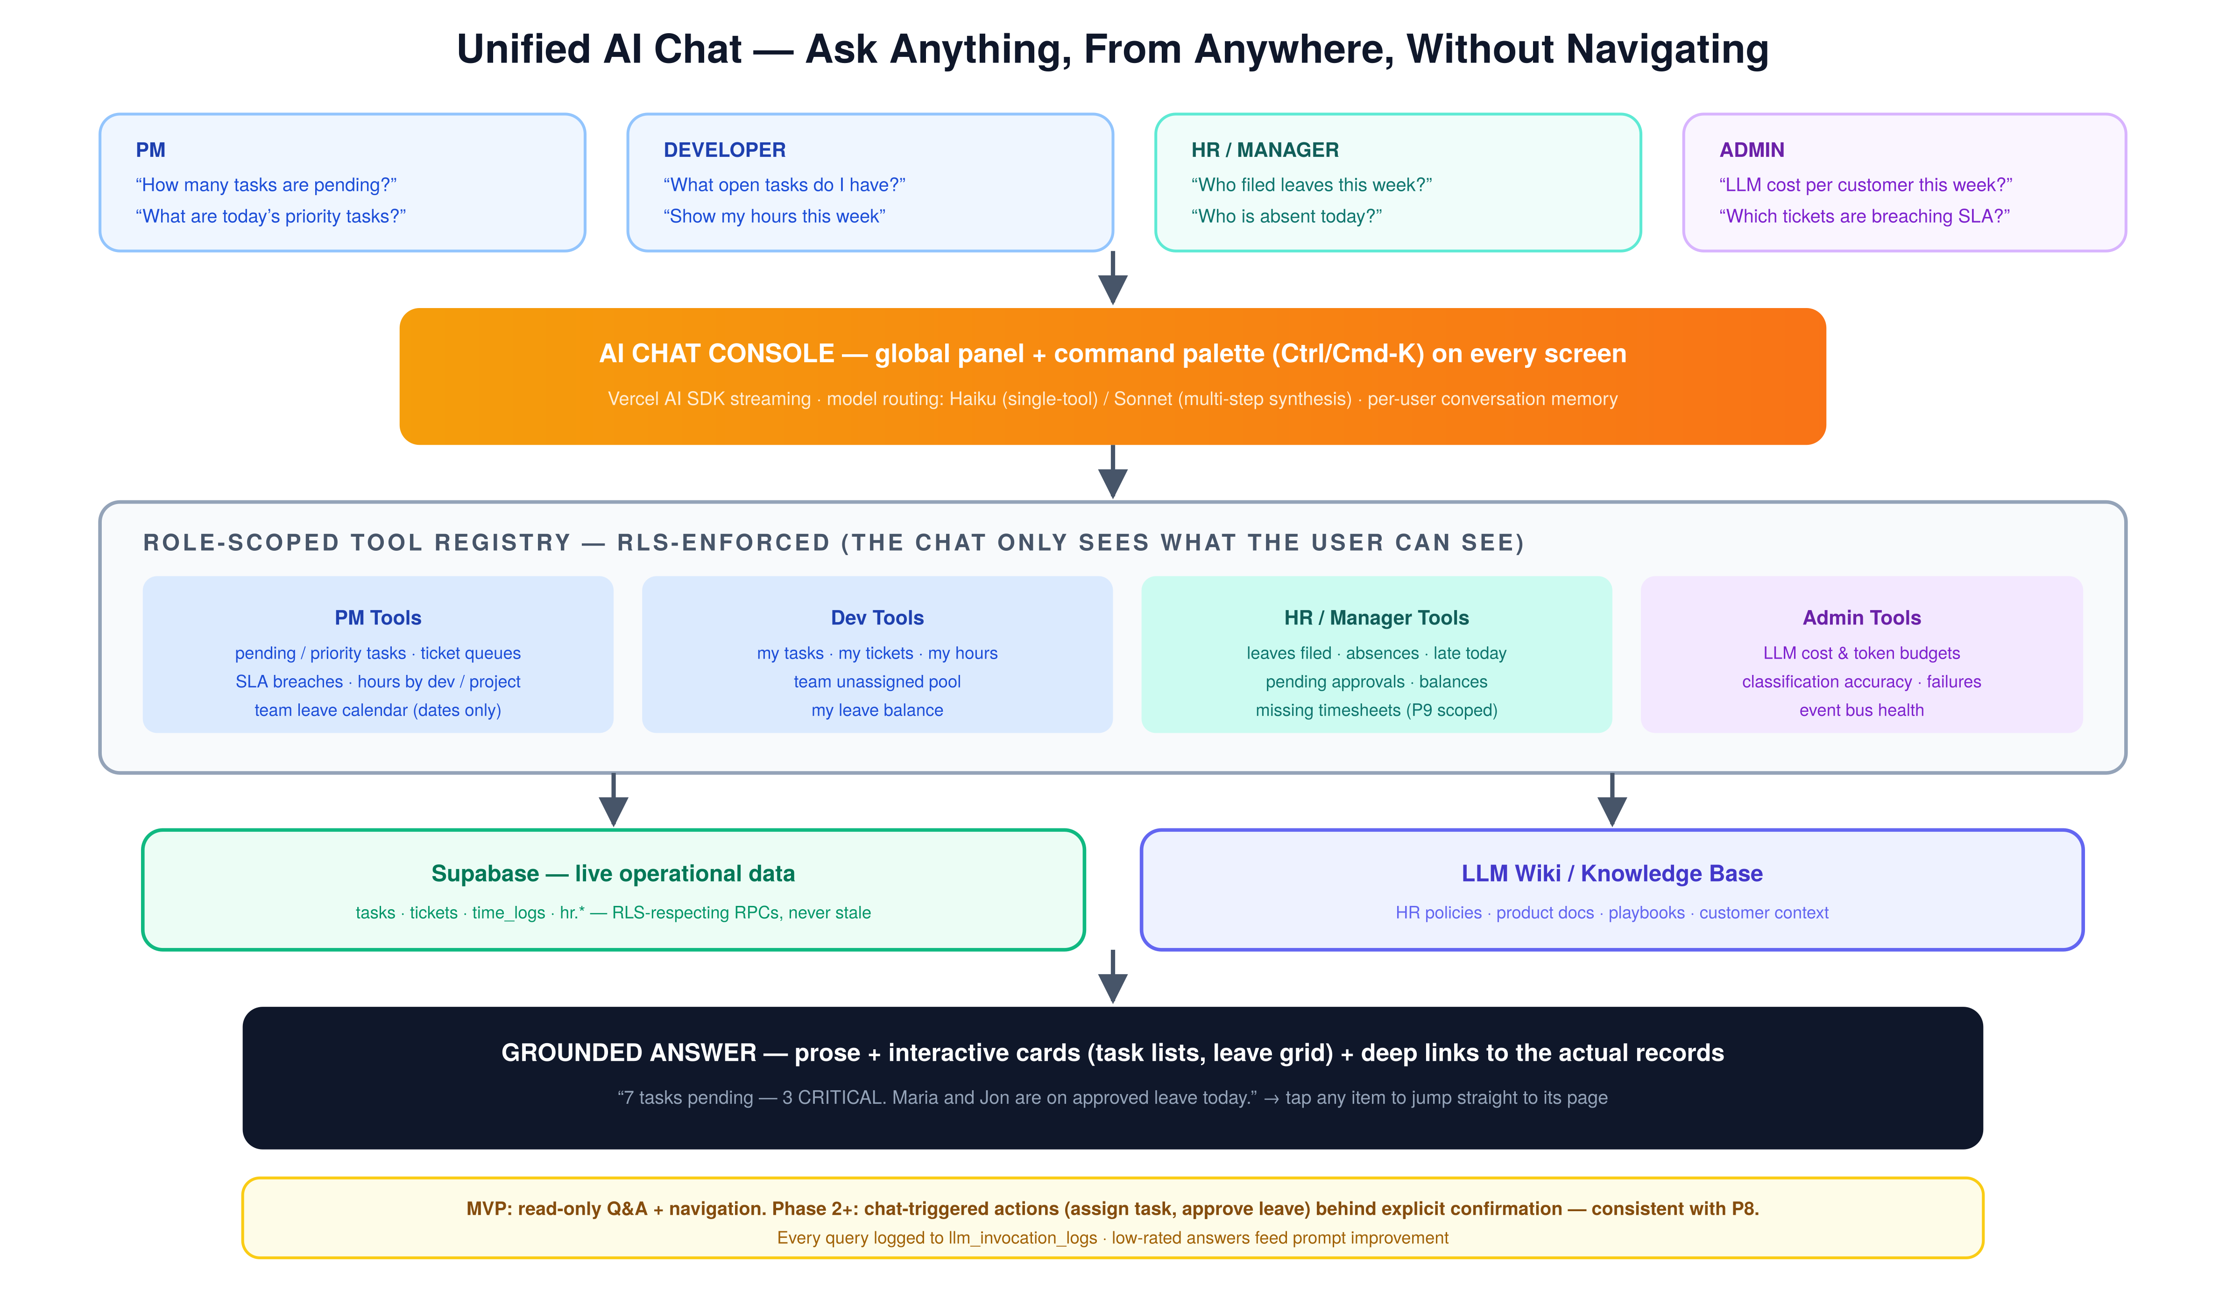
Figure 4 — One prompt fans out to role-scoped, RLS-enforced tools over live data and the LLM Wiki, returning a grounded answer with deep links.
- Global surface. Persistent chat panel + command palette (Ctrl/Cmd-K) on every screen; a dedicated tab in the mobile bottom nav. Conversation memory per user.
- Grounded in live data, not snapshots. Answers come from tool calls against RLS-respecting RPCs over tasks, tickets, time_logs, and hr.* tables — the same rows the dashboards render, so the chat is never stale.
- Connected to the KB. The LLM Wiki supplies policy and context: “how many leave days can I carry over?” answers from HR-policy wiki pages; customer and product context enriches PM answers.
- Role-scoped by construction. The tool registry exposed to the model is filtered by the requester's role, and every tool runs under the requester's RLS context — the chat can only see what the user can see. HR answers follow P9 scoping (e.g., a PM sees the team leave calendar dates; HR sees full records).
- Answers as UI, not just prose. Responses include interactive cards (task lists, leave/absence grids, hours tables) with deep links — tap any item to jump straight to its page.
- Model routing. Haiku handles single-tool lookups (the vast majority); Sonnet handles multi-step, cross-module synthesis (“compare hours by developer for May and flag anyone over the load threshold”). Configurable per llm_config (P7).
- Read-only at MVP. Q&A and navigation only. Phase 2+ adds chat-triggered actions (assign task, approve leave) behind explicit confirmation dialogs — consistent with P8, Manual First.
- Observability. Every chat invocation logs model, tokens, latency, and tools called to llm_invocation_logs; a one-tap answer rating feeds prompt improvement, mirroring the digest feedback loop.

8. Technical Specifications

8.1 Application Architecture
Next.js App Router with route groups per audience. Server Components render all dashboards (fast initial paint, RLS-scoped queries on the server). Server Actions handle mutations — each mutation that matters writes an event_bus row in the same transaction. Route Handlers exist only for the inbound email webhook, cron endpoints, and AI streaming. Long-running LLM work (plan generation, execution) runs via Supabase Queues and a cron-invoked worker, never inline in a user request.
src/app/(auth)/ login, magic link, password reset
src/app/(client)/ client portal: requests, onboarding, status
src/app/(hub)/dashboard/ role-based home (PM / Dev / HR variants)
src/app/(hub)/projects/ boards, lists, task detail
src/app/(hub)/desk/ ticket queues, ticket detail and thread
src/app/(hub)/orchestration/ classification review, plans, executions
src/app/(hub)/hr/ attendance, leaves, timesheets, people, announcements
src/app/(hub)/kb/ LLM Wiki browser and editor
src/app/(hub)/admin/ roles, llm_config, leave types, holidays
src/app/api/ events worker, inbound-email, cron, ai streaming
src/lib/ supabase, ai, sanity, github, resend, events, rbac

8.2 Authentication, Roles & Multi-Tenancy
- Supabase Auth: email + password and magic links for staff; magic-link / OTP for client portal users. Optional Google OAuth for staff.
- A profiles table extends auth.users with role (admin | hr | pm | developer | client) and, for clients, customer_id.
- RLS everywhere. Clients see only rows where customer_id matches their JWT. Developers see assigned or team-pool work plus their own time logs and HR records. PMs see all PM/Desk data and the team leave calendar (dates only). HR has the full HR schema but no special grant on customer execution data. Admin sees all.
- HR tables live in a dedicated Postgres schema (hr) so policy review is isolated (P9).
- All privileged mutations are audit-logged (actor, action, entity, before/after).

8.3 Data Model
Carried forward unchanged from v0.1: customers, customer_products, classification_records, requirements_assessments, implementation_plans, execution_records, playbooks, llm_invocation_logs, digest_logs, llm_config — with zoho_* columns dropped and source re-enumerated (portal | email | manual | recurring).

New — Project Management core
Table | Key Columns | Purpose
projects | customer_id, customer_product_id, status, dedicated_developers[] | Project workspace per customer/product; auto-created on onboarding completion
tasks | project_id, ticket_id, parent_task_id, task_type, priority, status, assignees[], due_date, estimate_hours, position, classification_id, github_pr_url, preview_url | Core work item; Kanban ordering via position; links the full AI context chain
task_comments | task_id, author_id, body | Threaded discussion per task
attachments | entity_type, entity_id, storage_path | Polymorphic file attachments (tasks, tickets, leaves)
time_logs | task_id, project_id, employee_id, date_logged, hours, billable, source (timer|manual), timesheet_id | Single source for PM hours views and HR timesheets

New — Client Request Desk
Table | Key Columns | Purpose
tickets | ticket_number (serial), customer_id, channel (portal|email|manual), priority, status, requester_email, sla_due_at, first_response_at, classification_id | Client request record; fires classification on insert
ticket_messages | ticket_id, author_type (client|staff|system|llm_draft), body, email_message_id, visibility (public|internal) | Threaded conversation incl. email threading and internal notes

New — HR schema (hr.*)
Table | Key Columns | Purpose
hr.employees | profile_id, employee_number, manager_id, employment_type, date_hired, status | Directory and org structure; manager drives approval routing
hr.attendance_punches | employee_id, punched_at, direction (in|out), ip, geo, device | Raw clock events (offline-queued on mobile)
hr.attendance_days | employee_id, work_date (unique pair), status, first_in, last_out, total_hours | Derived nightly by cron from punches + leaves + holidays
hr.leave_types | name, paid, accrual_rule (jsonb), carry_over_cap | Table-driven policy — no hard-coded rules
hr.leave_balances | employee_id, leave_type_id, year, accrued, used, balance | Auto-maintained by accrual cron and approvals
hr.leave_requests | employee_id, start/end_date, half_day, status, approver_id, attachment_path | Request → approval workflow; updates pool eligibility
hr.holidays | holiday_date, name, type (regular|special) | PH calendar; drives attendance derivation
hr.timesheets | employee_id, week_start (unique pair), status (draft→submitted→approved→locked) | Weekly rollup of time_logs; payroll export source
hr.announcements / hr.hr_requests | title, body, pinned / request_type, status | Company feed and generic HR requests

New — Platform plumbing
Table | Key Columns | Purpose
event_bus | event_type, entity_type, entity_id, payload, status, attempts, available_at | Transactional event queue — written by triggers in the same transaction as the mutation
notifications | recipient_id, event_type, title, link, read_at, channels_sent[] | Durable notification inbox (truth; realtime accelerates delivery)
notification_preferences | profile_id, event_type, in_app, push, email | Per-user channel matrix
push_subscriptions | profile_id, endpoint, keys | Web Push registrations
audit_logs | actor_id, action, entity, before, after | Privileged-mutation audit trail

8.4 Internal Event Bus (replaces Zoho webhooks)
- AFTER INSERT/UPDATE triggers on tickets, tasks, hr.leave_requests, and execution_records write typed rows into event_bus — transactional with the mutation, so no events are ever lost.
- A worker (invoked every minute by pg_cron via pg_net, and immediately by Server Actions for latency-sensitive events) claims pending rows with FOR UPDATE SKIP LOCKED and dispatches: ticket.created / task.created → Classification; classification.completed (high priority) → notification fan-out; leave.approved → balance deduction + pool refresh; execution.completed|failed → notifications + circuit-breaker counters.
- Handlers are idempotent; exponential backoff on attempts; rows marked failed after 5 attempts surface in the admin dashboard.
This preserves v0.1's “classification within 60 seconds” acceptance criterion with zero external webhook dependencies.

8.5 Realtime Architecture
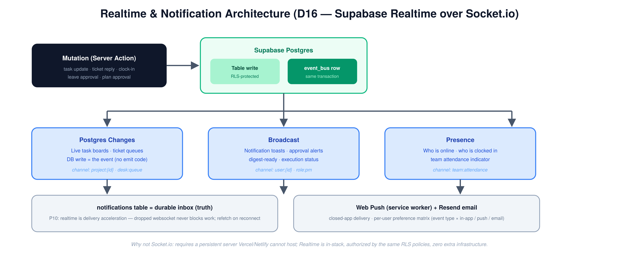
Figure 4 — One mutation fans out through Postgres Changes, Broadcast, and Presence; the notifications table remains the durable truth.
Feature | Mechanism | Channel scheme
Live task boards | Postgres Changes on tasks | project:{id} (RLS-authorized)
Ticket queue updates | Postgres Changes on tickets | desk:queue
Notification toasts / inbox | Broadcast | user:{profile_id}
Clocked-in indicator | Presence | team:attendance
Plan approval alerts | Broadcast | role:pm

- Client hook pattern: subscribe on mount, reconcile with a refetch on reconnect (P10 graceful degradation).
- Web Push (service worker) for closed-app delivery of HIGH/CRITICAL events, leave decisions, and digest-ready alerts.

8.6 PWA & Cross-Device Strategy
- Serwist service worker: precached app shell, stale-while-revalidate for static assets, network-first for data.
- manifest.json: standalone display, theme #0F172A, maskable 192/512 icons, app shortcuts (Clock In, New Task, My Tickets).
- Installable on iOS (Add to Home Screen), Android (install prompt), and desktop (Chrome/Edge).
- Offline behavior: shell + last-loaded dashboards readable. Queued offline mutations are out of MVP scope except clock-in/out punches, which queue in IndexedDB and sync on reconnect (field-friendly, D22).
- Responsive rules: bottom tab nav below 768px (Dashboard / Tasks / Clock / Inbox / More); sidebar at 768px and above; shadcn Sheet for mobile detail panes; large touch targets on attendance and approval actions.

8.7 API Surface
- Internal data access via Server Components + Server Actions — no public REST needed for the app itself.
- Route handlers (secret- or JWT-protected): POST /api/inbound-email (Resend Inbound → ticket), POST /api/cron/* (digest, attendance-derive, leave-accrual, wiki-lint, event-worker), POST /api/ai/chat (the unified Ops Console endpoint — AI SDK streaming with a per-role tool registry over PM, Desk, and HR data plus LLM Wiki retrieval), POST /api/github/webhook (PR status → task links).
- All LLM tool calls are read-scoped through RLS-respecting RPCs; the model never receives a service-role client for HR data (P9).

8.8 LLM Model Selection & Observability
Layer | Default Model | Notes
Classification | Claude Haiku (claude-haiku-4-5-20251001) | Unchanged from v0.1
Daily Digest | Claude Haiku | Now includes HR signals
Reply Generation | Claude Haiku | Unchanged
HR Assistant (new) | Claude Haiku | RLS-scoped tools, per-requester
Ops Chat / Query Engine (new) | Claude Haiku → Sonnet | Haiku for single-tool lookups; Sonnet for multi-step cross-module synthesis
Requirements Assessment | Claude Sonnet (claude-sonnet-4-6) | Unchanged
Plan Generation | Claude Sonnet | Unchanged
Code Execution | Claude Sonnet | Unchanged
Orchestration / Routing | Claude Sonnet | Unchanged

- llm_config table per layer (P7); every invocation logs model, tokens, latency, cost, customer_id; soft daily token budget per customer with PM alert.

8.9 Security & Compliance
- RLS on every table; HR schema policies reviewed independently (P9).
- Secrets in Vercel env / Supabase Vault — the Hub stores no product credentials (D4 carried forward); product access via MCP-provisioned tools.
- Audit log on: role changes, HR record edits, attendance corrections, leave decisions, plan approvals, executions, manual reclassification.
- PII: HR documents in a private Storage bucket, signed URLs with short TTL.
- Philippine Data Privacy Act (RA 10173) posture: documented lawful basis for employee data, retention schedule for separated employees, access logging via the audit table.
- Backups: Supabase PITR enabled; weekly logical dump to cold storage.

9. Integration Map (Revised)
System | Direction | What | How
Sanity CMS | Hub → Sanity | Create/update/publish documents, assets, scheduling | Sanity API per sanity_project_id
GitHub | Hub → GitHub | Branch, commit, PR creation (execution engine) | GitHub API / Actions + Claude Code
GitHub | GitHub → Hub | PR merged/closed, deploy preview URL | GitHub webhook
Vercel / Netlify | → Hub | Preview URL capture | Deploy webhook / GitHub status
Product APIs | Hub → Products | Settings changes | MCP tools
Resend | Hub → Email | All outbound notifications, replies, digests | Resend API + React Email
Resend Inbound | Email → Hub | support@ → ticket | Inbound webhook
Zoho (all) | — | Removed | Migration only (Section 10)

10. Zoho Migration Plan
Strategy: module-by-module cutover with a short read-only overlap. No long-running bidirectional sync (building sync to a system being decommissioned is wasted effort; freeze + import per module instead — D18).
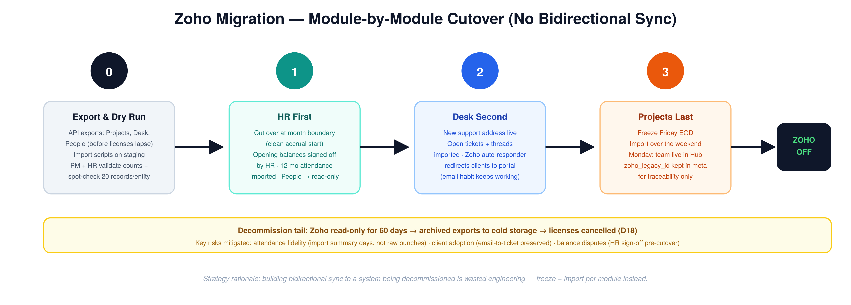
Figure 5 — Cutover order: HR first at a month boundary, Desk second, Projects last over a weekend freeze.
Step | Action
1. Export | Zoho Projects (projects, tasks, time logs via API/CSV), Zoho Desk (tickets + threads + attachments via API), Zoho People (employees, leave types, balances, leave history, attendance history). Cliq: nothing to migrate (ephemeral). Mail: no migration — mailboxes stay on the email provider.
2. Map & import | Node scripts against the Supabase service role: Zoho project → projects; task → tasks (status/priority mapping table); time log → time_logs; ticket → tickets + ticket_messages; employee → hr.employees; balances → hr.leave_balances (opening balances as adjustment rows); 12 months attendance → hr.attendance_days (marked source: zoho_import).
3. ID preservation | zoho_legacy_id stored in a meta jsonb column on imported rows for traceability — never used operationally.
4. Dry run | Full rehearsal on staging Supabase; PM + HR validate counts and spot-check 20 records per entity.
5. Cutover order | (a) HR first at a month boundary (clean accrual start), Zoho People → read-only. (b) Desk second — new support address live, Zoho auto-responder points clients to the portal, open tickets imported. (c) Projects last — freeze Friday, import over the weekend, Monday live.
6. Decommission | Zoho retained read-only for 60 days, then archived exports to cold storage and licenses cancelled.

Risks & mitigations: attendance history fidelity (import summary days, not raw punches) · client portal adoption (email-to-ticket keeps the old habit working) · leave balance disputes (HR sign-off on opening balances before cutover).

10.6 Migration from the Existing v0.1 Codebase (what stays, what changes)
Two sprints of v0.1 implementation already exist (customer creation, onboarding, classification engine, orchestration page, migrations 001–024). The v2.0 build extends that codebase — it does not restart it. The table below is the sprint-planning contract; anything marked “verify” gets confirmed against the repo in Sprint 0A.
Existing (v0.1) | v2.0 Disposition | Notes
customers, customer_products | KEEP, extend | Drop/ignore zoho_account_id and zoho_project_id (retain columns until Phase 1D for import traceability, then archive). sanity_project_id and github_repo stay — they power US-PUB-1.
customer_projects (migration 024) | RENAME → projects | Becomes the v2.0 projects table: add status, dedicated_developers[], customer_product_id FK per §8.3. Single ALTER/RENAME migration, no data copy.
classification_records | KEEP as-is (not renamed) | tickets is a NEW table, not a rename. Relationship: tickets.classification_id / tasks.classification_id → classification_records.id. Migration: widen source check from (zoho_desk, zoho_projects) to (portal, email, manual, recurring); zoho_ticket_id / zoho_task_id become nullable legacy columns moved into meta at Phase 1D.
requirements_assessments, implementation_plans, execution_records, playbooks, llm_invocation_logs, digest_logs, llm_config | KEEP unchanged | The AI chain tables carry forward exactly; execution_records.preview_url already exists and is reused by US-PUB-1.
/(hub)/orchestration page | KEEP as a dedicated surface | Remains the AI-pipeline review surface (classification review, plans, executions) under (hub)/orchestration. The new PM module links into it from task detail; it is not absorbed into Projects.
/(hub)/classification page | MERGE into orchestration | Classification review becomes the first tab of the orchestration surface; route redirects.
/(hub)/pm, /(hub)/dev stubs | BECOME dashboard variants | Fold into (hub)/dashboard role-based home per §8.1; routes redirect.
Onboarding flows (M1 work) | KEEP, change one hook | Completion handler now creates the native project row instead of a Zoho Project; everything else stands.
api/webhooks + api/zoho routes, lib/zoho | RETIRE | Replaced by the event bus (§8.4) and api/inbound-email. lib/zoho survives only inside one-off import scripts for Phase 1D, then is deleted.
Classification engine core | KEEP, swap the adapter | The Haiku classifier and record-writing logic are unchanged; only the input adapter changes from Zoho webhook payloads to event_bus rows (ticket.created / task.created).
Permissive RLS (migration 003) | REPLACE | Phase-1 permissive authenticated policies are superseded by the full v2.0 role matrix (§8.2) in Sprint 0A — this was already the planned tightening.
@ducanh2912/next-pwa setup | KEEP (verify) | Works for the v2.0 PWA scope; migrating to Serwist is optional and deferred unless push-handling requires it.

Net effect: roughly 80% of the existing code carries forward untouched. The destructive changes are exactly three — rename customer_projects, widen the classification source enum, and retire the Zoho webhook/client layer — each a single migration plus a route cleanup.

11. MVP Scope & Acceptance Criteria (v2.0)
The MVP validates two loops: (1) a client request arrives → classified → assessed → planned → human approves → executed → reply sent; and (2) the team runs a full week of attendance, leaves, and timesheets natively.
Milestone | Scope
M1 — Customer & Onboarding | Unchanged from v0.1 (dynamic forms, progressive completion, profile, product mapping)
M2 — Native Desk + Classification | Portal submission and email-to-ticket both create tickets; classification record within 60s; low-confidence surfaced for PM; manual reclassification
M3 — Requirements Assessment | Unchanged (CLEAR / PARTIAL / BLOCKED, clarification drafts, re-assessment on reply)
M4 — Daily Digest | Unchanged, plus HR signals for managers
M5 — Plan Generation (manual) | Unchanged (steps, affected files, risk flags, structured rejection reasons)
M6 — Execution + Reply | Unchanged; replies sent via Resend into the ticket thread
M7 — Native Project Management | Projects auto-created on onboarding completion; Kanban + list views; task CRUD, comments, attachments; live board updates; review/closure flow
M8 — Time Tracking | Timer + manual logs; PM hours queries by dev/project/task/date range; export
M9 — Developer Dashboard | Unchanged, native links
M10 — LLM Wiki Seed | Unchanged, plus HR policy pages in the Internal KB
M11 — HR Core (NEW) | Employee directory; clock in/out (mobile PWA, offline-queued); derived attendance days; leave types + request/approval + balances; weekly timesheet submit/approve; announcements; notification inbox + push
M12 — Migration Complete (NEW) | All three Zoho cutovers executed per Section 10; Zoho in read-only
M13 — Unified AI Chat (NEW) | Global chat panel + command palette; role-scoped read tools across PM, Desk, and HR; KB-grounded answers with deep links and interactive cards; per-query logging and answer rating
M14 — MVP Stats Page (NEW) | Minimal read-only reporting from MVP: hours by developer/project, task throughput (created vs completed per week), ticket volume + SLA hit rate, attendance summary — Supabase views + simple charts, no configurability. Leadership visibility from Week 16, not Week 30+. Full reporting dashboard still lands in Phase 2

Acceptance Criteria
# | Criterion
AC1 | A client submits a request from a phone via the portal; the PM sees it classified in the Hub within 60 seconds.
AC2 | A CONTENT_UPDATE completes classify → plan → approve → execute → client reply without leaving the Hub.
AC3 | A developer self-assigns from the team pool; the PM receives a realtime notification; logged hours appear in the PM hours view.
AC4 | An employee clocks in from mobile, files a half-day leave, gets manager approval — and the balance, team calendar, and assignment pool all update automatically.
AC5 | A full payroll-period timesheet export is produced from Hub data with zero reference to Zoho.
AC6 | A PM asks the chat “what are today's priority tasks, and who is absent?” and receives an accurate, RLS-scoped answer with deep links — without opening the Projects or HR tabs.
AC7 | PM clicks “Publish to dev” on a completed content task; the Hub publishes via Sanity, triggers the StackShift staging rebuild, and the dev URL appears on the task and in the drafted client reply (US-PUB-1).

12. Phase Roadmap (Revised)
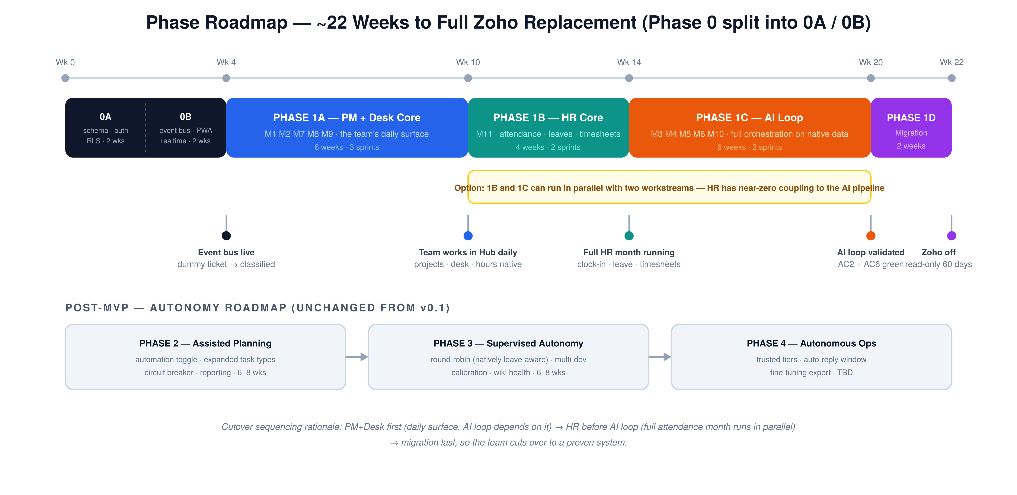
Figure 7 — ~20–21 weeks to full Zoho replacement; the post-MVP autonomy roadmap is unchanged from v0.1.
Phase | Scope | Duration
0A — Schema & Auth | Full v2.0 schema (PM + Desk + HR + plumbing) via migrations on the existing v0.1 database per §10.6 (rename customer_projects → projects, widen classification source enum), Supabase Auth + full role RLS matrix replacing permissive Phase-1 policies, Zoho export access verified (O5) | 2 wks
0B — Infra Wiring | Event bus end-to-end (dummy ticket → classification record via the existing classifier with the new adapter), Realtime channels proven, Resend wired, PWA shell verified installable, Internal KB seeded | 2 wks
1A — PM + Desk Core | M1, M2, M7, M8, M9 — the team's daily work surface | 6 wks (3 sprints)
1B — HR Core | M11 — attendance, leaves, timesheets, announcements | 4 wks (2 sprints)
1C — AI Loop | M3, M4, M5, M6, M10, M13, M14 — full orchestration loop on native data + unified AI chat + MVP stats page | 6 wks (3 sprints)
1D — Migration & Cutover | M12 per Section 10, hardening, training | 2 wks
2 — Assisted Planning | Automation toggle, expanded task types, circuit breaker, reporting dashboard (unchanged from v0.1) | 6–8 wks
3 — Supervised Autonomy | Round-robin (now natively leave-aware), multi-dev, calibration, wiki health (unchanged) | 6–8 wks
4 — Autonomous Operations | Trusted tiers, auto-reply window, fine-tuning export (unchanged) | TBD

Phase 0 is split into 0A and 0B (D24) so the schema/auth ground truth lands before infra wiring — the original 2–3-week single phase was optimistic for six-plus migrations plus wiring. Total to Zoho replacement is now ~22 weeks. Sequencing rationale: PM + Desk first because it is the team's daily surface and the AI loop depends on it; HR before the AI loop so a full attendance month runs in parallel with AI development; migration last so the team cuts over to a proven system. If timeline pressure demands it, 1B and 1C can run in parallel with two workstreams — HR has near-zero coupling to the orchestration pipeline (only the leave → assignment-pool hook, which is one query).

13. Success Metrics
All v0.1 metrics carry forward (classification accuracy > 75%, plan approval > 60%, digest usefulness > 70%, etc.), minus Zoho-specific ones, plus the following new targets:
Metric | Target
Ticket first-response SLA hit rate | > 90%
Attendance derivation accuracy (vs HR spot-check) | > 99%
Leave request → decision median time | < 24 hours
Timesheet on-time submission rate | > 95%
Realtime delivery (event → UI) p95 | < 3 seconds
Ops Chat answer accuracy (user-rated) | > 85% rated accurate
Queries resolved in chat without page navigation | Tracked (adoption signal)
Zoho licenses remaining 90 days post-cutover | 0

14. Decision Log (v2.0)
# | Decision | Rationale
D1–D3, D5, D7, D9–D15 | Carried forward from v0.1 | Unchanged
D4 | No credential storage in Hub | Carried forward
D6 → D6.2 | Hub = Intent, Zoho = Execution → superseded: Hub is the System of Record | New principle P4
D8 → D8.2 | Status via reply thread → superseded: native client portal with status + thread | First-party portal now has near-zero marginal cost
D16 | Supabase Realtime over Socket.io | Socket.io is incompatible with serverless hosting; Realtime is in-stack, RLS-authorized, and covers Changes / Broadcast / Presence. Revisit only if sub-50ms collaborative features emerge.
D17 | Resend for all outbound email + inbound ticket ingestion | Mailboxes stay on a standard provider; the Hub is a notification sender, not a mail client
D18 | Module-by-module cutover, no bidirectional Zoho sync | Sync to a dying system is wasted engineering; freeze + import per module
D19 | HR in a dedicated hr schema with independent RLS review | P9 — privileged data isolation
D20 | Event bus = transactional Postgres table + worker, not an external queue service | Events written in the same transaction as mutations (no loss); a SKIP LOCKED worker is sufficient at this scale
D21 | Payroll computation out of scope; approved-timesheet export only | Avoids regulatory scope creep at MVP; revisit Phase 3+
D22 | Offline mutation queue limited to attendance punches at MVP | Highest field value, lowest conflict risk
D23 | One unified Ops Chat instead of per-module prompt boxes | A single tool-calling surface with a per-role tool registry is cheaper to build, observe, and improve than three separate prompt features; read-only at MVP per P8
D24 | Phase 0 split into 0A (schema + auth) and 0B (infra wiring) | The single 2–3-week Phase 0 was optimistic for 6+ migrations plus event bus, realtime, PWA, and email wiring; 2 + 2 weeks is the honest timeline (review finding #3)
D25 | Minimal read-only stats page in MVP (M14) | Leadership should not fly blind for 20+ weeks until the Phase 2 reporting dashboard; M14 ships Supabase views + simple charts in Sprint 6 (review finding #4)

15. Open Items
# | Item | Owner | Priority
O1 | Final Task Type Taxonomy incl. HR_REQUEST sub-types | PM + HR | HIGH
O2 | Leave accrual rules + opening balance sign-off (per employee) | HR | HIGH
O3 | Attendance policy: grace period, geolocation on/off, correction window | HR + Mgmt | HIGH
O4 | Support email address + Resend Inbound domain setup | Dev | HIGH
O5 | Zoho API export access for all five products (before licenses lapse) | Admin | HIGH
O6 | SLA matrix per priority for the Desk | PM | MEDIUM
O7 | Notification preference defaults per role | PM | MEDIUM
O8 | PH holiday calendar 2026–2027 seed data | HR | MEDIUM
O9 | Client portal auth mode: magic link only vs optional password | PM | MEDIUM
O10 | Decide 1B/1C parallel workstreams vs sequential (staffing) | Mgmt | MEDIUM
O11 | Round-robin load threshold defaults (carried from v0.1) | PM | MEDIUM
O12 | Data fidelity sign-off on Zoho Projects export: Zoho status → Hub status (Backlog/To Do/In Progress/For Review/Done) and priority mapping table reviewed and approved by PM before the migration dry run | PM | HIGH

End of WebriQ Central Hub Specification v2.1 Draft — Confidential, Internal Use Only.

