# 

# **PRESS RELEASE**

**FOR IMMEDIATE RELEASE**  
**Title: Manuwa Announces New Single “Celebration” — A Reflective and Uplifting Anthem**  
**Release Date: 19th September 2025**

### **Lagos, Nigeria —**

Nigerian Afro-fusion artist **Manuwa** is set to release his highly anticipated single, “Celebration”, on **19th September 2025**. Known for his soulful blend of **Alte’, Afropop, and acoustic singer-songwriter** styles, Manuwa delivers a reflective yet uplifting track that reminds listeners to appreciate life’s victories — both big and small.

With a mood that is **happy, nostalgic, and calm**, “Celebration” combines the intimacy of live acoustic performance with the rhythmic pulse of Afropop, offering fans a song that resonates across personal milestones, everyday gratitude, and collective joy.

### **About the Artist**

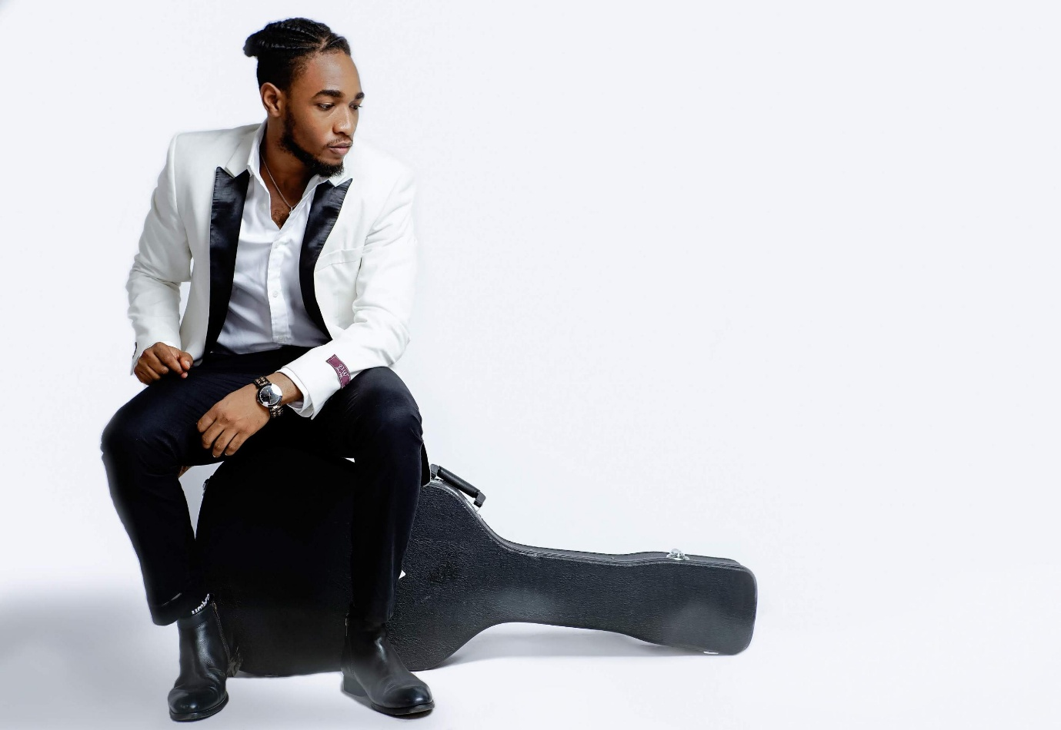Manuwa has been passionately involved in music for over **10 years**, building a diverse catalog that spans Afro-fusion, Afropop, and reflective acoustic sounds. A gifted **songwriter, vocalist, and guitarist**, his artistry has earned him recognition both locally and internationally.

* **Nigerian Idol 2015 Finalist (Runner-up)**
* **Live Performer** at Hard Rock Café, Live Lounge Lagos, and Wantan Signature Restaurant
* **Opened for Adekunle Gold** at his “Catch Me If You Can” concert at Eko Hotels (2022)
* **Performed at Ruger at the Beach** (2024)
* **Wrote theme song** “Lost in the Crowd” for the animated series “Gammy and the Living Things”

### **The Message Behind “Celebration”**

“This song is about gratitude,” says Manuwa. “It’s about pausing to reflect on life, to cherish moments of happiness, and to celebrate how far we’ve come. Whether it’s a personal win, a family moment, or simply being alive, there’s always a reason to celebrate.”

### **Target Audience**

The song is crafted for a wide demographic — from **Christians and Afrobeats enthusiasts to young professionals and diaspora audiences** across Nigeria, the UK, US, South Africa, and beyond. Its universal theme makes it a perfect fit for **weddings, graduations, events, and everyday playlists**.

### **Marketing Campaign**

A robust promotional campaign will roll out across **TikTok, Instagram, Facebook, and Nigerian entertainment blogs** such as **Pulse NG** and **BellaNaija**. Fans are encouraged to join the conversation using the hashtags:  
**#CelebrateWithManuwa #CelebrationSong #ManuwaCelebration #LifeIsACelebration #CelebrateLife #AlteCelebration**

### **Release Information**

“Celebration” will be available on **all major streaming platforms** on **19th September 2025**.

### **For Press & Media Inquiries:**

**Contact:** [paulmanuwa@gmail.com/07010460845]  
**Instagram/Twitter/TikTok:** [Paulmanuwa/Paulmanuwa1/manuwapaul]  
**YouTube:** https://youtube.com/@manuwa5608?si=AsIx74M2CMbrt172

### **About Manuwa**

Manuwa is a Lagos-based Afro-fusion artist, songwriter, and guitarist whose music blends Alte’, Afropop, and acoustic singer-songwriter traditions. With a career spanning over a decade, he has performed alongside industry greats and continues to inspire audiences with his storytelling and powerful live performances.