**Overview of Client Portal [updated April 13 2020]**

**All designs must be for a responsive site i.e. desktop/tablet/mobile version. Users of Client portal are not computer savvy.**

I am looking for the design of a simple client portal.

If a company has a backend to post messages and links to a specific client, then the client portal is for the clients to see and respond to those messages. When the client logs in, they will choose the case (if the client has more than one case) and then will see posts related to that case.

Posts can be in these formats:

A - One or MORE links to PDF Forms + a message -- > client will see the shared forms and the message from the company user + a link "I completed the form"

[we have to see if it can be made easy to mark each form marked as complete. Often one form is sent.

B - One or More links to Documents + a message

C - just a message i.e. a note.

E- Company can send a list of missing documents for the client to upload. [and client can deal with each - one at a time i.e. show the completion.]

F- the Client can post one or more Documents to post a photo of a document if on mobile + name it

G- The client can post a message for the company

We also need

A Document Checklist page design. Document Checklist shows the list of documents that needs to uploaded, and those which are already uploaded with a green checkmark beside them. It is like an aggregation of what the user has posted in one place.

**Here is a mock up of the of the idea:**

**Assume the Client portal users are very anywhere in the world, use any type of devices i.e. responsive, and their computer skills are MINIMAL. So easy of use is important**

|  |
| --- |
| Client Portal for John Smith ABC Company Logo  Case <case #> <case type> <Case status>  e.g. 2004-REF10 Consult Waiting for missing Documents  Upload Documents Take a Picture of a Document [if the user is on a mobile device] |
| [Company user] <message>  <form link1> 🡪 these forms like questionnaire that will open in tab or even a browser tab but when they save, it updates the form values on the server. [you don’t have to worry about the technology of this part, think of opening them in an iframe. <form Link 2> <form link 3>  Completed |
| [some icon?] Dear John, Please review and complete these forms  First Application  Section Application  Completed |
| [company user] <message>  <Document link> 🡪 when clicked they can preview this Doc e.g. image, pdf, MS Word  <Document link>  <document Link> |
| [Company user] <message>  E.g.  [icon or name] Hi John, I just wanted to let you know that we have scheduled a call for you on Thursday at 6pm. |
| I am uploading the requested Documents  Link 1 [each upload will either have file name or a name given by the client] Link 2 |
| Hi my rep, are there any information that I need to send you still? |
| [Company user] <message>  [file name 1] upload scan  [Filen name 2] upload scan |
| [Companyuser ] Please upload the following missing documents: Copy of your certificate 1 upload Picture of your driver’s license scan |
|  |

The colour scheme can use these brand colours:

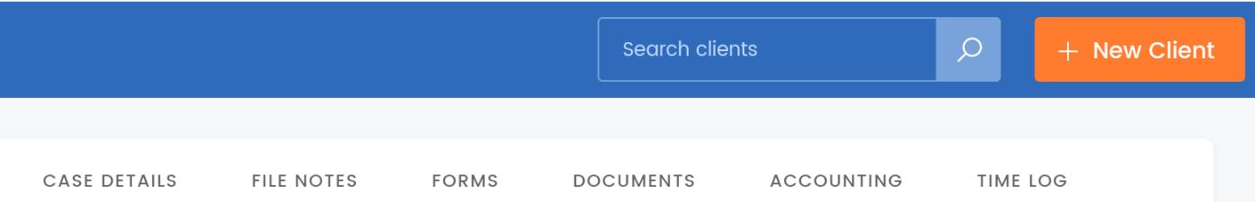

Blue, and some minimal orange and black.