Kala Design Co - Website Administration Guide
Welcome to your website admin panel! This guide will explain how to log in, manage your portfolio of projects, and check messages from potential clients.

1. Accessing the Admin Panel
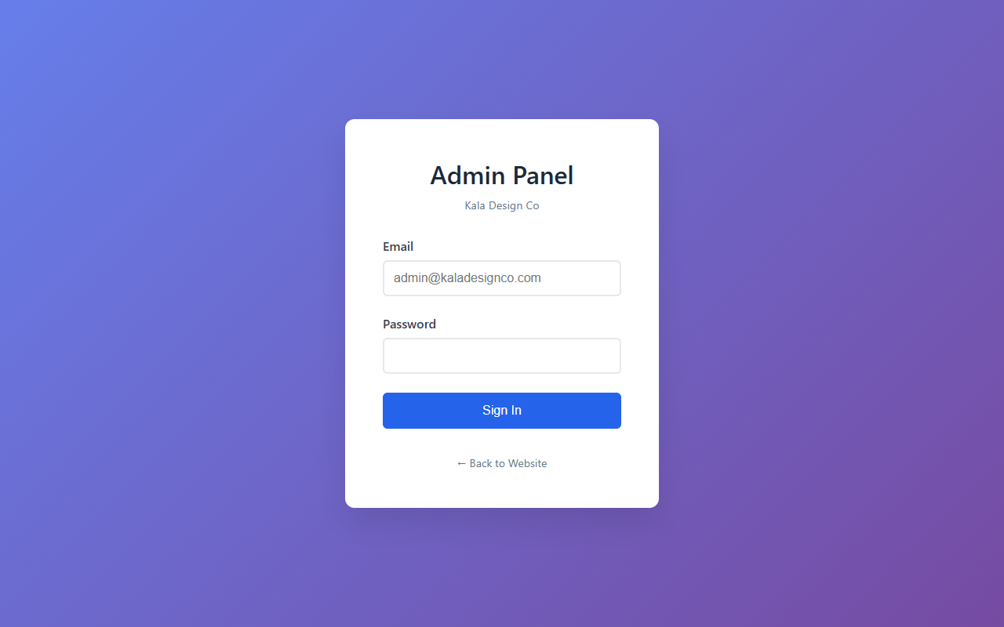
- Go to your website's admin URL (e.g., yourwebsite.com/admin or yourwebsite.com/admin/login.html).
- You will see a secure login screen.
- Enter your administrator email: admin@kaladesignco.com
- Enter your password. (If you haven't set one yet, please use the password you configured via Supabase).
- Click Login to access your dashboard.

2. Navigating the Dashboard
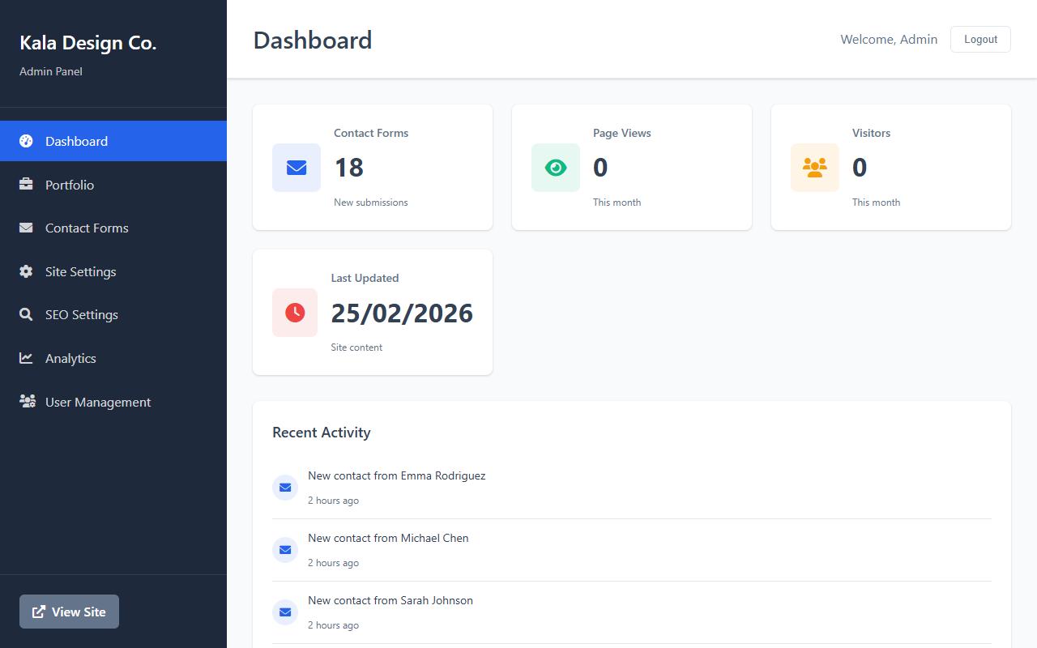
Once logged in, the left sidebar allows you to navigate the different areas of your admin panel:
- Dashboard Overview: A quick summary of your website's activity.
- Manage Works: Where you add, edit, or remove projects shown on your website's Portfolio.
- Messages: Access constraints, inquiries, and messages sent via your website's Contact form.

3. Managing Projects (Works)
This is how you keep your portfolio updated with your latest interior design projects.
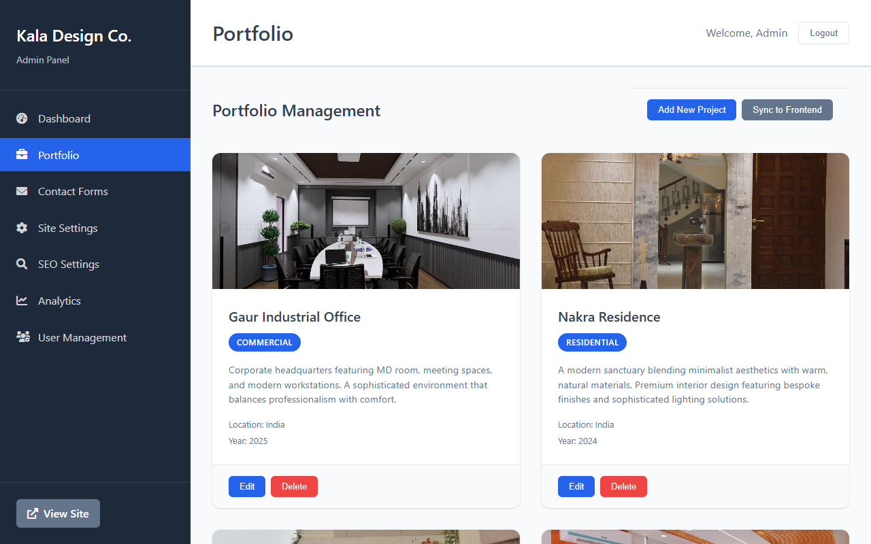

Adding a New Project
- Navigate to the Manage Works section from the sidebar.
- Click the "Add New Project" button.
- A form will appear. Fill in the following details:
  - Project Title: The name of the project (e.g., "Modern Minimalist Villa").
  - Category: The type of project (e.g., "Residential", "Commercial").
  - Location: Where the project is located.
  - Year: The year it was completed.
  - Description: A brief summary of the design goals and features.
  - Image URL: The path or internet link to the project's cover image.
    - If you uploaded an image inside your assets/projects/ folder, enter the path like this: ./assets/projects/your-image-name.jpg
  - Featured: Check this box if you want this project highlighted on your home page scroll.
- Click Save Changes. Your new project will automatically sync and appear live on your website!

Editing an Existing Project
- On the Manage Works page, scroll through your list of existing projects.
- Find the project you want to modify and click the "Edit" button next to it.
- Update any of the details in the form.
- Click Save Changes to publish your updates immediately.

Deleting a Project
- Find the project you wish to remove.
- Click the "Delete" button next to it.
- Confirm that you want to delete the project. Warning: This cannot be undone.

4. Checking Client Messages
When prospective clients fill out the contact form on your website, their information is stored here.
- Navigate to the Messages section from the admin sidebar.
- You will see a table listing all submitted inquiries, containing:
  - Date: When the message was sent.
  - Name & Email: The client's contact info.
  - Service: The type of service they selected (e.g., Consultation, Residential Design).
  - Message: Their direct message.
- You can review these items directly in this panel.
(Note: If you have enabled the Google Sheets integration, these messages will also appear in real-time in your designated Google Sheet document.)

Troubleshooting & Tips
- Images aren't loading: Ensure that your image paths strictly follow the correct spelling, including lowercase/uppercase letters. A typo like ./assets/Projects/image.JPG when the folder is actually projects/ and the image is .jpg will cause it to fail.
- Changes aren't syncing: Our system utilizes an auto-sync mechanism (frontend-sync.js). When you edit or add a project, saving the changes inside your admin immediately sends it to the database, which automatically pushes it to your live page. Try refreshing the live website to see recent changes!

