# PAGE EDITS

Different page sections and their respective Admin Panel URLs. From the URLs you will be able to edit content of sections from every page.

# About Page

ABOUT PAGE URL: <https://www.example.com/about>

# About heading and body

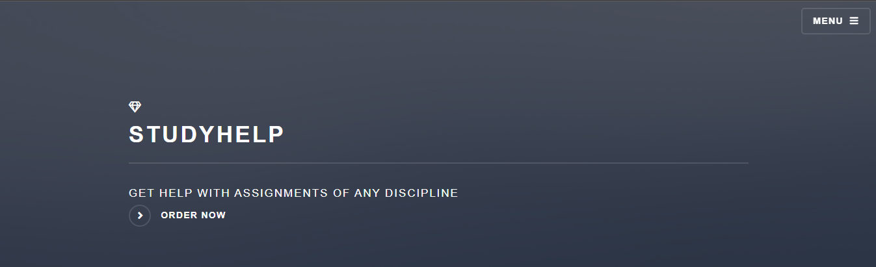

Figure : About heading and Summary

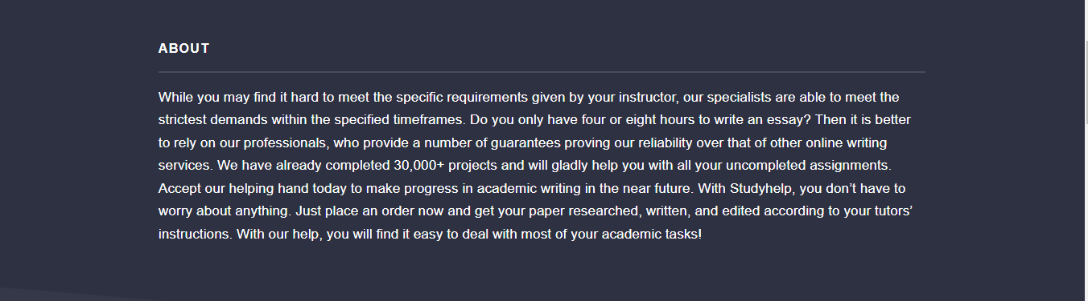

Figure : About Body

Admin URL: <https://www.example.com/admin/page_edits/aboutpage/1/change/>

# Frequently Asked Questions

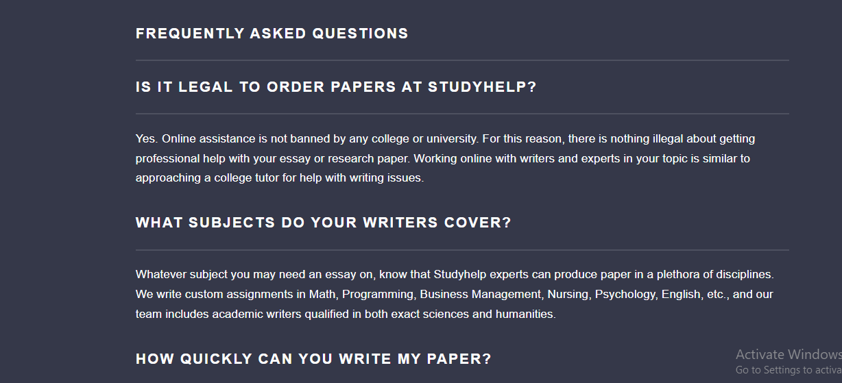

Figure : Frequently asked questions

Admin URL: <https://www.example.com/admin/how_we_work/faq/>

# Contact Section

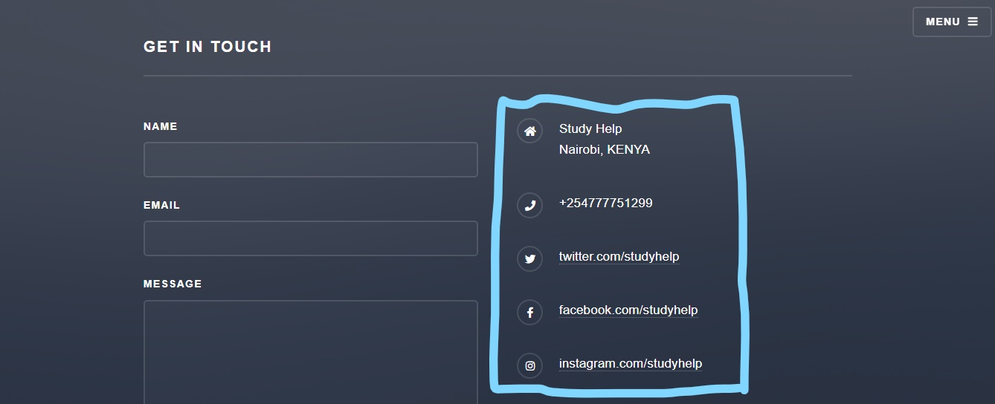

Figure : Address Links and Social Media

Admin URL: <https://www.example.com/admin/page_edits/>

# Order Page

ORDER PAGE URL: <https://www.example.com/create_order/>

## Brand Name and Header

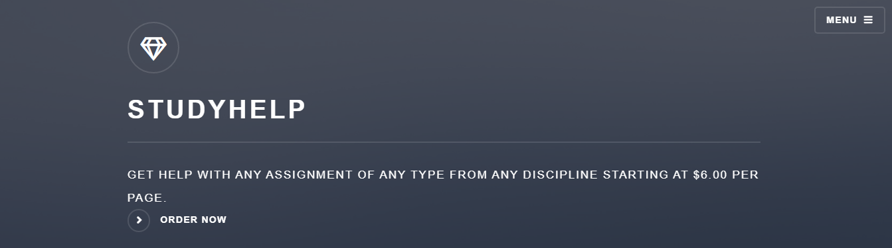

Figure : Brand name and Header

ADMIN URLS: <https://www.example.com/admin/page_edits/brandname/> ,

<https://www.example.com/admin/page_edits/homeheader/>

## How We Work Steps



Figure : How we work steps

ADMIN URLS: <https://www.example.com/admin/how_we_work/howweworkchecklist/>

## How We Work Summary

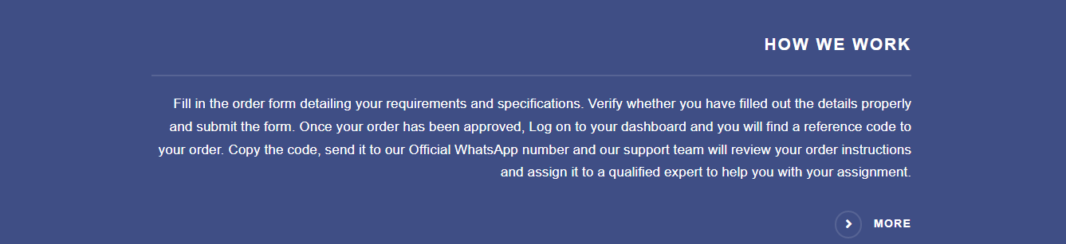

Figure : How We Work Introduction

ADMIN URL: <https://www.example.com/admin/how_we_work/howwework/1/change/>

# Dashboard Page

DASHBOARD PAGE URL: <https://www.example.com/dashboard/>

## Brand Name and Header



Figure : Brand Name and Header

ADMIN URLS: <https://www.example.com/admin/page_edits/brandname/> ,

<https://www.example.com/admin/page_edits/homeheader/>

## Contact Section



Figure : Address links and Social media

Admin URL: <https://www.example.com/admin/page_edits/>

# How we work page

HOW WE WORK URL: <https://www.example.com/how_we_work/>

## How We Work Introduction and Body

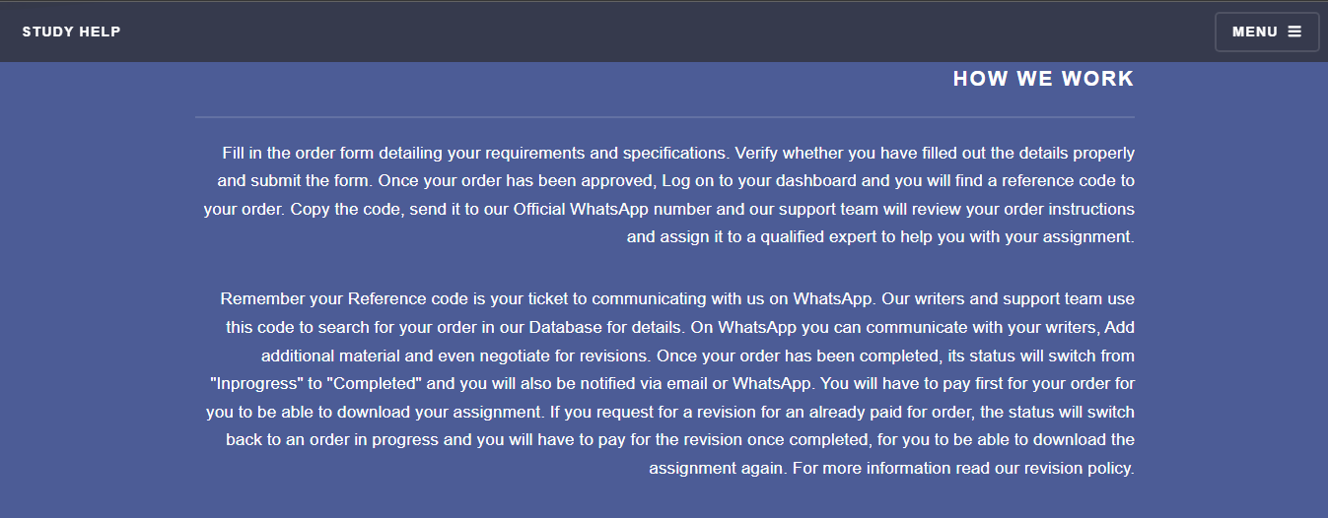

Figure : How we Work Introduction and Body

ADMIN URL: <https://www.example.com/admin/how_we_work/howwework/1/change/>

# Home Page

HOME PAGE URL: <https://www.example.com/>

## Brand Name and Header



Figure : Brand Name and Header

ADMIN URLS: <https://www.example.com/admin/page_edits/brandname/> ,

<https://www.example.com/admin/page_edits/homeheader/>

## Services

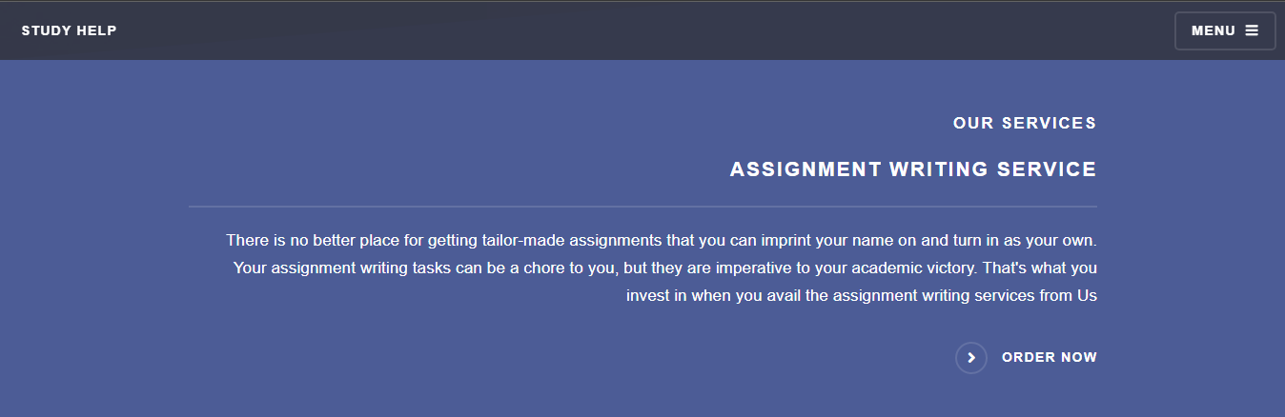

Figure : Services section

ADMIN URL: <https://www.example.com/admin/services/>

## How We Work

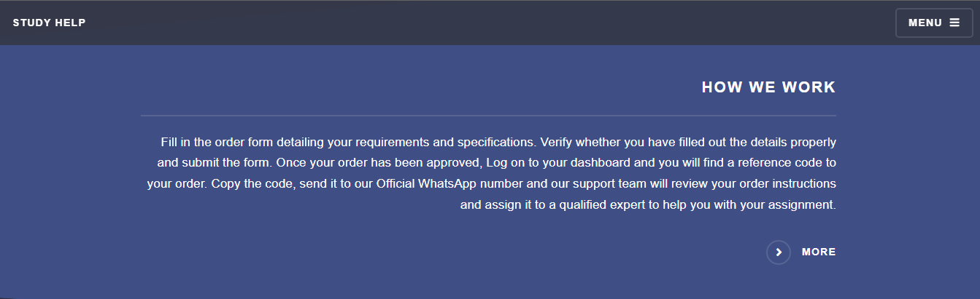

Figure : How we work Introduction

ADMIN URL: <https://www.example.com/admin/how_we_work/howwework/1/change/>

## Samples

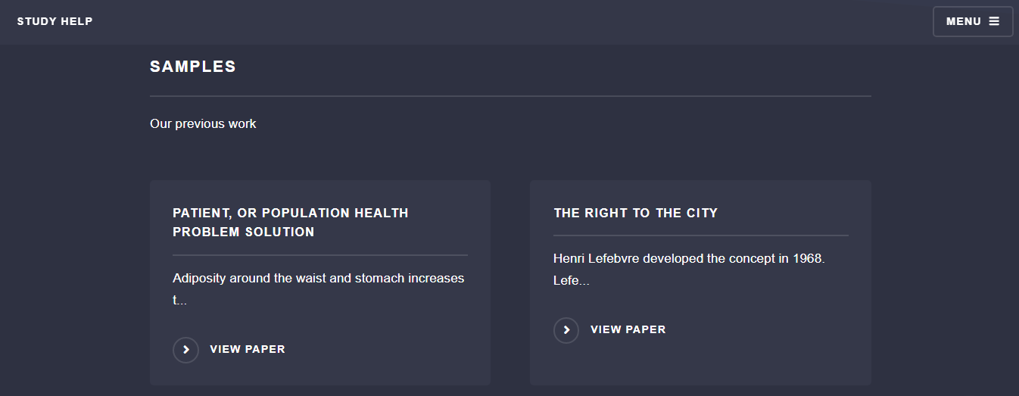

Figure : Samples section

ADMIN URL: <https://www.example.com/admin/jobs/sample/>

# Refund Policy Page

REFUND POLICY URL: <https://www.example.com/refund_policy/>

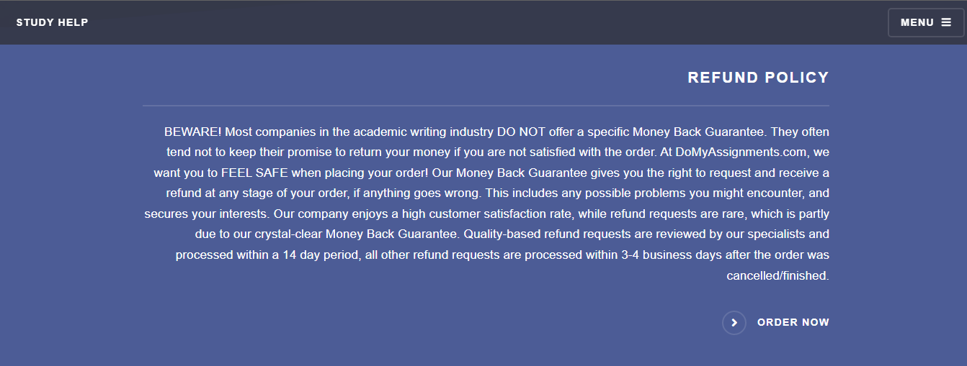

Figure : Refund policy page

ADMIN URL: <https://www.example.com/admin/refund_policy/>

Edit every section on the refund policy page via the link above.

# Revision Policy Page

REVISION POLICY URL: <https://www.example.com/revision_policy/>

## Introduction Section

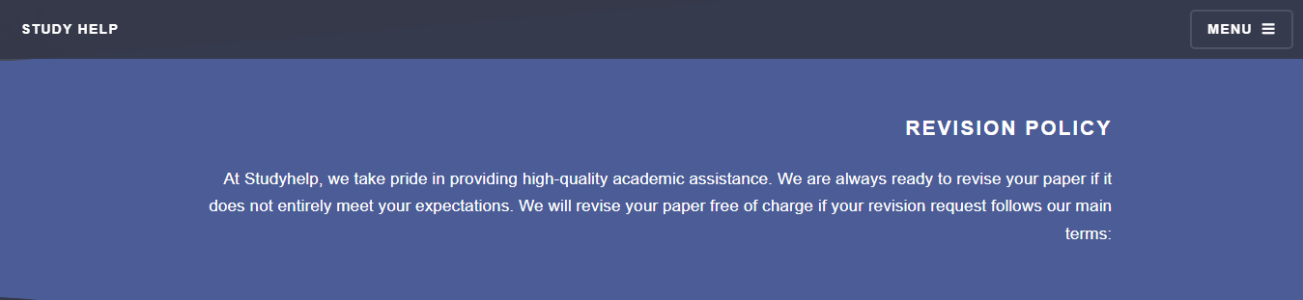

Figure : Revision Policy Introduction

ADMIN URL: <https://www.example.com/admin/revision_policy/introduction/>

## Instructions

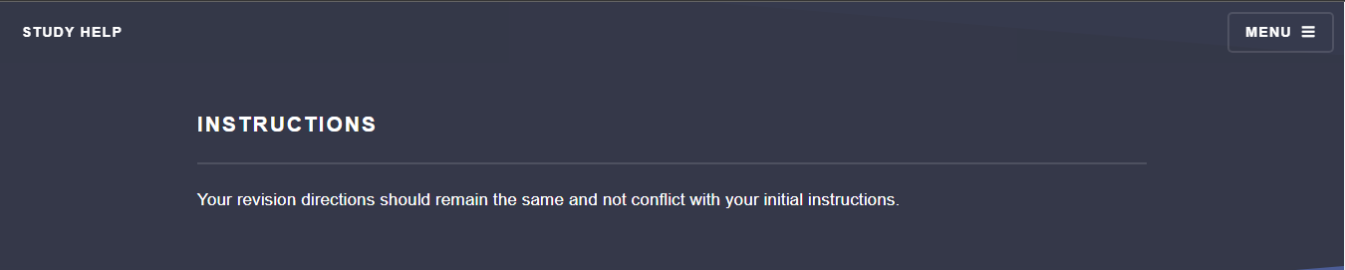

Figure : Revision Policy Instructions Section

ADMIN URL: <https://www.example.com/admin/revision_policy/instruction/>

## Submission section

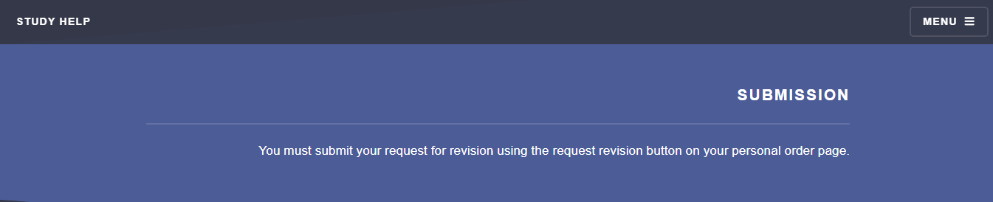

Figure : Revision policy Submission Section

ADMIN URL: <https://www.example.com/admin/revision_policy/submission/>

## Deadline

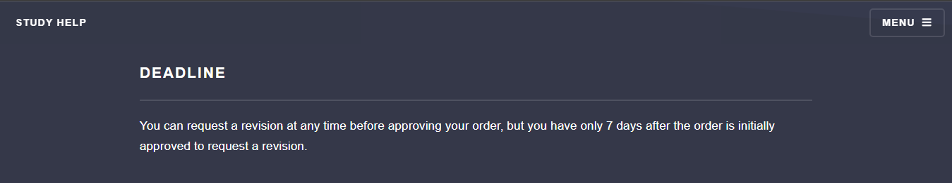

Figure : Revision Policy Deadline

ADMIN URL: <https://www.example.com/admin/revision_policy/deadline/>

## Revision Policy Conclusion

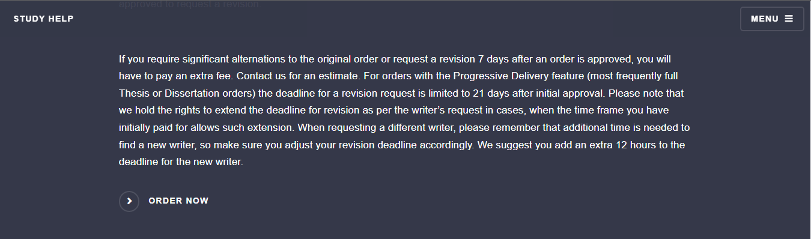

Figure : Revision policy Conclusion

ADMIN URL: <https://www.example.com/admin/revision_policy/conclusion/>