BoonYah Edits

1. Home page
   1. Let’s change the word “Opportunities” in the header of every page to “Jobs” and add “Business” to the header of all page which will hyperlink to the business page. Otherwise, there is no way to get to the business page from the white label page unless you go back to the home screen. We will still leave the “For Business” box on the home page.
   2. Remove the word “The”

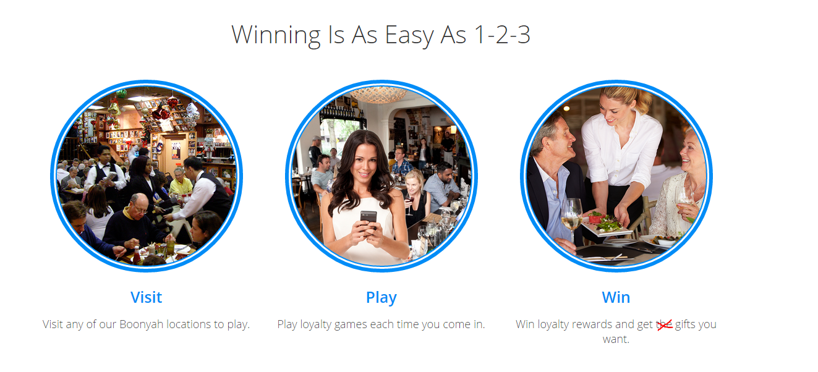

1. White Label
   1. There is an extra slide or something after slider #5 “Great results yet very affordable”. So there is something wrong with slider #6…the image is broken

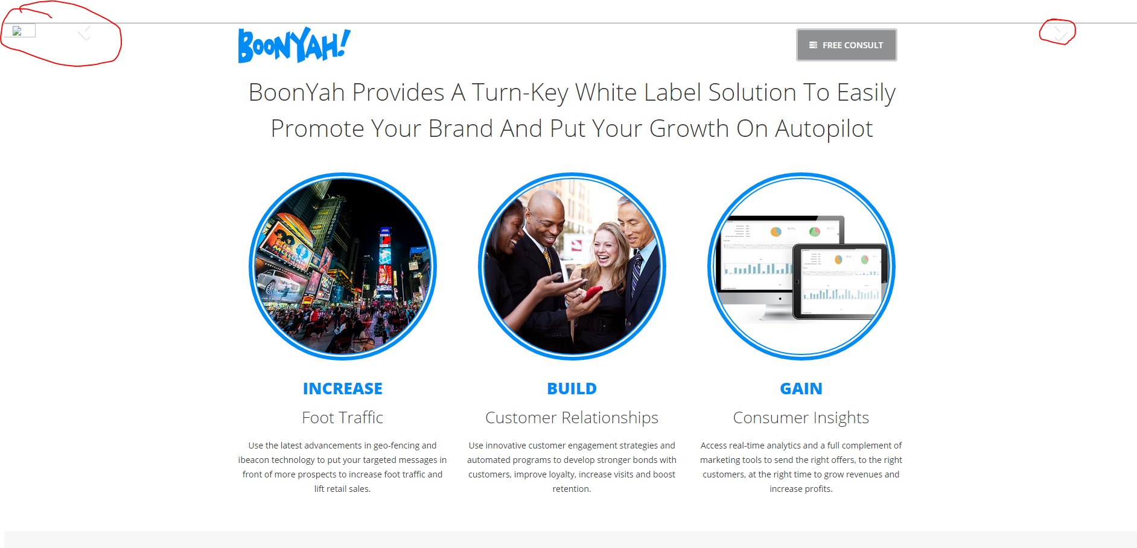

* 1. Remove the popups from the icons



* 1. We will need to make new images that doesn’t show the screen to be cut off

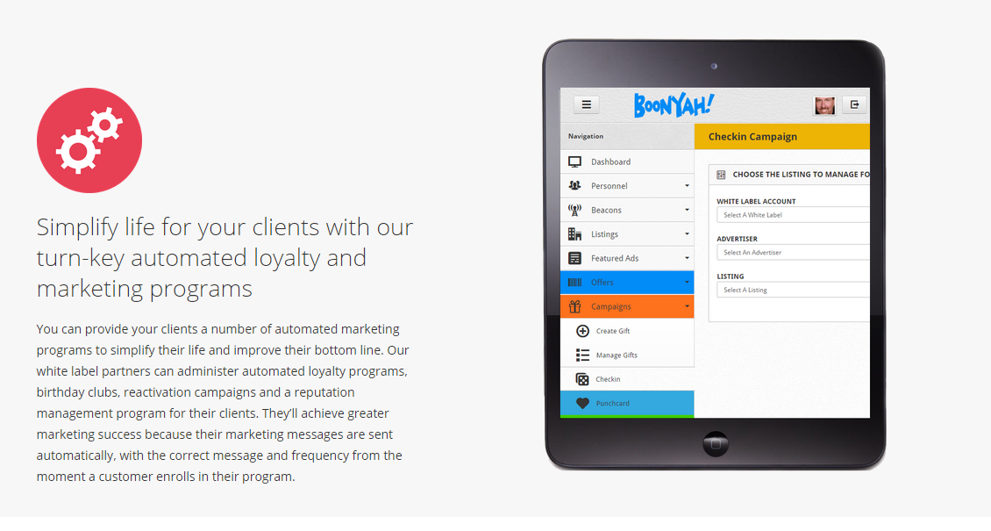



1. Business
   1. We will need to make new images that doesn’t show the screen to be cut off

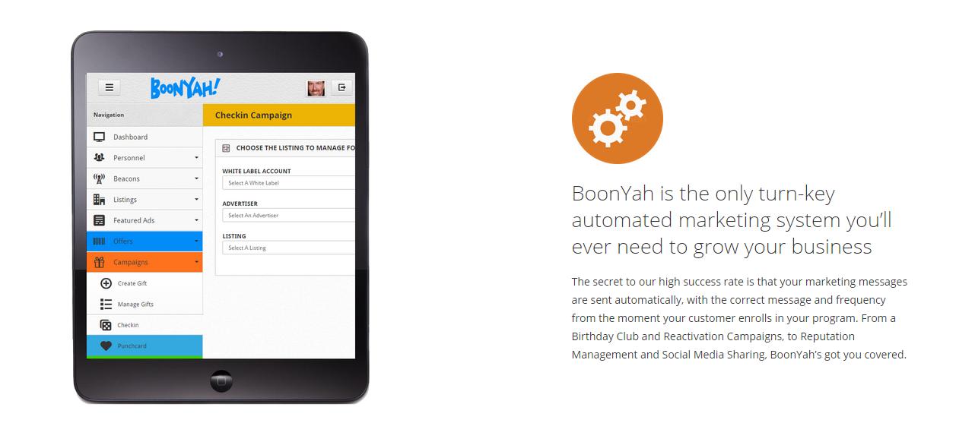

1. Images: Here are some images that you can save to try to fix the above images

