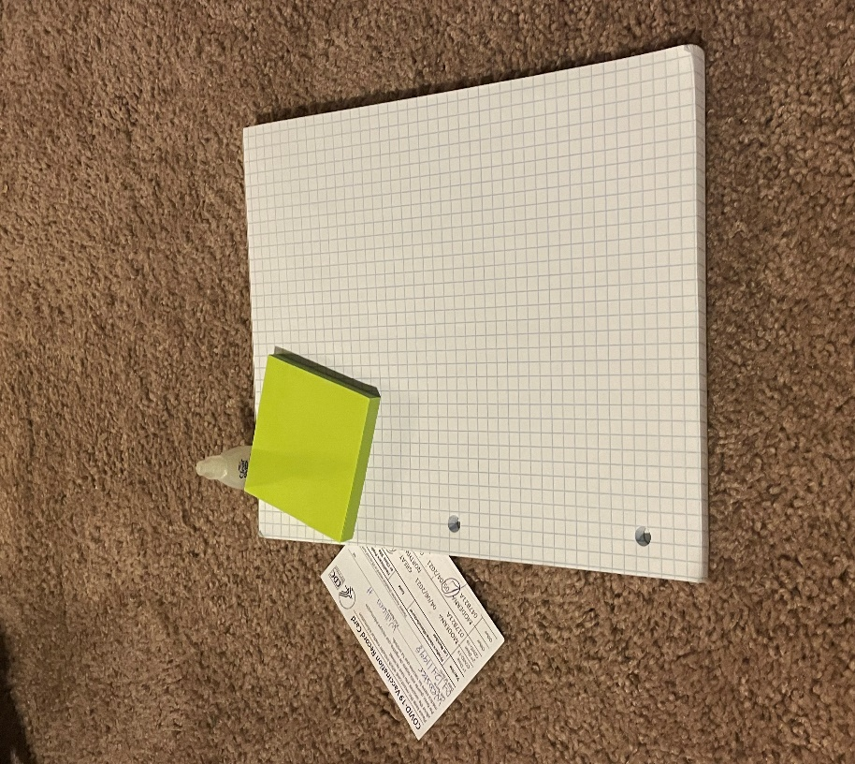 **Reference Image**

**Rendered Scene**

**Controls:**

W, A, S, D : Camera Movement Controls

Mouse: Camera Angle Control

Q : Move Camera Down.

E : Move Camera Up

O : Orthogonal Projection

P : Perspective Projection

Mouse Scroll Up : Increase Camera Speed

Mouse Scroll Down: Decrease Camera Speed

**Alternate Control Setup:**

Setting up an alternative input device would be require adding and/or replacing input processing functions from the initialization function. It would also be necessary to implement a custom method for controlling motion with devices such as gamepads or joysticks where input directions are not a simple on or off. OpenGL does have native support for such devices, so the implementation of such functions should not require additional libraries.

**A Note on Modularity & Future Development:**

When developing this program I had little to no experience with rendering scenes involving multiple objects, textures, and lighting. As such I will state that the program is not adequately modularized and the amount of code could be greatly reduced using the knowledge I have now. I would particularly note my MeshCreate and Render functions as notable offenders in this area. If I were to update or restart this project, the complete redesign of these methods would be my first task.

**Design Explanation:**

To begin with my documentation on my work, I wanted to state that this class was my first ever experience with anything remotely related to graphics and it manhandled me. For my final project, I went through many, many trials just to come near what I would deem to be an acceptable end product. Initially I had intended to use a basketball instead of eyedrops, but due to strange errors on my end I was unable to accomplish this. This was incredibly disheartening as I spent approximately 8 hours just trying to get this to work and essentially wasted an entire day just attempting to get it running. With that exposition aside, below I will explain my design choices for each of these objects.

**Post It Notes:**

This was my first ever foray into modeling objects and texturing. Initially I had wanted to start from the most basic object I could think of, so I decided to start with the basic cube. I had designed and implemented a method for instantiating this object in order to stack notes of different colors; however, I decided to remove the feature as my computer tended to chug whenever running the program. When lighting this object I opted to leave the ambient lighting at an average level and greatly reduced the specular lighting.

**Vaccination Card:**

The vaccination card was the last object I implemented when working on this project. At this point, I decided to attempt to capture and map my own textures to give it a personal touch and to try something new. While the mapping is not perfect, I believe that it adequately represents the real-world object. The lightly colored paper material of this object led to there being almost no specular reflections on this object while maintaining above average amounts of diffuse and ambient lighting.

**Notepad:**

Much the same as the Post It Notes, this example was a basic start to creating my scene. I wanted to use this as a chance to better understand texturing, so I selected an object with distinct markings on it that could be used to improve my texture mapping. While the notepad captured in the attached reference image is actually engineering paper, the initial notepad I had modelled after was a standard rule pad that I left back home recently and was unable to retrieve before capturing the updated reference image. Although the object is simple, I am proud of managing to properly texture this object to mirror its real-world counterpart

**Eye Drops:**

The eyedrops are the most complex object that I worked with on this assignment. The bottle is a prism with a wider base that a top, while the lid is comprised of an extremely rudimentary cylinder and cone. In terms of texturing, this object is the one that escaped me. I struggled for a long time with the mapping and was ultimately unable to properly texture the object. In the end I decided to apply a makeshift plastic texture that I captured myself from an image of the bottle. The lighting for this bottle is actually very interesting as its dull plastic material does not reflect ambient light well but has strong specular reflections.

**Lighting & Surface:**

Due to the relative lack of complexity for these objects they have been grouped together. There is a singular ambient light source positioned 15 units above the scene at a slight angle. This source represents my ceiling fan lightbulb and is tinted a slight yellow with a relatively low intensity. If I were to restart this endeavor, I might decide to add a point light from the camera’s perspective. The base of the entire scene is my actual carpet. I decided to capture the texture and adjust the mapping onto the plane until I achieved a suitable result with only slightly noticeable repetition.