# CS 340 Project 2 README

Hunter Webster

February 20, 2022

## About the Project/Project Title

*AACShelter (CRUD MODULE)*

This python script intended increase the efficiency of Mongo operations by enabling the automation of multiple tasks that might have previously been rather time consuming. First, this script allows for simple creation and insertion of documents into a Mongo database collection. Second, the ability to query a database with or without a given criteria. Through this function, users are able to view either the entirety of a collection or a specified slice. Third, I have implemented an update function that allows for the modification of specified documents and their fields. Fourth, a delete function has been included that allows for the easy removal of specified documents. This module has the ability to create, read update, and delete which is where it derives the name CRUD.

*ProjectTwoDashboard (DASHBOARD MODULE)*

This program was designed to utilize our CRUD module alongside Plotly’s dash to render a dynamic data table, histogram, and map. User’s have the capability to either manually select animals from the rendered data table or use the pre-defined filters to display a breakdown of animal breeds on the graph and their locations on the map. Both the filters and the graph rendered are intended to be modified by the user in order to allow for different types of graphing and custom filtering.

## Motivation

This project serves as a potential basis for automatically adding or querying from a user provided file containing a list of documents. Using this script is in its current form allows for swift creation, modification, deletion, and querying of documents within a specified database and collection. As it currently stands, this script is useful for quickly adding short dictionaries of hard-coded key-value pairs. In the future, I plan on adding the aforementioned functionality to provide swifter entry/querying.

## Getting Started

Core to the whole project is the PyMongo library. This library is a lightweight means of allowing a connection between MongoDB and our Python program. In order to get this project running, download the provided Jupyter and Python files and start up Mongo. From there, configure the Python file with the proper username and password for accessing your Mongo server. Once you have that set up, you are now able to query results that will be saved to a Data Frame. By modifying the app object in the dashboard notebook, each html attribute may be modified as necessary, as can the filter labels and settings within the callback segment of the program. The app’s data table returns queried rows which man be updated using the provided (or custom) filters.

## Installation

Python:

* Navigate to: <https://www.python.org/downloads/>
* Download the most recent version of Python
* Run the Python installer
* Follow the installation wizard

Jupyter:

* In your Python console, enter “pip install notebook”

MongoDB:

* Navigate to: <https://www.mongodb.com/try/download/community?tck=docs_server>
* Download the most recent version of MongoDB
* Run the MongoDB installer
* Follow the installation wizard

Dash

* When using the Jupyter notebook, install Dash using “pip install jupyter-dash”

## Usage

**Functionality**

*AACShelter (CRUD Module)*

1. Create
   * Purpose: A method designed to enable easy insertion of documents into a specified database and collection.
   * Parameters
     1. doc (dict or list of dicts): documents that will be inserted into the collection.
2. Read
   * Purpose: A method designed to allow for querying for either specified documents or all documents contained in a specified database and collection.
   * Parameters
     1. query (dict): key-value pairs that will be used to search the collection.
3. Update
   * Purpose: A method designed to easily query for and changes document(s) from a specified MongoDB database and specified collection.
   * Parameters
     1. existing (dict): key-value pairs that should be updated
     2. update (dict): key-value pairs that will replace the existing values.
4. Delete
   * Purpose: A method that queries for and removes document(s) from a specified MongoDB database and specified collection.
   * Parameters
     1. d (dict): a key-value pair that should be deleted.

*Dashboard*

1. Header/Top of Page
   * Basic HTML used to insert page title, my name, and the Grazioso Salvare logo.
2. Data Table
   * Radio Filtering
     1. Gives the user the ability to sort by the given rescue animal options.
   * User Filtering
     1. Allows the user to select animals on their own.
3. Mapping
   * Using the animals latitudinal and longitudinal coordinates, a marker can be placed on animals from the dataset based on user filters or the provided.

### Tests

CRUD MODULE

1. Graphical user interface, text, application, email

   Description automatically generated Create
   * A successful insertion operation returns True, while an unsuccessful insert returns False.
2. Text

   Description automatically generatedRead
   * In the provided test, the read function is tested in both a read-all and specific query context. In both cases the list of documents read is printed to verify successful operation.
   * If a bad value is passed, or another error occurs, an exception will be thrown.
3. A picture containing calendar

   Description automatically generatedUpdate
   * The provided test prints out all the updated documents and their new values.
   * Should invalid parameters be passed to the function, an exception will be thrown.
4. *Text

   Description automatically generated*Delete
   * Objects that are deleted are printed from the function. This can be disabled by commenting out the print operation in the AACShelter.py file. Furthermore, the tests provided print out both the remaining documents with the matching key-value pairs and all remaining documents to ensure that all documents have been deleted

### Screenshots

Single Animal Selection/ Dashboard Default

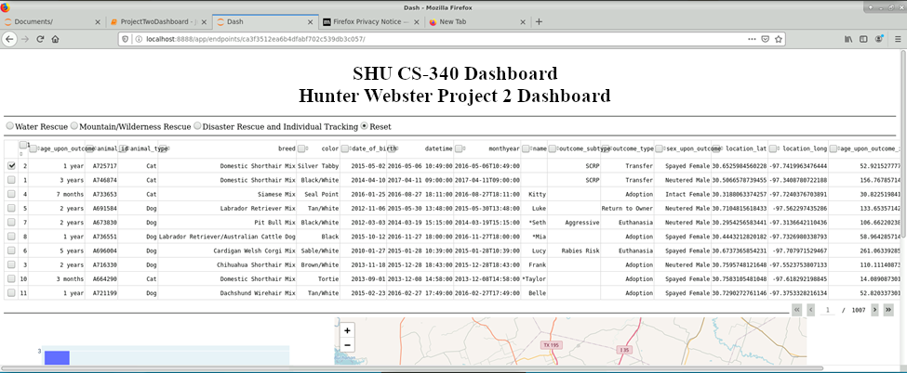

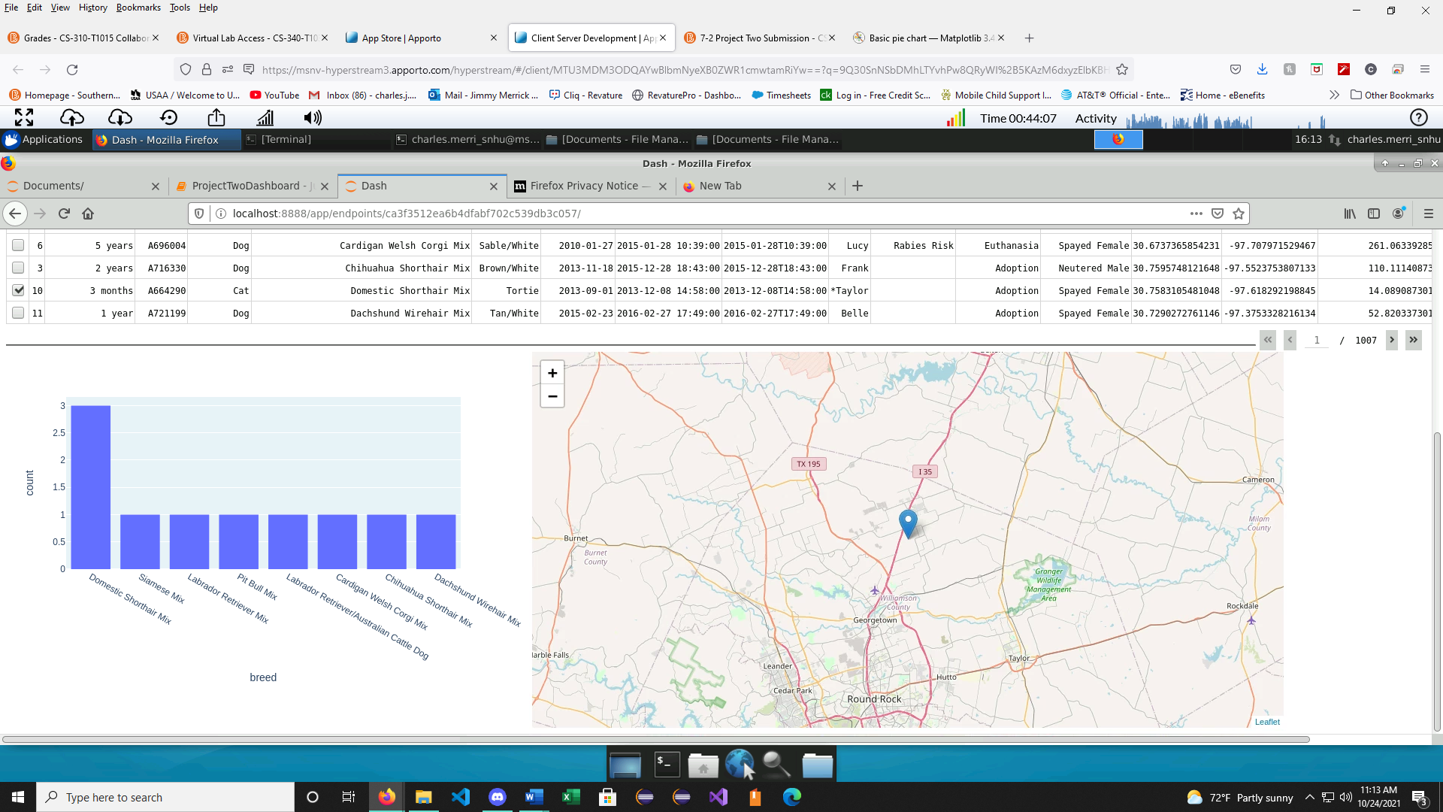

*Water Rescue Filter*

*Mountain Rescue Filter*

*Disaster Rescue*

*Reset*

## Contact

Your name: Hunter Webster