# CS 255 System Design Document Template

## UML Diagrams

### UML Use Case Diagram

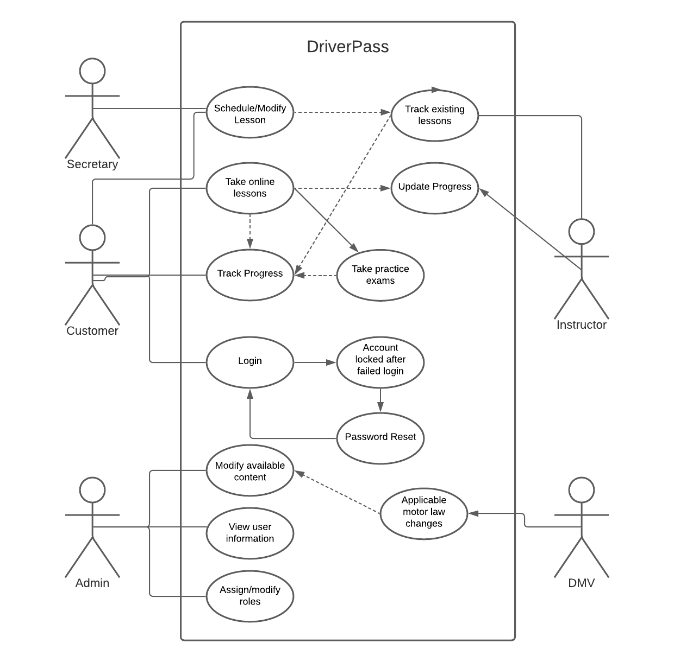

### UML Activity Diagrams

CASE 1: A user is attempting to access online learning resources

### UML Sequence Diagram

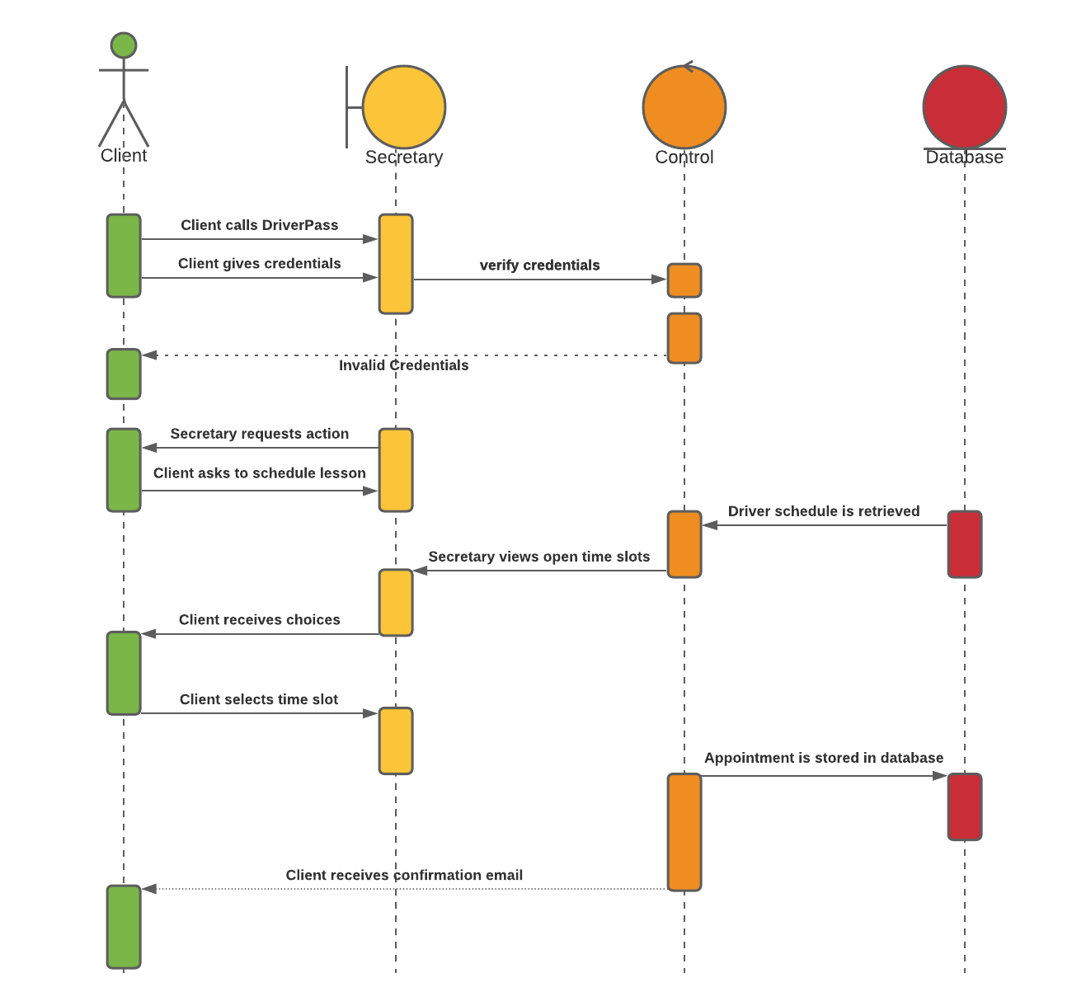

### UML Class Diagram

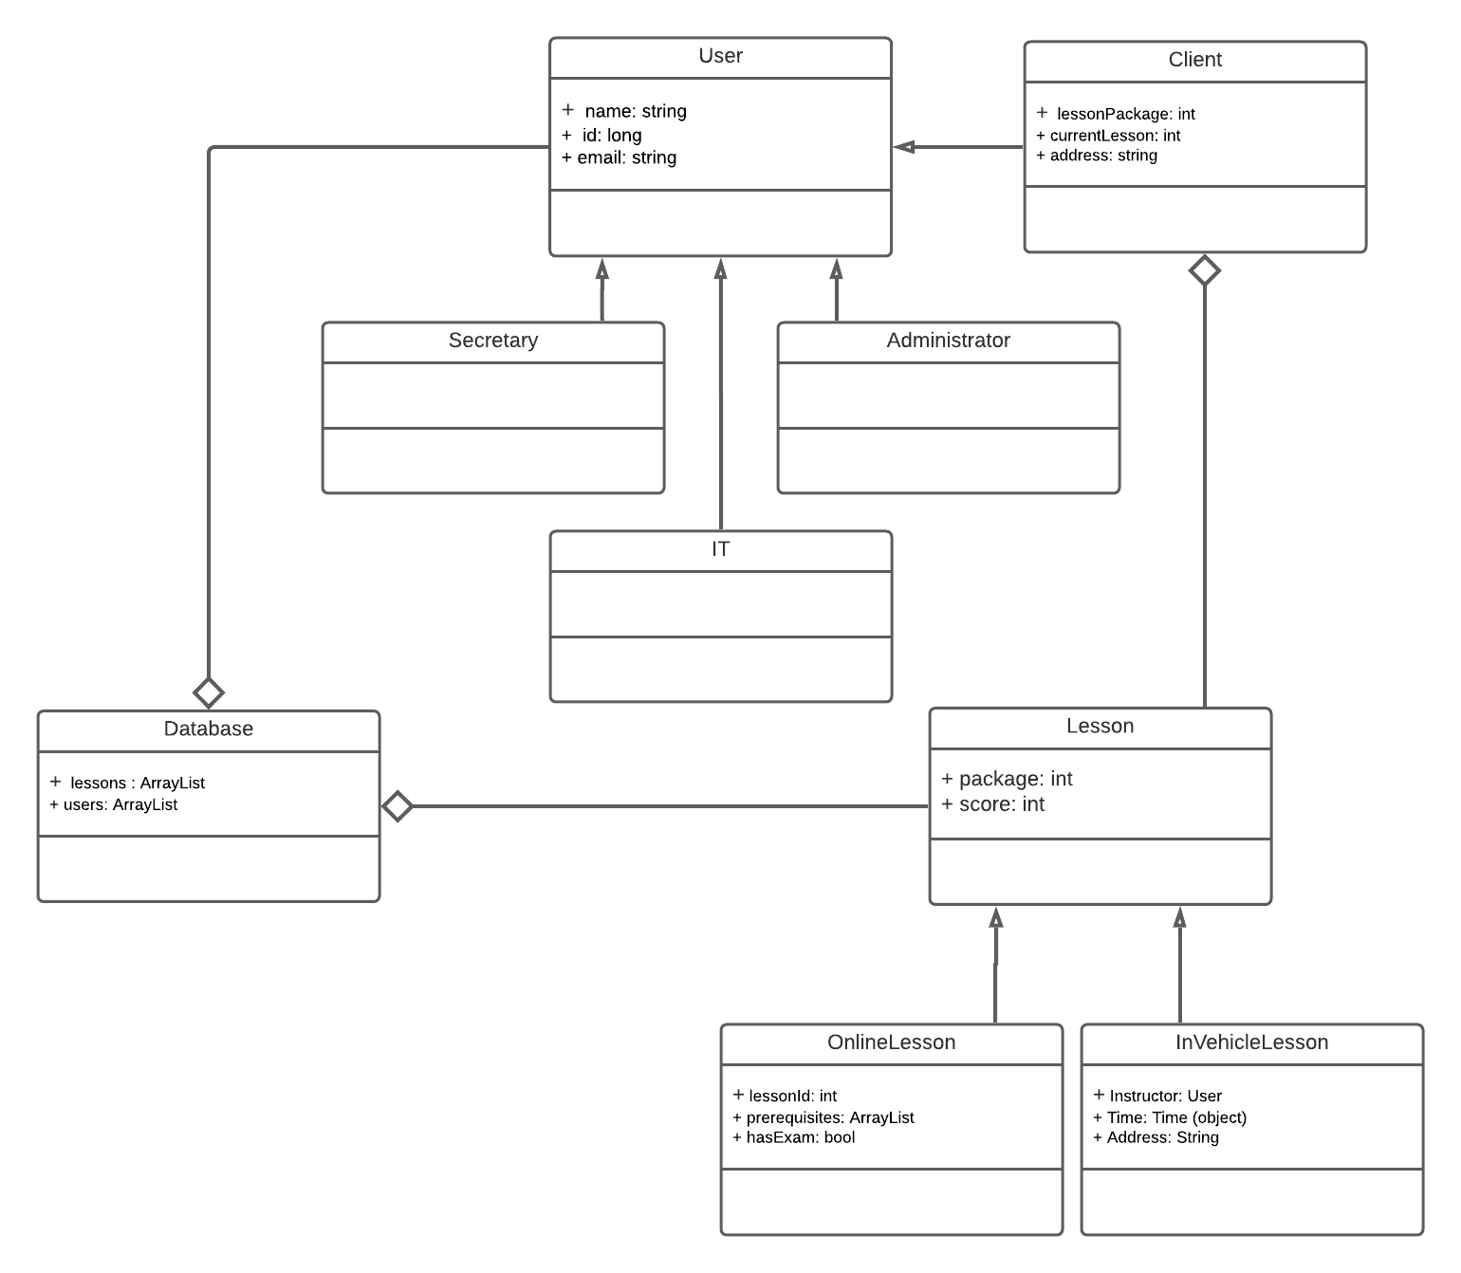

## Technical Requirements

Due to the nature of this system, there will be many requirements to ensure that the system runs as intended. First, I will be touching on the backend of the system. Due to the client’s desire to make the system a cloud-based web application, DriverPass will either need to find a partner for servers or acquire their own to operate their platform. Operating on a cloud-based platform will allow for easier maintenance as backups and development builds can be deployed, modified, and stored in a streamlined manner. A key point that will need to be considered throughout development will be the stability of the platform across all major web browsers as users’ preferences will be varied. The database that will be used to run the platform will need to securely store action logs, user information, software packages, and transaction information. Being able to accommodate any growth in any sudden increase in storage will be much easier to handle should the client choose to go with a third-party provider for servers/storage. Should the company choose to go down this route, it is also recommended that they employ an admin with a high level of understanding with whatever platform they select (AWS, Google, etc.).

Another important requirement for this sort of platform is security. The first measure of security that should be implemented by the team should be requiring HTTPS when accessing the platform. This is an essential step to take when building a web-based platform and will help prevent most forms of sensitive information from being accessible from external bad actors. Security measures will also need to be in place for all user accounts such as having verified emails, sufficiently strong passwords, and limited failed login attempts. Employing two-factor authentication would be another strong step but is not necessarily required.

We will also need to ensure that there are proper admin tools as specified by the client. There will be three separate roles for employees: secretary, IT officer, and admin. The secretary will need to be able to access client accounts and have the ability to schedule/modify lessons and make changes to user accounts. IT officers will need the ability to make changes to the system as needed. Lastly, the admin(s) will need the ability to modify available content and user information. These roles will be necessary to ensuring the seamless operation of the product as specified by the client. Finally, we will need to consider the user interface. This interface will be interacted with by users of all roles, so the options and tools available to users of each role. The content of each role’s interface will be determined by the administrator and should be able to be modified by either the IT team or the admin depending on the type of change that needs to be made. Another key consideration will need to be the integration of payment options into the interface. There are many providers for payment services, so the choice will ultimately be up to the company.