Count() Syntax : this function will return the number of rows that match its specified criterion. The count() function can be used to count a total number of items in a database to eliminate tedious counting time and human errors.

It is written as ‘count() ;’

Alias ‘Total Films’

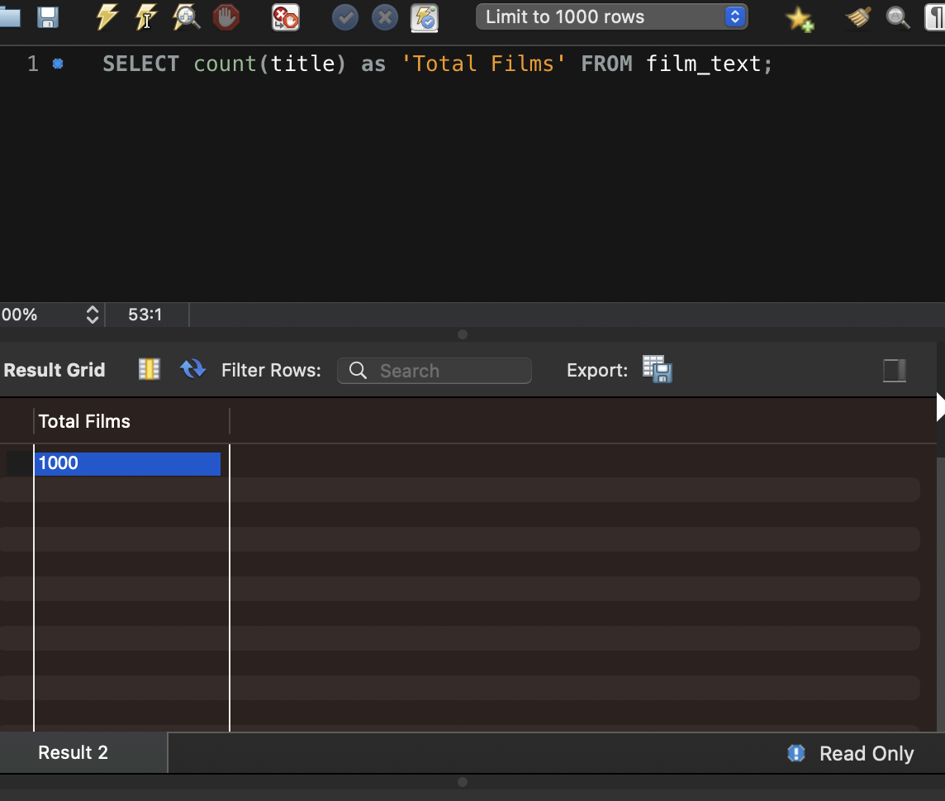

AVG() Syntax : This function will return the average value of a numeric column. The AVG() function can be used to find average prices, times, or any other numeric average.

It is written as ‘AVG()’

Alias ‘Average Length’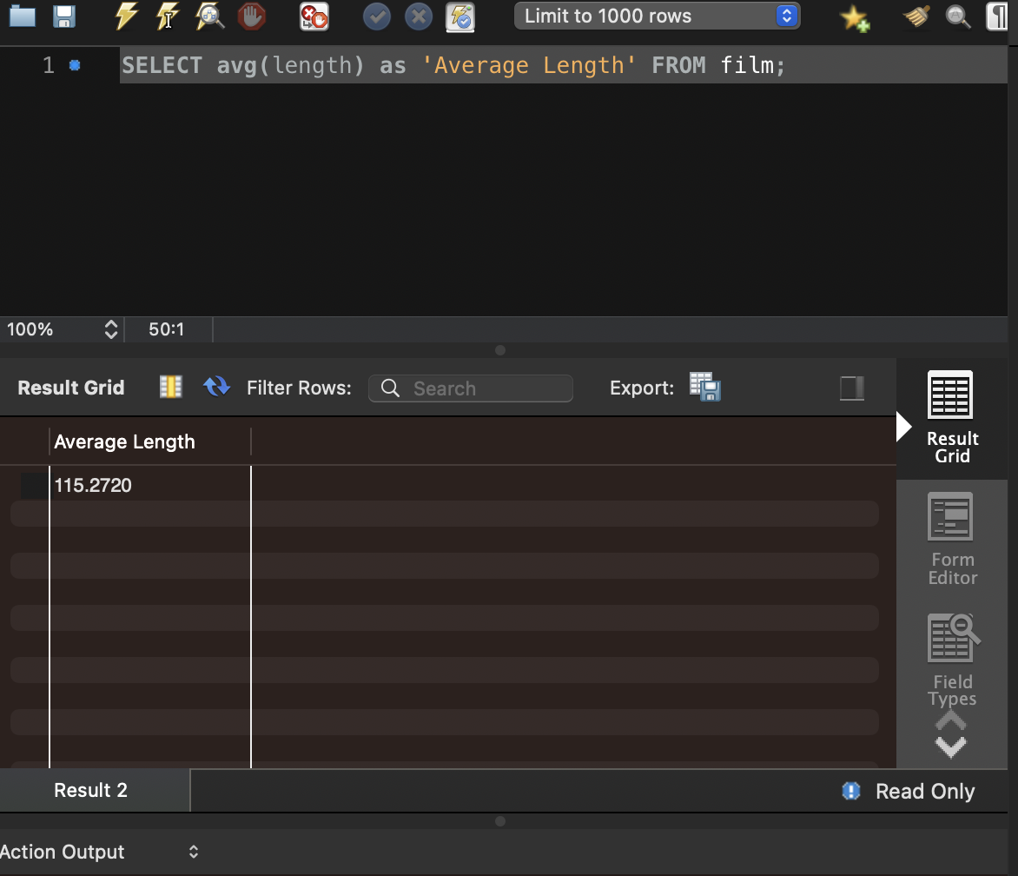

Max() : This function returns the maximum value within a given column. The Max() function can be used to find a maximum price of an item, length of item, or any other numerical value pertaining to an item.

It is written as ‘Max();’

Alias ‘Max Replacement Cost’

