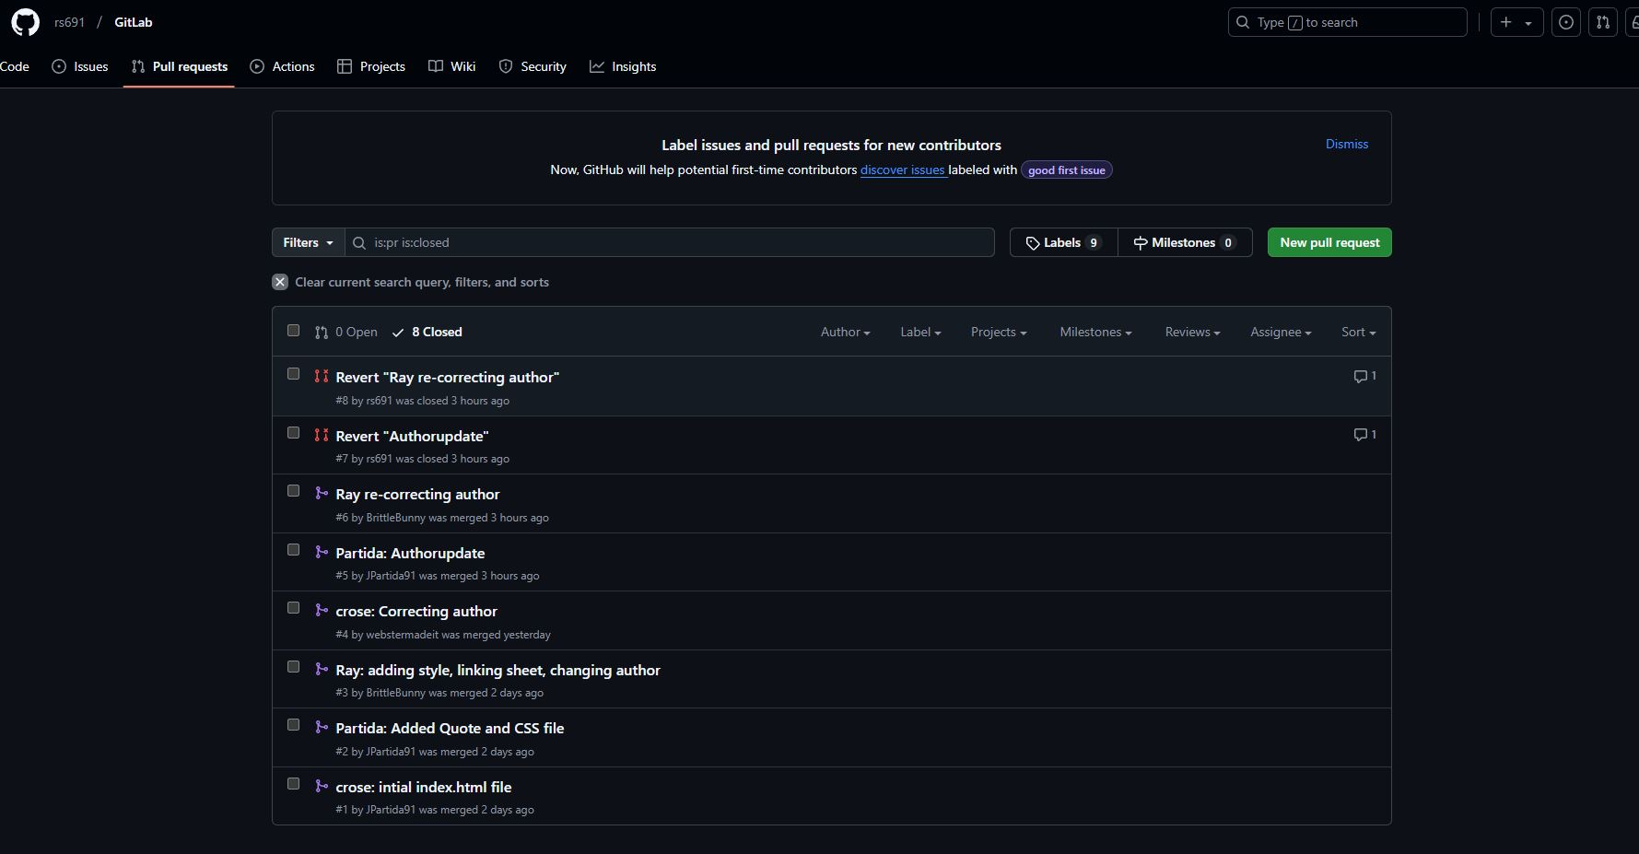

<https://github.com/rs691/GitLab>

webstermadeit