
HR Team, I CAN
31 Angel Gate
Goswell Road
London
EC1V 2PT

Email: jobs@ican.org.uk
Tel: 0207 239 0004

December 2017

Dear Applicant,

Principal

I CAN’s Meath School

Contract Type: Permanent, Full-Time
I CAN Leadership Pay Scale L19- L23, £61,804 - £68,049 p.a plus £4,701 non residential Head’s allowance

Meath School & Specialist Centre, Brox Road, Ottershaw, Surrey, KT16 0LF

Thank you for your interest in the above post. We are looking for an exceptional person to lead Meath School following the forthcoming retirement of our longstanding and hugely respected Principal, Janet Dunn. We hope that the information in our application pack will help you decide to apply.

Please find enclosed:

- Job Description and person specification
- Job Terms & Conditions
- Information about Meath School
- Application form & Equal Opportunities Monitoring Form

To apply, please send your completed application form back to jobs@ican.org.uk by 5pm on 15th January 2018. Interviews will be held in school at the school on 22nd and 23rd January 2018.
Informal enquiries about this post can be made to Deirdre Fitzpatrick, Director of Education on 0207 843 2545.

I CAN is committed to safeguarding and promoting the welfare of children. We carry out appropriate vetting and verifications on all staff.

Thank you for your interest and we look forward to hearing from you.

Yours sincerely,
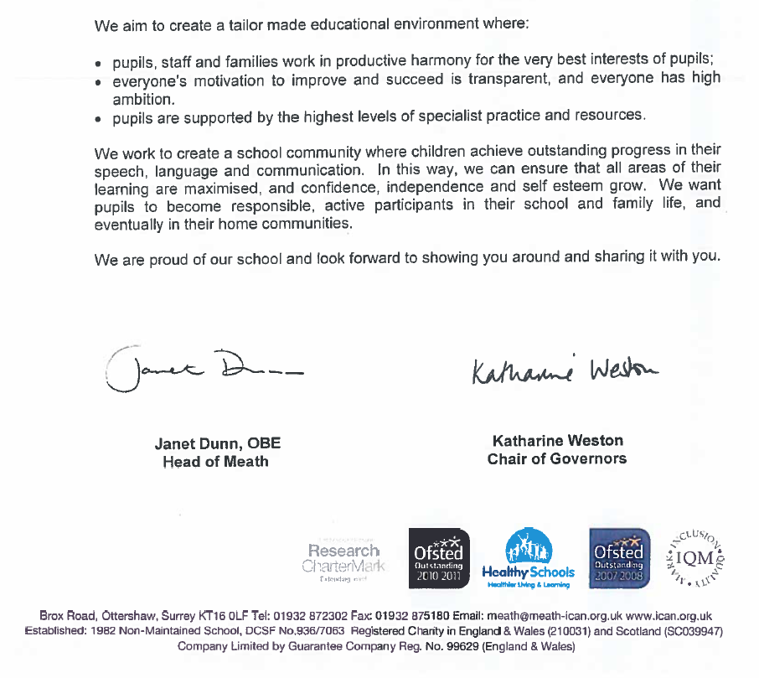

Katharine Weston
Chair of Governors


Meath School & Specialist Centre

I CAN's Meath School (www.meathschool.org.uk) based in Ottershaw, Surrey is a day and residential non-maintained primary special school for up to 75 pupils aged 4 to 11 years, where severe and complex speech, language and communication needs, including Asperger's Syndrome, is the primary need.

Our most recent Ofsted report (2016) is highly positive about the work of the school and the progress which our children make. The school is bursting with energy: all staff push pupils to achieve beyond the limits of what previously might have been thought possible. In particular, the pupils themselves develop an inspiring determination to learn, achieve success and overcome their difficulties.

A clear sense of moral purpose drives the school: to unlock pupils’ ability to speak and communicate so that they can appreciate and forge links with the world around them. The school’s relentless focus on developing speech and communication skills is tangible even in the youngest pupils. No opportunity is missed to encourage and praise talk and conversation.

Meath School is one of a very few schools in the UK which is tailor made for only young learners with SLCN. The school and care settings have been recognised repeatedly as ‘outstanding’ by Ofsted since 2008.
I CAN is the children’s communication charity.
We are experts in helping children develop the speech, language and communication skills they need to thrive in a 21st century world.

Our vision is a world where all children have the communication skills they need to fulfil their potential.
Our mission is that no child should be left out or left behind because of a difficulty speaking or understanding.
I CAN supports children from 0-19 through our Talk programmes and specialist schools, and through resources and information for parents, families and people who work with children and young people. We work in nurseries and schools across the UK with our evidence-based programmes and run two special schools for children with the most severe and complex needs. We share our expertise and knowledge to increase awareness of communication difficulties and inform policy making.
I CAN’s evidence-based programmes and training aim to provide practical help and support at every age and stage of a child’s and young person’s life. We work directly with the people who educate, care for, support and advise children and families. All our approaches are based on the best evidence available to ensure that children receive help that will get results. Our programmes are designed to help schools to meet Ofsted’s focus on developing and using pupils’ communication skills and to support settings and schools to narrow the gap between the lowest and highest attainment. Many of I CAN’s programmes and training use a cascade model. We have a network of expert Licensees across the UK, able to respond to local needs quickly and flexibly.
For more information about I CAN, its work and values go to www.ican.org.uk or www.talkingpoint.org.uk



I CAN Job Description

Job Title: Principal, Meath School

Grade: I CAN Leadership Pay Scale L19 –L23

Reports to: Director of Education

Accountable for: Achieving the overall effectiveness of Meath School. The Principal is a senior member of the management team of I CAN and will contribute to the overall direction and management of the charity.

Key contacts
Internal: Chief Executive and I CAN senior leadership team, specifically the Director of Education
Principal of Dawn House School
Care and education consultatnts
Corporate Services Team
School Governors
I CAN Advisors and Regional Managers

External: Local authorities
Parents
Social services
Ofsted Children’s Services
Mainstream and special schools networks
Regional and national educational management structures
Health Trusts/ Services
Voluntary organisations
Private sector organisations
Publics and professional audiences
Media

Job Purpose
I CAN is committed to support the communication development of all children, with a special focus on children with a communication disability. I CAN achieve these aims through a combination of direct services to children and enabling services delivered to partner organisations and the childcare workforce. The role of the Principal will be responsible for the management and delivery of special education at Meath School for pupils aged 4 and 11.

Leadership and Management of Meath School

Directly or through delegation, responsible for ensuring the operational management and development of Meath School in line with the National Standards for Headteachers (2014). This will include:
- Ensure that the school is operated in accordance with, and subject to, the relevant national policy, guidance and I CAN’s strategy and the trust deed of the school.
- Ensure best practice is in place to ensure pupils are safe.
- Liaise with, advising and consulting, where appropriate, I CAN managers and trustees, the governing body, school staff and parents about all aspects of the management and running of the school.
- (Directly or through the management structure) determine, organise and implement and appropriate curriculum for the school, with regards to the needs, experience, interests, aptitudes and stage of development of the pupils and the resources available to the school.
- Ensure that appropriate measures are taken to promote among the pupils, self esteem, self-discipline and proper regards for authority.
- Ensure effective progress of the pupils and ensure that it is monitored and recorded appropriately.
- Formulate the overall objectives of the school and policies, in line with the Charity’s aims and objectives, and ensure their implementation.
- Develop, agree, implement and regularly update the School Development Plan, for educational, therapy, and care services in accordance with statutory requirements.
- Evaluate the standards of teaching and learning in the school and ensure that proper standards of professional performance are establish and maintained.
- Lead on self evaluation for the school.
- Work towards the achievement of improved outcomes against education and care inspection criteria.
- Maintain and awareness of and respond to relevant advances in national guidance and education initiatives.
- Provide information as required to I CAN’s Communications Team and Philanthropy Team.
- Contribute to/ participate in cross organisational project teams, including research such as augmentative communication.
- Advise I CAN on the determination of appropriate school fees.
- Manage the school budget with the support of I CAN’s Finance team.
- Promote, negotiate and agree pupil placements with potential purchases and ensure it is best placed to attract pupils to the school.
- Lead on the development, implementation and operation of value added/ pupil progress within I CAN’s schools.
- Provide leadership, in accordance with I CAN’s agreed behaviours and mentor and motivate staff to ensure that delegated responsibilities are achieved.
- Lead and develop a strong multidisciplinary Senior Management Team.
- Act as line management and provide professional supervision to the staff at Meath School.
- Promote collaborative working relationships and effective communication.
- Evaluate the standards and practices of teaching, learning, and care within the school, and ensure proper standards of professional performance and best practice in all areas (Teaching, Assessment, Speech and Language, Residential and Pastoral Care) are maintained. The post holder will be able to draw on specialties advice on these areas as required.
- Be responsible for whole school staff management, including supervising and participating in appraisals, to ensure that all staff in the school have access to appropriate advice and training.
- To ensure that the effective deployment and management of all teaching and non-teaching staff of the school in a manner consistent with their conditions of employment and I CAN’s Policies and Procedures.
- Maintain appropriate staffing levels as agreed with the Director of Education and ensure the appropriate recruitment and selection of teaching and non teaching staff with guidance from HR, in line with safer recruitment procedures.
- Be responsible for the appropriate dissemination of information; to ensure that school staff receive information they need in order to carry out their professional duties effectively, and to provide information about the work and performance of the staff employed at the school as necessary.
- Ensure that all policies and procedures relating to the safeguarding of children in I CAN’s services are followed at all times.
- Safeguard confidentiality of information relating to children, staff and I CAN’s work.

I CAN is committed to safeguarding and promoting the welfare of children and young people. I CAN’s expects all staff and volunteers to share this commitment. This list of duties and responsibilities is not exhaustive and the post holder may be required to undertake other relevant and appropriate duties as reasonably required.

This job description is subject to regular review and appropriate modification.

Person Specification
Principal
Meath School

CRITERIA | ESSENTIAL | DESIRABLE | IDENTIFIED AT (recruitment stage)
Qualifications | - Graduate or equivalent  - Qualified Teacher, Speech and Language Therapist or comparable professional qualification | - Relevant degree or equivalent higher level professional qualification | - Application Form
Experience | - Experience of being successful in a Senior Leadership role  - Led high performing teams  - Experience of managing complex issues/ projects across teams  - Proven experience with regard to training and staff development  - Track record of providing inspiration and strong collaborative leadership to staff | - Voluntary sector experience  - Leadership of a non maintained specialist school  - Experience of primary, secondary and FE phases  - Mainstream school experience  - Extensive experience of communication disabilities  - A track record of innovation and delivering results  - Worked in two or more schools  - Experience of successful Ofsted inspection in a school  - Managing multidisciplinary teams | - Application Form and Interview
Skills and Knowledge | - Detailed knowledge of the characteristics of effective teaching and learning and of assessment practices  - Knowledge of SEN  - Excellent working knowledge of Ofsted frameworks and expectations  - Excellent knowledge of educational context  - Knowledge of communication development and its impact on educational progress (or willingness to learn)  - Knowledge of systems, processes and strategies that will support children’s communication development at all educational phases  - Strong analytical and problem solving skills  - Effective negotiating and promoting skills  - Self evaluation skills  - Ability to exercise a high degree of independent judgement in dealing with internal and external stakeholders  - Ability to work with and balance the views of a large number of stakeholders  - Presenting and disseminating information and vision to varied groups  - Ability to balance and manage multiple priorities  - Ability to create and maintain a culture where professionals challenge themselves and focus on their own professional development  - Excellent communication skills  - Ability to work independently and in a team  - Ability to organise own workload, take initiative and keep to deadlines  - Ability to ensure effective relationships with parents and carers to achieve best possible outcomes for pupils  - Willingness to enrol on appropriate training where necessary within an agreed timeframe | - Entrepreneurial flair  - Knowledge of quality frameworks within therapy and care  - Knowledge and experience of strategic financial planning, budget managements and effective resource management | - Application Form and Interview
Other factors | - Committed to the overall aims of I CAN and to developing and delivering I CAN’s Vision and Strategy  - Committed to ensuring that all policies and procedures related to the protection of children are followed at all times  - Committed to safeguarding and promoting the welfare of children and young people  - Ability to work collaboratively and  contribute effectively as a member of I CAN’s senior management team  - Ability to develop an maintain positive external relationships to forward the work of I CAN  - High standards of personal and professional integrity  - Evidence of continuing professional development  - Understanding and commitment to equal opportunities and empowerment |  | Application Form and Interview

I CAN

Summary of Terms and Conditions of Employment

Job Title: | Principal
Pay Grade: | I CAN Leadership Pay Scale L19- L23, £61,804 - £68,049 per annum  plus £4,701 non residential Head’s allowance
Location: | Meath School, Ottershaw, Surrey
Start Date: | September 2018
Location: | Meath School, Brox Road, Ottershaw, Surrey, KT16 0LF
Annual Leave: | 50 days inclusive of bank holidays
Hours: | Full-Time
Disclosure & Baring Service Check: | The successful candidate’s employment is subject to an enhanced DBS and barred list check
Probation Period: | There is a six month probationary period for this post
Pension: | Teachers Pension
Perkbox: | Employee wellbeing benefit providing hundreds of exclusive perks for staff ranging from discounts on shopping, entertainment and gifts, to gym membership, rewards and over 150 e-learning perks.
Childcare Voucher Scheme: | I CAN operates a childcare voucher scheme for staff which allows them to save on childcare costs.
Annual Flu Vaccination | Free annual flu vaccination offered to all I CAN employees.



Application Form for Employment

Please return to: I CAN Human Resources Team, 31 Angel Gate, Goswell Road London, EC1V 2PT
Email: : jobs@ican.org.uk Tel: 020 7239 0004
Please complete this form in full supplemented by additional sheets if necessary. CVs WILL NOT BE ACCEPTED
All personal data supplied to us on this form, which is subsequently processed on computer or by other means, is subject to the provisions of the Data Protection Act 1998.

Position applied for: Principal, Meath School |  | Closing Date: 15.01.2018
Where did you see this job
advertised?

Personal details:
Last Name: | Title: (Mr/Mrs/Miss/Ms/Dr/Prof) | First names: (for official purposes)
Address: |  | Preferred name: (name you wish to be known as)
Post code: |  | Preferred name: (name you wish to be known as)
E-mail address:

 |  | Mobile telephone number:
If you are a teacher, please provide:
DfE number:

Employment:
Name of current/ last employer:
Job title and description of your current job and key responsibilities: | Start date: End date:
Current /Final Salary:
What period of notice are you required to give to your present employer?
Reason for leaving:

Previous Employment:
Start Date | End Date | Job Title | Employer  (please also provide name of school if applicable) | Reason for Leaving

Gaps in employment history:
Please account for gaps in your employment history (in chronological order) in the space provided below.

Education and Qualifications:
Start Date | End Date | Name of School/College/University/ provider | Subject | Qualification gained and grade

Training:
Date | Topic Covered | Training Provider

Professional Membership/Registration:
Issuing Body | Registration Number | Expiry Date

Suitability:

Please assess yourself against the requirement of the Person Specification, giving examples of how you meet the defined criteria. Ensure you are concise and to the point. You may continue on additional sheets if necessary.

Referees:
Please give the names and addresses of two referees, one of whom should be your current or most recent employer. Your consent for I CAN to contact your referees is given by signature of this form. In line with Keeping Children Safe in Education, September 2016, I CAN will request references before interview. Please contact jobs@ican.org.uk if you have any queries about this. I CAN will seek your permission before contacting a current employer.

1. | Name: | Telephone number:
 | Capacity known to you:
 | Address: | Confidential fax number:
 |  | E-mail address:
2. | Name: | Telephone number:
 | Capacity known to you:
 | Address: | Confidential fax number:
 |  | E-mail address:

Additional Information:
Please give below any further information that is relevant to your application, e.g.: your application is for a job share; periods of time when you would be unavailable for interview; any special requirements should you be invited for interview.

Relationships:

Are you related to or acquainted with any of the Trustees, staff or pupils of I CAN? If so, please give details:

Asylum and Immigration Act 1996:
Do you require permission to work in the UK? | Yes |  |  | No

If “Yes”, please state the permission you have to work in the UK (e.g. visa type and visa expiry date)

_________________________________________

Rehabilitation of Offenders Act 1974:
Do you have any convictions, cautions, reprimands or final warnings that are not "protected" as defined by the Rehabilitation of Offenders Act 1974 (Exceptions) Order 1975 (as amended in 2013)*?

Yes No

If ‘yes’ please give details in a separate envelope. You are required to give details of a 'spent conviction' as provided by the Rehabilitation of Offenders Act 1974 as the post is one that involves direct contact with children where we need to know about all convictions.

*For further guidance on protected conviction and cautions, please visit:
- http://www.legislation.gov.uk/uksi/2013/1198/pdfs/uksi_20131198_en.pdf
- https://www.gov.uk/government/publications/dbs-check-eligible-positions-guidance

List 99/ Protection of Children Act List:
Are you included on List 99 or the Protection of Children Act List?

Yes No

I confirm that the information given on this form is, to the best of my knowledge and belief, true and complete. I also give my consent to the processing of my personal data by computer or other means in relation to my job application and possible future employment.

Signed……………………………………………………….. Date ………..

I CAN - Equal Opportunities Monitoring Form – Recruitment

Please do not write your name on this form.

Thank you for taking the time out to fill in this form. We are asking these questions to understand better the composition of our workforce by gender, ethnic origin, age, sexual orientation and faith. This information will help us guide our recruitment strategies.

We can assure you that the information provided will be kept completely confidential.

I CAN is committed to equal opportunities and has a policy that is supported by a code of practice.

Please state which post you are applying for

Gender (please tick) & Year of Birth
Male |  | Female |  | Year of Birth

Disability
Do you consider yourself to have a disability? (please tick) | Yes |  | No
The Disability discrimination Act defines disability as “a physical or mental impairment which has a substantial and long term effect on the person’s ability to carry out normal day to day activities”

Ethnic Origin
Please indicate how you would prefer to describe your ethnic origin (please tick) then specify in the most relevant sub-category (please tick)

A
Asian |  | Asian British |  | Asian English |  | Asian Scottish
Asian Welsh |  | Bangladeshi |  | Indian |  | Pakistani
Other (please specify)

B
Black |  | Black British |  | Black English |  | Black Scottish
Black Welsh |  | African |  | Caribbean
Other (please specify)

C
Chinese |  | Chinese British |  | Chinese English |  | Chinese Scottish
Chinese Welsh |  | Chinese |  | Other (please specify)

D
Mixed |  | White and Black African |  | White and Black Caribbean |  | White and Asian
Other(please specify)

E

Traveller or Gypsy

F
White |  | White British |  | White English |  | White Scottish
White Welsh |  | White Irish |  | Other please specify)

Faith
Please indicate below how you would prefer to describe your faith or tick “none” OR “prefer not to state”
None
Prefer not to state

Sexual Orientation

Please indicate how you would prefer to describe your sexual orientation (please tick)**
Bisexual |  | Gay |  | Heterosexual |  | Lesbian
Prefer not to state

By completing this form I understand that I give my consent under the Data Protection Act 1998 for the information contained in this form to be processed in accordance with I CAN policy for the purposes of equal opportunities monitoring.

*The categories used are those given by the Commission for Racial Equality.
** The categories used are those given by the Equal Opportunities Commission.

