WEBUILD GitHub Policies and Guidelines

Document Information
Version: 4.0 Last Updated: October 2025 Status: Active

Introduction
The WEBUILD Consortium leverages GitHub as its primary platform for technology collaboration across all Work Packages (WPs). This document establishes the foundational policies and guidelines that govern how GitHub is utilized throughout the consortium to facilitate joint development, review, and management of technical artifacts.
GitHub serves as the central hub where consortium partners collaborate on specifications, interface definitions, test environments, source code, and other technical deliverables. By standardizing our approach to GitHub usage, we ensure that all partners can work together efficiently while maintaining the highest standards of transparency, security, and accountability.

Purpose and Objectives
This policy framework serves multiple critical purposes within the WEBUILD Consortium:

Primary Objectives
Establish a Common Framework Create a unified approach to using GitHub that all consortium partners can follow, regardless of their individual organizational practices. This common framework reduces friction in cross-organizational collaboration and ensures that all partners understand the expected workflows and procedures.
Support Collaborative Technical Work Enable seamless collaboration between partners on technical deliverables. GitHub’s collaborative features—including pull requests, code reviews, and issue tracking—are leveraged to facilitate meaningful technical discussions and joint development efforts.
Maintain Version Control Excellence Ensure that all technical artifacts are properly versioned, with clear histories of changes, contributors, and decision points. This version control discipline is essential for maintaining the integrity of technical work and understanding how solutions evolved over time.
Enable Comprehensive Documentation Provide a structured environment where technical documentation lives alongside the artifacts it describes. This co-location of code and documentation ensures that information remains current and accessible to all partners.
Ensure Traceability and Accountability Maintain clear records of who contributed what, when, and why. This traceability is essential for project governance, quality assurance, and demonstrating compliance with consortium agreements and funding requirements.
Uphold Compliance Standards Ensure that all GitHub activities comply with project governance requirements, data protection regulations (including GDPR), and consortium-wide policies regarding intellectual property and information security.

Governance and Organizational Structure

Consortium GitHub Organization
The WEBUILD Consortium maintains a dedicated GitHub organization at https://github.com/webuild-consortium/. This organization serves as the authoritative location for all technical collaboration within the project. Hosting all repositories under a single organization provides several key benefits:
- Centralized Access Management: Simplifies the process of granting and revoking access as partners join or leave the consortium
- Unified Visibility: Enables consortium leadership to maintain oversight of all technical activities
- Consistent Branding: Presents a cohesive identity for the consortium’s technical work
- Simplified Archival: Facilitates long-term preservation of project outputs at the conclusion of the consortium

Organizational Hierarchy
The governance structure follows a clear hierarchy:
Technical Coordinator (Overall GitHub Administration)
├── WP Leads (WP-level oversight)
├── Group Leads (Group-level management)
├── Repository Maintainers (Day-to-day operations)
└── Contributors (Active participation)

Repository Organization
Each Work Package (WP) and specialized groups within Work Packages maintain their own repositories within the consortium organization. This distributed ownership model recognizes that different technical areas require autonomy while still benefiting from the shared organizational infrastructure.
The repository structure follows this pattern:
webuild-consortium/
├── wp4-qtsp-group/
├── wp4-trust-group/
├── wp4-semantics-group/
├── wp4-wallets-group/
├── wp4-interop-test-bed/
└── webuild-policies/
Repositories typically contain:
- Technical Specifications: Formal definitions of interfaces, protocols, and standards
- API Definitions: Machine-readable and human-readable API documentation
- Test Tools and Environments: Software and configurations for testing implementations
- Example Implementations: Reference code demonstrating how to implement specifications
- Supporting Documentation: Guides, tutorials, and explanatory materials

Roles and Responsibilities

Technical Coordinator
Responsibilities: - Overall GitHub organization administration - Policy definition and enforcement - Organization-wide settings and security management - Owner consolidation and management - Cross-WP coordination - Dispute resolution
Permissions: Organization Owner

Work Package (WP) Leads
Responsibilities: - WP-level repository oversight - Team member access management within WP - WP-specific policy implementation - Repository creation approval - Quality assurance for WP outputs - Coordination with Technical Coordinator
Permissions: Team Admin for WP team

Group Leads
Responsibilities: - Group-level repository management - Team member access for their group - Day-to-day repository operations - Code review coordination - Issue and project management - Documentation maintenance
Permissions: Repository Admin or Team Maintainer

Repository Maintainers
Responsibilities: - Code review and merge approval - Issue triage and management - Branch protection enforcement - Release management - Documentation updates - Community engagement
Permissions: Repository Write access with review rights

Contributors
Responsibilities: - Code and documentation contributions - Issue reporting and discussion - Pull request submission - Code review participation - Adherence to contribution guidelines
Permissions: Repository Write or Read access (depending on contribution model)

Decision-Making Authority
Decision Type | Authority | Consultation Required
Organization settings | Technical Coordinator | WP Leads
New repository creation | WP/Group Lead | Technical Coordinator
Repository deletion | Technical Coordinator | WP Lead, Group Lead
Access grants (WP-level) | WP Lead | Group Lead
Access grants (Group-level) | Group Lead | -
Making repository public | WP Lead + Technical Coordinator | All maintainers
License changes | Technical Coordinator | Legal team, WP Lead
Policy updates | Technical Coordinator | WP Leads, Group Leads

Essential Repository Components
Every repository within the consortium organization must include these foundational documents:
README File The README serves as the entry point for anyone accessing the repository. It should clearly explain the repository’s purpose, provide orientation for new contributors, and link to other relevant documentation. A well-crafted README significantly reduces the barrier to entry for partners joining ongoing technical work.
LICENSE File The LICENSE file specifies the legal terms under which the repository’s contents can be used, modified, and distributed. The default license is Apache License 2.0. Clear licensing is essential for ensuring that consortium outputs can be properly utilized by partners and, where appropriate, by the broader community.
CONTRIBUTING Guide The CONTRIBUTING guide explains how partners can contribute to the repository. It should detail the expected workflow for proposing changes, coding standards or documentation conventions to follow, and the review process that contributions will undergo.
Supporting Documentation Additional documentation may include architecture diagrams, decision records, meeting notes, or any other materials that help partners understand and contribute to the technical work effectively.

Access Management and Role Definitions

Account Requirements
All consortium members participating in GitHub activities must use their own personal GitHub accounts. This requirement serves several important purposes:
- Individual Accountability: Ensures that all actions can be traced to specific individuals
- Audit Trail Integrity: Maintains the authenticity of contribution histories
- Security Best Practices: Prevents the security risks associated with shared accounts
- Professional Recognition: Allows individuals to receive proper credit for their contributions
Partners should use professional email addresses associated with their organizations when configuring their GitHub accounts for consortium work. Configure your Git client with the correct email address to ensure commits are properly attributed:
git config --global user.name "Your Full Name"
git config --global user.email "your.email@organization.com"

Two-Factor Authentication (2FA)
Two-factor authentication is required for all consortium members. This is a mandatory security requirement that significantly enhances account security.
Setup Steps:
- Go to GitHub Settings → Password and authentication
- Click “Enable two-factor authentication”
- Choose authentication method:
  - Recommended: Authenticator app (Google Authenticator, Authy, 1Password)
  - Alternative: Security key (YubiKey, etc.)
  - Fallback: SMS (least secure)
- Save recovery codes securely
- Verify 2FA is enabled
Recovery Codes: - Store in secure password manager - Keep offline backup - Never share with anyone - Generate new codes if compromised

Access Request Process

For New Consortium Members
Diagram 1
Process:
- New member completes onboarding
- WP/Group lead submits access request to Technical Coordinator
- Technical Coordinator adds member to organization
- WP/Group lead adds member to appropriate team(s)
- Member receives welcome email with guidelines
Access Request Template:
Subject: GitHub Access Request - [Member Name]
## Member Information
- Name: [Full Name]
- GitHub Username: [@username]
- Email: [work.email@organization.com]
- Organization: [Partner Organization]
- Work Package: [WP Number]
- Group: [Group Name]
- Role: [Developer/Researcher/etc.]
## Access Requirements
- Organization Access: Yes
- Teams: [@webuild-consortium/wp4-trust]
- Repositories: [List specific repos if limited access]
- Permission Level: [Read/Write/Admin]
## Duration
- Start Date: [YYYY-MM-DD]
- End Date: [YYYY-MM-DD or "Ongoing"]

Permission Levels
Level | Capabilities | Typical Role
Read | View code, clone, download | External collaborators, observers
Triage | Read + manage issues/PRs | Community managers
Write | Triage + push to branches | Contributors
Maintain | Write + manage repo settings | Maintainers
Admin | Full control except deletion | Group leads
Owner | Full organizational control | Technical Coordinator

Access Review and Maintenance
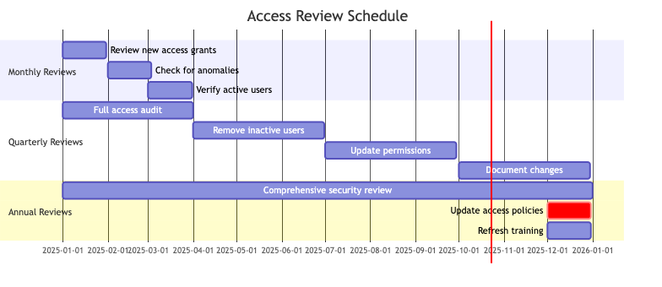
Diagram 2
Access rights are reviewed on a regular basis to ensure that:
- Permissions remain appropriate for each member’s current role in the consortium
- Former partners or members who have left the consortium have their access revoked
- New partners receive appropriate access in a timely manner
- The principle of least privilege is maintained (members have only the access they need)
Review Schedule:
Monthly: - Review new access grants - Check for anomalies - Verify active users
Quarterly: - Full access audit - Remove inactive users - Update permissions - Document changes
Annually: - Comprehensive security review - Update access policies - Refresh training - Audit compliance

Access Revocation
Access must be revoked immediately when: - Member leaves the consortium - Member changes role (no longer needs access) - Security incident involving the account - Violation of policies or code of conduct
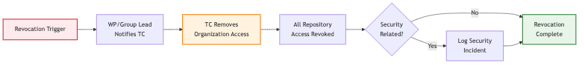
Diagram 3
Revocation Process:
- WP/Group lead notifies Technical Coordinator
- Technical Coordinator removes organization access
- All repository access automatically revoked
- Incident logged if security-related

Working Practices and Workflows

Branching Strategy
The consortium employs the Feature Branch Workflow as the standard branching strategy. This approach balances stability with the need for ongoing development:
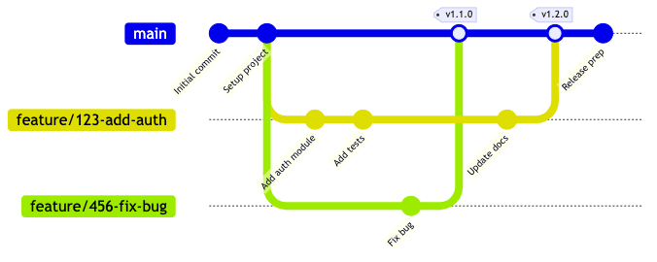
Diagram 4
Main Branch The main branch represents the stable, production-ready state of the repository. Content in the main branch should be thoroughly reviewed, tested, and approved. This branch serves as the authoritative source for released versions of specifications, stable APIs, and production-ready code.
Feature Branches Feature branches are created for specific pieces of work—whether implementing a new capability, fixing a bug, or drafting a section of a specification. Feature branches should be short-lived (ideally less than 2 weeks) and are deleted after their changes have been merged. Keeping branches short-lived reduces integration conflicts and ensures code remains synchronized with the main branch.
Branch Naming Convention:
<type>/<issue-number>-<description>
Examples:
feature/123-add-jwt-authentication
bugfix/456-fix-memory-leak
hotfix/789-patch-security-vulnerability
docs/012-update-api-documentation
Types: - feature/ - New features - bugfix/ - Bug fixes - hotfix/ - Production hotfixes - docs/ - Documentation only - refactor/ - Code refactoring - test/ - Test additions/changes
This branching strategy provides clear separation between stable outputs and individual contributions, making it easier to manage complex collaborative efforts. The strategy isolates work in progress from stable code, enables parallel development, and facilitates easier testing and rollback if needed.

Pull Request Workflow
All contributions to repositories must follow the pull request (PR) workflow. This requirement is fundamental to maintaining quality and fostering collaboration:
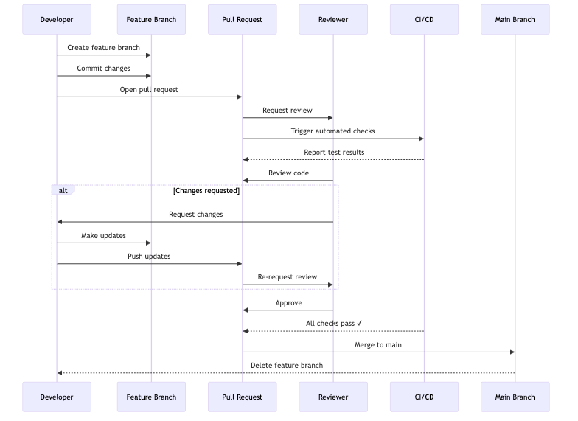
Diagram 5
Why Pull Requests Matter Pull requests serve multiple critical functions. They provide a structured mechanism for proposing changes, create a forum for technical discussion and review, maintain a permanent record of what changed and why, and ensure that at least two people (the author and a reviewer) have examined every change.
Pull Request Requirements Every pull request should:
- Be linked to a relevant issue that explains the motivation for the change
- Include a clear description of what is being changed and why
- Be reviewed and approved by at least one other consortium partner before merging
- Pass any automated checks or tests that have been configured for the repository
- Address any feedback or concerns raised during the review process
- Be reviewed within 2 business days to maintain development momentum
Pull Request Template:
## Description
Brief description of changes.
## Related Issues
Closes #[issue-number]
## Type of Change
- [ ] Bug fix
- [ ] New feature
- [ ] Breaking change
- [ ] Documentation update
## Testing
- [ ] Tests pass locally
- [ ] New tests added
- [ ] Manual testing completed
## Checklist
- [ ] Code follows style guidelines
- [ ] Self-review completed
- [ ] Documentation updated
- [ ] No new warnings
Cross-Partner Review The requirement that pull requests be reviewed by another partner (not just another person from the same organization) is particularly important. This cross-partner review ensures that technical decisions consider multiple perspectives and that knowledge is shared across organizational boundaries.
Code Review Best Practices:
For Authors: - Perform self-review before requesting review - Keep pull requests focused and reasonably sized - Provide context in the description - Respond to feedback constructively - Update the PR based on review comments
For Reviewers: - Review promptly (within 2 business days) - Be respectful and constructive - Focus on important issues - Explain your reasoning - Test changes when possible - Approve when satisfied with the quality

Commit Guidelines
Commit Message Format:
<type>(<scope>): <subject>
<body>
<footer>
Commit Types:
Type | Description | Example
feat | New feature | feat: add user registration
fix | Bug fix | fix: resolve login timeout
docs | Documentation only | docs: update API guide
style | Code style changes | style: format code with prettier
refactor | Code refactoring | refactor: simplify auth logic
test | Test additions/changes | test: add integration tests
chore | Maintenance tasks | chore: update dependencies
Example:
feat(auth): implement JWT authentication
- Add JWT token generation
- Implement token validation middleware
- Add refresh token support
- Update API documentation
Closes #123
Best Practices:
- Write clear, descriptive messages in imperative mood
- Use present tense (“add” not “added”)
- Keep subject line under 50 characters
- Explain what and why, not how
- Reference issues and PRs
- Make atomic commits (one logical change per commit)
- Commit frequently to avoid losing work
- Each commit should represent a complete, working state
Atomic Commits: Keep commits atomic—each commit should represent a single unit of work. This makes it easier to: - Understand the purpose of each change - Review code more effectively - Revert specific changes without side effects - Track down bugs using git bisect

Issue Tracking
GitHub Issues serve as the primary mechanism for tracking technical work, documenting decisions, and managing discussions:
Issue Purposes Issues are used to:
- Track Technical Progress: Break down large technical efforts into manageable, trackable pieces of work
- Document Discussions: Capture technical discussions and decisions in a searchable, permanent format
- Manage Updates: Coordinate changes to specifications, APIs, or implementations
- Report Problems: Document bugs, inconsistencies, or areas needing improvement
- Propose Enhancements: Suggest new features or improvements to existing work
Issue Labels
Standard Labels:
Label | Description
bug | Something isn’t working
enhancement | New feature or request
documentation | Documentation improvements
question | Further information requested
help wanted | Extra attention needed
good first issue | Good for newcomers
security | Security-related
priority: high | Critical, needs immediate attention
priority: medium | Important, should be addressed soon
priority: low | Nice to have, can wait
Issue Best Practices Effective issue management requires:
- Clear, descriptive titles that summarize the issue at a glance
- Detailed descriptions that provide sufficient context for others to understand the issue
- Appropriate labels to categorize and prioritize issues
- Assignment to specific individuals when someone is actively working on the issue
- Regular updates to keep other partners informed of progress
- Closure with a summary of the resolution when work is complete
- Linking related issues and pull requests for traceability

Version Tagging and Releases
Version tags mark important milestones in the evolution of technical artifacts. Tags should follow semantic versioning principles:
Semantic Versioning:
MAJOR.MINOR.PATCH
Example: 1.2.3
Version Increments:
- MAJOR (1.0.0 → 2.0.0): Breaking changes
- MINOR (1.0.0 → 1.1.0): New features (backwards compatible)
- PATCH (1.0.0 → 1.0.1): Bug fixes (backwards compatible)
Pre-release Versions:
- 1.0.0-alpha.1 - Alpha release
- 1.0.0-beta.1 - Beta release
- 1.0.0-rc.1 - Release candidate
When to Create Tags Tags should be created for:
- Major Releases: Significant versions of specifications or software that represent substantial milestones
- Stable Snapshots: Points in time when the repository contents are known to be stable and suitable for reference
- Deliverable Submissions: Versions that correspond to formal project deliverables
- Breaking Changes: Versions that introduce incompatible changes to APIs or interfaces
Tag Documentation Each tag should be accompanied by release notes that explain what has changed since the previous version, highlight any breaking changes or important updates, and acknowledge contributors to that release.
Creating Tags:
# Create annotated tag
git tag -a v1.0.0 -m "First production release"
# Push tag to remote
git push origin v1.0.0
# List all tags
git tag -l

Repository Management

Repository Lifecycle
Repositories progress through distinct lifecycle stages:
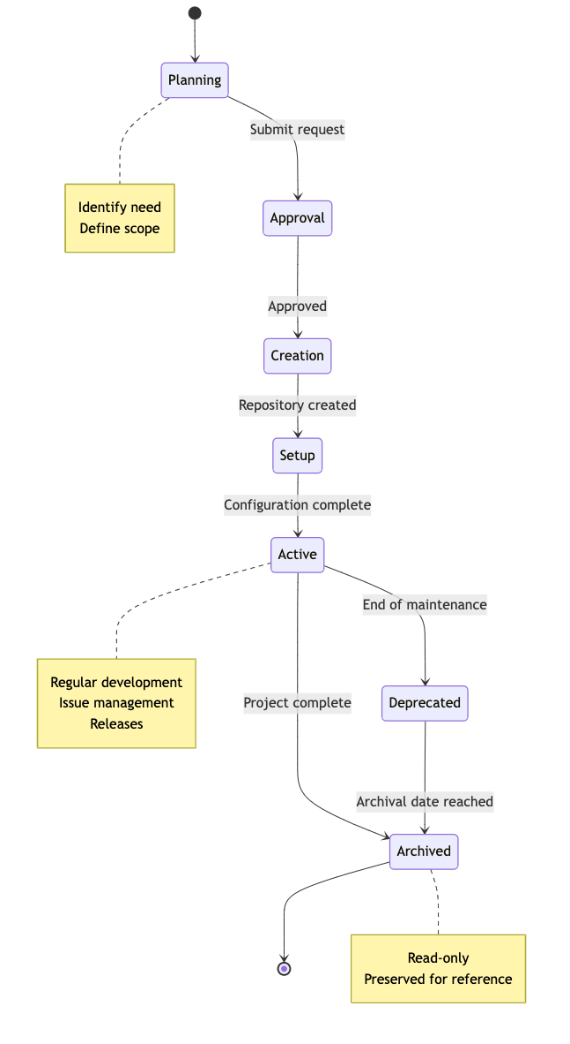
Diagram 6
Lifecycle Stages:
- Planning: Identify need, define purpose and scope
- Approval: Submit creation request, review by WP/Group lead, approval by Technical Coordinator
- Creation: Repository created in organization, initial structure set up
- Setup: Complete configuration, add required files, configure branch protection
- Active: Regular development activity, issue management, releases
- Deprecated: No longer actively maintained, security updates only
- Archived: Read-only status, preserved for reference

Creating New Repositories
When to Create a New Repository:
Create a new repository when:
- Starting a new component or service
- Separating concerns (e.g., API from UI)
- Creating standalone tools or libraries
- Establishing new group workspace
- Developing specifications or standards
- Setting up test frameworks
Do not create new repository for:
- Small features (use branches instead)
- Temporary experiments (use personal repos)
- Duplicate functionality
- Single files or scripts
Repository Naming Best Practices:
Follow a clear naming convention: - Use descriptive, specific names - Include project or team prefix if applicable - Indicate technology stack when relevant - Use lowercase with hyphens (e.g., wp4-trust-api) - Avoid special characters - Keep names concise but meaningful
Repository Creation Request Template:
## Repository Creation Request
### Basic Information
- **Repository Name:** wp4-trust-api
- **Purpose:** Trust infrastructure API implementation
- **Type:** Code Repository
- **Work Package:** WP4
- **Group:** Trust Infrastructure
- **Visibility:** Public
### Justification
Explain why this repository is needed and how it fits into the project architecture.
### Scope
- What will be included
- What will NOT be included
- Boundaries and interfaces
### Team
- **Owner:** [Group Lead Name]
- **Maintainers:** [List names]
- **Initial Contributors:** [List names]
### Approvals
- [ ] Group Lead: [Name]
- [ ] WP Lead: [Name]
- [ ] Technical Coordinator: [Pending]

Repository Configuration

Required Files
Every repository MUST include:
- README.md - Project overview and documentation
- LICENSE - Apache License 2.0 (default)
- CONTRIBUTING.md - Contribution guidelines
- .gitignore - Files to exclude from version control
- CODE_OF_CONDUCT.md - Community standards
- SECURITY.md - Security policy

Repository Topics
Classify repositories with topics to improve discoverability and organization:
- Navigate to repository Settings → About
- Add relevant topics (e.g., api, python, authentication, wp4)
- Topics help with searching, filtering, and organizing repositories
- Use consistent topics across similar repositories

Branch Protection Rules
For main branch:
- Require pull request reviews (minimum 1 approval)
- Require status checks to pass before merging
- Require conversation resolution before merging
- Include administrators in restrictions
- Restrict force pushes (disabled)
- Restrict deletions (disabled)
- Require linear history (optional, for cleaner history)

Security Settings
Enable:
- Dependency graph
- Dependabot alerts
- Dependabot security updates
- Secret scanning
- Code scanning (if applicable)

Repository Maintenance
Regular Maintenance Tasks:
Daily/Weekly: - Monitor and triage new issues - Review pull requests within 2 days - Check CI/CD status - Fix failing builds
Monthly: - Review Dependabot PRs - Update dependencies - Check security alerts - Update documentation - Review and clean up stale branches
Quarterly: - Review team access - Remove inactive users - Analyze repository metrics - Plan improvements

Archiving and Deprecation
When to Archive:
- Project completed
- No longer maintained
- Replaced by newer version
- End of project phase
- Historical reference only
Deprecation Process:
- Add deprecation notice to README
- Create migration guide
- Update documentation
- Notify users
- Set deprecation timeline
- Plan archival date
Deprecation Notice Template:
# DEPRECATED
**This repository is deprecated and no longer maintained.**
**Reason:** [Explain why deprecated]
**Alternative:** Please use [new-repository](link) instead.
**Migration Guide:** See [MIGRATION.md](MIGRATION.md) for migration instructions.
**Support:** Security fixes only until [date]. No new features will be added.

Licensing and Intellectual Property

Default License Policy
Standard License: Apache License 2.0
Rationale: - Permissive open-source license - Compatible with commercial use - Provides patent protection - Widely recognized and understood - Allows derivative works - Minimal restrictions on use

License Implementation
Every repository MUST include:
- LICENSE file in repository root
- License headers in source files (where applicable)
- README notice stating the license
- NOTICE file for attributions (if needed)
Copyright Notice:
Copyright 2025 WEBUILD Consortium
Licensed under the Apache License, Version 2.0 (the "License");
you may not use this file except in compliance with the License.
You may obtain a copy of the License at
http://www.apache.org/licenses/LICENSE-2.0
Unless required by applicable law or agreed to in writing, software
distributed under the License is distributed on an "AS IS" BASIS,
WITHOUT WARRANTIES OR CONDITIONS OF ANY KIND, either express or implied.
See the License for the specific language governing permissions and
limitations under the License.
Source File Headers:
# Copyright 2025 WEBUILD Consortium
# SPDX-License-Identifier: Apache-2.0

Third-Party Dependencies
Before Adding Dependencies:
- Check dependency license
- Verify license compatibility
- Review license obligations
- Check for patent clauses
- Assess security implications
- Document license in project
Acceptable Licenses:
- Apache 2.0
- MIT
- BSD 2-Clause, 3-Clause
- ISC
- Python Software Foundation
- Unlicense / Public Domain
Problematic Licenses (avoid):
- GPL 2.0 (incompatible with Apache 2.0)
- AGPL (strong copyleft)
- Proprietary licenses
- Licenses with field-of-use restrictions
Dependency Management Best Practices:
- Lock package versions in manifest files
- Align package versions across projects when possible
- Document all dependencies and their licenses
- Regularly review and update dependencies
- Use automated tools to track dependency vulnerabilities

Intellectual Property
Key Points:
- Background IP: Each partner retains ownership of pre-existing IP
- Foreground IP: New IP created during project is jointly owned
- Access Rights: Partners have access rights per consortium agreement
- Publication: Open access publication required by EU grant
- Exploitation: Partners may exploit results per agreement
Contributors retain copyright to their contributions, but grant rights to the consortium.

Security and Compliance

Security Principles
Core Principles:
- Defense in Depth: Implement multiple layers of security
- Least Privilege: Grant minimum necessary permissions
- Secure by Default: Security should be the default state
- Zero Trust: Never trust, always verify
Mandatory Requirements:
All members MUST:
- Enable two-factor authentication (2FA)
- Use strong, unique passwords
- Protect credentials and secrets
- Report security incidents immediately
- Follow secure coding practices
- Complete security training
- Review code for security issues
- Keep dependencies updated
Prohibited Activities:
Never:
- Commit secrets or credentials
- Store sensitive data in repositories
- Share accounts or credentials
- Disable security features
- Ignore security warnings
- Use weak or reused passwords
- Access unauthorized resources
- Bypass security controls

Secrets Management
What Are Secrets?
- API keys and tokens
- Passwords and passphrases
- Private keys and certificates
- Database credentials
- OAuth tokens
- Encryption keys
- Service account credentials
Never Commit Secrets
Secrets should never be committed to version control. Use environment variables and secure secret management tools instead.
Use .gitignore:
# Secrets and credentials
.env
.env.local
.env.*.local
secrets/
*.key
*.pem
*.p12
credentials.json
config/secrets.yml
If Secrets Are Committed:
- Rotate the secret immediately
- Remove from history using BFG Repo-Cleaner or git filter-branch
- Notify Technical Coordinator and security team
- Document the incident
Secure Storage:
- Local development: Use environment variables and .env files (excluded from git)
- CI/CD: Use GitHub Secrets for workflow automation
- Production: Use dedicated secret management services (AWS Secrets Manager, Azure Key Vault, HashiCorp Vault)
GitHub Secrets Best Practices:
- Store secrets at appropriate level (repository, environment, or organization)
- Use environment secrets for deployment-specific credentials
- Limit access to secrets through environment protection rules
- Rotate secrets regularly
- Never print secrets in logs or output
- Use secret scanning to detect accidental commits

Code Security
Secure Coding Practices:
Input Validation: - Always validate and sanitize input - Use parameterized queries - Validate data type, length, and format - Whitelist allowed values - Encode output properly
Authentication and Authorization: - Use strong password hashing (bcrypt, Argon2) - Implement rate limiting - Use secure session management - Implement proper authorization checks - Use HTTPS for all communications
Error Handling: - Log detailed errors server-side - Return generic messages to users - Don’t expose stack traces - Don’t reveal system information - Handle errors gracefully
Cryptography: - Use established libraries (cryptography, libsodium) - Use strong algorithms (AES-256, RSA-2048+) - Generate secure random keys - Protect encryption keys - Never implement your own crypto

Dependency Security
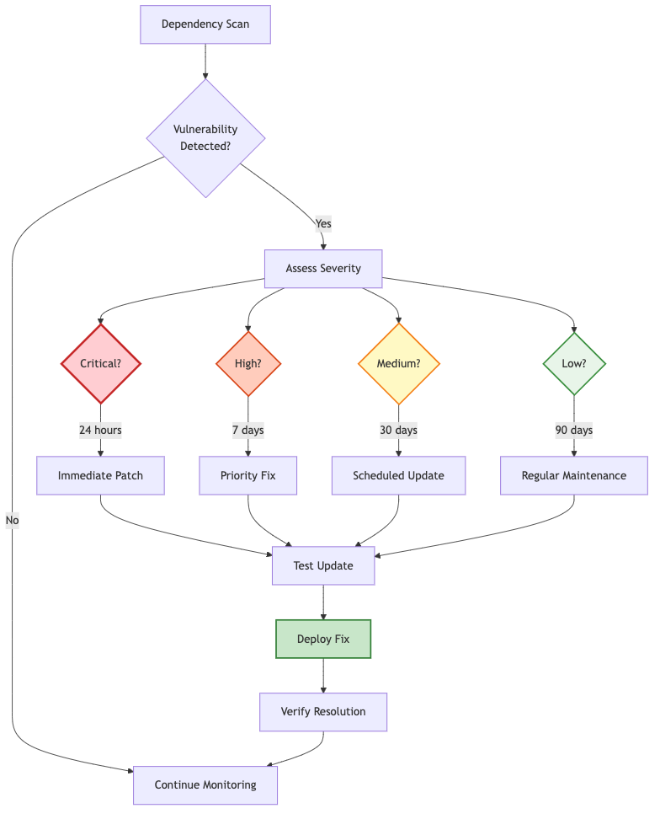
Diagram 7
Dependency Management:
Enable GitHub Features:
- Dependency graph
- Dependabot alerts
- Dependabot security updates
Vulnerability Response:
Severity | Response Time | Action
Critical | 24 hours | Immediate patch
High | 7 days | Priority fix
Medium | 30 days | Scheduled update
Low | 90 days | Regular maintenance
Update Strategy:
- Patch versions: Update automatically (1.2.3 → 1.2.4)
- Minor versions: Review and test (1.2.0 → 1.3.0)
- Major versions: Careful review and testing (1.0.0 → 2.0.0)
Best Practices:
- Don’t commit dependencies to source code (use package managers)
- Lock dependency versions to ensure reproducible builds
- Regularly review and update dependencies
- Monitor security advisories
- Test updates in non-production environments first

Data Protection and GDPR Compliance
Never store in repositories:
- Names and contact information
- Email addresses
- Phone numbers
- Physical addresses
- IP addresses
- User IDs (if personally identifiable)
- Any other personal data
If personal data needed for testing:
- Use synthetic/fake data
- Anonymize real data
- Use data generators
- Obtain explicit consent (if real data required)
Data Classification:
Level | Examples | Handling
Public | Published docs, open source code | No restrictions
Internal | Internal docs, non-sensitive code | Consortium only
Confidential | Partner data, unpublished research | Restricted access
Restricted | Credentials, personal data | Never in repos

Incident Response
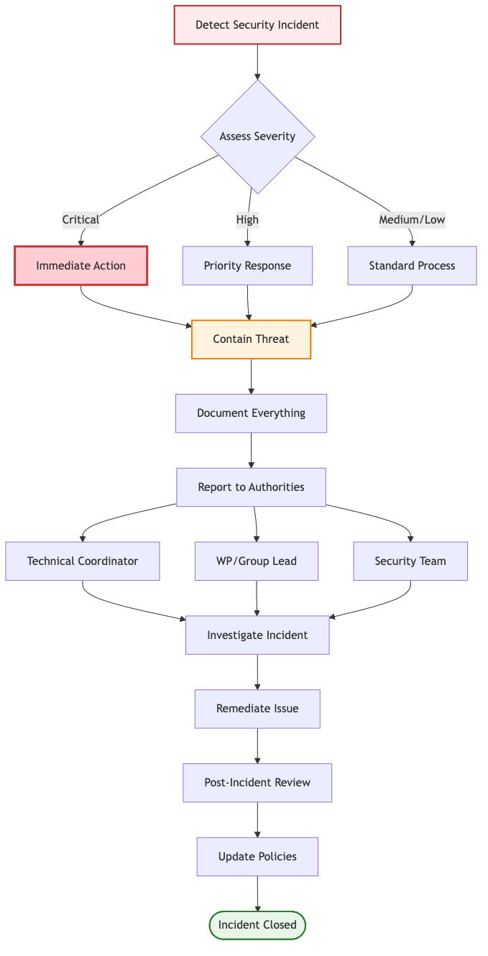
Diagram 8
What is a Security Incident?
- Unauthorized access to repositories
- Compromised credentials
- Data breach or exposure
- Malware or malicious code
- Denial of service attack
- Vulnerability exploitation
Reporting Incidents:
Immediate Actions:
- Don’t panic
- Document everything
- Report immediately to:
  - Technical Coordinator
  - WP/Group Lead
  - Security team
Include in report:
- What happened
- When it happened
- What was affected
- Current status
- Actions taken
- Evidence collected

Compliance Requirements
EU Regulations:
GDPR (General Data Protection Regulation):
- Lawful basis for data processing
- Explicit consent when required
- Data minimization
- Purpose limitation
- Storage limitation
- Appropriate security measures
- Accountability and documentation
Implementation:
- Data protection impact assessment
- Privacy by design
- Data processing records
- Data breach procedures
- Data subject rights procedures

Contribution Guidelines

Getting Started
Prerequisites:
Before contributing, ensure you have:
- GitHub account with 2FA enabled
- Access to WEBUILD organization
- Appropriate repository permissions
- Git installed and configured
- Development environment set up
- Familiarity with Git workflows

Contribution Workflow
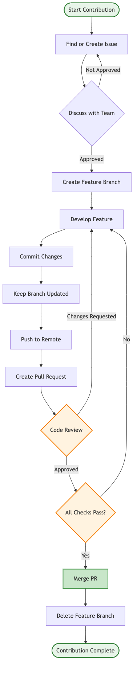
Diagram 9
Step-by-Step Process:

Step 1: Find or Create an Issue
- Search existing issues for similar work
- If no issue exists, create one describing the problem or feature
- Discuss approach with team
- Get approval from maintainer
- Get issue assigned to you

Step 2: Create Feature Branch
# Update local main
git checkout main
git pull origin main
# Create feature branch
git checkout -b feature/123-add-user-profile
# Verify branch
git branch

Step 3: Develop the Feature
# Make changes
# ... edit files ...
# Stage changes
git add src/profile.py tests/test_profile.py
# Commit with clear message
git commit -m "feat: add user profile management
- Implement profile CRUD operations
- Add profile validation
- Create profile API endpoints
- Add comprehensive tests
Closes #123
"
#### Step 4: Keep Branch Updated
```bash
# Fetch latest changes
git fetch origin
# Rebase on main (preferred)
git rebase origin/main
# Resolve conflicts if any
# ... fix conflicts ...
git add .
git rebase --continue

Step 5: Push and Create PR
# Push feature branch
git push origin feature/123-add-user-profile
# If rebased, may need force push
git push origin feature/123-add-user-profile --force-with-lease

Step 6: Address Review Feedback
# Make requested changes
# ... edit files ...
# Commit changes
git add .
git commit -m "refactor: address review feedback"
# Push updates
git push origin feature/123-add-user-profile

Step 7: Merge
After approval:
- Ensure all checks pass
- Resolve any conflicts
- Squash commits if needed
- Merge pull request
- Delete feature branch

Code Standards
General Principles:
- Write clean, readable code
- Follow SOLID principles
- Keep it simple
- Use meaningful variable names
- Add comments for complex logic
- Write self-documenting code where possible
Language-Specific Standards:
Follow established style guides for each language:
- Python: PEP 8, use pylint, flake8, black
- JavaScript/TypeScript: Airbnb style guide, use ESLint, Prettier
- Java: Google Java Style Guide, use checkstyle
Security Considerations:
Always:
- Validate all inputs
- Sanitize user data
- Use parameterized queries
- Implement proper authentication
- Follow principle of least privilege
- Keep dependencies updated
Never:
- Store passwords in plain text
- Commit secrets or credentials
- Trust user input
- Use deprecated security libraries
- Ignore security warnings

Testing Requirements
All code changes must include tests:
- New features require new tests
- Bug fixes require regression tests
- Refactoring maintains test coverage
- Tests must pass before merging
Types of Tests:
- Unit Tests: Test individual components in isolation
- Integration Tests: Test component interactions
- End-to-End Tests: Test complete user workflows
Minimum Requirements:
- Unit test coverage: 80%
- Critical paths: 100%
- New code: Must include tests
- Bug fixes: Must include regression tests

Code Review Guidelines
For Authors:
- Self-review first
- Provide clear PR description
- Link to relevant issues
- Explain design decisions
- Be responsive to feedback
- Make requested changes promptly
For Reviewers:
- Review promptly (within 2 days)
- Be respectful and constructive
- Focus on important issues
- Explain reasoning
- Approve when satisfied
- Test if possible
Review Checklist:
- Functionality: Does it work as intended?
- Code Quality: Is it well-written and maintainable?
- Tests: Are there adequate tests?
- Documentation: Is it properly documented?
- Security: Are there security concerns?
- Performance: Are there performance issues?
- Standards: Does it follow coding standards?

Onboarding Procedures
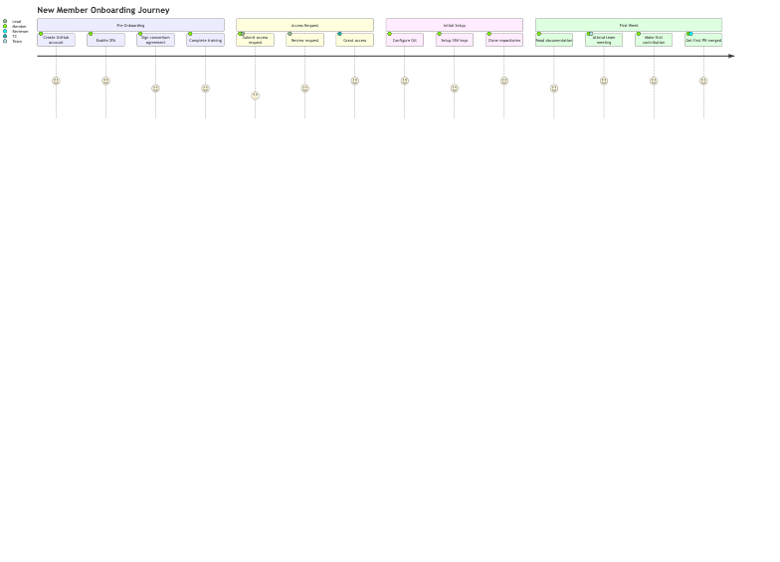
Diagram 10

Pre-Onboarding Requirements
Before requesting access, new members must:
Have a GitHub Account: - Create account at github.com - Use professional username (preferably real name) - Add profile picture - Enable two-factor authentication (2FA)
Complete Consortium Onboarding: - Sign consortium agreement - Complete data protection training - Acknowledge code of conduct - Receive partner organization approval
Understand Project Context: - Review project overview - Understand WP/Group objectives - Identify role and responsibilities - Know reporting structure

Initial Setup
Git Configuration:
# Set your name and email
git config --global user.name "Your Full Name"
git config --global user.email "your.email@organization.com"
# Set default branch name
git config --global init.defaultBranch main
# Enable credential caching
git config --global credential.helper cache
# Verify configuration
git config --list
SSH Key Setup (Recommended):
# Generate SSH key
ssh-keygen -t ed25519 -C "your.email@organization.com"
# Start SSH agent
eval "$(ssh-agent -s)"
# Add key to agent
ssh-add ~/.ssh/id_ed25519
# Copy public key and add to GitHub
cat ~/.ssh/id_ed25519.pub

First Week Goals
Week 1 Checklist:
- Complete environment setup
- Clone relevant repositories
- Read all documentation
- Attend team meeting
- Make first contribution (even if small)
- Get first PR merged
- Introduce yourself to team
- Set up communication channels

Offboarding Procedures
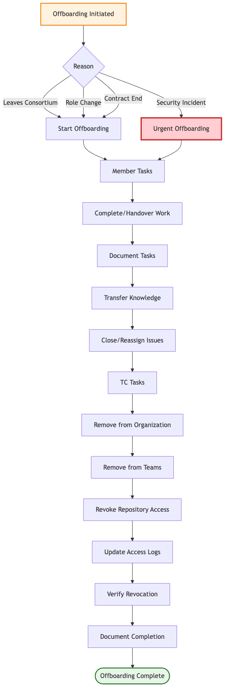
Diagram 11
When Offboarding is Required:
- Member leaves the consortium
- Partner organization exits project
- Contract/assignment ends
- Role changes (no longer needs access)
- Security incident requires access revocation
Offboarding Checklist:
For Departing Member: - [ ] Complete assigned work or hand over - [ ] Document ongoing tasks - [ ] Transfer knowledge to team - [ ] Update documentation - [ ] Close or reassign issues - [ ] Finish open pull requests
For Technical Coordinator: - [ ] Remove from organization - [ ] Remove from all teams - [ ] Revoke repository access - [ ] Update access logs - [ ] Verify access revocation complete - [ ] Document offboarding completion

EU Funding Acknowledgment
All repositories MUST include EU funding acknowledgment:
Required Text:
## Funding
![Co-funded by the European Union](https://github.com/EWC-consortium/ewc-wiki/assets/455274/1ac9b4e3-06b9-4c3c-a2af-ec5fbf584517)
The WEBUILD project is co-funded by the European Union. However, the views and
opinions expressed are those of the author(s) only and do not necessarily reflect
those of the European Union or the granting authority. Neither the European Union
nor the granting authority can be held responsible.
Placement: In README.md and major documentation files

Archival and Long-Term Preservation

Ongoing Maintenance Responsibilities
Each Work Package Lead bears responsibility for:
Repository Structure Maintenance Ensuring that repositories remain well-organized, with clear directory structures, up-to-date documentation, and appropriate use of GitHub features like wikis or project boards.
Documentation Currency Keeping README files, CONTRIBUTING guides, and other documentation current as the repository evolves. Outdated documentation can be more harmful than no documentation, as it misleads contributors.
Change Documentation Ensuring that significant changes are properly documented through commit messages, pull request descriptions, and release notes. This documentation creates a narrative of how the technical work evolved.
Quality Assurance Maintaining the quality and integrity of repository contents through consistent application of review processes and quality standards.

Project Closure and Archival
At the conclusion of the WEBUILD project, all repositories will be archived under the consortium GitHub organization. This archival process ensures:
Long-Term Preservation Technical outputs remain accessible for future reference, even after the consortium has concluded its active work. This preservation is important for demonstrating project impact and enabling future work to build on consortium achievements.
Historical Record The complete history of technical collaboration is preserved, including all commits, issues, pull requests, and discussions. This historical record has value for understanding how technical decisions were made and how solutions evolved.
Compliance with Funding Requirements Many funding agencies require that project outputs remain accessible for specified periods after project completion. Archival in the consortium GitHub organization helps meet these requirements.
Continued Access Archived repositories remain readable, allowing former partners and the broader community (for public repositories) to access the technical outputs of the consortium’s work.

Best Practices Summary

General Best Practices
Do:
- Keep branches short-lived (< 2 weeks)
- Update from main frequently
- Write clear commit messages
- Make atomic commits
- Test before pushing
- Review your own code first
- Delete merged branches
- Use branch protection rules
- Follow naming conventions
- Document significant decisions
- Commit frequently to avoid losing work
- Pull before you push to avoid conflicts
Don’t:
- Commit directly to main
- Force push to shared branches
- Leave branches unmerged for long
- Mix unrelated changes
- Commit broken code
- Ignore CI failures
- Skip code review
- Rewrite published history
- Commit dependencies or configuration files
- Hardcode secrets or credentials

Security Best Practices
Always:
- Enable 2FA on all accounts
- Use strong, unique passwords
- Protect credentials and secrets
- Validate all inputs
- Use parameterized queries
- Keep dependencies updated
- Review code for security issues
- Report incidents immediately
- Rotate secrets regularly
- Use environment variables for configuration
Never:
- Commit secrets or credentials
- Store sensitive data in repositories
- Share accounts or credentials
- Disable security features
- Ignore security warnings
- Trust user input without validation
- Use deprecated security libraries
- Expose secrets in logs

Code Quality Best Practices
Write Clean Code:
- Clear and readable
- Self-documenting where possible
- Consistent style
- Properly formatted
- Well-tested
- Adequately documented
Follow SOLID Principles:
- Single Responsibility
- Open/Closed
- Liskov Substitution
- Interface Segregation
- Dependency Inversion
Keep It Simple:
- Avoid over-engineering
- Use appropriate abstractions
- Prefer clarity over cleverness
- Make code maintainable

Repository Management Best Practices
Organization:
- Use clear naming conventions
- Classify repositories with topics
- Maintain comprehensive README files
- Keep repositories focused and scoped appropriately
- Archive dead or unmaintained repositories
Collaboration:
- Use pull requests for all changes
- Conduct thorough code reviews
- Leverage issue tracking effectively
- Use GitHub Projects for planning
- Communicate clearly and frequently

Support and Resources

Getting Help
For GitHub Issues:
- Check repository documentation
- Search existing issues
- Ask in repository discussions
- Contact repository maintainers
- Escalate to WP/Group lead
For Policy Questions:
- Review this documentation
- Contact your WP/Group lead
- Reach out to Technical Coordinator

Training and Resources
Internal Resources:
- Repository documentation
- Wiki pages
- Past pull requests and issues
- Team meeting notes
- Architecture diagrams
External Resources:
- GitHub Documentation
- Git Documentation
- Pro Git Book
- Apache License 2.0
- SPDX License List

Contact Information
Technical Coordinator: [Contact via consortium channels]
WP4 Lead: [Contact via consortium channels]
Group Leads: - QTSP Group: [Contact info] - Trust Group: [Contact info] - Semantics Group: [Contact info] - Wallets Group: [Contact info] - Interop Test Bed: [Contact info]

Appendices

Appendix A: Quick Reference Checklist
New Repository Setup:
- Repository created with appropriate name
- README.md with required content
- LICENSE file (Apache 2.0)
- CONTRIBUTING.md
- .gitignore configured
- Branch protection rules set
- Topics added
- Team access configured
- EU funding acknowledgment included
- Security settings enabled
Before Making Repository Public:
- Pre-publication checklist completed
- No secrets or credentials
- No sensitive data
- Appropriate license
- Documentation complete
- Approvals obtained
- Announcement prepared
Pull Request Checklist:
- Code follows style guidelines
- All tests pass locally
- New tests added for new functionality
- Documentation updated
- Commit messages are clear
- No merge conflicts with main
- Self-review completed
- No debugging code or console logs

Appendix B: Common Git Commands
Branch Management:
# Create branch
git checkout -b feature/123-name
# Update branch
git fetch origin
git rebase origin/main
# Delete branch
git branch -d feature/123-name
Commit and Push:
# Commit
git add .
git commit -m "type: description"
# Push
git push origin feature/123-name
# Force push (use with caution)
git push origin feature/123-name --force-with-lease
Sync with Main:
git checkout main
git pull origin main
git checkout feature/123-name
git rebase main
Stash Changes:
# Save work in progress
git stash save "WIP: feature implementation"
# Apply stash
git stash pop

Appendix C: Troubleshooting
Common Issues:
Issue: Merge Conflicts
# Update your branch
git fetch origin
git rebase origin/main
# Fix conflicts in files
git add .
git rebase --continue
Issue: Accidentally Committed to Main
# Move commit to new branch
git branch feature/accidental-commit
git reset --hard HEAD~1
git checkout feature/accidental-commit
Issue: Need to Change Last Commit Message
git commit --amend -m "New commit message"
git push origin branch-name --force-with-lease
Issue: Pushed Sensitive Data
- Rotate the secret immediately
- Remove from history using BFG Repo-Cleaner
- Notify Technical Coordinator
- Document the incident

Appendix D: Glossary
- Consortium: WEBUILD project partners
- WP: Work Package
- PR: Pull Request
- CI/CD: Continuous Integration/Continuous Deployment
- GDPR: General Data Protection Regulation
- IP: Intellectual Property
- EUDI: European Digital Identity
- 2FA: Two-Factor Authentication
- SSH: Secure Shell
- API: Application Programming Interface
- Atomic Commit: A commit containing a single logical change
- Branch Protection: Rules that prevent direct commits to protected branches
- Code Owner: Person or team responsible for reviewing changes to specific code
- Dependency: External library or package used by the project
- Fork: Personal copy of a repository
- Merge Conflict: When Git cannot automatically merge changes
- Rebase: Reapplying commits on top of another base
- Semantic Versioning: Version numbering scheme (MAJOR.MINOR.PATCH)
- Tag: Named reference to a specific commit

Conclusion
These policies and guidelines establish the foundation for effective, secure, and compliant use of GitHub within the WEBUILD Consortium. By following these practices, partners can collaborate effectively across organizational boundaries while maintaining the quality, security, and integrity of technical work.
Success in collaborative technical work requires more than just tools—it requires shared understanding of how those tools should be used. These guidelines provide that shared understanding, enabling partners to focus on the technical challenges at hand rather than on process questions.
As the consortium’s work evolves, these policies may be refined based on practical experience and changing needs. Partners are encouraged to provide feedback on these guidelines to help ensure they remain practical and effective.

Document History
Version | Date | Changes | Author
1.0 | October 2025 | Initial version based on Project Management Handbook | WEBUILD Technical Coordination
2.0 | October 2025 | Enhanced with content from 7 policy documents: GitHub Policies and Guidelines, Contribution Guidelines, Onboarding Procedures, Repository Management, Licensing Guidelines, Security and Compliance, and Branching and Workflow | WEBUILD Technical Coordination
3.0 | October 2025 | Incorporated insights from best practices documents covering branching strategies, version control workflows, secrets management, repository management, and general GitHub best practices | WEBUILD Technical Coordination
4.0 | October 2025 | Replaced ASCII diagrams with Mermaid diagrams and added additional visual diagrams for improved clarity and understanding | WEBUILD Technical Coordination
Next Review Date: January 2026

This document is maintained in the webuild-policies repository. For questions or suggestions, please open an issue or contact the Technical Coordinator.

