**MON 11.12.2017**

-1- \note

I finished chapter 1 for \note. For now I will stay on Minlano.

>N: Continue chapter 2.

-2- \vs2017

I looked at MVA course for git. I probably can do an init git within VS2017, without connecting to github.

>N: Text on Hyper-V Win10 the git init.

**THU 14.12.2017**

-1- Goals¦

This directory will help me to master the use of GIT, VS2017, TDD with Harry.

1. Imagine a web-based product for the public.
2. Advance TDD with Harry
3. Try to replicate the action from TDD with Harry in VS2017.
4. Understand GIT-BASH and GIT VS2017
5. Understand DJANGO

-2- VS17¦Hyper-V

In Hyper-V VS17 set-up I learned that I can start a DJANGO server without the debugging mode.

SELECT Projectname in ProjExpl > R-click > Python > Start server.

DJANGO starts then on localhost:8000.

I also installed the polling Django application with VS.

-3- VS17¦Milano

I have now two projects in mappeProjTDD.

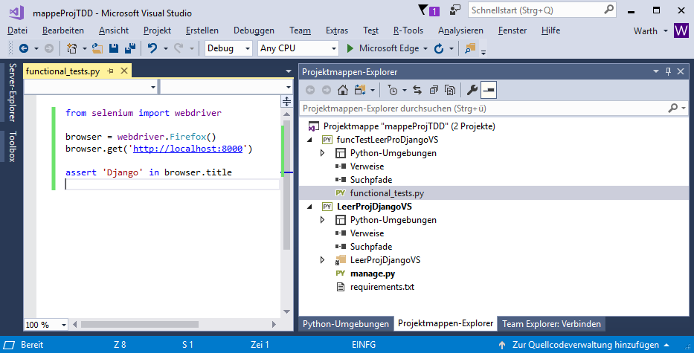

I can start from VS the DJANGO server in the LeerProjDjangoVS and then go funcTestLeerProDjangoVS and run the functional_tests.py file. It will function and output the results as the \note version of TDD. I can also use the GIT-BASH in the funcTestProDjangoVS, withouct skrewing up VS.

This is a nice progress !!

**FRI 15.12.2017**

-1- GIT¦MVA¦

Discovered GitHub Desktop (based on electron), Emmet (code snipets),

-2- VS17¦GIT¦VSTS¦

It appears it is now Visual Studio Team Services.

I created on Milano solution / Projectmappe “useGitVS17” with the project “pyAnwendung”. I use the project to explore selenium. I pushed it to VSTS/useGIT17mappe.

It appears that I cannot have a project connect to VSTS-GIT and another to GitHub in the same Solution/projectMapper.

Does VS17 create this Source Directory of did it come with GIT-BASH ?

C:\Users\raine_kd2ek0t\Source\Repos

Each VS17 has assigned an account. DATEI > Kontoestellungen…

-3- VSTS ¦ TFS ¦ Microsoft ¦ Visual Studio

Visual Studio is now a brand. It provides VS 2017 community, VS code, VSTS (Visual Studio Team Services), and Team Foundation Server (TFS).

I have the account [rainer.warth@hotmail.com](mailto:rainer.warth@hotmail.com) <> Nervi56-Wa on VSTS. I can invite some teammates, but first I need to read the docs.

<https://docs.microsoft.com/en-us/vsts/user-guide/>

Basically, this is the place I can use: Set-up an account, create a team, create a project, use git, do continuous integration and delivery, plan and track work.

Depending on the process chosen when the team project was created—[Scrum](https://docs.microsoft.com/en-us/vsts/work/work-items/guidance/scrum-process), [Agile](https://docs.microsoft.com/en-us/vsts/work/work-items/guidance/agile-process), or [CMMI](https://docs.microsoft.com/en-us/vsts/work/work-items/guidance/cmmi-process)—the types of work items you can create will differ. For example, backlog items may be called product backlog items (Scrum), user stories (Agile), or requirements (CMMI). All three are similar: they describe the customer value to deliver and the work to be performed.+

For an overview of all three processes, see [Choose a process](https://docs.microsoft.com/en-us/vsts/work/work-items/guidance/choose-process).

-4- GIT¦Repo server¦

[www.git.hub](http://www.git.hub) webwart nervi56f

[www.visualstudio.com](http://www.visualstudio.com) [rainer.warth@hotmail.com](mailto:rainer.warth@hotmail.com)

uberspace GIT bar repo

\Pub_CodeDev \ 140212_VersionsVerwaltung.docx

**FRI 16-02-2018**

-1- bookTDD¦MVA

I created the folder bookTDD, where I placed the .docx I copied from Harry’s website. I use these docs to add my comments.

I did finish the Django MVA course, but it is hard to remember anything. I need to practice it much more. In addition, it seems it does not run anymore. What would it bring to me if I wood master Django. ?

**TUE 11-02-2020**

-1- file¦folder¦cleaning

I removed two folders in which I experimented with VisualCode community edition. I also removed:

\Python-docs-hello-world\ in which I conneceted to flask on Azure with aministra <> Nervi56-Az