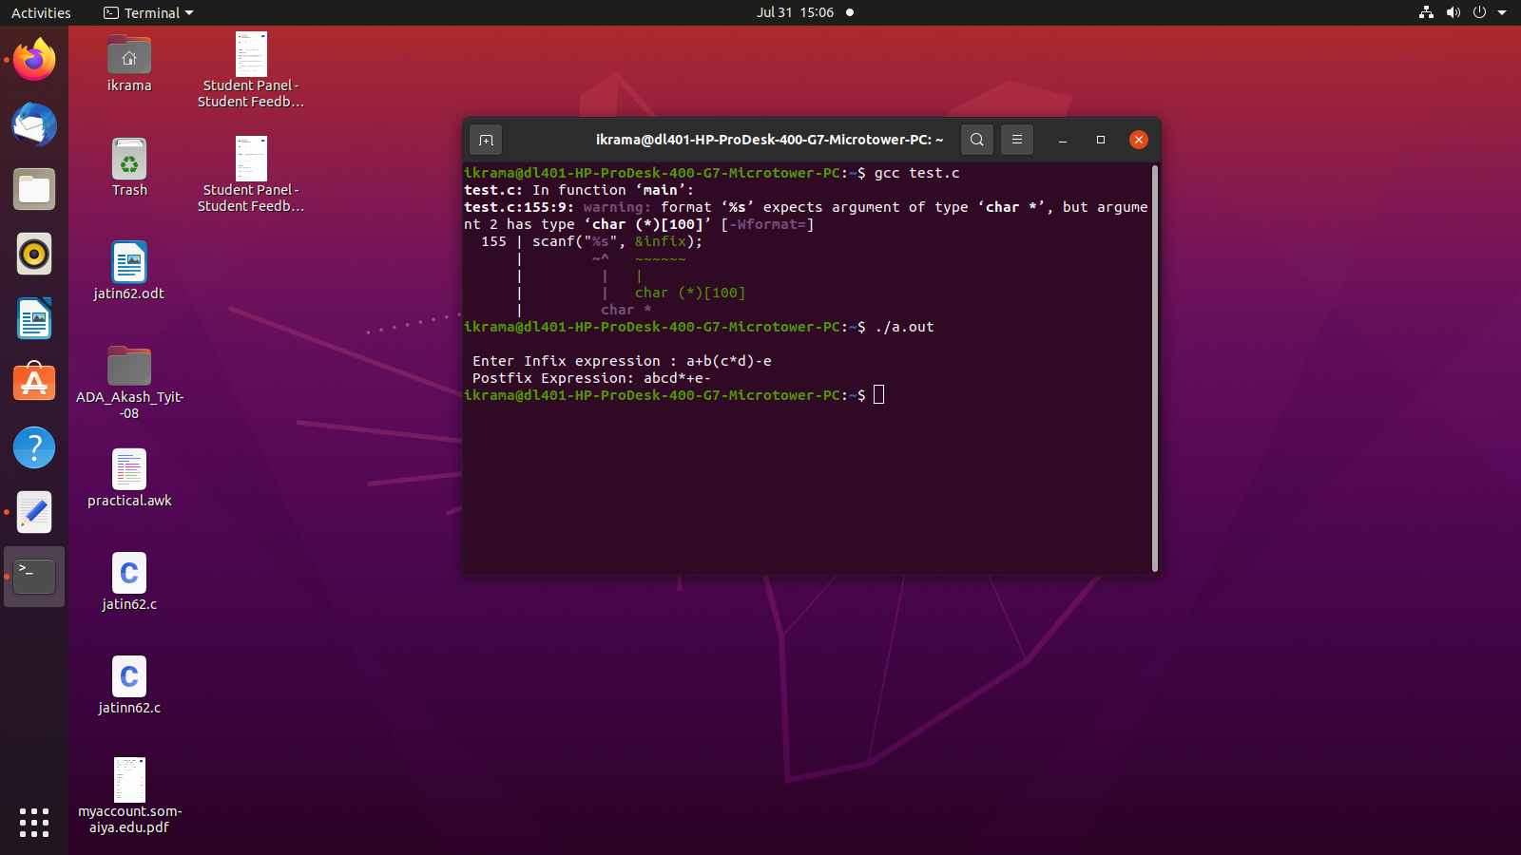
#include<stdio.h>
#include<stdlib.h>
#include<ctype.h>
#include<string.h>
#define SIZE 100
char stack[SIZE];
int top=-1;
void push(char item){
if(top>=SIZE-1){
printf("\n stack overflow");
}
else {
top=top+1;
stack[top]= item;
}
}
char pop(){
char item;
if(top<0){
printf("stack underflow: invalid infix expression");
getchar();
exit(1);
}
else{
item= stack[top];
top=top-1;
return(item);
}
}
int is_operator(char symbol)
{
if(symbol == '^' || symbol == '*' || symbol == '/' || symbol == '+' || symbol =='-')
{
return 1;
}
else
{
return 0;
}
}
/* to define the precedence of the opertors */
int precedence(char symbol)
{
if(symbol == '^')
{
return(3);
}
else if(symbol == '*' || symbol == '/')
{
return(2);
}
else if(symbol == '+' || symbol == '-')
{
return(1);
}
else
{
return(0);
}
}
void InfixToPostfix(char infix_exp[], char postfix_exp[])
{
int i, j;
char item;
char x;
push('('); /* push '(' onto stack */
strcat(infix_exp,")"); /* add ')' to infix expression */
i=0;
j=0;
item=infix_exp[i];
while(item != '\0')
{
if(item == '(')
{
push(item);
}
else if( isdigit(item) || isalpha(item))
{
postfix_exp[j] = item; /* add operand symbol to postfix expr */
j++;
}
else if(is_operator(item) == 1) /* means symbol is operator */
{
x=pop();
while(is_operator(x) == 1 && precedence(x)>= precedence(item))
{
postfix_exp[j] = x; /* so pop all higher precendence operator and */
j++;
x = pop(); /* add them to postfix expresion */
}
push(x);
push(item); /* push current oprerator symbol onto stack */
}
else if(item == ')') /* if current symbol is ')' then */
{
x = pop(); /* pop and keep popping until */
while(x != '(') /* '(' encounterd */
{
postfix_exp[j] = x;
j++;
x = pop();
}
}
else
{ /* if current symbol is neither operand not '(' nor ')' and nor operator */
printf("\nInvalid infix Expression.\n");
getchar();
exit(1);
}
i++;
item = infix_exp[i];
}
if(top>0)
{
printf("\nInvalid infix Expression.\n");
getchar();
exit(1);
}
postfix_exp[j] = '\0'; /* add sentinel else puts() fucntion */
/* will print entire postfix[] array upto SIZE */
}
/* === main function begins === */
int main()
{
char infix[SIZE], postfix[SIZE];
printf("\n Enter Infix expression : ");
scanf("%s", &infix);
InfixToPostfix(infix,postfix);
printf(" Postfix Expression: ");
puts(postfix);
return 0;
}

