Global Elements & Layouts
- Design System: A responsive Light/Dark theme leveraging CSS variables.
- Top Banner: The text "Rent Worx | Rajiv Kumar" has been completely removed. It now elegantly features an inline SVG phone icon for +64 21 712 912, an emergency pulse text ("In any emergency such as fire or theft, please call 111"), and an SVG email icon for rajiv@rentworx.co.nz.
- Navbar features Home, Landlords, Tenants, Rent/Viewing, Rent Appraisal, Services, About Us, Contact links. Special highlight Rent Appraisal, Services like a button.
- Footer Section: Contains a 4-column layout. The logo dynamically swaps between Rentworx_logo_light.png and Rentworx_logo_dark.png depending on the active theme. It features Navigation, Discover, and Connect columns, culminating in social links (Email, Facebook, Instagram) and copyright text.
- Floating Widgets: A permanent WhatsApp FAB (Floating Action Button) is pinned to the bottom left, linked directly to Rajiv's number. A sliding toast notification system (#toast-container) handles form submission feedback.
- Modals: A dynamic property details modal (#modal-property) loads high-resolution image galleries and extended descriptions when a user clicks to view a rental listing.

Pagewise Content Details
1. Home Page
- Hero Section: Features a multi-property background video (images/home-hero-clip.mp4) that plays muted and looped. There are absolutely no dimming overlays; the video is kept bright.
  - Delayed Emergence: The hero logo (images/Rentworx_logo_dark.png) fades in and drops down after 10 seconds (opacity: 0.9). The tagline "YOUR PROPERTY <br> OUR PRIORTY" follows with a similar emergence effect 5 seconds later. Show the details “Boutique property management with a personal touch—keeping you connected and your investment effortless.”
- Trust Banner: The title is "20+ years in Property Management". It features a grid of 4 metrics (380+ Properties Managed, 100% Healthy Homes Certified, < 12 Days Avg Time, 100% Happy Clients) triggered by a JavaScript IntersectionObserver that animates the numbers counting up.
- Replace the “Pioneering Property Management in Auckland” section with
Heading: “Property Management That Works For You”
Details: At Rent Worx, we believe property management is about more than managing a rental — it’s about looking after your property as if it matters to us too.
We provide personal, reliable property management across South and East Auckland, with a simple focus: good tenants, well-maintained properties and clear communication with owners.
We take the time to understand you, your property and what matters to you. We keep things straightforward, stay on top of the details and are always here when you need us.
Our aim is simple — to make property ownership easier, with a property manager you can trust.
paired with the image images/home-pm-auckland.jpg.
- Who We Are (Split Row): Explains the "Strategic Pillars" (High-Impact Placement, Comprehensive Vetting, etc.)
- CTA Banner: "Elevate Your Portfolio" set over images/home-cta.jpg. Replace the heading & text with
Heading: The Rent Worx Difference:
Details: Personal care, proactive updates, and zero stress. We manage the hard work so you can enjoy the returns.
- Testimonials: Features a 40-second continuous scrolling marquee (#home-marquee) displaying client endorsements.

2. Landlords Page
- Banner: "Empowering Auckland Landlords" over images/llord-banner.jpg. Replace with
Heading: Local Hands, Loyal Partners for Auckland Landlords
Details: Sharp, proactive management boosting your financial returns
- Specialised Solutions (Split Rows): Replace all existing and Update with
  - Proactive Updates:
We keep you perfectly informed, managing flawless communication between you and your tenants.
  - Rapid Response:
Tenant requests or owner queries—we handle everything instantly with swift, decisive action.
  - Dedicated Bilingual Manager:
You get a personal, dual-language property expert managing your daily operations.
  - Maximum Market Yield:
We keep our finger on Auckland's pulse to secure top-tier rental returns and zero vacancies.
  - Flawless Financial Management:
Rent collections, invoices, and property expenses are sorted and paid right on time.
  - 24/7 Digital Portal:
Track your investments instantly with easy online access to statements, ledgers, and documents.
  - Premium Tenant Selection:
We safeguard your property by placing premier tenants through rigorous background and credit vetting.
  - Total Maintenance Care:
We coordinate all repairs seamlessly, keeping you informed and getting things done only with your approval.
  - Routine Photo Inspections:
We conduct regular property reviews, providing you with detailed photo reports to protect your asset.
  - Zero-Headache Operations:
We take the stress and guesswork out of land lording so you can simply enjoy your returns.
  - Healthy Homes Auditing
Continuous compliance oversight ensuring your property meets heating, insulation, ventilation, and moisture ingress laws.
- Replace the “Standard of Excellence” section with
Heading: Local Hands. Loyal Partners
Details: We protect your capital and eliminate landlord risk through systematic workflows. From detailed photographic property records and vetted trade maintenance to strict arrears management, we look after your asset like our own.
# Include this new section: “Upgrade to Rent Worx Experience”
Design: This is copied from https://www.rentworks.nz/owners. We can not use the exact design and wording. Analyse our style and update this section accordingly.
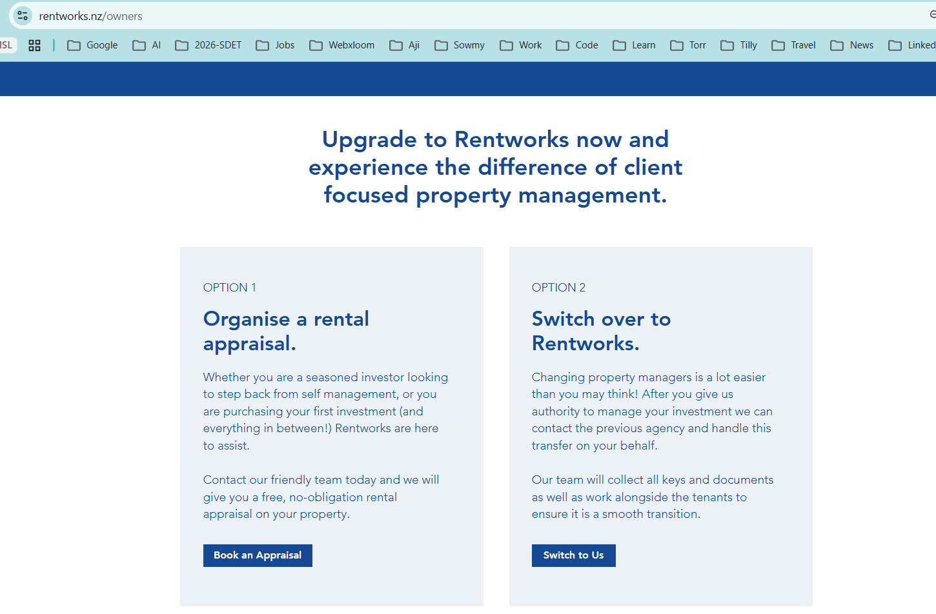
- Book an Appraisal should navigate to the #appraisal form page
- Switch to Us should move to a new form
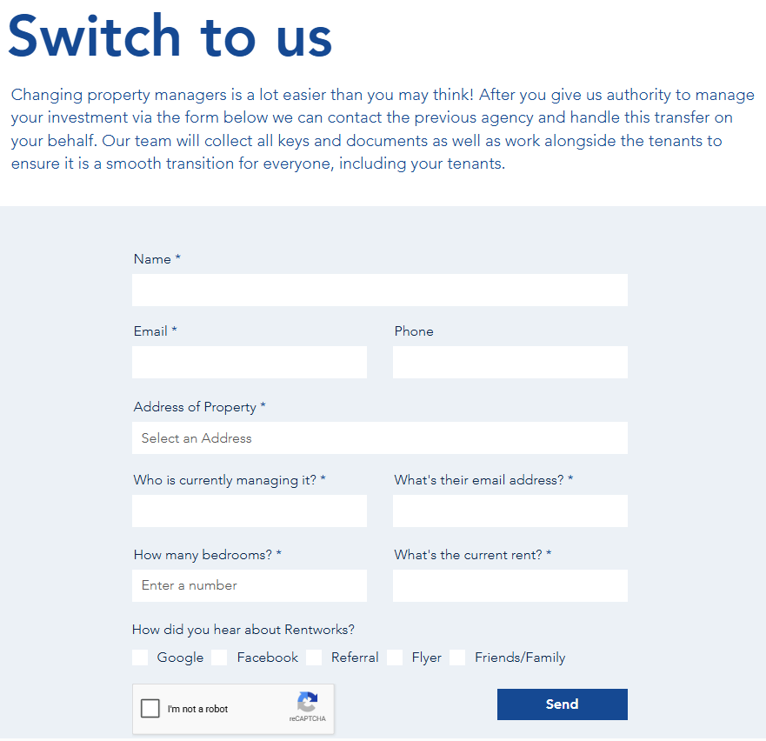
Update the placeholders and labels of the fields to our theme/style.

Landlord FAQs: A 7-item interactive accordion covering fees, tenant screening, arrears, Healthy Homes compliance, disbursements, and switching agencies. On click, the existing open question should auto-close.
- Include these with the existing FAQs
Do you collect a bond?
Yes. The Residential Tenancies Act requires that no more than four weeks' bond be collected. Unless otherwise agreed, Rent Worx considers three weeks to be the minimum that should be paid. The bond is paid before the tenant takes possession and is held by the Bond Centre until the tenant vacates.

How often do you pay Landlord?
We credit your funds directly into your bank account twice a month. To keep your books simple, we email you a comprehensive monthly statement on the first working day of the month, completely detailing all income, expenses, and attached invoice copies.

How much will your service cost me ?
Management Fees From Just 5%
Our property management packages range from 5% to 7% + GST, depending on the size of your portfolio and the level of support you want. We don't believe in one-size-fits-all fees.
Call us today to find out which package fits your investment goals perfectly!

Will I be charged for a vacant property ?
NO

Does Rent Worx guarantee me for any loss of rent ?
NO

How often do you inspect my property ?
We carry out regular property inspections, typically completing four per year unless agreed otherwise before management begins. Please check your insurance policy requirements, as most policies mandate a specific inspection frequency. Share this detail with your property manager, and we will align our schedule to keep you fully covered.

How do you handle missed rent payments?
We monitor rent payments digitally so we can spot a missed payment instantly and start debt recovery immediately. While we do everything we can to resolve issues early, we will escalate the matter to formal mediation or the Tenancy Tribunal if necessary. We do not charge for our time during these processes. You will only need to cover the standard government application fee, which is currently $29.00 including GST

I will be moving overseas- can you handle all repairs?
Yes. We use a trusted team of skilled, competitively priced tradespeople who prioritize our calls for fast turnarounds. If you have a preferred contractor, we are happy to use them.
Important Note . By law, if you are outside of New Zealand for more than 21 consecutive days, you must appoint a local agent to manage your property

- CTA Banner: "Ready to maximize your yield?" over images/llord-cta.jpg.

3. Tenants Page
- Banner: "Tenant Services & Resources" over images/tenant-banner.jpg.
- Fostering Great Tenancies: A split row featuring the vertical image images/tenant-fosterT.png.
Replace this with -
Heading: Welcome to Your Next Home
Details: We connect quality residents with safe, compliant, and well-maintained properties built on mutual respect and open communication. With Rent Worx, you get a dedicated team that values your peace of mind.
Why Rent With Us:
Healthy Homes: Every property is audited to ensure it is warm, dry, and fully compliant.
Rapid Response: We resolve maintenance logs quickly so your home stays in top shape.
24/7 Support: Residents benefit from an emergency dispatch line for urgent issues.
Simple Processes: Manage your tenancy effortlessly via our transparent online portal. Our processes are simple, stress-free, and we are always just a phone call away.

Useful Links Grid: 4 structured categories mapping out external resources for Tenancy Rights & Legal, Advocacy & Disputes, Relocation Logistics, and Search Portals.
Add these 2 under community:
1. Rubbish Collection Days (link: https://www.aucklandcouncil.govt.nz/en/rubbish-recycling/rubbish-recycling-collections/rubbish-recycling-collection-days.html)
2. Get Connected Easily (link: https://www.fastconnect.co.nz/applications/apply_now)
Tenant FAQs: A 6-item interactive accordion detailing the application process, required documents, bond handling, repair procedures, routine inspections, and tenant rights.
* Include these questions also:
HOW DO I APPLY ?
An application form is available by clicking here. Note each applicant is subject to a background and credit check.
WHAT ARE YOUR MOVE IN COST ?
On approval, every tenant is required to pay a four week bond and two week's rent in advance, unless stated otherwise in advertising.
HOW OFTEN DO YOU DO INSPECTION ?
We will inspect your home each quarter, unless otherwise stated by the property owner. All inspections and property access is done in accordance with the Residential Tenancies Act.
I WORK FULL TIME, HOW CAN I VIEW PROPERTY
We are available for viewings by appointment to suit.
WHAT NOTICE DO I HAVE TO GIVE TO LEAVE MY TENANCY
If you are on a periodic tenancy, the required notice is 21 days and must be provided in writing. Please note that legal service times apply. A vacate notice template is available in our forms section OR Tenancy Services provides an official template for this exact scenario
I NEED SOMETHING FIXED
Please contact us via email for all non-urgent maintenance. For urgent maintenance, please call and text.
- CTA Banner: "Looking for a new home?" over images/tenant-cta.jpg.

4. Rent / Viewings (Rentals) Page:
- Carousel Banner: Features an absolute-positioned, auto-looping background carousel (#rental-carousel-wrapper) seamlessly cycling through 14 images (images/rental-caro-1.jpg to images/rental-caro-14.jpg) beneath the glass text box.
- Filters Engine: Features distinct chip buttons for City selection (All Auckland, Manukau, Papakura). Clicking a city dynamically loads localized options into the Suburb dropdown. Includes additional filters for Bedrooms and a slider for Max Weekly Rent (up to $1500).
- Update the existing filters as given below:
- Replace the Manukau, Papakura chips with ‘South & More’, ‘East & More’
- For ‘South & More’ load these suburbs:
Alfriston
- Clendon Park
- Conifer Grove
- CLEVEDON
- Drury
- Goodwood Heights
- Hill Park
- Homai
- Manukau
- Manurewa
- Manurewa East
- Papakura
- Papatoetoe
- Randwick Park
- Rosehill
- Takanini
- The Gardens
- Totara Heights
- Wiri
- Wattle Downs
- Weymouth
- Bombay
- Karaka
- Paerata
- For ‘East & More’ load these suburbs:
- Bucklands Beach
- Cockle Bay
- Eastern Beach
- Farm Cove
- Half Moon Bay
- Howick
- Mellons Bay
- Pakuranga
- Pakuranga Heights
- Shelly Park
- Sunnyhills
- Botany Downs
- Dannemora
- East Tāmaki
- East Tāmaki Heights
- Flat Bush
- Golflinks
- Northpark
- Ormiston
- Somerville
- Beachlands
- Maraetai
- Whitford
- Property Grid: A JavaScript-rendered layout displaying 20 hardcoded properties. Cards feature pricing, "Available: " flags, beds/baths/carparks, and a Healthy Homes tag. Click to open the Modal with complete details including property gallery.
- Trade Me Integration: 5 dedicated cards for external routing (Studio, 1 Bed, 2 Beds, 3 Beds, 3+ Beds) opening Trademe URLs in a new tab.
- CTA Banner: "Can't find what you're looking for?" over images/rental-cta.jpg.

5. Rental Appraisal Page
- Banner: "Rental Appraisal" over images/rapp-banner.jpg.
updated heading: Rental Appraisal. Sub-heading: We Handle the Details. You Enjoy the Returns.
Yield Analysis: Features bulleted data-points paired with images/rapp-analysis.jpg.
Replace the text section with:
Appraisal Request
Please contact our team today if you require an accurate, up-to-date rental assessment in the Auckland region. Ensuring your asset is correctly aligned with the current market is essential for maximizing your overall yields. Furthermore, an official appraisal serves as a vital document to help determine your borrowing capacity and secure investment finance with major banks.
Every custom rental appraisal we generate delivers deep insights into key market drivers:

- Targeted Weekly Returns: A realistic estimation of the peak weekly rent your property can realistically command.
- Localized Area Analysis: Concrete comparisons showing the performance of similar rental properties nearby.
- Official Baseline Data:Verified market statistics detailing lower, median, and upper-tier rents based on bedroom counts.
- Suburban Growth Indicators: Comprehensive data regarding your property's unique features, local infrastructure, and neighbourhood amenities.

Please fill out the rental appraisal form below or get in touch if you have any additional questions.

- Unified Form Card: Features images/rapp-form.jpg alongside a highly detailed property form (City, Suburb dropdowns matching the Rentals page logic, Property Type, Beds, Baths, Intent). Form data routes to Formspree endpoint xoevvnkj.
- Keep this CTA below the appraisal form (Change wordings, style)
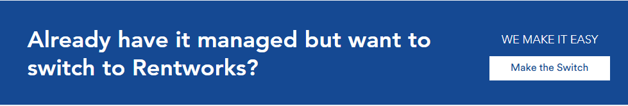
- CTA Banner: "Need immediate advice?" over images/rapp-cta.jpg.

6. Services Page
- Banner: "Our Property Management Services" over images/services-banner.jpg.
- Split Row Services: Each of the 9 services is paired with a distinct, gold inline SVG line-art icon:
  - Rent Collection: images/services-fix.jpg. Write-up: We manage rent collection and monitor payments closely, helping ensure rent is received on time and keeping you informed of any issues.
  - Tenant Screening: images/services-roofing.jpg. Write-up: Finding the right tenant matters. We carry out a thorough application and screening process, including appropriate reference and background checks, to help identify suitable tenants for your property.
  - Property Inspections: images/services-docs.jpg. Write-up: Regular property inspections help us identify maintenance needs early, monitor the condition of your property and keep you informed with clear inspection reports.
  - Repairs & Maintenance: images/services-local.jpg. Write-up: We work with a trusted network of qualified tradespeople to handle repairs and maintenance promptly and professionally, helping keep your property well maintained.
  - Property Knowledge: images/services-welcome.jpg. Write-up: With a strong understanding of the local property market and tenancy requirements, we help ensure your property is managed in line with current regulations and good industry practice.
  - Property Marketing: images/services-maint.jpg. Write-up: We present your property professionally across relevant platforms, arrange viewings and work to attract suitable tenants for your rental.
  - Methamphetamine Testing: <add image> Write-up: Where required, we can arrange methamphetamine testing to help identify potential contamination and provide greater peace of mind for property owners.
  - End-of-Year Financial Support: <add image> Write-up: We keep your property management records organised throughout the year, making it easier to access the information you need for your end-of-year accounting and tax requirements.
  - Tenancy Tribunal Support: Write-up: If a tenancy matter reaches the Tenancy Tribunal, we can assist with the process and represent you where appropriate, helping you understand the process and protect your interests.
- CTA Banner: "Ready to delegate?" over images/services-cta.jpg.

7. About Us Page
Banner: "About Us" over images/about-banner.jpg.
Replace the banner heading with:
The Rent Worx Story
Dedicated Operational Focus
- About Rajiv & Rent Worx: Narrative text (Vision, Mission) paired with images/Rentworx_Rajiv.png.
Replace the Narrative text with:
Led by Rajiv Kumar, Rent Worx was founded on a simple but powerful philosophy: residential property management demands absolute, dedicated operational focus.
A name synonymous with the Auckland real estate industry, Rajiv launched Rent Worx to elevate the standards of traditional property management. We believe that looking after an investment property shouldn't be a sideline service—it requires a boutique team that is entirely all-in.
We protect your portfolio by focusing fiercely on three core pillars:
Safeguarding Asset Condition: Through rigorous, systemized property reviews and detailed digital photo tracking, we actively preserve the structural and financial value of your property.
Flawless Healthy Homes Compliance: We navigate evolving New Zealand tenancy laws seamlessly, auditing every asset to ensure total compliance and completely removing legal risk from your shoulders.
Proactive Landlord Communication: No gaps, no guesswork. We pride ourselves on keeping you thoroughly in the loop with transparent updates and immediate access to your property information.
At Rent Worx, we don't just oversee rentals—we partner with you to make sure your investments genuinely thrive.

Reasons Landlords Choose Rent Worx: A stack of 6 specific commitment cards (.reason-long-card), featuring numbered circle icons and 3D hover effects.
- Replace the Narrative text with:
1. Focused Management: Our focus is entirely on managing rental properties and supporting landlords and tenants.

2. Exhaustive Tenant Screening: Complete identity, credit, reference, affordability, and Tenancy Tribunal records checked for every adult applicant.

3. Zero-Tolerance Arrears Policy: Automated tracking systems monitor rent payments daily, ensuring immediate intervention and rapid legal notices upon default.

4. Photographic Condition Audits: Comprehensive routine inspections delivered directly to your inbox with clear property recommendations.

5. Statutory Compliance:
Continuous Healthy Homes standards and Residential Tenancies Act tracking to protect owners from expensive tribunal liabilities.

6. Localized Market Expertise: Specialized, on-the-ground property management across South Auckland and East Auckland communities.
* Place the stacking number a bit faded with increased font size and beautifully positioned over the edge of the card.
* Add a matching image to either side of the cards randomly.
- CTA Banner: "Our Absolute Commitment" over images/about-cta.jpg.

8. Contact Page
- Banner: "Get in Touch" over images/contact-banner.jpg.
- Information Cards: Three distinct top cards summarising WhatsApp/Call, Email, and Emergency protocols.
- Unified Form Card: Features images/contact-form.jpg alongside a message form routed to Formspree endpoint mgavvlna.
- Location Map: A 420px height deep card featuring a Google Maps iframe firmly pinned using the query q=Auckland,%20New%20Zealand.
- CTA Banner: "Let's Talk Property" over images/contact-cta.jpg.

Component & Asset Specifications
- Hero Video Specs: The video container uses a standardized height of calc(100vh - 150px). The underlying <video> tag uses object-fit: cover with width: 100%; height: 100% to ensure edge-to-edge responsiveness across all monitor sizes.
- Universal Banner Engine: Every page banner and CTA banner uses a standardized class (.page-banner, .cta-banner). They are locked to height: calc(100vh - 150px) with a strict min-height: 500px. They use background-attachment: fixed for a parallax scroll effect and background-size: cover.
- The Glass Text Box: Text overlaying banners is enveloped in .glass-text-box. In light mode, it utilizes a highly transparent rgba(255, 255, 255, 0.08) background with a blur(5px) backdrop-filter and an rgba(255, 255, 255, 0.2) border. Text readability is maintained by a dense CSS text-shadow: 0 4px 15px rgba(0,0,0,0.8).
- Inner Images (.fade-img-wrapper): Inner layout images strip away borders and box-shadows. They rely on standard border-radius: 8px and object-fit: cover natively.
  - Proportional Scaling Exception: images/tenant-fosterT.png and images/Rentworx_Rajiv.png utilize explicit inline styles (object-fit: contain) so their vertical lengths perfectly match their adjacent text blocks without cropping tops or bottoms.
- Single-Card Forms (.card-split-form): On the Contact and Appraisal pages, the layout combines the image and form into a single flex container (align-items: stretch). This forces the background image container (.form-img-container img) to grow or shrink, perfectly matching the required length of the adjacent form.

