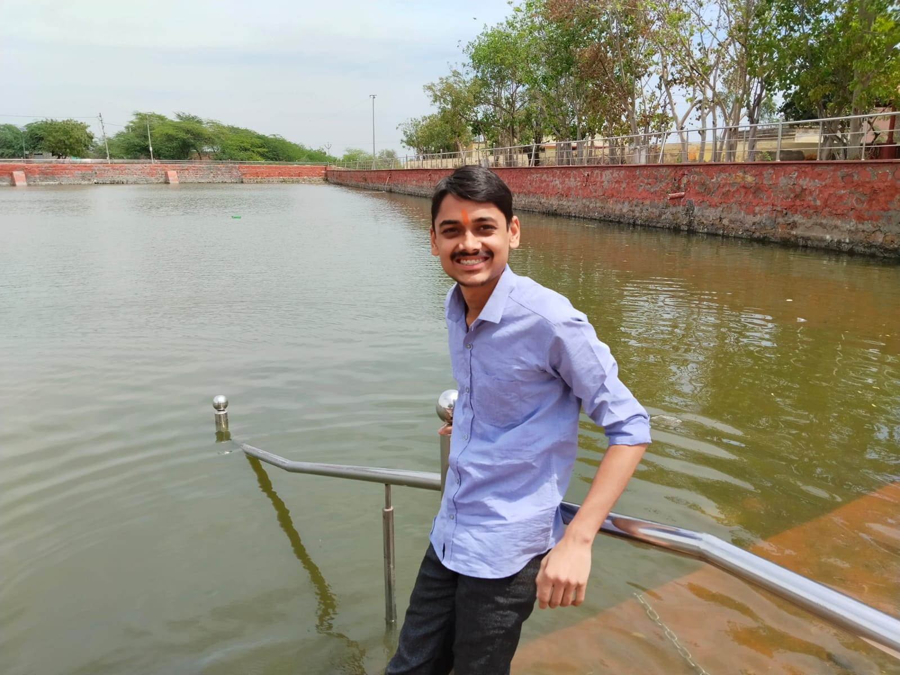 **Dev Varshney**

Hathras, [+91.9411041558](tel:+919411041558), [dev05vars@outlook.com](mailto:dev05vars@outlook.com)

LinkedIn: [Click Here](http://www.linkedin.com/in/webydev) || GitHub: [Click Here](https://github.com/weby-dev)

# EDUCATION

**Bachelor of Technology in Computer Science, *GLA University, Mathura, CGPA - 7.3 (1st Year)*** June 2027

**Intermediate, BLS International School, Hathras, *Percentage - 80%*** May 2023

**High School, BLS International School, Hathras, *Percentage - 85%*** May 2021

# INTERNSHIP/ TRAINING EXPERIENCE __________________________________________________________________

**National Physical Laboratory – CSIR, Delhi June** 2024 – Aug 2024

*Cloud and Arduino Intern*

* Development of Android Application for Magnetic Field Measurement via Bluetooth using Arduino
* Participated in the requirement gathering and prototype building process of software development.

**Job Oriented Value Added Course, GLA University, Mathura** June 2023 – July 2023

*Trainee*

* Intermediate in Python, PHP, MySql
* Post completing the training, created a Project named “ConCrt”, by using HTML, CSS, Javascript, PHP, Database, Cloud Computing.

# PROJECTS

**PG Search Application GitHub Link/ Website** Feb 2023 – Mar 2023

* I have created my own AI Chatbot and Hosted on Cloud Server. [Click Here](https://devai.in)
* I have developed an Android Application and Hardware (Arduino) During my internship. [Click Here](https://drive.google.com/file/d/1yi9Yexl3jCAmrhKdE9Ajd-2wJ7ni4bNj/view?usp=sharing)
* Working on file system like Google drive with multiple storage like FTP , HTTP etc.
* Working on automated Artificial Attendance system

# SKILLS

**Technical (max Top 5) Professional (Top 3)**

Javascript, PHP Effective Communication Skills

Bash, MySql, Python Team Work

Cloud Computing (2Y EXP) Interpersonal Skills

# PROFESSIONAL ACHIEVEMENTS/ INSIGHTS

* Certified in Machine Learning by Stanford. [Click Here](https://portfolio.devai.in/certificate/COURSERA_SUPERVISED_MACHINE_LEARNING.jpg)
* Attended workshop on Python programming and Backend Development, conducted by **Edulateral Foundation**.

# CO-CURRICULAR ACTIVITIES

* Coordinated SRIJAN (Cultural Fest, GLA, September, 2022).
* Participated in MAITREE (Sports Fest, GLA, October, 2022).
* Table Tennis District Level Gold medalist.
* 2 Year on Experience in Cloud Computing.
* Server management services freelancing from last 2 Years.

**DECLARATION________________________________________________________________________________________**

I hereby declare that all the above mentioned information is true and correct to the best of my knowledge.