|  |  |
| --- | --- |
| **Actor** | **System** |
| 1. Choose command “Add Product”  Main screen: | 2. Display “Add Product” screen  “Add Product” screen: |
| 3. Input data then click “Add” button  “Add Product” screen with data: | 4. Hide “Add Product” screen and display “Add Product Successfully” screen:  “Add Product Successfully” screen: |
| 5. Click on “OK” button: | 6. Display “Main” screen |

Add Customer

|  |  |
| --- | --- |
| **Actor** | **System** |
| 1. Choose command “Add Customer” | 2. Display “Add Customer screen”  “Add Customer screen” |
| 3. Input data then click “Add” button | 4. Hide “Add Customer” screen and display “Add Customer Successfully” screen |
| 5. Click on “OK” button | 6. Display “Main” screen |

Add Purchase

|  |  |
| --- | --- |
| **Actor** | **System** |
| 1. Choose command “Add Purchase” | 2. Display “Add Purchase screen”  “Add Purchase screen” |
| 3. Input data then click “Add” button | 4. Hide “Add Purchases” screen and display “Add Purchase Successfully” screen |
| 5. Click on “OK” button | 6. Display “Main” screen |

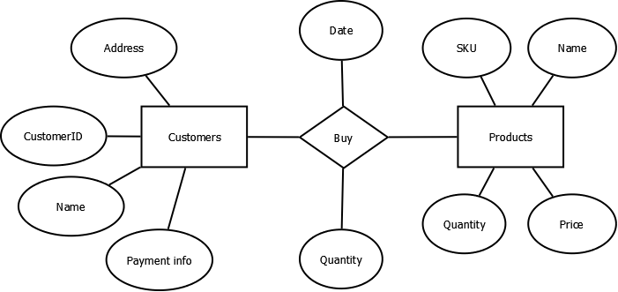

Products(**productid**, Barcode, name, expiration date, price, tax rate, quantity, supplier, manufactured date)

Customers(**customerid**, name, address, phone, payment info)

Purchase(**purchaseid**, *customerid*, *productid*, date time, quantity, price, tax, total cost)

 