> t=read.table(file.choose(),header=TRUE)

> t1=as.numeric(t$T1)

> t2=as.numeric(t$T2)

> D=t1

> T=t2

> hist(T,freq=F)

> lines(density(T),col="red",lwd=1)

> x=seq(0,2,0.1)

> r=2

> f=r\*x^(r-1)\*exp(-x^r)

> lines(x,f,col="blue")

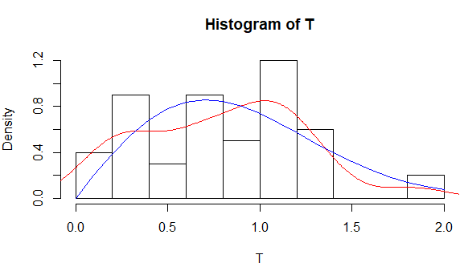

> hist(D,freq=F)

> lines(density(D),col="red",lwd=1)

> x=seq(0,2,0.1)

> r=2

> f=r\*x^(r-1)\*exp(-x^r)

> lines(x,f,col="blue")

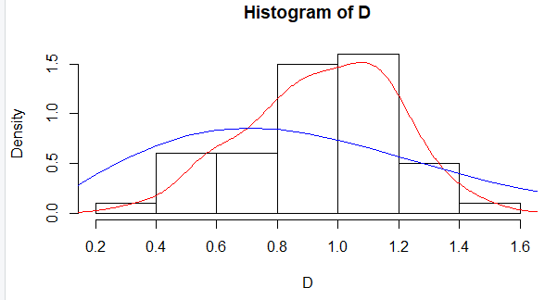

> r=rep(2,500)

> S=rep(0,500)

> I=rep(0,500)

> for(i in 1:500){

+ S[i]=50/r[i]+sum(log(T)\*(1-T^r[i]))

+ I[i]=50/r[i]^2+sum(log(T)^2\*T^r[i])

+

+ if (abs(S[i])<1e-08){

+ print(i)

+ print(r[i])

+ print(S[i])

+ print(I[i])

+ break

+ }

+ else

+ r[i+1]=r[i]+S[i]/I[i]

+ }

[1] 4

[1] 1.925482

[1] 2.217959e-11

[1] 19.17269

> for(i in 1:500){

+ S[i]=50/r[i]+sum(log(D)\*(1-D^r[i]))

+ I[i]=50/r[i]^2+sum(log(D)^2\*D^r[i])

+

+ if (abs(S[i])<1e-08){

+ print(i)

+ print(r[i])

+ print(S[i])

+ print(I[i])

+ break

+ }

+ else

+ r[i+1]=r[i]+S[i]/I[i]

+ }

[1] 6

[1] 4.40304

[1] 7.81597e-14

[1] 5.060485