**Course Overview and Schedule**

During this course, *Business Intelligence for IoT Solutions*, students are guided through a series of lab activities that provide hands-on experience querying and visualizing data.

The first module examines the characteristics of time series data – how it can be used for analysis and prediction. It specifically walks the student through how IoT telemetry data is typically generated as time series data and techniques for managing and analyzing it with Azure Time Series Insights.

Module two takes a closer look at specific features of Azure Time Series Insights – how it can be used to store, analyze and instantly query massive amounts of time series data.

In the third module, students get a general introduction to using Power BI, with specific emphasis on how Power BI can load, transform and visualize IoT data sets.

In the final module, students will move from using BI with static IoT data sets to working with real time streaming IoT data. Students use Azure Stream Analytics as a data source for Power BI and explore the unique capabilities and insights that provides.

All of the information that is needed to complete the course objectives is included in the course documents. The links to additional content that we've included are for those of you who are interested in digging deeper into the technologies.

After completing this course, students will be able to construct IoT data visualizations that allow a business to gain insights related to its operations.

**Students**

The target audience for this course is anyone interested in developing (or updating) business intelligence and data visualization skills for the IoT scenario. This course is well suited to existing data analysts who are new to IoT as well as people working in the IoT field who want to learn how to develop visualizations for their IoT data.

**Schedule**

*Business Intelligence for IoT Solutions* is a self-paced course that consists of four modules. All four of the modules are available when the course begins, and you can work your way through the modules at your own pace.

While each student will complete this course at a pace that suits their own requirements, we anticipate that an average student will be able to complete the lab assignments in about 10-15 hours. Please note that some of the labs are considerably longer than others due to the way that coding activities are distributed. You may find that the module 3 labs take longer to complete than the labs in the other modules.

**Module Structure**

This course is completely lab-based. There are no lectures or required reading sections. All of the learning content that you will need is embedded directly into the labs, right where and when you need it. Introductions to tools and technologies, references to additional content, video demonstrations, and code explanations are all built into the labs.

Some assessment questions will be presented during the labs. These questions will help you to prepare for the final assessment.

**Course Outline**

The *Business Intelligence for IoT Solutions* course includes four modules. Each of the four modules are described in the sections below.

**Module 1: Time Series Data**

* Lab 1: Introducing Time Series Insights
* Lab 2: Producing Simulated Data
* Lab 3: Provisioning Time Series Insights
* Lab 4: Analysis with Time Series Insights

**Module 2: Visualizing and Querying Data**

* Lab 1: Setting Up Data Generation
* Lab 2: Using Time Series Analysis Patterns
* Lab 3: Using Advanced TSI Features
* Lab 4: Managing Time Series Insights

**Module 3: Power BI and IoT**

* Lab 1: Introducing Power BI
* Lab 2: Transforming Data
* Lab 3: Modeling Data
* Lab 4: Visualizing Data

**Module 4: Streaming with Power BI**

* Lab 1: Using Power BI with Streaming Data
* Lab 2: Configuring Power BI
* Lab 3: Using Power BI in an IoT architecture
* Lab 4: Sharing Power BI Dashboards

## Introduction to Time Series Insights through the sandbox environment

 Bookmark this page

The first technology you will look at is Azure Time Series Insights. This is a technology built for storing, visualizing, and querying large amounts of time series data. The overarching goal of Time Series Insights is to provide an “out-of-the-box” experience for extracting business intelligence from streaming data. To that end, it has four key areas of functionality:

**Integration** – Time Series Insights is integrated with cloud gateways like Azure IoT Hub and Azure Event Hubs. It connects to these event sources and parses JSON and other structured data. It joins metadata with telemetry and it indexes your data in a columnar store.

**Storage** – Time Series Insights manages the storage of data. To ensure data is quickly accessible, it stores data in memory and Solid State Drives for up to 400 days. You can interactively query billions of events in seconds. In some IoT architectures, it is appropriate to use Time Series Insights as warm storage – generally when your focus will be time series analysis, but you don't need the kind of broad compatibility a more general-purpose storage solution would provide (Such as Cosmos DB).

**Visualization** – Time Series Insights provides out-of-the-box visualization via the TSI explorer.

**Extensibility** – Time Series Insights provides a query service, both in the TSI explorer and by using APIs for embedding time series data into custom applications.

In this step, you will get your first exposure to the Time Series Insight's visualization features. Microsoft hosts a sandbox environment of the TSI Explorer that has been pre-populated with tens of millions of rows of time series data. The site has a built-in introduction / tutorial and then allows you to explore and experiment.

1. Navigate to [time series insights demo](https://insights.timeseries.azure.com/demo)
2. Log in with a Microsoft identity (such as an Office 365 login).

This demo is built for a different scenario than the main one we will be using for this course. It analyzes three factories with 16 total machines. We are simply leveraging a pre-built environment, to get you familiar with the TSI Explorer.

1. You will be offered the chance to work through a tutorial. Click **Next** to start.

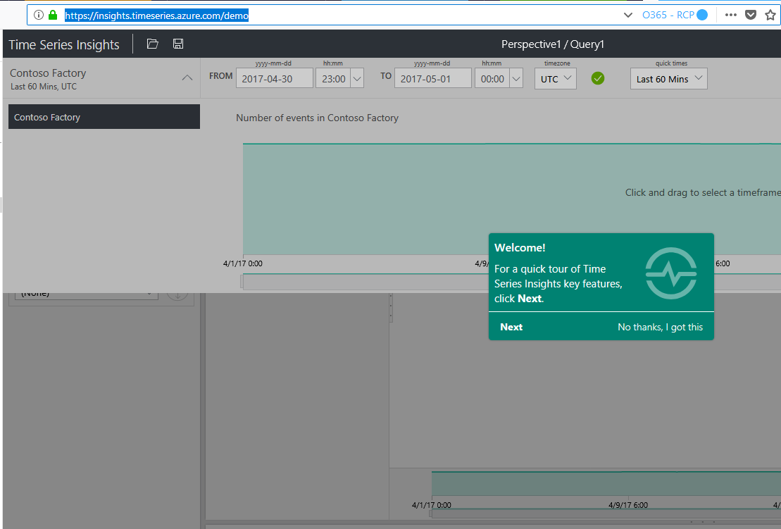

1. Work through the tutorial. You will get a hands-on tour of many of the main components of the TSI Explorer: the **Time selection panel**, the **Terms panel**, the chart region, the events grid, the export capabilities, the series filter… and more. Feel free to experiment. In the next step, we will have a guided walkthrough.

### Summary

In this lesson, you learned about the various components of the Azure Time Series Insights solution. You leveraged a Time Series Insights sandbox environment to learn about various aspects of the Time Series Insights Explorer.