**Multi-Problem Solving Plant Guard with Waste Bottles**

**1. Introduction**

The Plastic Bottle Plant Guard is a multi-functional and eco-friendly solution designed to protect and support growing plants. Utilizing recycled plastic bottles, this guard not only shields plants from potential harm but also incorporates water collection and drip irrigation features. Additionally, when used along roadsides, it serves as a reflector to enhance road safety.

**2. Purpose**

* **Plant Protection:** Shields plants from animals and people, reducing damage.
* **Water Conservation:** Collects rainwater and utilizes a drip irrigation system to provide consistent watering.
* **Road Safety:** Acts as a reflector when placed along roadsides to mark boundaries and improve visibility.
* **Environmental Impact:** Recycles plastic bottles, promoting sustainability.

**3. Design**

* **Structure:** A net-like or bowl-shaped guard made from recycled plastic bottles.
* **Size:** Adjustable based on the plant's growth and the surrounding environment.
* **Features:**
  + **Protective Net:** Prevents harm from animals and accidental damage.
  + **Water Collection Bowl:** Gathers rainwater and directs it to the plant using a drip method.
  + **Reflector:** Enhances visibility when used on roadsides.

**4. Benefits**

* **Eco-Friendly:** Utilizes recycled plastic, reducing waste and promoting sustainability.
* **Cost-Effective:** Low-cost materials and simple construction process.
* **Versatile:** Provides plant protection, water conservation, and enhances road safety.
* **Durable:** Plastic bottles are weather-resistant and long-lasting.

**5. Conclusion**

The Plastic Bottle Plant Guard offers an innovative solution for plant protection and water conservation, while also contributing to road safety. By repurposing plastic bottles, this project addresses multiple challenges in an environmentally friendly and cost-effective manner. Its versatility in application makes it a valuable addition to gardening, urban green spaces, and roadside safety measures.

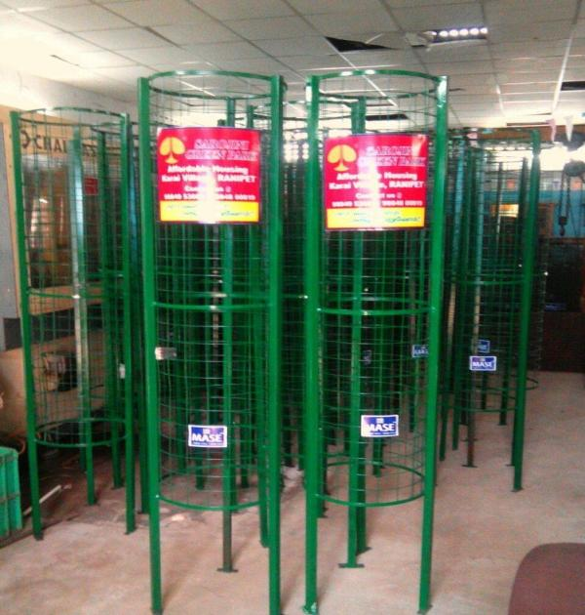**Traditional metal tree guards present several disadvantages compared to the Plastic Bottle Plant Guard. Firstly, metal guards are prone to rust and corrosion, especially in humid or rainy conditions, which can lead to deterioration over time. This rust can create sharp edges that might harm plants or animals. Additionally, metal guards are often heavier and more cumbersome, making them less flexible and more difficult to install or adjust. Unlike the Plastic Bottle Plant Guard, metal guards do not typically incorporate water collection or irrigation features, potentially leading to less efficient plant watering. Furthermore, metal guards do not offer any reflective properties, which limits their functionality in enhancing road safety and marking boundaries. Lastly, metal guards can be more expensive and less environmentally friendly, as they do not utilize recycled materials.**

