# 进入容器

docker exec -it 容器名 sh

# 修改配置

vi /etc/docker/registry/config.yml

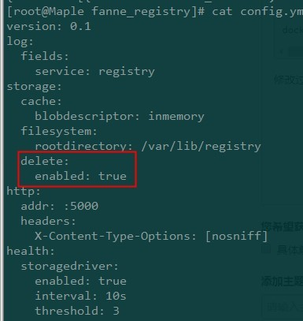

#查看仓库中的镜像信息

curl -X GET http://172.16.32.59:5000/v2/_catalog

{"repositories":["centos_php_7.13","php7.13-fpm"]}

# 查看容器大小

du –sch /var/lib/registry/

# 删除

获取digest值

curl -I -X GET http://172.16.32.59:5000/v2/centos_php_7.13/manifests/latest

HTTP/1.1 200 OK

Content-Length: 5559

Content-Type: application/vnd.docker.distribution.manifest.v1+prettyjws

Docker-Content-Digest: sha256:3a07b4e06c73b2e3924008270c7f3c3c6e3f70d4dbb814ad8bff2697123ca33c

Docker-Distribution-Api-Version: registry/2.0

Etag: "sha256:3a07b4e06c73b2e3924008270c7f3c3c6e3f70d4dbb814ad8bff2697123ca33c"

X-Content-Type-Options: nosniff

Date: Sun, 31 Jul 2016 11:09:22 GMT

执行删除

curl -X DELETE http://172.16.32.59:5000/v2/centos_php_7.13/manifests/sha256:56a9148f0a3162f1199ea4653d7d512861d9160393691f5669d3f9c6dc97d043

http://127.0.0.1:6000/v2/myfirstimage/manifests/sha256:3a07b4e06c73b2e3924008270c7f3c3c6e3f70d4dbb814ad8bff2697123ca33c

{"errors":[{"code":"MANIFEST_UNKNOWN","message":"manifest unknown"}]}

curl <http://172.16.32.59:5000/v2/> centos_php_7.13/manifests/latest

# 垃圾回收

centos_php_7.13

curl --header "Accept: application/vnd.docker.distribution.manifest.v2+json" \

-I \

-X HEAD http://172.16.32.59:5000/v2/centos_php_7.13/manifests/latest

curl -X DELETE http://172.16.32.59:5000/v2/centos_php_7.13/manifests/sha256:9915557b5617fd5a5cd03d1f582f295b5c0358c609c793fba9f0e94c83905a16

查看tags

curl 172.16.32.59:5000/v2/centos_php_7.13/tags/list

现在进入registry中进行垃圾回收

[root@docker1 ~]# docker exec -it <容器ID|容器名称> /bin/sh

/ # cd /var/lib/registry/

/var/lib/registry # du -sch

10.3M .

10.3M total

/var/lib/registry # registry garbage-collect /etc/docker/registry/config.yml

/var/lib/registry # du -sch

28.0K .

28.0K total