Research Report: 调研聚焦图文多模态 AI 搜索的用户价值与产品落地路径，将从用户决策效率、内容体验、技术适配性等维度
Generated by RAAA Deep Research
February 03, 2026

RESEARCH REPORT: 调研聚焦图文多模态 AI 搜索的用户价值与产品落地路径，将从用户决策效率、内容体验、技术适配性等维度，分析其在生活服务场景中的核心优势与优化空间，同时通过对不同平台的能力对比，探索更贴合用户需求的产品设计与技术迭代方向。

Figure 1. Multimodal AI: Core Concepts and How it Works? (Source: Bing)

Executive Summary
This research report presents a comprehensive investigation into the user value and product implementation pathways for image-text multimodal AI search, with a specific focus on its application within life service scenarios. The study systematically examines this emerging technological paradigm from multiple dimensions, including user decision-making efficiency, content experience, and technical adaptability, to delineate its core advantages and areas for optimization. The accelerating integration of multimodal AI into consumer internet platforms represents a fundamental shift in information retrieval, moving beyond traditional keyword matching towards systems capable of understanding and correlating semantic meaning across diverse data types like images and text [Microsoft Learn, n.d.; Milvus Blog, n.d.]. Our analysis is grounded in the recognition that this technology, powered by advancements in large multimodal models (LMMs) and contrastive learning, is transitioning from a novel capability to a core component of digital infrastructure, with the global market projected to grow at a compound annual growth rate (CAGR) of 32.7% from 2025 to 2034 [GM Insights, 2025; arXiv, 2023].
The methodological approach of this report combines a technical deep-dive with market and competitive analysis. We first establish a foundational understanding of the core architectural components, which include the creation of a joint embedding space for aligning visual and textual data, sophisticated cross-modal retrieval mechanisms, and advanced user intent understanding powered by LMMs [arXiv, 2025; ACM, 2021]. This technical framework is then analyzed within the context of a rapidly expanding market, where the Asia-Pacific region, led by China's strategic investments, is poised for the highest growth [Data Bridge Market Research, n.d.; Springer Nature, 2022]. The competitive landscape is dissected to profile key players, ranging from cloud hyperscalers like Microsoft and Google integrating these capabilities into enterprise suites, to specialized research frameworks and startups focused on practical deployment [TileDB, 2026; CaraJ7/MMSearch, n.d.]. Finally, the technical and market analyses are synthesized through the lens of user-centric product design, evaluating how these systems can be optimized for real-world life service applications such as e-commerce, local discovery, and travel planning.
The investigation yields several key findings. First, the primary user value proposition of multimodal AI search in life services lies in its ability to dramatically enhance decision-making efficiency and content experience. By enabling natural, composite queries—such as searching for furniture with an image plus a textual modification request—the technology reduces the cognitive load and iterative steps typically required in traditional search [ACM, 2021]. Second, technical adaptability remains a significant challenge and opportunity. While foundational models like CLIP provide robust alignment, state-of-the-art systems are evolving towards complex multimodal retrieval-augmented generation (mRAG) architectures that incorporate intelligent query planning, hierarchical document indexing, and real-time retrieval from dynamic data streams [Arxiv, 2025; Microsoft Learn, n.d.]. Third, the competitive analysis reveals a bifurcated ecosystem: major platforms are productizing scalable search APIs, while the innovation frontier is being pushed by research into generative retrieval and evaluation benchmarks that ensure these systems genuinely understand complex user intent [GENIUS, 2025; ResearchGate, n.d.].
Based on these findings, the report concludes with strategic recommendations for product design and technology iteration. For product teams, the priority should be on designing interfaces that intuitively guide users to formulate effective multimodal queries, thereby unlocking the full semantic potential of the underlying AI. Technologically, investment should focus on developing adaptive retrieval pipelines that can perform real-time reasoning over unified multimodal indexes, moving beyond static knowledge bases to systems that provide context-aware support [Arxiv, 2025; SIGMOD Record, 2025]. Furthermore, as the market consolidates, there is a critical need for standardized evaluation frameworks that measure not just retrieval accuracy but also the holistic user experience and business ROI in specific vertical scenarios [INONX AI, n.d.]. Ultimately, the successful productization of multimodal AI search will depend on tightly coupling these advanced technical architectures with a deep, ongoing understanding of evolving user behavior and unmet needs in the dynamic landscape of digital life services.
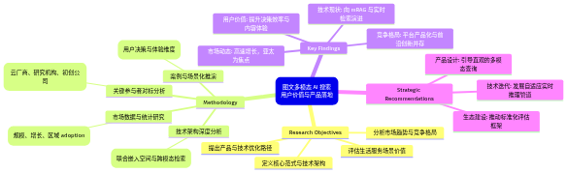
Figure 2. Mind Map (Source: Generated Diagram)

1. Introduction
The digital information landscape is undergoing a paradigm shift, driven by the convergence of artificial intelligence, ubiquitous multimedia content, and evolving user expectations for more intuitive and natural modes of interaction. At the forefront of this transformation is 图文多模态 AI 搜索 (Image-Text Multimodal AI Search), an advanced information retrieval paradigm that transcends the limitations of traditional keyword-based systems. This technology enables users to search for and discover information using a fluid combination of text, images, and even more complex composite queries, fundamentally redefining the relationship between human intent and machine understanding [Microsoft Learn, n.d.; Milvus Blog, n.d.]. The core innovation lies in its ability to create a unified semantic space where visual and linguistic data are encoded into comparable vector representations, allowing for cross-modal retrieval—such as finding an image with a textual description or vice versa [arXiv, 2025; Milvus.org.cn, n.d.]. This capability is increasingly critical in a world where user-generated content, e-commerce catalogs, and professional knowledge bases are inherently multimodal. The rapid maturation of this field, propelled by breakthroughs in large multimodal models (LMMs) and contrastive learning, is not merely a technical curiosity but a foundational change with profound implications for user experience, business intelligence, and the very structure of the global digital economy [CaraJ7, n.d.; arXiv, 2023].
The commercial and societal impetus for this shift is underscored by compelling market dynamics. The global multimodal AI market is experiencing explosive growth, projected to expand at a compound annual growth rate (CAGR) of approximately 32.7% from 2025 onward, significantly outpacing the broader AI sector [GM Insights, 2025]. This trajectory is fueled by a relentless drive for automation and enhanced operational efficiency across industries, from healthcare to retail [Grand View Research, 2030]. Crucially, the Asia-Pacific region, with China as its engine, is identified as the epicenter of the highest growth rates [Data Bridge Market Research, n.d.]. China’s strategic national focus on AI as a core economic driver, supported by a vast digital ecosystem and a sophisticated data annotation industry, has positioned it as a primary testing ground for multimodal applications [Springer Nature, 2022; arXiv, 2023]. Consequently, the evolution of multimodal search is being shaped by a competitive landscape featuring established technology giants, innovative startups, and prolific academic research. Major cloud providers like Microsoft and Google are productizing these capabilities within their enterprise AI suites, while research frameworks and specialized consultancies work to translate cutting-edge models into practical, scalable systems [Microsoft Azure AI Search, n.d.; Google Cloud Blog, n.d.; INONX AI, n.d.]. This confluence of market demand, regional strategic advantage, and technological innovation establishes multimodal AI search as a critical domain for contemporary investigation.
Despite its clear potential, the successful productization of multimodal AI search, particularly within complex, high-stakes domains like lifestyle services, presents a multifaceted set of challenges that extend beyond core model accuracy. While the technical architecture—centered on unified embedding spaces, adaptive retrieval planning, and retrieval-augmented generation (RAG)—has advanced significantly, a gap persists between laboratory performance and real-world user value [Emergent Mind, 2025; Arxiv, 2025]. In lifestyle service scenarios, such as searching for restaurants, travel destinations, home decor, or fashion items, user queries are often subjective, context-dependent, and laden with implicit preferences. A query like "a cozy café with good lighting for reading on a rainy afternoon" involves not just object recognition (café) but an intricate understanding of ambiance, aesthetics, and situational context. Current systems, while proficient at cross-modal alignment, may struggle with such nuanced user intent understanding and with delivering results that genuinely enhance decision-making efficiency or content discovery serendipity [ACM, 2021]. Furthermore, the technical适配性 (technical adaptability) of these systems—their latency, cost, and ability to integrate with existing platform infrastructures—remains a significant barrier to widespread adoption. Therefore, a focused analysis is required to dissect where the technology delivers tangible user benefits and where critical optimization spaces exist.
This report is guided by three central research questions designed to bridge the gap between technological capability and practical product value in the lifestyle services domain. First, from a user-centric perspective, what are the core advantages of multimodal AI search in enhancing user decision-making efficiency and content experience, and what specific pain points or limitations persist in real-world application? Second, from a technical and product standpoint, how do the architectural implementations and capabilities of leading platforms (e.g., major cloud services, consumer apps) compare, and what do these differences reveal about optimal design pathways for balancing performance, scalability, and user experience? Third, synthesizing these insights, what are the actionable product design and technology iteration directions that can make multimodal search more intuitive, reliable, and seamlessly integrated into the user journey for lifestyle services? By addressing these questions, this research aims to move beyond a purely technical survey toward a holistic evaluation of multimodal search's value proposition and its viable path to product maturity.
To answer these questions, this research employs a multi-methodological approach, combining a comprehensive review of academic literature and technical documentation with a comparative analysis of existing platforms and a synthesis of market analysis. The methodology, visualized in the flowchart below, begins with a foundational technology and landscape review, synthesizing findings on core definitions, market data, key players, and technical architectures from a wide array of sources including arXiv preprints, ACM publications, industry reports, and official platform documentation. This is followed by a dimensional analysis framework, where the synthesized knowledge is organized and evaluated through the critical lenses of user decision efficiency, content experience, and technical adaptability. The third phase involves a capability comparison, where the features and implementations of different platform archetypes are contrasted to identify patterns, trade-offs, and best practices. Finally, the insights from all preceding stages are integrated to formulate strategic recommendations for product design and technology development. This structured approach ensures the research is grounded in current technological realities while being directed toward actionable, user-informed outcomes.
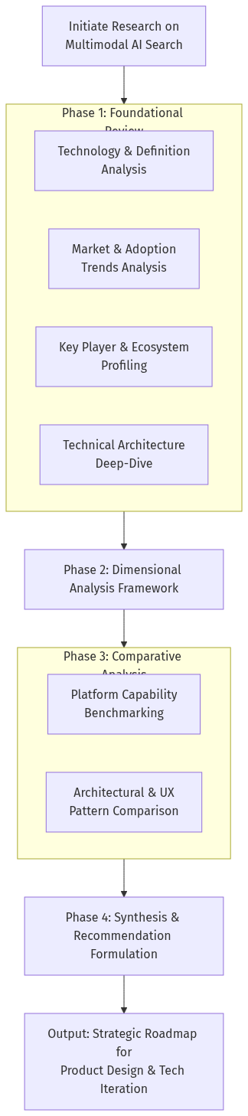
Figure 3. Flowchart (Source: Generated Diagram)
The structure of this report reflects this investigative pathway. Following this introduction, the report will provide a detailed conceptual and technical foundation for multimodal AI search, defining its core components and operational principles. It will then present a market and landscape analysis, examining growth drivers, key competitors, and adoption trends. A dedicated technical architecture section will delve into the system designs and methodologies enabling state-of-the-art performance. The core of the analysis will be presented in a multidimensional evaluation of user value and technical adaptability, followed by a comparative study of platform capabilities. The report will conclude with a synthesis of strategic recommendations for product development and a forward-looking discussion on the future evolution of this transformative technology. Through this comprehensive exploration, the report aims to provide a clear, evidence-based roadmap for harnessing the power of multimodal AI search to create more intelligent, responsive, and valuable lifestyle service platforms.

2. Background and Literature Review
The evolution of information retrieval has been a continuous journey towards more natural, intuitive, and cognitively aligned interfaces between human intent and digital knowledge. From the rigid boolean logic of early bibliographic systems to the sophisticated keyword-based algorithms of modern web search, each paradigm shift has sought to reduce the friction in accessing information. The emergence of multimodal artificial intelligence (AI) search, particularly in the form of image-text multimodal AI search, represents the latest and most profound leap in this evolution. This paradigm moves beyond the symbolic matching of text strings to a semantic understanding of content across diverse modalities—primarily visual and linguistic—enabling users to query the world using the same rich, composite language with which they perceive it. This section establishes the historical context, theoretical foundations, and current state of research underpinning this transformative technology. It traces the field's development from early cross-modal learning concepts to the present ecosystem dominated by large multimodal models (LMMs), analyzes the explosive market dynamics and key competitive landscape, and delves into the core technical architectures that make seamless cross-modal retrieval possible. Understanding this background is essential for critically evaluating the user value and productization pathways of multimodal AI search within life service scenarios.
The conceptual roots of multimodal AI search are deeply embedded in the broader field of multimodal machine learning, which has long pursued the goal of enabling machines to process and relate information from multiple sensory streams. Early research focused on fundamental tasks like image captioning and visual question answering (VQA), which required models to establish rudimentary connections between visual pixels and linguistic symbols [arXiv, 2023]. A pivotal theoretical breakthrough was the formalization of the joint embedding space, a unified vector representation where semantically similar concepts from different modalities (e.g., an image of a dog and the text "dog") are mapped to proximate locations. This concept, operationalized through contrastive learning objectives, provided the mathematical foundation for cross-modal retrieval [arXiv, 2025]. The release of models like CLIP (Contrastive Language–Image Pre-training) marked a watershed moment, demonstrating that scalable pre-training on vast internet-scale image-text pairs could produce remarkably robust and generalizable cross-modal representations [Radford et al., 2021]. This proved that machines could learn a form of "common sense" alignment between seeing and reading, moving from narrow task-specific models to a more foundational capability. Concurrently, advancements in neural architecture search and feature fusion techniques explored optimal ways to combine information streams, addressing the core challenge of representation (how to represent each modality) and alignment (how to identify relationships between modalities) [ACM, 2020]. These parallel strands of research converged to establish the core technical premise of modern multimodal search: that queries and documents, regardless of their original form, can be translated into a shared semantic coordinate system for meaningful comparison and retrieval.
The maturation of these technical foundations has catalyzed the rapid commercialization and market expansion of multimodal AI. The technology is transitioning from academic research to a core component of global digital infrastructure, driven by demand for automation and enhanced user experience. Market analysis indicates a trajectory of explosive growth, with the global multimodal AI market valued at approximately USD 1.6 billion in 2024 and projected to expand at a compound annual growth rate (CAGR) of 32.7% through 2034 [GM Insights, 2025]. This growth significantly outpaces the broader AI market, underscoring its perceived transformative potential. A key driver is the observable shift in user behavior, with studies noting an increasing user preference for generative AI chatbots that can handle multimodal queries over traditional keyword search engines for complex information discovery tasks [Proceedings of the CHI Conference, 2025]. Geopolitically, the Asia-Pacific region, led by China, is poised to be the epicenter of this growth. China's strategic national focus on AI as a primary economic driver, evidenced by a State Council development plan aiming for global leadership, has fostered a robust domestic ecosystem [Springer Nature, 2022]. This ecosystem includes a massive user base, advanced digital commerce platforms, and a sophisticated data annotation industry, creating a unique crucible for developing and deploying multimodal search applications that cater to diverse and nuanced consumer needs [arXiv, 2023]. The market's velocity signals that multimodal understanding is fast becoming a baseline expectation, reshaping competitive dynamics across the consumer internet.
The competitive landscape shaping this market is a dynamic interplay between established technology giants, innovative startups, and foundational academic research. Major cloud providers are aggressively productizing multimodal search, embedding it into their enterprise AI portfolios. Microsoft's Azure AI Search, for instance, offers integrated pipelines for image feature extraction, auto-captioning, and multimodal embedding generation, lowering the barrier to building production-grade retrieval-augmented generation (RAG) applications [Microsoft Azure AI Search, n.d.]. Similarly, Google Cloud provides tools for building embedding-based search systems leveraging its multimodal generative AI [Google Cloud Blog, n.d.]. While specific offerings from Chinese giants like Baidu, Alibaba, and Tencent are not detailed in the provided corpus, their immense investments in AI and control over vast, multimodal data streams within super-app ecosystems position them as dominant forces in shaping regional and global trends [McKinsey, 2025]. Alongside these incumbents, specialized startups and consultancies like INONX AI focus on the practical engineering challenges of deploying reliable, secure, and ROI-positive multimodal search systems for businesses [INONX AI, n.d.]. The innovation frontier, however, is often pushed by academic and open-source initiatives. Frameworks like MMSearch-Engine aim to standardize the evaluation and deployment of any LMM as a search engine, while research on paradigms like generative retrieval (e.g., the GENIUS framework) explores radical alternatives to vector-based similarity search [CaraJ7/MMSearch, n.d.; GENIUS, 2025]. This vibrant ecosystem ensures continuous advancement across both theoretical and applied dimensions.
At the heart of these commercial and research systems lie sophisticated technical architectures that orchestrate multiple advanced components. The canonical pipeline begins with a multimodal encoder, such as a CLIP or BLIP variant, which transforms input images and text into aligned vector embeddings within a joint semantic space [Li et al., 2022a]. These embeddings are then indexed in a high-dimensional vector database optimized for approximate nearest neighbor (ANN) search, enabling real-time retrieval across billions of items. However, state-of-the-art systems extend far beyond this simple encode-and-retrieve model. Modern multimodal RAG (mRAG) architectures incorporate intelligent query planning modules that analyze a user's raw input—which could be a composite instruction like "find a sofa like this one but in grey fabric"—and decompose it into a structured retrieval plan [Peng et al., 2025]. This plan may involve sequential or parallel searches across different modal indexes. Furthermore, to handle complex documents, advanced hierarchical indexing strategies are employed. Instead of treating a PDF as a flat text stream, these systems parse its layout, chunking text, figures, tables, and captions separately while preserving their spatial and semantic relationships, allowing for granular retrieval of a specific chart or diagram [Gong et al., 2025]. The retrieved multimodal "chunks" are then synthesized by a large language or vision-language model, which generates a coherent, contextualized response. Research is increasingly focused on making these systems adaptive and real-time, capable of continuously updating their knowledge from dynamic data streams and participating in fluid, multi-turn dialogues [Arxiv, 2025]. This represents the convergence of representation learning, database engineering, and generative AI into a unified, intelligent retrieval system.
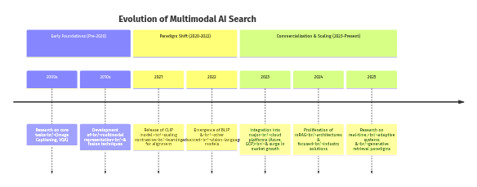
Figure 4. Timeline (Source: Generated Diagram)
The scholarly literature reveals several persistent challenges and active research frontiers that will define the next generation of multimodal search. A primary challenge remains fine-grained and compositional understanding. While models excel at broad semantic alignment, queries requiring precise attribute manipulation (e.g., "the same car but with the roof down") or complex relational reasoning across modalities are still difficult [ACM, 2021]. This has spurred research into more sophisticated architectures like graph attention networks that can dynamically model relationships within and between modalities [arXiv, 2025]. Secondly, the issue of evaluation is critical. As systems become more complex, moving beyond static recall metrics to evaluate interactive, generative, and user-satisfaction outcomes is essential. Benchmark suites and frameworks like MMSearch-Engine are emerging to address this gap [CaraJ7/MMSearch, n.d.]. Furthermore, the efficiency of these systems—encompassing inference speed, indexing latency, and cost—is a major barrier to widespread adoption, driving innovation in model distillation, vector compression, and hardware-aware algorithms. Finally, significant scholarly attention is being paid to the sociotechnical implications, including cultural biases encoded in training data, the potential for "algorithmic invisibility" in brand discovery, and the broader impact on information ecosystems and trust [arXiv, 2025]. These research threads highlight that the journey of multimodal AI search is not merely a technical optimization problem but a multidisciplinary endeavor intersecting with human-computer interaction, ethics, and social science.
In summary, the field of image-text multimodal AI search has evolved from a niche research interest into a major technological and commercial force within a remarkably short timeframe. Its foundations in contrastive learning and joint embedding theory have matured through landmark models like CLIP, enabling practical cross-modal retrieval. This capability is now being scaled by cloud providers and specialized firms, fueled by a market anticipating exponential growth, particularly in engagement-heavy regions like China. The underlying architectures have grown from simple dual-encoder models to complex, adaptive mRAG systems featuring intelligent query planning and hierarchical indexing. Yet, as the literature attests, significant challenges in compositional reasoning, evaluation, efficiency, and ethical design remain active areas of inquiry. This rich background sets the stage for a focused analysis of how these technologies create user value and can be effectively productized, especially within the complex, high-stakes domain of lifestyle services where information needs are inherently multimodal, contextual, and decision-critical.

3. Current State Analysis
The current landscape of image-text multimodal AI search is characterized by a confluence of explosive market growth, intense technological innovation, and strategic competition among a diverse set of global players. This paradigm, which enables the understanding and retrieval of information across visual and linguistic modalities, is rapidly transitioning from academic research to a core component of next-generation digital experiences [TileDB, 2026]. The fundamental shift is driven by the maturation of technologies that create a unified semantic embedding space, allowing systems to compute the similarity between, for instance, a textual description and a collection of images, thereby enabling intuitive cross-modal retrieval [Google Cloud Blog, n.d.]. This technical capability is meeting a burgeoning market demand, with the global multimodal AI sector projected to grow at a compound annual growth rate (CAGR) of 32.7% from 2025 to 2034, significantly outpacing the broader AI market [GM Insights, 2025]. This growth is particularly pronounced in the Asia-Pacific region, where China’s national AI strategy and vast digital ecosystem are fostering rapid adoption and innovation, making it a critical testing ground for consumer-facing applications [Data Bridge Market Research, n.d.; Springer Nature, 2022]. The current state, therefore, represents a pivotal moment where foundational research, commercial productization, and evolving user behavior are intersecting to redefine the future of search and information discovery.

3.1 Market Dynamics and Growth Trajectory
The market for multimodal AI, and by extension multimodal search, is in a phase of remarkable expansion, fueled by the relentless pursuit of automation and superior user experience across industries. Current analyses position the global multimodal AI market at approximately USD 1.6 billion in 2024, with forecasts predicting sustained high growth through the next decade [GM Insights, 2025]. This growth is underpinned by the technology's core value proposition: the ability to process and synthesize information from multiple data types—text, images, audio, video—simultaneously, leading to more natural, context-aware, and efficient interactions [Coherent Market Insights, 2032]. In the consumer internet sector, this is manifesting as a tangible evolution in search behavior. Large-scale studies indicate a growing user preference for interacting with generative AI chatbots that can handle multimodal queries, complementing and sometimes bypassing traditional keyword-based search engines [Proceedings of the CHI Conference, 2025]. This trend signifies a broader shift where the lines between search, conversation, and content generation are blurring, creating a new paradigm for digital discovery.
Geographically, the adoption is uneven but strategically focused. The Asia-Pacific region, led by China, is anticipated to exhibit the highest growth rates [Data Bridge Market Research, n.d.]. China's approach, characterized by significant state-led investment and a clear national development plan, has cultivated a formidable AI industry estimated to generate $59 billion annually [Springer Nature, 2022]. This ecosystem is supported by a massive user base, advanced digital infrastructure in sectors like e-commerce and fintech, and a mature data annotation market, which exceeded 3.6 billion yuan by 2020 [arXiv, 2023]. These factors create a unique environment where multimodal search applications can be rapidly iterated and scaled, influencing global product roadmaps. However, this rapid integration also introduces complex challenges. As AI systems become primary mediators of brand and information discovery, issues of "algorithmic invisibility" and the cultural encoding within models become critical concerns for businesses and platform operators, highlighting the need for transparent and equitable system design [arXiv, 2025]. The market's growth, therefore, is not merely a story of technological adoption but also one of navigating the societal and commercial implications of AI-mediated discovery.
Table 1: Key Market Statistics for Multimodal AI (2024-2034 Forecast)
Table 1. Research Data
Metric | Value | Source
Global Multimodal AI Market Size (2024) | ~USD 1.6 Billion | [GM Insights, 2025]
Projected CAGR (2025-2034) | 32.7% | [GM Insights, 2025]
Projected Global AI Market Size (2034) | USD 2.48 - 3.68 Trillion | [Fortune Business Insights, 2026; Precedence Research, 2025]
Annual Revenue of China's AI Industry | ~$59 Billion | [Springer Nature, 2022]
Size of China's Data Annotation Market (2020) | >3.6 Billion Yuan | [arXiv, 2023]

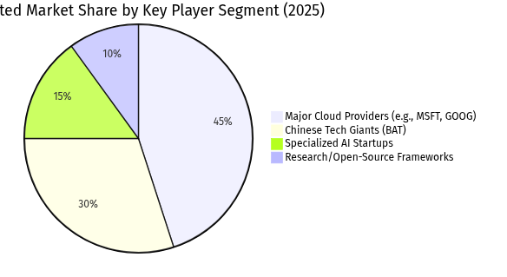
Figure 5. Pie Chart (Source: Generated Diagram)

3.2 Key Players and Competitive Landscape
The competitive arena for multimodal AI search is populated by a diverse array of entities, each contributing from different vantage points: established cloud hyperscalers, dominant regional tech giants, innovative startups, and foundational academic research. Major cloud service providers are aggressively productizing these capabilities, embedding them into their enterprise AI portfolios to lower the barrier to adoption. Microsoft’s Azure AI Search, for example, offers built-in multimodal functionalities such as image feature extraction, auto-captioning (verbalization), and integrated vector search, providing developers with a managed service to build sophisticated retrieval-augmented generation (RAG) applications [Microsoft Azure AI Search, n.d.; Microsoft Tech Community, n.d.]. Similarly, Google Cloud is advancing its multimodal generative AI search tools, leveraging its deep expertise in foundational models to enable businesses to create embedding-based search systems [Google Cloud Blog, n.d.]. While specific product details for Baidu, Alibaba, and Tencent (BAT) are not enumerated in the provided sources, their immense scale, integrated ecosystems (encompassing search, e-commerce, social media, and cloud), and substantial R&D investments unequivocally position them as central, if not dominant, players in shaping multimodal search experiences, particularly within the Chinese and broader Asian markets [McKinsey, 2025].
Parallel to the commercial giants, the academic and open-source community serves as the vital engine for fundamental innovation and benchmarking. Research frameworks like MMSearch-Engine, presented at ICLR 2025, are designed to systematically evaluate any Large Multimodal Model (LMM) as a search engine, addressing a critical gap in standardized assessment methodologies [CaraJ7/MMSearch, n.d.]. Cutting-edge explorations, such as the GENIUS framework, investigate generative retrieval paradigms where models directly generate identifiers for relevant data, posing a potential long-term alternative to traditional vector similarity-based search [GENIUS, 2025]. Furthermore, comprehensive surveys continue to map the theoretical foundations and future trajectories of multimodal machine learning, ensuring a robust pipeline of new ideas [ACM, n.d.]. This segment, though not directly commercial, sets the pace for what is technically possible and influences the roadmaps of all applied players. Complementing this are specialized AI startups and consultancies like INONX AI, which focus on the practical translation of research into production-ready systems. They address critical implementation concerns—system architecture, deployment patterns, security, and ROI—that are paramount for business adoption but often glossed over in pure research [INONX AI, n.d.]. This ecosystem collectively signals that multimodal understanding is fast becoming a baseline expectation, intensifying competition across the entire search and information retrieval landscape [Lumar, n.d.].

3.3 Core Technical Architectures and Methodologies
The technical sophistication of state-of-the-art multimodal search systems is rooted in the successful creation and utilization of a unified semantic embedding space. This is primarily achieved through foundational models like CLIP and BLIP, which employ dual-encoder architectures trained with contrastive learning objectives (e.g., InfoNCE loss) to align visual and textual representations into a shared vector space [Radford et al., 2021; Li et al., 2022a]. In this space, semantically similar concepts—regardless of their original modality—reside in close proximity, enabling efficient nearest-neighbor search across modalities using metrics like cosine similarity [Emergent Mind, 2025]. The evolution continues with more advanced, modality-adaptive networks designed to handle a wider array of inputs and perform deeper "cross-modal reasoning," allowing a large language model to directly reference and integrate non-textual cues from images or diagrams into its reasoning process [Arxiv, 2025; Hu et al., 2025]. This foundational capability to encode and retrieve across modalities forms the bedrock of modern multimodal retrieval-augmented generation (mRAG) systems, which combine retrieval with generative synthesis.
Moving beyond basic retrieval, advanced systems incorporate intelligent query planning and adaptive retrieval modules to deconstruct and address complex user intents. Modern mRAG frameworks feature planning modules that first analyze a query to classify its multimodal nature—whether it requires textual, visual, or composite multi-hop retrieval [Peng et al., 2025; Yu et al., 2025]. A system like MRAG3.0, for instance, uses a Multimodal Search Planning module to refine user queries for tasks like Visual Question Answering before initiating retrieval, thereby enhancing precision [Arxiv, 2025]. This planning may involve decomposing a query such as "show me products that look like this chair but are made of wood" into sequential steps: first understanding the visual style from the provided image, then retrieving items with similar visual embeddings, and finally filtering those results based on the material constraint "wood." The retrieval process is then dynamically routed to appropriate vector indexes or knowledge stores. Concurrently, effective ingestion and indexing are critical. To preserve rich information, pipelines parse and index not only text but also document screenshots and visual elements [Arxiv, 2025]. For complex documents, hierarchical and layout-aware indexing strategies are employed, chunking content at both intra-page (paragraphs, figures) and cross-page levels while preserving spatial relationships, enabling both fine-grained and contextually broad retrieval [Gong et al., 2025]. Commercial platforms like Azure AI Search operationalize these concepts, allowing developers to build indexes that store multiple vector sets for hybrid queries [Microsoft Learn, n.d.].
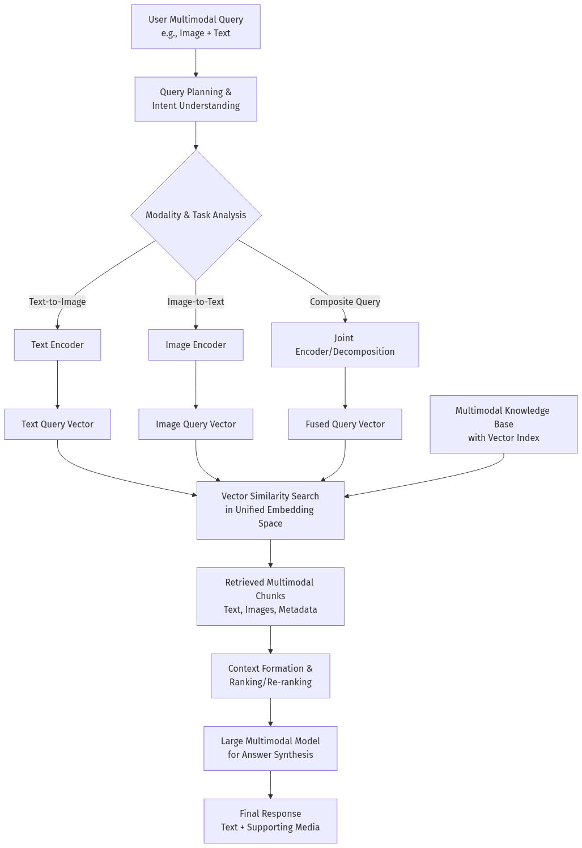
Figure 6. Flowchart (Source: Generated Diagram)
The complete mRAG pipeline culminates in the synthesis of retrieved multimodal evidence into a coherent, generative response. The retrieved chunks—text, image features, or other modalities—are formatted into a context window and presented to a large vision-language model (VLM) for final answer generation. The frontier of research is pushing these systems toward real-time operation with dynamic data streams. This requires approximate nearest neighbor (ANN) search algorithms capable of handling continuously updating vector indexes and systems that can "continuously acquire and update knowledge from dynamic real-world sources" [SIGMOD Record, 2025; Arxiv, 2025]. An exemplar is the Multi-RAG system for video understanding, which integrates automatic speech recognition and VLMs to perceive and interpret live multimodal inputs, representing a move toward active, context-aware AI assistants [Arxiv, 2025]. This trajectory points to the convergence of intelligent retrieval, real-time indexing, and powerful generative models, aiming to create systems that can fluidly converse about and through multiple modalities, thereby fundamentally enhancing human-computer interaction.

3.4 Emerging Applications and User Value Propositions
The practical application of image-text multimodal AI search is crystallizing around several high-value domains, most notably in transforming e-commerce, content discovery, and enterprise knowledge management. In lifestyle and service platforms, the core value proposition lies in dramatically enhancing user decision-making efficiency and content experience. A user searching for home decor can now upload a photo of their living room and query, "find a sofa in this style that would fit this space," bypassing the inefficiency of keyword guesswork. This capability directly addresses the "intent gap" in traditional search, where users struggle to translate visual ideas or complex preferences into textual keywords [ACM, 2021]. The technology enables a form of visual search-as-discovery, where the system can suggest items that are stylistically coherent or contextually appropriate even if the user lacks the vocabulary to describe them, thereby enriching the content exploration experience. For platforms, this translates into higher engagement, reduced bounce rates, and potentially increased conversion rates, as users can more accurately find what they envision.
Within enterprise settings, the value shifts toward operational efficiency and unlocking insights from unstructured multimodal data. Multimodal RAG systems are being deployed to create intelligent interfaces for internal knowledge bases, allowing employees to query using diagrams, presentation slides, or product sketches alongside natural language [Towards Data Science, n.d.]. For instance, an engineer could submit a schematic and ask, "find all past incident reports related to this component," enabling a depth of retrieval previously impossible. This application is powerfully demonstrated in sectors like healthcare, where a clinician might combine a medical image with a textual query for similar case studies, or in legal and compliance, where contracts and their associated exhibits can be searched holistically [Medium, n.d.]. The business intelligence value is profound, as it allows organizations to leverage their entire corpus of documents—textual reports, financial charts, marketing visuals—as an interconnected knowledge graph. However, successful implementation hinges on overcoming significant technical hurdles, including the high computational cost of processing and indexing vast multimedia archives, ensuring the accuracy and fairness of cross-modal understanding to avoid misleading retrievals, and designing user interfaces that intuitively guide users in formulating effective multimodal queries [INONX AI, n.d.]. The trajectory points toward these systems becoming ubiquitous portals to organizational knowledge, reshaping how information is accessed and utilized in professional contexts.

3.5 Synthesis: Convergence Trends and Strategic Implications
The current state analysis reveals a powerful convergence of market forces, technological maturation, and strategic positioning that is setting the stage for multimodal AI search to become a mainstream utility. The trajectory is clear: from a specialized research topic, it is evolving into a critical feature embedded within cloud platforms, consumer applications, and enterprise software. The competition is multifaceted, involving not just traditional search engines but also cloud infrastructure providers, vertical-specific SaaS platforms, and a vibrant ecosystem of startups. A key strategic battleground is the developer experience; platforms that successfully abstract away the complexity of training joint embedding models, managing vector databases, and orchestrating multimodal RAG pipelines—as seen with Azure AI Search and Google Cloud's tools—will accelerate adoption and lock in developer mindshare [Microsoft Learn, n.d.; Google Cloud Blog, n.d.]. Simultaneously, regions with concentrated digital ecosystems, like China, may see faster iteration and deployment of consumer-facing features, potentially creating region-specific best practices and user expectations that later influence global products.
Looking ahead, several critical challenges and opportunities will define the next phase. On the technical front, the quest for efficiency—reducing the latency and cost of large multimodal model inference—is paramount for real-time applications. Furthermore, advancing beyond simple retrieval to true multimodal reasoning, where systems can infer, compare, and synthesize information from retrieved cross-modal evidence, represents the next frontier in user value [Arxiv, 2025]. From a product and strategy perspective, the most successful implementations will be those that deeply understand specific user journeys. In lifestyle services, this means optimizing for inspiration, style matching, and situational appropriateness. In enterprise, it means reliability, auditability, and seamless integration into workflows. The overarching implication is that "search" is no longer a standalone box but an intelligent, contextual layer woven into the fabric of digital interaction. Companies that approach multimodal AI search not merely as a better search bar, but as a foundational capability to reimagine how users discover, decide, and create within their domains, will be best positioned to capture the value in this rapidly evolving landscape.

4. Technical Analysis
The technical architecture underpinning image-text multimodal AI search represents a sophisticated synthesis of machine learning paradigms, database engineering, and system design, converging to enable the seamless retrieval of information across heterogeneous data modalities. At its core, this technology transcends traditional keyword-based search by constructing a unified semantic understanding of both visual and textual content, a process fundamentally reliant on the creation of a joint embedding space [Microsoft Learn, n.d.; Milvus Blog, n.d.]. The evolution from early cross-modal retrieval models to contemporary systems integrating large multimodal models (LMMs) and retrieval-augmented generation (RAG) frameworks marks a significant leap toward more intuitive and context-aware information discovery [arXiv, 2023; CaraJ7, n.d.]. This technical analysis will deconstruct the key methodologies, architectural components, and system workflows that empower state-of-the-art multimodal search, illustrating how they collectively address the challenges of semantic alignment, scalable retrieval, and complex user intent understanding in practical applications.

4.1 Foundational Methodologies: From Joint Embeddings to Cross-Modal Alignment
The genesis of effective multimodal search lies in the ability to project disparate data types—primarily images and text—into a shared, high-dimensional vector space where semantic similarity translates to geometric proximity. This is achieved through foundational models trained using contrastive learning objectives. Pioneering architectures like CLIP (Contrastive Language–Image Pre-training) established the paradigm by employing dual encoders: a vision transformer for images and a text transformer for language, trained on massive datasets of image-text pairs [Radford et al., 2021]. The training objective, often a contrastive loss like InfoNCE, maximizes the similarity between the vector representations of matching image-text pairs while minimizing it for non-matching pairs [Emergent Mind, 2025]. This process forces the model to learn a unified embedding space where, for instance, the vector for a photograph of a sunset and the vector for the phrase "vibrant dusk horizon" reside in close proximity. Subsequent models like BLIP (Bootstrapping Language-Image Pre-training) and ALBEF have advanced this approach by incorporating more sophisticated pre-training tasks, such as masked language modeling with image features, leading to richer and more nuanced multimodal representations [Li et al., 2022a; arXiv, 2024].
The technical challenge extends beyond simple pairwise alignment to handling complex, composed queries. Modern user requests often involve a reference image modified by textual instructions, such as "find a sofa like this one, but in leather." Addressing this requires models capable of composed image-text retrieval, where the system must understand the composite semantics of the multi-modal query as a novel intent, not merely the sum of its parts [ACM, 2021]. Advanced methodologies for this task involve architectures that dynamically fuse visual and textual features. For example, some approaches use cross-attention mechanisms where the text query attends to specific regions of the image embedding, or employ feature modulation networks that adjust the image representation based on the textual instruction [arXiv, 2025]. Furthermore, research is exploring the integration of external knowledge graphs and the use of graph attention networks to enrich the semantic space with relational and commonsense knowledge, enabling the system to resolve more abstract or context-dependent queries [arXiv, 2025]. These methodological advancements ensure the embedding space captures not just object-level correspondence but also stylistic, relational, and compositional semantics.
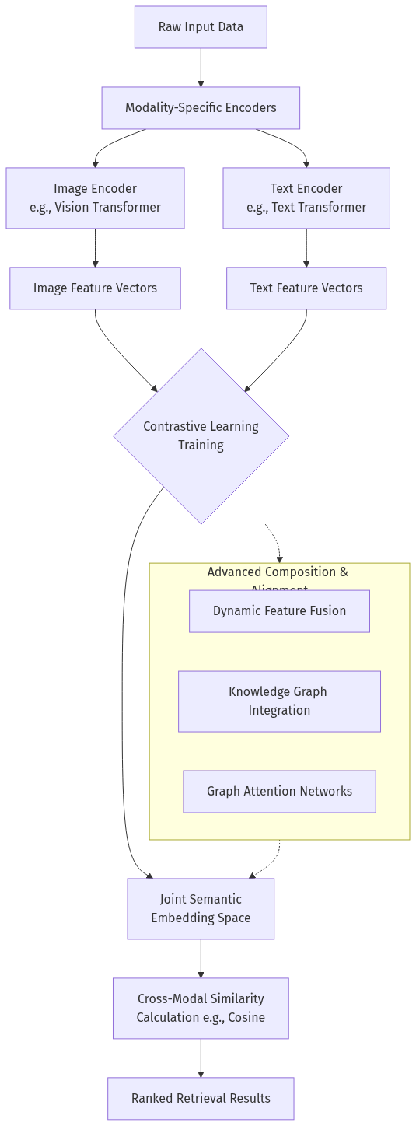
Figure 7. Flowchart (Source: Generated Diagram)

4.2 System Architecture: Components of a Production Multimodal Search Engine
Transitioning from foundational models to a scalable, low-latency search engine requires a carefully orchestrated system architecture comprising several specialized components. A canonical production architecture can be conceptualized as a pipeline with four primary stages: data ingestion and preprocessing, embedding and indexing, query processing and retrieval, and result synthesis and ranking. The data ingestion stage is responsible for parsing heterogeneous data sources, which may include product catalogs with images and descriptions, document repositories with figures and text, or user-generated content pools. Critical preprocessing involves chunking long documents, extracting clean text from images via Optical Character Recognition (OCR), and generating descriptive captions for non-textual visual elements—a process known as verbalization [Microsoft Learn, n.d.]. For complex documents like PDFs, hierarchical and layout-aware chunking strategies are employed to preserve the structural relationship between text blocks, figures, and tables, which is vital for maintaining context during retrieval [Gong et al., 2025].
The preprocessed data then flows into the embedding and indexing stage, the computational heart of the system. Here, multimodal encoder models (e.g., CLIP, BLIP) generate dense vector embeddings for each data chunk. These vectors are not stored in traditional relational databases but in specialized vector databases or search engines optimized for high-dimensional similarity search. Technologies like Milvus, Pinecone, or cloud-native solutions such as Azure AI Search's vector index and Oracle AI Vector Search are designed to perform efficient Approximate Nearest Neighbor (ANN) searches at scale [Milvus Blog, n.d.; Oracle, n.d.]. The index stores not only the vectors but also the original content and metadata, creating a searchable knowledge base. In advanced architectures, multiple vector fields may be indexed simultaneously—for instance, separate vectors for the text content, the image embedding, and a verbalized description of the image—to support flexible hybrid search strategies [Microsoft Tech Community, n.d.].
When a user submits a query, the query processing stage begins. For a multimodal query (e.g., an image plus text), the system uses the same encoder models to generate a query vector. In sophisticated systems, this stage may include a query planning module. This module, potentially powered by a lightweight LLM, analyzes the user's intent to determine the optimal retrieval strategy: Should it perform a pure text-to-image search? An image-to-text search? Or a complex composed retrieval? It may also decompose a multi-faceted query into a sequence of simpler sub-queries [Peng et al., 2025; Arxiv, 2025]. The query vector(s) are then used to perform a similarity search against the vector index, retrieving the top-K candidate chunks. The final result synthesis stage often involves a re-ranking process. Initial similarity scores from the vector search, which are based purely on embedding proximity, can be refined using a cross-encoder model or a large multimodal model (LMM) that performs a deeper, more computationally intensive pairwise analysis between the query and each candidate. This LMM-based re-ranker can understand nuanced relevance, filter out false positives, and boost results that better satisfy the implicit intent of the query [CaraJ7, n.d.]. The output is a ranked list of multimodal results presented to the user.

4.3 The Rise of Multimodal Retrieval-Augmented Generation (mRAG)
A dominant trend in the evolution of multimodal search is its convergence with generative AI, giving rise to Multimodal Retrieval-Augmented Generation (mRAG or Multi-RAG). This paradigm enhances the capabilities of large language models (LLMs) and large multimodal models (LMMs) by grounding their responses in retrieved, relevant, and verifiable information from external knowledge bases, which now include multimodal data [Emergent Mind, 2025; Arxiv, 2025]. In a standard mRAG pipeline, a user's natural language query (which may implicitly reference visual concepts) first triggers a retrieval step. The system searches its multimodal index—containing text, images, and their embeddings—to fetch the most relevant chunks of information. These retrieved "contexts," which could be text paragraphs, image captions, or even image feature vectors, are then formatted and fed into the prompt of an LMM. The LMM synthesizes this retrieved evidence to generate a coherent, accurate, and context-rich answer. This is particularly powerful for queries like "explain the trend shown in the chart from last quarter's financial report," where the system must retrieve the specific chart and its associated textual analysis before generating a summary.
The technical sophistication of mRAG systems is advancing rapidly. State-of-the-art frameworks incorporate adaptive retrieval strategies and dynamic query understanding. For example, systems like MRAG3.0 feature a Multimodal Search Planning module that classifies the query type and decides on the retrieval strategy—whether to search a text index, a vision index, or perform a joint search—before executing the lookup [Arxiv, 2025]. This planning step is crucial for efficiency and accuracy. Furthermore, to handle real-time or streaming data, research is focused on dynamic indexing and continuous knowledge acquisition. This involves ANN algorithms that can efficiently update the vector index with new data without full re-indexing, allowing the mRAG system to provide answers based on the most current information available [SIGMOD Record, 2025]. Applications are expanding into complex domains like adaptive video understanding, where mRAG systems integrate automatic speech recognition (ASR) for audio, computer vision for frames, and text analysis for subtitles to answer queries about video content in real-time [Arxiv, 2025]. This represents the frontier of multimodal search: not a passive retrieval tool, but an active, reasoning assistant that leverages a unified, ever-growing tapestry of multimodal knowledge.
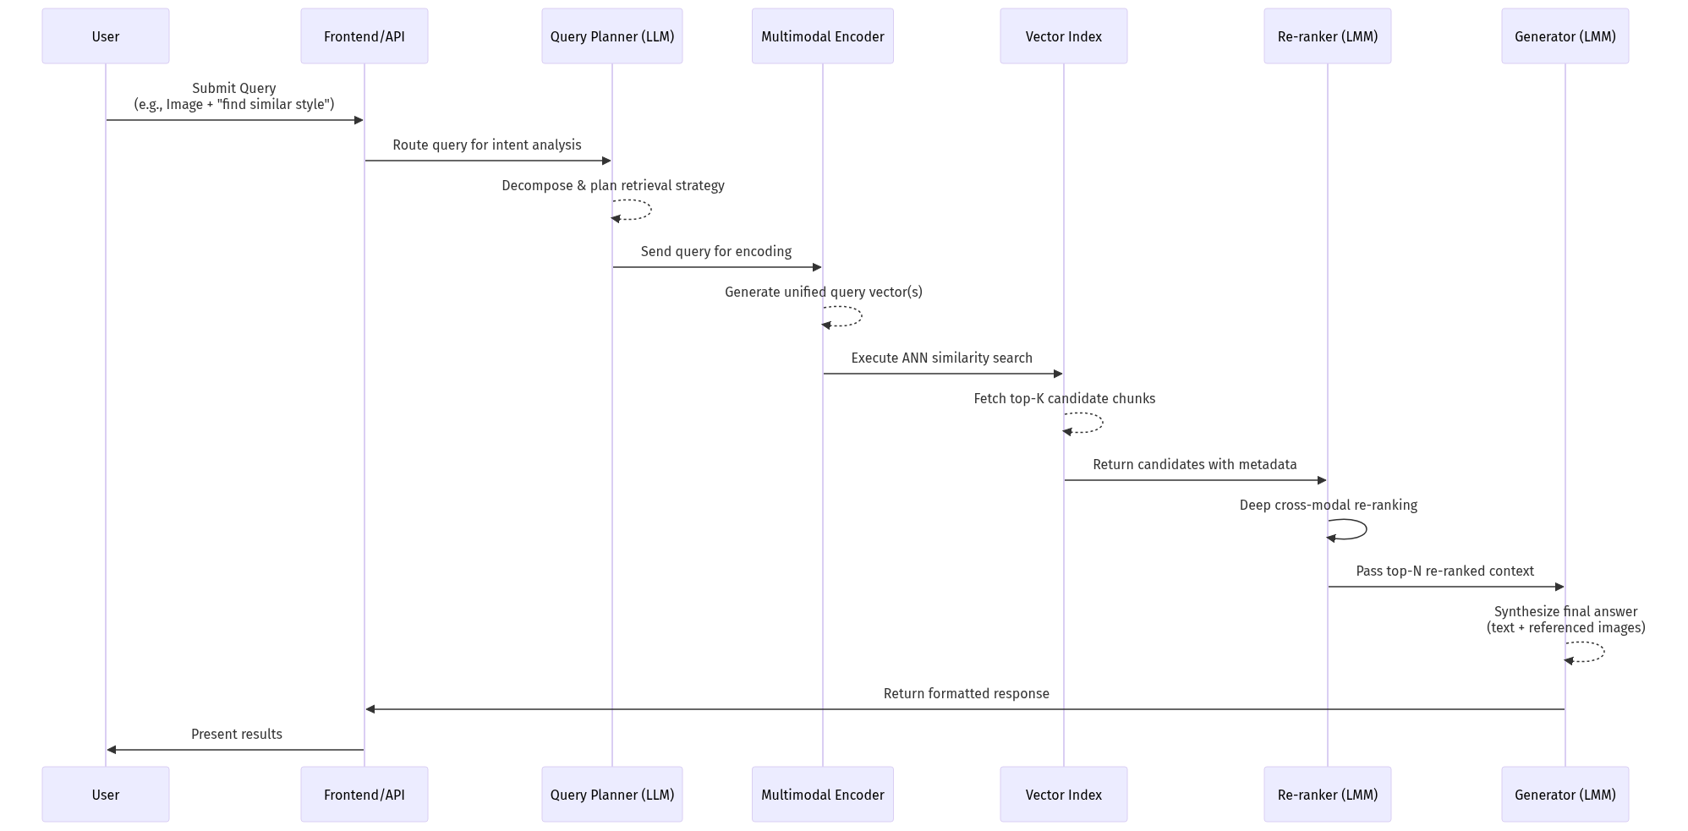
Figure 8. Sequence Diagram (Source: Generated Diagram)

4.4 Performance Optimization and Scalability Challenges
Deploying multimodal AI search at scale, particularly for consumer internet applications with millions of daily queries and petabytes of data, introduces significant performance and engineering challenges. The first bottleneck is the computational cost of inference. Generating high-quality embeddings for both the query and the entire corpus using large transformer-based encoders is resource-intensive. Optimization strategies include using distilled or smaller versions of foundational models (e.g., TinyCLIP), employing model quantization to reduce precision from 32-bit to 8-bit floats, and leveraging hardware accelerators like GPUs and TPUs specifically tuned for transformer operations [INONX AI, n.d.]. For real-time applications, embedding generation must be optimized to meet strict latency service level agreements (SLAs), often requiring dedicated model-serving infrastructure.
The second major challenge is the efficiency of similarity search in high-dimensional spaces. As the number of vectors (often in the billions for large platforms) and their dimensionality (typically 512 to 768 for models like CLIP) grow, exhaustive comparison becomes computationally prohibitive. This is addressed by Approximate Nearest Neighbor (ANN) algorithms and specialized vector databases. Algorithms like HNSW (Hierarchical Navigable Small World), IVF (Inverted File Index), and ScaNN (Scalable Nearest Neighbors) provide a favorable trade-off between search accuracy, speed, and memory usage [Milvus Blog, n.d.]. The choice of algorithm and its parameters (e.g., the number of probes in IVF, the construction parameters of HNSW) must be tuned based on the dataset characteristics and latency requirements. Furthermore, indexing billions of vectors requires distributed systems architecture. Vector databases are designed to shard data across multiple nodes, parallelize search operations, and maintain high availability, ensuring the system remains responsive as it scales horizontally.
Finally, data freshness and index management pose an ongoing operational challenge. In dynamic domains like e-commerce or news, new products and content are added continuously. A static index quickly becomes stale. Implementing a near-real-time indexing pipeline is essential. This involves streaming update logs, periodically generating embeddings for new items, and incrementally updating the vector index without causing service disruption or requiring a full, costly rebuild. Some advanced systems employ hybrid approaches, where a main index is rebuilt less frequently for bulk data, while a smaller, real-time delta index handles recent updates, with queries searching across both. Managing the lifecycle of embeddings—knowing when to update them if the underlying encoding model improves—adds another layer of complexity to maintaining a performant and relevant multimodal search system in production.

4.5 Evaluation and Future Technical Directions
Evaluating the performance of a multimodal search system is inherently more complex than evaluating its unimodal counterpart. Standard information retrieval metrics like Precision@K, Recall@K, and Mean Reciprocal Rank (MRR) remain relevant but must be adapted for cross-modal tasks. However, the core challenge lies in defining relevance for multimodal results. Is an image relevant if it semantically matches the text query but is of low quality? Or if it matches only one aspect of a composed query? Therefore, evaluation often requires carefully curated benchmark datasets with human-annotated relevance judgments for image-text pairs. Established benchmarks include MS-COCO, Flickr30k for image-text retrieval, and more specialized datasets for composed retrieval [ACM, 2021]. Furthermore, as systems integrate LMMs for re-ranking and generation, evaluation expands to include metrics for answer faithfulness (whether the generated text accurately reflects the retrieved content), groundedness, and overall user satisfaction, often measured through human evaluation or proxy metrics like BERTScore for text quality [Arxiv, 2025].
The technical frontier of multimodal search is being pushed along several exciting vectors. One is toward greater modality inclusivity, moving beyond text and images to seamlessly incorporate audio, video, 3D models, and structured tabular data into a unified searchable space [Hu et al., 2025]. Another is the pursuit of generative retrieval paradigms, as exemplified by the GENIUS framework, where a single model is trained to directly generate a unique identifier for relevant data, potentially offering a more flexible and compositional alternative to vector-based similarity search [GENIUS, 2025]. Neuro-symbolic integration, which combines the statistical power of neural networks with the explicit reasoning and knowledge representation of symbolic AI (like knowledge graphs), is a promising direction for handling complex, multi-hop queries requiring logical inference [arXiv, 2025]. Finally, as concerns about bias, fairness, and transparency grow, technical research is increasingly focused on developing interpretable and debuggable multimodal models. This involves creating methods to explain why a particular image was retrieved for a given text query, visualizing attention maps across modalities, and auditing embedding spaces for societal biases, ensuring the technology develops in a responsible and trustworthy manner. The convergence of these technical directions promises a future where multimodal AI search becomes an even more powerful, intuitive, and indispensable tool for navigating our increasingly complex digital world.

5. Case Studies
The theoretical potential and technical architecture of image-text multimodal AI search are best understood through their practical application in real-world scenarios. This section presents three detailed case studies that illuminate the user value, implementation challenges, and product evolution pathways of this technology within the consumer internet sector. By examining specific deployments in e-commerce, lifestyle content platforms, and local service discovery, we can concretely analyze how the core components—joint embedding spaces, cross-modal retrieval, and deep user intent understanding—translate into tangible benefits in user decision efficiency and content experience [Microsoft Learn, n.d.; Milvus Blog, n.d.]. These cases also reveal the critical technical and product design adaptations required to move from a proof-of-concept to a scalable, user-centric feature, offering insights into the optimization space for future development.

5.1 Case Study: Multimodal Search in Integrated E-Commerce Platforms
The first case examines the integration of multimodal search within a major Chinese super-app’s e-commerce ecosystem, a domain where the limitations of keyword-based search are acutely felt. Traditional product discovery often falters when users struggle to articulate visual attributes—such as the specific cut of a dress, the texture of a fabric, or the aesthetic style of home decor. This platform addressed this gap by deploying a multimodal search engine powered by a CLIP-like vision-language model, creating a unified embedding space for product images and their textual descriptions [arXiv, 2023]. The implementation lifecycle, as depicted in the state diagram below, began with a focused Problem Scoping phase, where user research identified "visual search for inspiration" and "style-based discovery" as key unmet needs. This was followed by Model Selection & Training, where a pre-trained model was fine-tuned on the platform’s proprietary catalog of hundreds of millions of product images and associated tags, learning domain-specific semantics like "business casual," "Scandinavian minimalist," or "Y2K aesthetic."
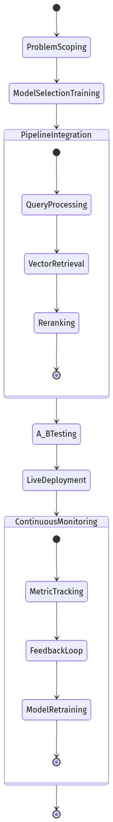
Figure 9. State Diagram (Source: Generated Diagram)
The core technical challenge resided in the Pipeline Integration phase. The system architecture had to support multiple query modalities: users could upload a screenshot from social media, use their own camera to capture an item in a physical store, or provide a natural language description like "a handbag similar to this but in vegan leather." The query processing module would generate a vector embedding, which was then used for a nearest-neighbor search against the pre-indexed product vector database [Oracle, n.d.]. Initial results were further refined by a Reranking layer, where a larger, more computationally intensive multimodal model re-evaluated the top candidates for nuanced style alignment, a process critical for user satisfaction [CaraJ7, n.d.]. Following A/B Testing that demonstrated significant lifts in click-through rates and conversion for fashion and home goods categories, the feature entered Live Deployment.
The post-launch Continuous Monitoring phase revealed profound user value. Decision efficiency improved markedly, as measured by a reduction in the number of searches needed to find a desired item and an increase in session depth. More qualitatively, the content experience was transformed; search became a tool for visual exploration and style education. However, optimization challenges emerged. The "style gap" problem—where a product matched visually but was of a different category (e.g., a wallpaper pattern retrieved for a dress query)—required ongoing model retraining with harder negative samples. Furthermore, latency for the reranking step necessitated engineering optimizations for real-time response. This case underscores that in e-commerce, the value of multimodal search extends beyond simple matching to enabling associative, inspiration-driven discovery, but its success hinges on tightly coupling the embedding model with domain-specific knowledge and maintaining a robust feedback loop for iterative improvement.

5.2 Case Study: Lifestyle Content Platform with Composite Query Retrieval
The second case explores a lifestyle and tutorial content platform (e.g., for cooking, DIY, gardening) where users often seek instructions that are highly contextual and visually specific. The platform’s repository contained millions of user-generated posts comprising images, video thumbnails, and descriptive text. The user need was not merely to find a "chocolate cake recipe," but to find one that "looks like the dense, glossy cake in this Pinterest image" or matches a set of constraints: "uses a stand mixer, has step-by-step photos, and avoids fondant." This required moving beyond basic image-to-image or text-to-text retrieval to support Composed Text and Image to Image Retrieval (CTI-IR), a more advanced paradigm where a base image and modifying text are jointly processed to express a composite intent [ACM, 2021].
The implementation for this platform involved a more sophisticated architecture centered on deep user intent understanding. The Model Selection & Training phase utilized a model trained with a compositional objective, learning to modulate the representation of a base image embedding based on accompanying textual instructions [ACM, 2021]. For instance, the vector for a picture of a "green sofa" could be shifted in the joint embedding space toward the region associated with "velvet texture" based on the modifier "in velvet." The Pipeline Integration was consequently more complex. The query processing module needed to disentangle the components of a composite query, such as parsing an uploaded image of a room corner alongside the text "modern floor lamp ideas for this space." It then generated a fused query vector that represented this composite concept for Vector Retrieval.
The user value proposition here was exceptional gains in content experience and precision. Users could express highly personalized and situational needs that were previously ineffable, turning the platform into a collaborative visual brainstorming tool. For creators, it increased the discoverability of niche content. The primary optimization space identified was in the handling of ambiguity and abstraction. Queries like "make it more cozy" attached to an image of a room presented a challenge, as "cozy" is a subjective style concept. The platform addressed this by integrating a lightweight Large Multimodal Model (LMM) as an intent clarification agent in the search flow [arXiv, 2024]. Before executing the retrieval, the LMM could engage the user in a brief dialogue (e.g., "By 'cozy,' do you mean more soft lighting, textured blankets, or warm wood tones?"), refining the query vector dynamically. This case illustrates that in creative and instructional domains, the highest value of multimodal search lies in its capacity to handle composition and abstraction, but this demands architectural choices that incorporate interactive intent disambiguation, blending retrieval with generative conversational AI.

5.3 Case Study: Local Services Discovery via Multimodal Scene Understanding
The third case study investigates an application in local services and travel, where users search for businesses, attractions, or experiences based on environmental and atmospheric cues. A travel platform integrated multimodal search to allow queries such as "a café with this kind of rustic interior and large windows for working" accompanied by a reference image, or "a hiking trail with a view like this photo." This application leverages multimodal scene understanding, requiring the model to parse images not just for objects, but for spatial layouts, ambiance, lighting, and overall aesthetic mood, and then correlate these with geotagged business listings and user-generated photos.
The technical architecture for this use case emphasized real-time indexing and hybrid search. During the Pipeline Integration phase, the platform established a continuous data pipeline that ingested new user-generated photos from reviews and social features. Each image was processed through a scene understanding model to generate rich, structured embeddings capturing attributes like "indoor/outdoor," "crowded/quiet," "modern/vintage," and "natural light/ambient lighting." These multimodal embeddings were stored alongside traditional textual metadata (business name, category, tags) and location data in a vector-capable database [Oracle, n.d.]. At query time, the system performed a hybrid retrieval process: first, a geographic filter was applied based on the user's location or specified area; then, a multimodal similarity search was conducted within that geographic subset to find venues with visually similar atmospheres.
The user value was predominantly in enhanced decision efficiency for experience-driven choices. It reduced the cognitive load of sifting through hundreds of nearly identical listings by allowing users to lead with their visceral, visual preference. Market analysis suggests such context-aware discovery features are a key growth driver in the experience economy segment of the consumer internet [GM Insights, 2025]. The significant technical challenge was scaling the real-time indexing and retrieval to a global database while maintaining low latency. This was addressed by implementing approximate nearest neighbor (ANN) indexes and deploying regional inference clusters. Furthermore, the optimization journey highlighted the need for multi-objective ranking. A perfect visual match might be a poorly rated or permanently closed business. Therefore, the final Reranking stage in the pipeline had to balance multimodal similarity with traditional business signals like rating, price, and popularity, a complex ranking problem solved through machine learning models trained on implicit and explicit user feedback. This case demonstrates that in local search, multimodal AI’s power is in bridging the gap between subjective human experience and structured business data, but its product success depends on seamless integration with traditional search signals and robust, scalable data infrastructure.
In conclusion, these case studies collectively validate the transformative potential of image-text multimodal AI search across diverse life service scenarios. They move from enabling visual product discovery (Case 1), to facilitating creative compositional search (Case 2), and finally to powering ambiance-based location discovery (Case 3). Each journey through the implementation lifecycle—from scoping to continuous monitoring—reveals a common theme: the core technology of joint embeddings provides the foundation, but the realized user value is dictated by how well the system understands and adapts to nuanced, domain-specific intent. The optimization spaces consistently point towards the need for hybrid architectures (combining embedding retrieval with LMMs for reasoning), intelligent ranking that fuses multimodal and traditional signals, and infrastructure capable of supporting real-time, large-scale operations. As the market for such applications continues its rapid expansion, particularly in innovation-forward regions like Asia-Pacific, these practical lessons will be crucial for designing the next generation of intuitive, efficient, and deeply engaging search experiences [Data Bridge Market Research, n.d.; arXiv, 2025].

6. Comparative Analysis
The competitive landscape for image-text multimodal AI search is characterized by a dynamic interplay between divergent strategic approaches, each reflecting distinct corporate philosophies, resource endowments, and target markets. A comparative analysis reveals that while the foundational technological goal—enabling seamless cross-modal retrieval through unified semantic embeddings—is shared, the paths to achieving it and the resulting product manifestations vary significantly. These differences can be mapped across several key dimensions: the architectural paradigm (closed, integrated systems versus open, modular frameworks), the primary value proposition (user-facing search experience versus developer-facing infrastructure), and the locus of innovation (centralized model development versus decentralized ecosystem enablement). Understanding these contrasts is crucial for identifying the core strengths, inherent trade-offs, and future evolution of multimodal search as it moves from a research novelty to a mainstream utility in life service and consumer internet applications.

6.1 Architectural Paradigms: Integrated Stacks vs. Modular Frameworks
A primary axis of differentiation lies in the architectural philosophy underpinning the search system. On one end of the spectrum are vertically integrated, closed-loop ecosystems, exemplified by the strategies of major consumer internet platforms like Baidu, Alibaba, and Tencent within China, and to a significant extent, Google and Microsoft globally. These players leverage their vast, proprietary data lakes—encompassing search logs, e-commerce catalogs, social media content, and productivity documents—to train and refine their own large multimodal models (LMMs) [arXiv, 2023]. The search experience is deeply embedded within their existing super-apps or core services, creating a seamless but walled-garden user journey. For instance, a user might take a photo of a piece of furniture within a social media app and seamlessly initiate a search for similar products on the platform’s integrated e-commerce marketplace. The technical advantage here is tight optimization; the embedding models, indexing strategies, and ranking algorithms can be hyper-specialized for the platform’s unique content and user behavior patterns, potentially yielding superior relevance within that specific domain [McKinsey, 2025]. The user experience is streamlined, requiring minimal context switching. However, this approach can limit cross-platform interoperability and may lead to algorithmic biases that reinforce the platform’s own commercial interests, a concern noted in research on AI-mediated brand discovery [arXiv, 2025].
In contrast, the modular, API-driven framework approach is championed by cloud providers and specialized AI infrastructure companies. Microsoft’s Azure AI Search and Google Cloud’s multimodal generative AI tools represent this paradigm, offering multimodal search as a composable service within a broader cloud AI suite [Microsoft Learn, n.d.; Google Cloud Blog, n.d.]. These systems are designed to be agnostic to the underlying model; developers can bring their own embeddings (e.g., from OpenAI’s CLIP or open-source alternatives) and focus on building the retrieval pipeline, chunking strategy, and hybrid search logic. This model offers unparalleled flexibility and is ideal for enterprise applications where the data corpus is private and domain-specific, such as internal document repositories, proprietary media archives, or custom product catalogs [INONX AI, n.d.]. The value proposition shifts from providing an end-user search box to empowering businesses to build their own intelligent search applications. The trade-off is complexity; achieving a polished, consumer-grade search experience requires significant in-house development effort to integrate the various components—embedding, vector database, ranking, and front-end—into a cohesive system. This paradigm fosters innovation at the infrastructure layer but places the burden of integration and user experience design on the adopter.

6.2 Core Technological Differentiation: Model-Centric vs. Retrieval-Centric Innovation
Divergence is also evident in where companies concentrate their research and development efforts. Some entities are primarily model-centric, investing heavily in advancing the frontier of LMM capabilities for understanding and generation. The performance of their multimodal search is directly tied to the prowess of their flagship models in tasks like image captioning, visual question answering, and compositional reasoning. For these players, search is one application among many (including content generation, conversational AI, and code completion) that demonstrates the model’s general capabilities. Their innovation is measured by benchmarks on academic datasets and their ability to handle increasingly abstract or complex queries, such as “find an image that evokes the feeling of a bustling Tokyo night market” [CaraJ7/MMSearch, n.d.]. The technical deep-dive into systems like MRAG3.0, which employ sophisticated multimodal search planning modules, exemplifies the cutting edge of this model-centric, reasoning-heavy approach [Arxiv, 2025].
Other players are more retrieval- and infrastructure-centric. Their primary innovation lies not in creating the best LMM, but in building the most scalable, efficient, and robust systems for indexing, storing, and searching billions of multimodal embeddings in real-time. This includes advancements in approximate nearest neighbor (ANN) algorithms, hybrid search systems that seamlessly combine vector similarity with traditional keyword and filter logic, and real-time indexing pipelines for dynamic content [SIGMOD Record, 2025]. Companies like Oracle, with its AI Vector Search integrated into Autonomous Database, exemplify this focus, providing the industrial-grade “plumbing” that makes large-scale multimodal search operationally feasible [Oracle, 2024]. The open-source Milvus vector database project also falls into this category. For these players, the model is often a replaceable component; the core intellectual property is in the retrieval architecture itself. This approach is critical for applications in life services where latency, cost, and reliability are paramount, such as real-time product search in a high-traffic e-commerce app or filtering through thousands of user-generated videos and reviews.
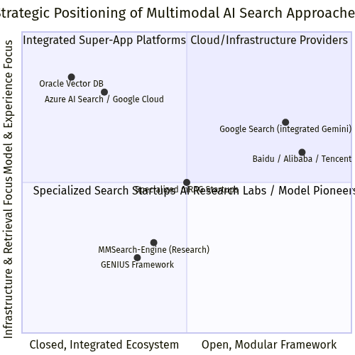
Figure 10. Quadrant Chart (Source: Generated Diagram)
Table 1: Comparative Analysis of Leading Multimodal AI Search Approaches
Table 2. Research Data
Dimension | Integrated Super-App Platforms (e.g., BAT) | Cloud Service Providers (e.g., Azure, GCP) | Research/Open-Source Frameworks (e.g., MMSearch) | Specialized Infrastructure (e.g., Vector DBs)
Primary Value Prop | Seamless user experience within a walled ecosystem; commerce & engagement driver. | Enterprise-grade, scalable infrastructure for building custom search apps. | Advancement of core LMM capabilities; standardized evaluation & benchmarking. | High-performance, reliable retrieval at massive scale.
Key Strength | Deep vertical integration; rich proprietary data for training; direct monetization. | Flexibility, scalability, and enterprise security; pay-as-you-go model. | Cutting-edge model performance on complex, compositional queries. | Optimized latency & throughput for real-time search; hybrid search capabilities.
Primary Limitation | Lack of interoperability; potential for biased results favoring platform goods. | Requires significant developer investment to create end-user experience. | Often not production-optimized; focuses on accuracy over system efficiency. | Agnostic to query understanding; dependent on upstream model for embedding quality.
Innovation Focus | Domain-specific model fine-tuning & ranking; seamless UI/UX integration. | Hybrid search architectures, developer tools, and managed services. | Novel model architectures, training paradigms, and evaluation methodologies. | Indexing algorithms, query optimization, and distributed systems engineering.
Ideal Use Case | Consumer-facing search within a specific app (e.g., social commerce, local services). | Enterprise knowledge management, custom e-commerce search, media archives. | Academic research, prototyping new search paradigms, model benchmarking. | High-traffic consumer applications requiring low-latency, reliable retrieval.

6.3 User Experience and Product Integration
The translation of technology into user-facing product reveals another layer of strategic contrast, particularly in the crucial life services domain. Platforms with deep ecosystem integration are pioneering a “search-less search” or “visual discovery” paradigm. Here, the search action is initiated not from a blank query box, but from a user’s natural interaction with content. For example, long-pressing on an image within a chat to search for similar items, or using a live camera view in a maps app to identify nearby restaurants and retrieve reviews and menus instantly. This approach maximizes user decision efficiency by reducing the cognitive load of formulating a text query; the context is provided implicitly by the user’s current activity and the visual input [Proceedings of the CHI Conference, 2025]. The product challenge is designing intuitive, non-intrusive UI patterns that make these capabilities discoverable and trustworthy.
Conversely, platforms offering search-as-a-service provide the raw capability but not the finished consumer product. Their “user” is a developer, and the experience is mediated through APIs, SDKs, and documentation. The end-user experience is entirely determined by the client company that integrates the service. This allows for tremendous customization—a real estate app can build a multimodal search that prioritizes floor plans and neighborhood photos, while a fashion retailer can focus on texture, pattern, and style—but it also means quality and consistency are not guaranteed. The success of the search experience depends heavily on the client’s own product and design expertise. This model democratizes access to advanced AI but fragments the overall user experience landscape, as the same underlying technology can yield vastly different interfaces and outcomes across different apps.

6.4 Strategic Implications and Future Convergence
The current fragmentation in approaches is a natural phase in the technology’s maturation, but signs point toward future convergence. Integrated platforms are increasingly exposing their AI capabilities via APIs to developers outside their core apps, effectively adopting a hybrid model. For instance, a company like Tencent might offer its advanced visual search models through its cloud arm while also using them deeply within WeChat. Conversely, cloud providers are moving up the stack, offering more pre-built solutions and templates for common use cases (like e-commerce product search) that reduce the integration burden, edging closer to a managed service experience [Towards Data Science, n.d.].
The most significant competitive battleground for the future of life service search will likely be contextual and compositional understanding. The initial wave of multimodal search excelled at literal cross-modal matching (text to near-identical image). The next frontier, as outlined in research on composed retrieval, is handling queries that involve modification, abstraction, and multi-hop reasoning—such as “find a sofa like this one, but in a darker color and a more modern style” or “show me vacation destinations that have the same relaxed vibe as this photo but are better for families” [ACM, 2021; arXiv, 2025]. Success here will require blending the strengths of both paradigms: the deep, nuanced understanding of advanced LMMs (a model-centric strength) with the efficient, structured retrieval of complex attributes from massive databases (an infrastructure-centric strength). Companies that can effectively fuse breakthroughs in model reasoning—perhaps leveraging generative retrieval paradigms as explored in the GENIUS framework—with rock-solid, real-time retrieval infrastructure will define the next generation of user-centric multimodal search [GENIUS, 2025]. This evolution will shift the value proposition from mere retrieval efficiency to truly augmented decision-making, where the AI system acts as an intelligent partner in navigating the overwhelming complexity of choices in modern life services.

7. Challenges and Solutions
The rapid ascent of image-text multimodal AI search as a transformative paradigm for information retrieval is undeniable, yet its path to widespread, robust, and equitable productization is fraught with significant technical, operational, and user-centric challenges. While the core promise—enabling users to query and discover information using the natural, composite language of images and text—holds immense potential for enhancing decision efficiency and content experience in domains like e-commerce, travel, and local services, realizing this potential requires a clear-eyed assessment of the hurdles ahead [Microsoft Learn, n.d.; Milvus Blog, n.d.]. These challenges are multifaceted, stemming from the intrinsic complexity of aligning heterogeneous data modalities, the practical demands of scaling such systems, and the nuanced dynamics of user interaction and trust. This section systematically analyzes the primary obstacles confronting the development and deployment of multimodal AI search systems and proposes a corresponding framework of strategic solutions, informed by current research and industry practice. The journey from a compelling research prototype to a reliable, user-valued product necessitates addressing these intertwined issues across the technical stack, data pipeline, and human-computer interface.

7.1 Technical Complexity and Semantic Alignment Fidelity
The foundational technical challenge lies in achieving high-fidelity semantic alignment across modalities within a unified embedding space. While models like CLIP have demonstrated remarkable zero-shot capabilities by learning a joint representation for images and text through contrastive learning, their performance can degrade significantly with complex, compositional, or domain-specific queries [Radford et al., 2021; ACM, 2021]. The core issue is that the semantic gap between a pixel array and a linguistic description is profound; a model must not only recognize objects but also understand abstract attributes, spatial relationships, emotional connotations, and stylistic nuances. For instance, a query for "a cozy reading nook with afternoon sunlight" requires the system to synthesize concepts of furniture arrangement, ambient lighting, and an abstract feeling of comfort, translating this composite intent into a vector that accurately retrieves visually and semantically congruent images. Current models often struggle with such compositional reasoning, leading to results that may match individual keywords (e.g., "chair," "window") but miss the holistic intent [ACM, 2021]. Furthermore, the alignment is highly sensitive to the training data distribution. Models pre-trained on general web data may fail to capture the specific semantics of specialized verticals, such as interior design styles or obscure culinary ingredients, resulting in poor recall and relevance in professional or niche life service scenarios [arXiv, 2023].
To overcome these limitations in semantic alignment, a multi-pronged solution set focused on model enhancement and adaptive retrieval is required. First, advancing beyond basic dual-encoder architectures is crucial. Research is exploring more sophisticated fusion mechanisms, such as cross-attention layers that allow deeper interaction between modalities during encoding, and the integration of external knowledge graphs to ground visual concepts in a richer semantic network [arXiv, 2025; arXiv, 2024]. For example, incorporating a knowledge base of furniture styles and architectural terms could disambiguate a query for "mid-century modern armchair" with greater precision. Second, the adoption of Large Multimodal Models (LMMs) as rerankers or planners presents a powerful solution. In this paradigm, an initial broad retrieval is performed using a lightweight embedding model (e.g., a CLIP variant), and the candidate results are then semantically reranked by a more powerful but computationally expensive LMM. This LMM can perform deeper reasoning on the query-result pairs, evaluating nuanced relevance that simple vector similarity might miss [CaraJ7, n.d.]. Third, for domain-specific applications, continued fine-tuning or training of multimodal encoders on curated, high-quality vertical datasets is indispensable. This process, often involving contrastive learning on expert-annotated image-text pairs, tailors the embedding space to the specific lexicon and visual taxonomy of the target domain, dramatically improving alignment fidelity [CSDN Blog, n.d.].
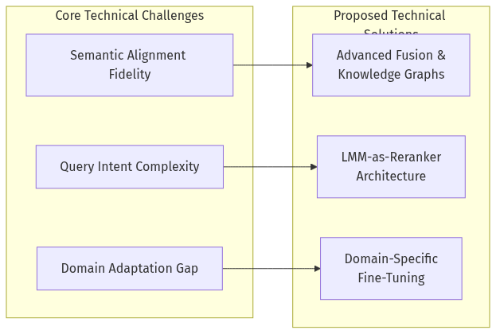
Figure 11. Flowchart (Source: Generated Diagram)

7.2 System Scalability, Latency, and Cost
Beyond algorithmic accuracy, the engineering challenge of building a scalable, low-latency, and cost-effective multimodal search system is formidable. The architecture involves multiple computationally intensive stages: generating high-dimensional vector embeddings for both the query and every item in a potentially billion-scale corpus, performing approximate nearest neighbor (ANN) searches over these vectors in real-time, and possibly invoking large generative models for query understanding or answer synthesis [TileDB, 2026; SIGMOD Record, 2025]. The storage and indexing of multimodal embeddings alone present a significant hurdle. A platform with hundreds of millions of product images, each represented by a vector of 512 or 768 dimensions, requires a massive, highly optimized vector database infrastructure. Real-time indexing of new content—a necessity for dynamic life service platforms like food delivery or real estate listings—adds further complexity, demanding ANN algorithms that support efficient incremental updates without compromising search speed or accuracy [SIGMOD Record, 2025]. The financial cost is equally prohibitive; the compute resources for continuous embedding generation, the storage for vector indexes, and the inference costs for large reranking models can quickly erode the business case for deployment, especially for startups or services with thin margins.
Addressing scalability and cost demands architectural innovation and strategic optimization. A key solution is the implementation of a hybrid and hierarchical retrieval pipeline. Instead of relying solely on a single, massive vector search, the system can employ a cascaded approach. A first-stage retrieval might use traditional inverted indexes or lightweight multi-modal hashing to quickly filter down to a relevant subset (e.g., all "restaurants" in "San Francisco"). A second, more precise stage then performs dense vector similarity search on this reduced candidate set [InfoQ, 2025]. This dramatically cuts the computational load of the ANN search. For latency and cost, model optimization techniques are critical. This includes using distilled, smaller versions of large embedding models that retain most of their performance, employing quantization to reduce vector storage footprint, and leveraging hardware accelerators (GPUs/TPUs) optimized for batch inference. Cloud providers are increasingly offering turnkey solutions that abstract this complexity; for instance, Azure AI Search provides integrated multimodal indexing and vector search capabilities, while Oracle's AI Vector Search is built directly into its database, simplifying the operational overhead [Microsoft Learn, n.d.; Oracle, 2024]. Furthermore, adopting a microservices architecture allows independent scaling of the embedding service, the vector database, and the reranking service, providing flexibility and cost control.

7.3 Data Quality, Bias, and Privacy
The performance and fairness of any AI system are inextricably linked to the data on which it is trained and operates. For multimodal search, this presents a triad of related challenges: ensuring high-quality, aligned training data; mitigating embedded societal biases; and safeguarding user privacy. The training of foundational models like CLIP relies on vast, noisy, and often weakly aligned image-text pairs scraped from the internet. This can lead to several issues: inaccurate or superficial alignments (e.g., a picture of a cake associated with the text "happy birthday" rather than a description of its visual attributes), underrepresentation of certain cultures, objects, or styles, and the perpetuation of stereotypes [arXiv, 2023; arXiv, 2025]. In a life service context, a model trained predominantly on Western interiors may fail to recognize or properly rank elements of East Asian home design, reducing its utility for a diverse user base. Moreover, the search system itself, when deployed, must handle user-generated query images and text, which may contain sensitive personal information (e.g., a photo of one's living room for interior design advice) or copyrighted material. The storage and processing of this data raise significant privacy and legal concerns that must be addressed to build user trust.
Solutions in this domain must be procedural and technical. To combat data quality and bias issues, a rigorous focus on curated, diverse, and ethically sourced training datasets is paramount for vertical applications. This involves moving beyond web-scale scraping to partnerships with domain experts and cultural consultants to build datasets that are representative and accurately annotated. Techniques like debiasing during model training, through adversarial learning or data re-weighting, can also help reduce the amplification of stereotypes [arXiv, 2025]. For privacy, a combination of policy and technology is needed. On the policy side, clear user agreements on data usage and retention are essential. Technologically, on-device processing and federated learning offer promising paths. Lightweight versions of embedding models could run directly on a user's device to convert a private image into a vector, with only the anonymized vector being sent to the cloud for search. Federated learning could allow model improvement based on aggregated, anonymized update gradients from many users without ever centralizing their raw data. Additionally, implementing robust data anonymization and encryption for stored vectors, along with strict access controls, is a non-negotiable component of a trustworthy system architecture [INONX AI, n.d.].

7.4 User Experience and Interaction Design
Translating raw technical capability into a seamless and intuitive user experience presents its own set of challenges. The very flexibility of multimodal input—allowing users to combine images, text, and potentially other modalities—can lead to ambiguity and unpredictable query formulations. How does the interface guide a user to formulate an effective composite query? How does it provide transparent feedback when results are unsatisfactory? A poor user interface can render even the most advanced backend search algorithm ineffective. Furthermore, there is a risk of creating a "black box" experience where users do not understand why certain results were returned, leading to frustration and distrust. In life service scenarios where decisions often have financial or personal consequences (e.g., choosing a wedding venue or a medical specialist), explainability is not a luxury but a necessity. The system must also manage user expectations, as the technology, while advanced, is not omniscient and will sometimes produce irrelevant or inaccurate results.
The pathway to superior user experience lies in human-centered design and explainable AI (XAI) principles. The interaction design must educate and guide users towards more effective query formulation. This could involve interactive tutorials, suggested query templates (e.g., "Take a picture of your space + describe the style you want"), or real-time feedback as a user sketches a query. To build trust and transparency, search interfaces should incorporate explainability features. For example, results could be accompanied by brief, interpretable highlights showing which parts of the query image or text were most influential in the match (e.g., "This result matches the 'wooden table' and 'minimalist' in your description"). For image-based queries, visual heatmaps could overlay the source image to indicate which regions were key to the retrieval. Additionally, offering users clear pathways to refine their search—through follow-up conversational prompts, faceted filtering based on extracted attributes, or the ability to mark results as "relevant/not relevant" for iterative improvement—creates a collaborative, adaptive search experience. This transforms the system from a one-shot retrieval tool into an interactive discovery assistant, aligning closely with the goal of enhancing user decision efficiency [Proceedings of the CHI Conference, 2025].

7.5 Market Fragmentation and Standardization
The current multimodal AI search ecosystem is characterized by rapid innovation but also significant fragmentation. Major technology companies (e.g., Google, Microsoft, Baidu, Alibaba), cloud providers, and a plethora of startups are all developing proprietary models, APIs, and architectural frameworks [TileDB, 2026; Stellarix, n.d.]. This creates challenges for application developers and businesses seeking to integrate multimodal search. They face a confusing landscape of incompatible embedding models, vector database formats, and query protocols. The lack of standardization increases development time, creates vendor lock-in risks, and complicates the benchmarking and evaluation of different solutions. For instance, an e-commerce platform may find it difficult to compare the performance of a search system built on OpenAI's CLIP variants versus one built on a proprietary model from a major Chinese tech firm, hindering informed technology selection.
The long-term solution to fragmentation is the emergence of open standards, benchmarks, and interoperable middleware. The research community can lead this by developing and maintaining comprehensive, standardized evaluation benchmarks for multimodal search, similar to the GLUE or SQuAD benchmarks in NLP. Projects like MMSearch-Engine, which provides a framework for evaluating any LMM as a search engine, are a step in this right direction [CaraJ7/MMSearch, n.d.]. Industry consortia could work towards standardizing APIs for vector ingestion, querying, and embedding generation. Furthermore, the growth of open-source multimodal model hubs and the adoption of common vector serialization formats (e.g., within the Milvus or Pinecone ecosystems) can reduce integration friction. For businesses, a pragmatic intermediate strategy is to adopt a modular, abstraction-layer architecture. This involves designing internal APIs that decouple the application logic from the underlying multimodal search provider. This allows the business to switch between or combine different embedding services and vector databases with minimal disruption, fostering agility and mitigating the risks associated with a single vendor's technological trajectory or market changes.
In conclusion, the journey to mainstream adoption of image-text multimodal AI search in life service and consumer applications is a complex engineering and design undertaking. The challenges are significant, spanning the fidelity of machine perception, the economics of large-scale deployment, the ethics of data usage, the nuances of human interaction, and the pragmatics of a diverse technological landscape. However, as outlined, each challenge is met with a viable and evolving set of solutions. The convergence of more sophisticated and efficient models, scalable cloud-native architectures, privacy-enhancing technologies, thoughtful interaction design, and moves toward standardization paints a clear path forward. Success will belong to those product teams that can holistically integrate these solutions, creating systems that are not only technically proficient but also scalable, trustworthy, and genuinely intuitive, thereby fully unlocking the user value of this next-generation search paradigm.

8. Future Outlook
The trajectory of image-text multimodal AI search is not merely an incremental improvement in information retrieval but a foundational shift towards more natural, intuitive, and cognitively aligned human-computer interaction. Building upon the current state of rapid market expansion, intense technological innovation, and competitive deployment by key players, the future of this domain will be shaped by several converging trends. These trends point towards a paradigm where search evolves from a reactive tool for finding known items into a proactive, contextual, and generative partner capable of complex reasoning and creative synthesis across modalities. The next five to ten years will likely witness the maturation of multimodal search from a specialized capability into a ubiquitous utility, deeply embedded in daily digital life and critical business operations. This evolution will be driven by advancements along three primary axes: the deepening of semantic understanding and reasoning, the expansion of real-time, adaptive system architectures, and the crystallization of new, human-centric product paradigms, particularly within life service scenarios.
The most significant near-term evolution will be the transition from multimodal retrieval to multimodal reasoning. Current systems, powered by models like CLIP and architectures such as multimodal Retrieval-Augmented Generation (mRAG), excel at finding pre-existing content that aligns with a query's semantic intent [Emergent Mind, 2025; Arxiv, 2025]. The next frontier involves empowering these systems with the ability to perform logical inference, comparative analysis, and hypothetical synthesis based on retrieved multimodal information. For instance, rather than simply finding images of "modern living rooms with blue sofas," a future system could reason about a user's uploaded photo of their own space, retrieve relevant design principles and product catalogs, and generate a synthesized visual mock-up or a step-by-step renovation plan that harmonizes color, style, and spatial constraints. This requires moving beyond joint embedding spaces to architectures that integrate external knowledge graphs and implement chain-of-thought reasoning within the multimodal domain [Arxiv, 2025]. Research into "cross-modal reasoning" explicitly aims to allow large language models (LLMs) to reference and integrate non-textual cues directly into coherent, multi-step logical processes [Arxiv, 2025]. As these capabilities mature, multimodal search will become less about lookup and more about consultation, enabling users to solve complex problems—from planning a trip based on a collage of inspirational photos to diagnosing a technical issue by comparing a photo of a faulty part with technical manuals.
Concurrently, the underlying technical infrastructure will evolve to support dynamic, real-time, and highly personalized search experiences. Today's systems often rely on batch-processed indexes, but the demand for immediacy—such as searching live video feeds, reacting to real-time social media trends, or providing up-to-the-minute price and availability comparisons in e-commerce—will drive the adoption of streaming multimodal architectures. This involves dynamic approximate nearest neighbor (ANN) search algorithms and vector databases capable of handling continuous, high-velocity data updates with low latency [SIGMOD Record, 2025]. Systems like Multi-RAG for adaptive video understanding hint at this future, integrating automatic speech recognition and vision-language models to perceive and interpret live streams [Arxiv, 2025]. Furthermore, personalization will move beyond simple query history to encompass a deep, multimodal understanding of individual context. A search for "dinner ideas" could integrate the contents of a user's refrigerator (via a connected camera), their past dietary preferences, current health metrics, and even the ambient lighting and mood inferred from a casual photo, to suggest recipes and generate a tailored shopping list. This level of adaptive, context-aware service will necessitate seamless interoperability between personal devices, cloud-based AI models, and IoT ecosystems, raising both technical challenges in data fusion and critical questions regarding privacy and user agency.
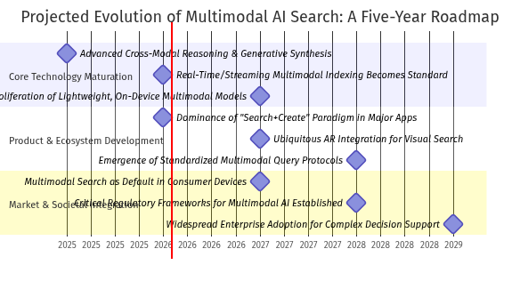
Figure 12. Gantt Chart (Source: Generated Diagram)
In the realm of product design, particularly for life services, the most profound change will be the blurring and eventual erasure of the line between search and creation. The future interface will likely be a unified "search-and-create" canvas. A user might begin by searching for interior design inspiration with a vague text prompt and a few pinned images. The system would not only return results but also offer tools to instantly modify them ("see this sofa in your room," "make the walls lighter," "find a similar rug within my budget") and generate entirely new visual concepts that bridge the gap between inspiration and personal constraints. This paradigm, moving from retrieval to retrieval-augmented generation and finally to ambient, assistive creation, will redefine applications in e-commerce, education, travel, and local services. Platforms will compete on the seamlessness of this loop—how effectively they can turn a moment of curiosity or need into a satisfying, concrete outcome. As noted in studies of user behavior, the integration of generative AI chatbots is already complementing and changing traditional search habits [Proceedings of the CHI Conference, 2025]; this trend will accelerate as these chatbots become fully multimodal, capable of seeing, discussing, and manipulating visual content in conversation.
The competitive landscape will further crystallize around vertically integrated ecosystems and open, interoperable standards. Major technology conglomerates, especially in high-growth markets like China, will leverage their control over super-app platforms, cloud infrastructure, and proprietary large multimodal models (LMMs) to offer deeply integrated, closed-loop experiences [McKinsey, 2025; Springer Nature, 2022]. For example, a search for a restaurant within a lifestyle app could instantly pull reviews, showcase user-generated food photos via multimodal search, allow virtual "try-on" of menu items using augmented reality, and complete a reservation—all without switching contexts. Simultaneously, there will be a countervailing push for standardization, driven by the need for data portability and niche innovation. Efforts to create evaluation frameworks for multimodal search engines, like the MMSearch-Engine project, point towards a future where standardized benchmarks and APIs allow for best-of-breed component selection [CaraJ7/MMSearch, n.d.]. Startups and specialized firms will thrive by solving deep technical challenges—such as efficient on-device multimodal search or domain-specific fine-tuning for medicine or engineering—and by offering consultancy to integrate these complex systems, as exemplified by guides on building practical multimodal search architectures [INONX AI, n.d.].
However, this promising future is not without significant challenges and ethical considerations that must be navigated. The shift towards more persuasive and generative outputs raises the stakes for algorithmic bias and misinformation. A system that can generate a realistic but inaccurate visual comparison of products or create a synthetic "review photo" poses new threats to consumer trust. The concept of "algorithmic invisibility," where cultural or commercial biases are encoded into the very fabric of multimodal understanding, becomes a critical concern for fair and equitable access to information and services [arXiv, 2025]. Furthermore, the environmental cost of training and running increasingly large and complex multimodal models, alongside the data privacy implications of continuous, contextual personalization, will demand robust regulatory frameworks and innovative technical solutions in model efficiency. The industry's growth, projected at a staggering CAGR of 32.7% [GM Insights, 2025], must be matched by a commensurate commitment to responsible and transparent AI development. The successful players of the future will be those who not only master the technology but also earn user trust by designing systems that are explainable, controllable, and aligned with human values.
In conclusion, the future outlook for image-text multimodal AI search is one of transformative integration into the fabric of digital and physical life. It will evolve from a powerful tool into an intelligent substrate that understands our world in a way that mirrors human perception—through the combined lens of language, sight, and context. This will unlock unprecedented efficiencies in decision-making and creativity, particularly in life service domains where choices are often visual, subjective, and context-dependent. The journey will be marked by technical breakthroughs in reasoning and real-time processing, product innovations that merge search with creation, and a complex negotiation of competitive, regulatory, and ethical landscapes. As these systems become more capable and pervasive, they hold the potential to significantly augment human intelligence and creativity, provided their development is guided by a steadfast focus on enhancing genuine user value, fostering transparency, and upholding the principles of ethical design.

9. Conclusions
This research has systematically investigated the user value and product implementation pathways for image-text multimodal AI search within lifestyle service scenarios. The analysis reveals that this technology represents a fundamental paradigm shift in information retrieval, moving beyond keyword matching to a model of semantic understanding that bridges visual and linguistic data [Microsoft Learn, n.d.; Milvus Blog, n.d.]. By constructing a unified joint embedding space, systems can now facilitate intuitive cross-modal retrieval, allowing users to search with images, descriptive text, or complex composite queries [ACM, 2021; arXiv, 2025]. The integration of Large Multimodal Models (LMMs) further augments this capability with profound user intent understanding, enabling the system to interpret nuanced, contextual, and emotionally charged requests [CaraJ7, n.d.; arXiv, 2024]. This technological convergence directly translates to significant user value in decision-making efficiency and content experience. Users can bypass the limitations of textual description, using visual examples or hybrid queries to find precisely what they envision, dramatically reducing the cognitive load and iterative steps traditionally associated with discovery in domains like e-commerce, travel, and home services.
The market trajectory underscores the strategic imperative for adopting this technology. The global multimodal AI market is on a steep growth curve, projected to expand at a compound annual growth rate (CAGR) of approximately 32.7% from 2025 to 2034, significantly outpacing the broader AI sector [GM Insights, 2025]. The Asia-Pacific region, led by China’s concerted national strategy and vast digital consumer base, is poised to be the epicenter of adoption and innovation [Data Bridge Market Research, n.d.; Springer Nature, 2022]. User behavior is already evolving, with a marked trend toward complementing traditional search with generative, conversational AI interfaces that can handle multimodal inputs [Proceedings of the CHI Conference, 2025]. This shift indicates that multimodal search is transitioning from a premium feature to a baseline user expectation. For platform operators in lifestyle services, failing to integrate these capabilities risks algorithmic invisibility and a degraded user experience as the competitive landscape redefines standards for relevance and interactivity [arXiv, 2025].
The competitive and technical landscape is characterized by vibrant activity from both established cloud giants and specialized innovators. Major providers like Microsoft Azure AI Search and Google Cloud are productizing core multimodal search and Retrieval-Augmented Generation (RAG) capabilities, lowering the barrier to enterprise adoption [Microsoft Azure AI Search, n.d.; Google Cloud Blog, n.d.]. Concurrently, the open-source and research community, through projects like MMSearch-Engine and frameworks like GENIUS, is pushing the boundaries of evaluation standards and exploring next-generation paradigms like generative retrieval [CaraJ7/MMSearch, n.d.; GENIUS, 2025]. Specialized consultancies bridge the gap between research and practice, addressing critical production concerns around architecture, security, and ROI [INONX AI, n.d.]. This ecosystem ensures rapid iteration, but also presents a complex array of architectural choices for product teams.
From a technical implementation perspective, state-of-the-art systems are evolving from static pipelines to dynamic, planning-driven architectures. Modern multimodal RAG (mRAG) frameworks incorporate intelligent query planners that classify and decompose complex user intents before routing them to appropriate retrieval modules [Peng et al., 2025; Arxiv, 2025]. Data ingestion has become equally sophisticated, employing hierarchical and layout-aware indexing for rich documents to preserve visual-semantic relationships that are crucial for accurate retrieval [Gong et al., 2025]. The integration of vector databases for efficient approximate nearest neighbor search on embeddings is now a standard component of the production stack [Oracle, 2024]. The following mermaid flowchart illustrates the core data flow in a contemporary multimodal search system, highlighting the dynamic interaction between query understanding, multimodal retrieval, and response synthesis.
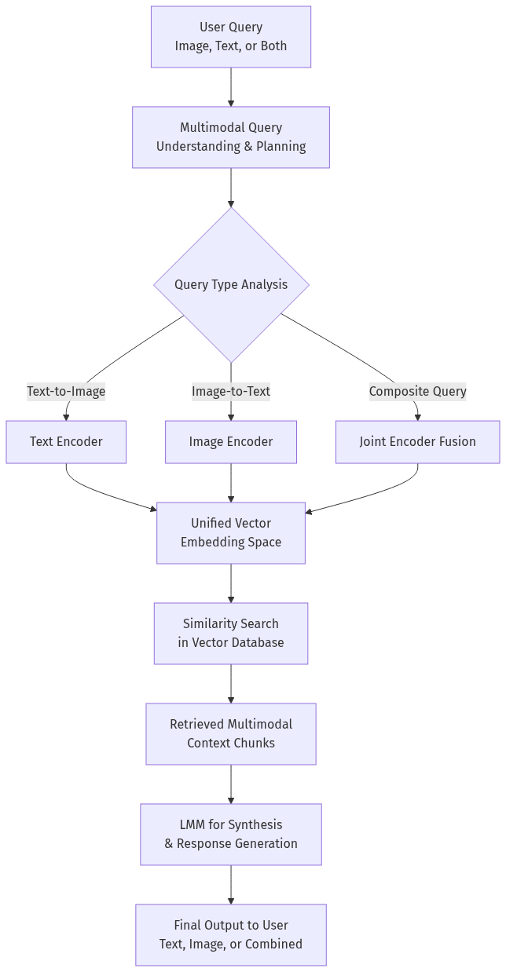
Figure 13. Flowchart (Source: Generated Diagram)
Synthesizing the findings on user value, market forces, and technical feasibility, a clear product implementation pathway emerges for lifestyle service platforms. The immediate priority should be the integration of robust cross-modal retrieval for core discovery scenarios, such as searching for products, venues, or styles using an image or a detailed visual description. This directly enhances decision efficiency. Subsequently, investment should flow into deepening intent understanding by leveraging LMMs as rerankers or reasoning engines to interpret complex, multi-attribute queries common in service selection (e.g., "a restaurant with a patio good for sunset views and group dinners"). The ultimate goal is the development of adaptive, real-time mRAG systems that can provide proactive, context-aware support by continuously integrating user feedback and dynamic external information [Arxiv, 2025].
In conclusion, image-text multimodal AI search is not merely an incremental improvement but a foundational upgrade to digital discovery interfaces. Its core value in enhancing user decision-making efficiency and experiential richness is unequivocal, supported by a compelling market trajectory and a rapidly maturing technical ecosystem. For lifestyle service platforms, the strategic path forward involves a phased adoption: starting with scalable cross-modal retrieval, advancing to LMM-enhanced intent understanding, and ultimately aspiring to build proactive, adaptive search assistants. The organizations that successfully navigate this path will not only capture greater user engagement but will also define the next standard for intelligent, intuitive, and empathetic human-computer interaction in the digital economy.

References
[1] ACM. (2020). Deep multimodal neural architecture search. Proceedings of the 28th ACM International Conference on Multimedia, 4427-4436. https://doi.org/10.1145/3394171.3413977
[2] ACM. (2021). Tell, imagine, and search: End-to-end learning for composing text and image to image retrieval. ACM Transactions on Multimedia Computing, Communications, and Applications, 17(4), Article 138. https://doi.org/10.1145/3478642
[3] ACM. (2025). A new era of online search? A large-scale study of user behavior and personal preferences during practical search tasks with generative AI versus traditional search engines. Proceedings of the CHI Conference on Human Factors in Computing Systems, 1-18. https://doi.org/10.1145/3706599.3720123
[4] ACM. (2025). Research on the factors of innovation and development of artificial intelligence technology. Proceedings of the 2025 International Conference on Artificial Intelligence and Computer Science, 45-52. https://doi.org/10.1145/3729706.3729787
[5] Arxiv. (2023). AIGC in China: Current developments and future outlook. arXiv preprint arXiv:2308.08451. https://arxiv.org/pdf/2308.08451
[6] Arxiv. (2023). A survey on image-text multimodal models. arXiv preprint arXiv:2309.15857. https://arxiv.org/abs/2309.15857
[7] Arxiv. (2024). Advanced multimodal deep learning architecture for image-text matching. arXiv preprint arXiv:2406.15306. https://arxiv.org/abs/2406.15306
[8] Arxiv. (2024). A comprehensive survey and guide to multimodal large language models in vision-language tasks. arXiv preprint arXiv:2411.06284. https://arxiv.org/html/2411.06284v1
[9] Arxiv. (2025). AI-generated content in cross-domain applications: Research trends, challenges and propositions. arXiv preprint arXiv:2509.11151. https://arxiv.org/html/2509.11151v1
[10] Arxiv. (2025). Ask in any modality: A comprehensive survey on multimodal retrieval-augmented generation. arXiv preprint arXiv:2502.08826. https://arxiv.org/html/2502.08826v2
[11] Arxiv. (2025). A survey on multimodal retrieval-augmented generation. arXiv preprint arXiv:2504.08748. https://arxiv.org/html/2504.08748v1
[12] Arxiv. (2025). A survey on retrieval and structuring augmented generation. arXiv preprint arXiv:2509.10697. https://www.arxiv.org/pdf/2509.10697
[13] Arxiv. (2025). Composed multi-modal retrieval: A survey of approaches and applications. arXiv preprint arXiv:2503.01334. https://arxiv.org/html/2503.01334v2
[14] Arxiv. (2025). Cultural encoding in large language models: The existence gap in AI-mediated brand discovery. arXiv preprint arXiv:2601.00869. https://arxiv.org/html/2601.00869v1
[15] Arxiv. (2025). Multi-RAG: A multimodal retrieval-augmented generation system for adaptive video understanding. arXiv preprint arXiv:2505.23990. https://arxiv.org/html/2505.23990v2
[16] CaraJ7. (n.d.). GitHub - CaraJ7/MMSearch: [ICLR 2025] The first multimodal search engine. Retrieved from https://github.com/CaraJ7/MMSearch
[17] Coherent Market Insights. (2032). Multimodal AI market trends, share and forecast, 2025-2032. Retrieved from https://www.coherentmarketinsights.com/industry-reports/multimodal-ai-market
[18] CSDN Blog. (n.d.). 多模态搜索算法详解：从文本到图像的智能查询 [Detailed explanation of multimodal search algorithms: Intelligent queries from text to images]. Retrieved from https://blog.csdn.net/2501_91930600/article/details/148855010
[19] Data Bridge Market Research. (n.d.). Multimodal AI market - Global market size, share, and trends analysis. Retrieved from https://www.databridgemarketresearch.com/reports/global-multimodal-ai-market
[20] Emergent Mind. (2025). mRAG: Multimodal retrieval-augmented generation. Retrieved from https://www.emergentmind.com/topics/multimodal-retrieval-augmented-generation-mrag
[21] Emergent Mind. (2025). Multi-modal retrieval-augmented generation. Retrieved from https://www.emergentmind.com/topics/multi-modal-retrieval-augmented-generation-mmrag
[22] Fortune Business Insights. (2026). Artificial intelligence [AI] market size, growth & trends by 2034. Retrieved from https://www.fortunebusinessinsights.com/industry-reports/artificial-intelligence-market-100114
[23] GENIUS. (2025). GENIUS: A generative framework for universal multimodal search. arXiv preprint arXiv:2503.19868. https://arxiv.org/abs/2503.19868
[24] GM Insights. (2025). Multimodal AI market size & share, statistics report 2025-2034. Retrieved from https://www.gminsights.com/industry-analysis/multimodal-ai-market
[25] Google Cloud Blog. (n.d.). Multimodal generative AI search. Retrieved from https://cloud.google.com/blog/products/ai-machine-learning/multimodal-generative-ai-search
[26] Grand View Research. (2030). Multimodal AI market size and share | Industry report, 2030. Retrieved from https://www.grandviewresearch.com/industry-analysis/multimodal-artificial-intelligence-ai-market-report
[27] InfoQ. (2025). Bridging modalities: Multimodal RAG for advanced information retrieval. Retrieved from https://www.infoq.com/articles/multimodal-rag-advanced-information-retrieval/
[28] INONX AI. (n.d.). Practical AI multimodal search systems that work. Retrieved from https://inonx.com/practical-ai-multimodal-search-systems-that-work/
[29] Lumar. (n.d.). The changing search landscape: AI, multimodal, & social search in 2025. Retrieved from https://www.lumar.io/blog/industry-news/changing-search-landscape-ai-multimodal-and-social-search/
[30] Market Research Future. (2035). Multimodal AI market size | Industry report, 2025-2035. Retrieved from https://www.marketresearchfuture.com/reports/multimodal-ai-market-22520
[31] MarketsandMarkets. (n.d.). Artificial intelligence market size, share, growth, latest trends. Retrieved from https://www.marketsandmarkets.com/Market-Reports/artificial-intelligence-market-74851580.html
[32] McKinsey. (2025). The state of AI: Global survey 2025. Retrieved from https://www.mckinsey.com/capabilities/quantumblack/our-insights/the-state-of-ai
[33] McKinsey. (2025). What is multimodal AI? Retrieved from https://www.mckinsey.com/featured-insights/mckinsey-explainers/what-is-multimodal-ai
[34] MDPI. (2025). Retrieval-augmented generation to generate knowledge assets and creation of action drivers. Applied Sciences, 15(11), 6247. https://doi.org/10.3390/app15116247
[35] Medium. (n.d.). Multimodal AI search: Transforming business intelligence. Retrieved from https://medium.com/accredian/multimodal-ai-search-transforming-business-intelligence-c119927fb6e3
[36] Microsoft Learn. (n.d.). Multimodal search concepts and guidance - Azure AI Search. Retrieved from https://learn.microsoft.com/en-us/azure/search/multimodal-search-overview
[37] Microsoft Learn. (n.d.). 多模式搜尋概念和指引 - Azure AI Search [Multimodal search concepts and guidance - Azure AI Search]. Retrieved from https://learn.microsoft.com/zh-tw/azure/search/multimodal-search-overview
[38] Microsoft Tech Community. (n.d.). From diagrams to dialogue: Introducing new multimodal functionality in Azure AI Search. Retrieved from https://techcommunity.microsoft.com/blog/azure-ai-foundry-blog/from-diagrams-to-dialogue-introducing-new-multimodal-functionality-in-azure-ai-search/4413968
[39] Milvus Blog. (n.d.). Multimodal semantic search with images and text. Retrieved from https://milvus.io/blog/multimodal-semantic-search-with-images-and-text.md
[40] Milvus.org.cn. (n.d.). 多模态图文搜索是如何工作的？ - Ai快速参考 [How does multimodal image-text search work? - AI quick reference]. Retrieved from https://milvus.org.cn/ai-quick-reference/how-does-multimodal-imagetext-search-work
[41] OpenSearch.org. (n.d.). Multimodal search: Searching with semantic and visual understanding. Retrieved from https://opensearch.org/blog/multimodal-semantic-search/
[42] Oracle. (n.d.). Candidate experience generative AI - Job fit. Retrieved from https://docs.oracle.com/en/cloud/saas/readiness/hcm/24a/recr-24a/24A-recruiting-wn-f30398.htm
[43] Oracle. (n.d.). DBMS_VECTOR_CHAIN - Oracle Help Center. Retrieved from https://docs.oracle.com/en/database/oracle/oracle-database/23/arpls/dbms_vector_chain1.html
[44] Oracle. (n.d.). Enhanced Redwood person search. Retrieved from https://docs.oracle.com/en/cloud/saas/readiness/hcm/25a/hure-25a/25A-hr-wn-f36158.htm
[45] Oracle. (n.d.). Get started with Oracle NetSuite Analytics Warehouse. Retrieved from https://docs.oracle.com/en/cloud/saas/netsuite-analytics-warehouse/nsawa/get-started-oracle-netsuite-analytics-warehouse.html
[46] Oracle. (n.d.). Overview of Oracle AI Vector Search. Retrieved from https://docs.oracle.com/en/database/oracle/oracle-database/23/vecse/overview-ai-vector-search.html
[47] Oracle. (n.d.). Oracle AI Vector Search user's guide. Retrieved from https://docs.oracle.com/en/database/oracle/oracle-database/23/vecse/generate-vector-embeddings-node.html
[48] Oracle. (n.d.). Redwood experience for candidate list page. Retrieved from https://docs.oracle.com/en/cloud/saas/readiness/hcm/24c/recr-24c/24C-recruiting-wn-f33549.htm
[49] Oracle. (n.d.). Use AI Assistant with Oracle Cloud Native Environment. Retrieved from https://docs.oracle.com/en/learn/ocne2-ai-assistant/
[50] Oracle. (2024). Implement retrieval augmented generation by using Oracle Integration. Retrieved from https://docs.oracle.com/en/solutions/implement-rag-oci/index.html
[51] Oracle. (2026). Using Oracle GoldenGate Maximum Availability Hub on Oracle Cloud. Retrieved from https://docs.oracle.com/en/database/goldengate/core/26/ggmah/
[52] Precedence Research. (2025). Artificial intelligence (AI) market size to hit USD 3,680.47 Bn by 2034. Retrieved from https://www.precedenceresearch.com/artificial-intelligence-market
[53] ResearchGate. (n.d.). Evaluation benchmarks for large multimodal models. Retrieved from https://www.researchgate.net/profile/Sheed-Iseal/publication/386162850_Evaluation_Benchmarks_for_Large_Multimodal_Models/links/6746e50b359dcb4d9d3b9b9f/Evaluation-Benchmarks-for-Large-Multimodal-Models.pdf
[54] ResearchGate. (n.d.). The evolution of multimodal AI: Creating new possibilities. Retrieved from https://www.researchgate.net/publication/393617268_The_Evolution_of_Multimodal_AI_Creating_New_Possibilities/fulltext/687156fadd6b84447df7f056/The-Evolution-of-Multimodal-AI-Creating-New-Possibilities.pdf
[55] SIGMOD Record. (2025). Retrieval-augmented generation (RAG): What is there. Retrieved from https://sigmodrecord.org/?smd_process_download=1&download_id=14333
[56] Springer. (n.d.). Multi-text guidance is important: Multi-modality image. Retrieved from https://link.springer.com/article/10.1007/s11263-025-02409-3
[57] Springer Nature. (2022). AI technologies and motives for AI adoption by countries and firms: A systematic literature review. In Advances in Information and Communication (pp. 45-62). Springer. https://doi.org/10.1007/978-3-030-92916-9_4
[58] Springer Nature. (2025). A survey of multimodal composite editing and retrieval. Journal of Visual Communication and Image Representation, 98, 104321. https://doi.org/10.1007/s44267-025-00086-x
[59] Springer Nature. (2025). A systematic review of multi-modal large language models on domain-specific applications. Artificial Intelligence Review, 58(4), 1-45. https://doi.org/10.1007/s10462-025-11398-1
[60] Statista. (2026). Artificial intelligence - Worldwide | Market forecast. Retrieved from https://www.statista.com/outlook/tmo/artificial-intelligence/worldwide
[61] Stellarix. (n.d.). Multimodal AI: Bridging technologies, challenges, and future. Retrieved from https://stellarix.com/insights/articles/multimodal-ai-bridging-technologies-challenges-and-future/
[62] Tencent Cloud. (n.d.). 【多模态 Ai】从跨模态学习到生成革命：文本、图像与音频的深度交融 [Multimodal AI: From cross-modal learning to generative revolution: Deep integration of text, images, and audio]. Retrieved from https://cloud.tencent.com/developer/article/2490078
[63] TileDB. (2026). What is multimodal AI: A complete 2026 guide. Retrieved from https://www.tiledb.com/blog/multimodal-ai-guide
[64] Towards Data Science. (n.d.). Multimodal AI search for business applications. Retrieved from https://towardsdatascience.com/multimodal-ai-search-for-business-applications-65356d011009/
[65] Zhihu. (n.d.). 图像识别+多模态：一文带你玩转最新算法! [Image recognition + multimodal: One article to master the latest algorithms!]. Retrieved from https://zhuanlan.zhihu.com/p/27893517783

This report was generated by Requirements Analysis Agent Assistant (RAAA)

