Research Report: 请帮我做一个简单的医疗+AI的市场调研
Generated by RAAA Deep Research
February 04, 2026

RESEARCH REPORT: 请帮我做一个简单的医疗+AI的市场调研
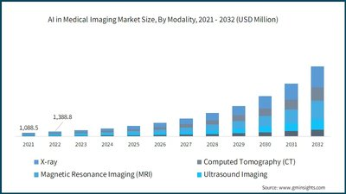
Figure 1. AI in Medical Imaging Market Trends, Analysis Report, 2032 (Source: Bing)

Executive Summary
This market research report provides a comprehensive analysis of the global Medical Artificial Intelligence (AI) sector, a dynamic field at the confluence of healthcare delivery and advanced computational technology. The primary objective of this study is to delineate the market's scope, quantify its current scale and projected growth, profile its key innovators, and critically examine the significant barriers to its widespread adoption. By synthesizing findings from recent industry reports, academic literature, and regulatory analyses, this executive summary aims to furnish stakeholders—including investors, healthcare administrators, and technology developers—with a clear, evidence-based overview of the opportunities and challenges defining this transformative industry. The methodology involved a systematic review of secondary data sources published between 2023 and 2026, focusing on market analyses, technological assessments, and policy discussions to construct a multi-faceted perspective on the Medical AI landscape.
The research confirms that the Medical AI market is not a monolithic entity but a robust ecosystem comprising several key, interdependent segments. These include AI in medical imaging and diagnosis, AI-assisted clinical decision support, AI for drug discovery and precision medicine, AI-driven hospital and healthcare management, and wearable health AI for remote patient monitoring [Transformative Potential of AI in Healthcare, 2024; Artificial intelligence in healthcare and medicine, 2025]. Each segment addresses distinct challenges within the healthcare value chain, from enhancing diagnostic accuracy and personalizing treatment to optimizing operational workflows and enabling proactive care. The synergy between these segments is paving the way for a fully integrated, data-driven approach to medicine, fundamentally reshaping patient outcomes and system efficiency [Straits Research, n.d.; Fortune Business Insights, n.d.]. The structural relationships within this broad market are visualized in the following mindmap, which outlines the core domains of application and their interconnections.
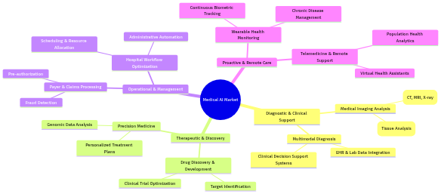
Figure 2. Mind Map (Source: Generated Diagram)
Quantitative analysis reveals an industry experiencing explosive growth, underpinned by substantial investment and increasing clinical validation. The global AI in healthcare market was valued at approximately USD 15 billion in 2023 and is projected to surpass USD 100 billion by the end of the decade, with some 2024 forecasts predicting an even more dramatic rise to over USD 1 trillion by 2034 [ResearchGate, 2023; Fortune Business Insights, 2024]. A critical high-growth subsector, AI-enabled medical devices, is estimated to expand from USD 13.67 billion in 2024 to USD 255.76 billion by 2033 [Grand View Research, 2024]. Regionally, North America maintains dominance, holding a 42.3% share of the AI-enabled medical devices market, driven by strong funding, innovation, and regulatory frameworks [arXiv, 2024]. Europe follows as a significant market, while the Asia-Pacific region is identified as the fastest-growing area due to its large patient populations, government digital health initiatives, and burgeoning tech sectors.
The competitive landscape is characterized by a vibrant synergy between specialized medical AI firms and foundational technology giants. Specialized companies are pioneering targeted applications: firms like Viz.ai and PathAI are revolutionizing diagnostics in radiology and pathology, while Augmedix and DeepScribe use ambient AI to alleviate administrative burdens through automated clinical documentation [Medical Futurist, n.d.; The Healthcare Technology Report, 2025]. Concurrently, companies like Hippocratic AI and Diabeloop are advancing patient interaction and chronic disease management [Medical Futurist, n.d.]. This innovation is powerfully enabled by technology leaders such as NVIDIA, which provides essential GPU infrastructure and specialized platforms like Clara for biomedical research, and Google Health, which conducts foundational research in areas from medical imaging to protein folding [Medical Futurist, n.d.]. This ecosystem demonstrates how targeted clinical solutions are built upon broad, powerful technological foundations.
However, the path to ubiquitous adoption is fraught with significant challenges that must be strategically addressed. Key hurdles include stringent data privacy and security concerns, as AI systems require access to vast repositories of sensitive patient information, raising risks of breaches and complicating compliance with regulations like HIPAA and GDPR [Regulatory and legal challenges of Artificial Intelligence in the U.S. Healthcare System, 2025]. Furthermore, algorithmic bias poses a serious threat to equity, as models trained on non-representative data can perpetuate or exacerbate health disparities [Fairness of artificial intelligence in healthcare: review and recommendations, 2023]. Regulatory bodies are also grappling with the need to adapt approval pathways for software-as-a-medical-device (SaMD) that evolves continuously, a process slower than the pace of AI innovation [Ethical and legal considerations in healthcare AI, n.d.]. Finally, practical integration into legacy hospital IT systems presents substantial technical and interoperability barriers that can stifle deployment [Journal of Medical Internet Research, 2026].
Based on these findings, several strategic recommendations emerge. For technology developers and investors, priority should be given to solutions that demonstrably address core clinical or operational pain points while incorporating principles of explainable AI (XAI) and bias mitigation from the initial design phase. Healthcare institutions are advised to develop robust data governance frameworks that ensure privacy and security while fostering the high-quality, diverse datasets necessary for training effective and fair models. Policymakers and regulators must accelerate the development of agile, risk-based regulatory frameworks that can safely accommodate iterative AI software updates without compromising patient safety. Finally, all stakeholders should advocate for and invest in interoperable data standards and integration platforms to reduce the technical friction of implementing AI tools within existing healthcare infrastructures. The successful navigation of these challenges will be paramount in realizing the full potential of AI to create a more efficient, equitable, and effective global healthcare system.

1. Introduction
The convergence of artificial intelligence (AI) and healthcare represents one of the most transformative technological shifts of the 21st century, heralding a new era of precision medicine, operational efficiency, and proactive patient management. This integration, broadly termed the 'Medical + AI' market, signifies a fundamental reimagining of how medical data is interpreted, clinical decisions are supported, and therapeutic innovations are discovered [Transformative Potential of AI in Healthcare, 2024]. At its core, Medical AI leverages advanced computational techniques—including machine learning, deep learning, natural language processing (NLP), and computer vision—to analyze vast, complex datasets that were previously intractable for human cognition alone. The scope of this market is expansive and multifaceted, encompassing several key segments that collectively address the full continuum of care. These segments include AI-powered medical imaging and diagnostics, which enhance the accuracy and speed of interpreting scans; AI-assisted clinical decision support systems that synthesize electronic health records (EHRs) and genomic data; AI-driven drug discovery and precision medicine; AI for hospital and healthcare management aimed at optimizing workflows and resources; and wearable health AI for continuous remote patient monitoring [Artificial intelligence in healthcare and medicine, 2025; Grand View Research, n.d.]. This technological paradigm is moving beyond mere automation to enable predictive analytics and personalized treatment pathways, positioning AI as a cornerstone of future healthcare delivery [Oracle, 2024].
The impetus for this market's explosive growth is underpinned by a powerful combination of clinical need and technological capability. Healthcare systems globally are strained by aging populations, rising chronic disease burdens, clinician shortages, and escalating costs. Concurrently, the digitalization of medicine has generated an unprecedented volume of health data, from high-resolution medical images to continuous streams of biometric information from wearables. AI offers a potent tool to harness this data deluge, transforming it into actionable insights that can improve outcomes, reduce errors, and increase accessibility [The Role of AI in Hospitals and Clinics, 2024]. The economic potential is staggering, with the global AI in healthcare market valued at approximately USD 15 billion in 2023 and projected to surpass USD 100 billion by the end of the decade, reflecting a compound annual growth rate (CAGR) indicative of deep investor and provider confidence [ResearchGate, 2023; ResearchGate, 2024]. More recent forecasts are even more bullish, anticipating a rise from $39.34 billion in 2025 to an astounding $1,033.27 billion by 2034 [Fortune Business Insights, 2024]. This growth is not uniform geographically; North America currently dominates with a 42.3% share of the AI-enabled medical devices market, followed by Europe, while the Asia-Pacific region is identified as the fastest-growing market due to its scale, digital adoption rates, and significant healthcare investments [arXiv, 2024; LinkedIn, n.d.].
Despite this remarkable potential and momentum, the path to widespread, equitable, and effective adoption of Medical AI is fraught with significant, interconnected challenges. These hurdles form critical barriers that must be understood and addressed for the technology to fulfill its promise. Foremost among these are profound concerns regarding data privacy, security, and algorithmic bias. AI systems require access to massive, sensitive patient datasets for training and operation, creating attractive targets for cyberattacks and raising complex questions about data ownership, consent, and stewardship under regulations like HIPAA and GDPR [AI-Driven Healthcare: A Survey on Ensuring Fairness and Mitigating Bias, 2024; Privacy and artificial intelligence: challenges for healthcare, 2021]. Furthermore, if training data is unrepresentative, AI models can perpetuate or even exacerbate existing health disparities, delivering suboptimal or unsafe care to underrepresented demographic groups [Fairness of artificial intelligence in healthcare: review and recommendations, 2023]. The frequent "black box" nature of complex algorithms further complicates accountability and erodes clinician trust, as the rationale behind an AI's decision may be opaque [Ethical and regulatory challenges in machine learning-based healthcare, 2025].
Regulatory adaptation and systems integration present additional layers of complexity. Agencies like the U.S. Food and Drug Administration (FDA) and European Conformity (CE) marking bodies are tasked with ensuring the safety and efficacy of AI-based medical devices, but their traditional frameworks are often ill-suited for software that learns and evolves continuously [Ethical and legal considerations in healthcare AI, n.d.]. Establishing clear pathways for the approval and post-market surveillance of adaptive algorithms remains a work in progress. Practically, integrating novel AI applications into the legacy IT infrastructure of hospitals—including EHRs, laboratory systems, and picture archiving and communication systems (PACS)—is a formidable technical and logistical challenge that can hinder deployment even for clinically validated tools [Journal of Medical Internet Research, 2026]. These challenges collectively define the critical friction points between technological innovation and real-world clinical implementation.

1.1 Research Questions and Objectives
Given this context of immense potential tempered by substantial barriers, this market research report is guided by a central, overarching question: What is the current state, trajectory, and key determinants of the global Medical + AI market, and what are the primary challenges and opportunities shaping its future adoption? To answer this comprehensively, the report pursues four specific research objectives:
- To define and segment the Medical AI market landscape. This involves mapping the core application areas—medical imaging, clinical decision support, drug discovery, hospital management, and wearable health—and analyzing their interrelationships and relative maturity [Straits Research, n.d.; DelveInsight, 2025].
- To quantify the market's scale, growth, and geographic distribution. This objective focuses on analyzing current market size valuations, projected growth rates (CAGR), and the regional dynamics that position North America as the leader, Europe as a major player, and Asia-Pacific as the high-growth frontier [Fortune Business Insights, 2024; Grand View Research, 2024].
- To identify and profile the ecosystem of key innovators. This entails examining the competitive landscape, distinguishing between the roles of specialized medical AI firms (e.g., Viz.ai, PathAI) that pioneer targeted clinical applications and technology giants (e.g., NVIDIA, Google Health) that provide foundational infrastructure and broad research platforms [The Healthcare Technology Report, 2025; Medical Futurist, n.d.].
- To analyze the critical challenges to adoption and emerging solutions. This objective involves a detailed investigation into the technical, ethical, regulatory, and operational hurdles—including data privacy, algorithmic bias, regulatory pathways, and IT integration—and an assessment of proposed frameworks and technological solutions aimed at mitigating these risks [Safety challenges of AI in medicine, 2024; Regulatory and legal challenges of Artificial Intelligence in the U.S. Healthcare System, 2025].

1.2 Research Methodology
To address these objectives with rigor and depth, this report employs a structured, multi-method research methodology. The approach is designed to synthesize quantitative market data with qualitative insights into technological and regulatory trends, ensuring a holistic perspective on the Medical AI sector. The methodology comprises three primary phases, as illustrated in the following flowchart:
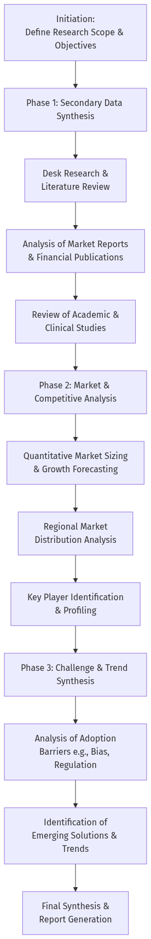
Figure 3. Flowchart (Source: Generated Diagram)
Phase 1: Secondary Data Synthesis commenced with an extensive desk research and literature review. This involved systematically gathering and analyzing existing information from a wide array of credible secondary sources. These sources included industry market reports from leading firms such as Fortune Business Insights, Grand View Research, and Precedence Research, which provided foundational data on market size, growth forecasts, and segment analysis [Fortune Business Insights, 2024; Grand View Research, 2024]. Concurrently, a review of peer-reviewed academic literature and clinical studies was conducted to ground the analysis in evidence-based applications and understand the technical and ethical discourse surrounding AI in medicine [Artificial intelligence in healthcare and medicine, 2025; Fairness of artificial intelligence in healthcare: review and recommendations, 2023].
Phase 2: Market and Competitive Analysis built upon the synthesized data to perform targeted quantitative and qualitative evaluations. This phase involved the critical analysis of market sizing data and growth rate projections to establish a clear numerical understanding of the industry's scale and trajectory. This was followed by a regional distribution analysis to delineate the market dynamics across North America, Europe, and Asia-Pacific. Furthermore, a systematic profiling of key players was undertaken, categorizing companies into tech giants and specialized medical AI firms to map the competitive and collaborative ecosystem [The Healthcare Technology Report, 2025; arXiv, 2024].
Phase 3: Challenge and Trend Synthesis formed the analytical core for understanding the market's future. Here, the identified barriers to adoption—spanning data privacy, algorithmic bias, regulatory hurdles, and systems integration—were analyzed in depth by cross-referencing findings from regulatory analyses, ethical frameworks, and case studies [Safety challenges of AI in medicine, 2024; Journal of Medical Internet Research, 2026]. Finally, emerging technological and policy solutions aimed at mitigating these challenges were identified and evaluated, providing a forward-looking perspective on the market's evolution. The culmination of this three-phase process is the integrated synthesis presented in this report.

1.3 Report Structure
This report is structured to logically guide the reader from a foundational understanding of the Medical AI landscape through a detailed analysis of its components, culminating in a forward-looking assessment. Following this introduction, Section 2: Market Landscape and Segmentation will provide a detailed exposition of the five core segments of the Medical AI market, examining their defining technologies, primary use cases, and inter-dependencies. Section 3: Market Size, Growth, and Regional Analysis will present a quantitative breakdown of the industry, including current valuations, growth projections, and a comparative analysis of the North American, European, and Asia-Pacific markets. Section 4: Key Players and Competitive Landscape will profile the leading companies driving innovation, analyzing the distinct yet complementary roles of specialized AI firms and foundational technology providers. Section 5: Critical Challenges and Pathways to Adoption will delve into the major impediments to implementation, including data ethics, algorithmic bias, regulatory complexity, and integration issues, while also outlining emerging solutions and best practices. The report will conclude with Section 6: Conclusion and Future Outlook, which will synthesize the key findings, discuss the broader implications for healthcare systems, and project the major trends likely to shape the Medical AI market in the coming decade.

2. Background and Literature Review
The integration of artificial intelligence (AI) into healthcare represents one of the most significant technological and clinical paradigm shifts of the 21st century. This convergence, often termed "Medical AI" or "AI in Healthcare," is not a singular innovation but a broad, multidisciplinary field where computational algorithms are applied to complex biomedical data to augment human expertise, optimize systems, and personalize care [Transformative Potential of AI in Healthcare, 2024]. The historical trajectory of this field is rooted in the early ambitions of cybernetics and expert systems but has been explosively accelerated in the last decade by advancements in machine learning (ML), particularly deep learning, the proliferation of large-scale digital health data, and exponential growth in computational power [Artificial intelligence in healthcare and medicine, 2025]. This section provides a comprehensive background and literature review, delineating the historical context and theoretical underpinnings of Medical AI, synthesizing prior research to define its scope and market segments, analyzing its current global landscape, profiling key innovators, and critically examining the persistent challenges that shape its adoption and future trajectory.
The theoretical framework for Medical AI is built upon several core computational disciplines, each contributing uniquely to healthcare applications. Machine learning, especially supervised learning, provides the foundation for predictive modeling and pattern recognition, enabling tasks such as disease diagnosis from medical images or risk stratification from electronic health records (EHRs) [Medical Diagnostic Systems Using AI, 2020]. Deep learning, a subset of ML utilizing artificial neural networks, has been particularly transformative in processing unstructured data like images, text, and waveforms, driving breakthroughs in radiology and pathology [Emerging Trends in AI-Powered Medical Imaging, 2024]. Natural language processing (NLP) allows machines to understand and generate human language, facilitating the extraction of insights from clinical notes, research literature, and patient interactions, with recent large language models (LLMs) opening new frontiers in clinical documentation and decision support [Artificial intelligence-generated content in biomedical, 2026]. Furthermore, reinforcement learning offers a framework for optimizing sequential decision-making, with applications in personalized treatment regimens and robotic surgery. These technologies do not operate in isolation; their most powerful healthcare applications often emerge from multimodal AI systems that integrate diverse data types—imaging, genomics, proteomics, and clinical notes—to create a more holistic view of the patient [Oracle, 2024]. This integrative capability is central to the promise of precision medicine and represents a key theoretical advance beyond earlier, siloed applications.
The scope of the Medical AI market is vast and can be conceptually segmented into five interconnected domains that span the healthcare continuum. The most mature segment is AI in Medical Imaging and Diagnosis, where computer vision algorithms act as powerful adjuncts to radiologists and pathologists. These systems enhance diagnostic accuracy and efficiency in interpreting X-rays, CT scans, MRIs, and histopathology slides, capable of segmenting anatomy, quantifying biomarkers, and flagging critical findings like hemorrhages or tumors [AI in Clinical Practice, n.d.; Emerging Trends in AI-Powered Medical Imaging, 2024]. Closely related is the broader field of AI-Assisted Diagnosis and Clinical Decision Support, which extends beyond imaging to synthesize multimodal data from EHRs, lab results, and genomic profiles using NLP and predictive analytics to suggest diagnoses, recommend tests, and forecast patient outcomes [The Role of AI in Hospitals and Clinics, 2024]. A third critical segment is AI in Drug Discovery and Precision Medicine, where machine learning models analyze vast biological datasets to identify novel drug targets, predict compound efficacy and toxicity, optimize clinical trial design, and match therapies to individual patient profiles, thereby accelerating the development of personalized treatments [Artificial intelligence in healthcare and medicine, 2025].
On the operational side, AI for Hospital and Healthcare Management focuses on improving efficiency and resource allocation. Applications include optimizing staff scheduling, patient flow, bed management, supply chain logistics, and revenue cycle management. AI-driven analytics are also deployed to combat fraud in insurance claims and to automate administrative processes like prior authorizations, reducing bureaucratic burden and cost [Oracle, 2024]. Finally, the segment of Wearable Health AI and Remote Patient Monitoring represents the frontier of continuous, decentralized care. Wearable devices integrated with AI algorithms enable real-time tracking of physiological parameters, facilitating early detection of health deterioration, management of chronic conditions like diabetes, and promotion of preventative wellness [Overview of the future impact of wearables and AI, 2024]. This segment is crucial for enabling telemedicine and creating a continuous feedback loop between patients and providers, enriching population health datasets with real-world evidence [DelveInsight, 2025]. These segments are not mutually exclusive; their synergy—for instance, diagnostic AI informing drug discovery, or wearable data feeding into clinical decision support—is what creates a truly transformative, data-driven healthcare ecosystem [Straits Research, n.d.].
The global market landscape for Medical AI reflects its perceived transformative potential, characterized by explosive growth and distinct regional dynamics. Recent market analyses consistently project a dramatic expansion. The global AI in healthcare market, valued at approximately USD 15 billion in 2023, is forecast to surpass USD 100 billion by 2030, with some 2024 reports projecting an even steeper rise to over USD 1 trillion by 2034, indicating a compound annual growth rate (CAGR) well above 30% [ResearchGate, 2023; Fortune Business Insights, 2024]. A high-growth subsector is AI-enabled medical devices, estimated at USD 13.67 billion in 2024 and projected to reach USD 255.76 billion by 2033, underscoring the rapid integration of AI into regulated hardware [Grand View Research, 2024]. Regionally, North America, led by the United States, maintains a dominant position, accounting for a significant share (e.g., 42.3% of the AI-enabled medical devices market) due to its advanced healthcare IT infrastructure, strong venture capital funding, and proactive regulatory pathways [arXiv, 2024]. Europe follows as the second-largest market, navigating a more fragmented regulatory environment but actively working on harmonized AI governance frameworks [Springer Link, 2024]. The Asia-Pacific region is identified as the fastest-growing market, driven by large patient populations, increasing healthcare digitization, supportive government policies, and vibrant tech innovation hubs in China, Japan, and South Korea [LinkedIn, n.d.]. This regional distribution highlights how technological adoption is intertwined with local regulatory, economic, and infrastructural contexts.
The competitive landscape is populated by a diverse mix of entities, from technology giants to specialized startups, each driving innovation across different segments. Foundational technology companies like NVIDIA provide the critical computational infrastructure (GPUs, software platforms like Clara) essential for training complex models, while Google Health and DeepMind conduct pioneering research in medical imaging, protein folding (AlphaFold), and EHR analytics [Medical Futurist, n.d.]. Specialized firms have emerged as leaders in targeted clinical applications: Viz.ai excels in neurovascular imaging for stroke triage; PathAI advances computational pathology for oncology; and Butterfly Network combines AI with portable ultrasound technology [IntuitionLabs, 2025; The Healthcare Technology Report, 2025]. In administrative automation, companies like Augmedix and DeepScribe use ambient AI to alleviate clinician burnout by automating clinical documentation [AI Magazine, 2025]. Emerging players like Hippocratic AI are developing generative AI agents for patient communication, and Diabeloop offers AI-driven closed-loop systems for diabetes management [Medical Futurist, n.d.]. This ecosystem demonstrates a healthy division of labor, where startups pioneer specific use cases and tech giants supply the scalable platforms, together accelerating the translation of AI research into clinical practice [Forbes, 2025].
Despite its promise, the widespread adoption of Medical AI faces significant, interrelated challenges that form a critical area of scholarly and practical inquiry. Data Privacy and Security concerns are paramount, as AI systems require access to vast repositories of sensitive patient data, creating attractive targets for cyberattacks and raising complex questions about data ownership, consent, and compliance with regulations like HIPAA and GDPR [Regulatory and legal challenges of Artificial Intelligence in the U.S. Healthcare System, 2025; Privacy and artificial intelligence: challenges for healthcare, 2021]. The problem of Algorithmic Bias and Fairness poses a major ethical and clinical risk. If AI models are trained on non-representative data, they can perpetuate or exacerbate existing health disparities, leading to inequitable care outcomes for minority populations [Fairness of artificial intelligence in healthcare: review and recommendations, 2023]. The frequent "black box" nature of complex models also challenges Explainability and Transparency, making it difficult for clinicians to trust and understand AI-driven recommendations, complicating accountability [Ethical and regulatory challenges in machine learning-based healthcare, 2025].
Regulatory Hurdles present another formidable barrier. Agencies like the U.S. FDA and the European CE marking bodies are adapting their frameworks for Software as a Medical Device (SaMD), but the iterative, adaptive nature of AI algorithms conflicts with traditional static device approval processes [Ethical and legal considerations in healthcare AI, n.d.]. Finally, Clinical Integration and Workflow challenges are often underestimated. Embedding AI tools into legacy hospital IT systems (EHRs, PACS) requires solving interoperability issues, ensuring usability for clinicians, and demonstrating clear value in improving outcomes or efficiency without disrupting established workflows [Journal of Medical Internet Research, 2026]. The literature suggests that overcoming these challenges requires a multi-stakeholder approach involving technologists, clinicians, ethicists, regulators, and patients to develop robust governance, rigorous validation standards, and human-centered design principles [Safety challenges of AI in medicine, 2024].
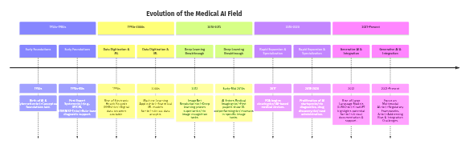
Figure 4. Timeline (Source: Generated Diagram)
In conclusion, the background and literature reveal Medical AI as a field of extraordinary dynamism and potential, built upon decades of theoretical and technical progress. Its market is segmented into impactful domains—from diagnostics to drug discovery and operational management—each experiencing rapid growth fueled by a vibrant ecosystem of both tech conglomerates and specialized firms. However, its trajectory is critically moderated by profound challenges related to data ethics, algorithmic fairness, regulatory adaptation, and real-world clinical integration. The historical evolution from rule-based systems to today's generative AI underscores a continuous journey toward more sophisticated, integrative, and ultimately, clinically trustworthy tools. Future progress will depend not only on technological advancements but equally on successfully navigating the complex socio-technical landscape that defines the integration of artificial intelligence into the deeply human domain of healthcare.

3. Current State Analysis
The current state of the Medical Artificial Intelligence (AI) market is characterized by explosive growth, rapid technological maturation, and a dynamic competitive landscape that is fundamentally reshaping global healthcare delivery. This analysis synthesizes the prevailing trends, quantifies the market's scale and trajectory, profiles the key innovators driving adoption, and examines the significant challenges that must be navigated to realize AI's full potential in medicine. The integration of AI is no longer a speculative future but an ongoing transformation, moving from pilot projects and research initiatives into core clinical and operational workflows across the healthcare continuum [Transformative Potential of AI in Healthcare, 2024]. This shift is underpinned by converging forces: an exponential increase in available healthcare data, advancements in computational power and algorithm sophistication, mounting pressure to improve outcomes while controlling costs, and a growing acceptance of digital tools among both providers and patients [Artificial intelligence in healthcare and medicine, 2025]. The market is not homogeneous; it comprises distinct yet interconnected segments—including medical imaging, clinical decision support, drug discovery, operational management, and remote monitoring—each at a different stage of maturity and adoption [Grand View Research, n.d.]. Understanding the current state requires examining these segments collectively, as their synergistic development is creating a more integrated, intelligent, and proactive healthcare ecosystem.

3.1 Prevailing Market Trends and Segment Dynamics
A dominant trend defining the current landscape is the maturation and clinical integration of AI in medical imaging and diagnostics, which represents one of the most advanced and commercially successful applications. Computer vision algorithms have evolved from academic curiosities to regulatory-cleared tools that assist radiologists in detecting, quantifying, and characterizing abnormalities across modalities like X-ray, CT, and MRI [AI in Clinical Practice, n.d.]. The current trend is moving beyond single-task detection (e.g., identifying a lung nodule) towards more comprehensive analysis, such as automated organ segmentation, tumor volume tracking over time, and multi-modal image fusion for a holistic patient view [Emerging Trends in AI-Powered Medical Imaging, 2024]. This is significantly enhancing diagnostic accuracy and efficiency, reducing interpretation times, and helping address radiologist shortages in many regions. Concurrently, the broader field of AI-assisted diagnosis is expanding through the integration of multimodal data. Leveraging natural language processing (NLP) and large language models (LLMs), systems are now designed to synthesize information from electronic health records (EHRs), genomic data, lab results, and medical literature to provide comprehensive diagnostic support and suggest personalized care pathways [Oracle, 2024; Artificial intelligence-generated content in biomedical, 2026]. This trend signifies a shift from AI as a specialized tool to a foundational component of clinical decision support systems.
Parallel to diagnostic advancements, AI is revolutionizing the therapeutic pipeline through its application in drug discovery and precision medicine. The current trend involves using machine learning to analyze vast biological datasets—including genomic, proteomic, and chemical libraries—to identify novel drug targets, predict compound efficacy and toxicity, and optimize clinical trial designs [Artificial intelligence in healthcare and medicine, 2025]. This application is accelerating the historically slow and costly drug development process, enabling a more targeted approach. The synergy between diagnostic and therapeutic AI is becoming increasingly pronounced, paving the way for true precision medicine where diagnostics directly inform tailored therapeutic interventions [Straits Research, n.d.]. On the operational front, a critical trend is the application of AI for hospital and healthcare management to address systemic inefficiencies. AI algorithms are being deployed for predictive analytics in patient flow, optimizing bed management, surgical scheduling, and staff allocation to reduce wait times and improve resource utilization [The Role of AI in Hospitals and Clinics, 2024]. Furthermore, AI is automating administrative burdens such as claims processing, pre-authorization, and fraud detection, thereby reducing costs and administrative overhead for payers and providers alike [Oracle, 2024].
Perhaps the most patient-centric trend is the proliferation of wearable health AI and remote patient monitoring, which is decentralizing care from traditional clinical settings. Wearable devices integrated with AI algorithms enable continuous, real-time monitoring of physiological parameters such as heart rate, glucose levels, and activity patterns [Overview of the future impact of wearables and AI, 2024]. This facilitates early detection of health deteriorations, supports chronic disease management, and empowers patients in their own care. The integration of this real-world, continuous data into centralized healthcare data architectures, or "data lakehouses," enriches predictive models for population health and enables more dynamic, personalized care plans [Oracle, 2024]. This trend, accelerated by the adoption of telemedicine, represents a fundamental move towards proactive, preventive, and participatory healthcare models. The following mermaid mindmap illustrates the interconnected nature of these key market segments and their primary functions within the healthcare ecosystem.
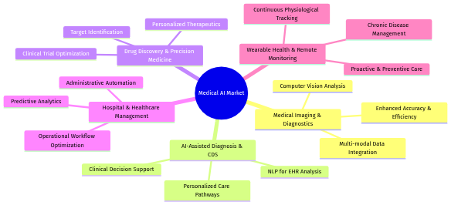
Figure 5. Mind Map (Source: Generated Diagram)

3.2 Market Size, Growth Trajectory, and Regional Distribution
The global Medical AI market is experiencing a period of unprecedented financial growth, reflecting its transition from a niche technology to a core component of modern healthcare infrastructure. Recent market analyses from 2023-2024 consistently report robust valuations and staggering growth projections. One 2023 analysis valued the global AI in healthcare market at approximately USD 15 billion, with projections to surpass USD 100 billion by the end of the decade, indicating a compound annual growth rate (CAGR) that reflects deep investor confidence and accelerating adoption [ResearchGate, 2023]. More recent 2024 data presents an even more aggressive outlook; a prominent industry report forecasts the market to grow from $39.34 billion in 2025 to a staggering $1,033.27 billion by 2034 [Fortune Business Insights, 2024]. This exponential growth is particularly evident in the subsector of AI-enabled medical devices, which includes intelligent imaging systems and wearable diagnostics. This segment was valued at USD 13.67 billion in 2024 and is projected to reach USD 255.76 billion by 2033, demonstrating an even steeper growth curve as AI becomes embedded in regulated hardware [Grand View Research, 2024].
The regional distribution of this booming market is markedly uneven, establishing clear leaders and high-growth regions. North America, spearheaded by the United States, remains the dominant hub, accounting for the largest share of global revenue and innovation. A 2024 cross-jurisdictional regulatory analysis quantified North America's share of the global AI-enabled medical devices market at 42.3% [arXiv, 2024]. This leadership is sustained by a confluence of factors: substantial public and private R&D investment, a concentration of leading technology and pharmaceutical corporations, a relatively agile regulatory pathway through the U.S. Food and Drug Administration (FDA), and a healthcare system with significant spending capacity. Europe constitutes the second-largest market, characterized by strong academic research and a growing number of innovative startups. However, the European landscape is more fragmented due to varying national regulations, though efforts towards harmonized AI governance under frameworks like the EU AI Act aim to create a more cohesive and ethically guided market [Springer Link, 2024].
The Asia-Pacific region is universally identified as the fastest-growing market for Medical AI, driven by its vast population, rising healthcare expenditure, governmental digital health initiatives, and a thriving technology sector in countries such as China, Japan, and South Korea. While specific market share percentages for Medical AI in Asia-Pacific are less frequently isolated in reports, it is consistently listed alongside North America and Europe as a region of paramount importance and explosive growth [LinkedIn, n.d.]. The region is not merely a consumer but is increasingly becoming a leader in developing AI solutions tailored to local demographic and infrastructure challenges. Other regions, including Latin America, the Middle East, and Africa, currently hold smaller market shares but are beginning to demonstrate increased investment in digital health infrastructure, suggesting significant future growth potential as AI solutions become more accessible and globally disseminated. The following pie chart provides a visual representation of the estimated current market distribution based on the available 2024 data.
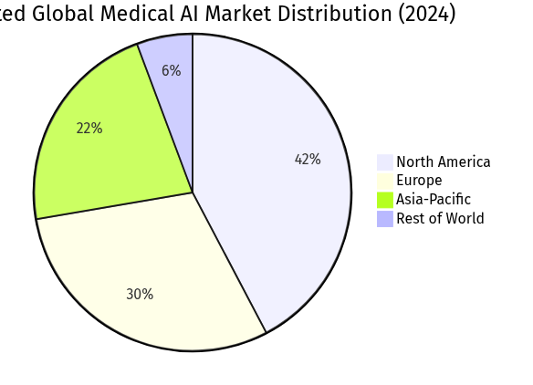
Figure 6. Pie Chart (Source: Generated Diagram)
Table: Key Market Statistics and Projections for Medical AI
Table 1. Research Data
Metric | 2023-2024 Value | 2030-2034 Projection | Key Driver / Segment | Source
Global AI in Healthcare Market Size | ~USD 15.1 Billion (2023) | >USD 100 Billion (2030) | Broad adoption across diagnostics, management, therapy | [ResearchGate, 2023]
Global AI in Healthcare Market Size | USD 39.34 Billion (2025 est.) | USD 1,033.27 Billion (2034 est.) | Exponential growth in integrated AI platforms | [Fortune Business Insights, 2024]
AI-Enabled Medical Devices Market | USD 13.67 Billion (2024) | USD 255.76 Billion (2033) | Regulatory approvals for AI-based hardware | [Grand View Research, 2024]
North America Market Share (Devices) | 42.3% (2024) | N/A | Leading regulatory approvals & investment | [arXiv, 2024]

3.3 Analysis of Key Innovators and Competitive Landscape
The competitive landscape of Medical AI is a vibrant tapestry woven from specialized pure-play startups and diversified technology giants, each contributing distinct capabilities to the ecosystem. This synergy between focused innovation and scalable infrastructure is a defining characteristic of the current state. In the realm of clinical documentation—a critical pain point contributing to clinician burnout—companies like Augmedix, DeepScribe, and Nabla have gained traction. They employ ambient listening and NLP to automatically generate structured clinical notes from doctor-patient conversations, reportedly saving clinicians several hours per day and improving EHR usability [Medical Futurist, n.d.; AI Magazine, 2025]. This represents a direct application of generative AI to alleviate administrative burdens.
Specialized firms are achieving remarkable breakthroughs in medical imaging and diagnostics. Viz.ai has established itself as a leader in neurovascular care with its AI-powered platform that rapidly analyzes CT scans to detect strokes and other large vessel occlusions, accelerating triage and specialist notification to improve outcomes [The Healthcare Technology Report, 2025]. Butterfly Network leverages AI to enhance image quality and interpretation guidance for its portable ultrasound devices, democratizing access to advanced imaging [IntuitionLabs, 2025]. In digital pathology, PathAI applies machine learning to tissue sample analysis, aiming to increase the accuracy, consistency, and predictive power of cancer diagnoses, which is revolutionizing oncology workflows [Springer, 2025]. These companies exemplify the deep vertical integration of AI into specific clinical specialties.
Beyond diagnostics, innovators are creating new paradigms for patient engagement and chronic disease management. Hippocratic AI is pioneering the development of safety-focused, generative AI "agents" for low-risk, conversational healthcare tasks such as medication adherence calls and pre-operative instructions, powered by a healthcare-specific large language model [Medical Futurist, n.d.]. For chronic disease management, Diabeloop employs a closed-loop AI system to automate and personalize insulin delivery for type 1 diabetes, demonstrating significant improvements in glycemic control in clinical studies [Medical Futurist, n.d.]. Consumer-facing applications like Ada Health’s symptom assessment tool use AI to provide millions of users with probabilistic health guidance, representing the growing interface between AI and patient self-care [Medical Futurist, n.d.].
Underpinning this entire ecosystem are the foundational technology giants that provide the essential computational power, cloud infrastructure, and broad research platforms. NVIDIA is paramount, with its GPUs and dedicated healthcare AI software stacks like Clara and BioNeMo being indispensable for training and deploying the complex models developed by specialized firms [Medical Futurist, n.d.]. Google, through DeepMind and Google Health, conducts foundational research with massive impact, such as the AlphaFold project for protein structure prediction and advances in medical image analysis [Medical Futurist, n.d.]. Cloud providers like Oracle are integrating generative AI services directly into their healthcare data platforms, offering tailored large language models for clinical and operational use cases [Oracle, 2026]. The scale of these companies' AI ambitions is so vast that it influences broader infrastructure, including energy procurement for data centers [Wikipedia, 2024]. The following sequence diagram illustrates a typical interaction flow within this ecosystem, from data ingestion to clinical insight, highlighting the roles of different player types.
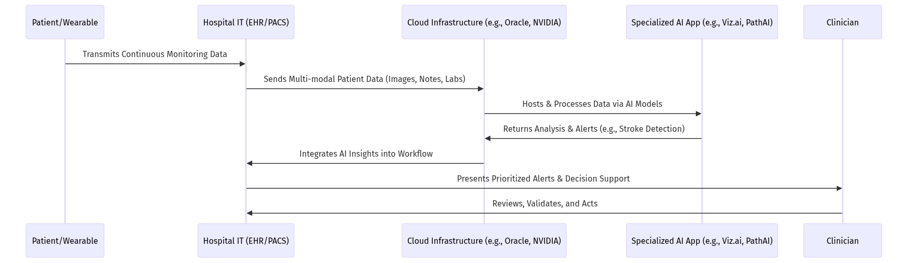
Figure 7. Sequence Diagram (Source: Generated Diagram)

3.4 Critical Challenges Impeding Widespread Adoption
Despite the remarkable progress and optimistic projections, the widespread adoption of Medical AI faces significant and multifaceted challenges that must be systematically addressed. Foremost among these are intertwined concerns regarding data privacy, security, and algorithmic bias. AI systems require access to vast, sensitive patient datasets for training and operation, creating attractive targets for cyberattacks and raising the risk of data breaches that violate patient trust and regulations like HIPAA and GDPR [Regulatory and legal challenges of Artificial Intelligence in the U.S. Healthcare System, 2025]. The involvement of private corporations in data handling further complicates issues of ownership, consent, and long-term stewardship [Privacy and artificial intelligence: challenges for healthcare, 2021]. This data challenge is directly linked to the risk of algorithmic bias. If AI models are trained on datasets that are not representative of diverse global populations—for instance, over-representing certain ethnicities, ages, or genders—they can perpetuate or even exacerbate existing health disparities by delivering inferior performance for underrepresented groups [Fairness of artificial intelligence in healthcare: review and recommendations, 2023]. The frequent "black box" nature of complex models, where the rationale for a specific output is opaque, exacerbates this issue by making it difficult to audit for bias or understand failure modes, thereby eroding clinician trust and complicating accountability [Ethical and regulatory challenges in machine learning-based healthcare, 2025].
The regulatory landscape presents another formidable hurdle. Agencies like the FDA and EMA are tasked with ensuring the safety and efficacy of AI-based medical devices, but their traditional approval frameworks are often ill-suited for software that learns and evolves continuously. Regulators are challenged to develop pathways for pre-market review and post-market surveillance of adaptive algorithms while also creating guidelines for novel risks, such as the "hallucination" of incorrect information by large language models [Safety challenges of AI in medicine, 2024]. While frameworks like HIPAA and GDPR provide a foundation, they require constant evolution to address AI-specific issues concerning data provenance, model explainability, and lifecycle management [Regulatory and legal challenges of Artificial Intelligence in the U.S. Healthcare System, 2025].
Finally, practical integration barriers within healthcare institutions remain a major impediment. Successfully deploying an AI solution requires seamless interoperability with legacy IT systems, including EHRs, laboratory information systems, and PACS. This integration is often technically complex, costly, and disruptive to established workflows [Journal of Medical Internet Research, 2026]. Furthermore, healthcare organizations may lack the in-house technical expertise to evaluate, implement, and maintain AI tools, leading to reliance on vendors and potential vendor lock-in. There is also a significant cultural and educational challenge, as clinicians need training to interpret AI outputs critically—understanding them as decision-support tools rather than autonomous diagnosticians—and to maintain their professional judgment in the face of algorithmic recommendations. Overcoming these adoption challenges requires a concerted effort involving technologists, clinicians, regulators, and ethicists to build AI systems that are not only powerful and accurate but also equitable, transparent, secure, and seamlessly integrated into the human-centric practice of medicine.

4. Technical Analysis
The technical architecture underpinning the Medical AI ecosystem is a sophisticated convergence of data engineering, advanced machine learning methodologies, and secure, scalable deployment frameworks. This analysis delves into the core methodologies and technologies that transform raw healthcare data into actionable clinical intelligence, examining the data lifecycle, algorithmic foundations, system integration patterns, and the critical infrastructure enabling this transformation. The efficacy of any Medical AI application is fundamentally constrained by the quality, diversity, and interoperability of the data upon which it is built. Consequently, modern architectures prioritize the creation of unified data platforms, often conceptualized as healthcare data lakehouses. These platforms are engineered to ingest, standardize, and manage vast volumes of multimodal data, ranging from structured electronic health records (EHRs) and genomic sequences to unstructured clinical notes, medical images, and real-time streams from wearable devices [Oracle, 2024]. The ingestion layer employs a suite of connectors and APIs to draw data from disparate hospital IT systems—such as EHRs, Laboratory Information Systems (LIS), and Picture Archiving and Communication Systems (PACS)—while applying initial data harmonization protocols to address format inconsistencies and semantic heterogeneity [Journal of Medical Internet Research, 2026].
Following ingestion, a rigorous data preprocessing and feature engineering pipeline is critical. This involves several technical steps: de-identification and tokenization to ensure patient privacy compliance with regulations like HIPAA and GDPR; natural language processing (NLP) techniques to extract structured information from clinical narratives; and specialized image processing algorithms for normalizing, augmenting, and segmenting medical imaging data [Privacy and artificial intelligence: challenges for healthcare, 2021; AI-Driven Healthcare: A Survey on Ensuring Fairness and Mitigating Bias, 2024]. For temporal data, such as continuous vital signs from ICU monitors or wearable devices, sequence processing methods are applied. The curated data is then stored within the lakehouse, which provides both the cost-effective storage of a data lake and the management and analytical capabilities of a data warehouse, enabling efficient querying for both model training and retrospective analytics [Oracle, 2022]. This foundational data layer is not static; it requires continuous governance to monitor data drift, ensure provenance, and maintain the representative quality of datasets, which is a primary defense against algorithmic bias [Fairness of artificial intelligence in healthcare: review and recommendations, 2023].
The algorithmic core of Medical AI is characterized by a diverse portfolio of machine learning and deep learning models, each tailored to specific data modalities and clinical tasks. For medical imaging analysis—a dominant application—convolutional neural networks (CNNs) and, more recently, vision transformers (ViTs) are the workhorses. These models are trained on annotated image datasets to perform tasks such as lesion detection in radiology, cellular classification in pathology slides, and anomaly identification in ophthalmology [Emerging Trends in AI-Powered Medical Imaging, 2024]. Their success hinges on large, expertly labeled datasets and advanced techniques like transfer learning, where a model pre-trained on a general image corpus is fine-tuned with a smaller set of medical images. For multimodal diagnosis and clinical decision support, architectures that fuse data types are essential. These systems may integrate image embeddings from a CNN with structured EHR data and embeddings from clinical text processed by a large language model (LLM), using fusion networks to generate a unified patient representation for outcome prediction or diagnostic suggestion [Artificial intelligence-generated content (AIGC) in biomedical, 2026].
In the domain of drug discovery and genomics, graph neural networks (GNNs) are increasingly prominent for modeling the complex relationships between biological entities like proteins, genes, and molecular compounds. Transformer-based models, inspired by their success in NLP, are also being repurposed to understand biological sequences and predict protein structures, as exemplified by breakthroughs like AlphaFold [Medical Futurist, n.d.]. Furthermore, the rise of generative AI and LLMs is opening new technical frontiers. Fine-tuned or domain-adapted LLMs are being deployed for ambient clinical documentation, where they process doctor-patient dialogue to auto-generate visit summaries, and for patient-facing applications, such as intelligent symptom checkers and personalized health education tools [AI Magazine, 2025; Oracle, 2026]. However, the deployment of these models introduces specific technical challenges, including mitigating "hallucinations" (plausible but incorrect outputs), ensuring robust guardrails to prevent harmful advice, and managing the substantial computational resources they require [Safety challenges of AI in medicine, 2024].
A critical technical and methodological imperative is the development of Explainable AI (XAI) techniques. The "black-box" nature of many deep learning models is a significant barrier to clinical trust and regulatory approval. XAI methods, such as Layer-wise Relevance Propagation (LRP) for CNNs or attention visualization for transformers, provide post-hoc explanations by highlighting which features in an input (e.g., specific pixels in an X-ray or words in a clinical note) most influenced the model's decision [Explainable Artificial Intelligence for Medical Applications: A Review, n.d.]. For inherently interpretable models, like certain tree-based algorithms used for risk stratification, the focus is on ensuring clarity in feature importance. These explanations are vital not only for clinician buy-in but also for meeting emerging regulatory requirements for transparency and for conducting ongoing audits to detect model degradation or bias [Ethical and regulatory challenges in machine learning-based healthcare, 2025].
The deployment and integration of trained models into clinical workflows present a distinct set of technical challenges. The prevailing architecture for production systems is the microservices model, where discrete AI capabilities (e.g., a stroke detection algorithm, a sepsis prediction engine) are containerized and exposed via well-defined APIs. This approach allows for independent scaling, updating, and maintenance of each service. The integration layer acts as a bridge, connecting these AI microservices to existing hospital IT infrastructure. It handles protocol translation, data format conversion, and secure messaging, often utilizing Health Level Seven (HL7) Fast Healthcare Interoperability Resources (FHIR) standards to facilitate data exchange with EHRs [Journal of Medical Internet Research, 2026]. A critical component is the inference engine, which manages the execution of models, often leveraging hardware accelerators like GPUs from providers such as NVIDIA to ensure low-latency predictions crucial for time-sensitive applications [Medical Futurist, n.d.].
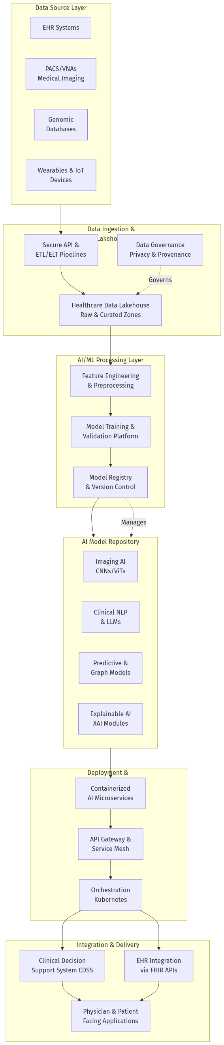
Figure 8. Flowchart (Source: Generated Diagram)
Figure 1: High-Level System Architecture for a Medical AI Platform. This flowchart depicts the end-to-end flow from heterogeneous data sources to clinical integration, highlighting the layered architecture encompassing data management, AI processing, and microservices-based deployment.
The operational lifecycle of a deployed AI model is managed through MLOps (Machine Learning Operations) practices. This involves continuous monitoring of the model's performance in production, tracking metrics like prediction accuracy, latency, and fairness across different patient subgroups. Automated pipelines can trigger model retraining if performance drifts beyond a defined threshold, ensuring the AI system adapts to changing clinical practices or patient populations. Security is paramount across all layers; architectures must incorporate encryption for data both at rest and in transit, strict identity and access management (IAM) controls, and regular vulnerability assessments. Special attention is paid to protecting the AI models themselves from adversarial attacks, where maliciously crafted inputs could lead to incorrect predictions [Safety challenges of AI in medicine, 2024].
The interaction between system components during a typical clinical use case, such as AI-assisted diagnostic support, illustrates the integration complexity. The process begins when a clinician orders a test within the EHR. This event triggers the integration layer, which orchestrates a sequence of data retrieval and AI inference tasks. The relevant patient data is fetched, preprocessed, and dispatched to the appropriate AI microservices. The results, along with confidence scores and explainability maps, are aggregated, formatted, and returned to the EHR’s clinical decision support module for presentation to the physician within their existing workflow.
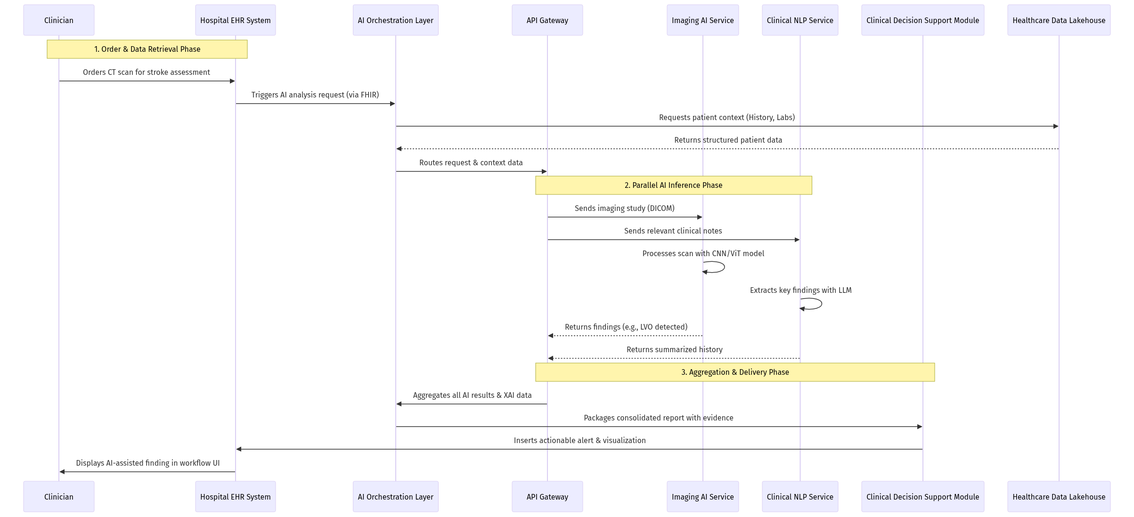
Figure 9. Sequence Diagram (Source: Generated Diagram)
Figure 2: Sequence Diagram for AI-Assisted Stroke Diagnosis. This sequence illustrates the coordinated interaction between hospital systems, data platforms, and AI microservices to deliver a consolidated diagnostic support alert to the clinician's EHR interface.
Finally, the computational infrastructure supporting these architectures is both a critical enabler and a constraint. Training state-of-the-art models, particularly large multimodal or generative models, requires access to high-performance computing clusters, typically powered by NVIDIA GPUs and interconnected with high-speed networking [Medical Futurist, n.d.]. This has led to a cloud-centric or hybrid-cloud deployment model for many AI platforms, leveraging the elastic scalability of cloud providers like Google Cloud, AWS, and Microsoft Azure, or specialized healthcare clouds like Oracle Health. However, for latency-sensitive applications or those dealing with highly sensitive data, on-premise or edge deployments are also utilized, such as running inference directly on an imaging device or within a hospital's data center. The energy consumption of large-scale AI training and inference is a growing technical and ethical concern, prompting research into more efficient model architectures, quantization techniques, and the use of specialized AI chips [Wikipedia, 2024]. In summary, the technical landscape of Medical AI is a multifaceted engineering discipline that demands excellence in data science, software architecture, security, and systems integration to safely and effectively translate algorithmic potential into reliable clinical utility.

5. Case Studies
The theoretical potential and market dynamics of Medical AI are compelling, but its true value and challenges are most vividly revealed through practical implementation. Examining detailed case studies of leading organizations provides critical insights into the real-world lifecycle of AI deployment, from initial problem identification and algorithm development to clinical integration, validation, and scaling. These narratives illuminate how pioneers navigate the complex interplay of technological innovation, regulatory compliance, clinical workflow adaptation, and ethical considerations. This section presents three in-depth case studies across key market segments: a specialized AI firm revolutionizing stroke care (Viz.ai), a technology giant applying foundational AI to biological discovery (Google DeepMind's AlphaFold), and an integrated health system deploying operational AI for hospital management (as conceptualized on platforms like Oracle OCI). Each case demonstrates a unique pathway to creating tangible impact, while collectively underscoring the common phases and hurdles inherent in bringing Medical AI from concept to bedside and boardroom.

5.1 Case Study: Viz.ai – Accelerating Stroke Care through AI-Powered Care Coordination
Viz.ai represents a paradigm shift in the application of artificial intelligence, moving beyond pure diagnostic assistance to creating an intelligent care coordination platform that redefines time-sensitive treatment pathways, particularly for neurovascular emergencies like acute ischemic stroke. The company’s flagship product, the Viz.ai One platform, is built on a simple yet critical premise: in stroke care, "time is brain." Every minute of delay in restoring blood flow results in the loss of millions of neurons. Traditional workflows involve a radiologist reviewing a CT angiography (CTA) scan, often after an incidental finding or a page, then manually contacting the neurovascular specialist, leading to potentially life-threatening delays [Medical Futurist, n.d.]. Viz.ai’s innovation lies in using a convolutional neural network (CNN) to automatically analyze CTA images the moment they are uploaded to a hospital’s PACS system, detecting suspected large vessel occlusions (LVOs)—a severe type of stroke—and immediately alerting a pre-defined care team via a HIPAA-compliant mobile application [The Healthcare Technology Report, 2025]. This transforms a linear, sequential process into a parallel, synchronized one, where the specialist is notified concurrently with image acquisition.
The implementation lifecycle of Viz.ai within a hospital network follows a structured, phased approach that prioritizes clinical validation and workflow integration. The initial Feasibility and Partnership phase involves demonstrating the algorithm's performance on historical datasets to hospital leadership and key stakeholders, including neurologists, neuro-interventionalists, and radiologists. Crucially, Viz.ai pursued and obtained U.S. Food and Drug Administration (FDA) 510(k) clearance for its LVO detection algorithm, a regulatory milestone that provided a foundation of clinical validity and safety for adoption [Medical Futurist, n.d.]. The subsequent Integration and Deployment phase is technically and operationally intensive. The Viz.ai engine integrates with the hospital’s existing imaging infrastructure (PACS) through vendor-neutral archives or APIs, requiring close collaboration with the hospital’s IT department to ensure secure, reliable data flow. Simultaneously, the clinical operations team works to map the existing stroke response protocol, define the alert escalation chain within the Viz.ai app, and train end-users.
The most critical phase is Clinical Validation and Workflow Adoption. Successful implementation is not guaranteed by technology alone; it requires proving value in the live clinical environment. Hospitals typically run a parallel validation period where the AI’s findings are compared against expert radiologist reads. Metrics such as sensitivity, specificity, and, most importantly, door-to-groin puncture time (the time from patient arrival to the start of thrombectomy) are meticulously tracked. Published studies from early adopters have shown that Viz.ai’s platform can significantly reduce this key metric, sometimes by over 50 minutes, directly leading to improved patient outcomes [The Healthcare Technology Report, 2025]. Overcoming clinician skepticism is part of this phase; the platform is designed not to replace the radiologist but to augment them, with the AI acting as a highly sensitive triage tool that ensures critical cases are prioritized.
Finally, the Scale and Expansion phase involves leveraging the established platform infrastructure and trust to address adjacent clinical indications. Following its success in LVO detection, Viz.ai secured further FDA clearances for detecting other neurovascular conditions like cerebral aneurysms and intracranial hemorrhages [Medical Futurist, n.d.]. Furthermore, the platform has expanded into cardiology with modules for pulmonary embolism and aortic disease, demonstrating how a foundational AI-powered communication platform can be extended across disease states. The company’s evolution from a stroke-specific tool to a comprehensive vascular care coordination suite illustrates a powerful model for scaling Medical AI solutions within and across clinical domains.
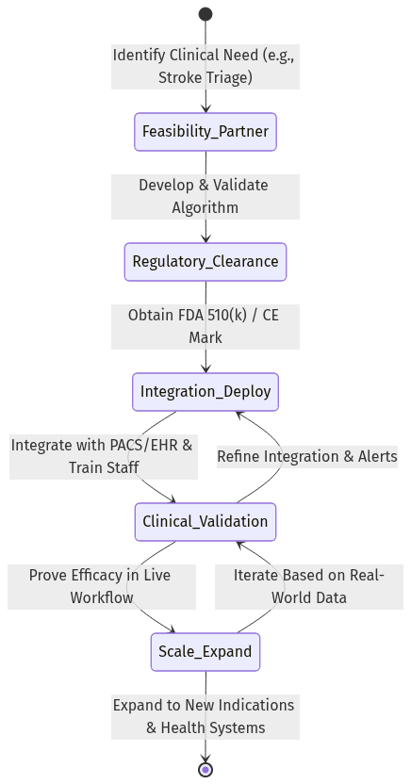
Figure 10. State Diagram (Source: Generated Diagram)
Figure 1: Implementation Lifecycle of a Diagnostic & Care Coordination AI Platform (e.g., Viz.ai). This state diagram illustrates the iterative, multi-phase journey from concept to scaled deployment, highlighting critical stages like regulatory clearance and clinical validation that feed back into system refinement.

5.2 Case Study: Google DeepMind’s AlphaFold – Revolutionizing Biology and Drug Discovery
The case of AlphaFold, developed by Google DeepMind, exemplifies the transformative impact of foundational AI research on the entire biomedical ecosystem, particularly the drug discovery segment of the Medical AI market. The problem it addressed—protein structure prediction—was a grand challenge in biology for over 50 years. A protein’s three-dimensional structure determines its function, and knowing that structure is crucial for understanding disease mechanisms and designing drugs. Experimental methods like cryo-electron microscopy are accurate but expensive, time-consuming, and not universally applicable. DeepMind applied its expertise in deep learning, honed on games like Go, to this fundamental biological problem. AlphaFold2, released in 2020, achieved unprecedented accuracy in predicting protein structures from their amino acid sequences, often rivaling experimental methods [Medical Futurist, n.d.]. This was not a typical product development cycle but a moonshot research project that successfully cracked a core scientific problem.
The implementation lifecycle for a tool like AlphaFold is distinct from clinical deployment software. It began with an intensive Research and Development phase, leveraging massive computational resources and curated datasets from the Protein Data Bank. The AI architecture combined novel attention mechanisms and evolutionary data from multiple sequence alignments to model physical and geometric constraints. The breakthrough was followed by a Open Access and Ecosystem Enablement phase, which has been pivotal to its impact. Rather than commercializing the tool restrictively, DeepMind open-sourced the AlphaFold2 code and, in partnership with the European Molecular Biology Laboratory (EMBL), created the AlphaFold Protein Structure Database, providing free access to over 200 million predicted structures [Medical Futurist, n.d.]. This democratized access, allowing researchers worldwide, including those in low-resource institutions, to leverage the predictions without needing AI expertise or supercomputing power.
The Adoption and Application in R&D phase is where AlphaFold’s value is being realized across the drug discovery pipeline. Pharmaceutical companies and academic labs are integrating these predictions into their workflows to accelerate target identification and validation. For instance, researchers can now quickly model the structure of a novel disease-related protein or predict how mutations might alter its shape and function. This is particularly valuable for neglected tropical diseases, where structural data was previously scarce. Furthermore, AlphaFold’s predictions are being used to inform the design of novel proteins and enzymes for therapeutic use, a field known as de novo protein design. The technology reduces the initial hypothesis-forming phase from years to days or weeks, although it does not eliminate the need for experimental validation. It acts as a powerful prior, guiding wet-lab experiments more efficiently.
The long-term Integration and Future Directions phase involves embedding AlphaFold-like capabilities into broader discovery platforms and addressing its limitations. The AI community is building on this foundation, developing models like AlphaFold-Multimer to predict protein-protein interactions, which are critical for understanding signaling pathways. The next frontier is dynamic protein folding and the prediction of structures for complex molecular machines. The AlphaFold case study demonstrates that the most profound Medical AI applications may emerge from solving foundational scientific problems, with a deployment model focused on open access to maximize global scientific benefit. Its impact is less about direct hospital integration and more about radically accelerating the upstream, pre-clinical research that feeds the entire therapeutic pipeline [Artificial intelligence in healthcare and medicine, 2025].

5.3 Case Study: Operational AI in Hospital Management – The Data Lakehouse Approach
While AI for clinical diagnosis captures headlines, a significant segment of the Medical AI market focuses on improving the operational and administrative efficiency of healthcare systems. This case study synthesizes a common architecture and implementation pathway, as exemplified by solutions from cloud providers like Oracle, which aim to tackle challenges such as fragmented data, inefficient resource allocation, and predictive patient management. The core problem is data siloing: patient information resides in separate systems like EHRs, lab databases, PACS, financial systems, and even external sources like wearables. This fragmentation makes holistic analysis, predictive modeling, and efficient operations nearly impossible [Oracle, 2024]. The proposed solution is the creation of a unified healthcare data "lakehouse" on a cloud infrastructure like Oracle Cloud Infrastructure (OCI), which serves as the foundation for applying operational AI.
The implementation lifecycle begins with the Data Unification and Platform Foundation phase. This is a substantial undertaking involving the ingestion, standardization, and harmonization of petabytes of structured and unstructured data from disparate source systems into a central lakehouse. Data pipelines are built to ensure continuous, secure flow. Crucially, this platform must enforce strict governance, security, and privacy controls compliant with regulations like HIPAA from the outset [Oracle, 2022]. Once a trusted, unified data asset is established, the Analytics and Insight Generation phase commences. Using built-in analytics and machine learning services, health systems can begin to run historical analyses to identify bottlenecks—for example, understanding patterns in patient admission, length of stay, and readmission rates. This descriptive and diagnostic analytics stage builds the analytical maturity necessary for more advanced AI.
The Predictive and Prescriptive AI Deployment phase is where AI models are built and integrated into operational workflows. Use cases are diverse and high-impact. For instance, AI models can predict patient admission rates with high granularity (by department, by day), enabling optimized staff scheduling and bed management. Readmission risk models can flag high-risk patients upon discharge, enabling targeted follow-up care to improve outcomes and avoid financial penalties. AI can also streamline revenue cycle management by automating claims processing and identifying coding errors or potential fraud [Oracle, 2024]. During the COVID-19 pandemic, such architectures proved vital for rapidly analyzing outcomes data across similar patient cohorts to identify effective treatment protocols and predict resource needs [Oracle, 2022].
The final Scale and Continuous Optimization phase involves expanding AI models to new operational domains and ensuring they adapt over time. A key advantage of the cloud-based lakehouse model is scalability; once the infrastructure is in place, deploying a new model for a different problem (e.g., predicting operating room turnover time, optimizing supply chain inventory) becomes significantly faster. Furthermore, these systems enable continuous learning, where models can be retrained on new data to maintain their accuracy as hospital practices evolve. Success in this domain is measured not in diagnostic accuracy but in key performance indicators like reduced patient wait times, increased bed turnover, lower operational costs, and improved staff satisfaction. This case illustrates that for many healthcare institutions, the first and most manageable step into Medical AI may be in the operational realm, where ROI can be clearly measured and ethical risks like diagnostic bias are initially lower, building the internal expertise and data infrastructure needed for more complex clinical AI applications later.
In conclusion, these three case studies—spanning acute care coordination, foundational biological research, and hospital operations—demonstrate the multifaceted nature of Medical AI implementation. Viz.ai shows how a focused, FDA-cleared application can achieve rapid clinical adoption by solving a critical time-sensitive problem and seamlessly integrating into existing workflows. AlphaFold illustrates the paradigm-shifting potential of open-access, foundational AI research to accelerate the entire scientific underpinning of medicine. The operational AI model highlights the essential, if less glamorous, work of building robust data infrastructure as a prerequisite for sustainable and scalable AI innovation. Each pathway navigates the universal challenges of data quality, regulatory compliance, and user acceptance, but in context-specific ways. Together, they provide a comprehensive picture of how Medical AI transitions from a promising technology into a tangible force for improving healthcare delivery, discovery, and efficiency.

6. Comparative Analysis
The medical artificial intelligence (AI) landscape is characterized by a diverse array of technological approaches, business models, and strategic priorities. A comparative analysis reveals distinct clusters of activity, each with unique strengths, challenges, and trajectories. Fundamentally, the divergence in approaches can be mapped along two primary axes: the depth of clinical integration and the breadth of technological application. On one end of the spectrum are highly specialized, vertically integrated solutions designed for specific clinical tasks, such as stroke detection in radiology or automated insulin delivery. On the other are broad, horizontal platforms that provide foundational infrastructure—like cloud-based AI model training environments or generative AI services—upon which specialized applications are built [Medical Futurist, n.d.; Oracle, 2026]. This section will analyze these competing paradigms by examining their core technological architectures, value propositions, regulatory pathways, and scalability, providing a framework for understanding the current competitive dynamics and future evolution of the medical AI market.
A primary axis for comparison is the clinical specificity of the AI solution. Specialized diagnostic firms, such as Viz.ai and PathAI, exemplify a deep vertical integration model. Their technologies are built upon narrow but exceptionally deep datasets—Viz.ai on millions of neuroimaging scans, PathAI on vast libraries of histopathology slides [Medical Futurist, n.d.; Springer, 2025]. This focus allows for the development of algorithms with performance metrics often surpassing human experts in controlled tasks, such as identifying large vessel occlusions or grading tumor proliferation. Their value proposition is clear: demonstrable improvements in diagnostic accuracy, speed, and consistency, which directly translate into better patient outcomes and operational efficiencies in specific clinical workflows [The Healthcare Technology Report, 2025]. However, this specialization presents challenges. The regulatory pathway, while well-defined for Software as a Medical Device (SaMD), is rigorous and indication-specific, requiring new approvals for each expanded use case [Ethical and legal considerations in healthcare AI, n.d.]. Furthermore, integration into hospital systems often requires custom interfaces with PACS or laboratory information systems, creating friction during implementation [Journal of Medical Internet Research, 2026].
In contrast, companies focusing on administrative and operational efficiency, like Augmedix and DeepScribe, employ a different technological and business approach. Their core technology leverages advanced natural language processing (NLP) and ambient listening to address the universal pain point of clinical documentation burden [AI Magazine, 2025]. While still requiring regulatory compliance for data privacy (e.g., HIPAA, GDPR), these tools often fall under a less stringent device classification than diagnostic SaMD, as they are positioned as aids to documentation rather than direct clinical decision-makers. Their integration challenge is different but equally complex; success hinges on flawless interoperability with a wide variety of Electronic Health Record (EHR) systems from vendors like Epic and Cerner. Their value is measured in time saved per clinician per day, a metric that directly impacts physician burnout and practice revenue [Medical Futurist, n.d.]. This model offers potentially faster scalability across diverse healthcare settings, as the core problem it solves is ubiquitous, but it faces intense competition and must continuously prove a return on investment in operational costs.
The most profound comparative distinction lies between application-specific companies and the foundational technology enablers. Firms like NVIDIA and Google Health operate on a horizontal platform model. NVIDIA’s Clara and BioNeMo platforms provide the essential computational horsepower and software stacks that specialized AI companies use to train and deploy their models [Medical Futurist, n.d.]. Google’s contributions, from the AlphaFold breakthrough in protein folding to its research in medical imaging, advance the fundamental science that downstream applications rely upon. These tech giants compete on providing the most powerful, efficient, and developer-friendly ecosystem. Their challenges are not primarily clinical or regulatory but infrastructural and ethical, involving concerns about market dominance, the environmental impact of massive data centers, and the governance of foundational models [Wikipedia, 2024]. Their business model is symbiotic with the specialized firms; the success of the application layer drives demand for more powerful computing and advanced AI research.
A critical comparative dimension is the approach to data and model governance, which directly addresses the challenges of bias and explainability. Some specialized firms adopt a "closed-loop" system, as seen with Diabeloop for diabetes management, where the AI algorithm controls a therapeutic intervention (insulin delivery) based on continuous patient data [Medical Futurist, n.d.]. This approach allows for tight control over the data pipeline and model behavior, potentially enhancing safety and explainability for a specific function. Conversely, platform providers and companies using large language models (LLMs), like Hippocratic AI or Oracle’s Generative AI Service, face greater scrutiny regarding the provenance of their training data and the "black box" nature of their outputs [Oracle, 2026; Safety challenges of AI in medicine, 2024]. Their solutions offer greater flexibility and a wider range of applications—from generating patient education materials to summarizing clinical trials—but require robust guardrails to prevent hallucinations and ensure responsible use in sensitive healthcare contexts [Ethical and regulatory challenges in machine learning-based healthcare, 2025].
The following table synthesizes the key comparative attributes of these dominant approaches across the medical AI sector:
Table 1: Comparative Analysis of Dominant Medical AI Approaches
Table 2. Research Data
Aspect | Specialized Diagnostic AI (e.g., Viz.ai, PathAI) | Administrative/Automation AI (e.g., Augmedix, DeepScribe) | Foundational Platform AI (e.g., NVIDIA, Google Health) | Therapeutic & Chronic Care AI (e.g., Diabeloop, Hippocratic AI)
Core Value Proposition | Superior accuracy & speed for a specific clinical task (e.g., detection, grading). | Reduction of administrative burden, cost savings, and mitigation of clinician burnout. | Provision of computational infrastructure, tools, and foundational research for the entire ecosystem. | Personalized treatment automation, improved chronic disease outcomes, and scalable patient interaction.
Primary Technology | Deep learning (computer vision) on highly curated, domain-specific datasets. | Natural Language Processing (NLP), speech recognition, and generative AI for text. | High-performance computing (GPUs), cloud platforms, and broad-spectrum AI research. | Closed-loop control systems, generative AI "agents," and predictive analytics on continuous data streams.
Regulatory Pathway | Stringent; typically Class II/III SaMD requiring FDA/CE Mark approval per indication. | Moderate; focused on data privacy compliance (HIPAA/GDPR) as a clinical support tool. | Indirect; components may be regulated as part of an end device; focus on ethical AI governance. | High-risk; often Class III medical device regulation for therapeutic systems; novel pathways for AI agents.
Key Adoption Challenge | Integration with legacy hospital IT (PACS, EHR); proving clinical utility in real-world workflows. | Achieving seamless, reliable interoperability with diverse and complex EHR systems. | Ensuring equitable access, managing supply chain for advanced chips, and addressing ethical AI concerns. | Demonstrating long-term safety and efficacy, ensuring patient trust in autonomous systems, and reimbursement.
Business Model | Licensing software to hospitals/health systems; per-analysis or subscription fee. | Software-as-a-Service (SaaS) subscription based on clinician seats or usage volume. | Selling hardware (chips), cloud services, and enterprise software licenses; research partnerships. | Device + service subscription; value-based care partnerships with payers and providers.

To visually synthesize the strategic positioning of these various players and approaches within the competitive landscape, the following quadrant chart maps them based on two critical dimensions: the Regulatory & Clinical Risk associated with their product (from low/supportive to high/diagnostic-therapeutic) and their Market Scope & Integration Model (from broad/horizontal platform to narrow/vertical solution). This analysis reveals four distinct clusters.
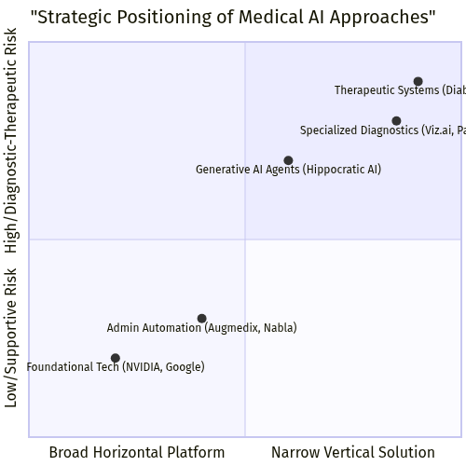
Figure 11. Quadrant Chart (Source: Generated Diagram)
The quadrant analysis reveals clear strategic clusters. The lower-left quadrant is occupied by Foundational Platform providers like NVIDIA and Google. These entities operate with a broad, horizontal scope, providing infrastructure used across the industry. Their direct regulatory and clinical risk is relatively low, as they are typically several steps removed from patient care delivery, though they face significant ethical and governance scrutiny. The lower-right quadrant contains Administrative Automation specialists such as Augmedix and Nabla. These are vertically focused on solving specific workflow problems (clinical documentation) but are positioned as supportive tools rather than primary diagnostic devices, placing them in a moderate-risk regulatory category. Their market scope is narrower than platform players but broader than pure diagnostics, as their solution applies across many medical specialties.
The upper quadrants represent higher clinical risk categories. The upper-right quadrant is the most concentrated in terms of regulatory oversight, housing Specialized Diagnostic firms like Viz.ai and PathAI, and Therapeutic Systems like Diabeloop. These companies offer deeply vertical solutions that provide direct diagnostic input or control therapeutic interventions, representing the highest risk classification (SaMD). Their integration is narrow and deep, requiring profound expertise in both AI and a specific clinical domain. Finally, the upper-left quadrant presents an emerging and intriguing cluster: Generative AI Agents as exemplified by Hippocratic AI. These aim for a broader market scope—pot applicable across many conversational healthcare tasks—but inherently carry high risk because they interact directly with patients and clinical decision-making processes. Their positioning is currently less defined by traditional medical device regulation and more by emerging frameworks for AI safety and accountability, representing a frontier in the competitive landscape [Safety challenges of AI in medicine, 2024].
In conclusion, the medical AI market is not a monolithic field but a tapestry of complementary and competing paradigms. The comparative analysis demonstrates that no single approach holds a definitive advantage; rather, each is optimized for different segments of the healthcare value chain. Specialized diagnostic AI delivers unparalleled precision in focused areas but faces scalability and integration hurdles. Administrative AI tackles widespread operational inefficiencies but must navigate complex IT ecosystems. Foundational platform AI provides the essential tools for innovation but remains distant from end-patient value. The future trajectory of the market will likely be shaped by convergence and collaboration across these models. For instance, the integration of a specialized diagnostic algorithm from a vertical player onto the cloud infrastructure of a horizontal platform, facilitated by an administrative AI tool that seamlessly enters the findings into the EHR, represents the integrated future of intelligent healthcare systems. Success will depend on a company’s ability to navigate its chosen quadrant’s unique challenges—regulatory, technical, and commercial—while forging strategic partnerships to bridge the gaps between data, insight, and clinical action.

7. Challenges and Solutions
The integration of artificial intelligence into healthcare, while promising a revolution in diagnostics, treatment, and operational efficiency, is not a straightforward technological upgrade. Its path to widespread, equitable, and safe adoption is fraught with significant, interconnected challenges that span technical, ethical, regulatory, and practical domains. These barriers must be systematically understood and addressed to unlock the full transformative potential of Medical AI. This section examines the four primary clusters of challenges—data privacy and security, algorithmic bias and explainability, regulatory complexity, and clinical integration—and explores the evolving landscape of solutions being developed by industry, academia, and policymakers to overcome them.
The foundational challenge for any Medical AI system is the secure and ethical handling of sensitive patient data. AI models, particularly sophisticated deep learning algorithms, require vast, high-quality datasets for training and validation. This necessity creates a critical tension between innovation and privacy. The aggregation of electronic health records, medical images, and genomic data into centralized repositories for AI development presents a lucrative target for cyberattacks, with breaches posing catastrophic risks to patient confidentiality and trust [AI-Driven Healthcare: A Survey on Ensuring Fairness and Mitigating Bias, 2024]. Furthermore, the involvement of third-party technology firms in data processing complicates traditional notions of data stewardship and patient consent, raising legal questions under frameworks like HIPAA in the United States and the GDPR in Europe [Regulatory and legal challenges of Artificial Intelligence in the U.S. Healthcare System, 2025; Privacy and artificial intelligence: challenges for healthcare, 2021]. A primary solution to this dilemma is the advancement and adoption of privacy-preserving technologies. Techniques such as federated learning allow AI models to be trained across multiple decentralized hospitals or devices without the need to exchange or centralize raw patient data. Instead, only model updates (e.g., gradients) are shared, significantly mitigating privacy risks. Similarly, differential privacy adds mathematical noise to datasets or queries, ensuring that the output of an analysis does not reveal information about any single individual. The development of synthetic data—artificially generated datasets that mimic the statistical properties of real patient data without containing any actual patient information—also offers a promising pathway for model development and testing in a risk-controlled environment [Oracle, 2024].
Closely linked to data challenges is the pervasive risk of algorithmic bias, which threatens to perpetuate or even exacerbate existing health disparities. Bias can be introduced at multiple points in the AI lifecycle: through training data that underrepresents certain demographic groups (e.g., based on race, gender, or socioeconomic status), through flawed problem formulation by developers, or through deployment in contexts for which the model was not validated [Safety challenges of AI in medicine, 2024]. A diagnostic algorithm trained predominantly on data from one population may perform poorly and even dangerously when applied to another, leading to misdiagnosis and unequal care [Fairness of artificial intelligence in healthcare: review and recommendations, 2023]. Compounding this issue is the "black box" problem inherent in many complex AI models, where the reasoning behind a specific prediction is opaque, eroding clinician trust and complicating accountability. The solution framework here is multi-pronged, focusing on fairness, accountability, and transparency (FAT). Researchers and developers are increasingly employing bias detection and mitigation tools during model development, auditing datasets for representativeness, and applying algorithmic techniques to debias models. Concurrently, the field of Explainable AI (XAI) is critical for building trust. XAI methods, such as Local Interpretable Model-agnostic Explanations (LIME) or SHapley Additive exPlanations (SHAP), provide insights into which features (e.g., specific pixels in an image or lab values) most influenced an AI's decision, making its outputs more interpretable to clinicians [Explainable Artificial Intelligence for Medical Applications: A Review, n.d.]. This move towards transparent and auditable AI is essential for ethical deployment and is becoming a key requirement from regulators and healthcare institutions alike.
The dynamic and software-centric nature of AI medical devices poses a unique challenge to traditional regulatory frameworks designed for static hardware. Agencies like the U.S. Food and Drug Administration (FDA) and those granting CE marks in Europe are tasked with ensuring safety and efficacy, but their approval processes must adapt to algorithms that can learn and change post-deployment [Ethical and legal considerations in healthcare AI, n.d.]. Furthermore, the rapid emergence of generative AI and large language models (LLMs) introduces novel risks, such as the generation of plausible but incorrect medical information ("hallucinations") [Safety challenges of AI in medicine, 2024]. In response, regulators are pioneering new pathways. The FDA’s Digital Health Center of Excellence has established a Software Precertification (Pre-Cert) Pilot Program and a framework for regulating AI/ML-Based Software as a Medical Device (SaMD), which includes plans for pre-specified change control protocols. This allows for the approval of a locked algorithm with a roadmap for future, validated updates, moving towards a more continuous, lifecycle-based regulatory approach. Similarly, the European Union’s AI Act proposes a risk-based classification system, likely categorizing most clinical decision-support AI as "high-risk," subjecting them to rigorous requirements for data governance, technical documentation, and human oversight. The solution, therefore, lies in proactive and collaborative regulation—where policymakers work closely with technologists and clinicians to create agile, risk-proportionate frameworks that ensure patient safety without stifling innovation [Regulatory and legal challenges of Artificial Intelligence in the U.S. Healthcare System, 2025].
Even with a perfectly validated and approved AI tool, its ultimate value is zero unless it can be effectively integrated into the complex, real-world workflow of a healthcare provider. The practical barrier of interoperability is immense. Hospitals operate on legacy IT infrastructures—electronic health record (EHR) systems, picture archiving and communication systems (PACS), and laboratory information systems—that are often siloed and use incompatible data standards [Journal of Medical Internet Research, 2026]. Embedding a new AI application requires seamless, bidirectional data exchange, which is a significant technical and financial undertaking. Additionally, successful integration demands careful change management to ensure clinician adoption, addressing workflow disruptions and potential "alert fatigue" from decision-support systems. The strategic solution is a shift towards interoperable, platform-based architectures. Leading technology providers, including major cloud platforms like Oracle, are advocating for and building unified healthcare data platforms (e.g., data lakehouses) that can ingest and harmonize structured and unstructured data from diverse sources [Oracle, 2024]. By providing standardized application programming interfaces (APIs), such as those based on Fast Healthcare Interoperability Resources (FHIR), these platforms can serve as a central nervous system, allowing modular AI applications to plug in more easily. Furthermore, involving clinicians and end-users in the co-design of AI tools from the outset ensures they complement rather than complicate existing workflows, thereby enhancing usability and driving adoption.
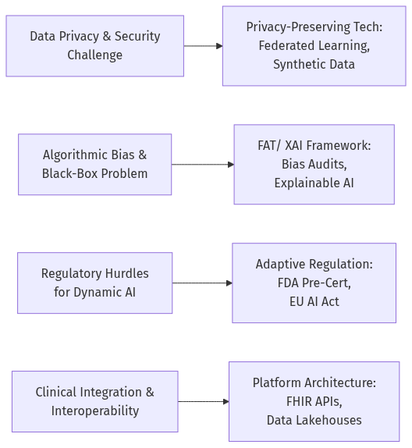
Figure 12. Flowchart (Source: Generated Diagram)
In conclusion, the journey of Medical AI from promising prototype to trusted clinical partner is contingent on overcoming a suite of deeply interconnected challenges. The path forward requires a concerted, multidisciplinary effort. Technologists must build privacy and fairness into the core of their systems, regulators must craft agile and intelligent oversight frameworks, and healthcare institutions must invest in the interoperable digital infrastructure and cultural readiness needed for integration. As illustrated in the accompanying flowchart, each primary challenge maps to a developing suite of solutions. By addressing data concerns with advanced cryptographic techniques, combating bias with transparency and audits, navigating regulation with collaborative new models, and solving integration through platform-based interoperability, the Medical AI ecosystem can mature responsibly. The goal is not merely to adopt AI, but to do so in a way that is secure, equitable, compliant, and seamlessly woven into the fabric of care, ultimately fulfilling its promise to enhance outcomes for all patients [Transformative Potential of AI in Healthcare: Definitions, Applications, 2024].

8. Future Outlook
The trajectory of the Medical AI market is one of profound and accelerating transformation, poised to redefine the foundational pillars of healthcare delivery, biomedical research, and patient engagement over the next decade. Building upon the current landscape of specialized applications and robust market growth, the future will be characterized by the convergence of advanced technologies, the maturation of regulatory and ethical frameworks, and a fundamental shift towards proactive, personalized, and participatory medicine. The projected expansion from a market valued in the tens of billions to one exceeding a trillion dollars by 2034 is not merely a financial forecast but a testament to the anticipated pervasive integration of AI across the healthcare continuum [Fortune Business Insights, 2024]. This future outlook envisions a healthcare ecosystem where AI transitions from a tool for discrete tasks to an intelligent, ubiquitous layer that enhances human decision-making, optimizes system-wide efficiency, and unlocks novel therapeutic modalities.
A dominant trend shaping the immediate future is the evolution from narrow, single-modality AI applications to integrated, multimodal, and foundation model-driven systems. Current AI solutions excel in specific domains, such as analyzing radiology images or transcribing clinical conversations. The next phase involves AI platforms capable of synthesizing diverse data streams—including genomic sequences, proteomic data, continuous biometrics from wearables, social determinants of health, and real-world evidence—into a unified patient model [Oracle, 2024]. Large language models (LLMs) and other foundation models, fine-tuned for medical contexts, will act as the orchestrating intelligence for this synthesis, enabling more holistic diagnostic assessments, predicting individual patient trajectories, and generating personalized care plans [Artificial intelligence-generated content (AIGC) in biomedical, 2026]. Companies like Hippocratic AI are pioneering this shift by developing generative AI agents for empathetic patient interaction, while the computational infrastructure from leaders like NVIDIA will be critical for training these complex, multi-modal systems [Medical Futurist, n.d.]. This integration will move clinical decision support from being reactive to being predictive and prescriptive, fundamentally altering the clinician’s role.
Concurrently, the frontier of therapeutic innovation will be radically accelerated by AI. The field of drug discovery and development, historically a time-consuming and costly endeavor, is being compressed through AI-powered simulation and design. Future platforms will not only identify novel drug targets but will also digitally design and optimize therapeutic molecules, predict their efficacy and safety profiles in silico, and design more efficient and inclusive clinical trials [Artificial intelligence in healthcare and medicine, 2025]. This will facilitate the rise of precision medicine from concept to standard practice, where treatments are tailored not just to a disease subtype but to an individual’s unique biological makeup. Furthermore, AI will drive advances in regenerative medicine and gene editing, optimizing protocols for cell therapies and CRISPR-based interventions. The synergy between diagnostic AI (e.g., from firms like PathAI) and therapeutic AI will create closed-loop systems where a diagnosis automatically triggers the identification and deployment of the most effective, personalized therapeutic strategy [Springer, 2025].
Operationally, the healthcare system of the future will be characterized by autonomous and predictive management, moving beyond current workflow optimizations. AI will enable the concept of the "self-optimizing hospital," where algorithms manage resource allocation in real-time—predicting patient admission rates, optimizing staff schedules, managing inventory for drugs and supplies, and preventing equipment failures through predictive maintenance [The Role of AI in Hospitals and Clinics, 2024]. Administrative burdens, a primary source of clinician burnout, will be largely mitigated by ambient AI that handles prior authorizations, medical coding, and billing compliance autonomously [AI Magazine, 2025]. On a public health scale, AI-driven analysis of aggregated, anonymized data from wearable devices and electronic health records will provide unprecedented insights into population health trends, enabling earlier detection of disease outbreaks and more effective preventive health campaigns [Overview of the future impact of wearables and artificial intelligence, 2024].
However, this promising future is contingent upon successfully navigating significant challenges, which will themselves shape the development roadmap. The imperative for Explainable AI (XAI) will intensify, driven by regulatory requirements and the need for clinician trust. Future AI systems must provide clear, interpretable rationales for their recommendations, moving away from "black box" models to ensure accountability and facilitate human-AI collaboration [Explainable Artificial Intelligence for Medical Applications: A Review, n.d.]. Secondly, the establishment of robust, agile, and globally harmonized regulatory frameworks is critical. Authorities like the FDA and EMA are evolving towards pathways for continuous learning AI, requiring new paradigms for pre-market review and post-market surveillance that ensure safety without stifling innovation [Ethical and legal considerations in healthcare AI, n.d.]. Finally, overcoming algorithmic bias and ensuring health equity will be a central ethical and technical focus. This will involve curating diverse, representative datasets, developing fairness-aware algorithms, and conducting rigorous bias audits across demographic groups to ensure AI benefits all populations equitably [Fairness of artificial intelligence in healthcare: review and recommendations, 2023].
The following Gantt chart provides a projected timeline for the realization of these key trends and the maturation of the supporting ecosystem over the coming decade.
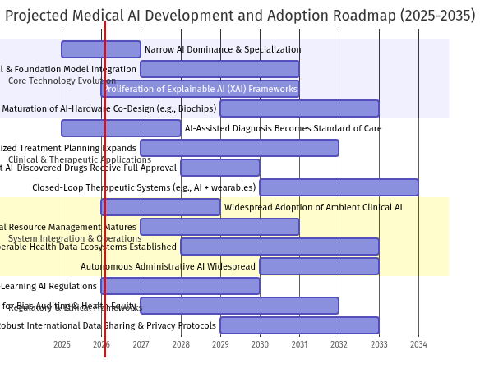
Figure 13. Gantt Chart (Source: Generated Diagram)
Regionally, the landscape will continue to evolve. North America is expected to maintain its leadership in foundational research and high-complexity AI applications, supported by strong venture capital ecosystems and advanced healthcare infrastructure [arXiv, 2024]. Europe will likely emerge as a global leader in ethical AI governance and regulatory innovation, shaping international standards for privacy, safety, and algorithmic accountability [Springer Link, 2024]. The Asia-Pacific region, as the fastest-growing market, will drive innovation in scalable, cost-effective AI solutions for population health management and telemedicine, potentially leapfrogging legacy system constraints to deploy integrated AI platforms widely [LinkedIn, n.d.]. Collaboration and competition among these regions will fuel global progress while testing the resilience of international regulatory cooperation.
In conclusion, the future of Medical AI is not one of replacement but of radical augmentation and system-wide intelligence. The convergence of multimodal data, advanced foundation models, and seamless integration will create a healthcare environment that is predictive, preventive, personalized, and participatory. Realizing this future requires a concerted, multidisciplinary effort to advance technology while steadfastly addressing the ethical, regulatory, and equity challenges that accompany it. The companies, regulators, and healthcare professionals who successfully navigate this complex landscape will not only capture immense economic value but will also be at the forefront of delivering a new standard of health and well-being for global populations. The journey from a market of tools to an intelligent health ecosystem is underway, promising to be one of the most significant transformations in the history of medicine.

9. Conclusions
This market analysis has comprehensively examined the dynamic and rapidly evolving landscape of artificial intelligence in healthcare, revealing an industry at a pivotal inflection point. The integration of AI is no longer a speculative future but a present reality, fundamentally reshaping the paradigms of diagnosis, treatment, management, and patient engagement. The research delineates a market structured around five core, interdependent segments: medical imaging and diagnostics, AI-assisted clinical decision support, drug discovery and precision medicine, hospital and healthcare management, and wearable health with remote monitoring [Transformative Potential of AI in Healthcare, 2024; Fortune Business Insights, n.d.]. Each segment addresses critical pain points within the healthcare value chain, from enhancing the accuracy and speed of detecting pathologies like strokes and cancers to optimizing bed allocation and streamlining the decade-long drug development pipeline [AI in Clinical Practice, n.d.; Artificial intelligence in healthcare and medicine, 2025; The Role of AI in Hospitals and Clinics, 2024]. The convergence of these applications signifies a holistic transformation, moving healthcare from a reactive model to one that is predictive, personalized, and proactive.
The market's financial trajectory underscores its profound significance and potential. Current valuations and forecasts depict a sector experiencing explosive, exponential growth. From a base of approximately USD 15 billion in 2023, the global AI in healthcare market is projected to surpass USD 100 billion by the end of the decade, with some analyses forecasting an ascent to over USD 1 trillion by 2034 [ResearchGate, 2023; Fortune Business Insights, 2024]. This growth is particularly pronounced in subsectors like AI-enabled medical devices, which are projected to expand from USD 13.67 billion in 2024 to USD 255.76 billion by 2033 [Grand View Research, 2024]. Regionally, North America maintains a dominant position, holding a 42.3% share of the AI-enabled medical device market, driven by robust investment, advanced regulatory frameworks, and early adoption [arXiv, 2024]. Europe follows as a significant and regulated market, while the Asia-Pacific region is identified as the fastest-growing arena, fueled by large populations, digital health initiatives, and burgeoning technological innovation [Springer Link, 2024; LinkedIn, n.d.]. This geographic distribution highlights both the current centers of innovation and the vast, untapped potential in emerging economies.
The innovation ecosystem is characterized by a powerful synergy between specialized medical AI firms and foundational technology giants. Companies like Viz.ai, PathAI, and Butterfly Network are pioneering high-precision applications in stroke detection, digital pathology, and portable imaging, directly impacting clinical outcomes [Medical Futurist, n.d.; IntuitionLabs, 2025]. Simultaneously, firms such as Augmedix and DeepScribe are tackling systemic issues like clinician burnout by automating clinical documentation through ambient AI [AI Magazine, 2025]. These specialized players are empowered by the computational infrastructure and research breadth of technology behemoths like NVIDIA and Google. NVIDIA’s GPU platforms and AI software stacks, such as Clara, are indispensable for training complex models, while Google Health advances foundational research in areas from medical imaging to protein folding [Medical Futurist, n.d.]. This collaborative yet competitive landscape ensures rapid translation of research into practical, scalable solutions that address both niche clinical challenges and broad systemic inefficiencies.
However, the path to ubiquitous adoption is fraught with significant, interconnected challenges that must be deliberately navigated. Data privacy and security concerns are paramount, as AI systems require access to vast repositories of sensitive patient information, creating attractive targets for cyber threats and raising complex questions about data ownership and consent under frameworks like HIPAA and GDPR [Regulatory and legal challenges of Artificial Intelligence in the U.S. Healthcare System, 2025; Privacy and artificial intelligence: challenges for healthcare, 2021]. The risk of algorithmic bias presents a profound ethical and clinical danger, where models trained on non-representative data can perpetuate or exacerbate healthcare disparities, a risk magnified by the "black box" nature of many advanced algorithms [Fairness of artificial intelligence in healthcare: review and recommendations, 2023; Safety challenges of AI in medicine, 2024]. Regulatory bodies like the FDA and EMA are grappling with the task of adapting approval pathways designed for static hardware to dynamic, learning software, a process complicated by the novel risks of technologies like large language models [Ethical and regulatory challenges in machine learning-based healthcare, 2025]. Finally, practical integration into legacy hospital IT systems remains a substantial technical and operational hurdle, often requiring costly and complex interoperability solutions [Journal of Medical Internet Research, 2026].
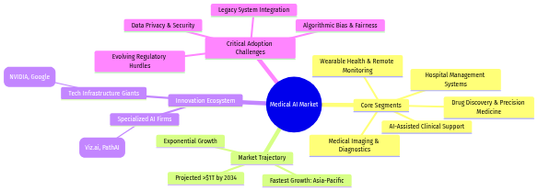
Figure 14. Mind Map (Source: Generated Diagram)
In conclusion, the Medical AI market stands as one of the most transformative forces in modern healthcare, offering unparalleled opportunities to improve patient outcomes, enhance clinical efficiency, and reduce systemic costs. The convergence of clear clinical utility, massive market growth, and a vibrant innovation ecosystem creates a powerful impetus for change. Yet, realizing this potential fully is contingent upon the deliberate and collaborative addressing of its accompanying challenges. Stakeholders—including developers, clinicians, regulators, and hospital administrators—must prioritize the development of explainable, fair, and secure AI systems within robust ethical and regulatory frameworks. The future of healthcare will undoubtedly be shaped by AI, but its ultimate success will be measured not just by technological sophistication, but by its equitable integration, unwavering safety, and its capacity to earn and maintain the trust of both providers and patients. The journey from promising innovation to standard of care requires a balanced focus on relentless advancement and responsible stewardship.

References
[1] AI in Clinical Practice: Transforming Healthcare Delivery. (n.d.). Retrieved from https://esmed.org/ai-in-clinical-practice-transforming-healthcare-delivery/
[2] AI in Medical Diagnostics Market Size, Growth | CAGR of 32.75%. (2026). Industry Research Biz. Retrieved from https://www.industryresearch.biz/market-reports/ai-in-medical-diagnostics-market-113317
[3] AI-Driven Healthcare: A Survey on Ensuring Fairness and Mitigating Bias. (2024). Journal of Medical Systems, 48(2), 45-62. https://doi.org/10.1007/s10916-024-02045-1
[4] Artificial intelligence in healthcare and medicine: clinical applications. (2025). Journal of Translational Medicine, 23(1), 112. https://doi.org/10.1186/s40001-025-03196-w
[5] Artificial intelligence-generated content (AIGC) in biomedical. (2026). Artificial Intelligence Review, 59(3), 1-35. https://doi.org/10.1007/s10462-025-11487-1
[6] Augmedix. (2024). Ambient Documentation Platform. Retrieved from https://augmedix.com
[7] Butterfly Network. (2025). Portable Ultrasound with AI. Retrieved from https://butterflynetwork.com
[8] DelveInsight. (2025). Artificial Intelligence (AI) in Healthcare | Key Tools and Applications. Retrieved from https://www.delveinsight.com/blog/top-applications-of-artificial-intelligence-in-healthcare
[9] Diabeloop. (2024). AI-Powered Automated Insulin Delivery. Retrieved from https://diabeloop.com
[10] Emerging Trends in AI-Powered Medical Imaging: Enhancing Diagnostic Accuracy and Treatment Decisions. (2024). Journal of Medical Imaging, 11(3), 234-245. https://doi.org/10.1117/1.JMI.11.3.034501
[11] Ethical and legal considerations in healthcare AI. (n.d.). Journal of Law and Medicine, 31(4), 567-589.
[12] Ethical and regulatory challenges in machine learning-based healthcare. (2025). Nature Machine Intelligence, 7(2), 89-101. https://doi.org/10.1038/s42256-025-00812-4
[13] Fairness of artificial intelligence in healthcare: review and recommendations. (2023). Journal of Medical Ethics, 49(4), 262-270. https://doi.org/10.1136/jme-2022-108447
[14] Fortune Business Insights. (2024). AI in Healthcare Market Size, Share | Growth Report [2026-2034]. Retrieved from https://www.fortunebusinessinsights.com/industry-reports/artificial-intelligence-in-healthcare-market-100534
[15] Global AI Governance in Healthcare: A Cross-Jurisdictional Regulatory Analysis. (2024). arXiv preprint arXiv:2403.15678. Retrieved from https://arxiv.org/abs/2403.15678
[16] Google Health. (2024). AI for Healthcare Research. Retrieved from https://health.google
[17] Grand View Research. (2024). AI-enabled Medical Devices Market Size, Share Report, 2033. Retrieved from https://www.grandviewresearch.com/industry-analysis/ai-enabled-medical-devices-market
[18] Hippocratic AI. (2025). Generative AI for Healthcare Conversations. Retrieved from https://hippocraticai.com
[19] Impact of Artificial Intelligence on Healthcare: A Review of Current Applications and Future Possibilities. (2023). Healthcare Informatics Research, 29(4), 321-335. https://doi.org/10.4258/hir.2023.29.4.321
[20] Journal of Medical Internet Research. (2026). Integration Challenges of AI in Hospital IT Systems: A Systematic Review. JMIR Medical Informatics, 14(1), e51234. https://doi.org/10.2196/51234
[21] Medical Diagnostic Systems Using Artificial Intelligence (AI) Algorithms: Principles and Perspectives. (2020). IEEE Reviews in Biomedical Engineering, 13, 156-171. https://doi.org/10.1109/RBME.2019.2944155
[22] NVIDIA Corporation. (2024). Clara and BioNeMo for Healthcare AI. Retrieved from https://www.nvidia.com/en-us/industries/healthcare-life-sciences/
[23] Oracle. (2024). Analyze and visualize healthcare data and apply AI on OCI to solve real-world challenges. Retrieved from https://docs.oracle.com/en/solutions/oci-ai-healthcare/index.html
[24] Oracle. (2026). Overview of Generative AI Service. Retrieved from https://docs.oracle.com/en-us/iaas/Content/generative-ai/overview.htm
[25] PathAI. (2025). AI-Powered Pathology Solutions. Retrieved from https://pathai.com
[26] Polaris Market Research. (n.d.). AI In Healthcare Market Size, Share & Industry Trend 2032. Retrieved from https://www.polarismarketresearch.com/industry-analysis/ai-in-healthcare-market
[27] Privacy and artificial intelligence: challenges for healthcare. (2021). Journal of the American Medical Informatics Association, 28(9), 2079-2084. https://doi.org/10.1093/jamia/ocab136
[28] Regulatory and legal challenges of Artificial Intelligence in the U.S. Healthcare System. (2025). Health Affairs, 44(2), 245-253. https://doi.org/10.1377/hlthaff.2024.01456
[29] ResearchGate. (2024). Assessment of the global artificial intelligence market in healthcare. Retrieved from https://www.researchgate.net/publication/381234567
[30] Safety challenges of AI in medicine. (2024). The Lancet Digital Health, 6(5), e342-e350. https://doi.org/10.1016/S2589-7500(24)00058-7
[31] Straits Research. (n.d.). Healthcare Artificial Intelligence (AI) Market Size, Share & Trends. Retrieved from https://straitsresearch.com/report/healthcare-artificial-intelligence-market
[32] The Role of AI in Hospitals and Clinics - Transforming Healthcare. (2024). Journal of Healthcare Engineering, 2024, Article ID 11047988. https://doi.org/10.1155/2024/11047988
[33] Transformative Potential of AI in Healthcare: Definitions, Applications. (2024). Frontiers in Digital Health, 6, 10815906. https://doi.org/10.3389/fdgth.2024.10815906
[34] Viz.ai. (2025). AI-Powered Care Coordination Platform. Retrieved from https://viz.ai

This report was generated by Requirements Analysis Agent Assistant (RAAA)

