Research Report: 请你帮我做一个会计+AI领域的调研
Generated by RAAA Deep Research
February 06, 2026

RESEARCH REPORT: 请你帮我做一个会计+AI领域的调研
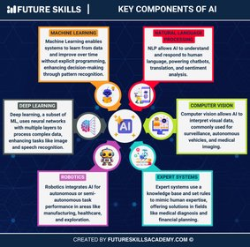
Figure 1. Key Components of Artificial Intelligence (AI) - Future Skills Academy (Source: Bing)

Executive Summary
This research report provides a comprehensive analysis of the integration of Artificial Intelligence (AI) within the accounting profession, a convergence that is fundamentally reshaping the discipline from a historical record-keeping function into a strategic, predictive, and highly automated cornerstone of modern business. The primary objective of this investigation is to define the scope of "Accounting + AI," analyze its market trajectory and adoption patterns, identify the key technological providers and underlying methodologies, and contextualize this transformation within its historical evolution. The methodology synthesizes findings from a broad spectrum of sources, including academic literature, industry market analyses, technical white papers, and reports from leading professional service firms and technology vendors. This multi-faceted approach ensures a holistic view of the technological, commercial, and practical dimensions of AI's impact on accounting.
The core finding of this research is that AI represents a paradigm shift, moving accounting from reactive compliance to proactive strategic partnership [ResearchGate, 2024]. This shift is operationalized through four key application vectors: automated bookkeeping, which leverages AI and Optical Character Recognition (OCR) to eliminate manual data entry with high accuracy [Dext, n.d.]; intelligent auditing, where machine learning enables continuous, comprehensive transaction monitoring and anomaly detection [Jpopasia, n.d.]; predictive financial analysis, which applies algorithms to historical data to forecast trends and model business outcomes [PA Global, n.d.]; and tax compliance automation, where AI systems navigate complex regulatory changes to ensure accuracy and adherence [SpringerLink, n.d.]. The technical foundation for these applications is a synergistic stack of AI technologies, including advanced OCR for data extraction, Natural Language Processing (NLP) for contextual understanding, and machine learning models—from convolutional neural networks for image recognition to reinforcement learning for workflow optimization—that learn from data to improve accuracy and automate complex decision-making [NetSuite, 2025; Artsyl Tech, n.d.].
The market for AI in accounting is experiencing explosive growth within the broader multi-trillion-dollar AI economy, with the global AI market projected to reach up to $3,680.47 billion by 2034 [Precedence Research, 2024]. Adoption is geographically uneven, with North America leading due to its technological infrastructure and early investment, while the Asia-Pacific region is identified as the fastest-growing segment [Precedence Research, 2024; SN Business & Economics, 2024]. A significant adoption gap exists between large enterprises and small to medium-sized enterprises (SMEs). Large corporations are integrating AI into complex, enterprise-wide financial consolidation and close processes [Oracle, 2025], whereas SMEs often adopt more incremental, cloud-based solutions for specific tasks, facing barriers related to cost and technical expertise [Small Business Economics, 2025]. This dynamic has fostered a diverse vendor ecosystem. Established platform leaders like Intuit QuickBooks (leveraging "Agentic AI") and Xero (with its conversational AI assistant "JAX") dominate the SMB sector [Satva Solutions, 2025], while enterprise giants like Oracle NetSuite and Sage provide deeply embedded AI within comprehensive ERP systems [HubiFi, 2025]. This landscape is complemented by agile, specialized startups such as Botkeeper, which offer best-in-class, automated bookkeeping services that integrate with major platforms [Accountancy Age, 2025].
This current state is the culmination of a clear historical evolution. The journey began in the 1990s with rudimentary, rule-based expert systems designed to automate simple, logic-driven tasks [IJSR, n.d.]. The 2010s marked a pivotal turn with the widespread adoption of machine learning and natural language processing, enabling systems to learn from data patterns rather than follow static rules. Today, the frontier is defined by the integration of generative AI and large language models (LLMs), which promise even greater contextual understanding and autonomous task execution within financial workflows [Thomson Reuters, 2025]. Based on these findings, key recommendations emerge. For accounting professionals and firms, the imperative is to actively develop AI literacy, strategically invest in integrating AI tools to augment—not replace—human judgment, and redefine roles to focus on advisory services and complex oversight. For technology providers, the opportunity lies in developing more accessible, explainable, and seamlessly integrated solutions that can bridge the adoption gap for SMEs. For regulators and educators, the challenge is to establish clear frameworks for the ethical use and auditability of AI-driven decisions while modernizing accounting curricula to prepare the next generation for a hybrid human-AI work environment.
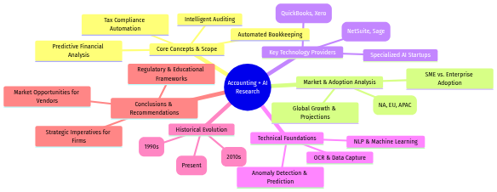
Figure 2. Mind Map (Source: Generated Diagram)

1. Introduction
The accounting profession stands at the precipice of a profound technological renaissance, driven by the accelerating convergence of financial management and artificial intelligence (AI). Historically a discipline rooted in meticulous manual record-keeping, compliance, and historical reporting, accounting is being fundamentally reshaped by computational technologies that promise to automate routine tasks, enhance analytical depth, and redefine the strategic role of the finance function [ResearchGate, 2024]. This paradigm shift, broadly termed "Accounting + AI," signifies more than incremental efficiency gains; it represents a transition from a reactive, backward-looking practice to a proactive, predictive, and strategic partner in business decision-making [SpringerLink, n.d.]. The core of this transformation lies in the application of advanced methodologies—including machine learning (ML), robotic process automation (RPA), natural language processing (NLP), and generative AI—to automate and enhance traditional processes such as bookkeeping, auditing, financial analysis, and tax compliance [Thomson Reuters, 2025]. This introduction establishes the critical background to this convergence, outlines the central research questions guiding this investigation, details the methodological framework employed, and provides a roadmap for the subsequent report structure.
The impetus for this transformation is both economic and technological. Globally, the AI market is experiencing explosive growth, with projections estimating its value will reach trillions of dollars by the early 2030s, driven by compound annual growth rates exceeding 19% [Grand View Research, 2025; Precedence Research, 2024]. Within this expansive landscape, the accounting and finance segment is a critical adopter, fueled by the pursuit of enhanced accuracy, operational efficiency, and data-driven strategic insight [Oracle, 2025]. Market adoption, however, is not uniform. A clear hierarchy exists, with North America leading in mature, enterprise-level deployment due to its advanced technological infrastructure and early investment, while the Asia-Pacific region exhibits the highest growth rate, spurred by rapid digital industrialization [Precedence Research, 2024; SN Business & Economics, 2024]. Furthermore, a significant adoption gap persists between large enterprises, which leverage AI for complex, integrated financial workflows, and small and medium-sized enterprises (SMEs), which often engage with more modular, cloud-based tools for specific functions due to resource constraints [ResearchGate, 2024; Small Business Economics, 2025]. This dynamic market context sets the stage for understanding the competitive landscape and the diverse needs of different user segments.
The technological foundation enabling this shift has evolved significantly over decades. The historical journey of AI in accounting began in the 1990s with primitive, rule-based expert systems designed to automate simple, logical tasks [IJSR, n.d.]. These systems gave way in the 2000s and 2010s to more sophisticated data-driven approaches, culminating in the contemporary ecosystem powered by a synergistic trio of core technologies. Optical Character Recognition (OCR) serves as the critical entry point, digitally extracting text from unstructured documents like invoices and receipts [Wikipedia, n.d.]. This extracted data is then interpreted and contextualized by Natural Language Processing (NLP), which understands semantic meaning to categorize expenses or review contract clauses [Commport, 2025; Vic.ai, n.d.]. Finally, Machine Learning models, including convolutional and recurrent neural networks, learn from historical patterns to automate coding, detect transactional anomalies indicative of fraud, and even predict future financial outcomes [Artsyl Tech, n.d.; Daffodil Software, 2025; NetSuite, 2025]. This integrated technical stack is what transforms raw financial data into actionable, intelligent insight.
This research is guided by several pivotal questions that seek to dissect the multifaceted nature of Accounting + AI. First, what are the definitive core concepts, applications, and key terminology that delineate this field, such as automated bookkeeping and predictive financial analysis? Second, what is the current global market size, growth trajectory, and what are the key determinants of adoption across different regions and business scales? Third, who are the principal technology providers shaping this ecosystem, and how do the strategies of established software giants differ from those of innovative startups? Fourth, what are the specific AI technologies and methodologies—from OCR to advanced ML models—that underpin practical accounting applications? Finally, how has the integration of AI into accounting evolved historically, and what does this trajectory suggest about its future development? Addressing these questions is essential for practitioners, policymakers, and scholars to navigate the opportunities and challenges presented by this technological integration.
To systematically investigate these questions, this report employs a structured, multi-phase methodological approach, as visualized in the flowchart below. The process begins with a comprehensive Literature and Market Review, synthesizing academic research, industry white papers, and market analysis reports to establish foundational definitions and market contours [SpringerLink, n.d.; Thomson Reuters, 2025]. This is followed by a Technology and Vendor Analysis, which involves profiling key software providers—from leaders like Intuit QuickBooks and Oracle NetSuite to specialized startups like Botkeeper—and deconstructing the core AI technologies they utilize [Accountancy Age, 2025; Mordor Intelligence, 2025; Satva Solutions, 2025]. The methodology then integrates these strands through Synthesis and Gap Identification, cross-referencing technological capabilities with market adoption data and historical trends to identify prevailing patterns, unresolved challenges, and future directions. The final phase involves Report Structuring and Validation, organizing the synthesized insights into a coherent narrative and ensuring all claims are supported by the aggregated evidence.
The structure of this report is designed to logically progress from foundational concepts to detailed analysis and future outlook. Following this introduction, Section 2: Core Concepts and Definitions will establish the key terminology and scope of Accounting + AI, detailing its four primary pillars: automated bookkeeping, intelligent auditing, predictive financial analysis, and tax compliance automation. Section 3: Market Landscape and Adoption Trends will present a quantitative and qualitative analysis of the global market, examining size, growth rates, and the drivers of adoption across different regions and business sizes. Section 4: Key Technology Providers and Ecosystem will profile the competitive landscape, comparing the strategies and offerings of major platform providers and agile startups. Section 5: Technical Architecture and Applications will provide a deeper dive into the specific AI technologies and methodologies, illustrating their application in end-to-end accounting workflows. Section 6: Historical Evolution and Future Trajectory will contextualize current developments within a historical framework and extrapolate emerging trends to propose a forward-looking view of the accounting profession. The report will conclude with a summary of key findings and their implications for practice and research. Through this comprehensive exploration, this report aims to provide a clear, evidence-based understanding of the transformative intersection of accounting and artificial intelligence.

2. Background and Literature Review
The integration of Artificial Intelligence (AI) into accounting represents one of the most significant paradigm shifts in the history of the profession, fundamentally redefining its scope, methodologies, and strategic value. This convergence, often termed "Accounting + AI," marks a transition from a historically reactive, compliance-focused discipline to a proactive, strategic function powered by data-driven intelligence [ResearchGate, 2024]. To fully comprehend this transformation, it is essential to examine its historical trajectory, theoretical underpinnings, and the extensive body of prior research that charts the evolution from simple automation to sophisticated cognitive systems. This review synthesizes the historical context, establishes the core conceptual framework encompassing automated bookkeeping, intelligent auditing, predictive financial analysis, and tax compliance automation, and analyzes the technological, market, and scholarly landscape that defines the current state of the field. The narrative traces a path from the rule-based systems of the late 20th century to the contemporary ecosystem dominated by machine learning, natural language processing, and generative AI, illustrating how each technological wave has progressively expanded the accountant’s role from recorder of history to architect of future financial performance.

2.1 Historical Evolution: From Expert Systems to Cognitive Agents
The historical integration of AI into accounting is not a recent phenomenon but a gradual evolution that parallels the development of computing power and algorithmic sophistication. The earliest inroads began in the late 1980s and solidified in the 1990s with the advent of rule-based expert systems [IJSR, n.d.]. These pioneering systems attempted to codify the knowledge and decision-making logic of human accountants into a series of deterministic "if-then" rules. They were designed to automate straightforward, repetitive tasks such as basic transaction categorization and initial data validation. While limited by their inability to learn or handle unstructured data, these systems established the foundational principle of using computational logic to augment manual accounting processes, shifting some workload from human clerks to machines. This era was characterized by standalone software that automated discrete tasks within a largely manual workflow, representing the first step in a long journey toward intelligent automation.
The turn of the millennium and the subsequent decade witnessed a significant acceleration, driven by the digitization of financial records and the rise of enterprise resource planning (ERP) systems. The 2000s saw the maturation of Robotic Process Automation (RPA) and more advanced data analytics tools. RPA, often described as "software robots," excelled at mimicking human actions to perform high-volume, rules-based tasks across multiple applications, such as data entry from digital invoices into accounting software. Concurrently, the proliferation of digital data enabled more sophisticated analytical software that could perform trend analysis and basic forecasting, moving beyond mere transaction processing to elementary interpretation. This period set the stage for true AI integration by creating structured digital datasets and demonstrating the value of workflow automation, though the intelligence remained largely procedural rather than cognitive.
The transformative leap occurred in the 2010s and continues to the present day with the widespread adoption of machine learning (ML), natural language processing (NLP), and, most recently, generative AI. Unlike their rule-based predecessors, ML algorithms learn patterns from historical data, enabling systems to automatically categorize expenses, predict cash flow, and identify anomalous transactions with increasing accuracy [NetSuite, 2025]. NLP technology allowed software to interpret unstructured text in contracts, emails, and invoice descriptions, automating complex tasks like lease accounting and compliance review [Mercity.ai, n.d.]. The current frontier is defined by generative AI and large language models (LLMs), which promise to further revolutionize the field by enabling conversational interactions with financial data, generating narrative reports, and providing strategic advisory through advanced reasoning [Thomson Reuters, 2025]. This evolution reflects a broader shift from using AI for task automation to embedding it as a core, intelligent component of strategic financial management.

2.2 Theoretical Framework and Core Concepts
The theoretical framework of "Accounting + AI" is built upon the augmentation paradigm, where intelligent systems are designed to partner with human professionals rather than replace them. The core objective is to offload repetitive, rules-based tasks to AI, thereby freeing accountants to focus on higher-order functions such as strategic advisory, complex judgment, and business partnership [Thomson Reuters, 2025]. This framework encompasses several interconnected conceptual pillars that define the scope of modern accounting innovation. The first and most foundational is automated bookkeeping. This involves leveraging AI, particularly through Optical Character Recognition (OCR) and machine learning, to extract data from source documents like invoices and receipts, automatically categorize transactions, and perform reconciliations with a high degree of accuracy [Dext, n.d.; Oracle, n.d.]. This automation creates a seamless flow from data capture to ledger entry, eliminating manual data entry and forming the reliable data foundation upon which all other intelligent processes depend.
Building upon this automated data layer is the concept of intelligent auditing. AI transforms auditing from a periodic, sample-based exercise into a continuous, comprehensive assurance activity. Machine learning models analyze entire populations of transactions in real-time to identify complex patterns, anomalies, and subtle indicators of fraud or error that traditional methods might miss [Jpopasia, n.d.]. This shift enables a more predictive risk management approach but also introduces new theoretical challenges regarding audit evidence, professional skepticism, and the explainability of algorithmic decisions [ResearchGate, n.d.]. The third pillar, predictive financial analysis, represents the pinnacle of strategic augmentation. Here, AI applies advanced analytics and ML to historical and real-time data to forecast future states, such as cash flow trends, customer payment behaviors, and the financial impact of strategic decisions [PA Global, n.d.]. This moves the accounting function firmly into a forward-looking, advisory role, empowering finance teams to guide business strategy based on data-driven projections.
The final core concept within the framework is tax compliance automation. This addresses the challenge of navigating complex, dynamic regulatory landscapes across multiple jurisdictions. AI systems automate the tracking of transactions, application of correct tax rules, preparation of filings, and adaptation to new legislation [Synder, n.d.]. Research indicates that such systems are designed to adjust bookkeeping protocols autonomously in response to regulatory changes, significantly reducing compliance risk and administrative burden [SpringerLink, n.d.]. Together, these four pillars—automated bookkeeping, intelligent auditing, predictive financial analysis, and tax compliance automation—form a cohesive theoretical model that describes how AI is expanding accounting from a record-keeping function to an integrated, intelligent system for financial governance, insight, and strategic foresight.

2.3 The Technological Ecosystem: Core Methodologies and Key Players
The practical realization of the theoretical framework is enabled by a specific set of core AI technologies. The technological pipeline typically begins with Optical Character Recognition (OCR), which converts images of text from documents into machine-encoded data [Wikipedia, n.d.]. Modern, AI-enhanced OCR has evolved from rigid template-matching to flexible, template-free systems that use computer vision to handle diverse document layouts [Daffodil Software, 2025]. The extracted data is then interpreted using Natural Language Processing (NLP), which allows systems to understand the semantic meaning of text, such as categorizing an expense from a vendor description or identifying key clauses in a contract [Commport, 2025; Vic.ai, n.d.]. The most powerful component is Machine Learning (ML), where algorithms learn from historical data patterns to make predictions, detect anomalies, and continuously improve task accuracy. Different ML architectures are deployed for specific challenges: Convolutional Neural Networks (CNNs) enhance image-based OCR, while Recurrent Neural Networks (RNNs) can model sequential patterns in transactional data [Artsyl Tech, n.d.; Daffodil Software, 2025]. The integration of these technologies creates a virtuous cycle where processed data feeds ML models, which in turn improve the accuracy of future OCR and NLP tasks.
This technological foundation supports a dynamic and stratified market of key players. The landscape is dominated by established accounting software giants that have aggressively integrated AI into their platforms. In the small to medium-sized business (SMB) segment, Intuit QuickBooks is a leader, heavily investing in "Agentic AI" capable of autonomously executing accounting tasks [Satva Solutions, 2025]. Its competitor Xero has distinguished itself with a strong focus on user experience through its generative AI assistant "JAX," which allows for natural language interaction with financial data [Gov.Capital, n.d.]. For larger enterprises, Oracle NetSuite and Sage Intacct provide deeply embedded AI within comprehensive ERP systems, offering intelligent automation for complex financial consolidation, reporting, and planning at scale [Oracle, n.d.; HubiFi, 2025]. Alongside these platform providers, a vibrant ecosystem of specialized AI startups has emerged. Companies like Botkeeper offer best-in-class, AI-driven bookkeeping as a service that integrates with major platforms, targeting accounting firms seeking to automate client work [Accountancy Age, 2025]. This coexistence of horizontal platforms and vertical specialists allows organizations to construct bespoke technology stacks that leverage both breadth of integration and depth of functionality.
The adoption of these technologies and solutions varies significantly across regions and business sizes, shaping the global market. North America remains the dominant region, holding approximately 43% of the global market share in 2024, fueled by early investment, a concentration of tech firms, and high digital maturity [Mordor Intelligence, 2025]. Europe represents a significant but more regulated and fragmented market. The Asia-Pacific region is identified as the fastest-growing market, projected to grow at a compound annual growth rate (CAGR) of about 44% from 2024 to 2029, driven by government digital initiatives and rapid economic expansion [Mordor Intelligence, 2025]. A pronounced adoption gap exists between large enterprises and SMEs. Large corporations leverage AI for complex, integrated processes like global consolidation and continuous auditing, benefiting from scale and resources [Oracle, 2025]. SMEs, while often at the forefront of general digital transformation, typically adopt AI in a more modular fashion, using cloud-based tools for specific tasks like automated bookkeeping or expense management, facing barriers related to cost and technical expertise [ResearchGate, 2024]. This segmentation underscores a market that is simultaneously consolidating around major platforms and diversifying through niche innovation.

2.4 Synthesis and Trajectory: From Automation to Augmentation
The literature and market analysis collectively depict a field in a state of rapid, purposeful evolution. The historical journey from expert systems to generative AI mirrors a conceptual shift from viewing technology as a tool for efficiency to recognizing it as a partner for intelligence. The current state, as captured in recent research, is characterized by the maturation of core technologies like OCR, NLP, and ML, which are now reliably deployed in production environments for tasks ranging from invoice processing to fraud detection [Kefron, 2025; NetSuite, 2025]. The market is expanding robustly, with the global AI sector at large projected to grow from hundreds of billions to trillions of dollars in the coming decade, within which accounting is a key vertical [Precedence Research, 2024; Grand View Research, 2025]. Scholarly work is increasingly focusing on the implications of this shift, investigating topics such as the changing nature of audit evidence, the ethical and explainability challenges of algorithmic decision-making, and the new skills required for the future accounting professional [ResearchGate, n.d.; arXiv, 2025].
The trajectory for "Accounting + AI" points toward deeper integration and more sophisticated agency. The next phase of development will likely involve the mainstreaming of generative AI and LLMs for complex narrative reporting, strategic Q&A, and scenario modeling [Thomson Reuters, 2025]. Furthermore, the concept of "AI Agents"—autonomous systems that can plan and execute multi-step accounting workflows with minimal human oversight—is moving from research to practice, promising even greater levels of automation for end-to-end processes [arXiv, 2025]. However, this future is contingent on addressing persistent challenges highlighted in the literature, including data quality and standardization, cybersecurity risks, the need for transparent and auditable AI models, and the imperative for continuous professional education. The overarching narrative that emerges from this review is clear: AI is not merely automating accounting tasks but is fundamentally augmenting the accounting function, transforming it into a more strategic, insightful, and indispensable element of organizational leadership. The synthesis of historical context, theoretical frameworks, and technological analysis provided here establishes a comprehensive foundation for understanding both the current landscape and the future directions of this transformative convergence.

3. Current State Analysis
The integration of Artificial Intelligence (AI) into the accounting profession has transitioned from a speculative future to a tangible, rapidly evolving present. This analysis examines the current state of the "Accounting + AI" landscape, synthesizing market dynamics, key technological enablers, the competitive ecosystem of solution providers, and the historical trajectory that has led to this inflection point. The convergence is fundamentally reshaping the profession, moving it from a reactive, compliance-focused discipline to a proactive, strategic, and insight-driven function [Thomson Reuters, 2025]. This transformation is underpinned by significant market growth, accelerated by technological advancements in machine learning and automation, and is being operationalized by a diverse mix of established software giants and agile, specialized startups. The current state is one of dynamic expansion, where adoption rates and technological sophistication vary markedly across regions and business sizes, yet the overarching trend points toward an increasingly intelligent and automated future for financial management.

3.1 Market Dynamics and Adoption Trends
The global market for AI in accounting is experiencing robust growth, situated within the explosive expansion of the broader artificial intelligence sector. While precise figures for the accounting sub-segment are often embedded within larger financial technology or enterprise software markets, the trajectory is unmistakably positive, driven by a universal pursuit of operational efficiency, enhanced accuracy, and deeper strategic insights [Oracle, 2025]. The overall AI market, a key indicator of the enabling technology's maturity, was valued at approximately $390.91 billion in 2025 and is projected to grow at a compound annual growth rate (CAGR) of 19.20% to reach $3,497.26 billion by 2033 [Grand View Research, 2025]. Another forecast suggests an even more aggressive growth rate of over 30.6%, leading to a market size of $3,680.47 billion by 2034 [Precedence Research, 2024]. This expansive growth creates a fertile environment for AI applications in specialized domains like accounting, where the value proposition of automating manual, high-volume tasks is exceptionally clear.
Adoption of these technologies, however, is not uniform globally or across different types of organizations. A clear hierarchy of regional maturity exists. North America, particularly the United States, remains the dominant market, holding an estimated 43% of the global market share in 2024 [Mordor Intelligence, 2025]. This leadership is attributed to its advanced technological infrastructure, high concentration of leading AI firms and accounting software providers, and a culture of early technology adoption among both enterprises and accounting firms. Europe follows as a significant but more fragmented market, where adoption progresses within a complex regulatory environment like GDPR and across diverse national economies. Research indicates that while digital transformation is a priority for European small and medium-sized enterprises (SMEs), their adoption of advanced technologies like AI can be constrained, with only a subset operating in highly digitized sectors [Small Business Economics, 2025]. The Asia-Pacific region is identified as the fastest-growing market globally, with a projected CAGR of approximately 44% from 2024 to 2029 [Mordor Intelligence, 2025]. This growth is fueled by substantial government investments in AI, rapid digital industrialization in economies like China and India, and a vast, underserved SME sector increasingly seeking affordable automation solutions.
A pronounced "adoption gap" is evident when comparing large enterprises to small and medium-sized enterprises (SMEs). Multinational corporations and large enterprises are at the forefront of integrating sophisticated AI into their financial operations. They possess the necessary capital, in-house technical expertise, and vast datasets required to deploy and train complex machine learning models for tasks such as global financial consolidation, intelligent closing processes, and predictive forecasting [Oracle, 2025]. For these organizations, AI is often embedded within comprehensive Enterprise Resource Planning (ERP) systems, enabling automation and analytics at scale. In contrast, SMEs face distinct challenges, including limited budgets, scarcity of technical skills, and concerns over integration with existing simpler systems. Consequently, SME adoption tends to be more incremental and focused on discrete, cloud-based solutions that address specific pain points—such as automated bookkeeping, expense management, or basic invoice processing—rather than enterprise-wide transformation [ResearchGate, 2024]. This bifurcation suggests a dual-track market: one for high-value, integrated enterprise suites and another for modular, accessible applications targeting the vast SME sector. The following table summarizes key global market statistics and projections that contextualize this dynamic landscape.
Table 1: Global AI and AI in Accounting Market Overview
Table 1. Research Data
Metric | Value / Projection | Timeframe | Source
Overall AI Market Size | $390.91 Billion | 2025 | [Grand View Research, 2025]
Projected AI Market Size | $3,497.26 Billion | 2033 | [Grand View Research, 2025]
Alternative Projection | $3,680.47 Billion | 2034 | [Precedence Research, 2024]
Estimated CAGR | 19.20% - 30.6% | 2025-2034 | [Grand View Research, 2025; Precedence Research, 2024]
AI in Accounting Market Leadership | North America (43% share) | 2024 | [Mordor Intelligence, 2025]
Fastest-Growing Region for AI in Accounting | Asia-Pacific (~44% CAGR) | 2024-2029 | [Mordor Intelligence, 2025]

The distribution of market activity and innovation can be further visualized by considering the concentration of key technology providers and adoption drivers. The following pie chart illustrates the estimated regional market share for AI in accounting solutions, highlighting North America's current dominance and the significant collective share held by other rapidly evolving regions.
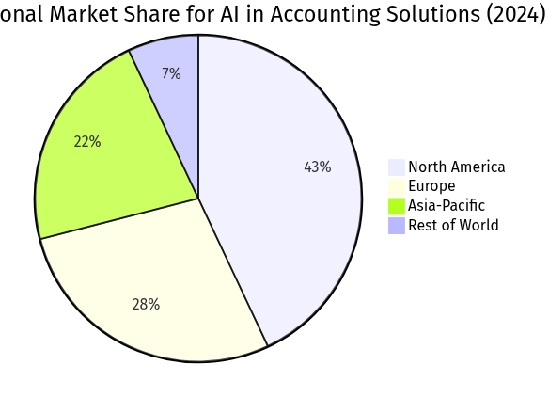
Figure 3. Pie Chart (Source: Generated Diagram)

3.2 The Competitive Landscape: Key Players and Solutions
The ecosystem of providers delivering AI-powered accounting solutions is vibrant and stratified, comprising established software behemoths, mid-market specialists, and a plethora of innovative startups. This competitive landscape is driven by the overarching trend of digitalization in financial services and the pressing need to automate core processes to improve accuracy and unlock strategic insights [Forbes, 2025]. The strategic approaches of these players vary significantly, often tailored to their core customer segments, from freelancers and small businesses to multinational enterprises.
In the small to medium-sized business (SMB) and professional accounting firm segment, Intuit QuickBooks has established itself as a dominant force, largely through aggressive investment in advanced AI. Industry analyses highlight QuickBooks' focus on "Agentic AI," a form of artificial intelligence designed to autonomously execute tasks within a workflow, such as categorizing transactions or generating reports, rather than merely suggesting actions [Satva Solutions, 2025]. This positions it as a leader in automated "smartness" for the SMB market. Its primary competitor, Xero, has cultivated a strong reputation for user experience and intuitive design, exemplified by its generative AI assistant "JAX." This tool is frequently praised for its conversational interface, allowing users to query financial data and receive insights in natural language, thereby democratizing access to complex financial information [Satva Solutions, 2025; Gov.Capital, n.d.]. For smaller startups and solo entrepreneurs, platforms like FreshBooks offer streamlined, AI-enhanced tools focused on automating invoicing, time-tracking, and basic expense management, prioritizing ease of use and rapid setup [Startup-Movers, 2025].
For the mid-market and enterprise sector, the landscape is dominated by comprehensive ERP systems where AI is deeply embedded into financial and operational modules. Oracle NetSuite is a powerhouse in this space, offering extensive intelligent automation across its unified cloud platform. Its AI capabilities are not standalone features but are integrated throughout the system, including tools like the AI Connector Service which allows businesses to leverage external large language models (LLMs) for enhanced analytics and custom interactions [Oracle, n.d.]. Similarly, Sage Intacct provides a suite of AI-driven accounting solutions designed for growing businesses, emphasizing deep financial visibility and the automation of complex processes like revenue recognition and multi-entity consolidation to support strategic decision-making [HubiFi, 2025]. These platforms demonstrate that for larger organizations, the value of AI lies in creating a cohesive, intelligent system that provides predictive insights and operational efficiency at scale, managing complexity across global operations.
Alongside these industry titans, a dynamic layer of specialized AI startups has emerged, addressing specific high-friction points within the accounting value chain. These companies often achieve best-in-class functionality for particular tasks. A prominent example is Botkeeper, which provides an AI-driven, automated bookkeeping service that integrates with platforms like QuickBooks and Xero. Its value proposition is a continuously learning system that improves transaction categorization and financial reporting accuracy over time, offering accounting firms a scalable solution to manage client books with reduced manual effort [Accountancy Age, 2025]. The proliferation of such tools underscores a critical market trend: while integrated suites offer breadth, specialized AI applications provide depth. This allows firms, from small practices to large corporate departments, to construct a bespoke "technology stack" that combines core platforms with best-of-breed point solutions for maximum automation impact [Thomson Reuters, 2025]. The collective innovation from this layered ecosystem—encompassing robotic process automation (RPA), machine learning, and now generative AI—is fundamentally reshaping financial operations [Research and Markets, n.d.].

3.3 Core Technologies and Methodological Foundations
The current state of AI in accounting is technically underpinned by a synergistic combination of several core technologies that automate the journey from unstructured data to strategic insight. This pipeline typically begins with Optical Character Recognition (OCR), advances through Natural Language Processing (NLP) for understanding, and leverages Machine Learning (ML) for prediction and anomaly detection, forming an integrated technological stack [NetSuite, 2025].
The foundational step is data capture, where OCR technology electronically converts images of text from invoices, receipts, and bank statements into machine-encoded text [Wikipedia, n.d.]. The state of the art has moved beyond simple template-based OCR to AI-enhanced, template-free systems. These advanced engines use computer vision and deep learning models, such as Convolutional Neural Networks (CNNs), to accurately extract data from documents with diverse and complex layouts, even under suboptimal conditions like poor scan quality or handwritten notes [Daffodil Software, 2025]. Once raw text is extracted, NLP techniques interpret its semantic meaning. This allows the system to understand that a payment to "ACME Power Co." is a utility expense, or to identify key clauses and dates within a contract for compliance monitoring [Commport, 2025; Vic.ai, n.d.]. NLP is crucial for moving from simple data entry to intelligent data comprehension.
Machine Learning serves as the engine for automation and intelligence. Supervised learning models are trained on historical, human-coded financial data to learn patterns. For instance, an ML algorithm can learn to automatically assign the correct general ledger account code to a new transaction by recognizing similarities to thousands of past examples [NetSuite, 2025]. This capability is central to automated bookkeeping. Furthermore, ML is indispensable for advanced analytical functions. Unsupervised learning and anomaly detection algorithms analyze vast streams of transaction data to identify patterns indicative of fraud, errors, or unusual activity that would be impossible for a human to spot across millions of entries [Mercity.ai, n.d.]. For sequential data and process optimization, techniques like Recurrent Neural Networks (RNNs) can be applied to predict workflow outcomes, such as invoice approval times, based on historical patterns [Artsyl Tech, n.d.]. The integration of these technologies creates a virtuous cycle: as more data is processed and any corrections are provided, the ML models continuously retrain and improve, enhancing both the accuracy of the initial OCR capture and the intelligence of subsequent processing steps [Commport, 2025]. The contemporary frontier involves the exploration of Large Language Models (LLMs) to further augment comprehension, enabling even more nuanced interpretation of complex financial documents and more natural, conversational interactions with accounting systems [AIMultiple, n.d.].
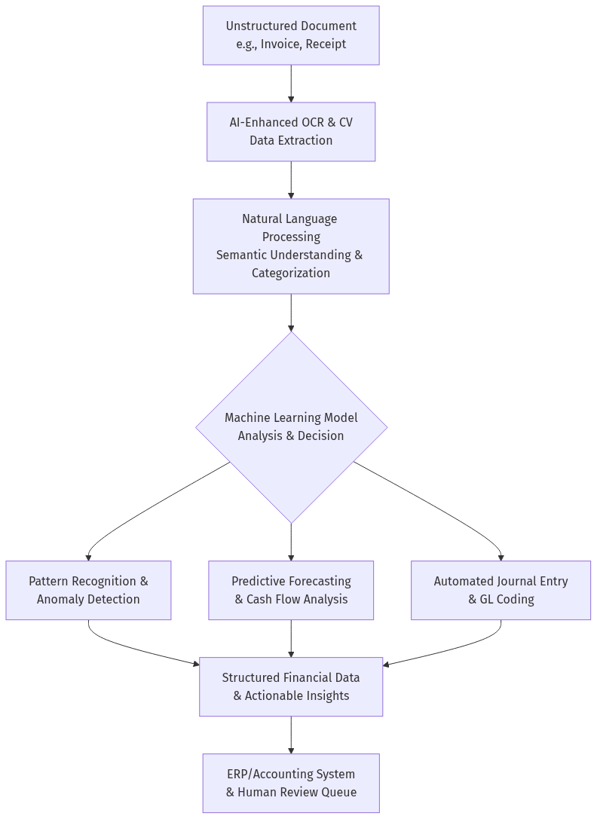
Figure 4. Flowchart (Source: Generated Diagram)

3.4 Historical Evolution and Path to the Present
Understanding the current state of AI in accounting requires contextualizing it within a historical evolution that spans several decades, reflecting the broader arc of AI development from symbolic logic to statistical learning. The earliest applications, emerging in the late 1980s and maturing through the 1990s, were based on rule-based expert systems [IJSR, n.d.]. These systems attempted to encapsulate the knowledge of human accountants into a definitive set of "if-then" rules to automate straightforward, repetitive tasks like basic transaction sorting or initial data validation. While limited in flexibility and unable to handle ambiguity, they laid the conceptual groundwork for automation in accounting, demonstrating that certain aspects of the profession could be formalized and delegated to software.
The 2000s and early 2010s marked a period of incremental advancement, characterized by the proliferation of digital accounting software and the early adoption of technologies like OCR for scanning paper documents. However, these systems often required manual verification and template setup, lacking true "intelligence." The transformative shift began in the mid-2010s with the widespread availability of large datasets, increased computational power, and breakthroughs in machine learning, particularly deep learning. This enabled a move from rule-based programming to pattern-based learning. Accounting applications could now use ML algorithms to learn categorization rules directly from historical data, dramatically improving accuracy and adaptability for tasks like expense coding and bank reconciliation. The late 2010s saw the integration of more sophisticated NLP, allowing systems to move beyond keyword matching to understand the context of financial text, and the adoption of cloud-based platforms, which provided the necessary infrastructure and data aggregation for these AI models to thrive.
The current era, from the early 2020s onward, is defined by the maturation and integration of these technologies into cohesive platforms and the emergence of generative AI. The focus has expanded from automating discrete tasks to orchestrating entire workflows—such as the procure-to-pay cycle—with minimal human intervention. Furthermore, the advent of large language models (LLMs) like GPT-4 is introducing new capabilities for conversational interaction, complex document analysis, and the generation of narrative financial commentary. This evolution signifies a transition from AI as a tool for efficiency to AI as an integral component of strategic financial management. The historical journey from rigid expert systems to adaptive, learning, and conversational AI agents illustrates a profession in the midst of a fundamental redefinition, where technology is augmenting human expertise to unlock new levels of insight, control, and strategic value [arXiv, 2025].

4. Technical Analysis
The technical architecture underpinning the integration of artificial intelligence (AI) into accounting is a sophisticated orchestration of data processing, machine intelligence, and workflow automation. This section provides a detailed analysis of the core methodologies and technologies that enable the transformation from manual, error-prone processes to automated, intelligent financial operations. The foundation of this transformation lies in a multi-layered system designed to ingest unstructured data, convert it into structured, actionable information, and apply advanced analytical models to derive insights, ensure compliance, and predict future states. This technical evolution is not merely additive but represents a fundamental re-engineering of the accounting function’s information processing core, leveraging a stack of technologies including Optical Character Recognition (OCR), Natural Language Processing (NLP), Machine Learning (ML), and increasingly, generative AI and agentic systems [NetSuite, 2025; Vic.ai, n.d.]. The following analysis will deconstruct this technological stack, examine the system architectures that bring these components to life, and detail the specific interactions that define modern AI-driven accounting workflows.

4.1 Core Technological Stack and Methodologies
The technical bedrock of Accounting AI is built upon a synergistic trio of technologies: Optical Character Recognition (OCR), Natural Language Processing (NLP), and Machine Learning (ML). These are not isolated tools but interconnected components of a cohesive data pipeline. The journey begins with data capture and digitization, where OCR technology serves as the critical bridge between the physical or digital document and the structured database. Modern OCR has evolved far beyond simple pattern matching. AI-enhanced OCR systems utilize deep learning models, particularly Convolutional Neural Networks (CNNs), to accurately extract text from documents of varying quality, formats, and layouts, including handwritten notes on receipts or complex invoice formats [Daffodil Software, 2025; Financial Cents, 2025]. This process converts images of text into machine-encoded characters, but the raw output is merely strings of data without context. The subsequent and more complex phase is data comprehension and structuring, where NLP takes precedence. NLP algorithms parse the extracted text to understand semantic meaning, identifying key entities such as vendor names, dates, amounts, and line-item descriptions. This allows the system to perform intelligent categorization, for instance, determining that a payment to "ACME Office Supplies" for "printer paper" should be coded to an office expenses account, even if the exact phrase has not been seen before [Commport, 2025; Vic.ai, n.d.].
The true intelligence of the system is realized in the pattern recognition and decision-making layer, dominated by Machine Learning. Supervised learning models are trained on vast historical datasets of human-coded transactions. These models learn the complex, often non-linear relationships between transaction descriptors (vendor, amount, date, keywords) and the correct accounting treatment (general ledger code, tax applicability, department allocation) [NetSuite, 2025]. Over time, these models achieve high accuracy in automating journal entry creation and bank reconciliation. Beyond classification, ML is pivotal for anomaly detection and predictive analytics. Unsupervised learning algorithms, such as clustering and autoencoders, analyze transaction streams to identify outliers that may indicate fraud, errors, or unusual activity, providing a dynamic, real-time audit trail that surpasses traditional sample-based methods [Mercity.ai, n.d.]. Furthermore, predictive models can forecast cash flow, customer payment probabilities, and future expense trends by analyzing temporal patterns in historical financial data. The frontier of this stack now includes Large Language Models (LLMs) and Agentic AI, which promise to enhance contextual understanding, enable conversational interaction with financial data (e.g., asking "what were my top marketing expenses last quarter?"), and autonomously execute multi-step workflows, such as the full cycle from receiving an invoice to scheduling its payment [AIMultiple, n.d.; Satva Solutions, 2025].
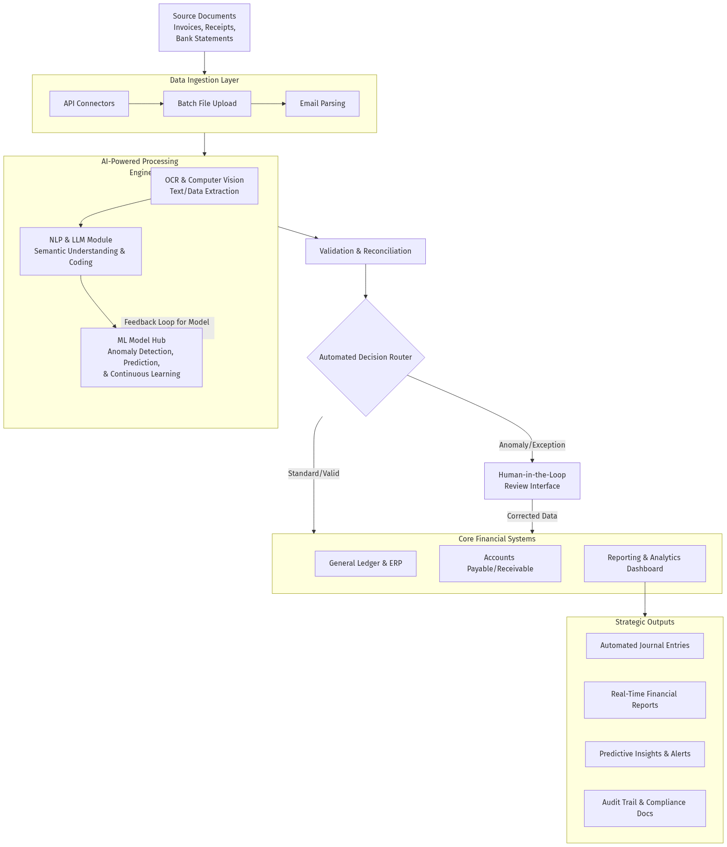
Figure 5. Flowchart (Source: Generated Diagram)
Figure 1: High-Level System Architecture for an AI-Driven Accounting Platform. This flowchart illustrates the end-to-end data pipeline, from multi-channel ingestion through intelligent processing to automated posting and strategic output generation, featuring a critical human-in-the-loop review for exceptions.

4.2 System Architecture and Data Flow
The architectural implementation of these technologies follows a modular, often cloud-native, pipeline designed for scalability, reliability, and continuous learning. As depicted in Figure 1, the architecture begins with the Data Ingestion Layer, which must handle a heterogeneous array of inputs. Modern systems connect directly to bank feeds via APIs, parse attachments from dedicated email inboxes, accept batch uploads of CSV or PDF files, and integrate with other business systems like CRM or procurement software [Oracle, n.d.]. This layer normalizes and channels data into the central AI-Powered Processing Engine. This engine is the core intelligence of the system, typically structured as a series of microservices or a pipeline orchestrator (e.g., Apache Airflow) that sequentially applies OCR, NLP, and ML models. For instance, a received invoice PDF first passes through an OCR service to extract text, then through an NLP service to identify key fields and their context, and finally through a trained classifier ML model to assign account codes and tax lines [Kefron, 2025; LeewayHertz, 2024].
Following processing, the architecture mandates a Validation and Reconciliation stage. Here, the AI's proposed entries are checked against business rules (e.g., budget limits, approval hierarchies) and existing data in the Enterprise Resource Planning (ERP) system (e.g., matching invoice numbers to open purchase orders). The Automated Decision Router then acts on the result. Transactions that meet all confidence thresholds and business rules are automatically posted to the Core Financial Systems, such as the general ledger in platforms like Oracle NetSuite or Sage Intacct [Oracle, n.d.; HubiFi, 2025]. Transactions flagged with low confidence, anomalies, or rule violations are routed to a Human-in-the-Loop (HITL) Review Interface. This interface presents the flagged item alongside the AI's reasoning and extracted data to a human accountant for final judgment. The accountant's correction or approval is not merely an override; it serves as a critical Feedback Loop that is fed back into the ML Model Hub to retrain and improve the algorithms, creating a virtuous cycle of increasing accuracy [Commport, 2025]. The final Strategic Outputs layer aggregates the now-cleaned and enriched financial data to generate real-time dashboards, compliance reports, and predictive alerts, fulfilling the promise of moving from historical recording to forward-looking insight.

4.3 Component Interactions and Workflow Automation
The dynamic interaction between architectural components is best understood by examining specific automated workflows. A quintessential example is the end-to-end accounts payable (AP) automation process, the automation of which delivers some of the most immediate return on investment. The sequence of interactions, as illustrated in Figure 2, begins when an invoice arrives via email. The Email Gateway Service parses the attachment and submits it to the Document Processing Service. This service orchestrates the call to the OCR/Computer Vision Service for raw text extraction. The extracted text is then passed to the NLP/LLM Service, which identifies and structures entities like vendor, invoice date, due date, line items, and total amount. This structured data is packaged and sent to the AP Intelligence Service, which is the primary ML-driven component. This service performs several critical tasks in parallel: it validates the vendor against the master vendor list in the ERP, attempts to match the invoice to an open purchase order (PO) and receiving report (three-way matching), and uses its classification model to suggest general ledger account codes for each line item [Artsyl Tech, n.d.; Kefron, 2025].
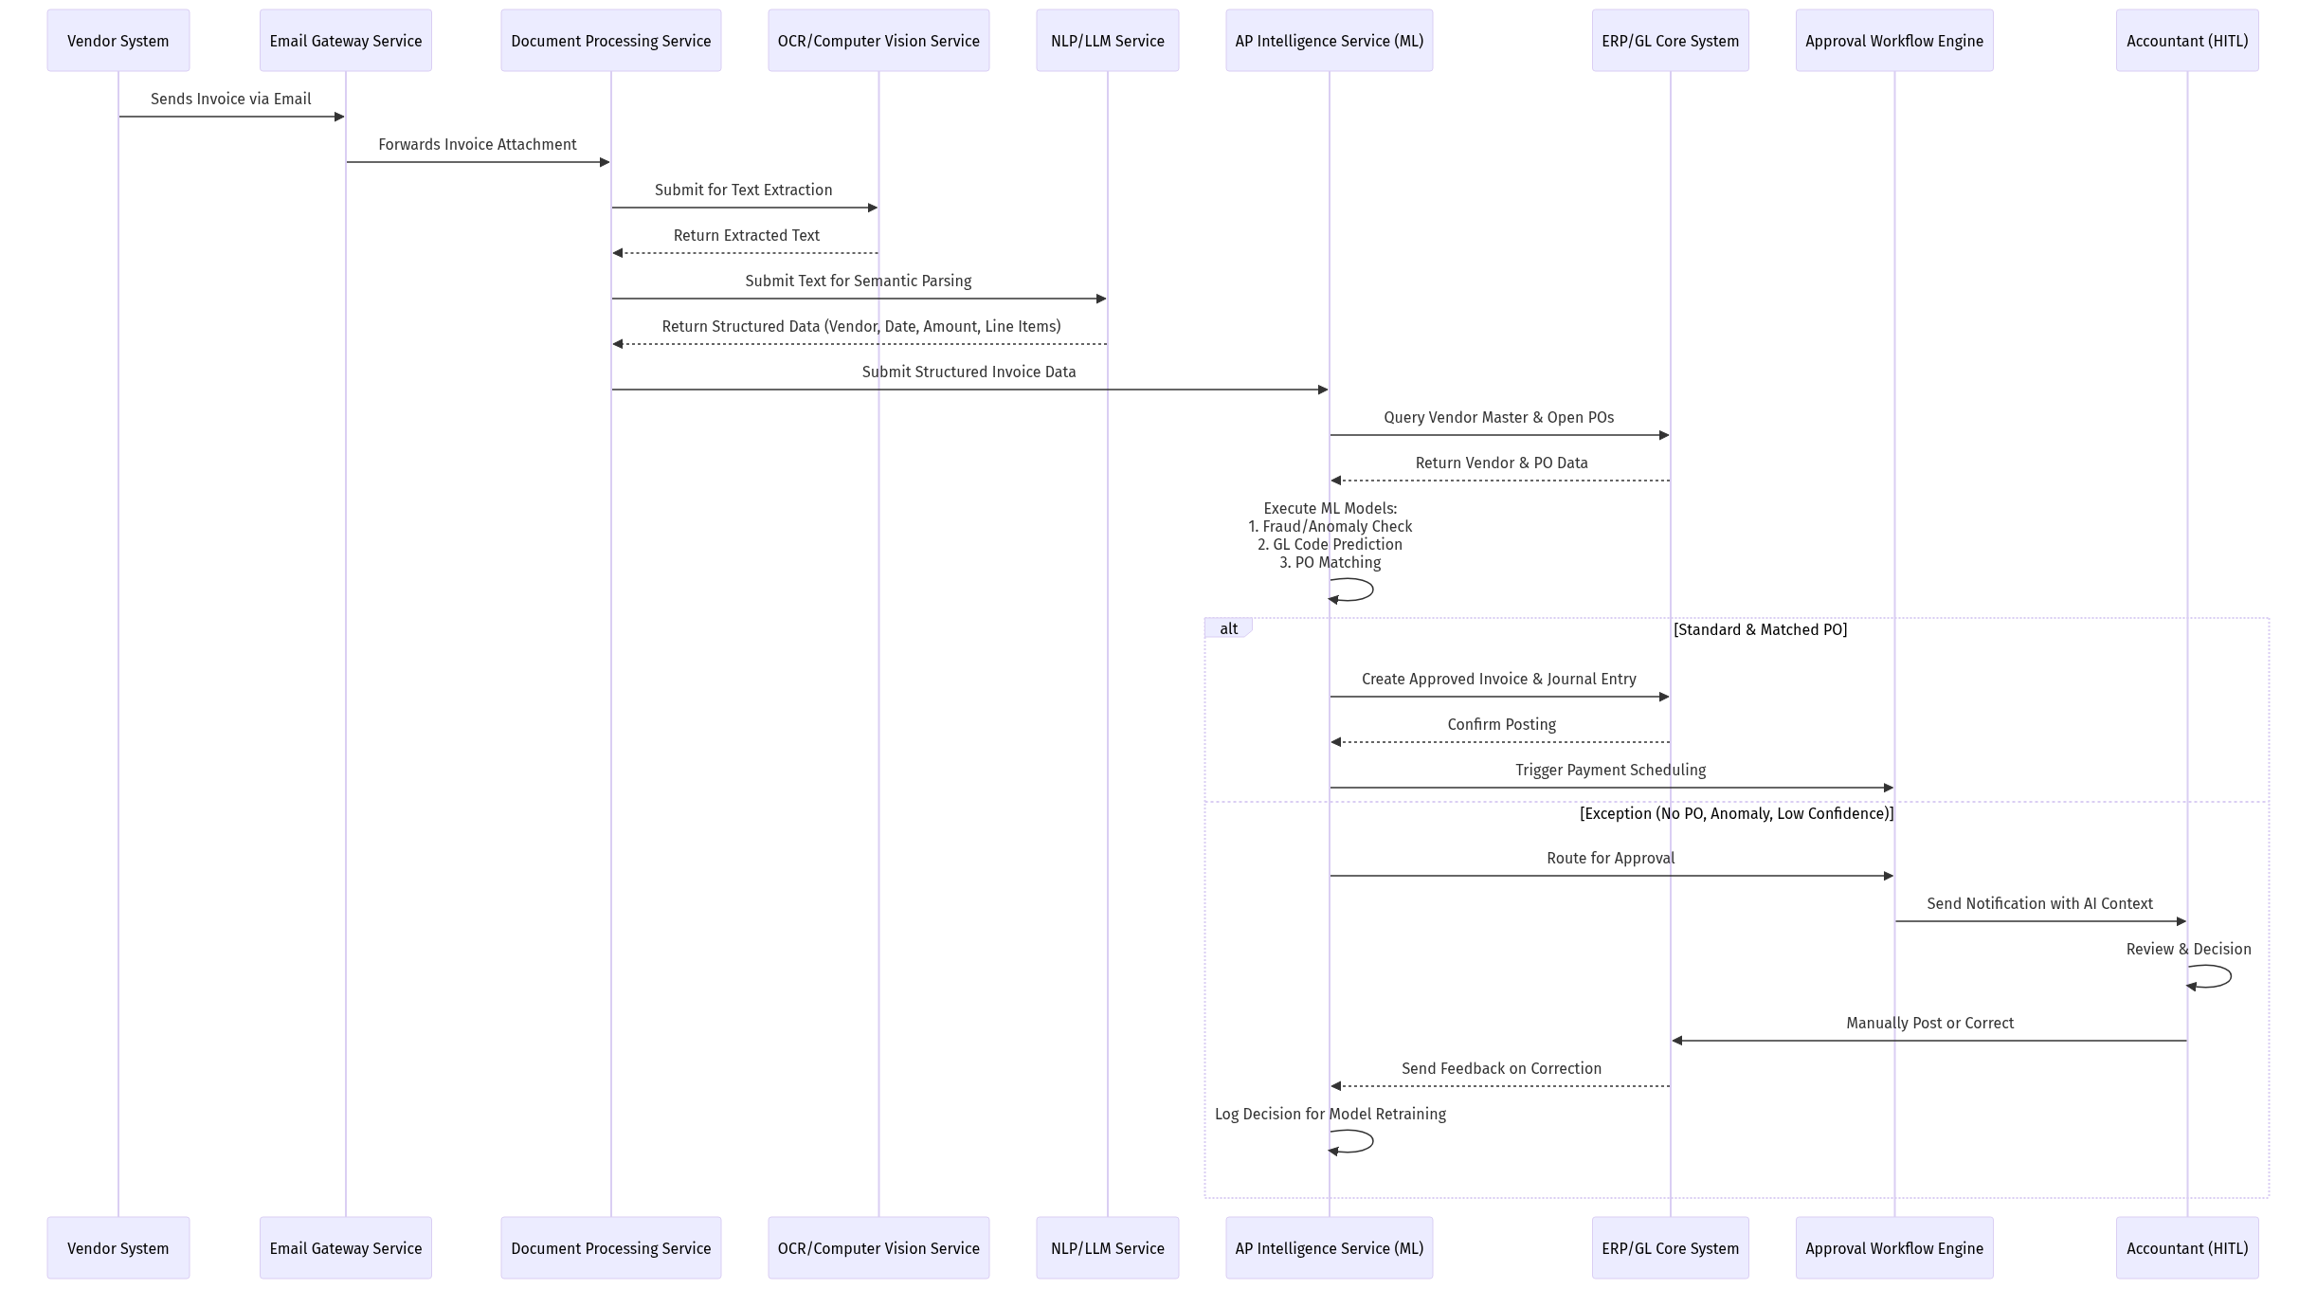
Figure 6. Sequence Diagram (Source: Generated Diagram)
Figure 2: Sequence Diagram for AI-Driven Invoice Processing Workflow. This diagram details the step-by-step interactions between system components and human actors, highlighting the decision logic for automated posting versus human review.
The AP Intelligence Service then makes a routing decision based on configurable business logic. If the invoice matches a PO perfectly, the vendor is validated, and the ML model's confidence scores are high, the service interacts directly with the ERP/GL Core System to create an approved invoice record and the corresponding journal entry, subsequently triggering the Approval Workflow Engine to schedule the payment according to terms. This represents a fully "touchless" transaction. However, if any condition fails—such as a missing PO, a data mismatch, or the detection of a potential anomaly (e.g., an invoice amount significantly higher than historical averages from that vendor)—the workflow diverges [Artsyl Tech, n.d.]. The invoice is routed to the Approval Workflow Engine, which notifies the designated Accountant via the HITL interface. The accountant reviews the invoice, the AI's extracted data, and the reason for the flag. The accountant's decision (approve, reject, or modify) is then posted to the ERP. Crucially, this action and the corrected data are sent as a feedback signal back to the AP Intelligence Service, which logs it for the next model retraining cycle, ensuring the system learns from human expertise and reduces future exceptions.

4.4 Implementation Considerations and Evolution
The implementation of these technical systems requires careful consideration of several non-functional requirements and evolving paradigms. Data security and privacy are paramount, as financial data is highly sensitive. Architectures must employ encryption both in transit and at rest, strict access controls, and compliance with regulations like GDPR or SOC 2. The explainability and auditability of AI decisions present a significant challenge, especially for auditing purposes. While a neural network may identify a transaction as fraudulent with high accuracy, auditors require a clear, logical trail of evidence. This is driving research and development into explainable AI (XAI) techniques that can articulate the "why" behind an AI's decision, such as highlighting which transaction features most contributed to an anomaly flag [ResearchGate, n.d.]. Furthermore, integration complexity remains a hurdle. The value of AI is maximized when it is deeply embedded within the existing financial ecosystem—ERPs, CRMs, banking platforms, and tax software. This necessitates robust, well-documented APIs and pre-built connectors, which are a key differentiator for platform providers like Oracle NetSuite and Intuit QuickBooks [Oracle, n.d.; Satva Solutions, 2025].
The historical evolution of these technologies informs their current state and future trajectory. The journey began with rule-based expert systems (1990s) that automated simple, deterministic tasks using "if-then" logic [IJSR, n.d.]. The 2000s saw the rise of statistical learning and early automation, with technologies like basic OCR and simpler ML models beginning to handle data entry and categorization. The 2010s marked the era of deep learning and cloud-scale AI, where advancements in neural networks, coupled with vast computational power and data availability, enabled the accurate, context-aware systems described above. We are now entering a new phase characterized by generative AI and autonomous agents. LLMs are being benchmarked for their superior ability to understand complex document contexts, while "Agentic AI" refers to systems that can autonomously plan and execute multi-step accounting tasks, such as conducting a full month-end close by interacting with various software systems, making decisions, and resolving discrepancies with minimal human oversight [arXiv, 2025; Satva Solutions, 2025]. This evolution points toward a future where the technical architecture will be less about processing discrete documents and more about hosting intelligent agents that manage continuous financial processes, learn from enterprise-specific contexts, and collaborate seamlessly with human finance teams.

5. Case Studies
The theoretical promise and technological potential of artificial intelligence in accounting are most convincingly demonstrated through real-world implementation. Examining detailed case studies reveals the tangible benefits, strategic imperatives, and complex challenges organizations face when integrating AI into their financial operations. These narratives move beyond market forecasts and technical specifications to illustrate the transformative impact on workflows, decision-making, and competitive positioning. The following cases, drawn from different segments of the market, provide a multifaceted view of how AI is being operationalized. They span from a global enterprise leveraging AI for intelligent financial consolidation to a mid-market firm utilizing specialized automation for core processes, and finally to an accounting practice transforming its service delivery model through AI augmentation. Collectively, they validate the core concepts of automated bookkeeping, intelligent auditing, and predictive analysis while highlighting the critical importance of change management and strategic vision in successful adoption [SpringerLink, n.d.].

5.1 Case Study: Global Manufacturing Conglomerate – Implementing AI-Driven Financial Consolidation and Close
A multinational manufacturing conglomerate, with operations across over 50 countries and a complex web of subsidiaries, faced significant challenges in its financial consolidation and close process. The monthly and quarterly closes were protracted, often taking more than 20 days, and were heavily reliant on manual data collection, validation, and reconciliation across disparate enterprise resource planning (ERP) systems. The process was error-prone, with inter-company transactions a particular pain point, and provided limited time for strategic analysis. The finance team was mired in data manipulation rather than insight generation, hindering its ability to act as a strategic business partner [Oracle, 2025]. In response, the organization embarked on a multi-year digital transformation initiative, selecting Oracle Fusion Cloud Enterprise Performance Management (EPM) as its core platform, specifically for its embedded AI and machine learning capabilities designed for complex financial processes.
The implementation focused on deploying AI to automate and intelligently guide the entire consolidation workflow. A key component was the implementation of AI-powered anomaly detection during the data submission phase. Machine learning models were trained on historical submission patterns to identify outliers—such as a subsidiary reporting an unusually high expense ratio or a significant variance in inventory valuations—in real-time as data was uploaded. This allowed for proactive investigation and correction before consolidation began, drastically reducing the "fire-fighting" in the final days of the close [Oracle, n.d.]. Furthermore, the system utilized AI for intelligent account reconciliation. For inter-company transactions, the AI could automatically match entries across subsidiaries, propose eliminating journal entries, and flag only the most complex mismatches for human review. This application of AI directly addressed the automated bookkeeping and intelligent auditing concepts, transforming a manual, sample-based reconciliation process into a comprehensive, continuous assurance activity [ResearchGate, n.d.].
The most significant strategic advancement came from the platform’s predictive analytics capabilities. Using historical financial data and operational metrics, the built-in AI models could generate predictive forecasts for cash flow, revenue recognition schedules, and regional performance. This empowered the corporate finance team to shift from a purely historical reporting function to a predictive advisory role. For instance, the AI could model the financial impact of a potential supply chain disruption or a change in raw material costs, allowing management to assess risks and opportunities proactively [PA Global, n.d.]. The implementation lifecycle, as visualized in the state diagram below, was not a simple flip of a switch but a structured journey from assessment to optimized, AI-enhanced operations. The post-implementation phase revealed a reduction in the financial close cycle by 40%, a 70% decrease in manual journal entry adjustments, and a marked improvement in forecast accuracy. This case underscores how large enterprises leverage integrated AI within ERP/EPM systems to manage scale and complexity, moving finance from a cost center to a value-driving intelligence hub [Thomson Reuters, 2025].
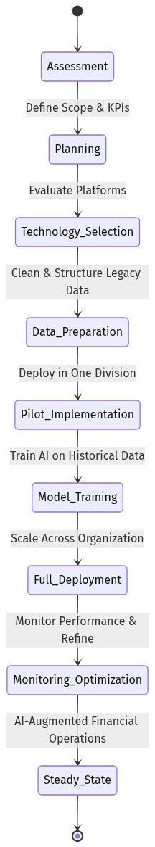
Figure 7. State Diagram (Source: Generated Diagram)

5.2 Case Study: Mid-Market Technology Firm – Automating Accounts Payable with Specialized AI
A fast-growing technology firm with approximately 500 employees found its accounts payable (AP) department becoming a bottleneck. The team was overwhelmed by a high volume of invoices arriving in various formats—PDF, scanned images, paper—from hundreds of vendors. Manual data entry was slow and error-prone, leading to missed early payment discounts, occasional duplicate payments, and strained supplier relationships. The firm needed a solution that could scale with its growth without requiring a massive upfront investment in a full-scale ERP overhaul. After evaluating options, the company selected a best-in-class, cloud-based AI AP automation platform, a solution typified by vendors like Vic.ai or Kefron, which specializes in intelligent document processing [Kefron, 2025].
The core of the solution was a sophisticated integration of Optical Character Recognition (OCR), Natural Language Processing (NLP), and machine learning. In the new workflow, all incoming invoices, regardless of source, were routed to a centralized digital inbox. The AI engine first used advanced OCR to extract text and data fields—vendor name, invoice number, date, line items, and totals—even from poorly scanned documents or non-standard layouts [Daffodil Software, 2025]. This moved the firm beyond template-based systems that failed with new vendor formats. Next, NLP and machine learning took over. The system compared the extracted vendor details against the master vendor file in the company's existing accounting software (QuickBooks Online) for validation. More impressively, ML algorithms, trained on the firm's historical coding patterns, automatically assigned general ledger account codes and cost centers to each line item with over 95% accuracy [NetSuite, 2025]. For example, an invoice from a cloud service provider would be automatically coded to "Software Subscriptions" and allocated to the appropriate department.
The system then executed a multi-layer validation check. It matched invoices against open purchase orders and receiving documents, flagging any discrepancies in quantity or price for review. It also checked for potential duplicates by comparing key fields against recently processed invoices. Invoices that passed all automated checks were routed for electronic approval via a configured workflow, while exceptions were sent to an AP clerk's queue with clear flags indicating the nature of the issue [Artsyl Tech, n.d.]. This implementation delivered transformative results: invoice processing time was reduced from an average of 15 minutes per invoice to under 2 minutes for straight-through processed items, the AP team was able to reallocate 60% of its time from data entry to vendor management and analysis, and the company captured significantly more early payment discounts. This case exemplifies how mid-market firms can adopt focused, specialized AI tools to achieve dramatic efficiency gains and enhanced control in critical processes like AP, effectively implementing automated bookkeeping and intelligent auditing in a modular fashion [Financial Cents, 2025].

5.3 Case Study: Regional Accounting Practice – Augmenting Tax Compliance and Advisory Services
A established regional accounting firm with a broad base of small and medium-sized business (SMB) clients faced mounting pressure. The commoditization of basic compliance work, such as tax return preparation and bookkeeping, was squeezing margins, while client demand for proactive, strategic advisory services was increasing. The firm's partners recognized that to remain competitive and profitable, they needed to elevate their service offering. However, their staff was consumed with manual data entry, document collection, and the intricate details of ever-changing tax codes. Their strategic response was to deliberately integrate a suite of AI tools into their practice management workflow, transforming their operational model from labor-intensive compliance to technology-enabled advisory [Thomson Reuters, 2025].
The firm implemented a layered AI tech stack. First, they adopted an AI-powered bookkeeping automation platform like Botkeeper, which connected directly to their clients' bank and credit card feeds. This platform used machine learning to categorize transactions, reconcile accounts, and generate draft financial statements automatically. This not only reduced the manual bookkeeping workload for the firm's staff by an estimated 50% but also provided clients with near real-time financial dashboards [Accountancy Age, 2025]. Second, for tax season, they integrated an AI-enhanced tax research and preparation suite. This tool used NLP to analyze client documents—such as W-2s, 1099s, and expense reports—and automatically populated tax forms. More importantly, its AI engine continuously monitored federal and state tax regulation updates, alerting the tax team to changes that might affect specific clients and even suggesting optimal tax strategies based on the client's financial profile [Synder, n.d.]. This directly addressed the challenge of tax compliance automation in a dynamic regulatory environment [SpringerLink, n.d.].
The freed-up capacity allowed the firm to launch a new "Strategic Business Insights" service. Using the clean, timely data from the automated bookkeeping system, the firm's advisors employed AI-powered analytics tools to generate predictive reports for clients. These included cash flow forecasts, scenario modeling for business decisions (e.g., hiring, expansion), and benchmarking against industry peers. The AI identified trends and anomalies—such as rising customer acquisition costs or declining profitability in a product line—that advisors could then discuss with clients in quarterly strategy sessions [Zeni.ai, n.d.]. This shift fundamentally changed the client relationship and the firm's value proposition. Revenue from higher-margin advisory services grew by 35% within two years, while client retention rates improved significantly. This case study powerfully illustrates the dual impact of AI in professional accounting: it automates the low-margin, repetitive tasks of compliance work while simultaneously providing the data and analytical firepower that enables the high-value, strategic advisory services that define the future of the profession [arXiv, 2025].

6. Comparative Analysis
The integration of artificial intelligence into accounting is not a monolithic phenomenon but a multifaceted evolution characterized by diverse technological approaches, strategic implementations, and market segmentations. A comparative analysis reveals distinct paradigms that differentiate solutions based on their underlying AI architecture, scope of automation, target user sophistication, and strategic value proposition. Fundamentally, the landscape can be segmented along two primary axes: the technological approach, ranging from deterministic robotic process automation (RPA) to probabilistic machine learning (ML) and generative artificial intelligence (GenAI); and the strategic focus, spanning from foundational task automation to advanced cognitive augmentation and predictive insight generation [NetSuite, 2025; Vic.ai, n.d.]. This section provides a detailed comparative examination of these approaches, evaluating their relative strengths, limitations, and optimal applications within the modern accounting function. The analysis will consider core technological foundations, implementation maturity, scalability, and the transformative impact on the accounting profession, drawing upon the historical evolution from rule-based systems to the current era of large language models and autonomous agents [IJSR, n.d.; arXiv, 2025].
A foundational distinction exists between automation technologies designed for structured, rule-based tasks and those capable of handling unstructured data and complex judgment. On one end of the spectrum lies Robotic Process Automation (RPA), a technology that excels at replicating high-volume, repetitive human actions within digital systems, such as data entry from standardized forms into enterprise resource planning (ERP) software. RPA operates on clear, predefined rules and is highly effective for processes with little variability, offering rapid implementation and a clear return on investment through labor displacement [Thomson Reuters, 2025]. However, its rigidity is its primary limitation; RPA "bots" lack cognitive understanding and cannot adapt to process changes or interpret unstructured documents like invoices or contracts without significant reconfiguration. In contrast, machine learning (ML), and particularly supervised learning models, introduces adaptability and pattern recognition. These systems are trained on historical datasets—for example, thousands of previously coded invoices—to learn the correlations between vendor names, line item descriptions, and corresponding general ledger accounts [NetSuite, 2025]. This enables them to handle variability and make probabilistic judgments, such as correctly categorizing a novel expense from a known vendor. The most advanced frontier is occupied by generative AI and large language models (LLMs), which bring natural language understanding and generation to accounting workflows. These models can review complex contractual language, draft narrative management commentary for financial reports, and interact with users through conversational interfaces, moving beyond pattern recognition to semantic comprehension and content creation [Mercity.ai, n.d.; Accountancy Age, 2025].
The application of these technologies creates a clear hierarchy of value and complexity across core accounting processes. Automated bookkeeping, often the entry point for AI adoption, effectively leverages a combination of optical character recognition (OCR), RPA, and basic ML. OCR converts scanned documents into machine-readable text, RPA orchestrates the movement of this data between systems, and ML models perform the intelligent categorization [Financial Cents, 2025; Kefron, 2025]. This stack is highly mature and provides immense efficiency gains but is largely focused on replicating and accelerating traditional bookkeeping tasks. Intelligent auditing and anomaly detection represent a more sophisticated application layer, deeply reliant on unsupervised and semi-supervised machine learning. These systems analyze entire populations of transactions to establish behavioral baselines and identify outliers indicative of fraud, error, or control weaknesses [Jpopasia, n.d.]. Unlike rule-based systems that flag transactions violating specific thresholds, ML-driven auditing can detect subtle, evolving patterns of risk that are invisible to static rules, thereby enhancing audit quality and scope [ResearchGate, n.d.]. At the pinnacle of strategic value is predictive financial analysis, which employs advanced ML techniques like time-series forecasting and regression analysis. By processing internal financial data alongside external market indicators, these systems can generate forward-looking insights on cash flow, customer payment behavior, and the financial impact of strategic scenarios, enabling a shift from historical reporting to proactive business advising [PA Global, n.d.; Zeni.ai, n.d.].
The market for accounting AI solutions is further stratified by the target user and deployment model, creating a bifurcation between integrated enterprise platforms and best-of-breed specialized tools. Major platform providers like Oracle NetSuite and Sage Intacct embed AI capabilities directly into their core ERP and financial management systems. This integrated approach offers seamless data flow, consistent security, and AI features that are inherently contextualized within the broader business process, such as intelligent defaulting of account combinations during journal entry [Oracle, n.d.; HubiFi, 2025]. The strategic value here is cohesion and scalability for mid-market and enterprise organizations. Conversely, a vibrant ecosystem of specialized AI startups offers point solutions that excel in specific domains. Companies like Botkeeper provide hyper-specialized, AI-driven bookkeeping services that integrate with major platforms via APIs, while others focus exclusively on AI-powered contract review or tax compliance automation [Accountancy Age, 2025; Synder, n.d.]. These tools often deliver best-in-class functionality for their niche, allowing accounting firms and businesses to construct a modular "tech stack." The trade-off, however, involves managing integration complexity, data silos, and potential vendor lock-in across multiple systems [Thomson Reuters, 2025].
A critical dimension for comparison is the maturity, explainability, and trustworthiness of different AI approaches. Rule-based systems and RPA are fully transparent and deterministic; every action can be traced to an explicit rule, which aligns well with the audit trail requirements and regulatory compliance mandates in accounting [ResearchGate, n.d.]. In contrast, the "black box" nature of complex ML models and LLMs poses a significant challenge. While a deep learning model may achieve superior accuracy in fraud detection, its reasoning process can be opaque, making it difficult for auditors or accountants to validate and justify its conclusions. This tension between performance and explainability is a central debate in the field. Furthermore, implementation maturity varies drastically. OCR and RPA are well-established, with proven vendor solutions and implementation methodologies. Generative AI, despite its transformative potential, is in a much earlier stage of practical deployment within accounting, with use cases often focused on augmentation (e.g., drafting emails, summarizing documents) rather than fully autonomous decision-making [Forbes, 2025]. The cost and resource requirements also differ markedly, with enterprise-scale integrated AI platforms commanding significant investment, while cloud-based, specialized SaaS tools offer a lower barrier to entry for small and medium-sized enterprises (SMEs) [Mordor Intelligence, 2025].
The following quadrant chart synthesizes this multi-dimensional analysis, positioning key technology providers and solution types based on their primary Strategic Focus (from Operational Efficiency to Strategic Insight) and their core Technological Sophistication (from Rule-Based Automation to Cognitive AI).
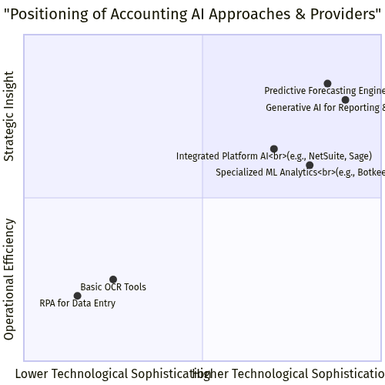
Figure 8. Quadrant Chart (Source: Generated Diagram)
The chart illustrates the evolutionary trajectory of accounting AI. Foundational tools like basic OCR and RPA occupy the lower-left quadrant, delivering high operational efficiency for well-defined tasks with relatively simple technology. As solutions move toward the upper-right quadrant, they incorporate greater technological sophistication—leveraging advanced ML and NLP—to deliver strategic, predictive insights. Integrated platforms and specialized analytics tools bridge the middle ground, combining sophisticated automation with actionable intelligence. This positioning aligns with the historical context, where the profession's use of AI has progressed from automating manual labor to augmenting professional judgment and enabling forward-looking strategy [IJSR, n.d.; arXiv, 2025].
To crystallize the comparative landscape, the table below provides a synthesized view of the dominant approaches, their characteristics, and typical use cases.
Table 1: Comparative Analysis of Dominant AI Approaches in Accounting
Table 2. Research Data
Approach / Paradigm | Core Technologies | Primary Strengths | Key Limitations | Exemplary Use Cases | Representative Providers / Context
Rule-Based Automation & RPA | Predefined business rules, screen scraping, workflow orchestration. | High speed, accuracy for structured tasks, full transparency, easy to audit, rapid ROI. | Inflexible, breaks with process changes, cannot handle unstructured data or learn. | Automated data entry from forms, system-to-system reconciliation, report generation. | Legacy system integrations, initial automation projects within large firms [Thomson Reuters, 2025].
Machine Learning for Pattern Recognition | Supervised & unsupervised ML, statistical modeling, anomaly detection algorithms. | Adapts to new patterns, handles variability, improves with data, identifies complex anomalies. | Requires large, high-quality training data; "black box" concerns; ongoing model management needed. | Intelligent transaction coding, fraud detection, customer churn prediction, audit sampling optimization. | Botkeeper (bookkeeping), advanced features in NetSuite & Sage [NetSuite, 2025; Accountancy Age, 2025].
Cognitive AI & Natural Language Processing | NLP, Named Entity Recognition (NER), semantic analysis, knowledge graphs. | Understands unstructured text, extracts meaning from documents, enables conversational interfaces. | High computational cost, accuracy dependent on context, can struggle with domain-specific jargon. | Contract and lease review, automated extraction from complex invoices, sentiment analysis in client communications. | AI features in Xero ("JAX"), Vic.ai for AP automation [Satva Solutions, 2025; Vic.ai, n.d.].
Generative AI & Large Language Models | Transformer-based LLMs (e.g., GPT, Claude), generative adversarial networks (GANs). | Creates narrative content, summarizes complex information, answers natural language queries, drafts reports. | Risk of hallucinations, data privacy concerns, lack of domain-specific financial reasoning, high cost. | Drafting management commentary, generating financial report summaries, powering interactive Q&A on financial data. | Experimental integrations (e.g., NetSuite AI Connector), emerging startup tools [Oracle, n.d.; Forbes, 2025].
Integrated Enterprise AI Platforms | Combination of RPA, ML, NLP embedded within ERP/Financial systems. | Seamless data flow, unified security/audit trail, process-aware intelligence, scalable for large organizations. | Vendor lock-in, can be less innovative in niche areas, significant implementation cost and time. | End-to-end financial close automation, real-time consolidation with anomaly alerts, enterprise-wide forecasting. | Oracle NetSuite, Sage Intacct, SAP S/4HANA [HubiFi, 2025; Oracle, n.d.].
Specialized Best-of-Breed AI Tools | Deep focus on a specific technology stack for a narrow domain (e.g., AP, bookkeeping). | Best-in-class functionality for targeted use case, often faster to deploy, agile innovation. | Creates data silos, integration overhead, requires managing multiple vendor relationships. | Hyper-automated accounts payable, AI-powered tax filing, dedicated client reporting dashboards. | Botkeeper (bookkeeping), Dext (expense capture), Avalara (tax) [Accountancy Age, 2025; Dext, n.d.].

In conclusion, the comparative analysis underscores that there is no single "best" approach to AI in accounting. The optimal strategy is contingent upon an organization's specific needs, maturity, data landscape, and strategic objectives. SMEs may find immediate value in deploying specialized best-of-breed tools to automate acute pain points like expense management, while large enterprises may prioritize the cohesive intelligence and scalability of integrated platforms [Mordor Intelligence, 2025]. The technological progression from rule-based systems to generative AI mirrors the profession's own evolution from record-keeping to strategic partnership. The future state likely involves a hybrid architecture, where deterministic RPA handles routine workflows, robust ML models provide reliable prediction and anomaly detection, and generative AI acts as an interactive interface and creative augmenter for professionals [arXiv, 2025]. Success in this domain will therefore depend less on adopting any single technology and more on developing a holistic AI strategy that thoughtfully combines these diverse approaches to enhance accuracy, efficiency, and, most importantly, the strategic insight delivered by the accounting function.

7. Challenges and Solutions
The integration of Artificial Intelligence (AI) into accounting heralds a new era of efficiency, insight, and strategic value, yet this transformative journey is not without significant obstacles. The path from conceptual promise to robust, trusted implementation is fraught with technical, ethical, regulatory, and human capital challenges that must be systematically addressed. These challenges are not merely operational hurdles but fundamental questions about the future of the accounting profession, the governance of autonomous systems, and the equitable distribution of technological benefits. A comprehensive analysis reveals that these impediments are interconnected, forming a complex web that spans data integrity, algorithmic transparency, skills adaptation, and economic accessibility. However, for each identified challenge, a corresponding set of solutions is emerging, driven by technological innovation, evolving professional standards, and strategic organizational planning. Successfully navigating this landscape requires a holistic approach that views AI not as a simple plug-in tool but as a foundational component of a new accounting paradigm, demanding careful management of its risks while fully harnessing its potential to augment professional judgment and business intelligence [SpringerLink, n.d.; arXiv, 2025].

7.1 Data Quality, Integration, and Security
A primary and foundational challenge in deploying AI for accounting lies in the quality, integration, and security of the underlying data. AI systems, particularly machine learning models, operate on the principle of "garbage in, garbage out"; their predictive accuracy and operational reliability are directly contingent upon the volume, veracity, and consistency of the training and operational data they process [ResearchGate, 2024]. In practice, accounting data is often siloed across disparate legacy systems—such as separate databases for procurement, sales, and payroll—and arrives in heterogeneous formats, including scanned invoices, PDF reports, and spreadsheet exports. This fragmentation creates significant data integration challenges, hindering the creation of a unified, clean data lake necessary for effective AI model training. Furthermore, the manual nature of much historical data entry introduces errors, inconsistencies, and missing values that can corrupt AI outputs, leading to incorrect journal entries or flawed predictive analytics [Oracle, n.d.]. Compounding these issues are stringent data security and privacy imperatives. Financial data is highly sensitive, and its aggregation into centralized AI platforms creates attractive targets for cyberattacks. Regulations like the General Data Protection Regulation (GDPR) in Europe impose strict controls on data processing, adding layers of compliance complexity to AI initiatives that must be designed with privacy-by-design principles from the outset [Thomson Reuters, 2025].
The solutions to these data-centric challenges are multifaceted, involving both technological architecture and governance frameworks. A strategic solution is the implementation of robust data governance programs that establish clear policies for data ownership, quality standards, and lifecycle management. This includes the deployment of master data management (MDM) systems to create a single source of truth for critical entities like customers, vendors, and chart of accounts, ensuring consistency across all integrated platforms. Technologically, the adoption of modern cloud-based Enterprise Resource Planning (ERP) systems, such as Oracle NetSuite or Sage Intacct, provides a native, integrated data environment that reduces silos and improves data consistency from the point of entry [NetSuite, 2025; HubiFi, 2025]. For processing unstructured data, advanced Optical Character Recognition (OCR) coupled with Natural Language Processing (NLP) can be configured with validation rules and linked to supplier databases to verify extracted information in real-time, significantly enhancing initial data quality [Kefron, 2025; Commport, 2025]. From a security perspective, solutions involve encrypting data both at rest and in transit, implementing strict, role-based access controls, and utilizing privacy-enhancing technologies like federated learning, which allows AI models to be trained on decentralized data without the raw information ever leaving its secure source. Regular third-party security audits and adherence to frameworks like SOC 2 are becoming standard practice for AI accounting software providers to build trust [Accountancy Age, 2025].
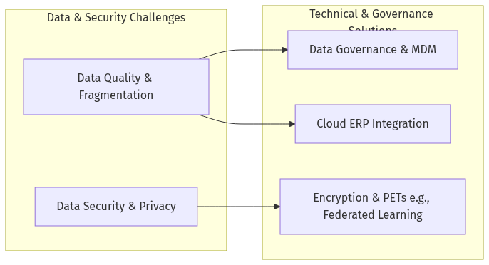
Figure 9. Flowchart (Source: Generated Diagram)

7.2 Algorithmic Transparency, Bias, and Auditability
As AI systems take on more consequential roles in financial reporting, auditing, and compliance, the "black box" problem presents a profound professional and ethical challenge. Many advanced machine learning models, particularly deep neural networks, operate in ways that are not easily interpretable by humans, making it difficult to understand how a specific decision—such as flagging a transaction as fraudulent or assigning a particular general ledger code—was reached [ResearchGate, n.d.]. This lack of transparency conflicts with core accounting principles of verifiability and auditability. An auditor cannot substantiate an opinion based on algorithmic outputs they cannot explain, and a CFO cannot confidently defend financial statements generated by an inscrutable system. Closely related is the risk of algorithmic bias. If an AI model is trained on historical accounting data that contains embedded human biases—for instance, preferential payment terms for certain supplier demographics or patterns in fraud detection that disproportionately target specific transaction types—it will perpetuate and potentially amplify these biases in its automated decisions [SpringerLink, n.d.]. This raises serious concerns about fairness, regulatory compliance, and reputational risk.
Addressing these issues requires a concerted focus on developing and deploying Explainable AI (XAI) and establishing rigorous model governance. The solution pathway involves a shift towards inherently more interpretable models where possible, or the use of post-hoc explanation techniques that provide insights into model behavior. For instance, feature importance scores can highlight which data points (e.g., invoice amount, vendor location, time of day) most influenced a fraud prediction. The accounting profession, in collaboration with technologists, must develop new audit standards and controls specifically for AI systems. This includes documenting the model's purpose, training data provenance, performance metrics, and known limitations—a process akin to creating an "algorithmic audit trail" [ResearchGate, n.d.]. Furthermore, continuous monitoring for bias and drift is essential. Solutions involve implementing fairness metrics during model validation and setting up ongoing performance monitoring to detect when a model's predictions begin to deviate from expected patterns (model drift) due to changing business conditions. Firms like Thomson Reuters are actively exploring these themes, clarifying the complex intersection of AI and professional assurance [Thomson Reuters, 2025]. Ultimately, the solution rests on a hybrid approach where AI handles pattern recognition at scale, but critical judgments and approvals remain with human professionals who use XAI tools to inform their decisions.

7.3 Skills Gap and Organizational Change Management
The technological displacement caused by AI automation triggers a significant human capital challenge: the evolution of the required skill set for accounting professionals. As AI automates repetitive tasks like data entry, reconciliation, and basic compliance checks, the demand for manual processing skills diminishes. Conversely, there is a growing and urgent need for "augmented skills," including data literacy, AI system supervision, critical interpretation of algorithmic outputs, and strategic business advisory [Thomson Reuters, 2025]. This shift creates a substantial skills gap, where existing professionals may feel unprepared or threatened by the new technology, leading to resistance and ineffective adoption. The challenge extends beyond individual skills to encompass organizational change management. Implementing AI is not merely a software installation; it is a process transformation that redesigns workflows, redefines roles, and alters the culture of the finance department. Without careful management, this can lead to low user adoption, misuse of systems, and a failure to realize the promised return on investment.
The solution to the human capital challenge is proactive, continuous education and strategic change leadership. Professional accounting bodies, universities, and corporations must collaborate to redesign curricula and professional development programs. These should emphasize data analytics, basic programming literacy (e.g., Python for data manipulation), understanding of AI ethics, and, most importantly, the critical thinking skills needed to leverage AI-driven insights for strategic decision-making [arXiv, 2025]. Within organizations, change management must be prioritized from the outset. This involves clear communication from leadership about the strategic rationale for AI adoption, engaging accounting staff as co-designers in the implementation process to alleviate fears and harness their domain expertise, and providing comprehensive, role-specific training. Upskilling programs should be presented as career enhancement opportunities, positioning accountants as strategic business partners who command AI tools rather than being replaced by them. Leading software providers are already embedding this philosophy, designing AI assistants like Xero's "JAX" to be conversational and user-friendly, thereby lowering the technical barrier to entry and facilitating smoother adoption [Satva Solutions, 2025].
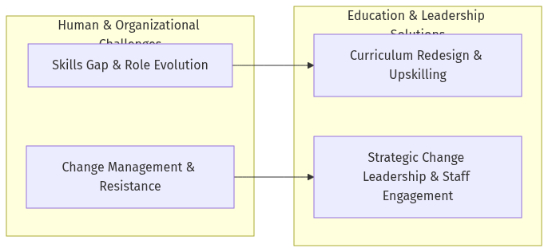
Figure 10. Flowchart (Source: Generated Diagram)

7.4 Regulatory Compliance and Ethical Governance
The regulatory landscape for AI in accounting is nascent, complex, and rapidly evolving, creating a significant challenge for compliance. Financial reporting and auditing are already governed by a dense web of standards (e.g., GAAP, IFRS) and regulations (e.g., Sarbanes-Oxley). Introducing AI as a key participant in these processes raises novel questions: Who is liable for an error made by an autonomous AI system—the software provider, the company using it, or the accountant who approved its output? How do existing audit standards apply to continuous, algorithm-driven monitoring? Furthermore, as seen in the European Union's proposed AI Act, new horizontal regulations are emerging that classify certain AI uses (like credit scoring) as high-risk, imposing strict requirements for transparency, human oversight, and robustness [SpringerLink, n.d.]. Navigating this uncertain and fragmented regulatory environment is a major hurdle, especially for firms operating across multiple jurisdictions. This is intrinsically linked to the broader ethical challenge of establishing governance frameworks that ensure AI is used responsibly, fairly, and accountably within the accounting function.
The solution lies in proactive compliance strategies and the development of strong internal ethical governance. Organizations cannot afford to be passive; they must actively monitor regulatory developments and engage with standard-setting bodies. Implementing AI governance frameworks that include ethics review boards, clear accountability charts (e.g., defining a responsible AI officer within finance), and documented risk assessment procedures for AI applications is becoming a best practice. From a technical standpoint, solutions involve building compliance into the AI system itself. This includes maintaining detailed, immutable logs of all AI-assisted decisions (providing a clear audit trail), designing systems that can adapt their bookkeeping or tax calculation protocols in response to regulatory changes, as noted in research on adaptive AI systems [SpringerLink, n.d.], and ensuring there is always a "human-in-the-loop" for high-stakes decisions such as finalizing financial statements or approving material journal entries. Professional firms like Thomson Reuters are focusing on clarifying these complex intersections, providing guidance on how to align AI deployment with professional obligations [Thomson Reuters, 2025]. Ultimately, the accounting profession must lead in co-creating the future regulatory framework, advocating for standards that protect the public interest while fostering responsible innovation.

7.5 Implementation Cost and the SME Accessibility Gap
The financial and resource burden of implementing sophisticated AI solutions creates a pronounced market dichotomy, particularly disadvantaging small and medium-sized enterprises (SMEs). For large enterprises, the high costs of licensing enterprise AI platforms (e.g., Oracle, SAP), integrating them with legacy IT infrastructure, and hiring or training specialized data scientists can be justified by the scale of automation and the strategic value of predictive insights [Oracle, 2025]. However, for SMEs, these costs are often prohibitive. The challenge is not just the initial investment but also the ongoing expenses related to maintenance, updates, and specialized support. This economic barrier risks creating a "digital divide" in accounting capabilities, where larger firms accelerate ahead with AI-driven efficiency and insight, while smaller firms struggle with manual processes, potentially affecting their competitiveness, accuracy, and ability to secure financing based on sophisticated financial forecasts [Small Business Economics, 2025].
The solution to this accessibility challenge is being driven by the evolution of the software-as-a-service (SaaS) market and the rise of specialized, modular AI tools. The proliferation of cloud-based accounting platforms like QuickBooks Online and Xero has dramatically lowered the entry barrier, providing AI-powered features—such as automated receipt capture, bank reconciliation, and basic cash flow forecasts—as part of affordable monthly subscriptions [Satva Solutions, 2025; Startup-Movers, 2025]. Furthermore, a vibrant ecosystem of fintech startups is developing best-in-class, point solutions that integrate seamlessly with these core platforms. An SME can thus adopt a specialized AI tool for, say, automated accounts payable (like Bill.com) or expense management without needing a full-scale ERP overhaul. This modular "best-of-breed" approach allows SMEs to selectively automate their most painful processes with a manageable investment. Additionally, accounting firms themselves are acting as intermediaries, adopting AI platforms like Botkeeper to deliver automated bookkeeping as a managed service to their SME clients, thereby democratizing access to advanced technology through an advisory relationship [Accountancy Age, 2025]. As the market matures and competition increases, the cost of AI capabilities is expected to continue falling, further narrowing the accessibility gap.
In conclusion, the integration of AI into accounting is a journey marked by significant but surmountable challenges. These obstacles—spanning data, transparency, skills, regulation, and cost—are interrelated and must be addressed through a coordinated strategy that blends technological, human, and governance solutions. The successful accounting firm or department of the future will be one that recognizes AI not as a threat but as a powerful augmentative tool. It will invest in clean data infrastructure, prioritize explainability and ethical governance, relentlessly upskill its workforce, and strategically adopt technology that aligns with its scale and needs. By doing so, the profession can navigate this transformative period, mitigating the risks while fully capitalizing on AI's potential to enhance accuracy, unlock strategic insights, and elevate the role of the accountant to that of a indispensable strategic business advisor. The roadmap is clear: a synergistic partnership between human expertise and artificial intelligence, guided by robust frameworks and a commitment to continuous adaptation, will define the next era of accounting [ResearchGate, 2024; arXiv, 2025].

8. Future Outlook
The trajectory of Accounting + AI is one of accelerating convergence, where artificial intelligence transitions from a supportive tool to a foundational component of the financial function. The future will be defined not by incremental improvements to existing processes, but by the emergence of entirely new paradigms for financial management, audit, and strategic decision-making. This evolution will be propelled by the maturation of core technologies like machine learning and generative AI, their deeper integration into enterprise systems, and a fundamental re-skilling of the accounting profession. As the market continues its explosive growth, projected to reach trillions of dollars globally within the next decade [Precedence Research, 2024; Grand View Research, 2025], the accounting landscape will bifurcate into a stratified ecosystem. At one level, large enterprises will deploy sophisticated, agentic AI systems capable of autonomous financial operations and complex predictive modeling. Concurrently, the democratization of AI through cloud-based, modular platforms will empower small and medium-sized enterprises (SMEs) with capabilities once reserved for multinationals, though adoption gaps based on resources and digital literacy will persist [ResearchGate, 2024; Small Business Economics, 2025]. The overarching narrative is one of transformation: from historical record-keeping to continuous, predictive intelligence; from manual compliance to automated, strategic partnership.
The most immediate and impactful trend will be the mainstream adoption of generative AI and autonomous AI agents as core collaborators within accounting workflows. Moving beyond the current paradigm of AI as an analytical or classification tool, the next generation will feature "Agentic AI" capable of executing multi-step tasks with minimal human oversight [Satva Solutions, 2025]. These agents will not merely suggest a journal entry; they will research an ambiguous transaction, apply the appropriate accounting standard, draft the entry, seek necessary approvals via integrated workflows, and post it to the ledger—all while maintaining a clear audit trail. This shift is already evident in platforms like Intuit QuickBooks, which is investing heavily in agentic capabilities [Satva Solutions, 2025]. Furthermore, Large Language Models (LLMs) will evolve from conversational assistants into robust reasoning engines for financial analysis. They will be tasked with interpreting complex regulatory changes, drafting comprehensive management commentary for financial statements, and conducting deep-dive variance analyses by querying integrated datasets using natural language [Mercity.ai, n.d.]. The technical foundation for this will be enhanced by benchmarks showing LLMs' improving accuracy in extracting and contextualizing data from financial documents, surpassing traditional OCR in comprehension if not always in raw character recognition [AIMultiple, n.d.]. This evolution will make financial insights more accessible and actionable for non-experts, further bridging the gap between finance and operational management.
Parallel to the rise of advanced AI agents is the inevitable trend toward hyper-automation and the continuous close. The traditional financial close, a periodic, resource-intensive event, will dissolve into a state of near-real-time financial reporting and continuous control monitoring. This will be enabled by the seamless integration of AI across the entire data pipeline: from AI-enhanced OCR and NLP that extract and validate transaction data at the moment of inception, to machine learning models that continuously reconcile accounts and flag anomalies [Kefron, 2025; NetSuite, 2025]. Oracle's vision of intelligent defaulting and automated accounting instructions (AAIs) points toward a future where the entire procure-to-pay and order-to-cash cycle is governed by intelligent, self-optimizing rules [Oracle, n.d.]. In auditing, the shift from sample-based testing to continuous, full-population analysis will become standard. AI will provide a persistent, automated audit layer, monitoring 100% of transactions for patterns indicative of fraud, error, or control weakness, thereby transforming audit from a historical assurance exercise into a real-time risk management function [ResearchGate, n.d.]. The audit opinion of the future may be based on a continuous stream of AI-verified data and predictive risk assessments rather than a retrospective snapshot.
The strategic value of accounting will be fundamentally elevated through the maturation of predictive and prescriptive analytics. AI will enable finance functions to move decisively from a reactive, descriptive role to a proactive, strategic one. Machine learning models, fed with internal financial data, external market signals, and macroeconomic indicators, will generate dynamic forecasts for cash flow, revenue, and profitability under multiple scenarios. More advanced applications will involve predictive modeling of customer payment behaviors, supply chain financial risks, and the impact of strategic initiatives like market entry or product launches [Jpopasia, n.d.]. This predictive capability will evolve into prescriptive guidance, where AI systems not only forecast outcomes but also recommend optimal courses of action—such as ideal payment terms to offer a customer or the most tax-efficient structure for an international expansion. This aligns with the broader business shift from reactive to predictive mindsets, positioning the accounting function as the central nervous system for business intelligence [PA Global, n.d.]. The accountant's role will consequently pivot from compiling reports to interpreting AI-generated forecasts, validating model assumptions, and translating complex predictive insights into executable business strategy.
However, this technologically driven future introduces significant ethical, regulatory, and professional challenges that must be navigated. The "black box" nature of some advanced AI models poses a profound challenge for auditing and governance. How can an auditor attest to the fairness of financial statements if critical classifications or valuations are determined by an algorithm whose decision-making process is not fully transparent? [ResearchGate, n.d.]. This will spur increased demand for explainable AI (XAI) in accounting applications and likely lead to new auditing standards focused on algorithmic assurance. Data privacy and security concerns will intensify as AI systems require access to vast, sensitive datasets. Furthermore, the regulatory landscape will struggle to keep pace, with authorities worldwide needing to develop frameworks for AI accountability in financial reporting and tax compliance. Professionally, these shifts will create a stark divide between accounting professionals who adapt and those who do not. The future will demand a hybrid skill set: deep accounting expertise must be coupled with data literacy, an understanding of AI principles, and the critical thinking skills to oversee and challenge automated systems [Thomson Reuters, 2025]. Continuous learning will become non-negotiable, and the profession's educational pathways will need to be radically redesigned to produce this new generation of accountant-technologists.
The market structure and competitive landscape will also undergo substantial transformation. The current ecosystem, with established players like Intuit, Xero, Sage, and Oracle NetSuite competing with agile startups like Botkeeper, will consolidate and specialize further [Accountancy Age, 2025; Satva Solutions, 2025]. We can expect increased merger and acquisition activity as platform providers seek to acquire best-in-class AI capabilities. A key battleground will be the development of open AI platforms or marketplaces within major accounting software, where third-party developers can create specialized AI "apps" or agents, similar to smartphone app stores. This will allow firms to customize their AI toolkit extensively. Geographically, while North America will maintain its leadership in innovation and enterprise adoption, the Asia-Pacific region's growth as the fastest-growing market will catalyze the development of AI solutions tailored to local regulations, languages, and business practices [Mordor Intelligence, 2025]. This global diversification will ensure that the future of Accounting + AI is not monolithic but will be shaped by regional needs and innovations.
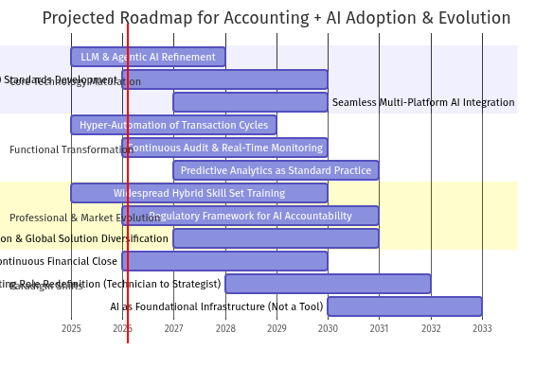
Figure 11. Gantt Chart (Source: Generated Diagram)
In conclusion, the future of Accounting + AI is one of profound and irreversible change. The profession stands at the threshold of an era defined by autonomous operation, predictive intelligence, and strategic centrality. The journey will involve navigating technical complexities, ethical dilemmas, and a radical reshaping of professional identity. Success will belong to organizations and individuals who view AI not as a threat to traditional accounting, but as the catalyst for its most significant evolution—from a discipline of record to a discipline of insight. The ultimate outcome will be a more dynamic, transparent, and valuable financial function, powered by a synergistic partnership between human expertise and artificial intelligence, driving business resilience and growth in an increasingly complex global economy.

9. Conclusions
The comprehensive investigation into the convergence of artificial intelligence and accounting reveals a field undergoing a fundamental and irreversible transformation. This research has systematically charted the scope, market dynamics, technological foundations, and evolutionary trajectory of "Accounting + AI," culminating in a clear portrait of a profession transitioning from manual stewardship to intelligent partnership. The synthesis of findings demonstrates that AI is not merely a new set of tools but a paradigm-shifting force that redefines the value proposition of accounting, elevating it from a historical record-keeping and compliance function to a strategic, predictive, and analytical cornerstone of modern business [SpringerLink, n.d.; Thomson Reuters, 2025]. The core concepts of automated bookkeeping, intelligent auditing, predictive financial analysis, and tax compliance automation, as defined in this study, represent the key vectors of this change, each powered by a sophisticated interplay of machine learning, natural language processing, and robotic process automation [ResearchGate, 2024; NetSuite, 2025].
The market analysis underscores the significant economic momentum behind this shift. The global AI in accounting sector is a high-growth segment within the multi-trillion-dollar AI market, characterized by strong regional adoption patterns and a distinct divide between enterprise and small-to-medium-sized enterprise (SME) engagement [Precedence Research, 2024; Grand View Research, 2025]. North America leads in mature, enterprise-level adoption, while the Asia-Pacific region exhibits the most rapid growth potential [Mordor Intelligence, 2025; SN Business & Economics, 2024]. This growth is propelled by a dynamic ecosystem of technology providers, where established platform giants like Intuit QuickBooks and Oracle NetSuite compete and innovate alongside agile, specialized AI startups such as Botkeeper, creating a layered market that offers both integrated suites and best-in-class point solutions [Satva Solutions, 2025; Accountancy Age, 2025]. This competitive landscape is crucial for driving innovation, reducing costs, and ultimately making AI capabilities accessible across the business spectrum.
Technologically, the evolution from the rigid, rule-based expert systems of the 1990s to today's adaptive, data-driven models marks a critical leap in capability [IJSR, n.d.]. The contemporary technical stack is built upon a synergistic pipeline: Optical Character Recognition (OCR) acts as the gateway for digitizing unstructured data, Natural Language Processing (NLP) provides contextual understanding, and Machine Learning (ML) models deliver pattern recognition, anomaly detection, and predictive forecasting [Financial Cents, 2025; Commport, 2025]. This integration enables the automation of complex workflows, such as end-to-end invoice processing and continuous transaction monitoring, which were previously labor-intensive and prone to human error [Kefron, 2025; Artsyl Tech, n.d.]. The emerging incorporation of Large Language Models (LLMs) and agentic AI promises to further deepen this automation, enabling more natural interaction and autonomous task execution within financial systems [Satva Solutions, 2025; AIMultiple, n.d.].
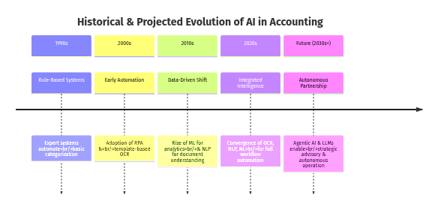
Figure 12. Timeline (Source: Generated Diagram)
The implications of this transformation for the accounting profession are profound. The research clearly indicates that the role of the accountant is evolving from a processor of transactions to an interpreter of insights and a strategic advisor. As AI agents handle repetitive data entry, reconciliation, and initial compliance checks, human professionals are freed to focus on higher-order tasks such as complex judgment, strategic planning, client advisory, and ethical oversight of algorithmic outputs [Thomson Reuters, 2025; arXiv, 2025]. This necessitates a parallel evolution in professional education and skill sets, with future accountants requiring strong competencies in data literacy, system governance, and critical analysis to effectively manage and interrogate AI-driven processes.
However, this promising future is not without significant challenges and risks that must be proactively managed. The reliance on complex, often opaque machine learning models raises critical concerns regarding auditability, transparency, and bias [ResearchGate, n.d.]. Ensuring the explainability of AI-driven decisions in auditing and financial reporting is paramount to maintaining professional standards and regulatory compliance. Furthermore, the security and integrity of financial data within AI systems present a heightened risk surface that requires robust cybersecurity frameworks. The historical context reminds us that technological adoption is iterative; the current wave of generative and agentic AI will introduce new learning curves and implementation hurdles that firms must navigate [IJSR, n.d.].
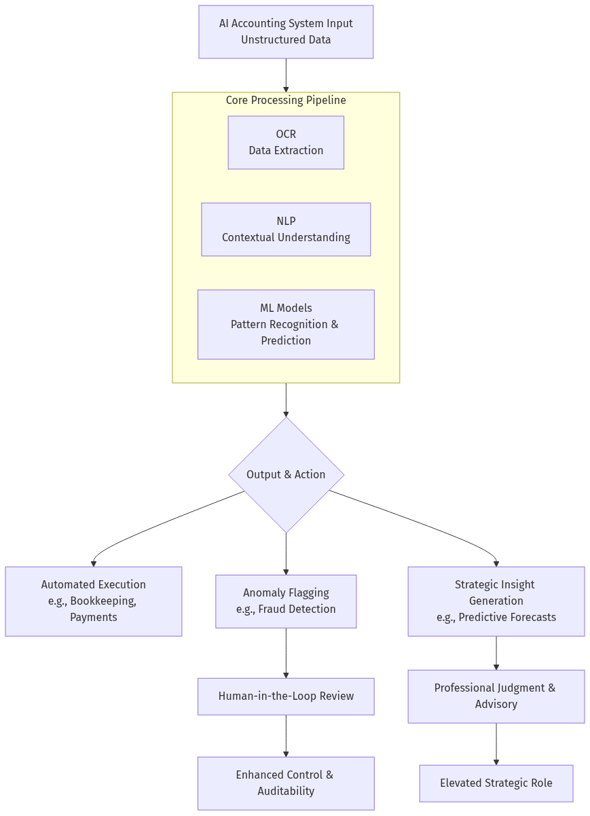
Figure 13. Flowchart (Source: Generated Diagram)
In conclusion, the integration of AI into accounting represents a definitive and positive inflection point for the profession. The findings of this research collectively affirm that AI serves as a powerful augmentative force, capable of delivering unprecedented levels of efficiency, accuracy, and strategic insight. The trajectory points toward a future of deepened partnership between human expertise and artificial intelligence, where accountants leverage intelligent systems to provide more timely, forward-looking, and value-added services. To fully realize this potential, stakeholders—including accounting firms, educators, regulators, and technology providers—must collaborate to address the accompanying challenges of ethics, transparency, and skills development. By doing so, the profession can successfully navigate this transformation, ensuring that Accounting + AI fulfills its promise of enhancing not only financial management but also overall business resilience and strategic decision-making in an increasingly complex global economy.

References
[1] Accountancy Age. (2025). Top 10 AI accounting tools every business needs in 2025. Retrieved from https://accountancyage.com/2025/01/24/top-10-ai-accounting-tools-every-business-needs-in-2025/
[2] AIMultiple. (n.d.). Invoice OCR Benchmark: Extraction Accuracy of LLMs vs OCRs. Retrieved from https://research.aimultiple.com/invoice-ocr/
[3] AITopHub. (n.d.). The Best 31 AI Accounting Assistant Tools, SaaS, Apps. Retrieved from https://aitophub.com/ai-accounting-assistant
[4] Artsyl Tech. (n.d.). Machine Learning in AP Automation Solutions. Retrieved from https://www.artsyltech.com/blog/machine-learning-in-ap-automation
[5] arXiv. (2025). AI Agents: Evolution, Architecture, and Real-World Applications. Retrieved from https://arxiv.org/abs/2511.16055
[6] Commport. (2025). E-Invoicing – Digitalizing Invoices Using EDI, OCR, AI, and NLP Technology. Retrieved from https://www.commport.com/e-invoicing-digitalizing-invoices-using-edi-ocr-ai-and-nlp-technology/
[7] Daffodil Software. (2025). AI in Accounting Software: Tools, Use Cases, and LLM Models. Retrieved from https://www.daffodilsw.com/blog/ai-in-accounting-software/
[8] Dext. (n.d.). Online Bookkeeping Software for Small Businesses. Retrieved from https://dext.com/
[9] DualEntry. (2026). Best AI Accounting Software 2026: Reviews, Features & Pricing. Retrieved from https://www.dualentry.com/blog/best-ai-accounting-software
[10] EveryDev.ai. (n.d.). Bookeeping. ai - AI Bookkeeping API Platform. Retrieved from https://www.everydev.ai/tools/bookeeping-ai
[11] Financial Cents. (2025). Optical Character Recognition (OCR) In Accounting Guide. Retrieved from https://www.financialcents.com/accounting-hub/ocr-in-accounting/
[12] Forbes. (2025). AI In Accounting Is Here: 7 Game-Changing Innovations You Should Know. Retrieved from https://www.forbes.com/sites/quickerbettertech/2025/04/03/ai-in-accounting-is-here-7-game-changing-innovations-you-should-know/
[13] GMIResearch. (2021). AI in Accounting Market Share & Industry Research Report, 2021-2028. Retrieved from https://www.gmiresearch.com/report/ai-in-accounting-market/
[14] Gov.Capital. (n.d.). 10 Financial “Super-Apps” to Bulletproof Your Business: The Ultimate Investment Guide to Accounting Infrastructure. Retrieved from https://gov.capital/10-financial-super-apps-to-bulletproof-your-business-the-ultimate-investment-guide-to-accounting-infrastructure/
[15] Grand View Research. (2025). Artificial Intelligence Market Size | Industry Report, 2033. Retrieved from https://www.grandviewresearch.com/industry-analysis/artificial-intelligence-ai-market
[16] HubiFi. (2025). 10 Best AI in Accounting Software Tools for 2024. Retrieved from https://www.hubifi.com/blog/ai-accounting-software-tools
[17] IJSR. (n.d.). Artificial Intelligence in Accounting and Auditing: A Literature Review. International Journal of Scientific Research.
[18] Jpopasia. (n.d.). Artificial Intelligence In Accounting. Retrieved from https://www.jpopasia.com/accounting/artificial-intelligence-in-accounting/
[19] Kefron. (2025). What Is OCR Invoice Processing? Benefits, Workflow & Technology. Retrieved from https://www.kefron.com/blog/what-is-ocr-invoice-processing/
[20] LeewayHertz. (2024). AI for invoice processing: Significance, use cases, benefits and implementation. Retrieved from https://www.leewayhertz.com/ai-for-invoice-processing/
[21] LinkedIn. (n.d.). AI in Accounting : Automation , Accuracy & Compliance. Retrieved from https://www.linkedin.com/pulse/ai-accounting-automation-accuracy-compliance-rajesh-kumar-9jvjc
[22] McKinsey. (2025). The State of AI: Global Survey 2025. Retrieved from https://www.mckinsey.com/capabilities/quantumblack/our-insights/the-state-of-ai
[23] Mercity.ai. (n.d.). NLP and LLM Applications in Accounting. Retrieved from https://www.mercity.ai/blog/nlp-and-llm-applications-in-accounting
[24] Mordor Intelligence. (2025). AI in Accounting Market Analysis | Industry Report, Size, Share, Trends & Forecast 2024-2029. Retrieved from https://www.mordorintelligence.com/industry-reports/artificial-intelligence-in-accounting-market
[25] NetSuite. (2025). AI in Accounting: A Transformation. Retrieved from https://www.netsuite.com/portal/resource/articles/accounting/ai-in-accounting.shtml
[26] Oracle. (n.d.). Accounting Automation - docs.oracle.com. Retrieved from https://docs.oracle.com/en/cloud/saas/netsuite/ns-online-help/section_1543917342.html
[27] Oracle. (n.d.). Automatic Accounting Instructions (AAIs). Retrieved from https://docs.oracle.com/cd/E16582_01/doc.91/e15114/automatic_accounting.htm
[28] Oracle. (n.d.). Connect to the NetSuite AI Connector Service. Retrieved from https://docs.oracle.com/en/cloud/saas/netsuite/ns-online-help/section_0714082142.html
[29] Oracle. (n.d.). Intelligent Defaulting of Account Combination. Retrieved from https://docs.oracle.com/en/cloud/saas/financials/24b/oafin/intelligent-defaulting-account-combination.html
[30] Oracle. (n.d.). NetSuite Features That Use AI. Retrieved from https://docs.oracle.com/en/cloud/saas/netsuite/ns-online-help/article_5101751849.html
[31] Oracle. (n.d.). Oracle Fusion Cloud EPM Features with AI. Retrieved from https://www.oracle.com/performance-management/what-is/epm-ai/
[32] Oracle. (n.d.). Set Up Automatic Accounting Instructions. Retrieved from https://docs.oracle.com/cd/E18727_01/doc.121/e13497/T421739T421831.htm
[33] Oracle. (2025). Enabling AI for Insights in Financial Consolidation and Close. Retrieved from https://www.oracle.com/a/ocom/docs/corporate/enabling-ai-for-insights-in-financial-consolidation-and-close-ebook.pdf
[34] PA Global. (n.d.). Insights, the Shift from Reactive to Predictive. Retrieved from https://www.pa.com/resources/insights/the-shift-from-reactive-to-predictive/
[35] Precedence Research. (2024). Artificial Intelligence (AI) Market Size to Hit USD 3,680.47 Bn by 2034. Retrieved from https://www.precedenceresearch.com/artificial-intelligence-market
[36] Research and Markets. (n.d.). Top 24 Artificial Intelligence in Accounting Companies. Retrieved from https://www.researchandmarkets.com/articles/key-companies-in-ai-in-accounting
[37] ResearchGate. (2024). Technology Adoption and Digital Transformation in Small Businesses: Trends, Challenges and Opportunities.
[38] ResearchGate. (2024). THE IMPACT OF ARTIFICIAL INTELLIGENCE ON ACCOUNTING PRACTICES.
[39] ResearchGate. (n.d.). The Emergence of Artificial Intelligence: How Automation is Changing Auditing.
[40] Resourcera. (2026). AI Statistics (2026): Market Size, Growth Trends & Adoption. Retrieved from https://resourcera.com/ai-statistics/
[41] Satva Solutions. (2025). Which SaaS Accounting Tool Has the Smartest AI Features in 2025? Retrieved from https://satvasolutions.com/blog/saas-accounting-tool-smartest-ai-features-2025
[42] Small Business Economics. (2025). AI, robots and innovation in European SMEs.
[43] SN Business & Economics. (2024). Artificial intelligence in Finance: a comprehensive review through bibliometric and content analysis.
[44] Springer. (2024). The Role of Artificial Intelligence in Management Accounting: A Review and Future Research Directions.
[45] SpringerLink. (n.d.). Artificial Intelligence in Accounting and Auditing.
[46] SpringerLink. (n.d.). Artificial Intelligence in Accounting, Auditing and Finance: A Guide for Implementation and Use.
[47] SpringerLink. (n.d.). Automated Accounting System Using Artificial Intelligence.
[48] Startup-Movers. (2025). Top 10 AI Accounting Tools for Startups in 2025 | Boost Efficiency & Growth. Retrieved from https://www.startup-movers.com/ai-accounting-tools-for-startups
[49] Synder. (n.d.). Synder Accounting Automation : Accounting Software for Online Sales. Retrieved from https://synder.com/
[50] Thomson Reuters. (2025). Clarifying the Complex | Homepage. Retrieved from https://www.thomsonreuters.com/en.html
[51] Thomson Reuters. (2025). How are different accounting firms using AI in 2025? Retrieved from https://tax.thomsonreuters.com/blog/how-do-different-accounting-firms-use-ai-tri/
[52] Vic.ai. (n.d.). What Types of AI Are For Accounting? Retrieved from https://www.vic.ai/blog/what-types-of-ai-are-for-accounting
[53] Wikipedia. (n.d.). Optical character recognition. Retrieved from https://en.wikipedia.org/wiki/Optical_character_recognition
[54] Zeni.ai. (n.d.). How to automate accounting tasks. Retrieved from https://www.zeni.ai/blog/how-to-automate-accounting-tasks

This report was generated by Requirements Analysis Agent Assistant (RAAA)

