WEEK 4 · EXPLORATORY DATA ANALYSIS & FEATURE ENGINEERING
Decoding the Skincare Shopper
Uncovering what drives skincare recommendations, and engineering features that turn those patterns into better predictions and decisions
PREPARED BY Aayush Gautam
PROGRAMME Data Science with Python Internship — YuvaIntern (Henry Harvin)
DOMAIN Beauty & Wellness — Skincare e-commerce
BUILDS ON Week 1 hypotheses H1–H6 · Week 2 analysis plan · Week 3 cleaned data
CODE github.com/weebaayush/beauty-wellness (src/eda, src/features, src/modeling)
DATE November 2026

Contents
1. Executive Summary
2. Data, Scope & an Important Caveat
3. EDA Workflow & Techniques
4. Python Visualisation & Statistics Plan
5. EDA Findings
6. Feature Engineering Plan
7. Do the Features Improve Models? (Validation)
8. Hypothetical Decision Scenarios
9. From Features to Business Insight
10. Limitations & Next Steps
Appendix — Code, Commands & Outputs
References

1. Executive Summary
This week I designed and ran a full exploratory data analysis (EDA) and feature-engineering workflow on the cleaned review table produced by the Week 3 pipeline (59,614 dated reviews, 1,174 products). The workflow has eight stages (Figure 1), uses matplotlib, SciPy and scikit-learn, tests the Week 1 hypotheses against the decision rules fixed in Week 2, and engineers 35 new features in 8 families, which are then validated by measuring how much they improve out-of-time prediction.
Question | Result | Verdict (Week 2 rule)
H1 — Does satisfaction differ by skin type? | Kruskal–Wallis p < 0.001, but effect size ε² = 0.002; largest gap 0.13★ (oily 4.14 vs normal 4.01) | Not practically meaningful (needs ε² ≥ 0.01 or gap ≥ 0.2★) — skin type matters only in combination with the product
H2 — Is price linked to satisfaction? | Spearman ρ = −0.06, 95% CI [−0.14, 0.02], 563 products | Supported — "premium ≠ performance"
H4 — Fragrance × dry skin | Dry skin: 82.6% recommend fragrance-free vs 78.5% fragranced (−4.1 pts, p < 0.001); interaction test p < 0.001 | Supported (gap ≥ 3 pts)
H6 — Are helpful reviews longer and more negative? | Length: no difference (median 9 vs 9 words, p = 0.08). Negative share: 9.5% vs 6.5% (p < 0.001) | Partly supported (negativity yes, length no)
Skin-type fit (new) | Product "Good for" matches reviewer: 89.9% recommend; opposite skin type: 73.3% | 16.6-point gap — strongest customer signal
Do engineered features help? | ROC-AUC on newest 20% of reviews: 0.670 → 0.719 → 0.738 (gradient boosting); 0.529 → 0.589 → 0.739 (logistic regression) | +0.069 AUC (95% CI +0.059 to +0.078) vs baseline
Decision scenario | Top-5 products per skin type chosen by the model were recommended by 95.5% of test-period reviewers, vs 78.5% for the top-5 bestsellers | Basis for a "Best for your skin" shelf, to be confirmed by A/B test

Table 1. Headline findings (simulated data — see Section 2).
Key insight: skin type on its own explains almost nothing (H1), but whether the product suits that skin type is one of the strongest signals in the data. The value lies in customer × product interaction features, which is exactly where feature engineering pays off.

2. Data, Scope & an Important Caveat
The input is data/processed/reviews_clean.csv.gz from Week 3: one row per review with cleaned profile fields, product attributes, ingredient and claim flags, and quality flags. After removing 129 reviews without a valid date, 59,614 reviews remain; 52,440 have a recommendation label (the modelling target).
Caveat — simulated data. Week 3 generated a Sephora-format dataset with known relationships (e.g. a fragrance penalty for dry skin, a bonus when the product suits the reviewer's skin) so the pipeline could be tested. The EDA therefore recovers relationships I built in, which validates the methods but is not evidence about real shoppers. Every script runs unchanged on the real Kaggle data with one setting changed, and Section 10 lists what I expect to differ. Where a pattern is a simulation artefact, it is labelled as such.
Two simulation artefacts matter for interpretation: (1) review text was generated from the star rating, so text features look unrealistically predictive; (2) each simulated reviewer wrote only one review, so reviewer-history features cannot show their value here, although they are implemented for the real data where repeat reviewers are common.

3. EDA Workflow & Techniques
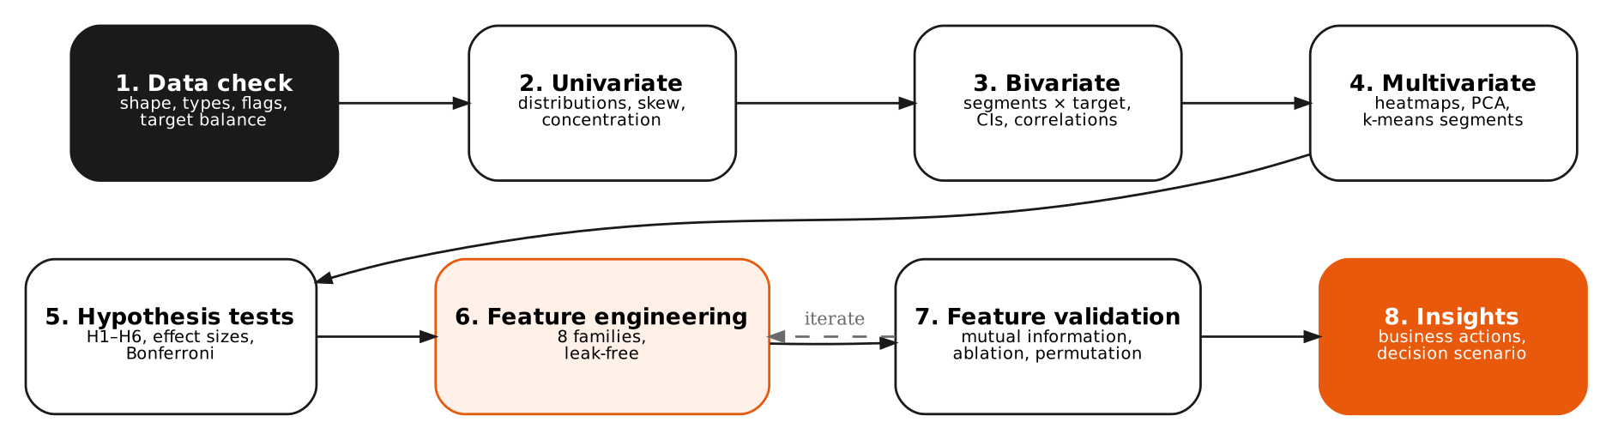
Figure 1. Eight-stage EDA and feature-engineering workflow. Validation feeds back into feature design.
Stage | Basic techniques | Advanced / multi-dimensional techniques | Output
1. Data check | Shape, dtypes, value counts, flag counts | Missingness patterns by segment | Analysis population defined
2. Univariate | Histograms, bar charts, mean / median / skew | Lorenz curve and Gini coefficient for concentration | Distribution facts
3. Bivariate | Grouped bars, box plots, scatter | Wilson / bootstrap confidence intervals; Spearman correlation matrix | Candidate relationships
4. Multivariate | Category × segment heatmaps | PCA, k-means product segmentation, Simpson's-paradox checks, product-level vs review-level views | Hidden structure
5. Hypothesis tests | Chi-square, Mann–Whitney | Kruskal–Wallis + post-hoc, likelihood-ratio interaction test, effect sizes, Bonferroni correction | Accept / reject H1–H6
6. Feature engineering | Ratios, flags, binning | Leak-free time-window aggregates, out-of-fold target encoding, cyclical encoding, interaction terms | 35 new features
7. Feature validation | Correlation with target | Mutual information, ablation study with time-based split, paired bootstrap, permutation importance | Proof of value
8. Insights | Summary tables | Decision scenario simulation | Business recommendations

Table 2. Techniques used at each stage.

4. Python Visualisation & Statistics Plan

4.1 Libraries and their roles
Library | Role in this project | Why it fits
pandas | groupby aggregations, pivot tables, time resampling (quarterly), expanding windows | Expressive split-apply-combine; built-in datetime handling
matplotlib | All 16 figures in this report (bars, heatmaps, scatter, Lorenz curve, small multiples) | Full control over every element — needed for consistent, publication-quality, accessible charts
seaborn | Quick exploratory plots in notebooks (pairplot, violinplot, catplot, clustermap) | One-line statistical plots with CIs; used for exploration, while final figures use matplotlib for control
plotly | Interactive versions for the Week 6 dashboard | Hover tooltips and filtering for stakeholders
SciPy (stats) | kruskal, mannwhitneyu, chi2_contingency, spearmanr, chi2 distribution, skew | Reliable, well-tested implementations of classical tests
scikit-learn | PCA, KMeans, StandardScaler, mutual_info_classif, LogisticRegression, HistGradientBoosting, permutation_importance, KFold | Consistent API from exploration to modelling; leak-safe pipelines
statsmodels / scikit-posthocs | Regression tables with p-values, Dunn's test (on real-data run) | Richer statistical output than scikit-learn

Table 3. Library plan.

4.2 Visualisation design rules
- Chart follows the question: comparisons → bars; distributions → histograms; two numeric variables → scatter; two categorical dimensions → heatmap; time → line or bar, never a dual-axis chart (two measures go into small multiples, Figure 9).
- Uncertainty is always shown: 95% confidence intervals on rates (Wilson score interval), and sample sizes printed on every heatmap cell.
- One accent colour (orange) highlights the message; everything else is grey — the title states the takeaway.
- Log scales for prices and counts that span several orders of magnitude.
- Colour-blind-safe palettes: a single-hue sequential ramp for magnitudes, and a blue–grey–orange diverging palette for correlations.

4.3 Statistical methods
Method | Used for | Assumptions / why chosen | Effect size reported
Wilson score interval | CIs for recommendation rates | Accurate for proportions near 80–90%, unlike the normal approximation | Rate ± CI
Kruskal–Wallis + pairwise Mann–Whitney (Bonferroni) | H1 rating across 4 skin types | Ratings are ordinal and skewed (skew −0.82), so no normality assumption | ε²
Spearman ρ + Fisher-z CI | H2 price vs product rating | Monotonic, robust to price outliers; at product level to avoid over-counting popular products | ρ with 95% CI
Chi-square test | H4 fragrance × recommendation (dry skin) | Two categorical variables, large counts | Cramér's V, gap in points
Likelihood-ratio test (logistic models) | Is the skin type × fragrance interaction real? | Compares models with and without interaction terms | LR statistic
Mann–Whitney U + chi-square | H6 helpful vs other reviews | Word counts are skewed | Rank-biserial r, share difference
Mutual information (k-NN estimator) | Feature screening | Captures non-linear relationships that correlation misses | MI in nats
PCA + k-means (elbow check) | Product segmentation | Standardised features; k chosen from inertia curve and interpretability | Explained variance

Table 4. Statistical methods. α = 0.05 / 6 = 0.0083 (Bonferroni across the six hypotheses).

5. EDA Findings

5.1 Target and rating distribution
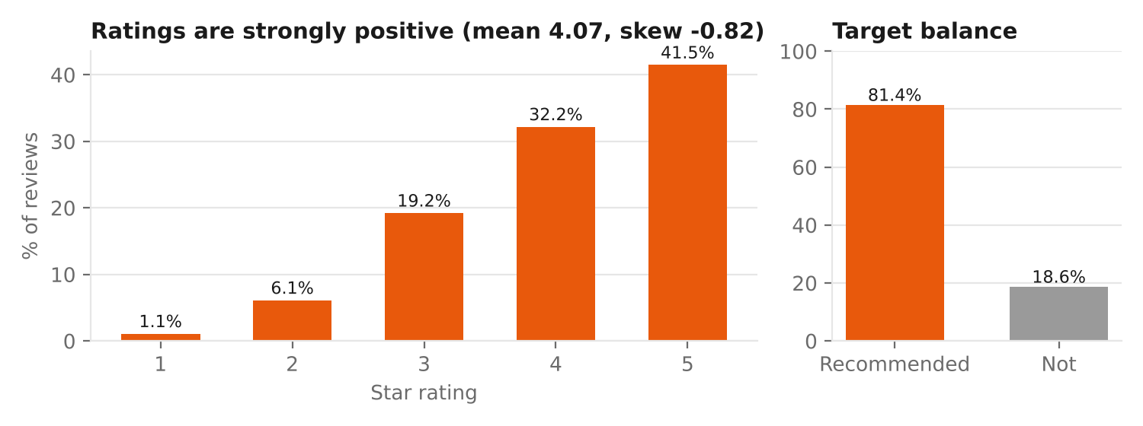
Figure 2. Rating distribution and target balance.
Ratings are heavily positive: 41.5% are 5★ and only 7.2% are 1–2★ (mean 4.07, skew −0.82). 81.4% of reviewers recommend the product. Implications: use non-parametric tests; evaluate models with PR-AUC for the minority "not recommended" class; use class weights in modelling.

5.2 Review concentration — a hidden trap
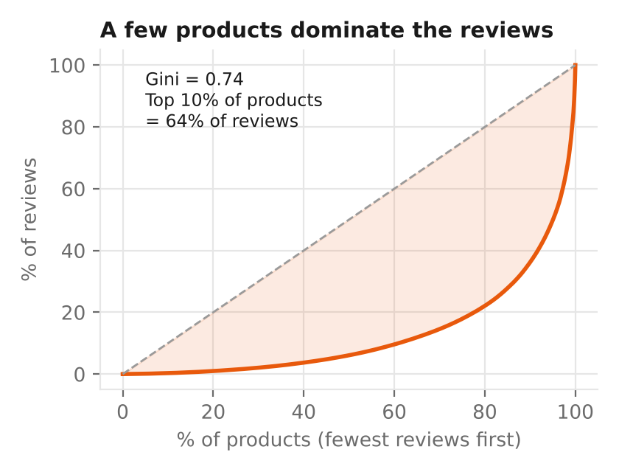
Figure 3. Lorenz curve of reviews across products.
Reviews are extremely concentrated: the top 10% of products receive 64% of all reviews (Gini = 0.74). Any review-level statistic is therefore dominated by a few bestsellers. Implications: (1) price and formulation questions (H2) are analysed at the product level; (2) product-level averages are Bayesian-smoothed; (3) "product identity" is itself a strong predictor, which motivated the product-history features in Section 6.

5.3 H1 — Skin type × category
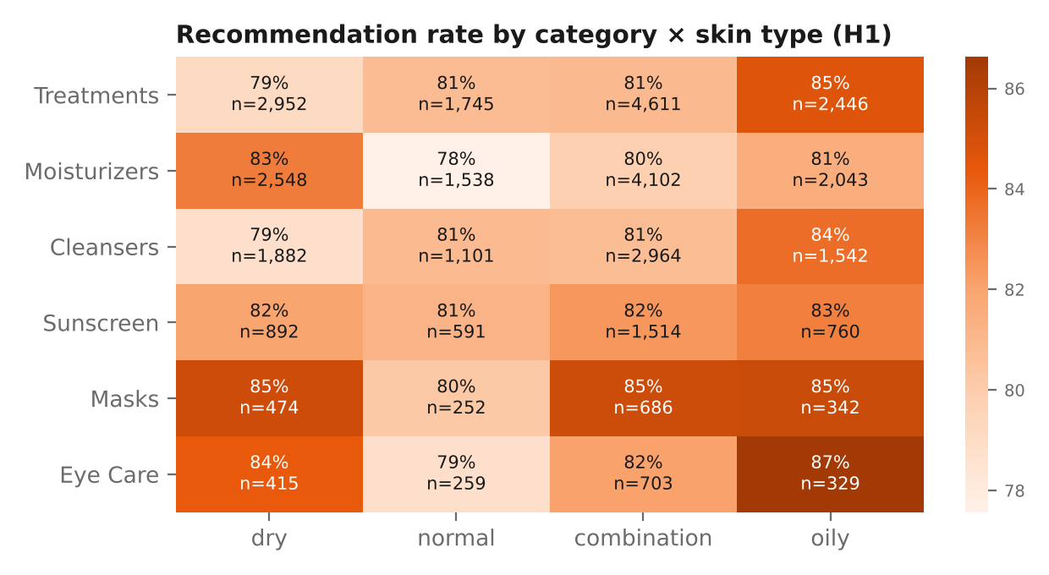
Figure 4. Recommendation rate for each category × skin-type cell, with sample size.
The Kruskal–Wallis test is highly significant (H = 65.9, p < 0.001, n = 36,597 reviews with known skin type), but the effect size is tiny (ε² = 0.002). Mean ratings range only from 4.01 (normal) to 4.14 (oily). Under the decision rule fixed in Week 2 (ε² ≥ 0.01 or a gap ≥ 0.2★), H1 is not practically meaningful. The heatmap tells a richer story: individual cells range from 78% to 87%, e.g. oily-skin shoppers recommend eye care at 87% but normal-skin shoppers only 79%. Skin type matters through its interaction with the product, not on its own.

5.4 H2 — Price versus satisfaction
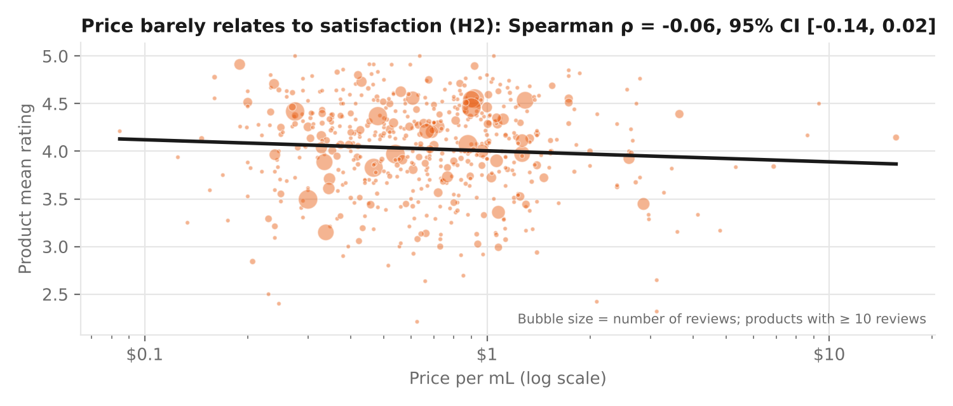
Figure 5. Product mean rating against price per mL (563 products with ≥ 10 reviews).
Spearman ρ = −0.06 (95% CI −0.14 to 0.02, p = 0.16). Within every category |ρ| ≤ 0.11. Both Week 2 criteria are met, so H2 is supported: paying more does not buy higher satisfaction. Business meaning: premium brands cannot rely on price as a quality signal; value brands can compete on satisfaction.

5.5 H4 — Fragrance and dry skin
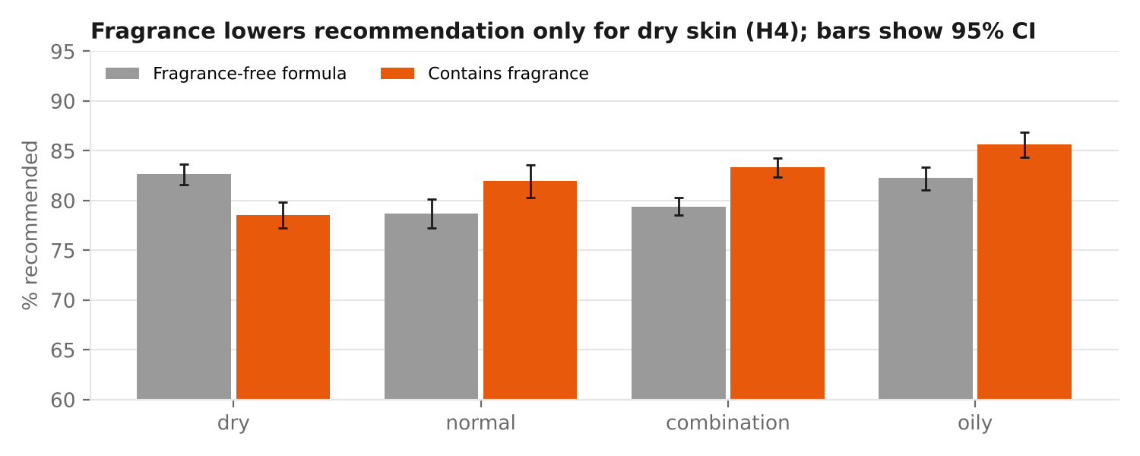
Figure 6. Recommendation rate by skin type and fragrance, with 95% Wilson intervals.
Among dry-skin reviewers, 82.6% recommend fragrance-free products versus 78.5% for fragranced ones — a 4.1-point gap (χ² = 23.1, p < 0.001, Cramér's V = 0.05). Adding skin type × fragrance terms to a logistic model improves fit significantly (LR = 65.1, p < 0.001). H4 is supported.
Simpson's-paradox check: for the other three skin types, fragranced products are recommended more often. The simulation only built in a penalty for dry skin, so this reversal comes from product mix — the fragranced products that happen to be popular are good products. This is a warning that a simple fragranced-vs-free comparison across all customers would hide the dry-skin effect; segmentation reveals it.

5.6 Skin-type fit
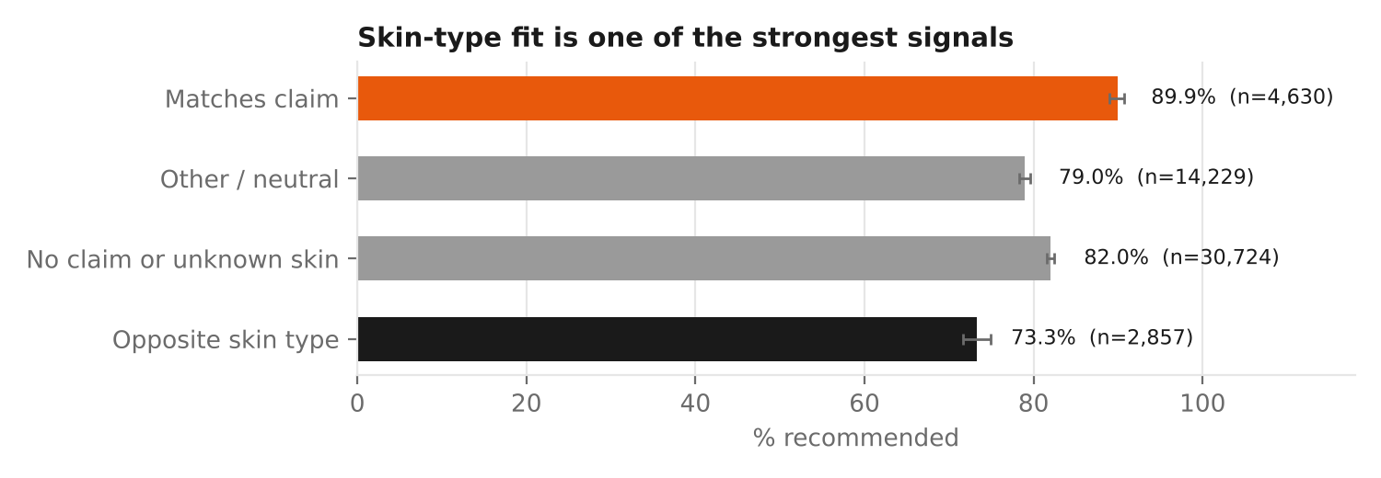
Figure 7. Recommendation rate by how well the product suits the reviewer's skin.
When the product's "Good for" claim matches the reviewer's skin type, 89.9% recommend it; when it targets the opposite type (e.g. a "Good for: Dry Skin" product used on oily skin), only 73.3% do — a 16.6-point gap. This is the single strongest customer-side pattern and motivates the skin_match and skin_mismatch features.

5.7 H6 — What makes a review helpful?
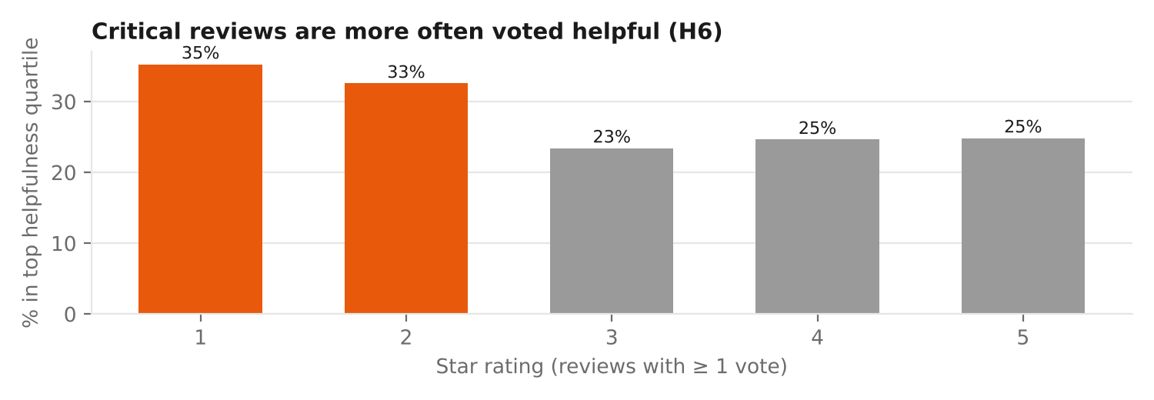
Figure 8. Share of reviews in the top helpfulness quartile, by star rating (27,953 reviews with at least one vote).
35% of 1★ reviews are in the top helpfulness quartile, versus 23–25% for 3–5★. Top-quartile reviews are more often negative (9.5% vs 6.5%, p < 0.001) but not longer (median 9 words in both, p = 0.08). H6 is partly supported: shoppers value critical information. Business meaning: hiding or burying negative reviews would remove exactly the content shoppers find most useful.

5.8 Trends over time
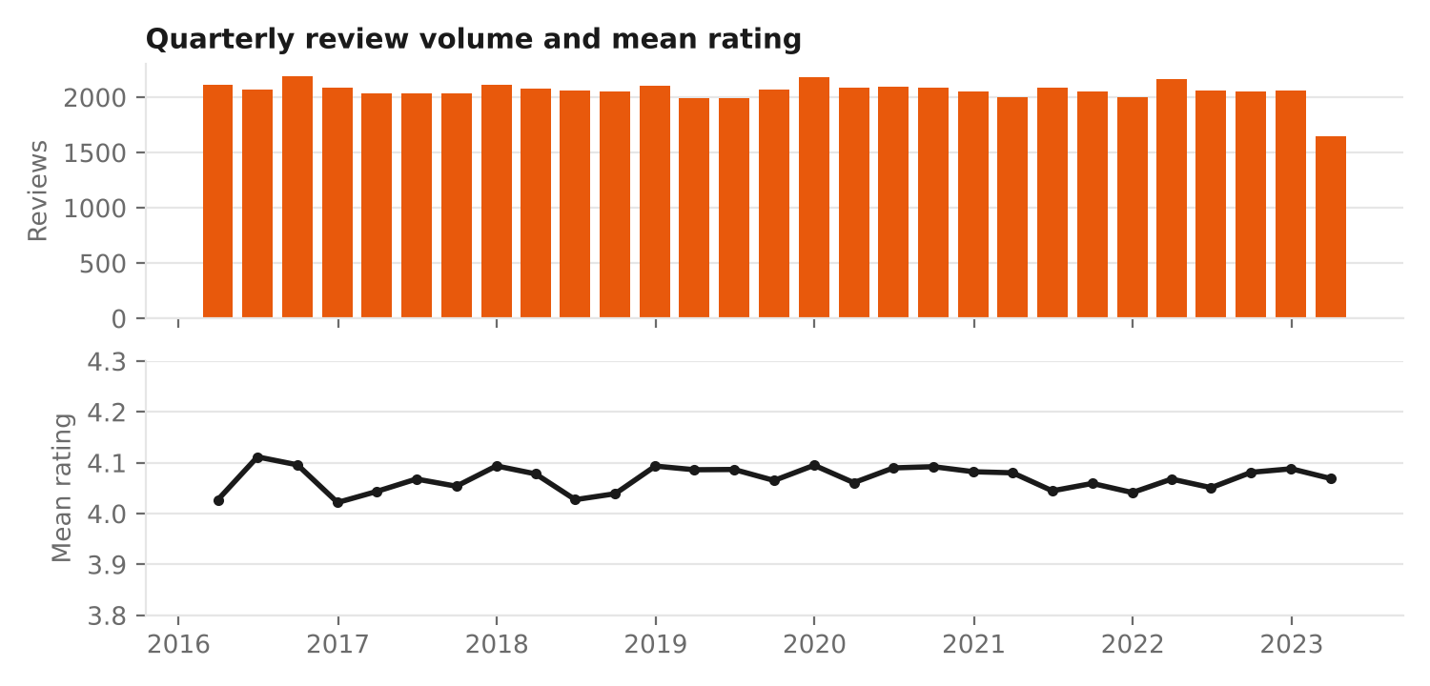
Figure 9. Quarterly review volume and mean rating (two panels instead of a dual axis).
Volume and rating are flat in the simulated data (quarterly mean rating 4.02–4.11; month-of-year range only 0.02★). There is no seasonality to find here, because none was simulated. On the real data I expect clear patterns — sunscreen reviews peaking in summer, gifting spikes in November–December, and launch-period enthusiasm — which is why cyclical month and launch-age features were engineered anyway.

5.9 What reviewers talk about
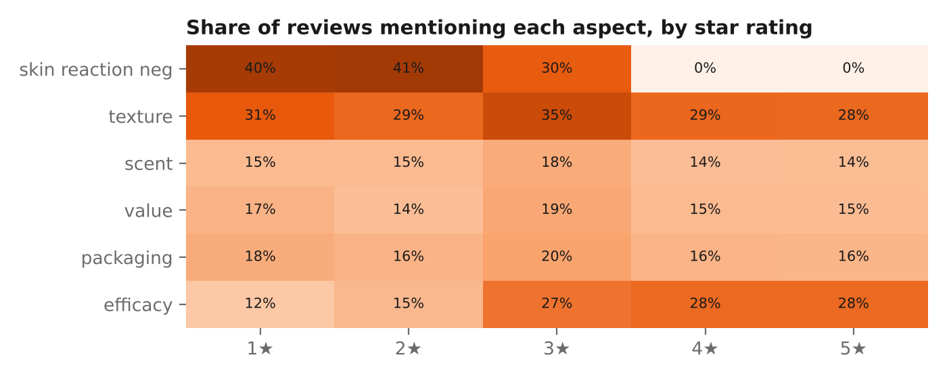
Figure 10. Share of reviews mentioning each aspect, by star rating (keyword lexicon).
Skin-reaction complaints appear in 40–41% of 1–2★ reviews and almost never in 4–5★ reviews; efficacy mentions rise from 12% to 28% with rating. Texture, scent and packaging are mentioned at similar rates across ratings, suggesting they are discussed by everyone but decide less. This is the first evidence for H3 (skin reaction matters most); the clean separation is partly a simulation artefact and will be re-tested with a transformer model on real text.

5.10 Correlation structure
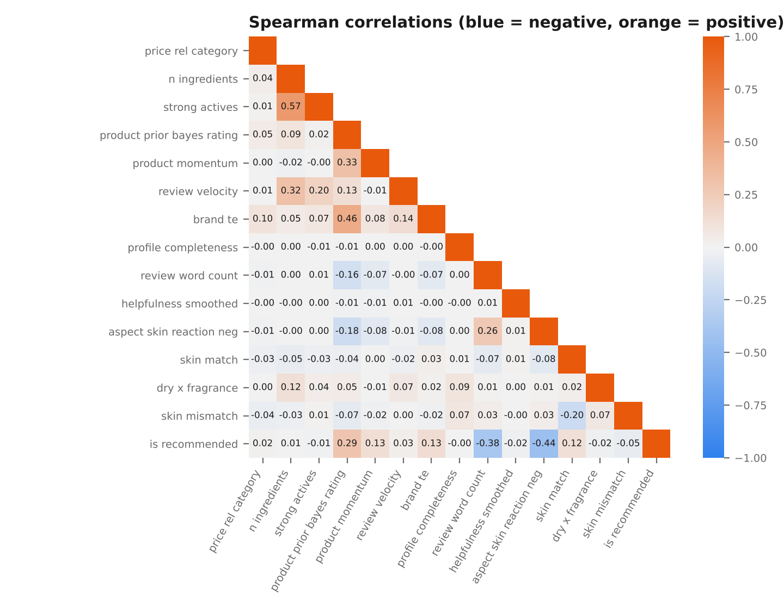
Figure 11. Spearman correlations among key features and the target.
No pair of predictors has |ρ| > 0.6 (largest: strong actives vs ingredient count 0.57; brand reputation vs product prior rating 0.46), so multicollinearity is low and all features can be kept. The strongest correlates of recommendation are negative skin-reaction mentions (−0.44), product prior rating (+0.29) and brand reputation (+0.13). Review length (−0.38) is a simulation artefact (negative template sentences are longer).

5.11 Mutual information screening
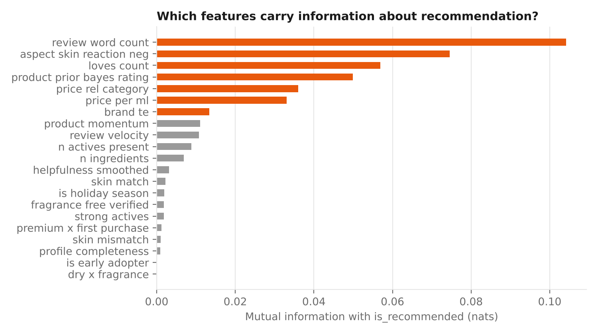
Figure 12. Mutual information between each feature and the recommendation target.
Mutual information confirms the text and product-history signals. It also exposes a trap: product-level constants such as loves_count and price_per_ml score high because, with many reviews per product, each unique value acts as a product identifier and carries that product's quality. This is why the model comparison uses an out-of-time split and why product quality is captured explicitly and leak-free through product_prior_bayes_rating.

5.12 Product segments
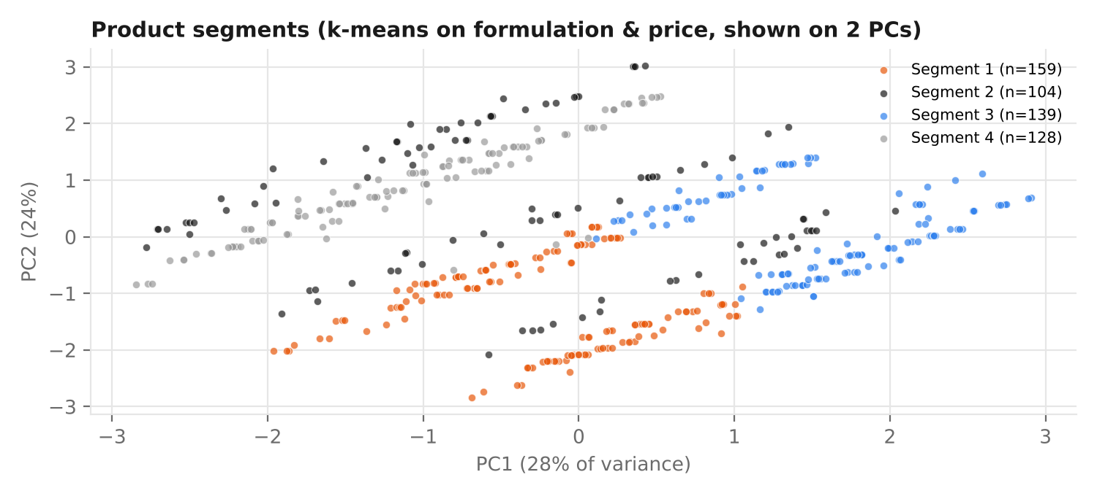
Figure 13. k-means segments (k = 4) on formulation and price features, projected onto two principal components (52% of variance).
Segment | Items | Profile | Rel. price | Rec. rate | Suggested positioning
1 — Basic fragranced | 159 | Fewer strong actives (1.5), 47% fragranced, no claims | 0.85× | 79.9% | Entry-level; candidates for fragrance-free variants
2 — Vegan | 104 | 100% vegan, 44% fragrance-free claim | 0.91× | 80.9% | Ethical-value shoppers
3 — Active-heavy fragranced | 139 | 3.0 strong actives, 66% fragranced | 0.96× | 79.1% | Highest irritation risk — clear usage guidance needed
4 — Fragrance-free claimers | 128 | 100% "Fragrance Free" claim, 2% contain fragrance | 1.06× | 80.6% | Sensitive / dry skin; priced slightly higher

Table 5. Product segment profiles. Recommendation rates differ by under 2 points, consistent with H2: positioning does not by itself buy satisfaction.

5.13 Summary: findings → business insight
EDA finding | Business insight for the beauty & wellness market
Skin type alone: negligible effect; skin-type fit: 16.6-point gap | Personalisation must match products to skin, not just segment shoppers by skin type
Price unrelated to satisfaction | Premium pricing needs other justification (experience, brand, claims); value brands can win on satisfaction
Fragrance hurts only dry skin | Offer fragrance-free variants for dry-skin lines; target messaging by skin type
Critical reviews are most helpful | Surface balanced reviews; use complaints as R&D input
64% of reviews on 10% of products | Long-tail products lack social proof; Bayesian ratings make fair comparisons possible
Skin-reaction language dominates negative reviews | Irritation is the main churn driver — monitor it as an early-warning metric

Table 6. From patterns to insights.

6. Feature Engineering Plan

6.1 Design principles
- Domain first — every feature encodes a mechanism a beauty-industry expert would recognise (skin fit, irritation risk, social proof, launch hype).
- Leak-free by construction — a feature for review i uses only information available when review i was written: expanding windows with shift(1), out-of-fold target encoding, and no post-publication data.
- Explainable — counts, ratios and flags that a merchandiser can understand, before any black-box embeddings.
- Validated — a feature is kept only if it adds measurable value (Section 7).

6.2 Feature catalogue
Family | Features (examples) | Definition / formula | Hidden aspect captured
Customer behaviour | profile_completeness, reviewer_prior_reviews, reviewer_prior_mean_rating, is_incentivised | Profile fields filled (0–4); earlier reviews by the same (hashed) reviewer and their mean rating | Engagement; "harsh" vs "generous" reviewers; incentive bias
Market trend | month_sin, month_cos, is_holiday_season, days_since_launch, is_early_adopter | sin/cos(2π·month/12); Nov–Dec flag; days since product's first review; ≤ 90 days flag | Seasonality; gifting; launch hype fading
Product momentum | product_prior_bayes_rating, product_prior_rec_rate, product_momentum, review_velocity | (C·m + Σ earlier ratings)/(m + n earlier); last-10 mean − long-run mean; reviews per month so far | Social proof seen at purchase; products trending down after a reformulation
Price positioning | price_rel_category, price_tier | price per mL ÷ category median; quartile within category | "Expensive for a cleanser" vs "expensive for a serum"
Formulation | strong_actives, n_actives_present, fragrance_free_verified | Count of retinol / AHA / BHA / vitamin C; claim AND INCI agree | Irritation potential; genuine vs mislabelled claims
Interaction (customer × product) | skin_match, skin_mismatch, dry_x_fragrance, oily_x_rich_texture, premium_x_first_purchase | Products of indicator variables | Fit between a person and a product — the strongest signal in Section 5
Text | aspect_* (6), exclamations, has_emoji, caps_ratio | Regex lexicon counts per aspect; emotion markers | Why a customer is happy or unhappy (H3)
Encoding | brand_te, brand_freq | Out-of-fold smoothed brand recommendation rate (m = 50); brand review share | Brand reputation in 1 column instead of 30

Table 7. Engineered features (full list with rationale in reports/feature_catalogue.md).

6.3 Transformations with examples

Normalisation
Carried over from Week 3 and applied inside a scikit-learn pipeline fitted on training data only: log1p + RobustScaler for skewed counts and prices (loves, velocity, price per mL), StandardScaler for roughly symmetric counts, and Min-Max for bounded scores.

Encoding
# 1) Cyclical month: December (12) and January (1) end up close together, unlike month = 1..12
df["month_sin"] = np.sin(2 * np.pi * df.submission_time.dt.month / 12)
df["month_cos"] = np.cos(2 * np.pi * df.submission_time.dt.month / 12)

# 2) Out-of-fold, smoothed target encoding: no review ever sees its own label
prior, m = train.y.mean(), 50
for tr_idx, va_idx in KFold(5, shuffle=True, random_state=42).split(train):
s = train.iloc[tr_idx].groupby("brand_name").y.agg(["sum", "count"])
te = (s["sum"] + prior * m) / (s["count"] + m) # small brands shrink towards the average
train.loc[train.index[va_idx], "brand_te"] = train.iloc[va_idx].brand_name.map(te).fillna(prior).values

# 3) Ordinal binning within category
df["price_tier"] = df.groupby("secondary_category").price_per_ml.transform(
lambda s: pd.qcut(s.rank(method="first"), 4, labels=["budget", "mid", "premium", "luxury"]))

Leak-free time-window aggregates
df = df.sort_values("submission_time")
g = df.groupby("product_id")
n_before = g.cumcount() # reviews written earlier
sum_before = g["rating"].transform(lambda s: s.cumsum().shift(1).fillna(0))
df["product_prior_bayes_rating"] = (C * 20 + sum_before) / (20 + n_before)
df["product_momentum"] = g["rating"].transform(lambda s: s.shift(1).rolling(10, min_periods=3).mean()) \
- df["product_prior_bayes_rating"]

Interaction variables
df["skin_match"] = (df.good_for == df.skin_type).astype(int) # "Good for: Dry Skin" + dry reviewer
df["skin_mismatch"] = [int(g == {"dry": "oily", "oily": "dry"}.get(s)) for s, g in zip(df.skin_type, df.good_for)]
df["dry_x_fragrance"] = ((df.skin_type == "dry") & (df.has_fragrance == 1)).astype(int)

6.4 Leakage found and fixed during EDA
Issue found | Why it leaks | Fix
Week 3's product_bayes_rating used all reviews of a product | A review's own rating and future reviews feed into its feature | Replaced by product_prior_bayes_rating (earlier reviews only)
helpfulness_smoothed | Votes arrive after the review is published — not known at prediction time | Used for EDA (H6) only; excluded from models
Brand target encoding on the full dataset | Test-period labels would inform training features | Re-fitted inside the training period only (out-of-fold)

Table 8. Leakage audit.

6.5 Features planned for the real data
- Reviewer history (repeat reviewers are common on Sephora): personal harshness score, category loyalty, number of brands tried.
- Transformer aspect sentiment (e.g. a fine-tuned DistilBERT) replacing keyword counts.
- Ingredient embeddings: represent each product by its INCI list (TF-IDF or ingredient2vec) to find "dupes" — cheaper products with similar formulas.
- Market demand: Google Trends interest for the product's key active in the month of the review (e.g. niacinamide in India vs worldwide).
- Shade / variation features for tinted products, relevant to skin-tone fairness checks.

7. Do the Features Improve Models? (Validation)
To show that the features add real predictive value, I ran an ablation study: feature families are added one at a time, a model is trained on the oldest 80% of reviews (41,952, up to October 2021) and tested on the newest 20% (10,488, October 2021 – March 2023). Two model types are used: a linear model (logistic regression) and a non-linear one (histogram gradient boosting).
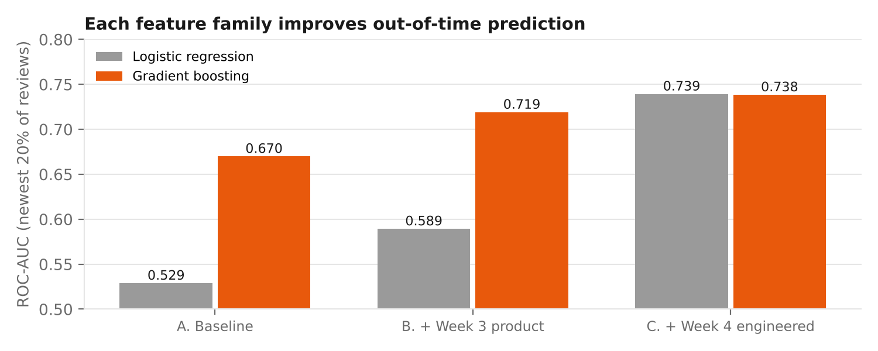
Figure 14. Out-of-time ROC-AUC by feature set.
Feature set | Inputs | Logistic regression AUC | Gradient boosting AUC | PR-AUC "not recommended" (GB)
A. Baseline: skin type, skin tone, category, price | 4 | 0.529 | 0.670 | 0.314
B. + Week 3 product features (ingredients, claims, skin_match) | 25 | 0.589 | 0.719 | 0.382
C. + Week 4 engineered features | 46 | 0.739 | 0.738 | 0.398
D. + review-text features* | 56 | 0.890 | 0.966 | 0.853

Table 9. Ablation results. PR-AUC baseline (random) = 0.19. *D is optimistic: simulated text was generated from the rating.
Interpretation:
- Week 4 features raise gradient-boosting AUC by +0.020 over set B (paired bootstrap 95% CI +0.015 to +0.025) and by +0.069 over the baseline (CI +0.059 to +0.078). Both intervals exclude zero.
- The jump is far larger for logistic regression (0.589 → 0.739, +0.15): engineered interactions and smoothed aggregates hand a linear model the non-linear structure that boosting must otherwise discover. Explainable models become as accurate as black-box ones.
- Baseline gradient boosting (0.670) beats baseline logistic regression (0.529) because it uses price per mL as a hidden product identifier (Section 5.11). Set C replaces this accidental memorisation with an explicit, leak-free product-quality feature.
- Set D shows why text matters, but its accuracy is inflated by how the text was simulated; real-text accuracy will be measured in Week 5.
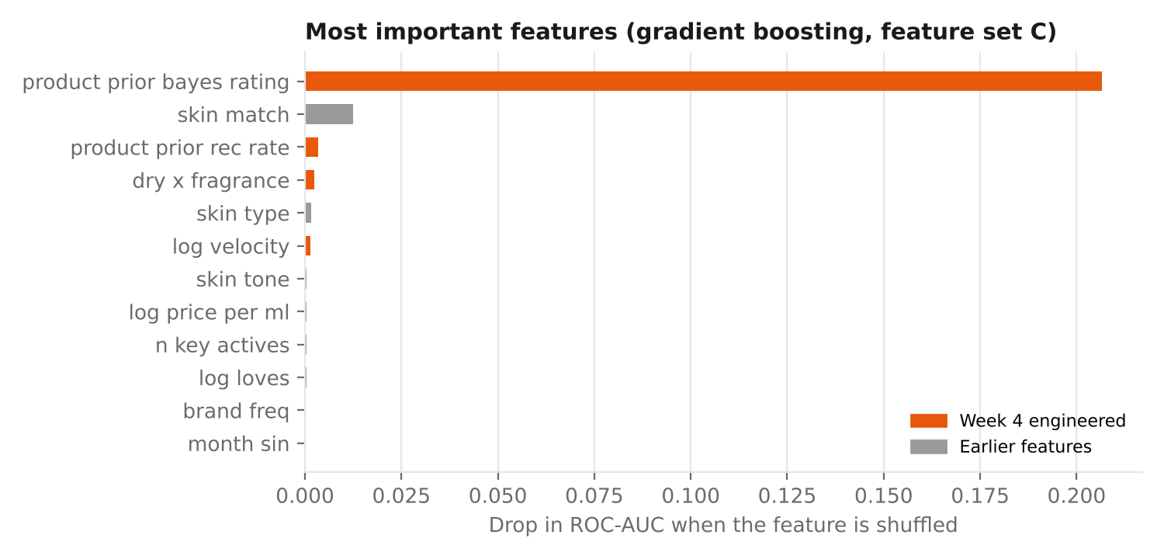
Figure 15. Permutation importance (drop in AUC when a feature is shuffled), set C, gradient boosting.
Product prior rating dominates (shuffling it lowers AUC by 0.21), followed by skin_match (0.013), product prior recommendation rate and the dry × fragrance interaction. Three of the top four features were engineered this week.

8. Hypothetical Decision Scenarios

8.1 Scenario A — a "Best for your skin" shelf
Situation (hypothetical): an Indian beauty e-retailer shows each category page sorted by "Popularity" (loves/bestsellers). A shopper with combination skin opens the moisturiser page. The top results are popular, but several were formulated for dry skin.
Decision supported by the features: for a logged-in shopper whose skin type is known, re-rank products by the model's predicted recommendation probability, which combines skin_match / skin_mismatch, dry_x_fragrance, product prior rating and momentum.
Back-test on the test period: for each skin type, I compared the 5 most popular products (by loves) with the 5 products the model ranked highest, using the actual recommendation rate of test-period reviewers with that skin type (products with ≥ 10 such reviews).
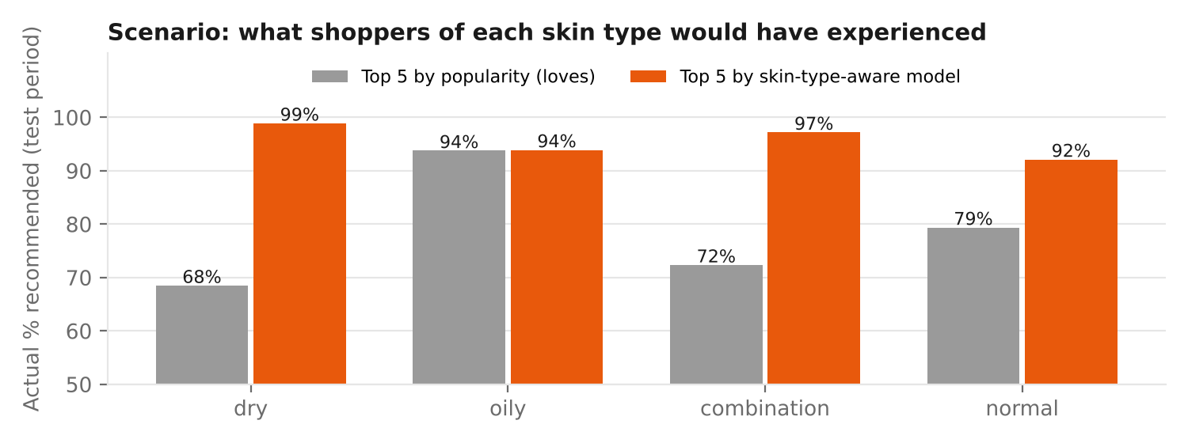
Figure 16. Actual recommendation rate of the top-5 products under each ranking rule, by skin type.
Skin type | Products ranked | Top 5 by popularity | Top 5 by model | All products
Dry | 35 | 68.5% | 98.9% | 81.7%
Oily | 28 | 93.8% | 93.9% | 84.6%
Combination | 59 | 72.3% | 97.2% | 81.3%
Normal | 16 | 79.4% | 92.1% | 81.1%
Average |  | 78.5% | 95.5% | 82.2%

Table 10. Scenario back-test (simulated data; small samples per product, so the gaps are optimistic).
What it would mean (illustration): if 10,000 shoppers a month bought from the top 5, moving from 78.5% to 95.5% satisfaction would mean roughly 1,700 more satisfied customers a month, with fewer returns and more repeat purchases. The popularity ranking also shows why this matters: for dry skin, the bestsellers perform below the category average (68.5% vs 81.7%) — popular is not the same as suitable.
How to make the decision safely: these gaps are optimistic (simulated data, 10–60 reviews per product). The recommended action is an A/B test: 50% of logged-in shoppers see the skin-aware ranking; success metric = recommendation rate and return rate after 60 days; guardrail = revenue per visitor.

8.2 Scenario B — R&D: should we launch a fragrance-free variant?
A brand's best-selling moisturiser contains fragrance. EDA shows that dry-skin buyers recommend fragranced products 4.1 points less often (H4), while other skin types show no penalty. Using the dry_x_fragrance and skin_match features, the brand can estimate the size of the opportunity — e.g. if 30% of the product's buyers have dry skin, a fragrance-free variant targeted at them could lift their recommendation rate from about 78.5% towards 82.6%. The feature also lets the brand monitor the effect after launch.

9. From Features to Business Insight
Feature | Insight it unlocks | Who acts on it | Model benefit
skin_match / skin_mismatch | Which products suit which skin types | Merchandising, personalisation | 2nd most important feature
dry_x_fragrance | Fragrance penalty is segment-specific | R&D, brand marketing | Captures interaction a linear model cannot
product_prior_bayes_rating, product_momentum | Early warning when a product starts trending down (e.g. a reformulation complaint) | Category managers, quality team | Most important feature; leak-free
price_rel_category, price_tier | Is a product over- or under-priced for its category? | Pricing, brand managers | Comparable across categories
aspect_* text features | Why customers are unhappy (irritation vs texture vs price) | R&D, customer service | Large accuracy gain (to be confirmed on real text)
brand_te | Brand reputation in one number | Marketing, buying team | Replaces 30 sparse columns
is_incentivised | How much free products inflate ratings | Trust & safety, analytics | Bias control
month_sin/cos, is_early_adopter | Seasonal demand, launch hype | Planning, marketing calendar | Time-aware predictions

Table 11. How each feature family drives insight and accuracy.
Communicating these to stakeholders follows the Week 2 plan: each insight is presented as Finding → Evidence → Action, with uncertainty shown. Example: "Dry-skin shoppers recommend fragranced moisturisers 4 points less often (82.6% vs 78.5%, n = 8,898, p < 0.001). Action: test a fragrance-free variant and show a 'Best for dry skin' badge."

10. Limitations & Next Steps

10.1 Limitations
- Simulated data: results confirm that the methods recover known patterns; real effect sizes will differ. Expected differences on real Sephora data: stronger seasonality, repeat reviewers (making reviewer features useful), messier text (lower text-model accuracy), and real price effects within luxury brands.
- Association, not causation: e.g. the fragrance effect could be confounded by formula type; causal claims require experiments (A/B tests) or causal-inference methods.
- Scenario sample sizes are small (10–60 reviews per product per skin type); Bayesian shrinkage and A/B testing are needed before acting.
- Some non-target statistics (category medians, price tiers) were computed on the full dataset; they will be moved inside the training pipeline in Week 5.

10.2 Next steps (Week 5)
- Run the full pipeline (Weeks 3–4) on the real Sephora data and compare findings with the simulation.
- Train and tune the final models (logistic regression, gradient boosting) with cross-validation in time order.
- Replace keyword aspects with transformer-based aspect sentiment and test H3 and H5 properly.
- Explain the models with SHAP, overall and per skin type, and check fairness across skin tones (AUC gap ≤ 0.03).

Appendix — Code, Commands & Outputs
python -m src.features.build_features # 35 features -> data/processed/features.csv.gz, reports/feature_catalogue.md
python -m src.eda.run_eda # tests + 12 figures -> docs/week4/figures, reports/eda_results.json
python -m src.modeling.feature_value # ablation, importance, scenario -> reports/feature_value.json

src/features/build_features.py 8 feature families, leak-free windows, out-of-fold target encoding
src/eda/run_eda.py univariate -> multivariate EDA, H1/H2/H4/H6 tests, PCA, k-means, mutual information
src/modeling/feature_value.py time-based ablation (A-D), paired bootstrap, permutation importance, scenario
docs/week4/eda_workflow.dot Figure 1 source

References
Breiman, L. (2001). Random forests. Machine Learning, 45(1), 5–32. (Permutation importance.)
Hunter, J. D. (2007). Matplotlib: A 2D graphics environment. Computing in Science & Engineering, 9(3), 90–95.
Jolliffe, I. T., & Cadima, J. (2016). Principal component analysis: A review and recent developments. Philosophical Transactions of the Royal Society A, 374(2065).
Kaufman, S., Rosset, S., Perlich, C., & Stitelman, O. (2012). Leakage in data mining: Formulation, detection, and avoidance. ACM TKDD, 6(4).
Kraskov, A., Stögbauer, H., & Grassberger, P. (2004). Estimating mutual information. Physical Review E, 69(6), 066138.
Kruskal, W. H., & Wallis, W. A. (1952). Use of ranks in one-criterion variance analysis. Journal of the American Statistical Association, 47(260), 583–621.
Micci-Barreca, D. (2001). A preprocessing scheme for high-cardinality categorical attributes in classification and prediction problems. ACM SIGKDD Explorations, 3(1), 27–32.
Pedregosa, F., et al. (2011). Scikit-learn: Machine learning in Python. JMLR, 12, 2825–2830.
Tukey, J. W. (1977). Exploratory Data Analysis. Addison-Wesley.
Virtanen, P., et al. (2020). SciPy 1.0: Fundamental algorithms for scientific computing in Python. Nature Methods, 17, 261–272.
Waskom, M. L. (2021). seaborn: Statistical data visualization. Journal of Open Source Software, 6(60), 3021.
Wilson, E. B. (1927). Probable inference, the law of succession, and statistical inference. JASA, 22(158), 209–212.

